A | 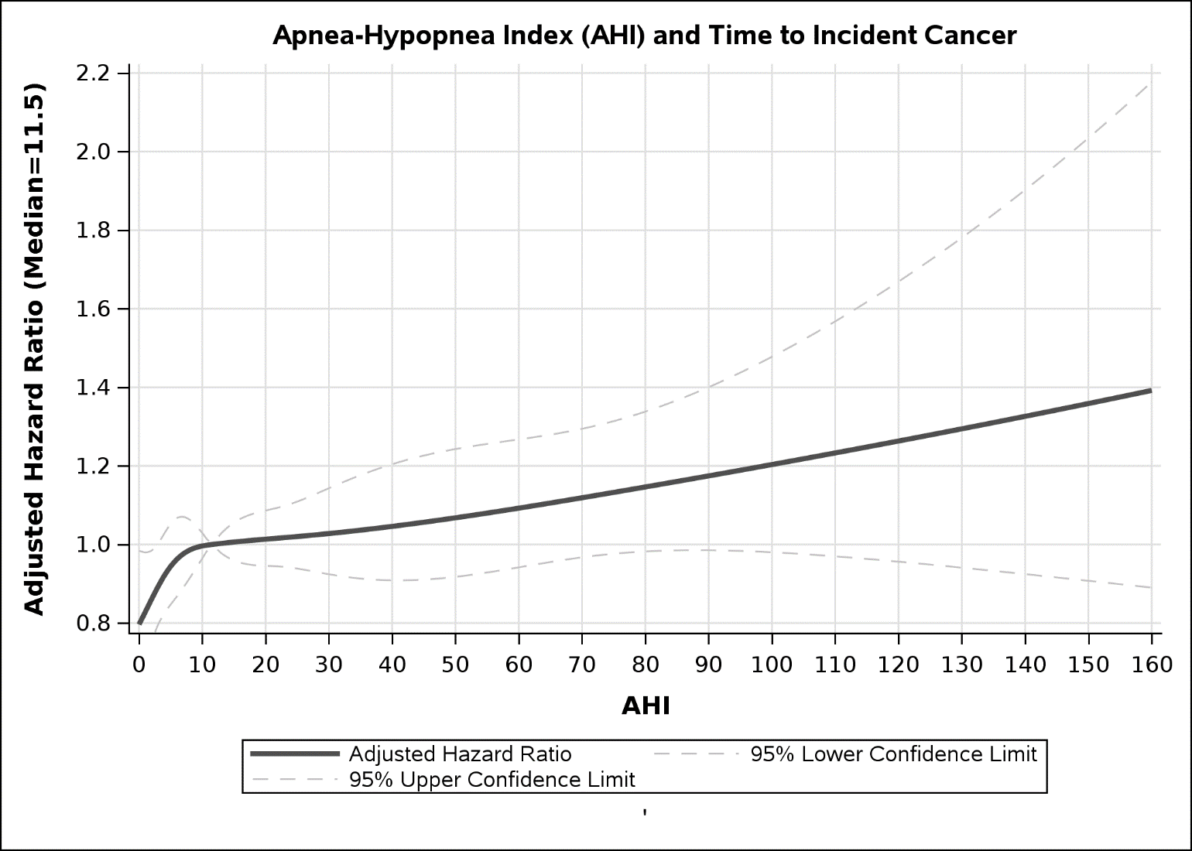
B | 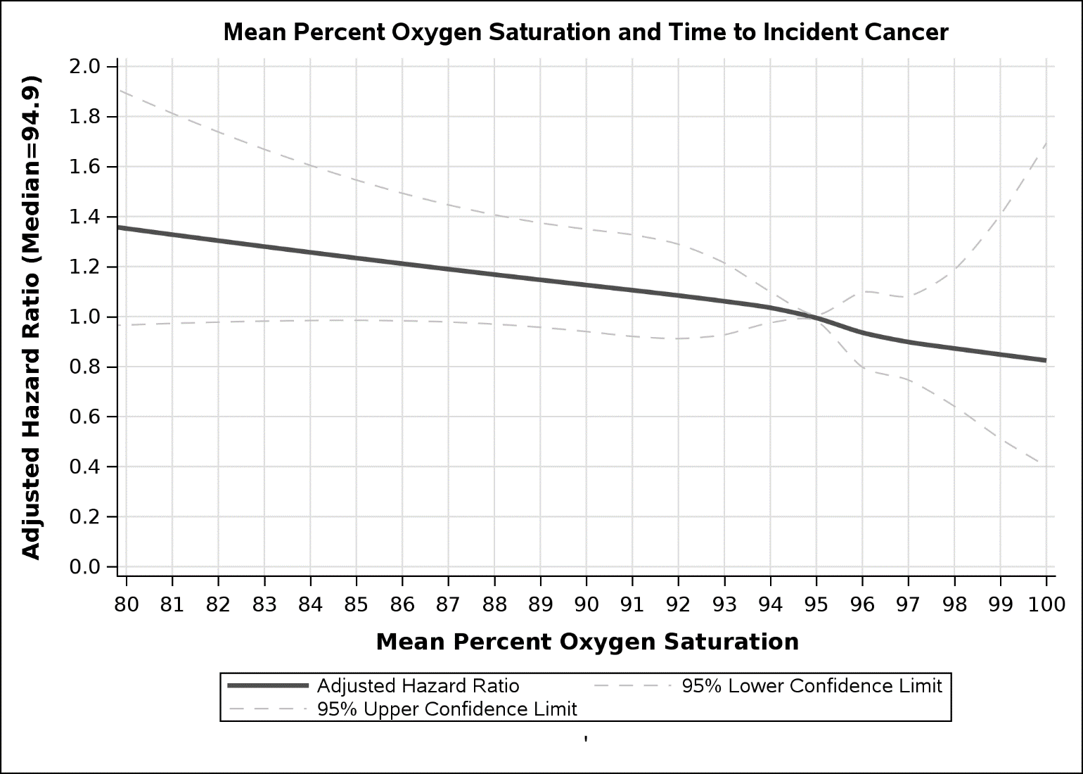
C | 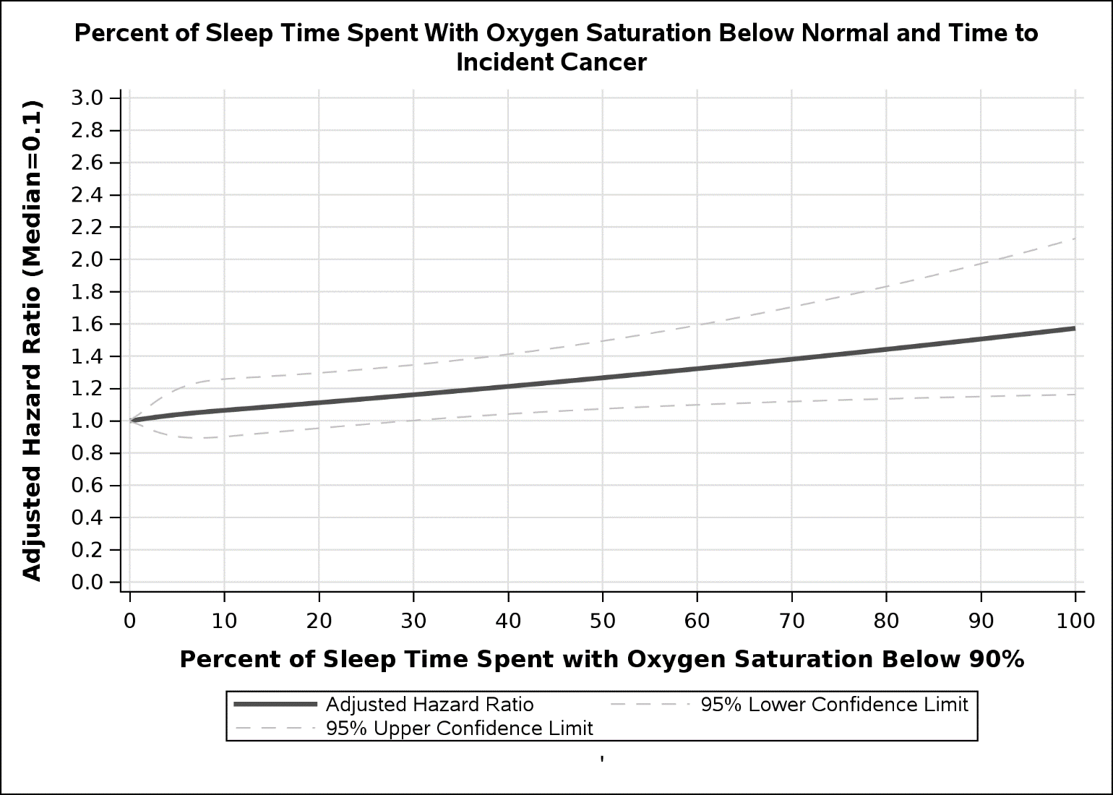

Figure S4. Dose-response relationship between obstructive sleep apnea (OSA) severity as measured by the apnea-hypopnea index (AHI) (A), the mean percent oxygen saturation (B), and the percent of sleep time spent with oxygen saturation below 90% (C) presented as adjusted hazard ratios (HRs) and 95% confidence interval with the median as a comparison group.

