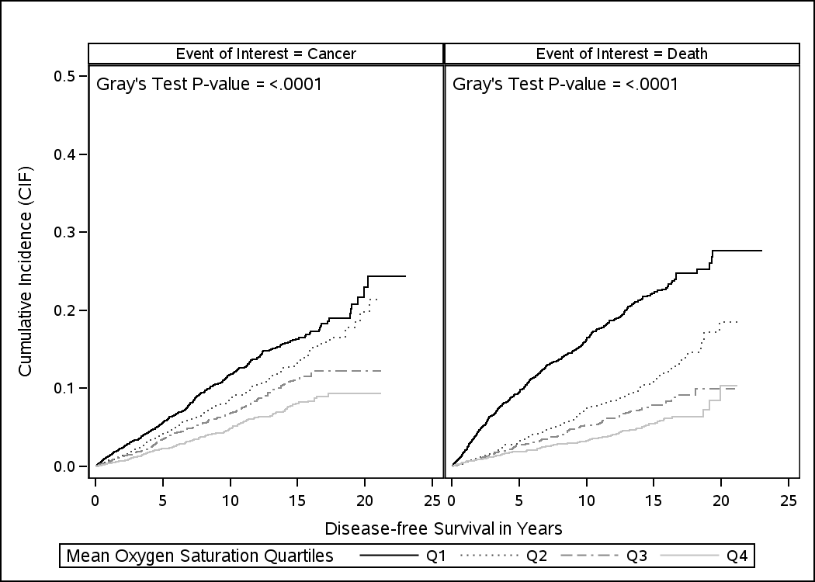
Figure S3. Estimated cumulative incidence of incident cancer and all-cause mortality by the degree of nocturnal oxygen desaturation as measured by mean oxygen saturation quartiles (Q): Q1 (SaO2 <93.4%), Q2 (SaO2 93.4-94.9%), Q3 (SaO2 94.9%-96%), Q4 (SaO2 ≥96%). At 10 years, the cumulative incidence of cancer was 11.8% (95% confidence interval [CI]: 10.5%–13.1%) among individuals at first quartile, 8.6% (95% CI: 7.6%–9.7%) among individuals at second quartile, 6.8% (95% CI: 5.8%–7.8%) among individuals at third quartile, and 4.8% (95% CI: 4.0%–5.7%) among individuals at fourth quartile. The corresponding rates at 15 years were 16.3% (95% CI: 14.7%–18.1%), 13.2% (95% CI: 11.7%–14.8%), 11.1% (95% CI: 9.6%–12.7%), and 8.1% (95% CI: 6.8%–9.5%), respectively.

