Supplementary Table 1: Genetic associations with gallstone and gall bladder cancer

SNPID | Gene | Gallstone disease |  |  |  |  |  |  |  |  |  |  |  |  |  | Gallbladder Cancer |  |  |  |  |  | Remark
 |  | European Population |  |  |  |  |  |  | Indian Population |  |  |  |  |  |  | Indian Population
 |  | minA/majA | OR | CIL | CIU | P | MAF* (%) | minA/majA |  | OR | CIL | CIU | P | MAF (%) | minA/majA |  | OR | CIL | CIU | P | MAF (%)
rs2291428 | MARCH8 | C/G | 1.08 | 1.07 | 1.10 | 2.4E-27 | 22 | C/G |  | 0.96 | 0.85 | 1.08 | 0.4420 | 26 | C/G |  | 0.99 | 0.91 | 1.08 | 0.8670 | 26
rs2290846 | LRBA | A/G | 1.08 | 1.07 | 1.10 | 4.7E-27 | 28 | A/G |  | 1.18 | 1.01 | 1.38 | 0.0390 | 10 | A/G |  | 1.09 | 0.96 | 1.24 | 0.1900 | 10
rs1800961 | HNF4A | T/C | 1.19 | 1.15 | 1.23 | 5.7E-26 | 4.6 | T/C |  | 1.41 | 1.11 | 1.80 | 0.0040 | 2.7 | T/C |  | 1.59 | 1.29 | 1.97 | ≤0.0001 | 2.7 | Excluded; outliers in radial MR estimates
rs601338 | FUT2 | G/A | 0.94 | 0.92 | 0.95 | 9.4E-22 | 39 | G/A |  | 1.13 | 1.00 | 1.29 | 0.0450 | 73 | G/A |  | 1.15 | 1.04 | 1.26 | 0.0060 | 73 | Excluded; outliers in radial MR estimates
rs708686 | FUT6 | T/C | 1.17 | 1.13 | 1.21 | 7.4E-20 | 23 | T/C |  | 1.03 | 0.94 | 1.15 | 0.4870 | 37 | T/C |  | 0.99 | 0.92 | 1.08 | 0.9220 | 37 | Excluded; outliers in radial MR estimates
rs28929474 | SERPINA1 | T/C | 1.22 | 1.17 | 1.28 | 1.8E-17 | 0.81 | T/C |  | 1.14 | 0.34 | 3.87 | 0.8310 | 0.16 | T/C |  | 0.80 | 0.27 | 2.35 | 0.6890 | 0.16
rs34851490 | IRF2BP1 | G/A | 1.08 | 1.06 | 1.10 | 4.2E-15 | 8.5 | G/A |  | 1.33 | 1.09 | 1.62 | 0.0060 | 4.9 | G/A |  | 1.15 | 0.97 | 1.36 | 0.1150 | 4.9 | Excluded due to LD
rs1169288 | HNF1A | C/A | 0.94 | 0.93 | 0.96 | 1.6E-14 | 31 | C/A |  | 0.99 | 0.89 | 1.10 | 0.9010 | 43 | C/A |  | 1.03 | 0.95 | 1.11 | 0.4780 | 43
rs13280055 | FDFT1/GATA4 | A/G | 1.08 | 1.05 | 1.10 | 6.9E-14 | 13 | A/G |  | 1.09 | 0.79 | 1.51 | 0.6050 | 2.4 | A/G |  | 1.10 | 0.84 | 1.42 | 0.5150 | 2.4
rs56398830 | SLC10A2 | A/G | 1.24 | 1.17 | 1.31 | 2.1E-12 | 0.59 | A/G |  | 1.57 | 0.66 | 3.74 | 0.3030 | 0.38 | A/G |  | 1.46 | 0.65 | 3.28 | 0.3580 | 0.38
rs174567 | FADS2 | G/A | 1.05 | 1.03 | 1.06 | 2.3E-12 | 39 | G/A |  | 1.03 | 0.90 | 1.18 | 0.6480 | 15 | G/A |  | 0.98 | 0.88 | 1.09 | 0.6800 | 15
rs11012737 | MLLT10 | A/G | 1.05 | 1.03 | 1.06 | 3.7E-12 | 27 | A/G |  | 1.00 | 0.88 | 1.15 | 0.9620 | 18 | A/G |  | 0.99 | 0.89 | 1.10 | 0.7930 | 18
rs2469991 | MAL2 | T/A | 0.95 | 0.94 | 0.97 | 9.2E-12 | 32 | T/A |  | 1.01 | 0.92 | 1.12 | 0.8160 | 53 | T/A |  | 1.03 | 0.95 | 1.11 | 0.4980 | 53 | Excluded; for being palindromic
rs1935 | JMJD1C | C/G | 0.96 | 0.94 | 0.97 | 9.2E-12 | 48 | C/G |  | 1.03 | 0.93 | 1.13 | 0.6030 | 47 | C/G |  | 0.92 | 0.85 | 0.99 | 0.0390 | 47 | Excluded; for being palindromic
rs17240268 | ANPEP | A/G | 0.93 | 0.91 | 0.95 | 6E-11 | 12 | A/G |  | 0.89 | 0.71 | 1.11 | 0.3070 | 4.7 | A/G |  | 0.99 | 0.83 | 1.19 | 0.9270 | 4.7
rs12004 | KDELR3 | G/T | 1.05 | 1.03 | 1.06 | 1.2E-10 | 31 | G/T |  | 1.05 | 0.94 | 1.17 | 0.3730 | 30.0 | G/T |  | 1.06 | 0.98 | 1.15 | 0.1670 | 30.0
rs55971546 | SLC10A2 | T/C | 1.10 | 1.07 | 1.13 | 1.8E-10 | 4.1 | T/C |  | 1.17 | 0.67 | 2.05 | 0.5860 | 1.2 | T/C |  | 1.08 | 0.68 | 1.71 | 0.7460 | 1.2
rs11641445 | LITAF | T/C | 1.04 | 1.03 | 1.05 | 4.2E-10 | 34 | T/C |  | 1.08 | 0.97 | 1.19 | 0.1410 | 38 | T/C |  | 1.11 | 1.02 | 1.19 | 0.0120 | 38
rs17138478 | HNF1B | A/C | 1.06 | 1.04 | 1.08 | 5.1E-10 | 13 | A/C |  | 1.01 | 0.89 | 1.15 | 0.8970 | 19 | A/C |  | 1.06 | 0.97 | 1.18 | 0.2230 | 19
rs2292553 | TMBIM1 | G/A | 0.96 | 0.94 | 0.97 | 1.1E-08 | 46 | G/A |  | 0.99 | 0.89 | 1.10 | 0.7560 | 35 | G/A |  | 0.93 | 0.86 | 1.01 | 0.0850 | 35
rs12968116 | ATP8B1 | T/C | 0.94 | 0.92 | 0.97 | 1.2E-08 | 16 | T/C |  | 1.04 | 0.82 | 1.32 | 0.7580 | 4.9 | T/C |  | 0.90 | 0.75 | 1.10 | 0.2990 | 4.9
rs11887534 | ABCG8 | C/G | 1.58 | 1.55 | 1.66 | 1.0E-353 | 5.5 | C/G |  | 1.54 | 1.24 | 1.90 | ≤0.0001 | 3.6 | C/G |  | 1.35 | 1.12 | 1.64 | 0.0020 | 3.6
rs212100 | SULT2A1 | T/C | 0.90 | 0.88 | 0.92 | 2E-31 | 16 | T/C |  | 0.92 | 0.77 | 1.08 | 0.2900 | 11 | T/C |  | 0.91 | 0.80 | 1.03 | 0.1410 | 11
rs12633863 | TM4SF4 | G/A | 1.08 | 1.06 | 1.09 | 3.6E-30 | 45 | G/A |  | 0.97 | 0.88 | 1.08 | 0.5720 | 42 | G/A |  | 0.97 | 0.89 | 1.05 | 0.4650 | 42
rs4148808 | ABCB4 | C/T | 0.90 | 0.89 | 0.92 | 8.6E-28 | 16 | C/T |  | 0.82 | 0.69 | 0.97 | 0.0190 | 14 | C/T |  | 0.69 | 0.60 | 0.79 | ≤0.0001 | 14 | Excluded; outliers in radial MR estimates
rs6471717 | CYP7A1 | G/A | 1.08 | 1.06 | 1.09 | 9.9E-26 | 31 | G/A |  | 1.11 | 1.00 | 1.24 | 0.0440 | 31 | G/A |  | 1.05 | 0.97 | 1.15 | 0.2250 | 31
rs686030 | TTC39B | C/A | 0.92 | 0.89 | 0.93 | 1.8E-20 | 13 | C/A |  | 0.75 | 0.58 | 0.97 | 0.0300 | 5.8 | C/A |  | 0.77 | 0.64 | 0.92 | 0.0050 | 5.8 | Excluded; outliers in radial MR estimates
rs756082276 | ABCB4 | NA | NA | NA | NA | NA | NA | NA |  | NA | NA | NA | NA | NA | NA |  | NA | NA | NA | NA | NA | neither genotype nor imputed
rs1260326 | GCKR | T/C | 0.95 | 0.94 | 0.96 | 2E-16 | 34 | T/C |  | 0.97 | 0.86 | 1.10 | 0.7000 | 0.42 | T/C |  | 0.99 | 0.90 | 1.08 | 0.7720 | 0.42
rs756935975 | ABCB4 | T/C | NA | NA | NA | NA | NA | NA |  | NA | NA | NA | NA | NA | NA |  | NA | NA | NA | NA | NA | neither genotype nor imputed
rs2070959 | UGT1A6 | G/A | 1.05 | 1.03 | 1.06 | 8.5E-11 | 32 | G/A |  | 1.02 | 0.92 | 1.13 | 0.6790 | 42 | G/A |  | 1.02 | 0.94 | 1.11 | 0.5720 | 42
rs45575636 | ABCB4 | T/C | 1.22 | 1.14 | 1.31 | 7.9E-09 | 0.31 | T/C |  | 3.71 | 0.84 | 16.7 | 0.0870 | 0.13 | T/C |  | 2.57 | 0.61 | 10.79 | 0.1970 | 0.13 | Excluded due to LD
*Icelandic population
Effect estimates were multiplied by log2(=0.693) to represent a per-doubling in effect

Supplementary Table 2: Outlier SNPs identified in Radial IVW and MR-Egger regression

SNP | Q Statistics | P-Value
rs4148808 | 20.68 | 5.43E-06
rs601338 | 12.25 | 4.66E-04
rs1800961 | 11.98 | 5.36E-04
rs708686 | 5.91 | 0.015
rs686030 | 4.93 | 0.026

Supplementary Table 3: Associations between self-reported gallstone history and genetic risk score with potential confounders (n=2751)
Variables | Self-reported gallstone history |  |  |  | Unweighted genetic risk score
 | Mean(SD) | F-Statistic | R²-Statistic | p* | Mean(SD) | F-Statistic | R²-Statistic | p*
Age,β on linear regression | 0.16(0.37) | 8.15 | 0.018 | ≤0.0001 | 11.78(2.53) | 5.32 | 0.012 | 0.138
Sex |  | 9.10 | 0.020 | ≤0.0001 |  | 6.44 | 0.014 | 0.260
Male | 0.13(0.34) |  |  |  | 11.69(2.54)
Female | 0.18(0.38) |  |  |  | 11.83(2.53)
Highest level of education |  | 6.79 | 0.015 | ≤0.0001 |  | 3.98 | 0.009 | 0.444
Less than 5 years schooling | 0.21(0.41) |  |  |  | 11.84(2.50)
≥5 year of education | 0.15(0.35) |  |  |  | 11.76(2.54)
Current residential region |  | 6.59 | 0.014 | 0.779 |  | 6.79 | 0.146 | 0.779
North | 0.2(0.40) |  |  |  | 11.77(2.55)
North East | 0.21(0.41) |  |  |  | 11.69(2.59)
South | 0.03(0.19) |  |  |  | 11.64(2.53)
West | 0.07(0.25) |  |  |  | 11.83(2.46)
Central | 0.13(0.34) |  |  |  | 12.13(2.41)
Waist-to-hip ratio-β on linear regression | 0.16(0.37) | 4.89 | 0.011 | 0.038 | 11.78(2.53) | 4.19 | 0.009 | 0.847
Per capita per month mustard oil consumption-β on linear regression | 0.16(0.37) | 50.03 | 0.099 | 0.003 | 11.78(2.53) | 49.10 | 0.097 | 0.091
Per capita per week fresh fish consumption-β on linear regression | 0.16(0.37) | 4.79 | 0.011 | 0.055 | 11.78(2.53) | 4.32 | 0.010 | 0.353
Self-reported History of gall stone | n/a |  |  |  |  | 11.62 | 0.025 | 0.033
No |  |  |  |  | 11.74(2.51) | n/a
Yes |  |  |  |  | 11.99(2.63)

Supplementary Figure 1: Forest Plot for Two-Sample MR effect of Gallstones on Gallbladder Cancer

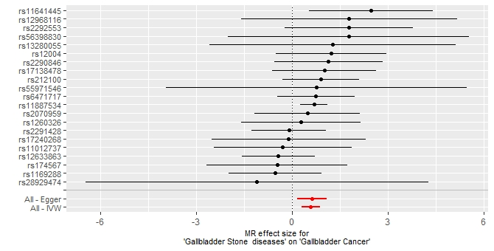

Supplementary Figure 2: Scatter plot of single nucleotide polymorphism (SNPs) effect estimates of gallstones on gall bladder cancer in Two-Sample MR

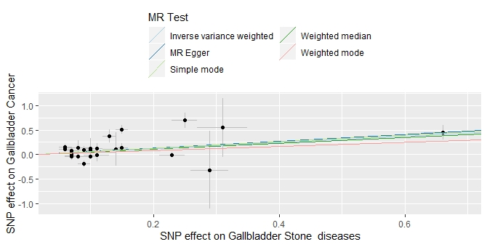

Supplementary Figure 3: Funnel plot of single nucleotide polymorphism (SNPs) effect estimates of gallstones on gall bladder cancer (n=26) in Two-Sample MR

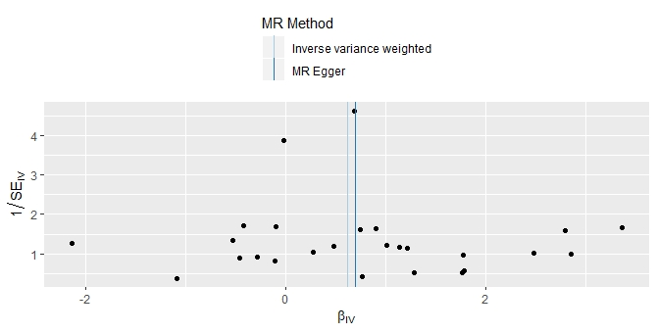
Supplementary Figure 4: Radial MR Plot of gallstone and gallbladder cancer

