Supplementary Figure 1: Study Population

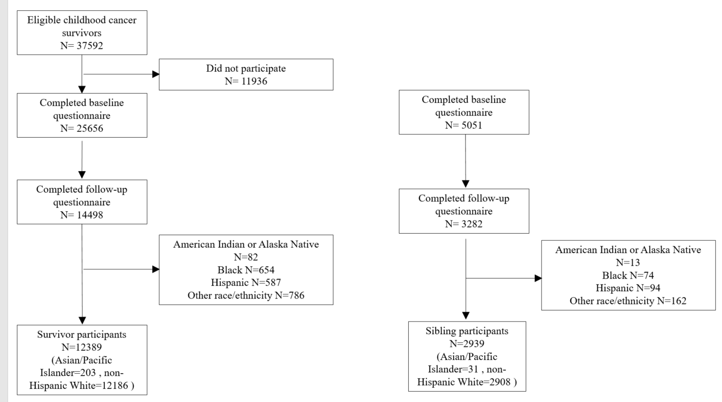
Survivors: Sibling controls:

Supplementary Figure S1 describes the flowchart of the study population (survivors and sibling controls). For this study, 14,498 eligible survivors and 3,282 siblings completed both the baseline and follow-up questionnaires on functional outcomes in 2003, 2007 or 2015. We excluded participants in the American Indian or Alaska Native, Black, Hispanic, and other racial categories. Finally, we analyzed data from 12,389 survivors and 2,939 sibling controls of Asian/ Pacific Islander and non-Hispanic White descents.

