Supplement
Additional methodology information on Joinpoint regression
The Joinpoint software (http://surveillance.cancer.gov/joinpoint) provides the point and interval estimates of the slope parameters for each segment, as well as the point and interval estimates of the locations of joinpoints.¹ As mentioned in the text, when modeled in log-scale, the slope of a single segment is equivalent to the annual percent change (APC) rate. The APC measures the cancer rate change per year so that it is comparable across different scales, for both rare and common cancer sites. However, the APC is calculated in a segment where the rate change is at a constant rate. To summarize cancer trends, cancer rates are often compared with a certain fixed period, such as the last 10- or 5-year interval, etc. When there is a trend change within that fixed time period, the rate change is no longer a constant. In such a case, the APC cannot be used to compare across different sites, and the average APC (AAPC) should be used instead. The AAPC is a weighted average of the APC(s) over a time period that may span several segments, with weights depending on the length of each segment. On the occasion that the AAPC is calculated over a period that has no trend change, the AAPC is identical to the APC.
Joinpoint software has been continuously updated and expanded to improve its accuracy and efficiency. In the Cancer 2012 methodology papers^{3,7}, we evaluated the performance of projection accuracy of models selected by the permutation test procedure and modified Bayesian information criterion (MBIC). It was shown that the MBIC performs better than permutation test in projection and is the current mortality projection method. The MBIC was introduced as an improved version of the BIC (a faster alternative to the default permutation procedure), specifically where the BIC tended to overfit the model. Since then, two novel weighted BIC (WBIC) options have also been introduced.² The WBIC combines the original BIC and another BIC algorithm, the BIC3, using a weighted penalty term, thereby assigning a harsher penalty when change sizes are relatively large, similar to the selection rule for BIC3, and a smaller penalty otherwise, similar to BIC. The WBIC-alt (short for “alternative”) is similar to the WBIC but assigns different weights.
The Joinpoint program also allows a user to change model‐fitting specifications, which include the maximum number of joinpoints, the minimum number of observations from a joinpoint to either end of the data, and the minimum number of observations between two joinpoints. In our evaluation, we examined the use of an APC versus a more conservative, 4-year AAPC for the temporal projection component. When prediction is based on the APC of the last segment of the joinpoint model, the variance of the APC for a short final segment can sometimes be large and lead to the projection veering off too wildly. Pairing the 4-year AAPC with a shorter last segment allows the model to find a joinpoint closer to the end of the data series, but at the same time, theoretically makes the projection more stable.
For APC projections, we used a maximum of 2 joinpoints, a minimum of 3 observations from a joinpoint to either end of the data (excluding any joinpoint), and a minimum of 2 observations between 2 joinpoints (excluding any joinpoint). For the four-year AAPC method, we adjusted the minimum number of observations from a joinpoint to the end of the data down to 2.
The joinpoint model projection considered in our comparison include three model selections method: MBIC, WBIC, and WBIC-alt; and two types of slope: APC and AAPC. Totally we considered 6 combinations of Joinpoint method: MBIC-APC, MBIC-AAPC, WBIC-APC, WBIC-AAPC, WBIC-alt-APC, WBIC-alt-AAPC. To illustrate the notation, MBIC-APC stands for using MBIC model selection criteria and APC of the last segment for projection. Likewise, WBIC-AAPC stands for using WBIC model selection criteria and the last 4-year AAPC for projection.

References
1. Statistical Research and Applications Branch. National Cancer Institute. Joinpoint Regression Program. Version 4.7.0.0. Statistical Research and Applications Branch, National Cancer Institute; 2019.
2. National Cancer Institute. Joinpoint Alpha and Beta Versions. Available from URL: https://surveillance.cancer.gov/help/joinpoint/tech-help/alpha-and-beta-versions [accessed July 21, 2020].

Supplement Table 1. Cancer Sites Used in the Analysis
National level
Acute lymphocytic leukemia; Acute myeloid leukemia; Anus, anal canal, and anorectum; Brain and other nervous system; Breast (male and female); Bones and joints; Chronic lymphocytic leukemia; Chronic myeloid leukemia; Colon and rectum combined (mortality only); Colon (incidence only); Esophagus; Eye and orbit; Gallbladder and other biliary; Hodgkin lymphoma; Kidney and renal pelvis; Larynx; Leukemia; Liver and intrahepatic bile duct; Lung and bronchus; Melanoma of the skin; Mouth; Multiple myeloma; Non‐Hodgkin lymphoma; Other and unspecified primary sites; Other digestive organs; Other endocrine; Other leukemia; Other nonepithelial skin; Other oral cavity; Other respiratory organs; Ovary; Pancreas; Penis and other male genital; Pharynx; Prostate; Rectum (incidence only); Small intestine; Soft tissue (including heart); Stomach; Testis; Thyroid; Tongue; Ureter and other urinary organs; Urinary bladder; Uterine cervix; Uterine corpus; Vagina and other female genital; Vulva
State level

Brain and other nervous system; Breast (female only); Esophagus; Colon and rectum; Hodgkin lymphoma; Kidney and renal pelvis; Larynx; Leukemia; Liver and intrahepatic bile duct; Lung and bronchus; Melanoma of the skin; Multiple myeloma; Non‐Hodgkin lymphoma; Oral cavity and pharynx; Ovary; Pancreas; Prostate; Stomach; Urinary bladder; Uterine cervix; Uterine corpus

Supplement Table 2. National ARDs (%) of the 4-Year Ahead Incidence Projection for the Most Common Cancers
 | Breast | Prostate | Lung & bronchus |  | Colon |  | Uterine corpus | Urinary bladder
 | Female |  | Female | Male | Female | Male |  | Male
VAR-None modeled | 4.5 | 35.8 | 2.6 | 0.1 | 5.2 | 5.1 | 3.6 | 0.6
VAR-None mixed | 1.6 | 33.4 | 0.3 | 4.5 | 6.6 | 0.8 | 3.5 | 1.8
VAR-Trend modeled | 0.0 | 22.7 | 0.0 | 0.9 | 9.1 | 18.0 | 4.5 | 0.0
VAR-Trend mixed | 2.8 | 22.2 | 4.5 | 0.8 | 0.2 | 12.8 | 3.9 | 1.9
JP-WBIC-Alt AAPC mixed | 4.0 | 32.4 | 4.1 | 0.9 | 3.3 | 5.9 | 4.0 | 0.3
JP-WBIC-Alt AAPC modeled | 1.7 | 10.7 | 0.8 | 1.3 | 6.5 | 10.2 | 2.1 | 0.6
JP-MBIC-AAPC mixed | 7.7 | 32.4 | 4.1 | 0.9 | 1.4 | 0.8 | 2.1 | 0.6
JP-MBIC-AAPC modeled | 7.0 | 33.6 | 1.1 | 0.0 | 4.6 | 6.2 | 4.0 | 0.3
JP-WBIC-AAPC mixed | 4.0 | 32.4 | 4.1 | 0.9 | 3.3 | 5.9 | 2.6 | 0.4
JP-WBIC-AAPC modeled | 1.7 | 10.7 | 0.8 | 1.3 | 4.6 | 10.2 | 4.0 | 0.3
JP-WBIC-Alt APC mixed | 4.0 | 32.4 | 4.1 | 0.9 | 3.3 | 5.9 | 4.0 | 0.3
JP-WBIC-Alt APC modeled | 1.7 | 13.3 | 0.4 | 0.0 | 4.6 | 6.7 | 2.1 | 0.6
JP-MBIC-APC mixed | 7.7 | 32.4 | 4.1 | 0.9 | 1.4 | 0.8 | 4.0 | 0.3
JP-MBIC-APC modeled | 7.0 | 33.6 | 1.1 | 0.0 | 4.6 | 6.2 | 2.6 | 0.4
JP-WBIC-APC mixed | 4.0 | 32.4 | 4.1 | 0.9 | 3.3 | 5.9 | 4.0 | 0.3
JP-WBIC-APC modeled | 1.7 | 13.3 | 1.1 | 0.0 | 4.6 | 6.7 | 2.1 | 0.6
BSS mixed | 7.4 | 14.1 | 4.4 | 0.8 | 2.2 | 7.8 | 10.0 | 4.2
BSS modeled | 9.7 | 24.2 | 0.3 | 3.3 | 7.9 | 2.4 | 12.2 | 4.9

Grey highlight indicates the lowest ARD by column.
ARD indicates absolute relative deviation; AAPC, average annual percent change; APC, annual percent change; BSS, Bayesstate‐space method; JP‐MBIC, joinpoint method with modified Bayesian information criterion; JP‐WBIC, joinpoint method with weighted BIC; VAR, vector autoregressive analysis method.

Supplement Table 3. State-Level AARDs (%) of the 3‐Year‐Ahead Mortality Projection
 | JP-MBIC-APC* | JP-MBIC-AAPC | JP-WBIC-APC | JP-WBIC-AAPC | JP-WBIC-Alt-APC | JP-WBIC-Alt-AAPC | BSS
All scenarios combined | 18.7 | 18.8 | 21.8 | 22.8 | 20.9 | 21.6 | 17.3†
By observed deaths (# scenarios)
<50 (2772) | 39.6 | 39.9 | 46.5 | 48.4 | 44.5 | 46.1 | 33.8†
50-<100 (1311) | 12.1† | 12.1† | 14.7 | 15.8 | 13.9 | 14.5 | 15.3
100-<250 (1872) | 9.4† | 9.5 | 10.8 | 11.4 | 10.4 | 10.7 | 11.3
250-<500 (1009) | 6.7† | 6.8 | 7.7 | 7.9 | 7.5 | 7.6 | 8.8
500-<1,000 (613) | 5.6† | 5.6† | 6.1 | 6.4 | 5.9 | 6.1 | 7.6
1,000-<5k (589) | 3.8 | 3.8 | 3.7† | 3.9 | 3.7† | 3.8 | 4.8
5k or more (198) | 2.0† | 2.0† | 2.1 | 2.1 | 2.1 | 2.1 | 3.5
*Current method. †Indicates the best fit by row. Methods within the 10% threshold of the best fit are indicated in grey highlight.
AARD indicates average absolute relative deviation; AAPC, average annual percent change; APC, annual percent change; BSS, Bayes state‐space method; JP‐MBIC, joinpoint method with modified Bayesian information criterion; JP‐WBIC, joinpoint method with weighted BIC; VAR, vector autoregressive analysis method.

Supplement Figure 1. State level boxplots of incidence ARDs by model type
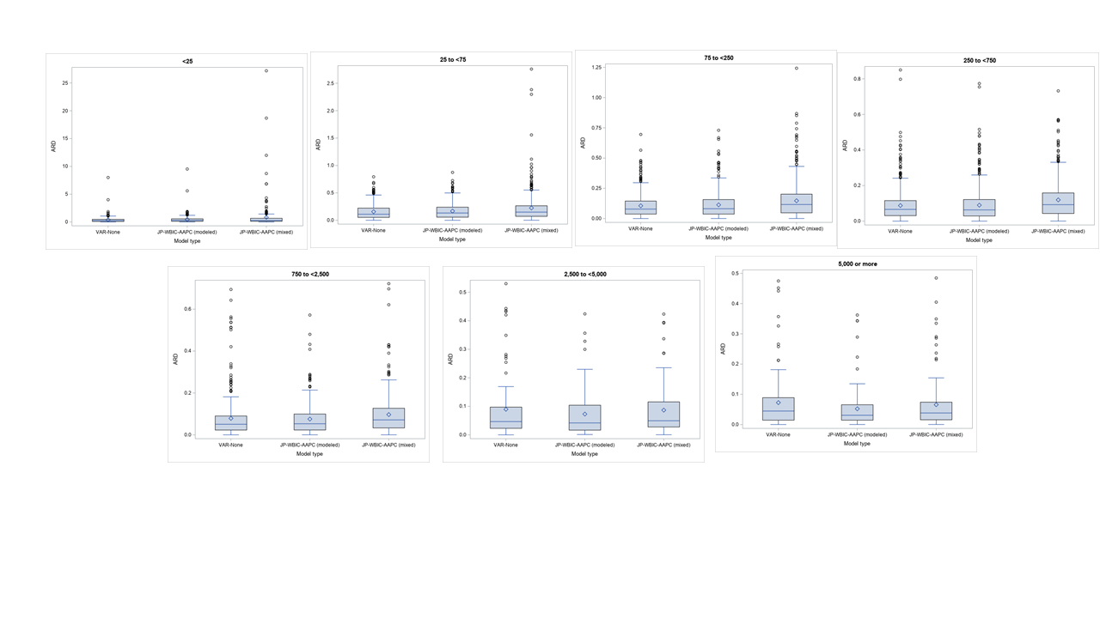
ARD indicates average relative deviation. The diamond indicates the average of the ARDs; the midline of each box indicates the median. The “whiskers” indicate the furthest ARD within 1.5 times the IQR. The small circles indicate outliers.

Supplement Figure 2. State level boxplots of mortality ARDs by model type
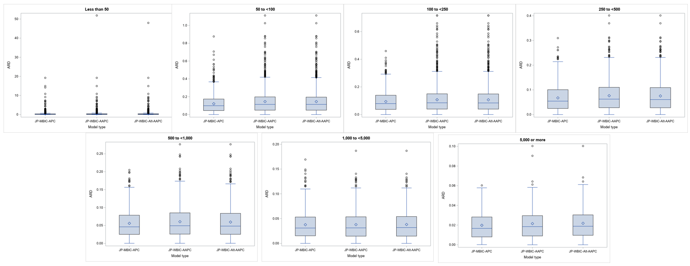
ARD indicates average relative deviation. The diamond indicates the average of ARDs; the midline of each box indicates the median. The “whiskers” indicate the furthest ARD within 1.5 times the IQR. The small circles indicate outliers.

