Rising prostate cancer incidence in sub-Saharan Africa:
a trend analysis of data from the African Cancer Registry Network
Tobias P. Seraphin; W. Yvonne Joko-Fru; Bakarou Kamaté; Eric Chokunonga;
Henry Wabinga; Nontuthuzelo I.M. Somdyala,; Shyam S. Manraj; Olufemi Ogunbiyi;
Charles P. Dzamalala; Anne Finesse; Ann Korir; Guy N’Da; Cesaltina Lorenzoni, Biying Liu;
Eva J. Kantelhardt; Donald M. Parkin

Supplementary Figures:

Supplementary Figure 1A:
Results of the joinpoint regression modelling of the age-standardised incidence rates, showing the best fits per registry, first half of the registries
Supplementary Figure 1B:
Results of the joinpoint regression modelling of the age-standardised incidence rates, showing the best fits per registry, second half of the registries
Supplementary Figure 2:
Number of cases by age in years by registry

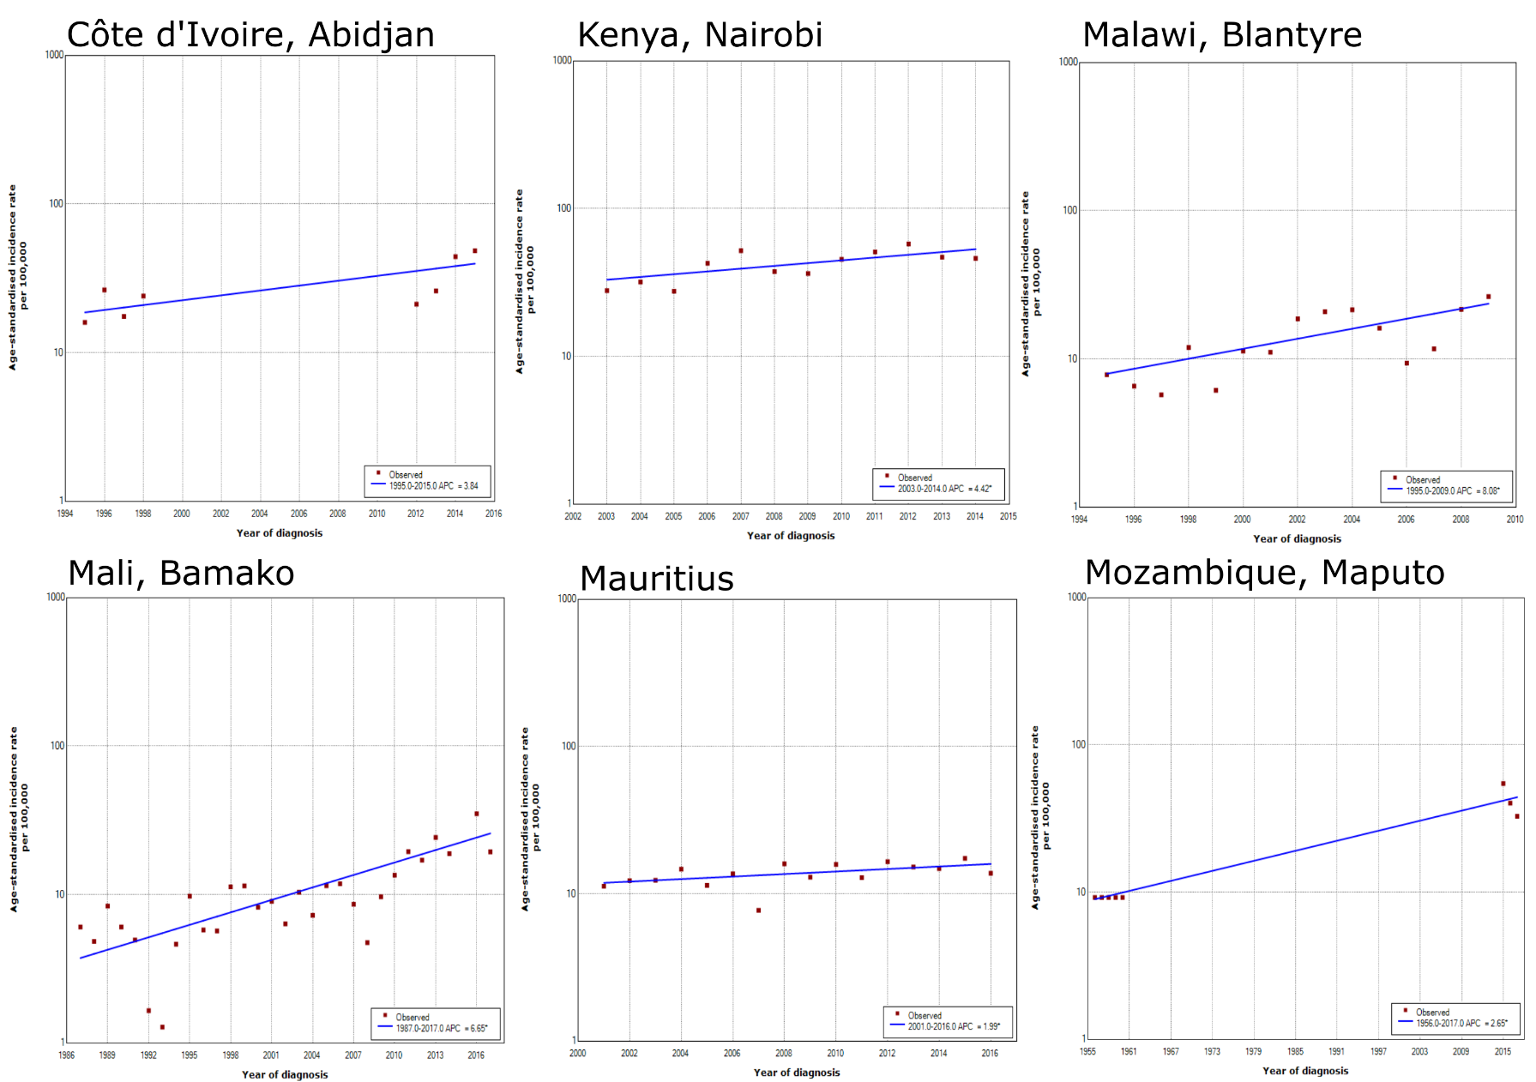
Supplementary Figure 1A :
Results of the joinpoint regression modelling of the age-standardised incidence rates, showing the best fits per registry, first half of the registries
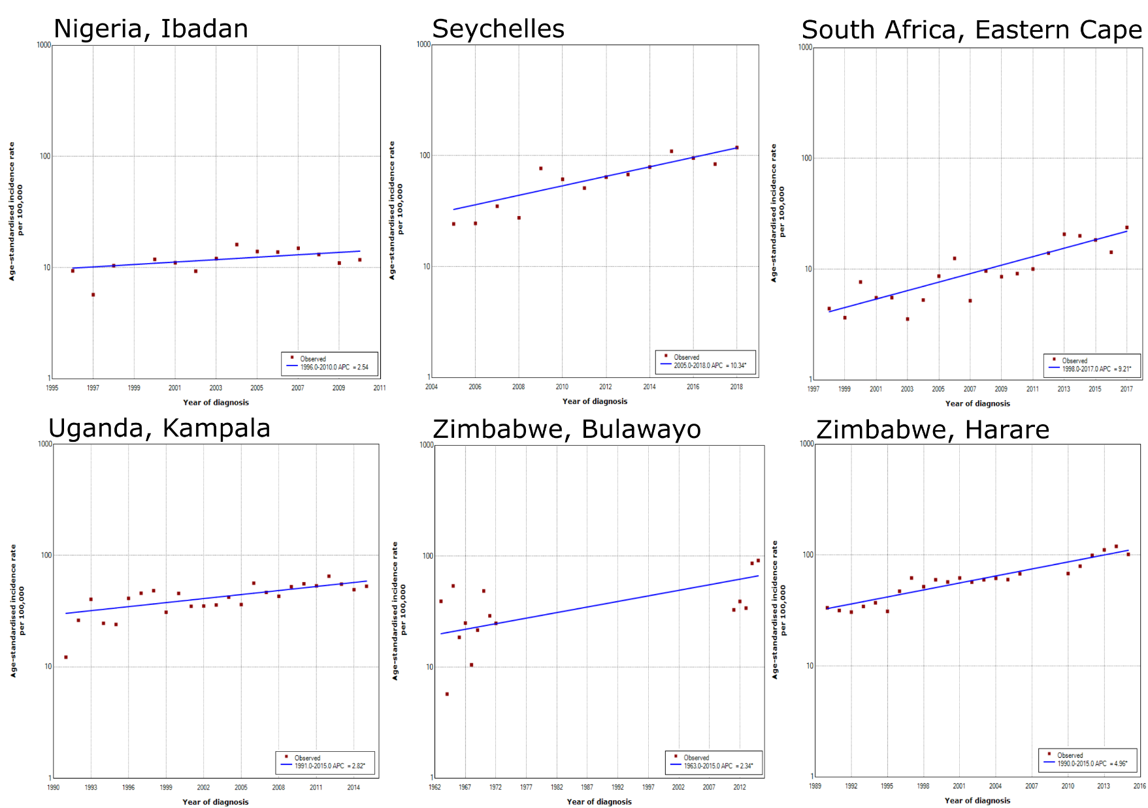
Supplementary Figure 1 B:
Results of the joinpoint regression modelling of the age-standardised incidence rates, showing the best fits per registry, second half of the registries
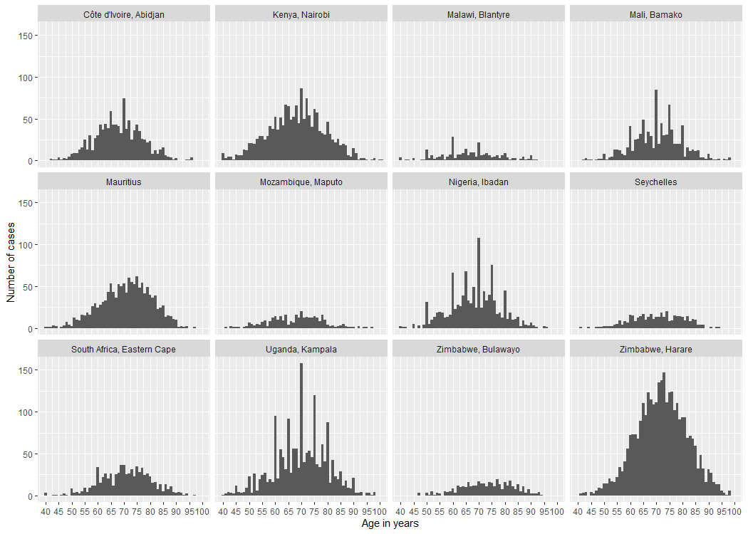
Supplementary Figure 2:
Number of cases by age in years by registry

