Supplementary Figure 1. Distribution of cigarette filter ventilation level
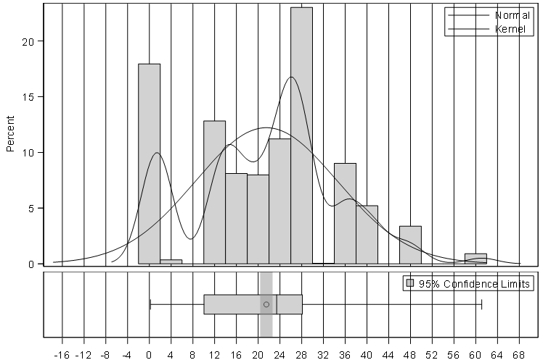
Filter Ventilation (%)
Percent of participants

