SUPPLEMENTAL MATERIALS

Supplemental Table 1: American Cancer Society list of top ten cancer types and percent contributing to overall cancer incidence and mortality in males and females, 2019³⁸.

MALE |  | FEMALE
Incidence |  | Incidence
Prostate | 20% | Breast | 30%
Lung & bronchus | 13% | Lung & bronchus | 13%
Colon & rectum | 9% | Colon & rectum | 7%
Urinary bladder | 7% | Uterine corpus | 7%
Melanoma of the skin | 7% | Melanoma of the skin | 5%
Kidney & renal pelvis | 5% | Thyroid | 4%
Non-Hodgkin lymphoma | 5% | Non-Hodgkin lymphoma | 4%
Oral cavity & pharynx | 4% | Kidney & renal pelvis | 3%
Leukemia | 4% | Pancreas | 3%
Pancreas | 3% | Leukemia | 3%
Mortality |  | Mortality
Lung & bronchus | 24% | Lung & bronchus | 23%
Prostate | 10% | Breast | 15%
Colon & rectum | 9% | Colon & rectum | 8%
Pancreas | 7% | Pancreas | 8%
Liver & intrahepatic bile duct | 7% | Ovary | 5%
Leukemia | 4% | Uterine corpus | 4%
Esophagus | 4% | Liver & intrahepatic bile duct | 4%
Urinary bladder | 4% | Leukemia | 3%
Non-Hodgkin lymphoma | 4% | Non-Hodgkin lymphoma | 3%
Brain & other nervous system | 3% | Brain & other nervous system | 3%

Supplemental Figure 1: Crude Average Annual Incidence per 100,000 persons aged 50-79
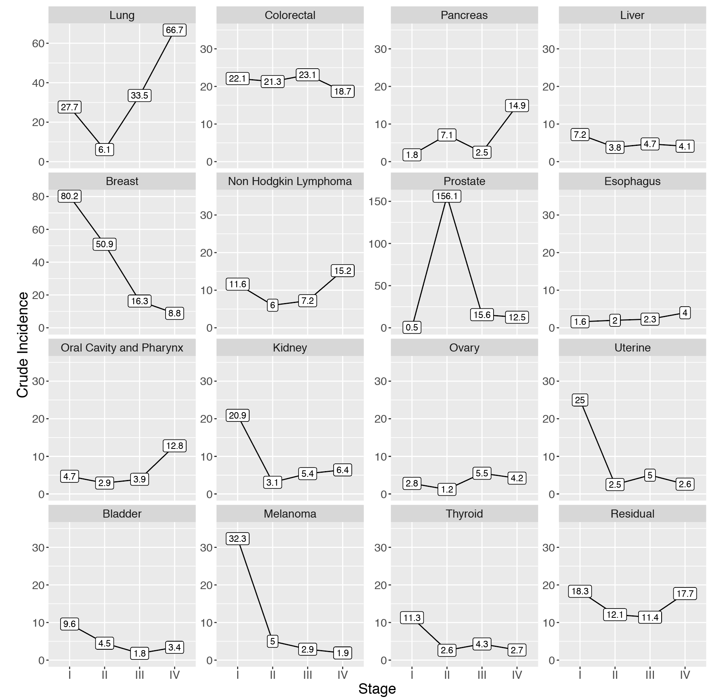
Crude average annual incidence per 100,000 of selected cancer types by AJCC stage at diagnosis for persons aged 50-79 years, SEER18, 2006-2015. These diagnosis years were chosen to ensure consistent AJCC 6th edition staging classification across the time period, as stage at patients diagnosed in 2016 and beyond is only available in a different system (SEER Combined Stage). Unknown stage not shown.

Supplemental Figure 2: Cancer-related Death Five Years Post Diagnosis
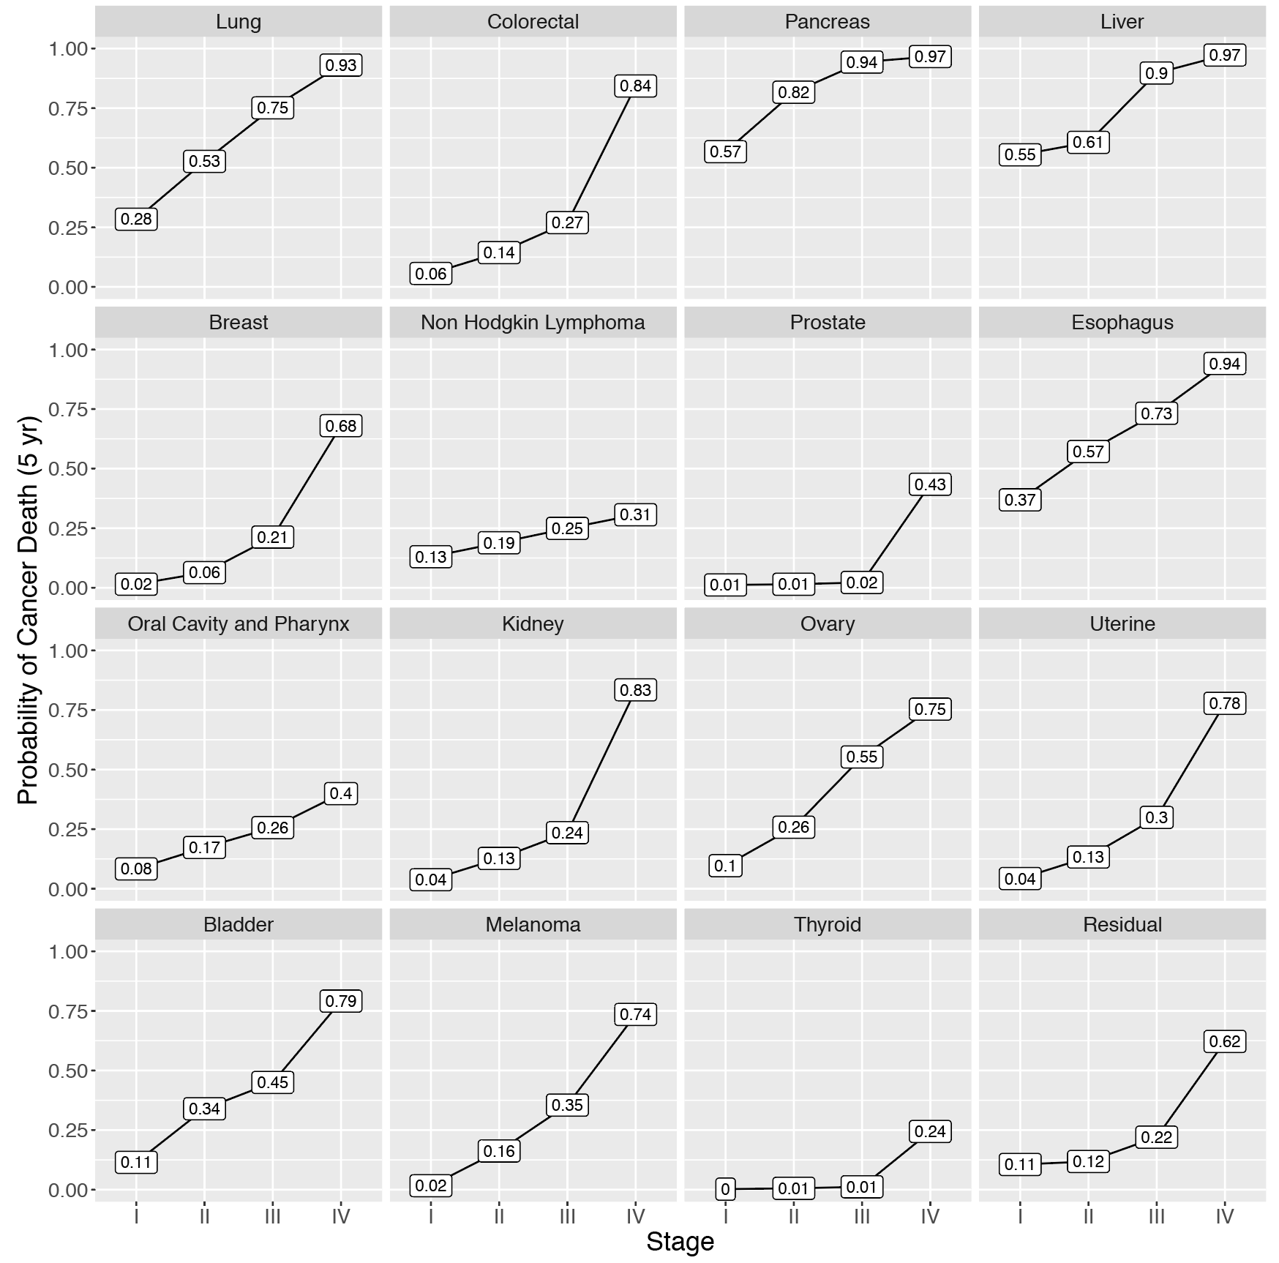
Cumulative probability of cancer-related death five years after diagnosis for selected cancer types by AJCC stage at diagnosis among persons aged 50-79 years, SEER18, averaged over the diagnosis years 2006-2015. These diagnosis years were chosen to ensure consistent AJCC 6th edition staging classification across the time period, as stage at patients diagnosed in 2016 and beyond is only available in a different system (SEER Combined Stage). Unknown stage not shown.
Supplemental Table 2: Absolute numbers of cancer cases and deaths expected in a hypothetical cohort of 100,000 persons after 5 years of follow-up, assuming a stage shift whereby all stage IV cancers had outcome similar to stage III, based on incidence and cancer specific mortality rates for persons aged 40-79 years from SEER18, 2006-2015.

 | Cancer diagnoses in first year | Deaths after 5 years | Deaths after hypothetical stage shift | Absolute deaths averted | Proportion deaths averted*
All cancers | 804 | 241 | 203 | 38 | 0.16
Selected cancers
Lung | 102 | 74 | 66 | 8 | 0.11
Colorectal | 70 | 21 | 13 | 8 | 0.39
Pancreas | 21 | 19 | 18 | 0 | 0.01
Liver | 18 | 13 | 13 | 0 | 0.02
Breast | 134 | 12 | 9 | 3 | 0.26
Non Hodgkin Lymphoma | 33 | 7 | 6 | 1 | 0.10
Prostate | 135 | 6 | 3 | 4 | 0.56
Kidney | 29 | 6 | 3 | 3 | 0.46
Oral Cavity and Pharynx | 22 | 6 | 5 | 1 | 0.23
Ovary | 12 | 6 | 5 | 1 | 0.12
Esophagus | 8 | 6 | 5 | 1 | 0.10
Bladder | 14 | 4 | 4 | 1 | 0.17
Uterine | 29 | 5 | 4 | 1 | 0.18
Melanoma | 37 | 3 | 3 | 1 | 0.17
Thyroid | 22 | 1 | 0 | 0 | 0.77

*Estimated deaths shown rounded up to the nearest integer, while proportion based on division of estimates with 2 decimal places.

Supplemental Table 3: Absolute numbers of cancer cases and deaths expected in a hypothetical cohort of 1,000,000 persons after 5 years of follow-up, assuming a stage shift whereby one-third of stage IV cancers had outcome similar to stage III, one-third had outcome similar to stage II and one-third had outcome similar to stage I, based on incidence and cancer specific mortality rates for persons aged 40-79 years from SEER18, 2006-2015.

 | Cancer diagnoses in first year | Deaths after 5 years | Deaths after hypothetical stage shift | Absolute deaths averted | Proportion deaths averted*
All cancers | 804 | 241 | 182 | 59 | 0.24
Selected cancers
Lung | 102 | 74 | 55 | 19 | 0.26
Colorectal | 70 | 21 | 11 | 10 | 0.46
Pancreas | 21 | 19 | 16 | 2 | 0.11
Liver | 18 | 13 | 12 | 1 | 0.06
Breast | 134 | 12 | 8 | 4 | 0.32
Non Hodgkin Lymphoma | 33 | 7 | 6 | 1 | 0.19
Prostate | 135 | 6 | 3 | 4 | 0.57
Kidney | 29 | 6 | 3 | 3 | 0.54
Oral Cavity and Pharynx | 22 | 6 | 4 | 2 | 0.36
Ovary | 12 | 6 | 4 | 1 | 0.25
Esophagus | 8 | 6 | 5 | 1 | 0.19
Bladder | 14 | 4 | 3 | 1 | 0.25
Uterine | 29 | 5 | 4 | 1 | 0.23
Melanoma | 37 | 3 | 2 | 1 | 0.25
Thyroid | 22 | 1 | 0 | 0 | 0.79

*Estimated deaths shown rounded up to the nearest integer, while proportion based on division of estimates with 2 decimal places.

