Online Only Supplements

Page 2-3 Supplementary Texts and eFigure 1

Page 4 eFigure 2

Page 5 eTables

Supplementary Texts and eFigure1

Data Sources

The data for this analysis was extracted from the following data sources that are maintained by the Roswell Park Comprehensive Cancer Center (RPCCC) Radiation Oncology Department: the Oral Mucositis Survery database, the Mosaiq Radiotherapy Information System Database, and the Head and Neck Cancer Database.

The Oral Mucositis Survey Database recorded patients’ oral mucositis symptoms that was self-reported weekly as part of patients’ radiation treatment regimen. The validated Oral Mucositis Daily Questionnaire (ref 18, details in Appendix 1) were used to assess how much soreness they experienced in the mouth and throat during the past 24 hours, as well as the impact of the soreness on activities of eating, drinking, talking, and sleeping, with a Likert-type scale for response, “0-no, 1-a little, 2-moderate, 3-quite a lot, and 4-extreme”.

The Mosaiq Radiotherapy Information System Database recorded detailed information of the date, time (hour, minute), and dosage of a particular radiation treatment. This system also records a number of low level details, such as the dosage and anatomical sites affected.

The Head and Neck Cancer Database captured detailed information about head-neck cancer patients diagnosed at RPCCC at the time of radiation therapy, such as cancer diagnosis, treatment history, alcohol and tobacco use, HPV status, tumor pathology information, start and end dates of the radiation therapy, and total amount of radiation (measured in grays) received by the tumor site and surrounding tissues. A summary of the information recorded in this database is provided in Appendix 2.

Analytical Cohort Generation

The following flow chart illustrates the steps taken to create our analytical dataset. Briefly, we extracted radiotherapy treatment information for 226 patients that were treated at Roswell Park between 2015 to 2017. The final cohort consisted of 190 head and neck squamous cell carcinoma (SCC) cancer patients after excluding three patients whose primary cancer site was not head-neck, two patients who had no mucositis survey data, four patients who had previous radiotherapy at the head and neck site, one patient with unusual treatment frequency, 10 who did not complete radiotherapy due to non-mucositis causes, and 16 patients with histology other than SCC. We kept records of the first treatment course only for subjects who had more than one treatment course during this period.

eFigure1. Flow chart of analytical cohort data generation



Appendix 1: Oral Mucositis Daily Questionnaire

Q1: How would you rate your overall health during the last 24 hours?

Answer: choose a number on a scale between 0 (worst) to 10 (perfect health).

Q2: During the last 24 hours, how much Mouth and Throat Soreness did you have?

Answer: 0-No soreness; 1-A little soreness; 2-Moderate soreness; 3-Quite a lot of soreness; 4-Extreme soreness.

Q3-7: During the last 24 hours, how much did Mouth and Throat Soreness limit you in the activities of Swallowing (Q3), Drinking (Q4), Eating (Q5), Talking (Q6) and Sleeping (Q7)?

Answer: 0-Not limited; 1-Limited a little; 2-Limited some; 3-Limited a lot; 4-Unable to do.

Q8: On a scale of 1 to 10, how would you rate your Overall Mouth and Throat Soreness during the last 24 hours?

Answer: choose a number between 0 (no soreness) to 10 (worst possible)

Appendix 2: Head and Neck Cancer Database information

* Previous or other current cancer history
* HPV status
* Previous chemotherapy history
* Previous radiation therapy history
* Previous bone marrow transplant history
* Previous surgery to treat cancer history
* Current alcohol consumption
* Current smoking status within one month of treatment
* Type of cancer diagnosed
* Overall pathological stage of cancer diagnosed
* Type of treatment regimen (e.g., radiation only, concurrent chemotherapy and radiation)
* Start and end dates of radiation therapy regimen
* Type of radiation
* Amount of radiation received (in grays) by primary site of cancer
* Amount of radiation received (in grays) by primary site surrounding tissue
* Unilateral or bilateral radiation treatment given
* Pretreatment ECOG Score
* Physical measurements (e.g., height, weight, BMI, pre-treatment weight, post-treatment weight)
* Date of physical measurement
* Weight or weight loss
* Response to treatment (and date the response was recorded)

eFigure 2. Example* distribution of daily treatment times across the entire treatment course

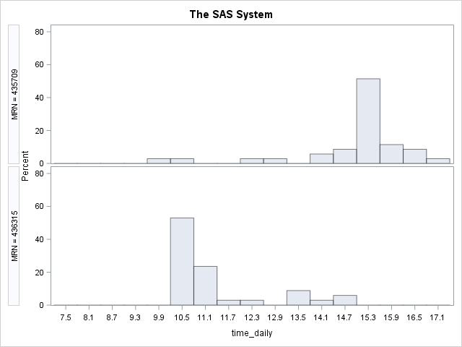

*Examples from 46 patients whose 10th-90th percentile range of daily treatment times across the entire treatment course was greater than three hours.

eTable 1. Estimated MTS* by treatment week and hour using Mixed model (n=1156)

|  |  |  |  |  |  |  |  |
| --- | --- | --- | --- | --- | --- | --- | --- |
| **Time category** | **week 1** | **week 2** | **week 3** | **week 4** | **week 5** | **week 6** | **week 7** |
| 8:30 - <9:30 | 0.51 (0.12) | 0.75 (0.12) | 1.00 (0.12) | 1.24 (0.12) | 1.48 (0.12) | 1.72 (0.12) | 1.97 (0.13) |
| 9:30 - <10:30 | 0.84 (0.11) | 1.08 (0.11) | 1.32 (0.11) | 1.56 (0.11) | 1.80 (0.11) | 2.05 (0.11) | 2.29 (0.11) |
| 10:30 - <11:30 | 0.88 (0.11) | 1.12 (0.11) | 1.36 (0.10) | 1.61 (0.10) | 1.85 (0.10) | 2.09 (0.11) | 2.33 (0.11) |
| 11:30-<12:30 | 0.67 (0.12) | 0.91 (0.12) | 1.15 (0.12) | 1.40 (0.12) | 1.64 (0.12) | 1.88 (0.12) | 2.12 (0.12) |
| 12:30-<2:00 | 0.74 (0.12) | 0.98 (0.12) | 1.22 (0.12) | 1.46 (0.12) | 1.71 (0.12) | 1.95 (0.12) | 2.19 (0.12) |
| 13:30-<15:00 | 1.02 (0.13) | 1.26 (0.12) | 1.50 (0.12) | 1.74 (0.12) | 1.99 (0.12) | 2.23 (0.12) | 2.47 (0.13) |
| 15 - <16:30 | 0.84 (0.15) | 1.08 (0.15) | 1.32 (0.15) | 1.57 (0.15) | 1.81 (0.15) | 2.05 (0.16) | 2.29 (0.16) |

*LSmeans and standard errors from the mixed model, with MTS as the dependent variable (0,1,2,3,4 as continuous); the independent variable included treatment time point (categorical), cumulative dosage, treatment week (continuous), smoking status (ordinal), type of radiotherapy (post-operative vs. others). Subject ID was considered as random factor.

eTable 2. Maximum MTS by treatment time using GLM model in 185 patients*

|  |  |  |  |  |
| --- | --- | --- | --- | --- |
| **Time category** | **No. Patient** | **LSmean\*\*** | **95% CI** | **P valueǂ** |
| 8:30 - <9:30 am | 32 | 2.24 | 1.95-2.53 | 0.027 |
| 9:30 - <10:30 am | 32 | 2.31 | 2.02-2.60 |  |
| 10:30 - <11:30 am | 36 | 2.46 | 2.19-2.73 |  |
| 11:30 am - <12:30 pm | 24 | 2.75 | 2.42-3.08 |  |
| 12:30 - <2:00 pm | 22 | 2.81 | 2.46-3.16 |  |
| 2:00 - <3:00 pm | 25 | 2.67 | 2.34-3.00 |  |
| 3:00 - <4:30 pm | 14 | 2.36 | 1.91-2.81 |  |

* A sensitivity analysis by excluding five patients with the range of 10th-90th percentile daily treatment time greater than 3 hours, and the treatment time had more than one mode that was located at both the morning and afternoon time periods.

** LSmeans (marginal average score adjusting for other factors) were obtained from GLM model with maximum MTS as dependent variable (0, 1, 2, 3, 4; continuous), adjusting for the same covariates in the same way as Table 4.