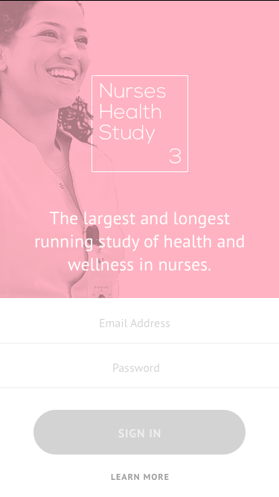 | 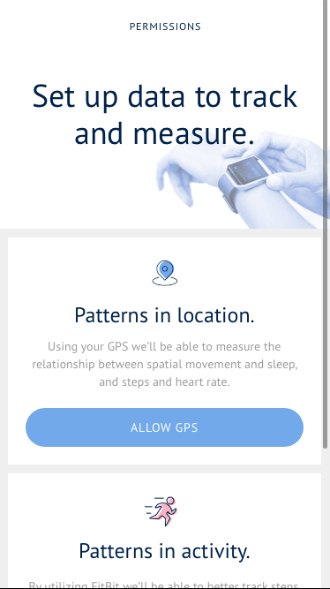 | 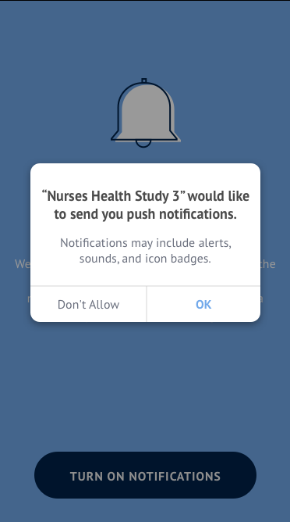
Supplemental Figure 1. Screenshots of NHS3 smartphone app.
Nurses’ Health Study 3 (NHS3) participants:
48,809

Not transmitting substudy data:
65 (14%)
Transmitting substudy data:
435 (86%)
Eligible to participate:
597 (80%)
Completed eligibility screener: 743 (56%)
NHS3 participants invited to complete the Mobile Health Substudy eligibility screener: 1,337
Mobile Health Substudy participants:
500 (99%)
Completed substudy consent form, mailed Fitbit:
506 (88%)
Withdrew from substudy:
6 (1%)
Did not complete substudy consent form:
70 (12%)
Ineligible to participate:
Did not have an iPhone:
128 (17%)
Had a doctor diagnosed sleep disorder:
24 (3%)

Did not complete eligibility screener:
594 (44%)

Supplemental Figure 2. CONSORT Diagram of Participation Rates Across Recruitment Stages

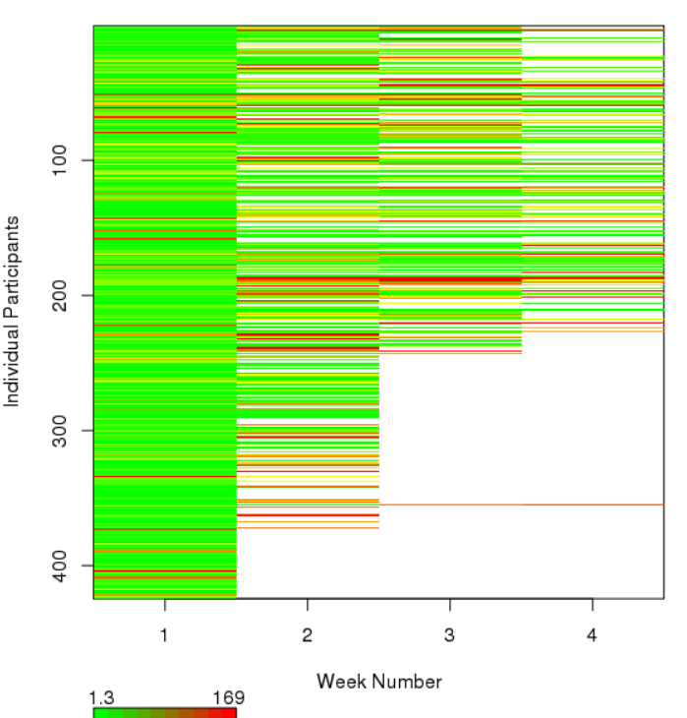
Supplemental Figure 3. Hours of missing heart rate data per participant week. Green represents high compliance, yellow medium compliance, and red poor compliance. White areas represent sampling periods that have not yet begun.

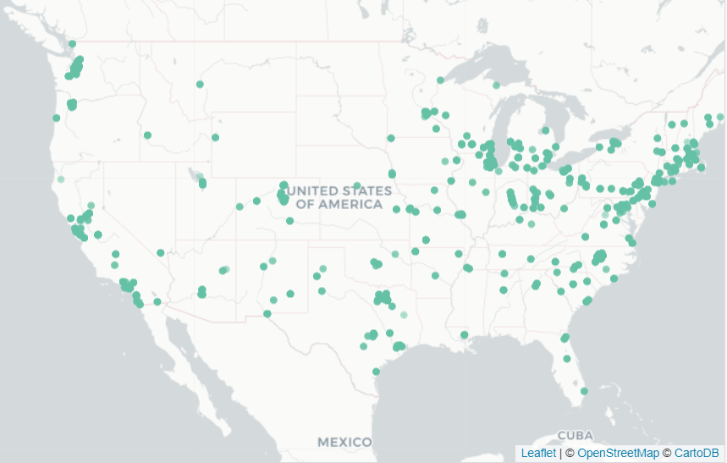
Supplemental Figure 4. Map of Participant GPS data
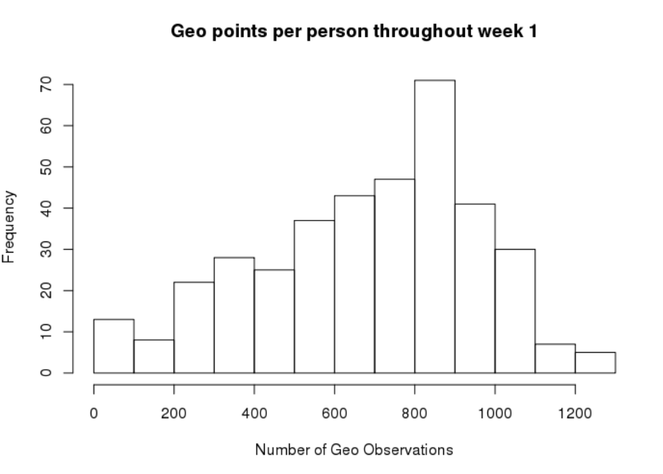
Frequency
Number of GPS observations
GPS observations per participant in Sampling Week 1
Supplemental Figure 5. GPS Observations per participant in Sampling Week 1

