Supplemental Table 1
Post-Sampling Questionnaire. At the end of the four sampling periods, participants will be emailed a questionnaire asking about physical activity and sleep in the previous year.
Physical Activity and Sedentary Behavior
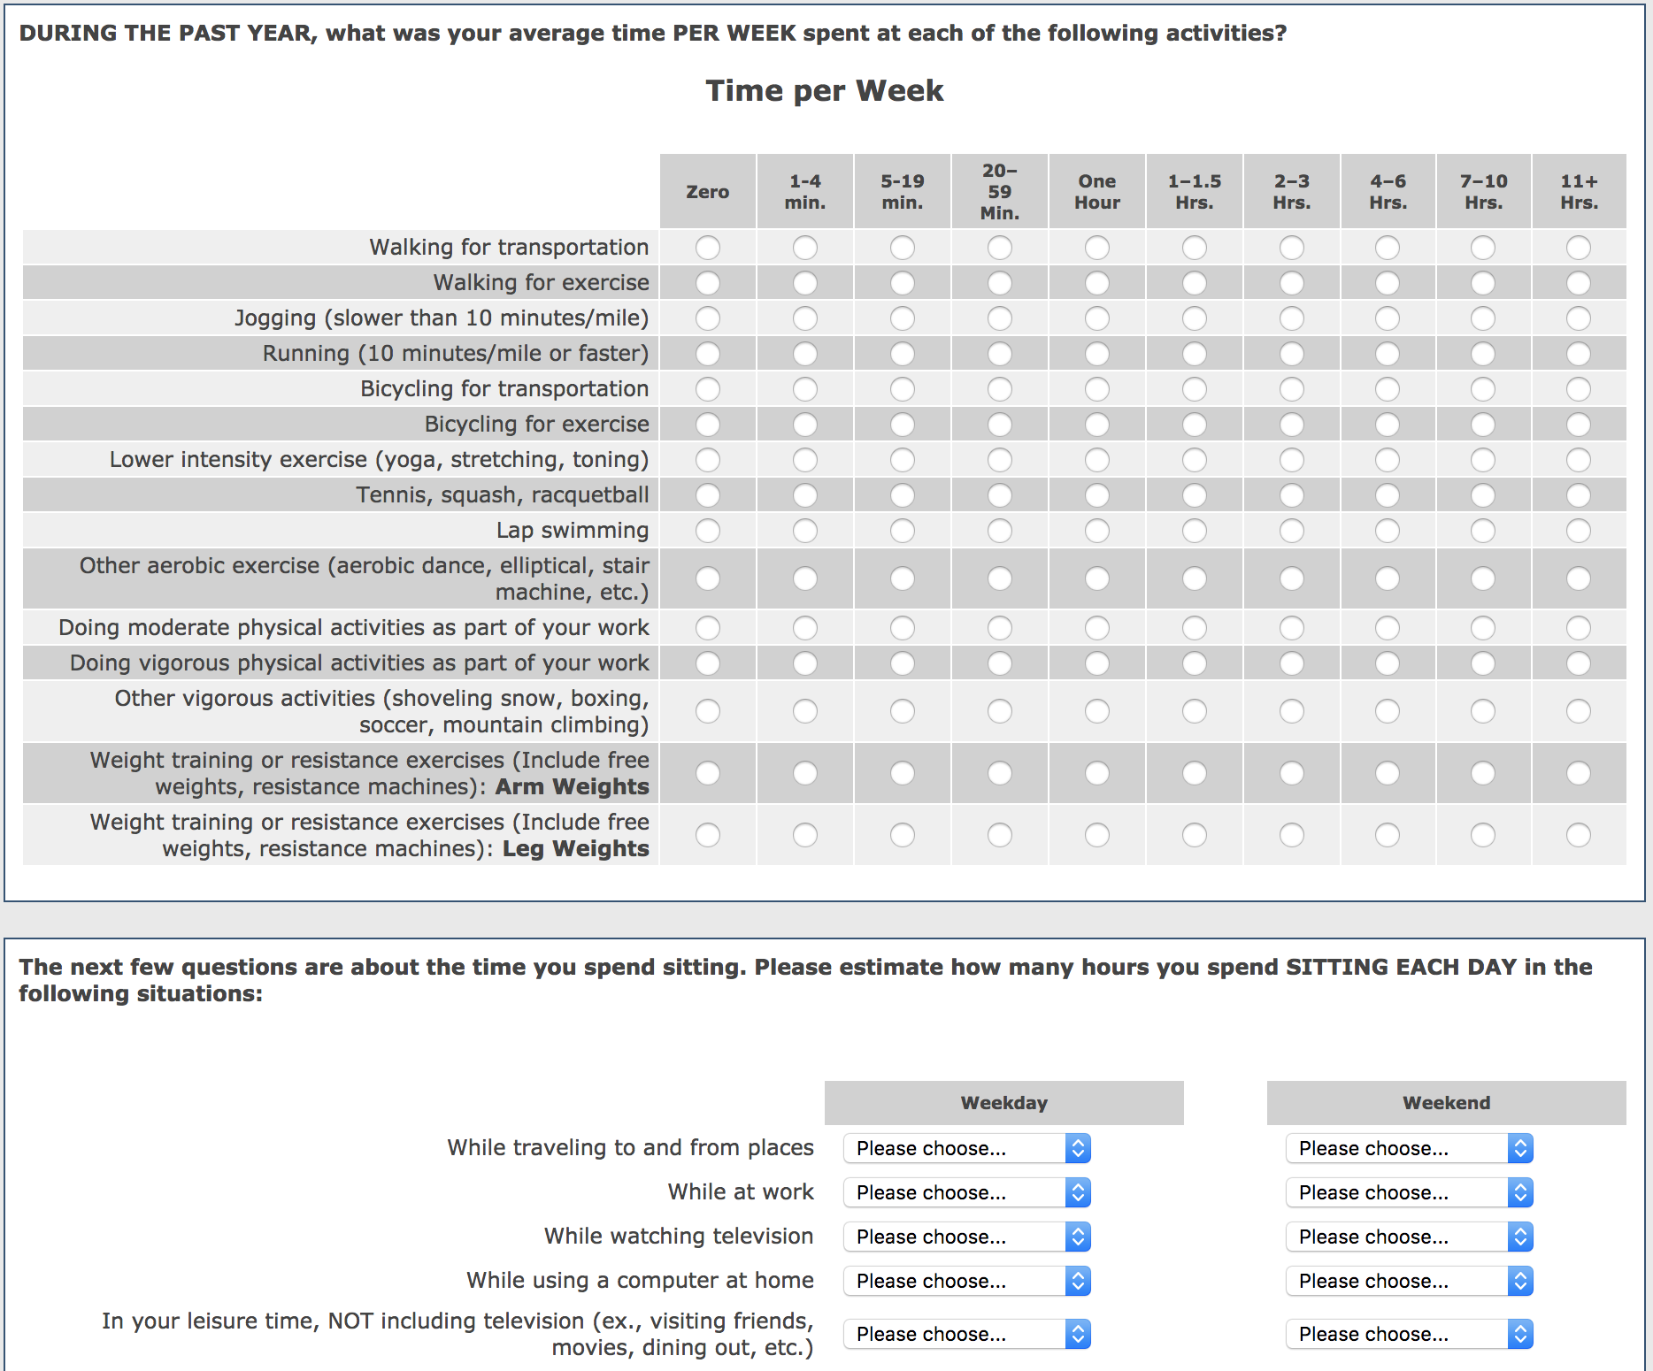
Categories for sitting responses:
Less than 15 mins/  day | 15 mins/  day | 30 mins/  day | 1 hour/  day | 2 hours/day | 3 hours/day | 4 hours/day | 5 hours/day | 6 hours/day | 7 hours/day

Sleep and Night Shift Work