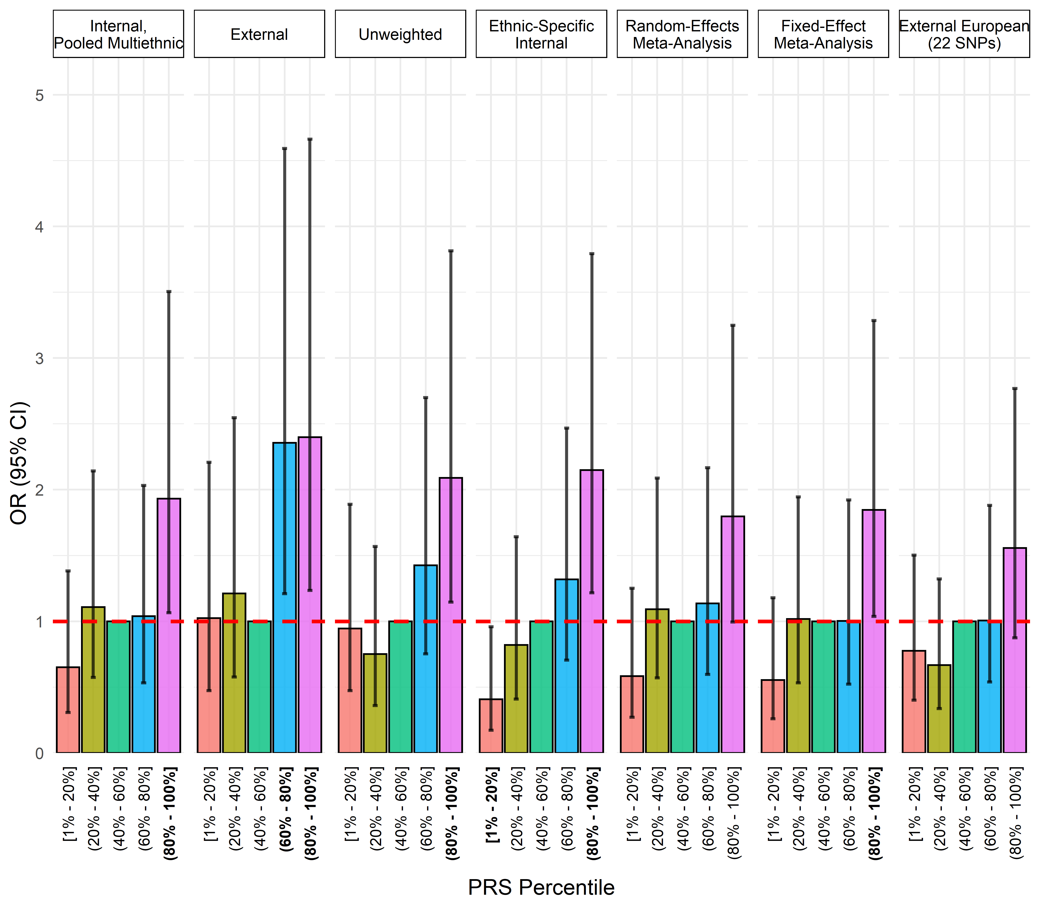
Supplementary Figure 10. Comparison of polygenic risk score calculation methods in the Latino analysis. In ethnic-specific internal scores, if SNP MAF < 0.05, the multiethnic weight was used to avoid unstable scores.

