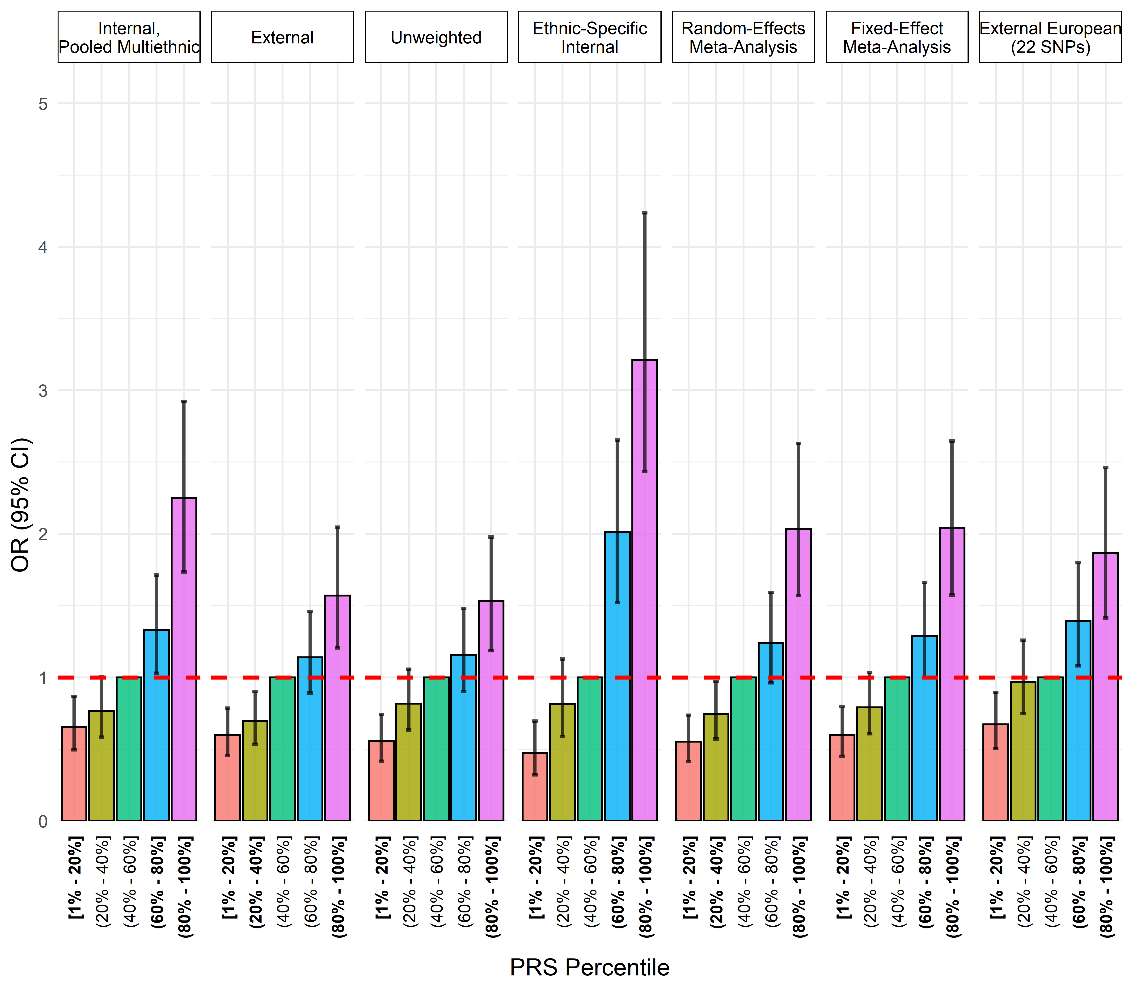
Supplementary Figure 6. Comparison of polygenic risk score calculation methods in the multiethnic analysis. In ethnic-specific internal scores, if SNP MAF < 0.05, the multiethnic weight was used to avoid unstable scores.

