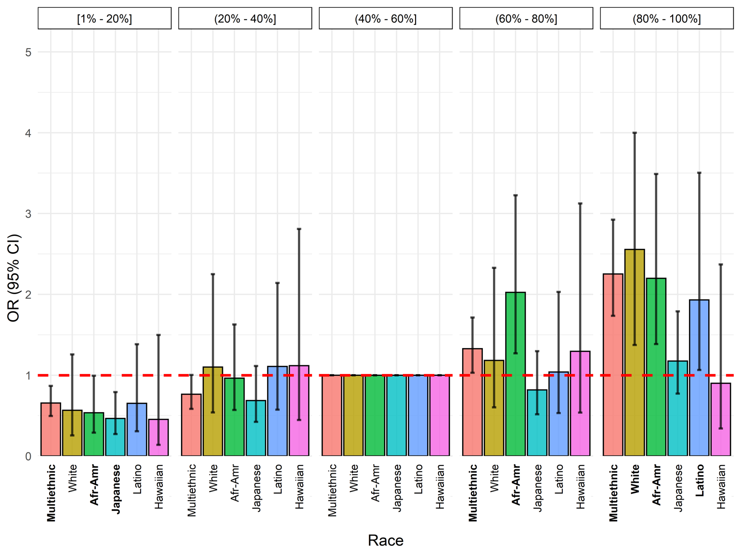
Supplementary Figure 5. Multiethnic and ethnic-specific polygenic risk score odds ratios (ORs) and 95% confidence intervals (CIs). Weights used from multiethnic replication analysis. Multiethnic analysis used binned risk score percentile groups from the complete, multiethnic, sample among controls. Ethnic-specific analysis used binned risk score percentile groups from the control ethnic-specific risk score distribution among controls. Bolded race labels correspond to p values from likelihood ratios tests with p < 0.05.

