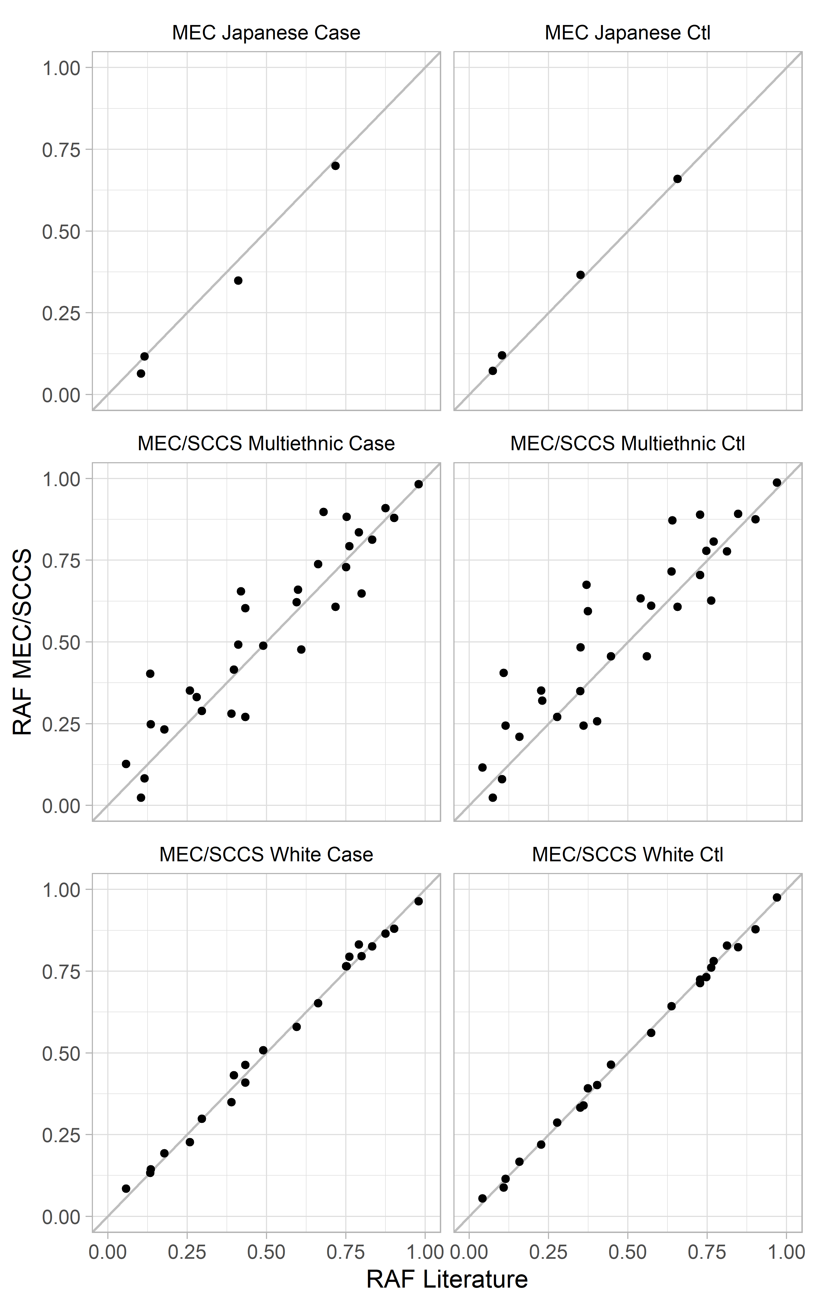
Supplementary Figure 4. Comparison of risk allele frequencies (RAFs) within the Multiethnic Cohort (MEC) and Southern Community Cohort Study (SCCS) with the reported RAF from the most recent GWAS results reported in the literature.

