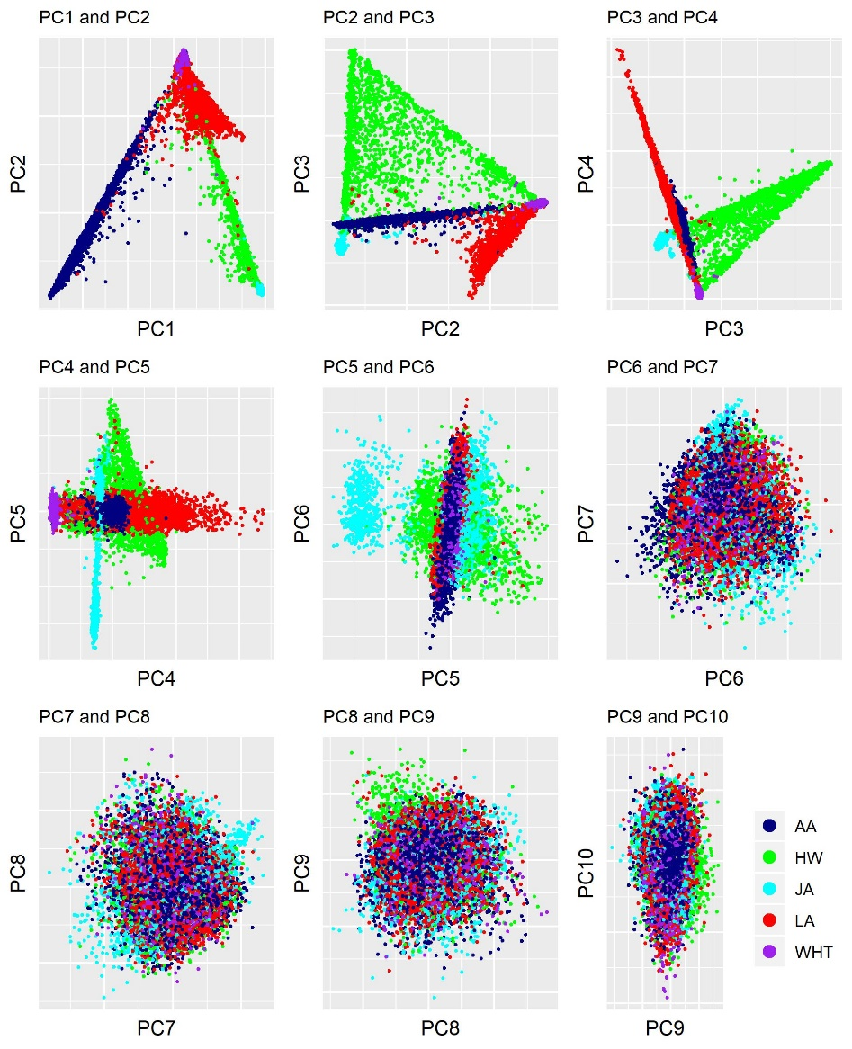
Supplementary Figure 3. Principal component (PC) analysis plots with point color corresponding to self-reported race/ethnicity from baseline questionnaires.

