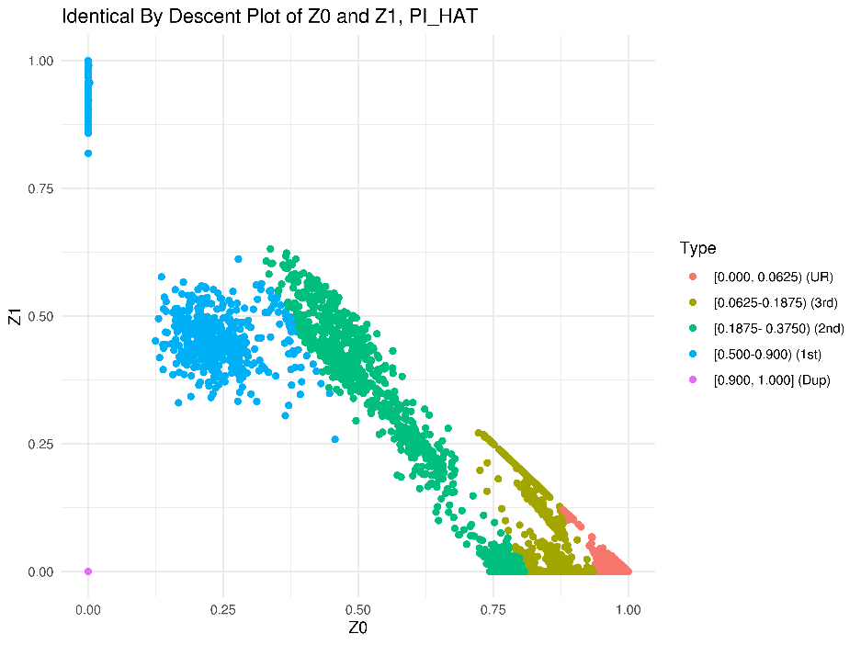
Supplementary Figure 2. Identical by descent plot showing relatedness of samples within the Multiethnic Cohort (MEC) and Southern Community Cohort Study (SCCS) prior to filtering based on relatedness. Z0 refers to the probability of 0 (none) alleles being identical by descent. Z1 refers to the probability of one allele being identical by descent. Point colors correspond to PI_HAT values produced by relationship inference in PLINK. PI_HAT values represent the proportion of alleles that are estimated to be identical by descent. This value is calculated as P(IBD=2) + 0.5*P(IBD=1).

