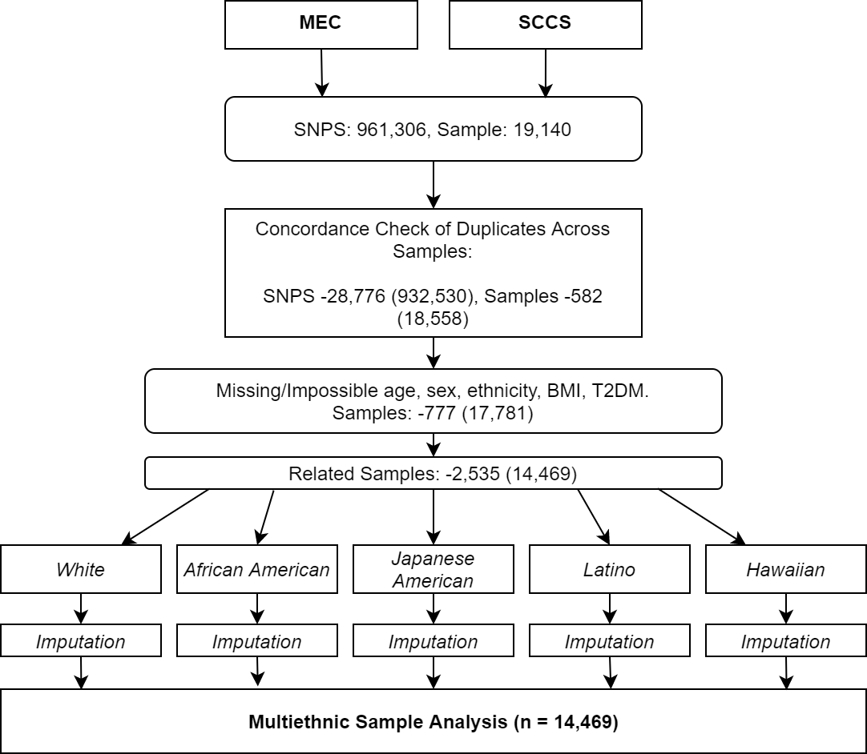
Supplementary Figure 1. Flow diagram of the data cleaning, exclusion, and imputation for the sample. Multiethnic Cohort (MEC) and Southern Community Cohort Study (SCCS) samples were combined, samples then underwent quality control of genetic data. Following this process, samples were removed based on missing data. Related pairs were then identified, and the most intra-cohort related individual removed, producing independent observations used in analysis.

