Verification of a blood based targeted proteomics signature for malignant pleural mesothelioma

Ferdinando Cerciello, Meena Choi, Sara L. Sinicropi-Yao, Katie Lomeo, Joseph M. Amann, Emanuela Felley-Bosco, Rolf A. Stahel, Bruce WS Robinson, Jenette Creaney, Harvey I. Pass, Olga Vitek, David P. Carbone

Supplementary Materials
Supplementary Methods
Processing of serum samples
Sample distribution
Serum samples of the cohort were processed in 96-well plate batches for a total of seven plates. Batches were processed at separated time points within an approximate time range of 3 months between processing of the first and the last 96-well plate batch. Sera were randomly distributed over the 96-well plates balancing each plate for approximatively equal numbers of serum samples from MPM and asbestos exposed subjects as well as biobank of origin (at the time of the processing MPM stages were not considered or not known to the experimenter). Each 96-well plate included samples (minimum of two and maximum of four) from a commercially available serum stock obtained from one single healthy donor (Zenbio, Research Triangle Park, NC). The same order of distribution used for sample processing was also used for the analysis on the LC-SRM platform as reported below.
Enrichment of N-glycoproteins
For targeted proteomics investigation, N-linked glycoproteins (N-glycoproteins) were enriched from serum samples using hydrazide chemistry strategies (1-3) on 96-well plates. Briefly, 50 µl of serum were loaded in 2 ml vials on 96-deepwell plates (Waters, Milford, MA). Non-human proteins invertase glycoprotein from Saccharomyces cerevisiae (Sigma Aldrich, Saint Louis, MO) and recombinant viral B19R protein from vaccinia viruses (R&D Systems, Minneapolis, MN) were added to each serum sample at final concentrations of 1 ng/µl and 5 ng/µl respectively. Serum proteins were oxidized by 1 hour incubation with 10 mM sodium metaperiodate in 0.1 M sodium acetate, pH 5.5 at 4°C in the dark and gentle shacking followed by acidification with 10% formic acid (FA) and C18 clean-up on activated Oasis HLB LP 96-well Plate 60µm (60mg) (Waters) performing four 0.1% FA washing steps with the help of a 96-well plates vacuum manifold (Analytical Sales and Services, Inc., Pompton Plains, NJ). Acetonitrile (ACN) mobile phase at decreasing concentrations was used to elute proteins directly to a 96-well protein precipitation plate (Sirocco protein precipitation plate, Waters, Milford, MA) containing 10 mg per vial of 1 µm hydrazide-terminated magnetic beads (Bioclone Inc, San Diego, California) in 0.1 M sodium acetate, 1 M sodium chloride, pH 4.5. Plates were mixed for 4 h at room temperature (RT) to allow for binding of glycoproteins to hydrazide-terminated beads.
Protein digestion and peptides isolation
Glycoproteins linked to beads were denatured by 1h incubation with 8M urea, 50mM TrisHCl, pH 7.5 with addition of tris(2-carboxyethyl)phosphine hydrochloride (TCEP-HCl) at 10mM final concentration to reduce disulfide bonds. Free cysteins were alkylated by additional 30 minutes incubation in the dark with iodoacetamide added at 25 mM final concentration. For tryptic digestion, glycoproteins linked to beads were washed and re-suspended in 50 mM Tris-HCl buffer, pH 7.5 and sequencing grade modified trypsin (Promega, Madison, WI) was added at 100 ng/µl final concentration followed by overnight incubation at 37°C on gentle shaker. For removal of non-glycosylated peptides, beads were extensively washed on 96-well plates vacuum manifold using in the order 5M sodium chloride, water, 80% ACN, 100% methanol, water and finally 0.1 M disodium-hydrogenphosphate buffer, 25 mM EDTA, pH 7.1. N-linked glycopeptides (N-glycopeptides) were released from beads by 4h incubation with 500 U of PNGaseF (New England Biolabs, Ipswich, MA) at 37°C and gentle shaking. Acidified peptides were then directly released to Oasis HLB 96-well µElution Plate (Waters) for desalting, followed by elution and drying on 96-Well microplate (Sigma–Aldrich) using vacuum concentrator (Eppendorf, Hamburg, Germany).
Liquid chromatographic mass spectrometry and spectral processing

Peptides resuspension

For MS analysis, N-glycopeptides were resuspended in 20 µl matrix of 2% ACN, 0.1% FA. For correct peptide signal assignment and quantification across samples, resuspension matrix contained synthetic heavy-isotope labeled (C-terminal arginine, R, isotope U-13C6, 15N4, mass shift +10Da, and lysine, K, isotope U-13C6, 15N2, mass shift +8Da) sequences (heavy peptides) of signature biomarker peptides and peptides from invertase glycoprotein from Saccharomyces cerevisiae (HeavyPeptide AQUA Ultimate, ThermoFisher Scientific, Waltham, MA) as well as peptides from viral soluble interferon alpha/beta receptor B19 (Spike-Tides_L, JPT Peptide Technologies, Berlin, Germany). The concentration distribution of the isotope-labeled synthetic peptides in the resuspension matrix was empirically established to match the signal intensity ranges of the endogenous serum biomarker peptides and peptides from Saccharomyces cerevisiae and viral B19R glycoproteins. Resuspension matrix also contained iRT peptides (Biognosys, Schlieren, Switzerland) (4) used for monitoring instrument performance and also heavy isotope labeled sequences matching additional peptides from the proteins Saccharomyces cerevisiae and viral B19R glycoproteins, haptoglobin (UniProt entry identifier P00738), kininogen-1 (UniProt entry identifier P01042) (Spike-Tides_L, JPT Peptide Technologies) and the protein anthrax toxin receptor 1 (UniProt entry identifier Q9H6X2) but which were not further used for the analysis (peptide sequences and monitored transitions are reported in Supplementary Table 7). Synthetic peptide sequences had aspartic acid (D) replacing putative glycosylated asparagine (N) according to mass shift introduced by treatment of endogenous serum peptides with PNGaseF enzyme.

Liquid chromatography

Reversed-phase peptide separation was performed using a 1D nanoAcquity UPLC system (Waters, Milford, MA). 2 µl of digested N-glycopeptides in resuspension matrix were loaded from the cooled autosampler manager to a nanoACQUITY UPLC Symmetry C18 Trap Column or ACQUITY UPLC M-Class Trap Column (internal diameter 180 µm, length 20 mm, silica particle size 5 µm, pore size 100Å -Waters) and separated on Atlantis dc18 nanoACQUITY column (internal diameter 75 µm, length 150 mm, silica particle size 3 µm, pore size 100Å - Waters). Separation was performed at 300 nl/min flow rates using mobile phases of 0.1% FA in water (solvent A) and 0.1% FA in ACN (solvent B) and gradient of 2-15% B in 3 min, 15-35% B in 13 min, 35-90% B in 3 min, 90% B in 5 min followed by decrease to 2% B in 1 min and column re-equilibration at 2% B for 5 min.

Mass spectrometry

Peptides were directly eluted to a nanoFlow ESI (Waters) electrospray ion source coupled to a StepWave Xevo TQ-S (Waters) triple quadrupole type of instrument operated in positive ion mode multiple reaction monitoring (MRM). In the tune file, capillary voltage was set to 2.5 kV, low mass and high mass resolution for the first quadrupole were set to 2.90 and 14.50 respectively with ion energy of 0.1 and 2.70 and 14.40 for the second quadrupole with ion energy of 0.8. Collision energy (CE) was obtained using the software Skyline-daily (beta versions v2.1 or higher; https://skyline.ms/project/home/begin.view) (5) using equation CE = (0.037 * m/z) - 1.066 for doubly charged ions and CE = (0.036*m/z) - 1.328 for triply charged ions. Cone voltage was also from Skyline-daily and was 35 V. A minimum of four and a maximum of seven transitions was used to monitor biomarker peptides and peptides from invertase glycoprotein from Saccharomyces cerevisiae and recombinant viral B19R protein. Retention time windows for MRM acquisition was set to 4 min (for peptides VVDSTTGPGEHLR and LGGNETQVR retention time window was 7 min because eluting early in the gradient with no concomitant transitions) which resulted in maximally ~ 120 concurrent transitions, dwell time per transition was set to 20 ms for biomarker peptides as well as for peptides from invertase and viral B19R glycoproteins and to 10 ms for iRT peptides and peptides from haptoglobin and kininogen-1 proteins, resulting in maximal cycle time of ~ 2120 ms. Bovine serum albumin digestion standards (MassPREP, Waters) and [Glu1]-Fibrinopeptide B standards (Waters) in 2% ACN, 0.1% FA were regularly injected in between serum samples to monitor chromatography and platform performance. The software MassLynx V4.1 SCN905 (Waters) was used.

Spectral processing

Skyline-daily (from beta v2.1 and higher) was used for visualization of peptide traces, peak-integration and peptide quantitation based on signal-intensity area under the peptide elution curve as determined by the heavy peptide elution with manual adjustment where necessary. Each LC-SRM run was manually inspected and quality of traces acquisition was verified based on the overall intensities of the signals above the noise, quality and intensities of the signals from the heavy peptides and the iRT peptides and also peptides from haptoglobin and poor quality runs with overall signals close or within the noise were excluded. A minimum of three and up to six transitions per peptides were used for quantification, selected based on stability of the signal (Supplementary Table 1 and 2, online only).

Partitioning the subjects into a training and a testing set, and protein-level summarization

402 unique subjects in the dataset were divided randomly into training set with 209 subjects and testing set with 193 subjects, while matching the frequencies of age and stage among the sets. The training set was composed of 105 MPM patients, and of 104 asbestos exposed donors. The testing set was composed of 108 MPM patients, and of 85 asbestos exposed donors.

After the log2-transformation and the first two normalizations (see below), the transition peak intensities and technical replicates for each subject were summarized using MSstats (v 3.10.2) on a relative scale into a single number per peptide and per subject, separately in the training set and in the testing set. The summarized peptide abundance was normalized by the third normalization (see below) and then was used as input for the downstream analysis.

Normalization for peak intensities data from SRM measurement

The peak intensities (quantified by areas under the peak curve) of quantitative transitions annotated with peptide sequences were exported from Skyline-daily (from beta v2.1 and higher versions). The log2-transformed peak intensities were used for all the subsequent analysis steps. The normalization consisted of three steps, as follows. For the first two normalization steps, all the LC-SRM runs in the study were normalized jointly, in order to remove systematic artifacts of data acquisitions. First, isotopically labeled synthetic peptides (heavy peptides) with sequences matching the targeted endogenous peptides were used to account for systematic shifts in peak intensities between LC-SRM runs. The medians of peak intensities across all heavy peptides per LC-SRM run were equalized, and peak intensities from endogenous peptides in the same run were shifted by the same amount. The second step of normalization relied on peak intensities of the endogenous peptides HYNDITWYK from the spiked-in recombinant viral B19R and endogenous peptides FATDTTLTK from the spiked-in non-human proteins invertase1, to account for potential sample processing artifacts. The endogenous peak intensities of the individual peptide in each LC-SRM run were summarized on a relative scale in a single value per run using MSstats (v3.10.2). The medians of summarized peak intensities from the two peptides in a run were equalized across all runs, and endogenous peak intensities of the other peptides in the corresponding run were shifted by the same amount.

The third step of normalization was performed after the peptide abundances were summarized for each subject, and after partitioning the data into the training and the validation sets. The normalization aimed to account for plate-specific artifacts, as follows. Six subjects in MPM group and six subjects in asbestos exposed donors group per plate were randomly selected from the training set (six is the minimum number of patients per group across all the plates in the training set). The selected subjects formed a 'sub-training set'. In this sub-training set, the systematic shifts between the plates were estimated by 1) calculating the medians of summarized peptide abundance per group, plate, and protein, denoted a_{ijk} (i=Protein I, j=1, … , 7 for plate, k = 1 or 2 for group, 1=MPM, 2=asbestos exposed donors), 2) calculating the medians of a_{ijk} between two groups per plate and protein, denoted b_{ij} = median(a_{ijk}) between k=1 and 2, 3) calculating the medians of b_{ij} among plates per protein, denoted c_{i} = median(b_{ij}) across j=1, … , 7, 4) calculating the shifts between the plates d_{ij} = b_{ij} - c_{i}. Next, the medians of summarized peptide abundance per plate and protein (b_{ij}) were equalized across all plates per protein (c_{i}), by subtracting d_{ij} from the protein abundance in the corresponding plate in the entire training set. Finally, the summarized peptide abundances in the corresponding plate and protein in the testing set were shifted by the same amount (d_{ij}).

Predictive analysis

Logistic regression models were fit to the training set to discriminate between MPM patients and asbestos exposed donors as follows (Supplementary Fig 4). First, a reduced logistic regression model, with the summarized peptide abundance of KWDVTSLETLK as the sole predictor, was fit to the training set. The resulting parameter estimates were:

ln{Prob(MPM) / (1-Prob(MPM))} = -14.622 + 1.028 × KWDVTSLETLK.

Next, a logistic regression model with the 6 summarized peptide abundances as predictors was fit to the training set. The parameters of the multivariate logistic regression were:

ln{Prob(MPM) / (1-Prob(MPM))} = 8.5809 + 0.1794 × ADLTVVLLR - 0.3578 × VVDSTTGPGHLR - 0.5656 × HADWTLTPLK - 0.2115 × ALVDFTR + 1.0239 × KWDVTSLETLK - 0.2358 × VIDETWAWK.

In both full and reduced models, probability cutoff for classification was determined to maximize the predictive accuracy on the training set. The predictive ability of the models was then evaluated on the testing set, in terms of the area under the ROC curve, accuracy, sensitivity, specificity, negative predictive value and positive predictive value.

SMRP ELISA were quantified in the testing cohort, and a pre-defined cutoff of 2 nM proposed in the literature (6) was used to classify the subjects. The predictive performance of the assay was compared to that of the multivariate signature, and to that of the mesothelin peptide KWDVTSLETLK as the only predictor (Supplementary Fig 4).

Further, the ability of the multivariate signature, or of the SMRP ELISA, to detect subjects with early stage MPM (stage I and II) was evaluated by (1) reducing the testing set to early stage MPM patients and asbestos exposed donors, and (2) using the same probability cut-off for classification as above.

The joint predictive performance of the multivariate signature with 6 LC-SRM quantified peptides, combined with the SMRP ELISA, was evaluated on the testing set using ten-fold cross-validation (Supplementary Fig 10). Within each fold, the relative abundance of the six peptides and the abundances of SMRP ELISA formed the input to a 7-predictor logistic regression in nine-tenths of the testing set. The predictive accuracy of the fitted model was evaluated on the remaining one-tenth of the subjects in the testing set, and summarized with a ROC curve. The process was repeated ten times, by systematically rotating the one-tenth of the left-out subjects. An unbiased estimate of the joint predictive ability of the 6 LC-SRM quantified peptides and of SMRP ELISA was obtained by the pseudomedian fold of the cross-validation, which corresponds to the 5th largest AUC value out of the ten folds. The upper bound for the area under the ROC curve was obtained by fitting the 7-predictor logistic regression to the entire testing set. The estimate of variability associated with the ROC curve was obtained by plotting the 25th and the 75th quantile of the sensitivity of each value of 1-specificity over ten folds. Other four combinations of relative peptide abundance by LC-SRM and SMRP ELISA ((1) SMRP ELISA only, (2) LC-SRM quantified mesothelin peptide KWDVTSLETLK, combined with the SMRP ELISA, (3) 6 LC-SRM quantified peptides, combined with the SMRP ELISA, and (4) 5 LC-SRM quantified peptides excluded KWDVTSLETLK, combined with the SMRP ELISA) were also evaluated in the testing set with the same statistical workflow.

The ROC curves, as well as other measures of performances (i.e. accuracy, sensitivity, specificity, negative predictive value and positive predictive value) were obtained with the R package pROC. When comparing the AUCs of two ROCs, 99% confidence intervals for the area under the ROC curve, accuracy, sensitivity, specificity, negative predictive value and positive predictive value were derived from 2,000 bootstrap replicates.
Definition of the quantities used to assess the diagnostic property of the proteomic signature and ELISA

Pre-test probability refers to the probability of a patient to have MPM before the test is performed and post-test probability refers to the probability of MPM after the test, given with cutoff and sensitivity and specificity. The positive likelihood ratio (LR +) of the test is calculated as: LR+ = sensitivity/(1-specificity) and the negative likelihood ratio (LR-) is calculated as: LR- = (1-sensitivity)/specificity. We calculated pre-test odds as: pre-test odds = pre-test probability/(1-pre-test probability); and post-test odds as: post-test odds = pre-test odds * LR. Post-test probability was calculated as: post-test probability = post-test odds/(post-test odds + 1).

Survival analysis

The survival analysis is summarized in Supplementary Fig 10. Only the MPM patients in both training and testing sets were used for analysis. First, the Cox proportional hazard (CPH) model with the 6 LC-SRM quantified peptides as predictors was fit to the training set. The resulting parameter estimates are listed in Supplementary Table 6. The prognostic index (PI) for each subject in the training set was calculated as linear combination of the intensities of the 6 peptides, with the coefficients from the CPH model. The median of PI in the training set was chosen as the putative cut-off for survival risk groups. Subjects in the training set with the PI below the cut-off were assigned to the "low risk" group and subjects with the PI above the cut-off to the "high risk" group. Next, the PI index was calculated for each subject in the testing set using the coefficients developed in the training set above. Subjects in the testing set with the PI below the cut-off determined on the training set were assigned to the “low risk” group, and subjects with the PI above the cut-off to the “high risk” group. The difference in survival in these two groups was assessed by plotting their Kaplan-Meier (KM) curves. Equivalence between the curves of the two risk groups in the testing set was assessed using log-rank test. Median survival months and 95% confidence interval were calculated among uncensored (deceased) individuals. Mean survival months were restricted with upper limit = 74.5.

CPH model with established risk group as a covariate in the testing set was used. Wald test was used to evaluate the significance of hazard ratio (HR) for risk group in the testing set. Then survival was stratified by stage and risk group assignment in the testing set. Cox Proportional model was fitted with age, stage - early or advanced -, and risk group - low or high - and the survival curves were drawn for the respected groups of subjects - stage = early versus advanced, and risk group = low versus high - with the fixed parameter, age=64. For the CPH model with age, stage and risk group factor coefficients were as follow: for age, the coefficient was 0.02918 (HR 1.0296, P = 0.01269); for stage (early or advanced), the coefficient was 0.72192 (HR 2.0584, P = 0.0027); for risk (low or high), the coefficient was 0.6553 (HR 1.9258, P = 0.0095). All survival analyses were performed using the survival R package (v 2.42-3) and survminer R package (v 0.4.0).

Literature reference
1. Zhang H, Li XJ, Martin DB, Aebersold R. Identification and quantification of N-linked glycoproteins using hydrazide chemistry, stable isotope labeling and mass spectrometry. Nat Biotechnol 2003;21(6):660-6.
2. Li Y, Zhang H. High-throughput analysis of glycoproteins from plasma. Methods Mol Biol 2011;728:125-33.
3. Cerciello F, Choi M, Nicastri A, Bausch-Fluck D, Ziegler A, Vitek O, et al. Identification of a seven glycopeptide signature for malignant pleural mesothelioma in human serum by selected reaction monitoring. Clin Proteomics 2013;10(1):16.
4. Escher C, Reiter L, MacLean B, Ossola R, Herzog F, Chilton J, et al. Using iRT, a normalized retention time for more targeted measurement of peptides. Proteomics 2012;12(8):1111-21.
5. MacLean B, Tomazela DM, Shulman N, Chambers M, Finney GL, Frewen B, et al. Skyline: an open source document editor for creating and analyzing targeted proteomics experiments. Bioinformatics 2010;26(7):966-8.
6. Hollevoet K, Reitsma JB, Creaney J, Grigoriu BD, Robinson BW, Scherpereel A, et al. Serum mesothelin for diagnosing malignant pleural mesothelioma: an individual patient data meta-analysis. J Clin Oncol 2012;30(13):1541-9.

Supplementary figures
Supplementary Fig 1. Reproducibility of replicate measurements. Replicate measurements of the endogenous biomarker peptides composing the multivariate proteomic signature are assessed in aliquot serum samples from one HD distributed over the 7 different 96-well plates (color key) and processed over 21 replicates. Dots represent the log2 peptide normalized intensities of each of the 21 replicates. Replicate measurements are represented separately for the training and the testing set. Reported are the coefficient of variations (CV) and standard deviations (SD) for each of the peptides.
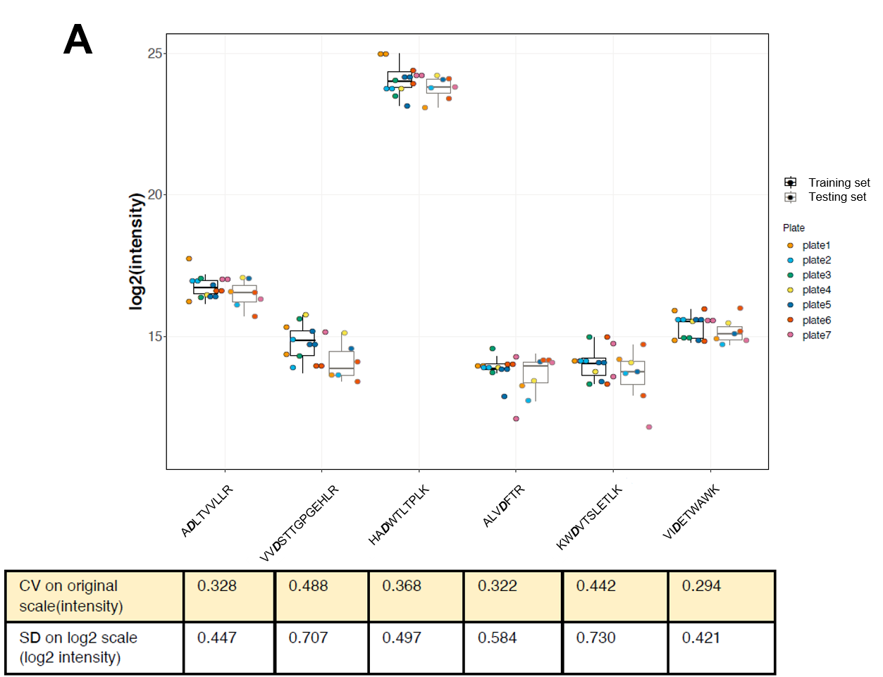

Supplementary Fig 2. Examples of SRM elution traces of the signature peptides. Reported are LC-SRM traces of the 6 peptides composing the targeted proteomic MPM signature (ADLTVVLLR: A and B; ALVDFTR: C and D; HADWTLTPLK: E and F; KWDVTSLETLK: G and H; VIDETWAWK: I and J; VVDSTTGPGEHLR: K and L). Serum samples are from different MPM patients (A, C, E, G, I, K) and asbestos exposed donors (B, D, F, H, J, L) and processed on different plates. Color legends indicate traces of the ions used for quantification. Boundaries indicate the area under the signal curve used for peptide quantification. For each peptide sequence traces used for the quantification of the endogenous (red curve of the figures “integrated transition”) and of the heavy peptide (blue curve of the figures “integrated transition”) are reported. Visualization of the sequence traces are reported applying Savitzky-Golay smoothing (smoothing applied) as well as without any smoothing applied (no transform).

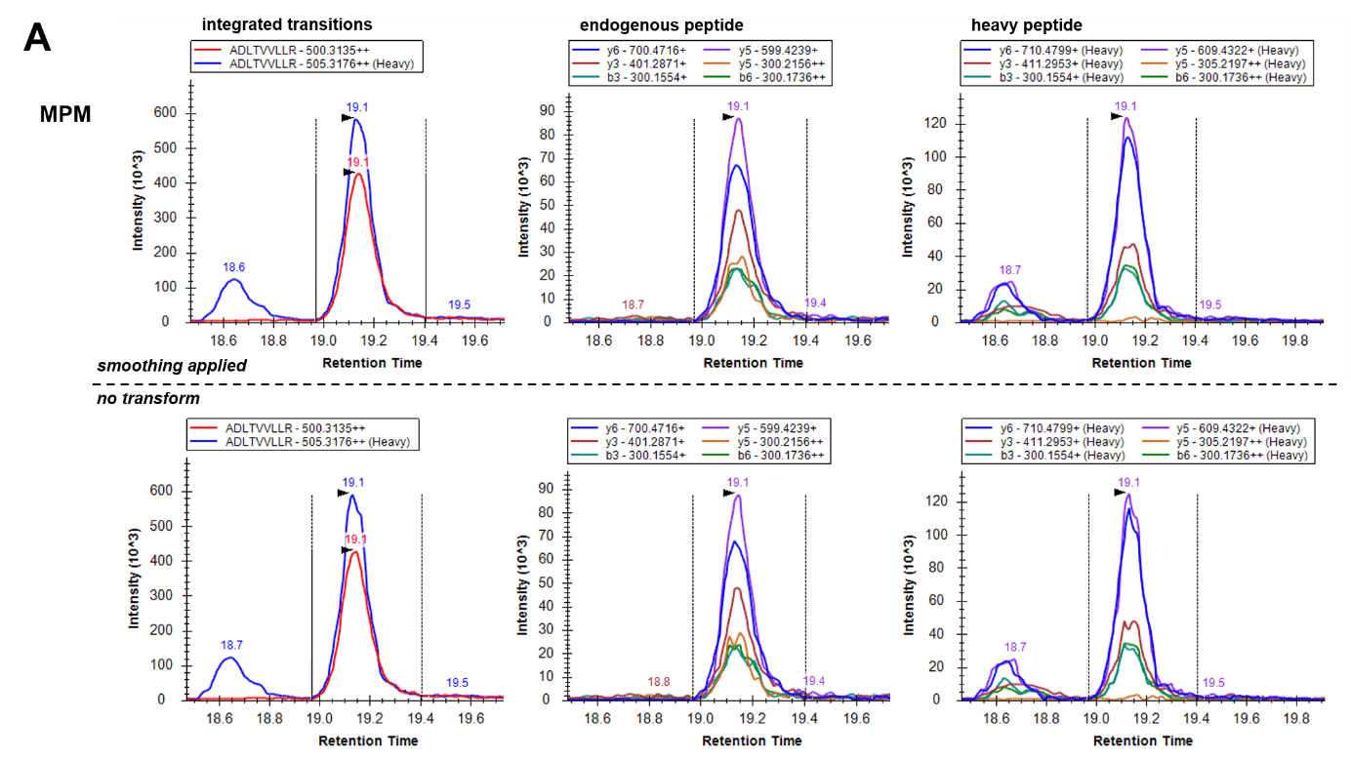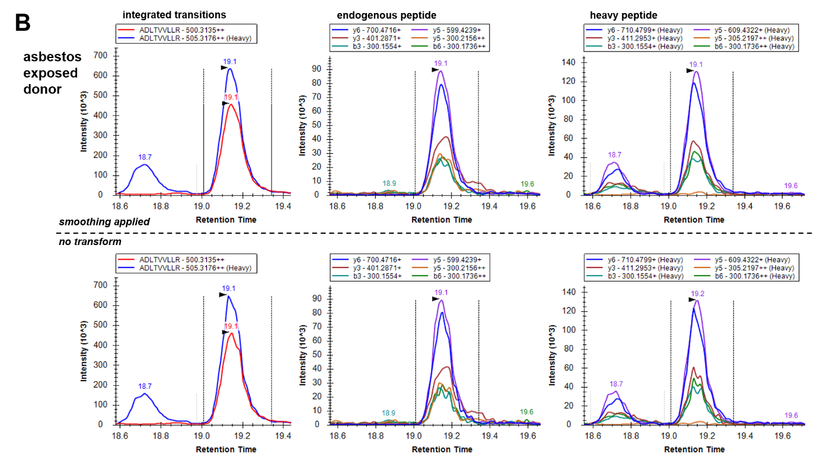
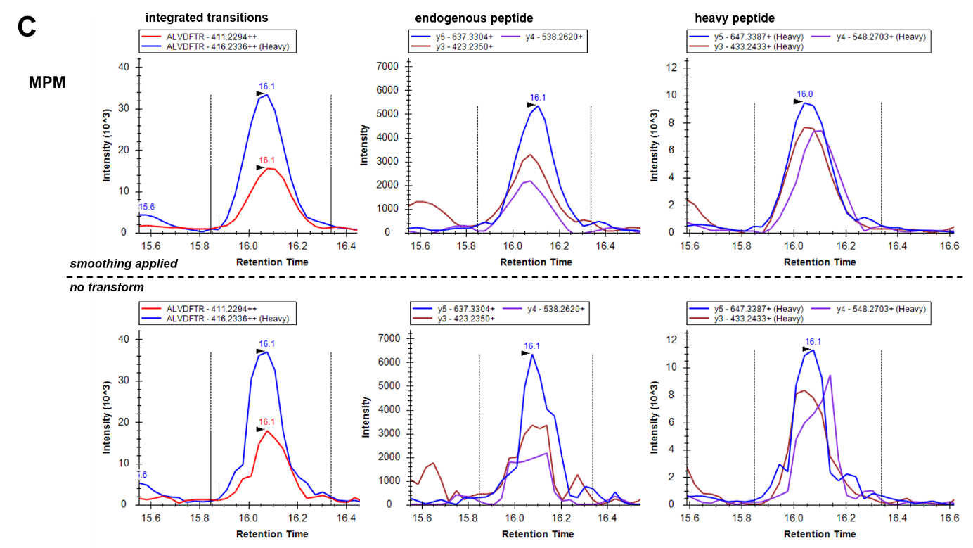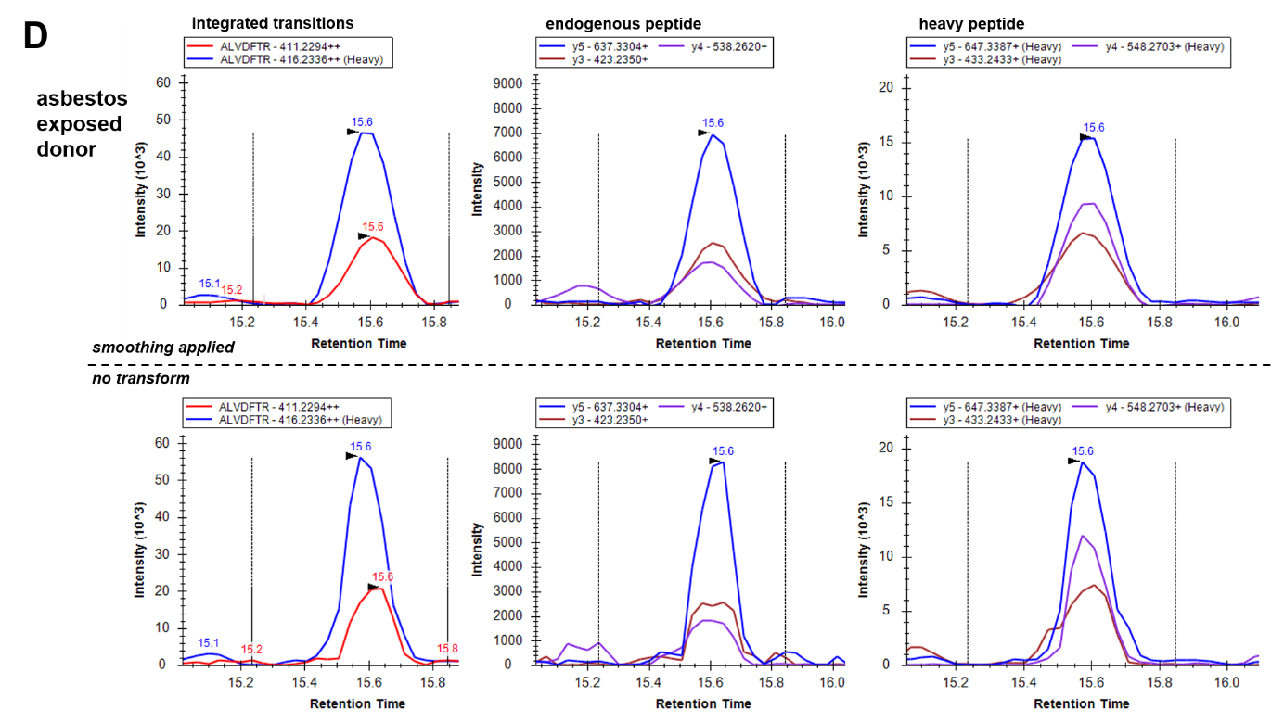
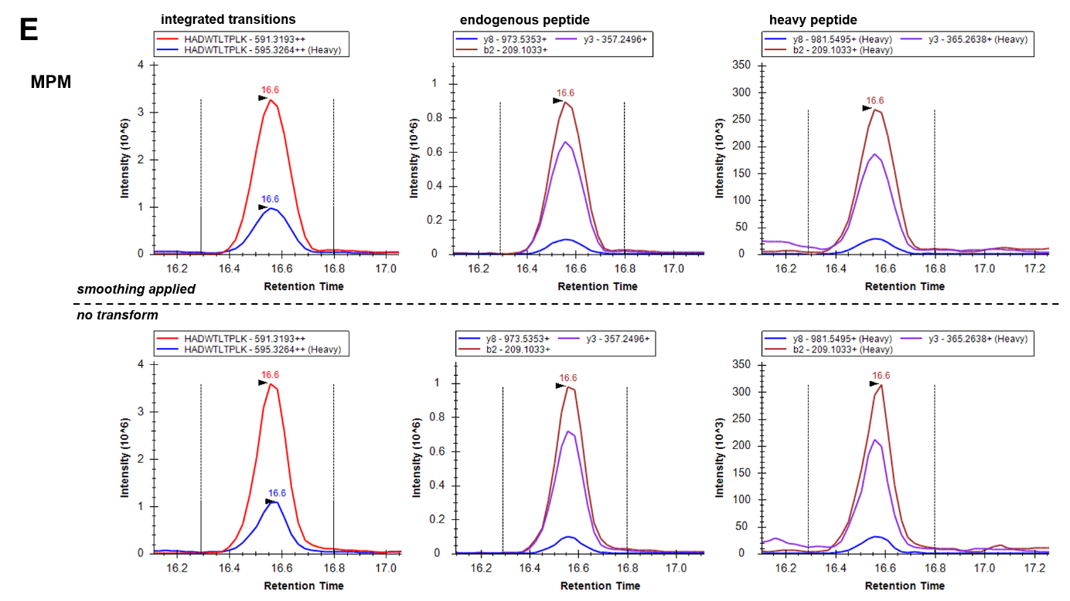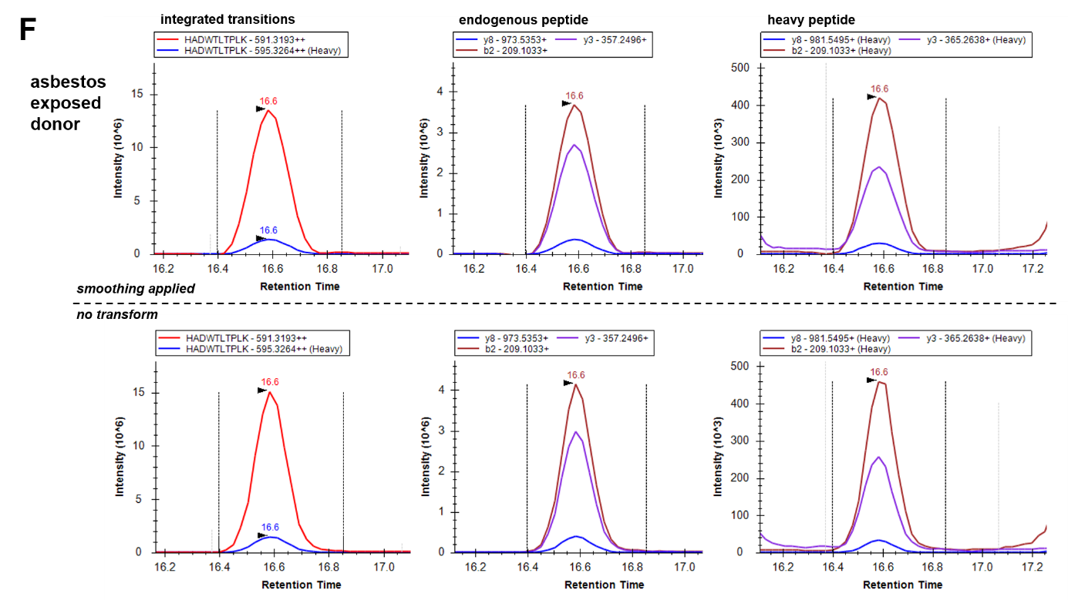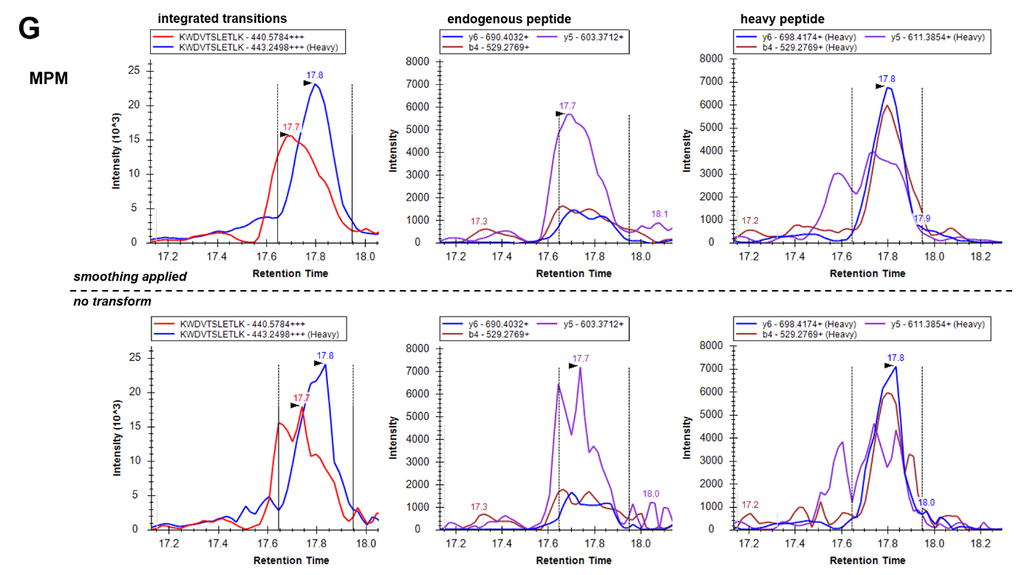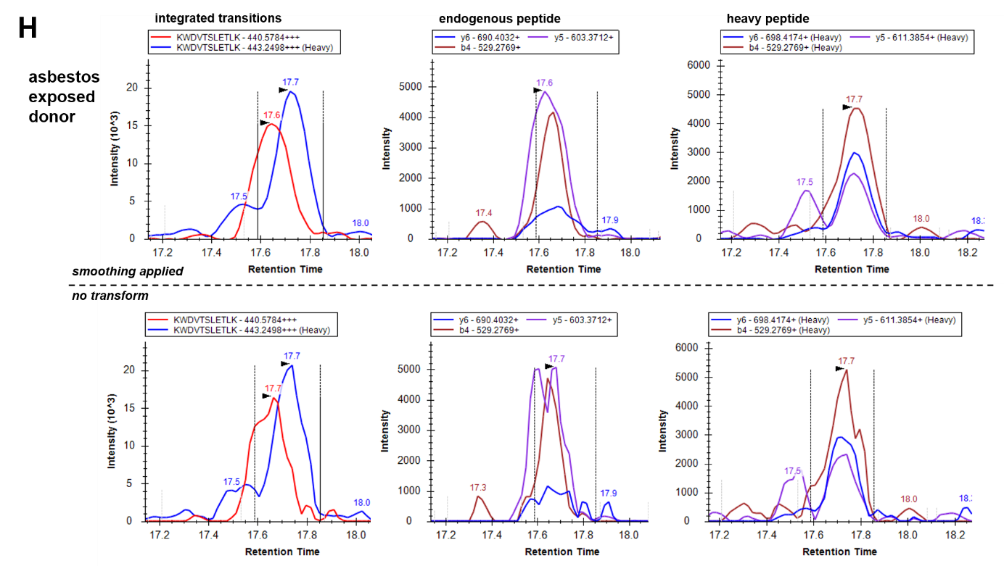
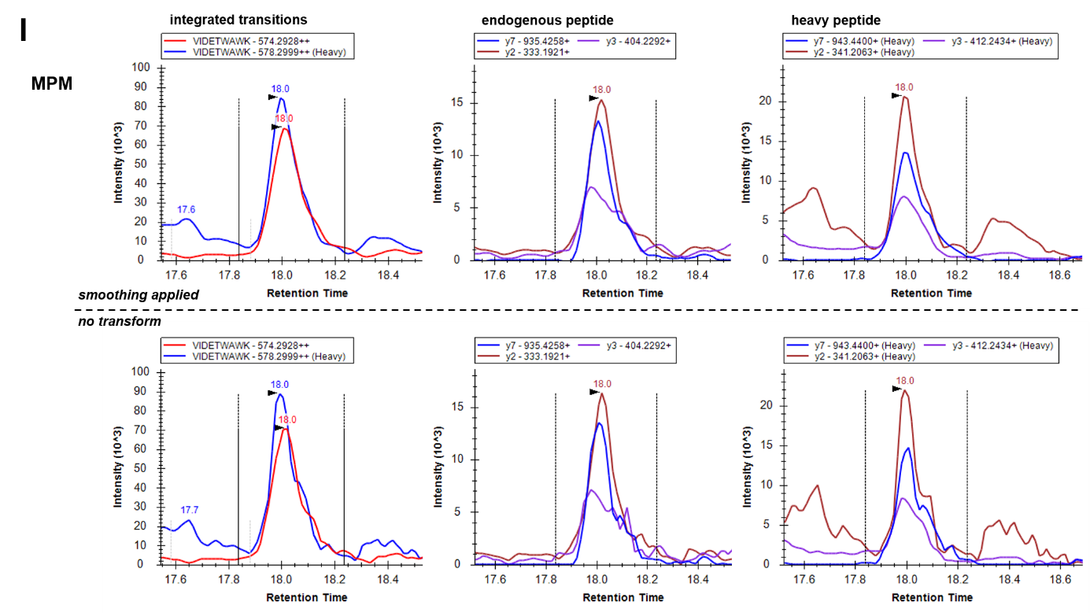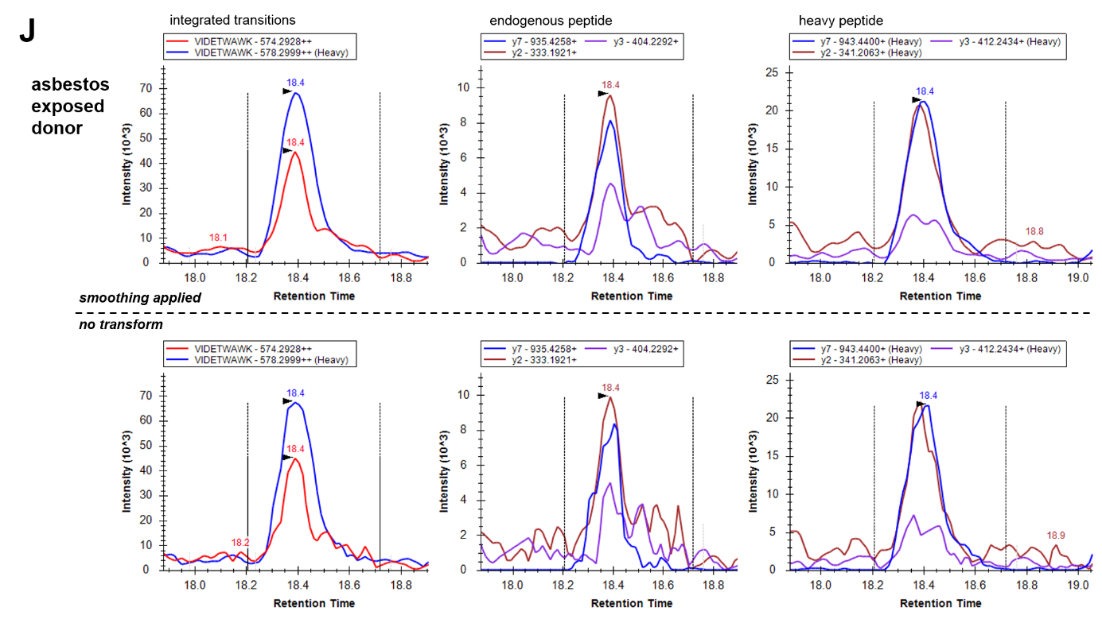

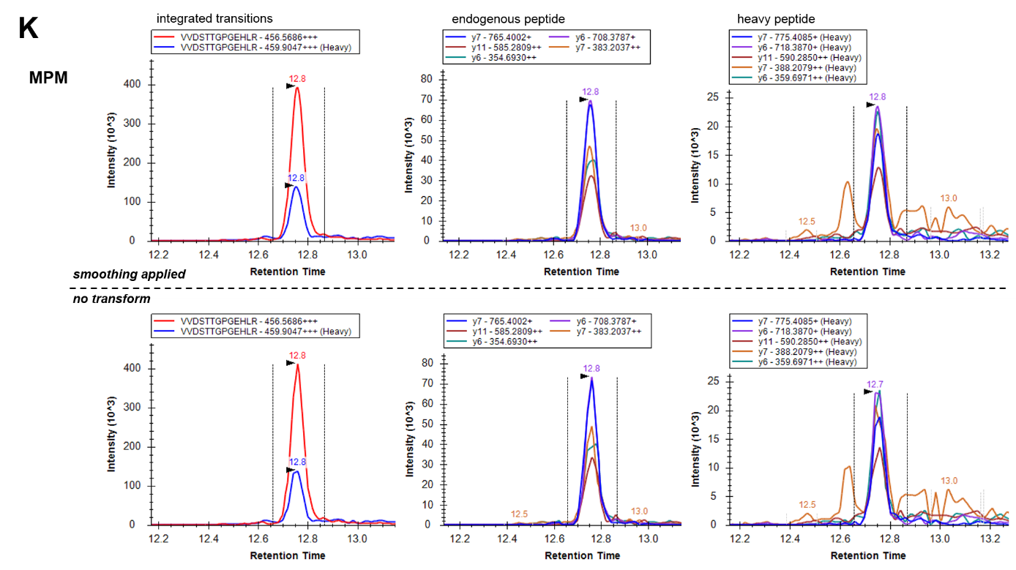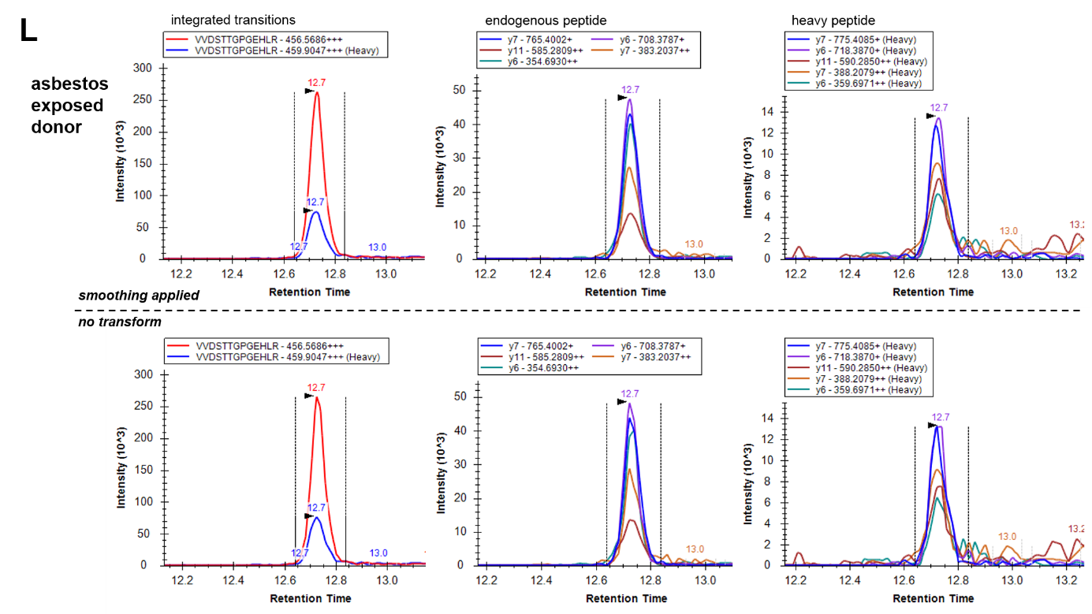

Supplementary Fig 3. Heatmap of standardized peptide abundance of 6 peptides across all subjects in the training set (A) and the testing set (B). The subjects are arranged in columns and the peptides in rows. For the visualization purpose, the summarized peptide abundances were standardized by protein (by row) on a quantile scale. Hierarchical clustering with Euclidian distance and Ward linkage was employed to cluster subjects by similarity of standardized peptide abundance (unsupervised classification).
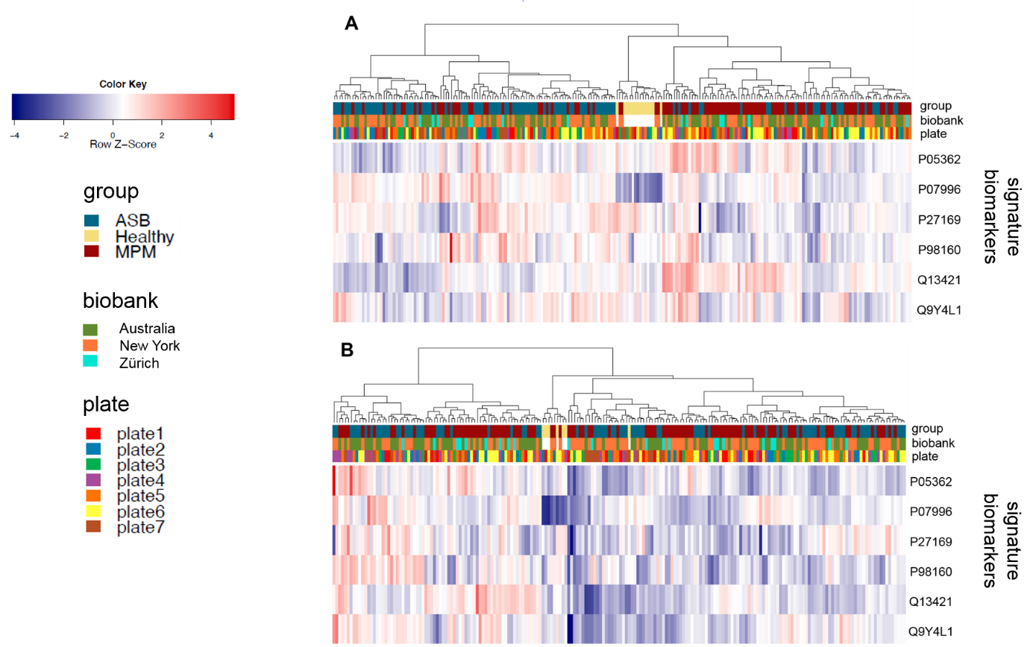

Supplementary Fig 4. Workflow for predictive analysis (A) with multivariate signature, (B) with peptide KWDVTSLETLK in LC-SRM, and (C) with SMRP ELISA.

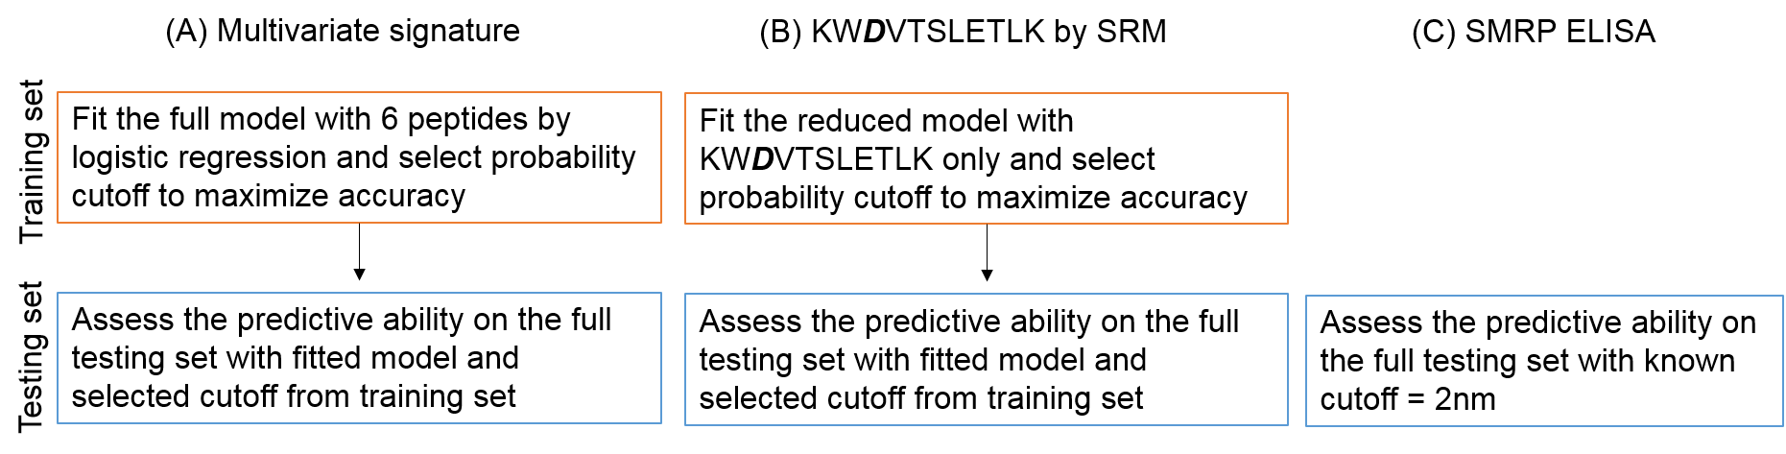

Supplementary Fig 5. Receiver operating characteristic curves (ROC) for the discrimination of MPM patients and asbestos exposed donors in the training set using the multivariate proteomic biomarker signature. The inserts report the AUC and the signature cut-off.
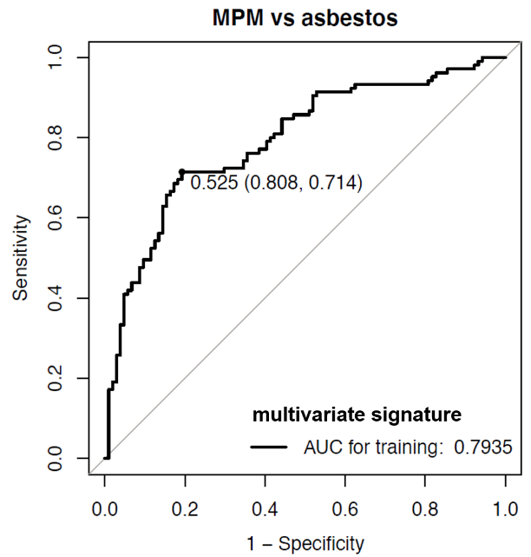
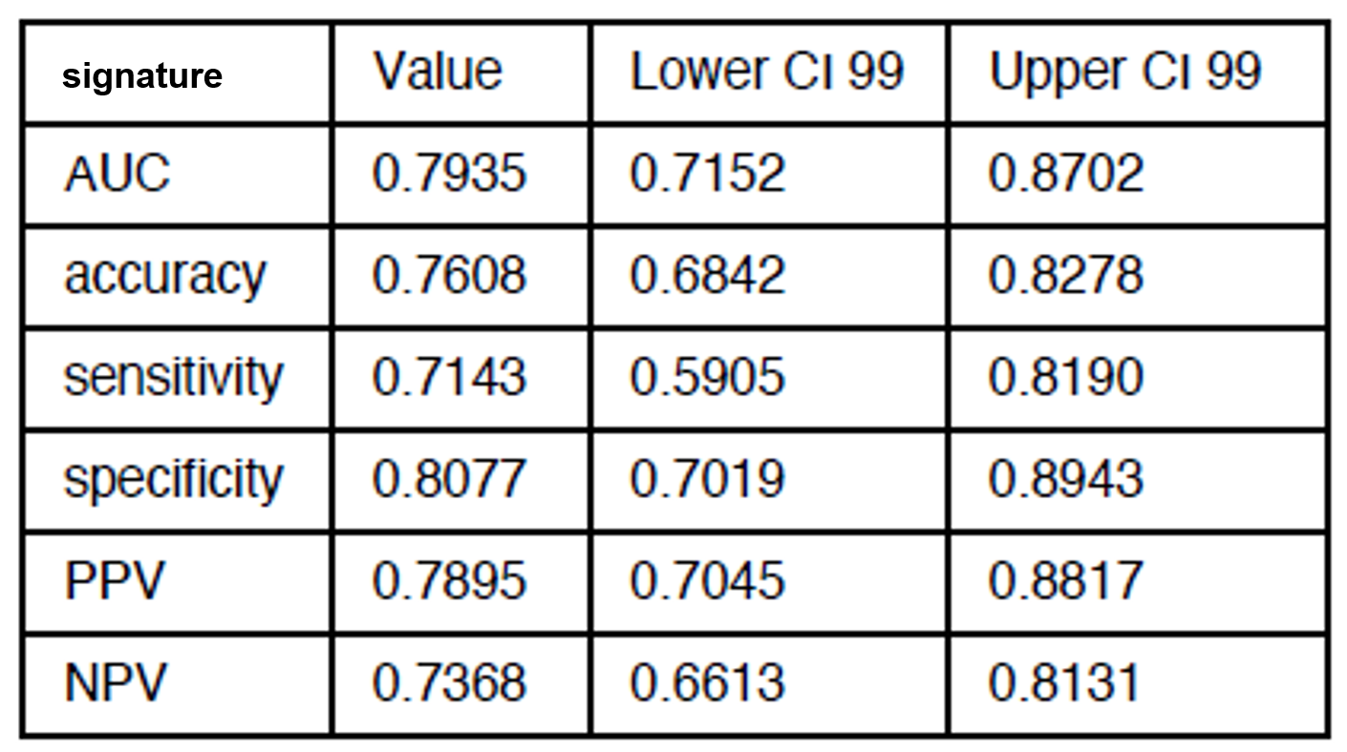
Supplementary Fig 6. Receiver operating characteristic curves (ROC) for the discrimination of MPM patients and asbestos exposed donors in the training set using the single peptide KWDVTSLETLK from the protein mesothelin. The inserts report the AUC and cut-off.
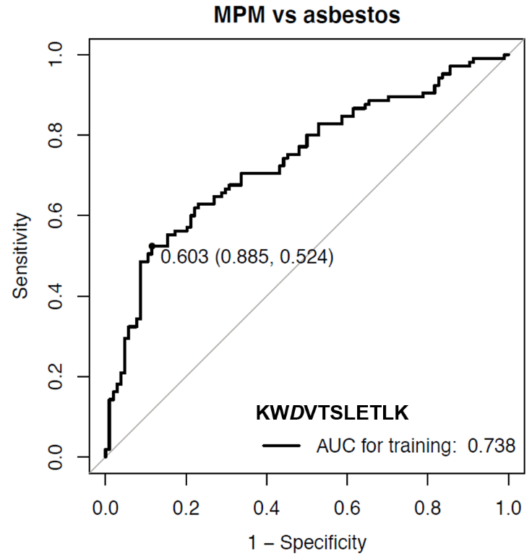
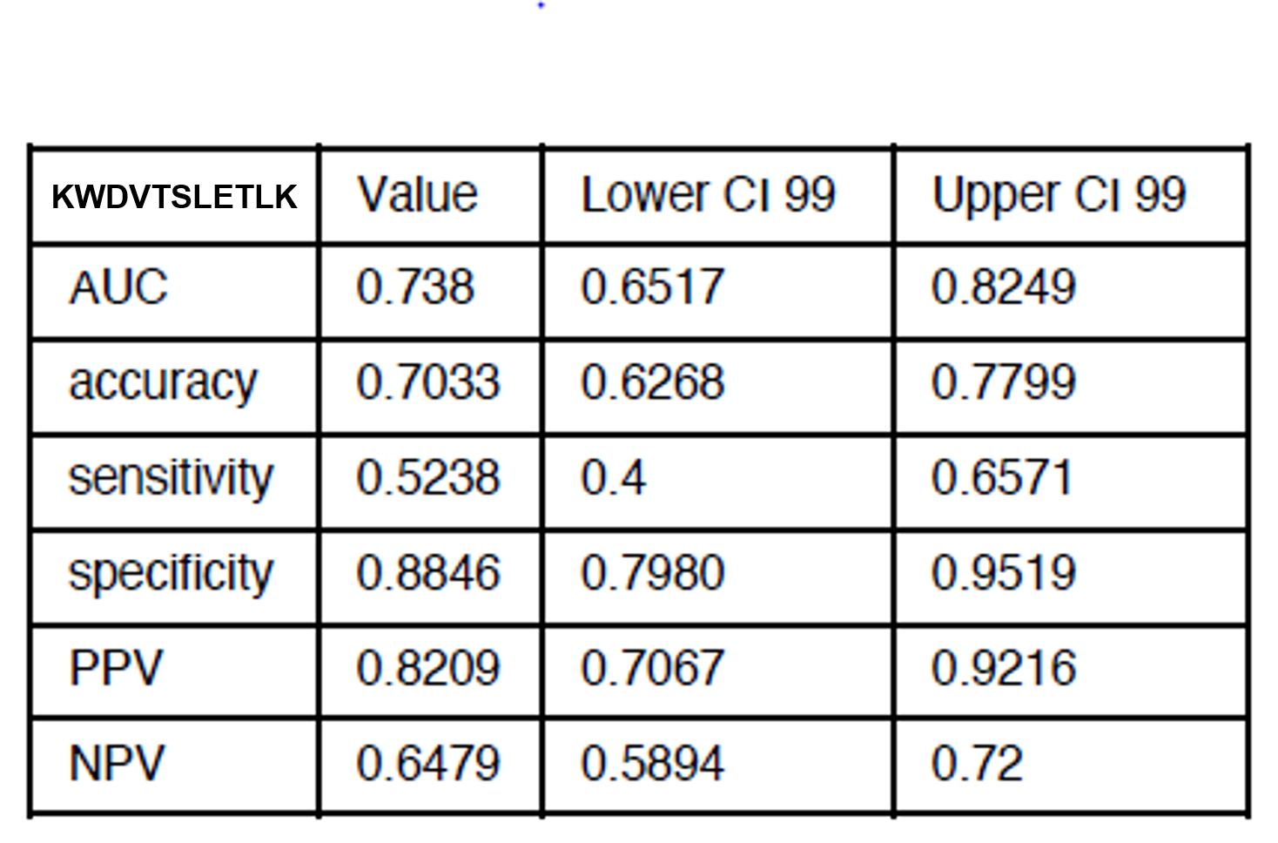
Supplementary Fig 7. Receiver operating characteristic curves (ROC) for the discrimination of MPM patients and asbestos exposed donors in the training and the testing set using separately one peptide of the multivariate signature at a time. Logistic regression models were fit with one peptide of the multivariate signature at a time to the training set and then the predictive ability of the models was evaluated on the testing set. Reported are the Uniprot entry numbers of the proteins from which the signature peptides are derived from and the AUC for each of the peptides.

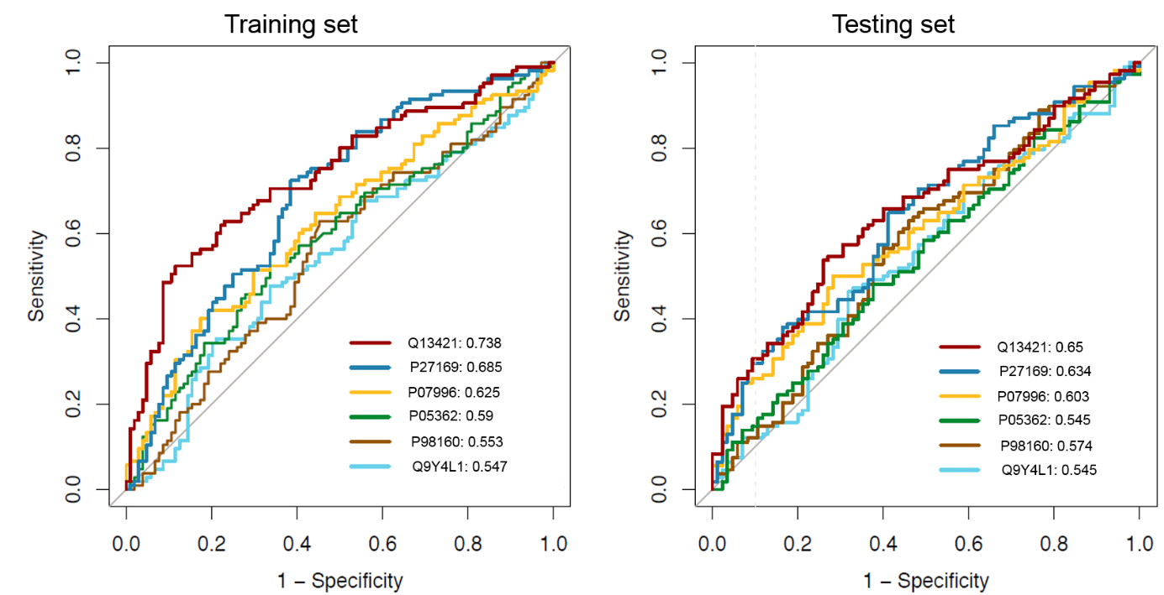

Supplementary Fig 8. Relative peptide abundance of mesothelin peptide KWDVTSLETLK by LC-SRM (A, C) and concentration distribution of SMRP assessed by ELISA (B, D) in MPM patients (MPM) and asbestos exposed donors (ASB) of the testing set. Box-and-whiskers plots represent median, 25th and 75th percentile. P-values are reported.
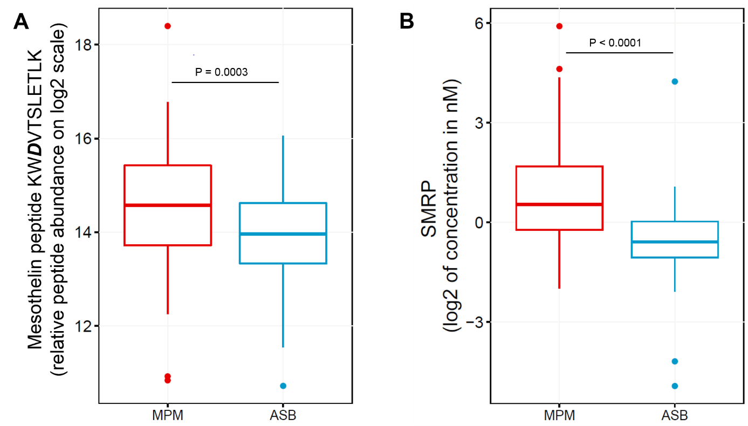
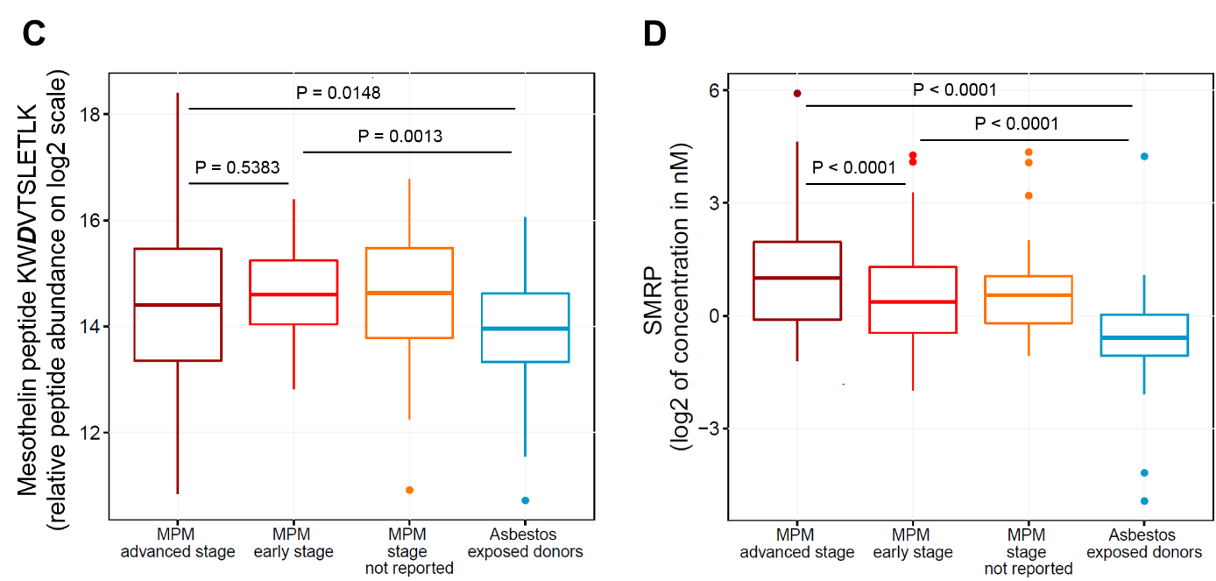

Supplementary Fig 9. Correlation of mesothelin quantification by LC-SRM and SMRP by ELISA. SMRP concentration by ELISA on log2 scale (X-axis) is plotted together with the quantification of the mesothelin peptide KWDVTSLETLK using LC-SRM (Y-axis). Dots are samples from MPM patients or asbestos exposed donors of the testing set. Colors are red for MPM early stages, purple for MPM at advanced stages, yellow if stage was not available and blue for asbestos exposed donors. Vertical red line is the SMRP cut-off of 2 nM (on log2 scale) for MPM assignment (as suggested from the literature, ref. 19 in the main text). Dashed black line: linear regression, (ŷ) = 0.4897+ 0.0621 x, Pearson correlation r = 0.410 (P < 0.0001).

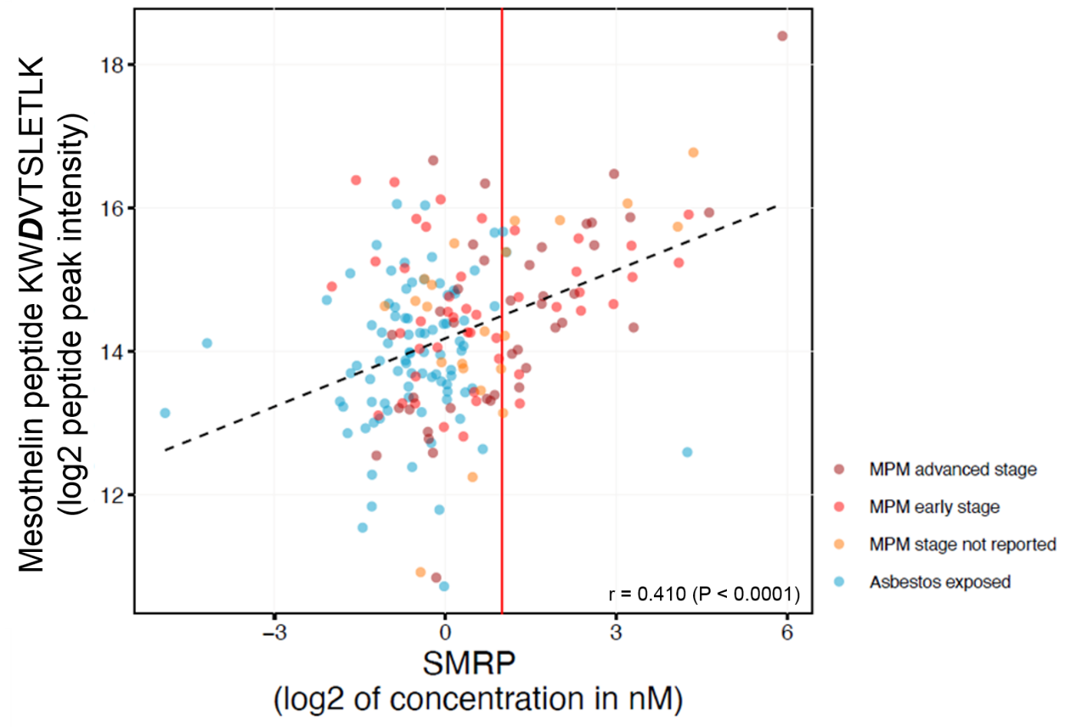

Supplementary Fig 10. Signatures combining 6 LC-SRM quantified peptides and SMRP ELISA. Five combinations of relative peptide abundance from up to six peptides by LC-SRM and SMRP ELISA were evaluated in the testing set. (1) 6-peptide components of multivariate signature by LC-SRM, (2) SMRP ELISA, (3) SMRP ELISA and mesothelin peptide KWDVTSLETLK by LC-SRM, (4) SMRP ELISA and 6-peptide components of multivariate signature by LC-SRM, and (5) SMRP ELISA and 5-peptide components of multivariate signature excluded KWDVTSLETLK. The logistic regression model with each combination was fit to the complete testing dataset and the predictive accuracy was quantified using AUC (reported in figure as “complete”) by cross-validation. An unbiased estimate of predictive ability was obtained by the pseudo-median fold of the ten-fold cross-validation, which corresponds to the 5th largest AUC value out of the ten folds (AUC reported in figure as “pseudo-median”). An estimate of variability associated with the ROC curve was obtained by plotting the 25th and the 75th quantile of the sensitivities for each value of 1-specificity over ten folds. 99% CIs for the area under the ROC curve were derived from 2,000 bootstrap replicates. P-values for comparing pairs of ROC curves were calculated from 2,000 bootstrap replicates and are reported in the figure.
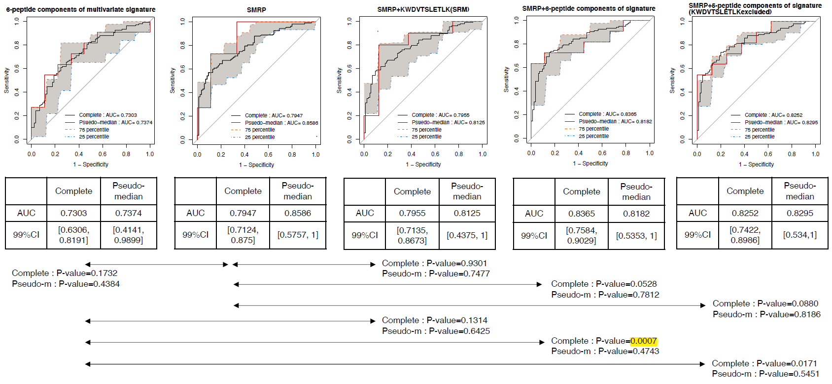

Supplementary Fig 11. Workflow for survival analysis with six LC-SRM quantified peptides abundance as predictors. Kaplan-Meier curves for the training set and the testing set are shown in Figure 3.
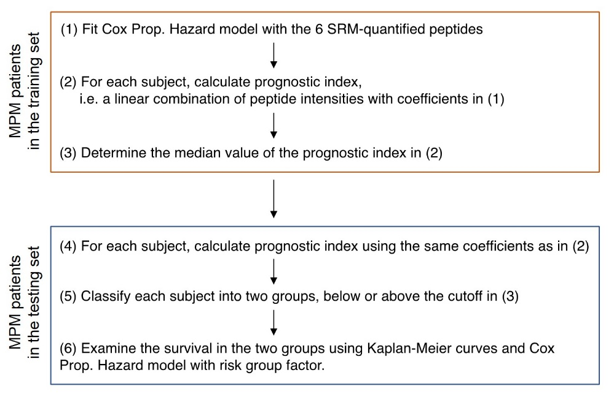

Supplementary Table 6. Multivariable CPH model from the training set.

