Supplementary Data

for

Characterization of Squamous Cell Lung Cancers from Appalachian Kentucky

Jinpeng Liu^{1‡,}, Thilakam Murali^{2,‡}, Tianxin Yu^{2,‡}, Chunming Liu², Theru A.Sivakumaran³, Hunter N.B. Moseley², Igor B. Zhulin^{4,5}, Heidi L. Weiss¹, Eric B. Durbin^{1,6}, Sally R. Ellingson^{1,6}, Jinze Liu^{1,7}, Bin Huang^{1,10}, Brent J. Hallahan¹, Craig M. Horbinski⁸, Kurt Hodges³, Dana L. Napier¹, Thèrése Bocklage³, Joseph Mueller¹, Nathan L. Vanderford^{1,9}, David W. Fardo¹⁰, Chi Wang^{1,10,*}, Susanne M. Arnold^{1, 11,*}

Supplementary Methods
Supplementary Method S1: Data sources
1. Data for TCGA Lung SQCC Nature (2012) cohort were downloaded from the following websites:

CNV: http://gdac.broadinstitute.org/runs/analyses__2012_02_17/reports/cancer/LUSC/
SNV: https://tcga-data.nci.nih.gov/docs/publications/lusc_2012/LUSC_Paper_v8.aggregated.tcga.somatic.maf.gz
Clinical: https://tcga-data.nci.nih.gov/docs/publications/lusc_2012/LUSC%20Public%20Clinical%20Data%20178%20participants.xlsx

2. Data for Campbell et al., Nature Genetics (2016) cohort were downloaded from the following website:

http://www.cbioportal.org/study?id=nsclc_tcga_broad_2016#summary
3. Data for Kim et al. J Clin Oncol (2014) cohort were provided by Dr. Youngwook Kim.
4. Data for Li et al. Scientific Reports (2015) cohort were downloaded from the following website:
https://media.nature.com/original/nature-assets/srep/2015/151027/srep14237/extref/srep14237-s3.xls

Supplementary Method S2: Primers used for IDH1 mutagenesis
Primers used for R132H mutagenesis were 5’-CATCATAGGTCATCATGCTTATGGGG-3’ and 5’-CCCCATAAGCATGATGACCTATGATG-3’; primers used for V178A mutagenesis were 5’-GAAGGTGGTGGTGCTGCCATGGGGATGT-3’ and 5’-ACATCCCCATGGCAGCACCACCACCTTC-3’; primers used for A307S mutagenesis were 5’- AGAAGCAGAGTCTGCCCACGGGACT-3’ and 5’- AGTCCCGTGGGCAGACTCTGCTTCT-3’; and primers used for L352P mutagenesis were 5’-AACAATAAAGAGCCTGCCTTCTTTGCA-3’ and 5’-TGCAAAGAAGGCAGGCTCTTTATTGTT-3’.

Supplementary Method S3: HEK293T cells authentication
HEK293T (ATCC) cells were last authenticated on Oct 23rd, 2014 by Genetica DNA Laboratories. Fifteen autosomal short tandem repeat (STR) loci and the gender identity locus amelogenin were profiled using PowerPlex 16 HS (Promega Corporation). Mycoplasma testing has not been performed on this cell line since purchased from ATCC. Passage number is not available. Cells were used in the described experiment 2-4 weeks after thawing.
Supplementary Method S4: Immunohistochemistry (IHC) Protocol
IHC was performed on 4-micron thick sections of formalin fixed paraffin embedded tissue. Samples were deparaffinized and heat-induced epitope retrieval (HIER) was performed in a Dako PT Link pre-treatment module with EnVision FLEX high pH Target Retrieval Solution according to manufacturer’s instructions. Slides were incubated with anti-IDH1 R132H antibody (Dianova, DIA-H09, diluted 1:20) for 20 minutes on a Dako autostainer, followed by incubation with Dako mouse linker (15 minutes) then Dako’s EnVision FLEX-HRP (20 minutes) according to manufacturer’s recommendations. Staining was visualized using 3, 3′-diaminobenzidine (DAB) chromogen (10 minutes-Dako, CA) and slides were lightly counterstained with hematoxylin. A known IDH1 mutant was run simultaneously as a positive control. A second slide of the patient tissue was run with mouse IgG in place of primary antibody, as a negative control.

Supplementary Figures
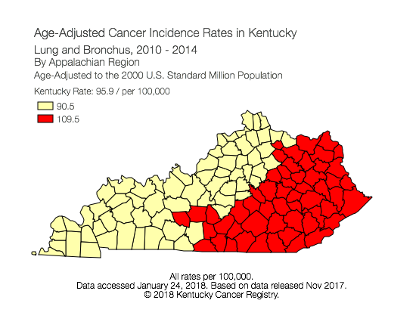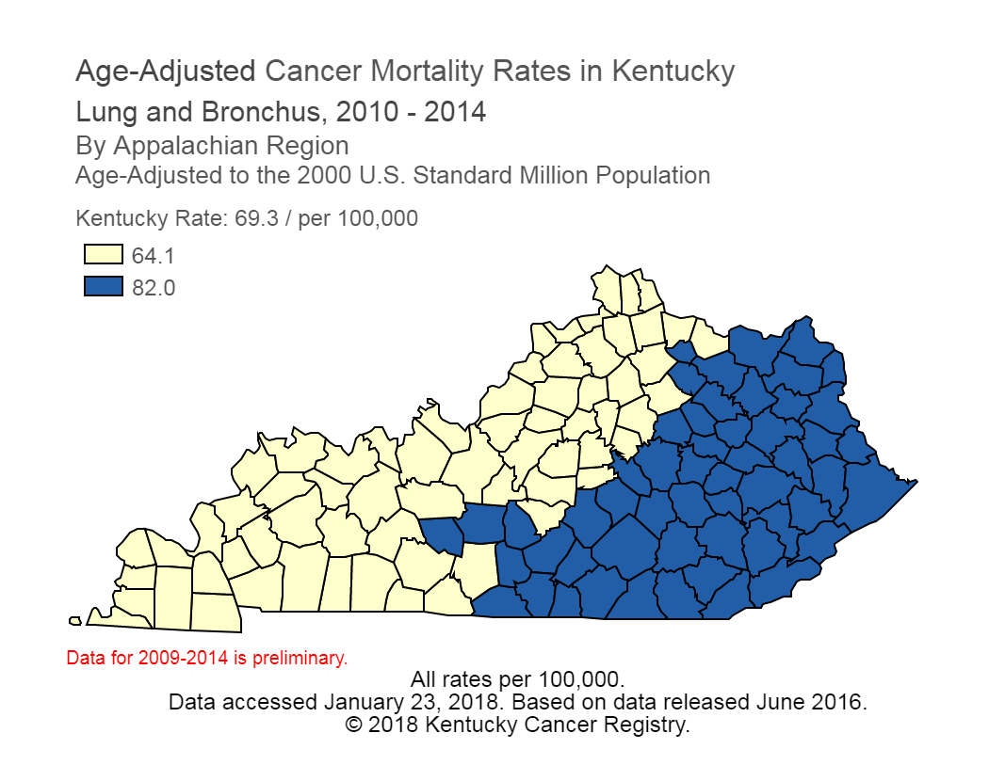
Supplementary Figure S1. Lung cancer characteristics in Kentucky. In 2015, 4845 lung cancer cases were diagnosed in Kentucky, and almost 80% were diagnosed at advanced stage. Kentucky’s age-adjusted lung cancer incidence rate (left panel) is 95.9/100,000 (2010-2014) compared to 61.2/100,000 in US. Kentucky's death rate from lung cancer (right panel) is 69.3/100,000 (2010-2014) compared to 44.7/100,000 in US. Particularly, the lung cancer incidence rate in Appalachian Kentucky (red area in left panel) is 109.5/100,000 and the lung cancer death rate in Appalachian Kentucky (blue area in right panel) is 82.0/100,000. The figures were generated from the Kentucky Cancer Registry website (https://www.cancer-rates.info/ky/?datasource=mort, last accessed Jan 23, 2018). The lung cancer incidence and death rates in US were obtained from United States Cancer Statistics website (https://nccd.cdc.gov/uscs/, last accessed Jan 23, 2018).

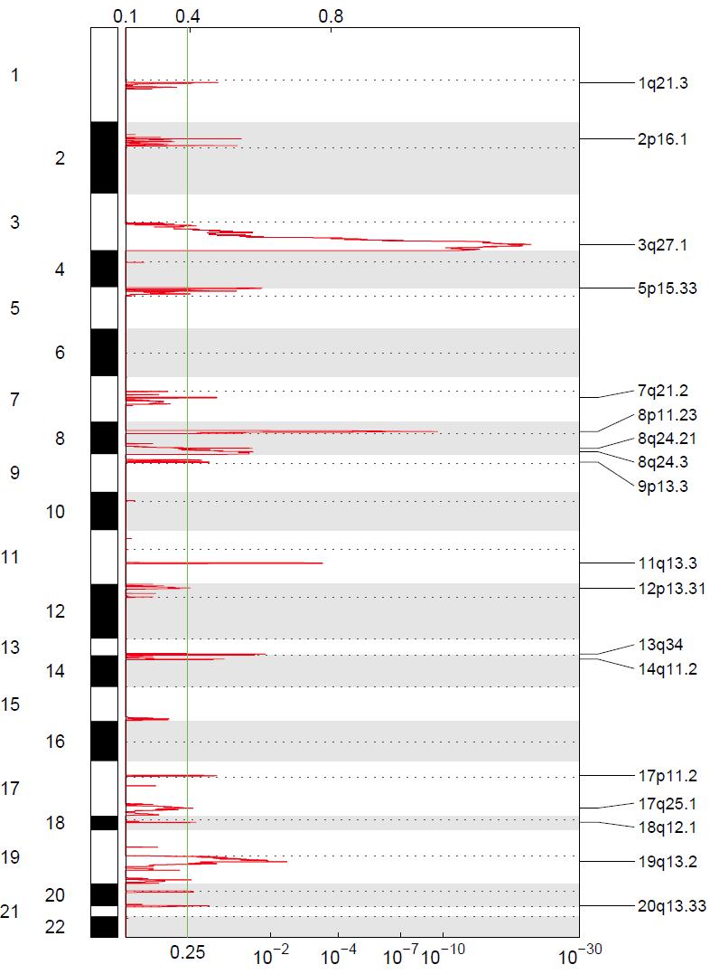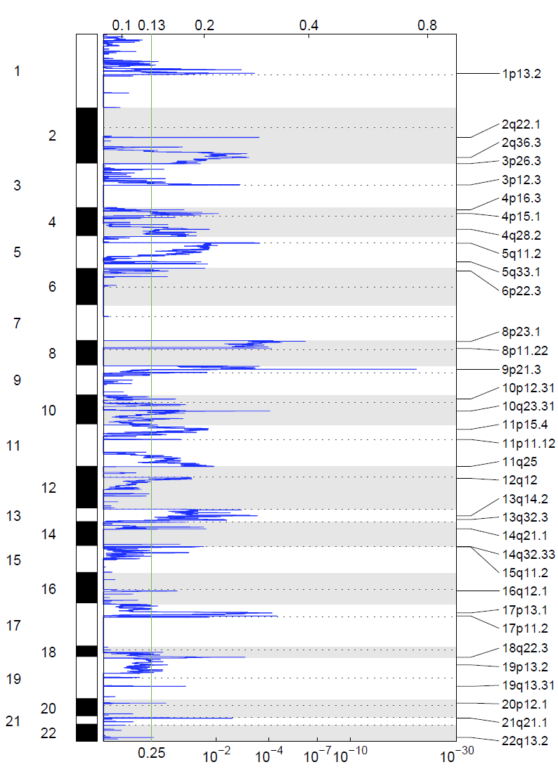

Supplementary Figure S2. GISTIC amplification (left) and deletion (right) plots of the G-scores (shown at the top of the figure) and q-values (shown at the bottom of the figure) across the entire region analyzed.
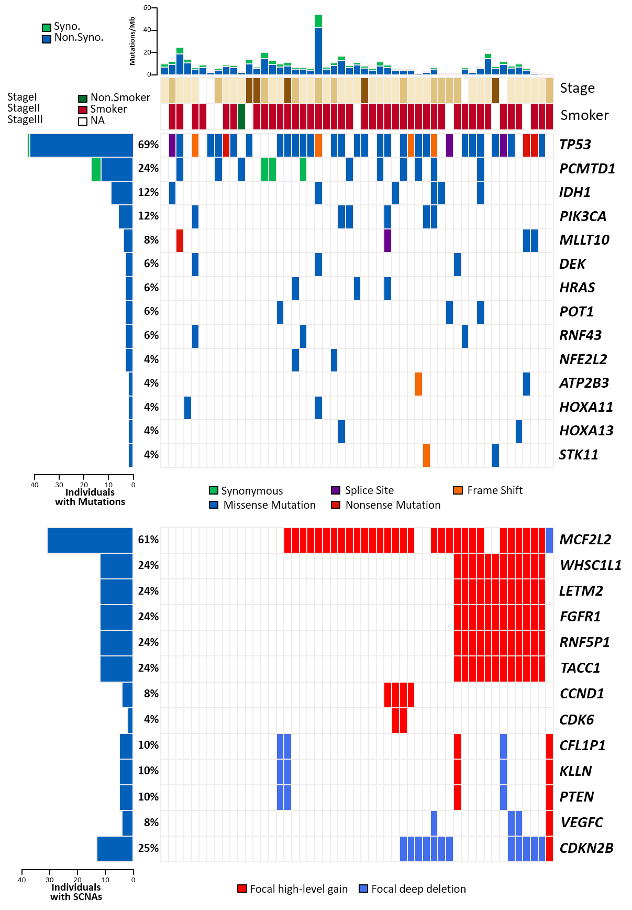
Supplementary Figure S3. Somatic genomic alterations from the AppKY cohort. Genes that were significantly mutated are shown on the top and genes that were contained in the amplification/deletion wide peaks are shown at the bottom. The number and percentage of samples with mutations or SCNAs in each gene are shown on the left. Samples are displayed as columns.

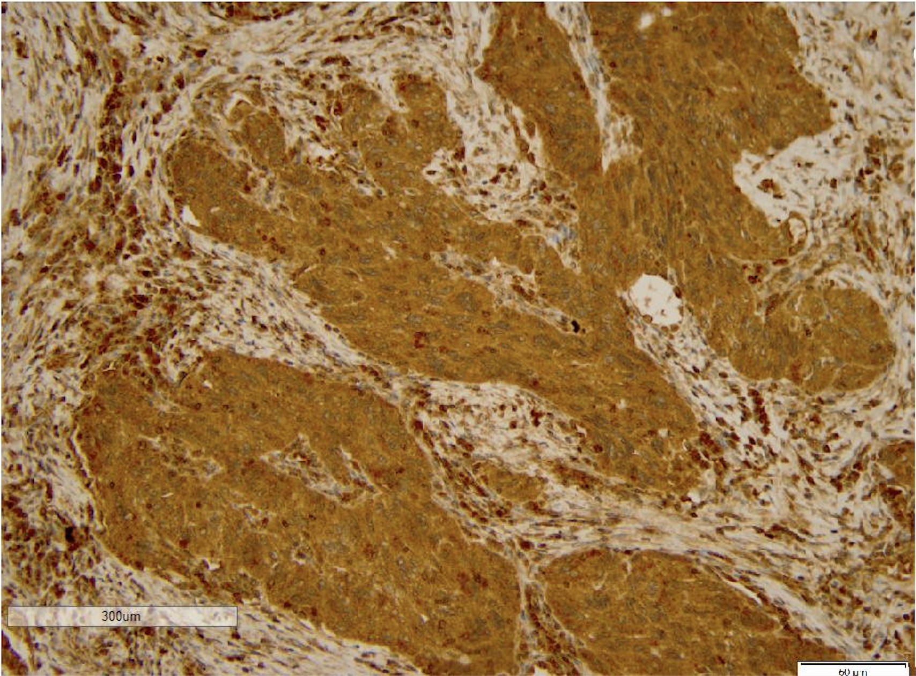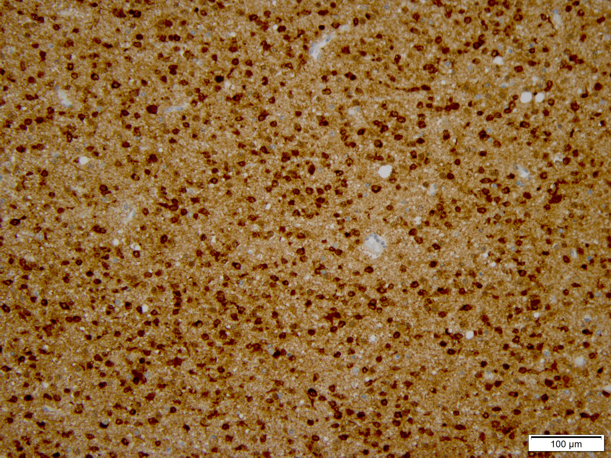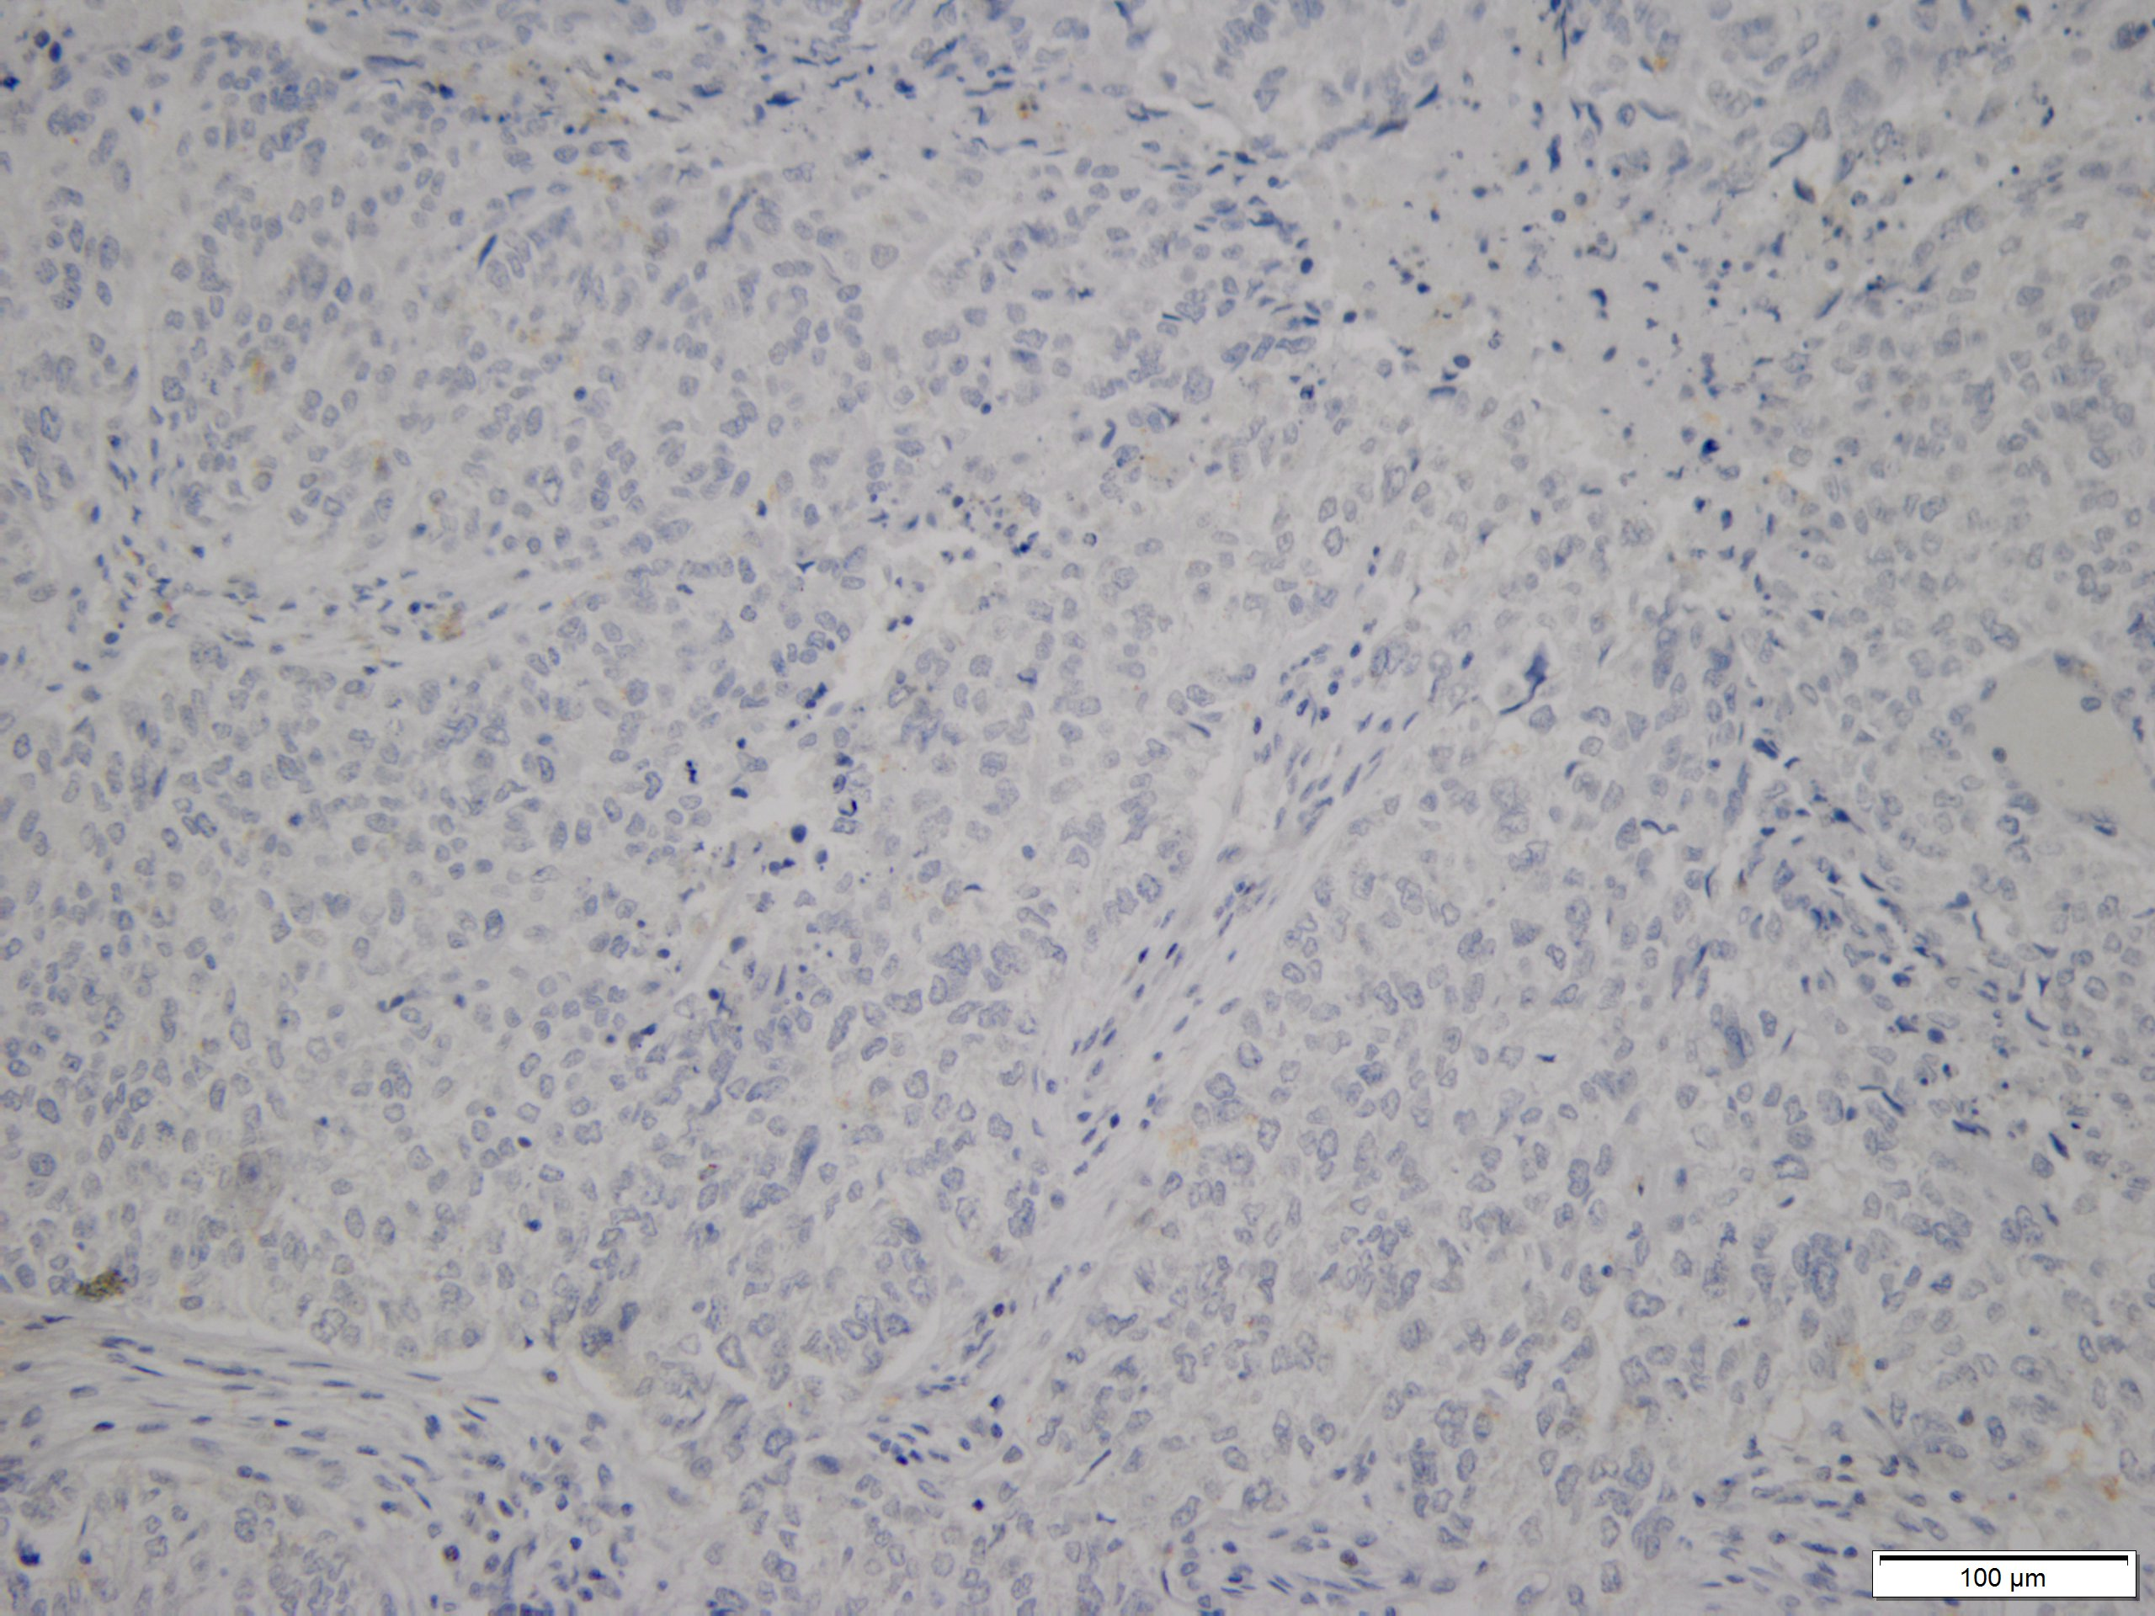
Supplementary Figure S4. Immunohistochemistry (IHC) staining confirmed the IDH1 R132H mutation for one patient in the AppKY cohort. The IHC were performed on formalin fixed paraffin embedded representative tumor tissue (left) from patient MCC4545401228, who had a single IDH1 R132H mutation based on the whole-exome sequencing result. A known IDH1 mutant was run simultaneously as a positive control (middle). A second slide of the patient tissue was run with mouse IgG in place of primary antibody, as a negative control (right).

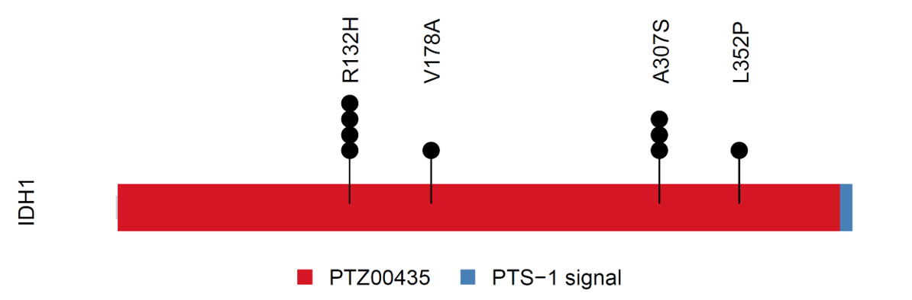

A

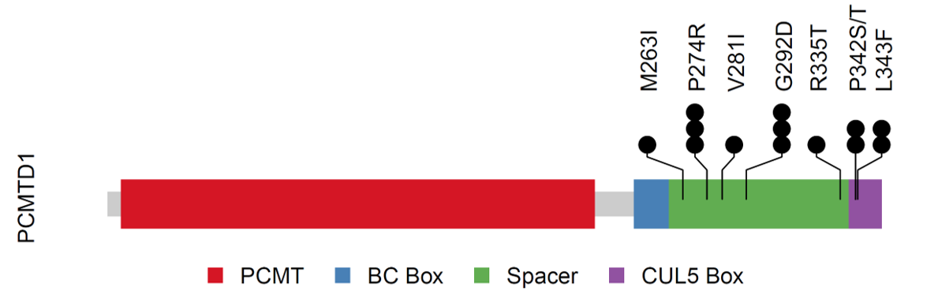
B

Supplementary Figure S5. IDH1 and PCMTD1 mutations. (A) IDH1 mutations and their mutation frequencies (circles). (B) PCMTD1 mutations and their frequencies (circles).
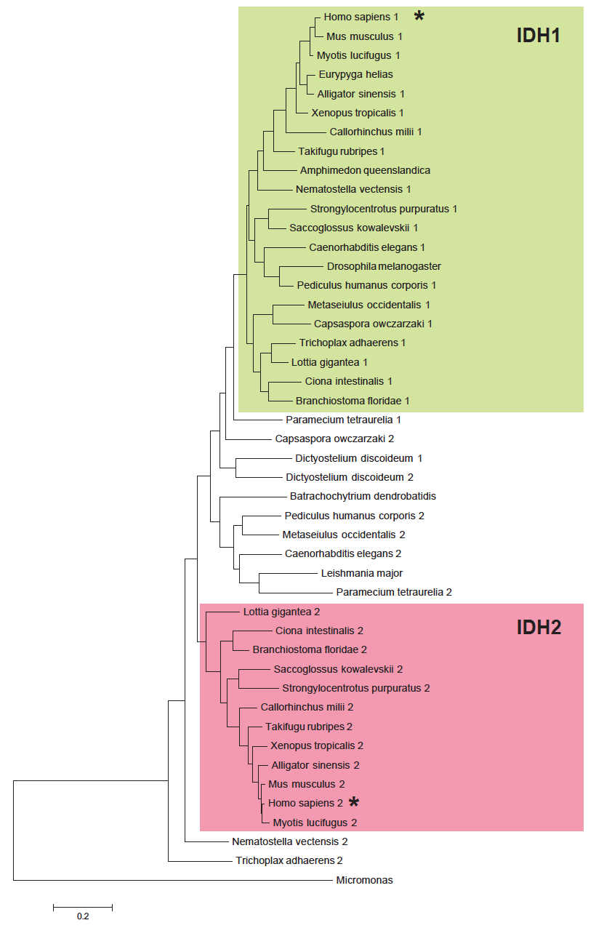
Supplementary Figure S6. Maximum likelihood phylogenetic tree of IDH1 and IDH2 proteins from a representative genome set. Clades of definite IDH1 and IDH2 orthologs are highlighted in green and magenta, correspondingly. Multiple sequence alignment was used to construct the tree and sequence accession numbers are shown in Supplementary Figure S7. Human proteins are marked by a star.
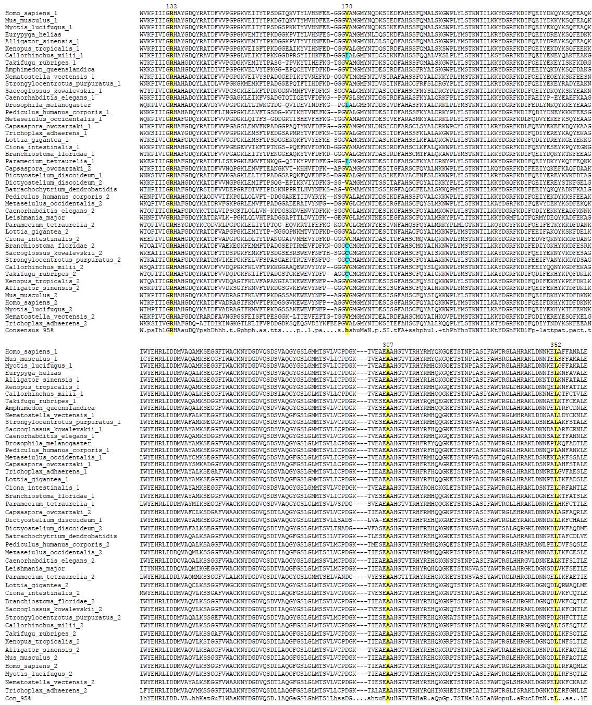
Supplementary Figure S7. Multiple sequence alignment of IDH1 and IDH2 proteins from a representative genome set. Sequence labels and the order of sequences correspond to that of the phylogenetic tree shown in Supplementary Figure S6. Positions corresponding to K132, V178, A307, and L352 in the human IDH1 are highlighted.

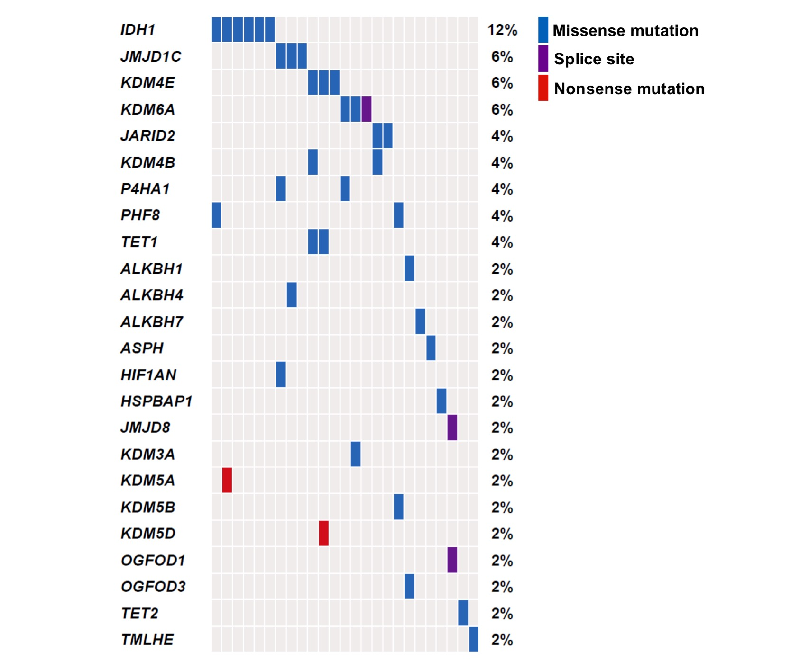
Supplementary Figure S8. 2-OG dependent enzymes as a group are mutually exclusive with IDH1 mutations. All known 2-OG dependent enzymes including protein demethylases, DNA and RNA demethylases and amino acid hydroxylases were included in the analyses.

