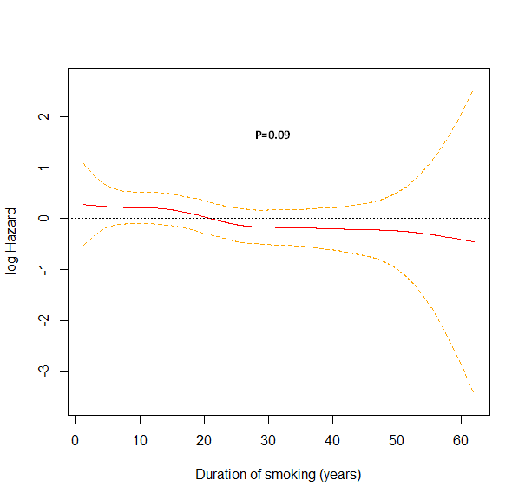
Figure S1

Figure S1. Relation of duration of smoking and its dose-response patterns with risk of melanoma. The solid line represents log hazard, and the dashed line represents its 95% confidence Intervals.

Figure S2

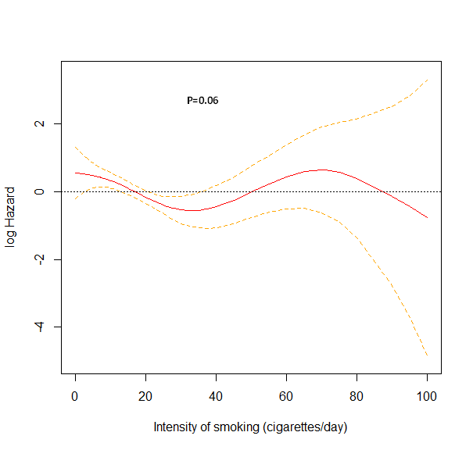
Figure S2. Relation of smoking intensity and its dose-response patterns with risk of melanoma. The solid line represents log hazard, and the dashed line represents its 95% confidence Intervals.

Figure S3
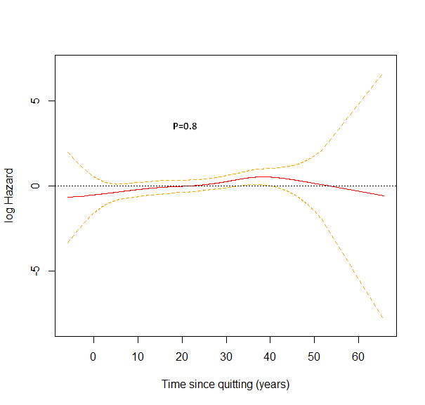
Figure S3. Relation of time since quitting smoking and its dose-response patterns with risk of melanoma. The solid line represents the log hazard, and the dashed line represents its 95% confidence Intervals.

