**Supplementary Information**

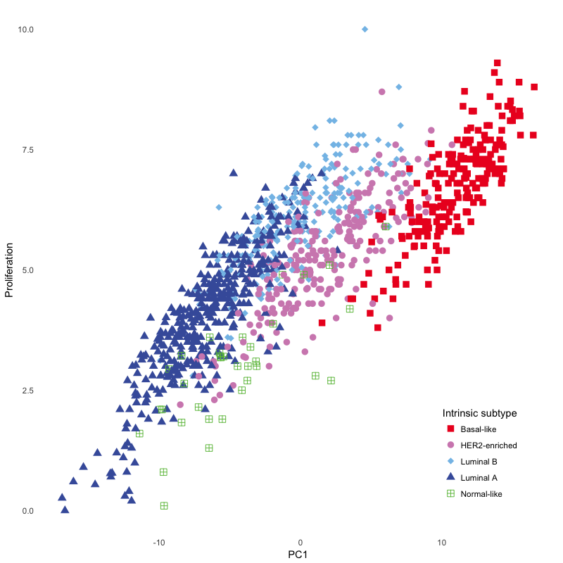**S1 Figure**. Correlation of PAM50 proliferation score with PC1 in LACE/Pathways.

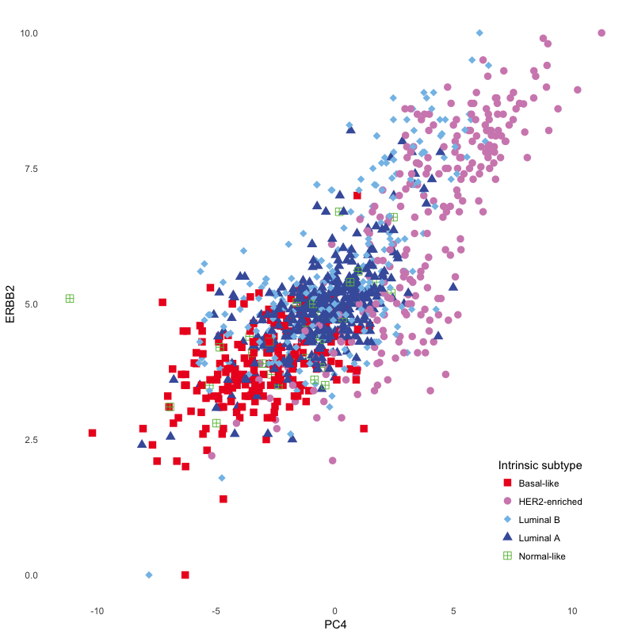

## **S2 Figure.** Correlation of PAM50 ERBB2 score with PC4 in LACE/Pathways.



**S3 Figure**. Distribution of PC scores by intrinsic subtype replicate in TCGA expression data. **a.** PC1, PC2 and PC4 capture key features of intrinsic subtypes. **b**. PC3 and PC5 are independent of intrinsic subtype.



## **S4 Figure**. Intrinsic subtypes remain evident in TCGA breast tumors based on direct application of the PC1, PC2, and PC4 equations (linear combinations of expression) derived from PAM50 (LACE/Pathways) to RNAseq data from TCGA breast tumors.



## **S5 Figure.** Distribution of intrinsic subtypes in pedigrees and population set (LACE/Pathways, white women). For individual pedigrees, unadjusted p-values for a goodness-of-fit test to the population set are shown. To account for multiple testing, a Bonferroni-adjusted significance threshold of 0.0045 should be used.

## **S1 Table.** Eigenvectors and eigenvalues of principal components 1-5.