Supplementary Table S1. Leading causes of death among females worldwide, 2012
Rank | Top ten causes of death | Deaths (thousands) | %
1 | Cardiovascular diseases | 8,820 | 34
2 | Malignant neoplasms | 3,544 | 14
3 | Infectious and parasitic diseases | 3,016 | 12
4 | Respiratory diseases | 1,756 | 7
5 | Respiratory infections | 1,461 | 6
6 | Unintentional injuries | 1,328 | 5
7 | Neonatal conditions | 1,097 | 4
8 | Digestive diseases | 929 | 4
9 | Neurological conditions | 821 | 3
10 | Diabetes mellitus | 813 | 3
 | All causes | 26,023

Supplementary Table S2. Leading causes of death among females by world region, 2012
Rank | Top ten causes of death | Deaths (thousands) | % | Top ten causes of death | Deaths (thousands) | %
 | Africa |  |  | Americas
1 | Infectious and parasitic diseases | 1,568 | 35 | Cardiovascular diseases | 934 | 31
2 | Cardiovascular diseases | 513 | 12 | Malignant neoplasms | 615 | 20
3 | Respiratory infections | 479 | 11 | Neurological conditions | 259 | 9
4 | Neonatal conditions | 393 | 9 | Respiratory diseases | 200 | 7
5 | Unintentional injuries | 253 | 6 | Diabetes mellitus | 161 | 5
6 | Malignant neoplasms | 232 | 5 | Digestive diseases | 137 | 5
7 | Nutritional deficiencies | 174 | 4 | Respiratory infections | 132 | 4
8 | Maternal conditions | 171 | 4 | Unintentional injuries | 110 | 4
9 | Digestive diseases | 134 | 3 | Infectious and parasitic diseases | 110 | 4
10 | Diabetes mellitus | 99 | 2 | Genitourinary diseases | 91 | 3
 | All causes | 4,446 |  | All causes | 3,011
 | South-East Asia |  |  | Europe
1 | Cardiovascular diseases | 1,685 | 27 | Cardiovascular diseases | 2,406 | 53
2 | Infectious and parasitic diseases | 889 | 14 | Malignant neoplasms | 886 | 20
3 | Respiratory diseases | 661 | 11 | Neurological conditions | 215 | 5
4 | Malignant neoplasms | 554 | 9 | Digestive diseases | 190 | 4
5 | Unintentional injuries | 436 | 7 | Respiratory diseases | 161 | 4
6 | Neonatal conditions | 402 | 6 | Unintentional injuries | 123 | 3
7 | Respiratory infections | 376 | 6 | Respiratory infections | 102 | 2
8 | Digestive diseases | 243 | 4 | Diabetes mellitus | 87 | 2
9 | Diabetes mellitus | 208 | 3 | Infectious and parasitic diseases | 86 | 2
10 | Genitourinary diseases | 181 | 3 | Genitourinary diseases | 75 | 2
 | All causes | 6,216 |  | All causes | 4,527
 | Eastern Mediterranean |  |  | Western Pacific
1 | Cardiovascular diseases | 523 | 29 | Cardiovascular diseases | 2,730 | 71
2 | Infectious and parasitic diseases | 220 | 12 | Malignant neoplasms | 1,064 | 28
3 | Malignant neoplasms | 174 | 10 | Respiratory diseases | 602 | 16
4 | Neonatal conditions | 162 | 9 | Unintentional injuries | 299 | 8
5 | Respiratory infections | 139 | 8 | Respiratory infections | 228 | 6
6 | Unintentional injuries | 103 | 6 | Diabetes mellitus | 187 | 5
7 | Digestive diseases | 76 | 4 | Digestive diseases | 144 | 4
8 | Diabetes mellitus | 63 | 4 | Infectious and parasitic diseases | 142 | 4
9 | Respiratory diseases | 56 | 3 | Neurological conditions | 106 | 3
10 | Genitourinary diseases | 50 | 3 | Genitourinary diseases | 103 | 3
 | All causes | 1,792 |  | All causes | 3,870

Supplementary Table S3. Estimated number of new cancer cases and deaths among females by world area, 2012*
World area | Cases (thousands) | Deaths (thousands)
Africa
Eastern Africa | 171 | 116
Middle Africa | 44 | 31
Northern Africa | 115 | 67
Southern Africa | 43 | 26
Western Africa | 113 | 74
Asia
Eastern Asia | 1,714 | 1,002
South-central Asia | 802 | 490
South-eastern Asia | 404 | 238
Western Asia | 149 | 79
Americas
Caribbean | 43 | 24
Central America | 110 | 57
Northern America | 866 | 329
South America | 410 | 209
Europe
Central and Eastern Europe | 523 | 287
Northern Europe | 254 | 116
Southern Europe | 339 | 163
Western Europe | 496 | 214
Oceania
Australia/New Zealand | 62 | 23
Melanesia | 6 | 4
Micronesia | 0.4 | 0.1
Polynesia | 0.6 | 0.3
*All sites excluding non-melanoma skin cancers
Supplementary Figure S1. Female breast cancer incidence and mortality rates, age-standardized rate (world), 2012
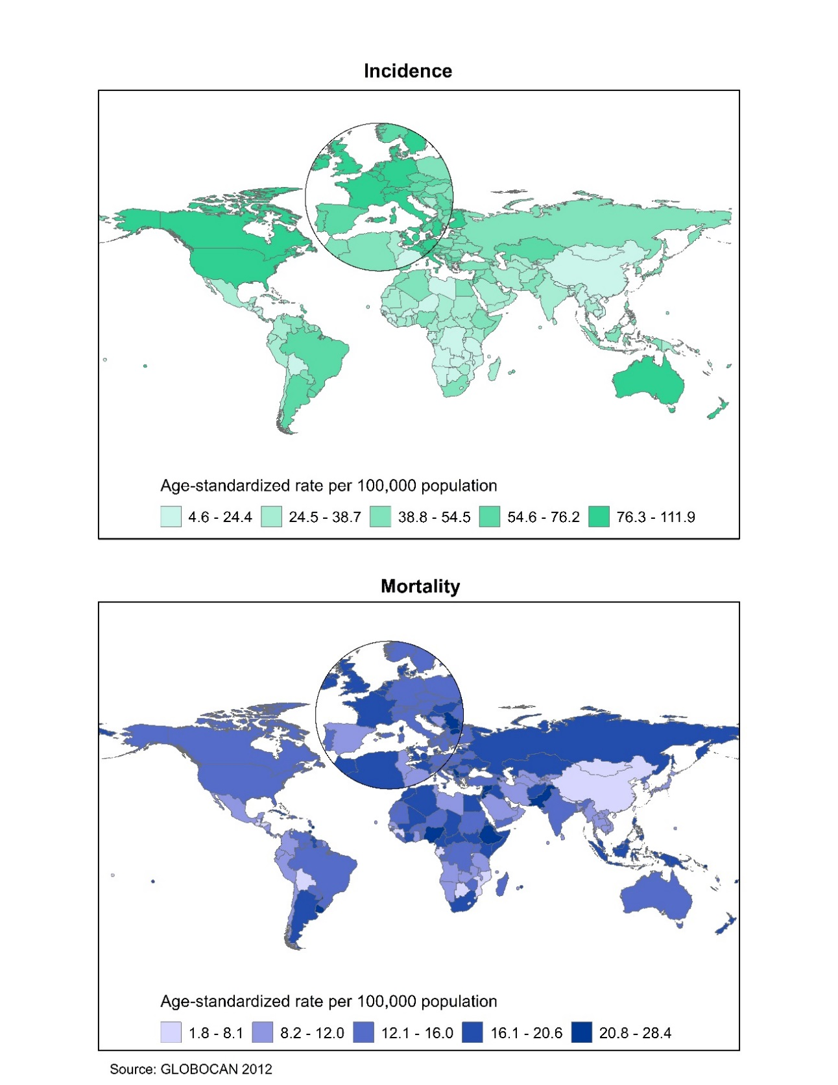
Supplementary Figure S2. Female breast cancer incidence trends, age-standardized rate (world), select countries, 1973-2012
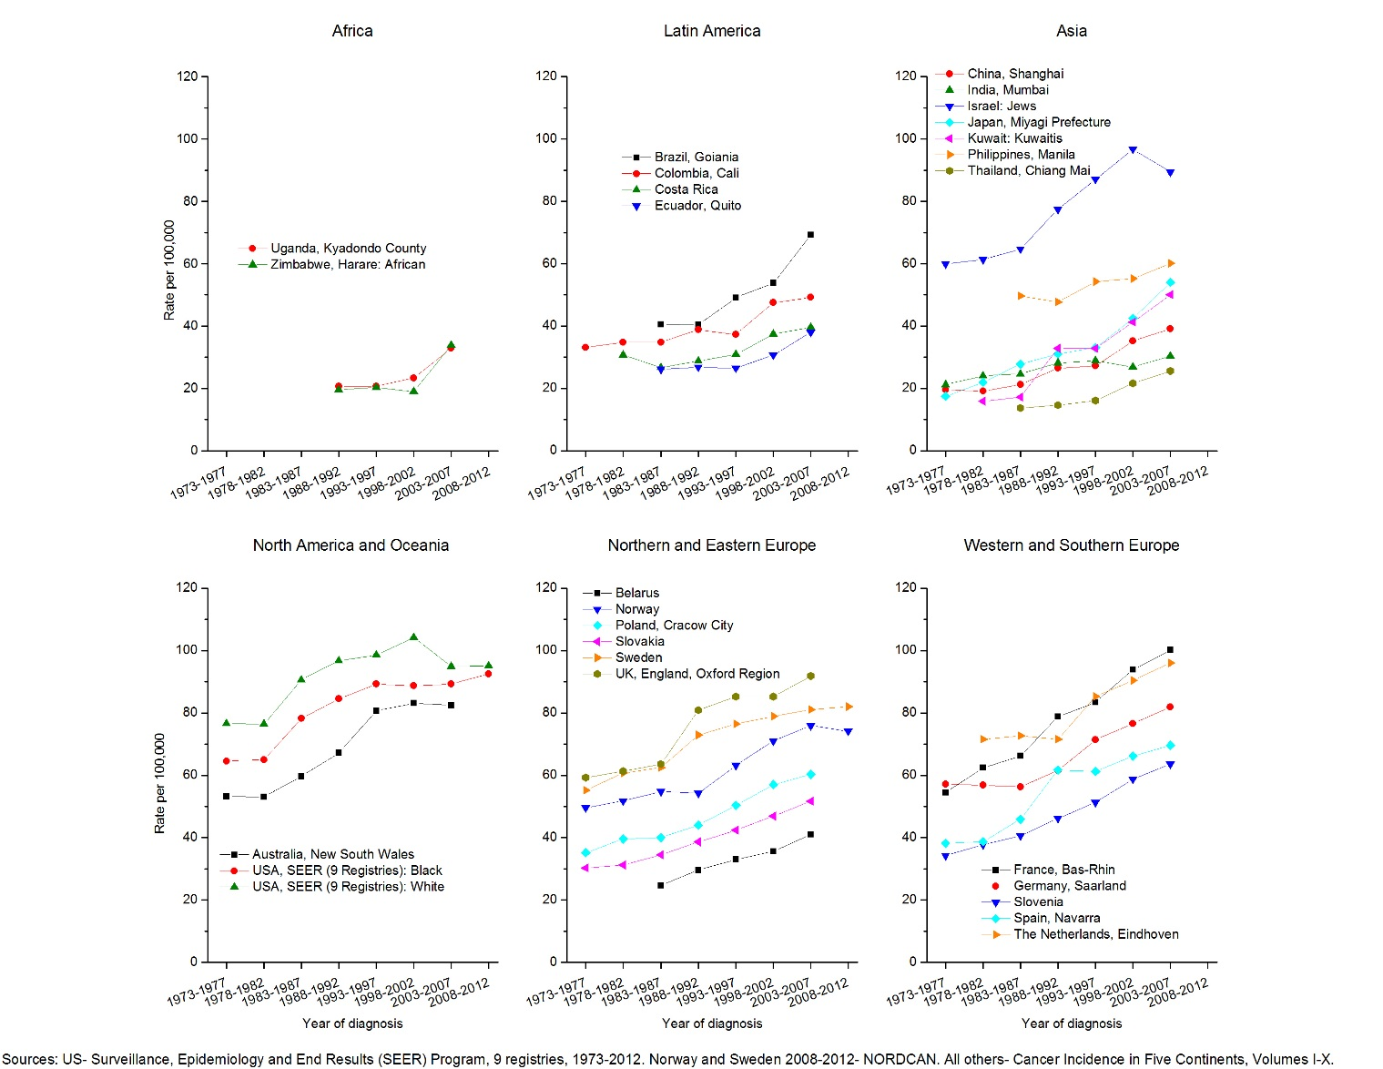
Supplementary Figure S3. Female breast cancer survivors diagnosed in last five years (through 2012 or latest available)
Supplementary Figure S4. Cervical cancer incidence and mortality rates, age-standardized rate (world), 2012
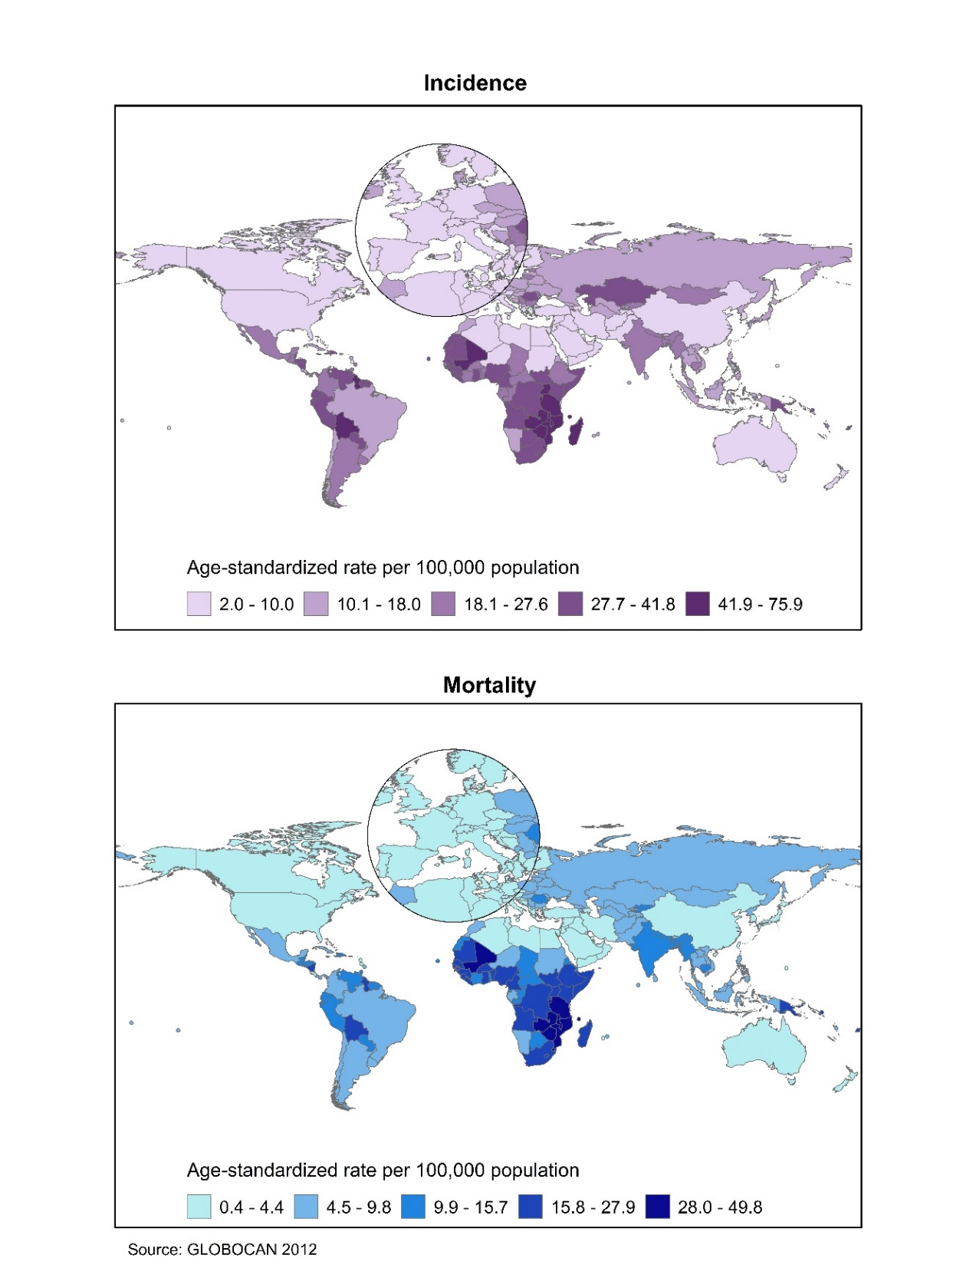
Supplementary Figure S5. Prevalence (%) of cervical HPV infection among women by region, all types combined, 1995-2009
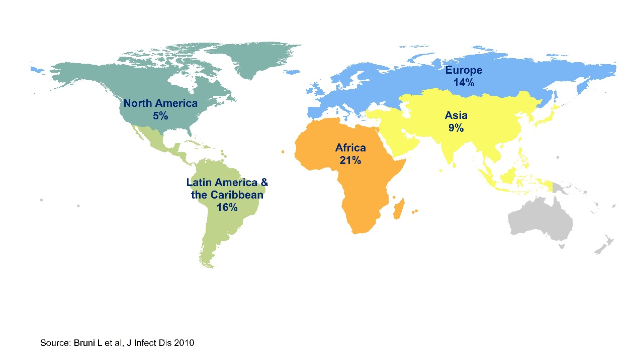
Supplementary Figure S6. Cervical cancer incidence trends, age-standardized rate (world), select countries, 1975-2007
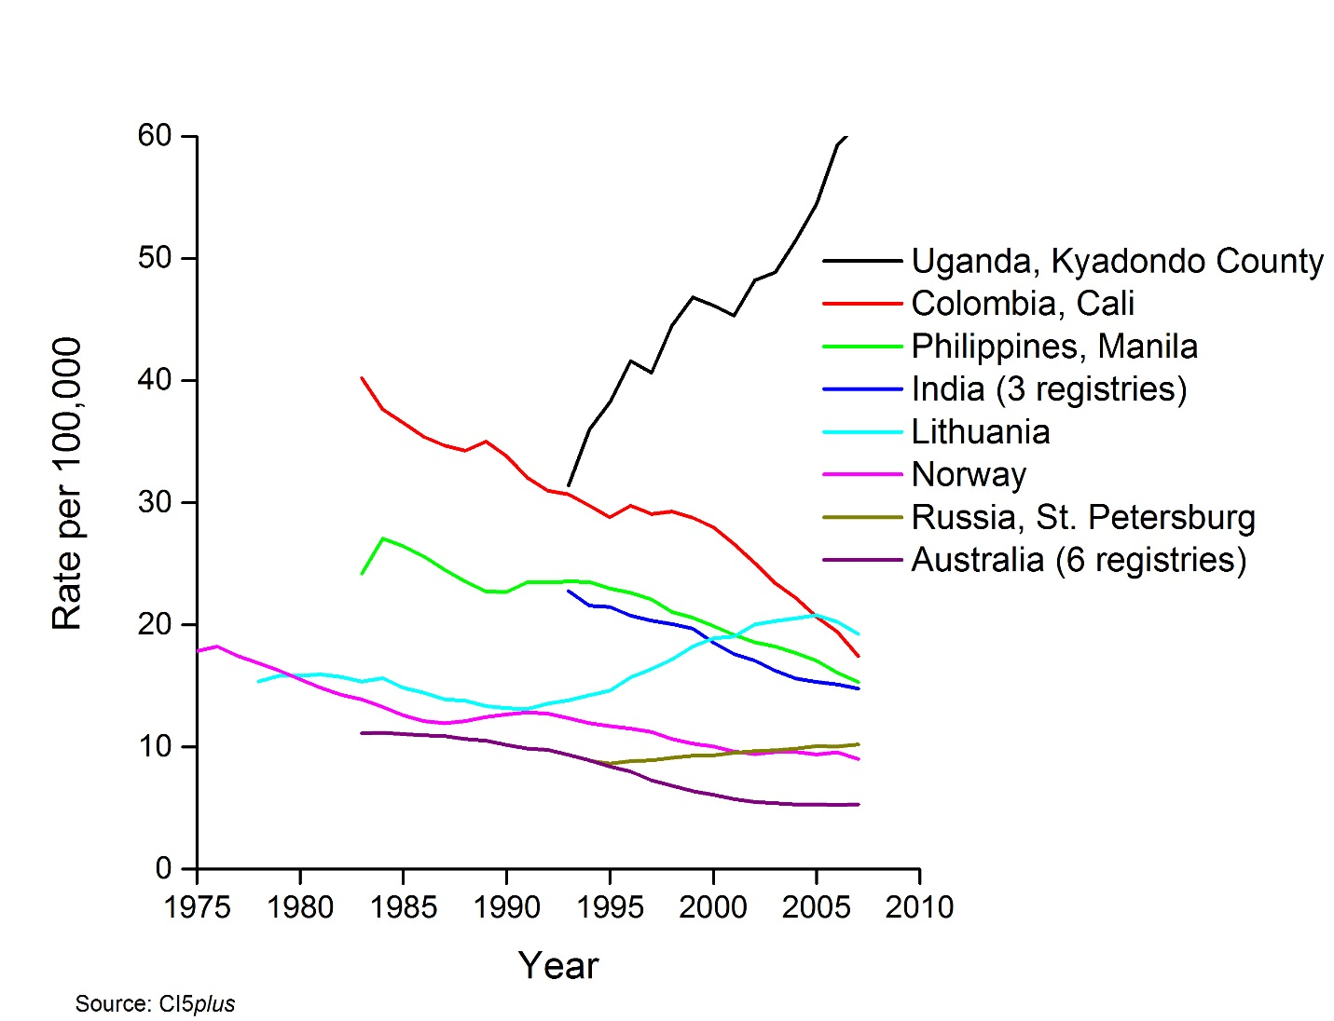
Supplementary Figure S7. Cervical cancer survivors diagnosed in last five years (through 2012 or latest available)
Supplementary Figure S8. Uterine corpus cancer incidence and mortality rates, females, age-standardized rate (world), 2012
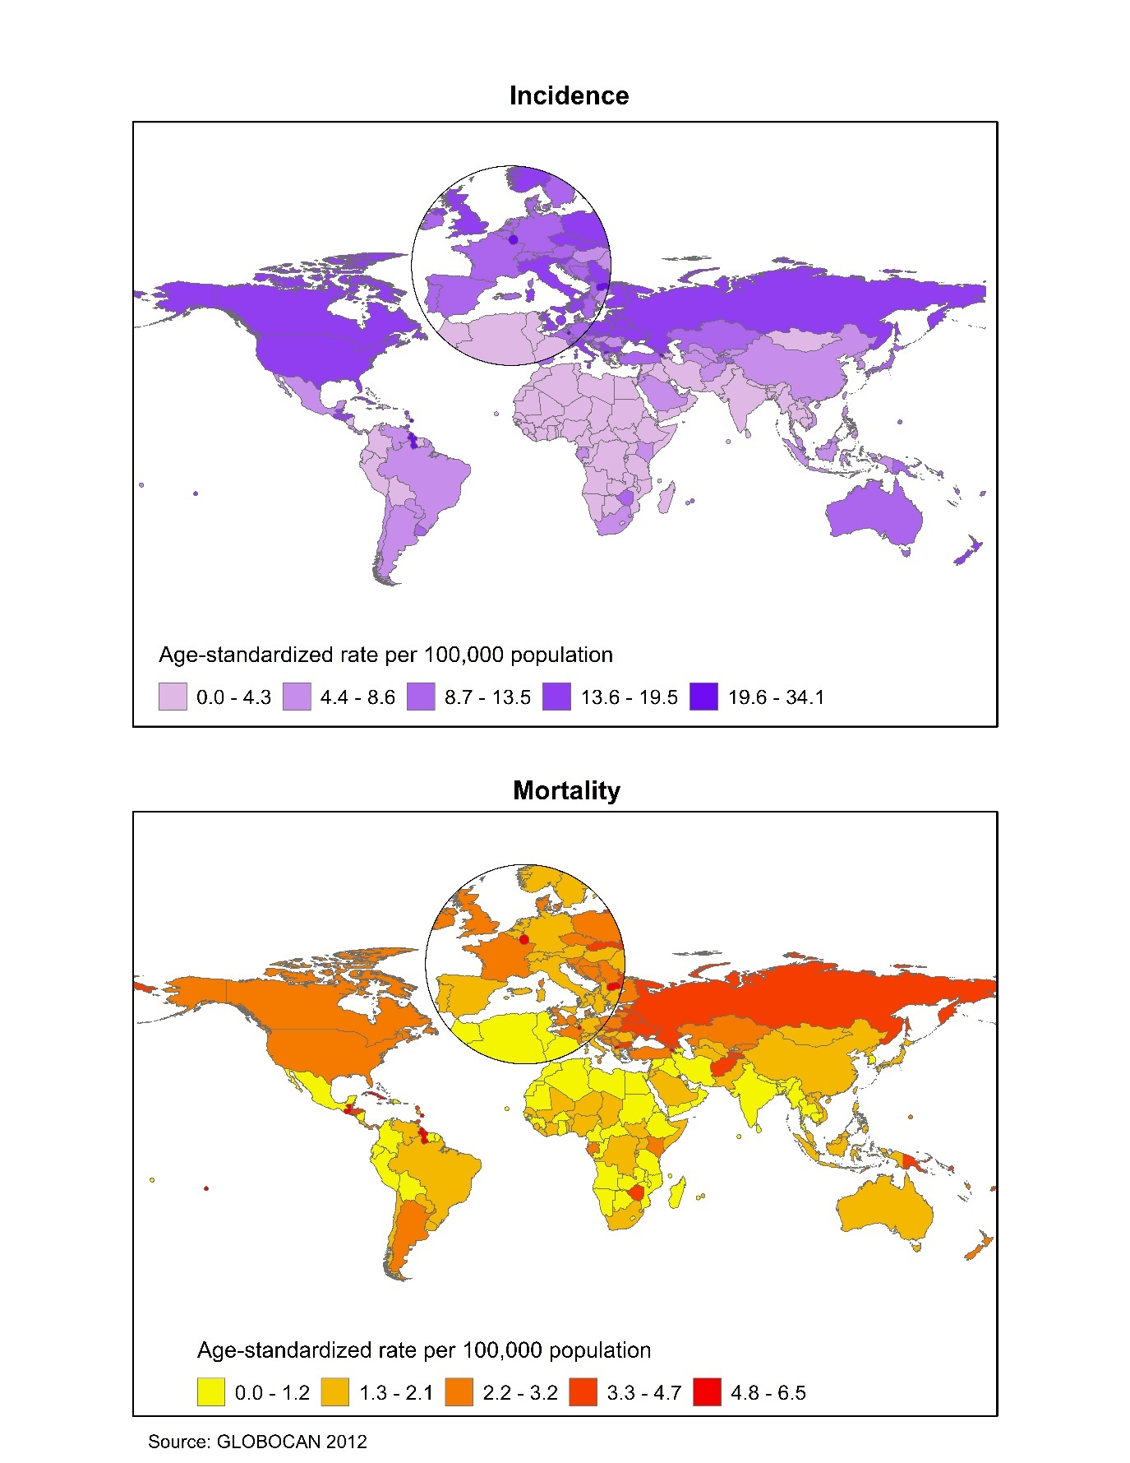
Supplementary Figure S9. Uterine corpus cancer mortality trends, age-standardized rate (world), select countries, 1990-2014

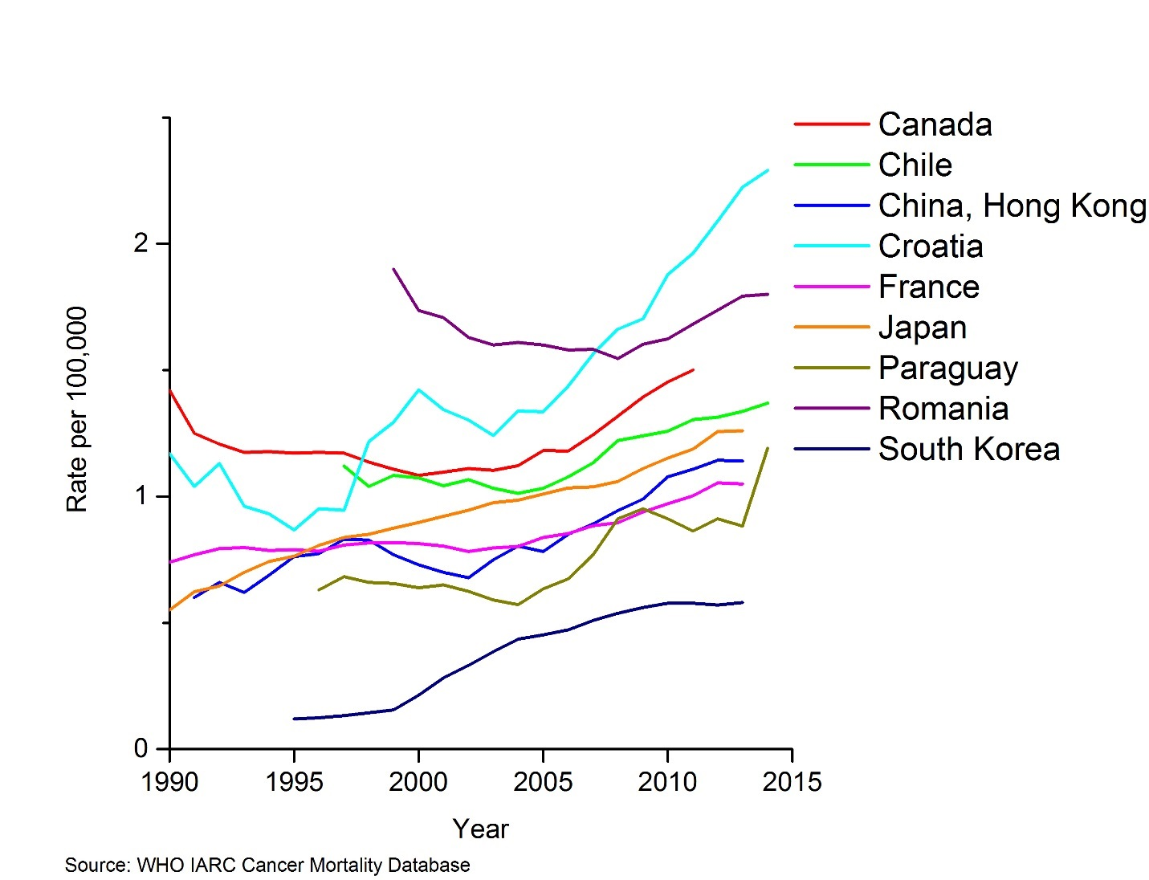
Supplementary Figure S10. Ovarian cancer incidence and mortality rates, females, age-standardized rate (world), 2012
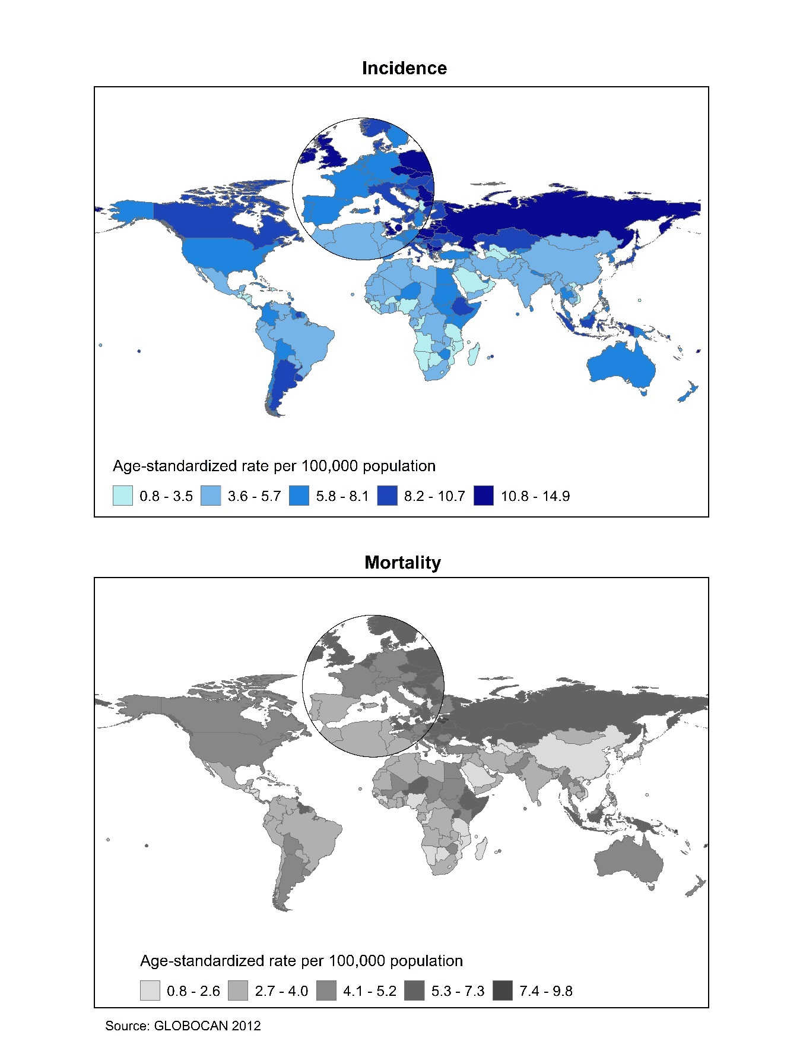
Supplementary Figure S11. Ovarian cancer mortality trends, age-standardized rate (world), select countries, 1980-2014

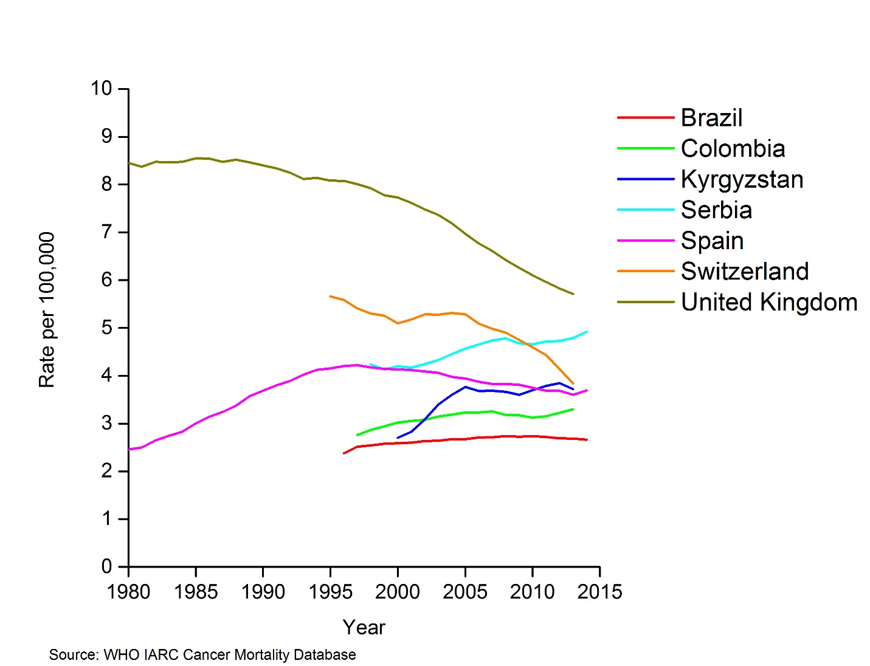
Supplementary Figure S12. Colorectal cancer incidence and mortality rates, females, age-standardized rate (world), 2012
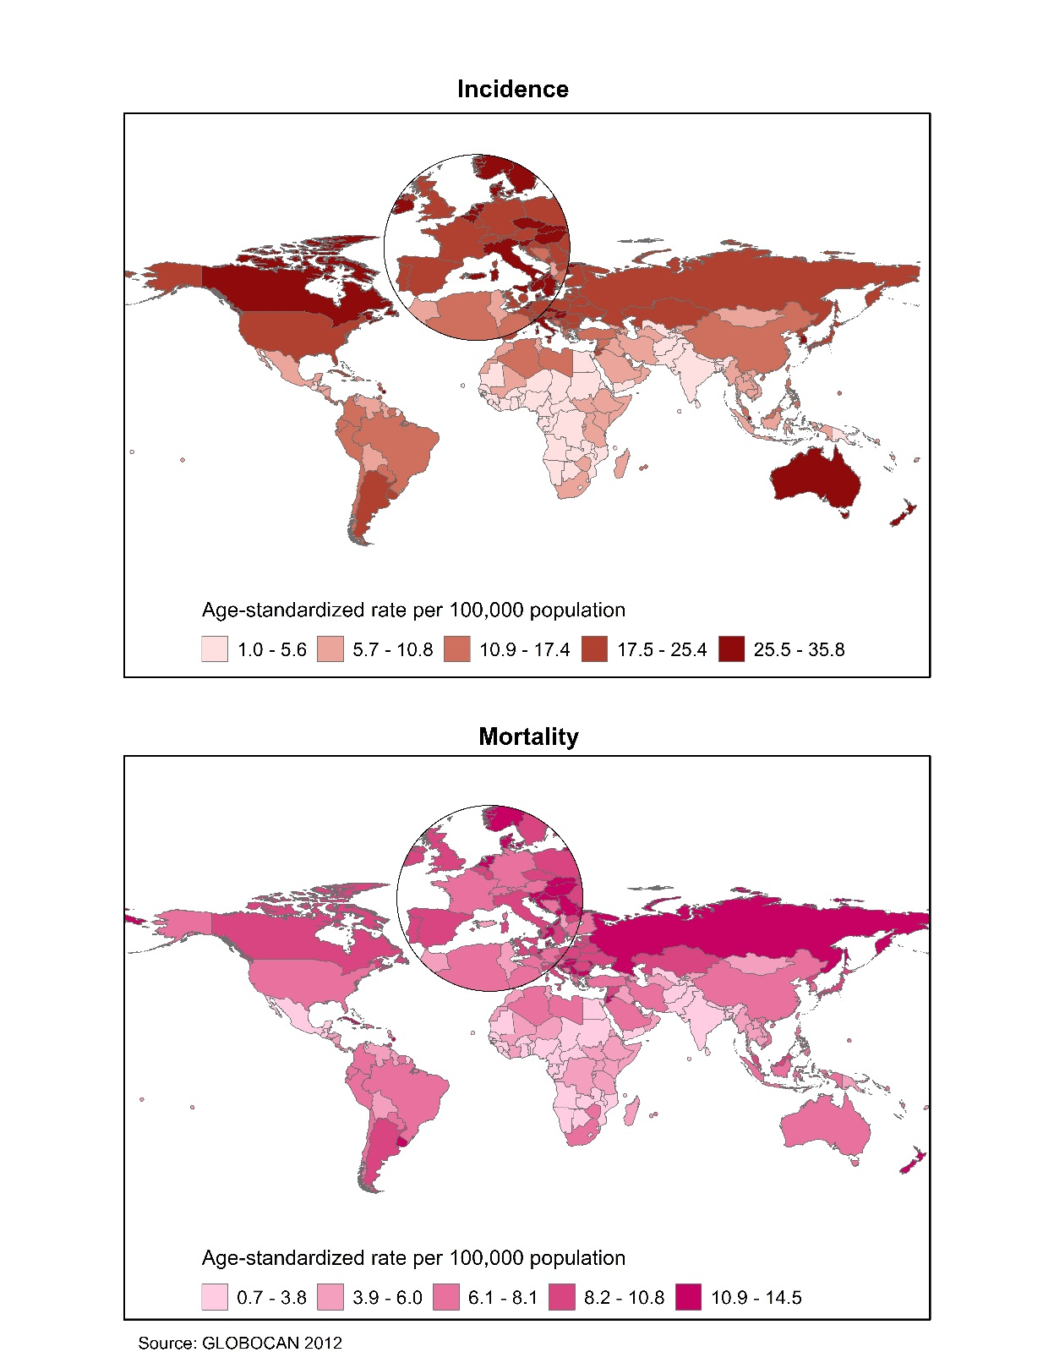
Supplementary Figure S13. Colorectal cancer incidence trends, females, select countries, 1980-2014
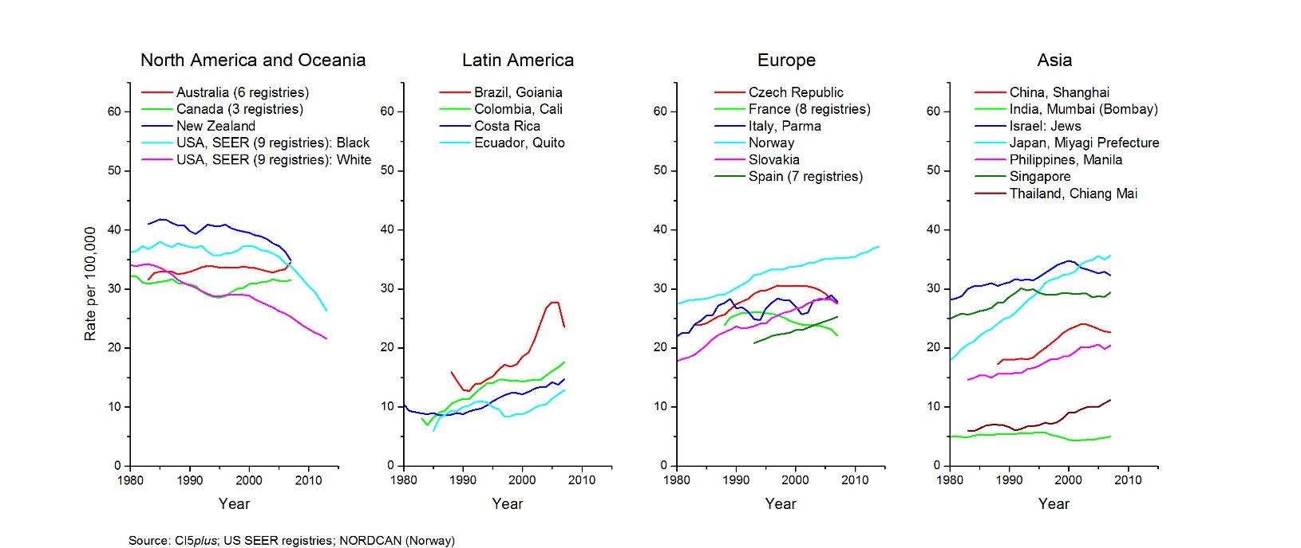
Supplementary Figure S14. Colorectal cancer mortality trends, females, age-standardized rate (world), select countries, 1975-2014
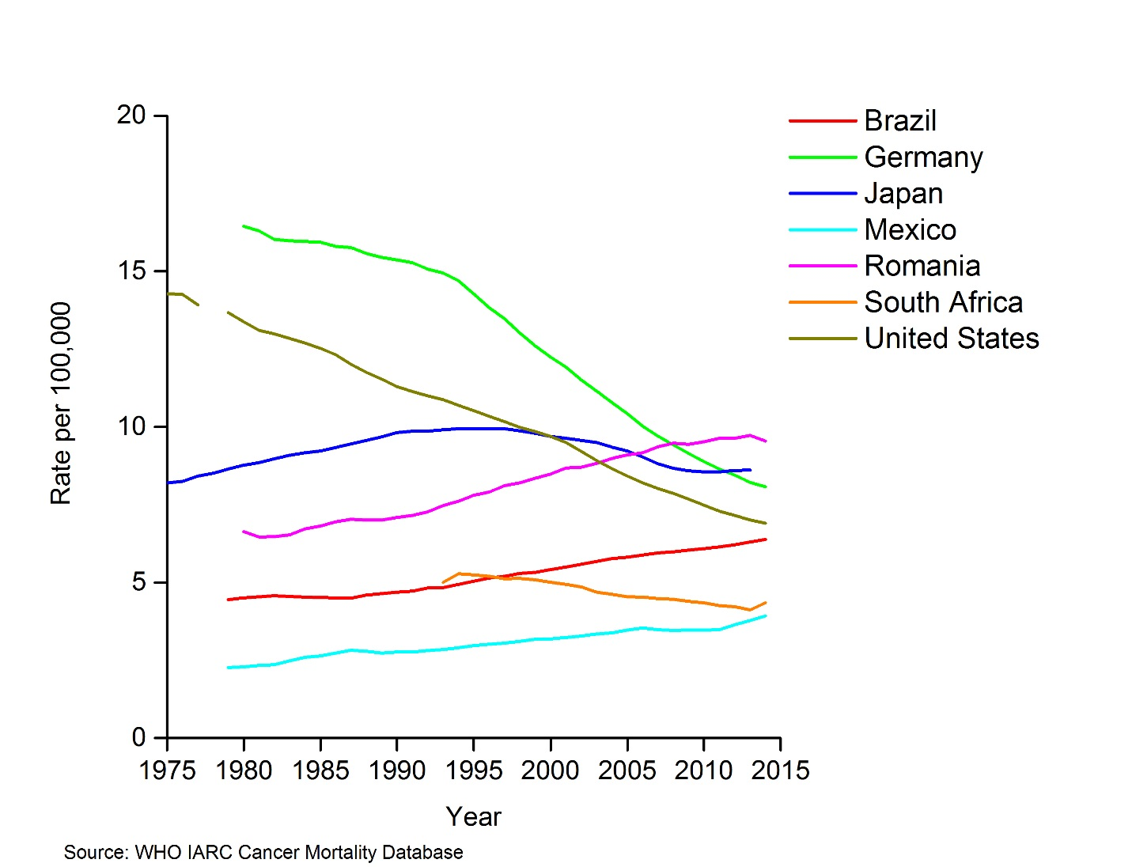

Supplementary Figure S15. Lung cancer incidence and mortality rates, females, age-standardized rate (world), 2012
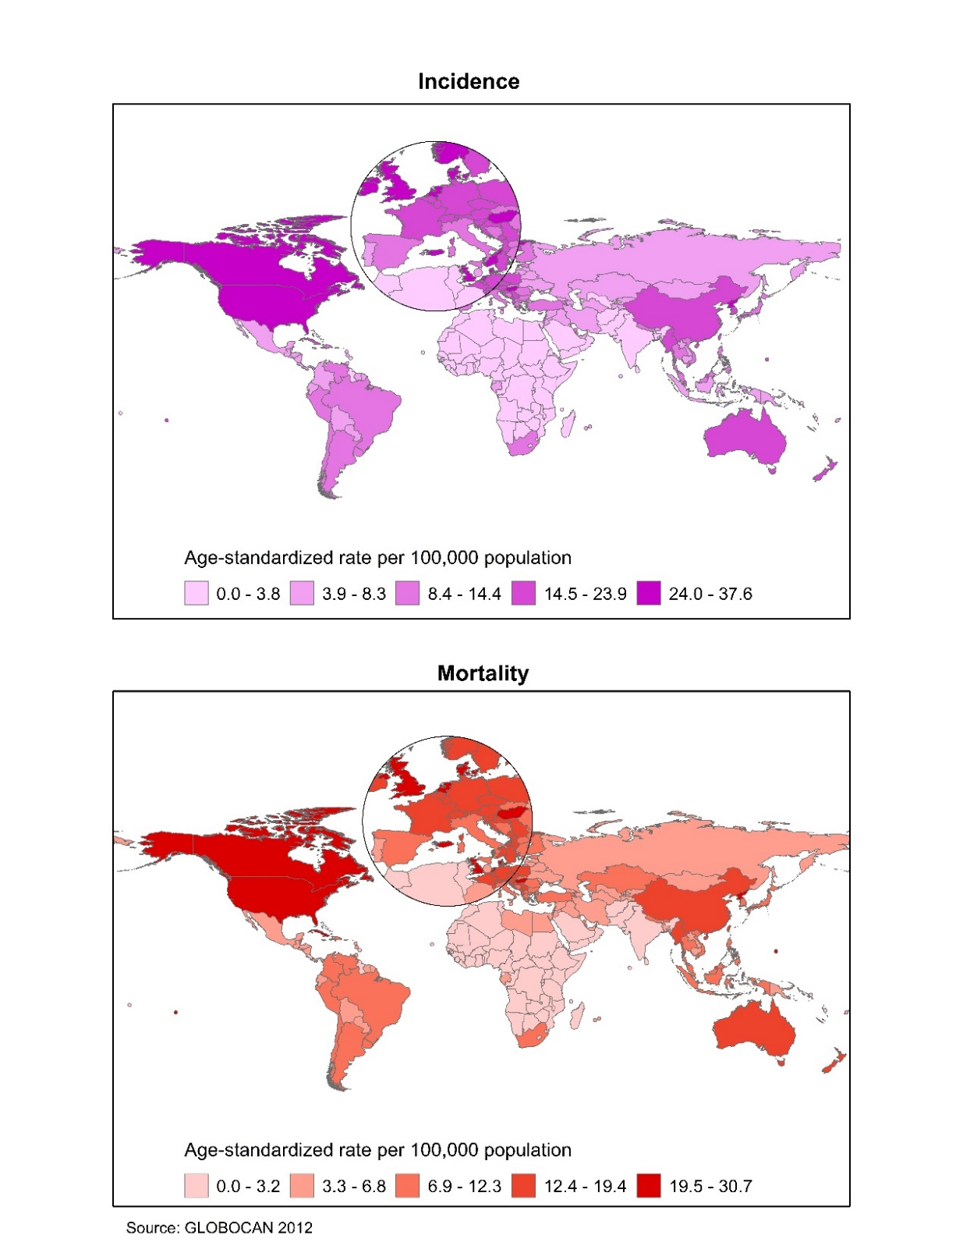
Supplementary Figure S16. Population using solid fuels for heating and/or cooking, 2013
Supplementary Figure S17. Adult female smoking prevalence, age 15+ years, 2013
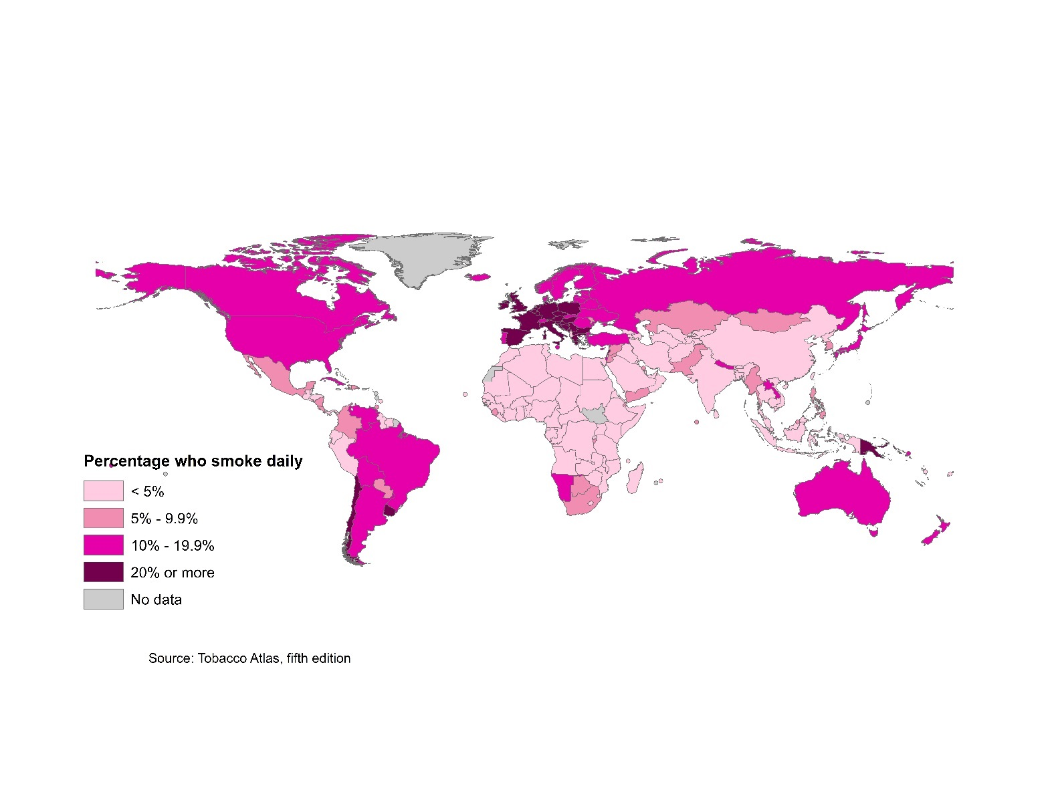

Supplementary Figure S18. Female youth smoking prevalence, age 13-15 years, 2011 or latest available data
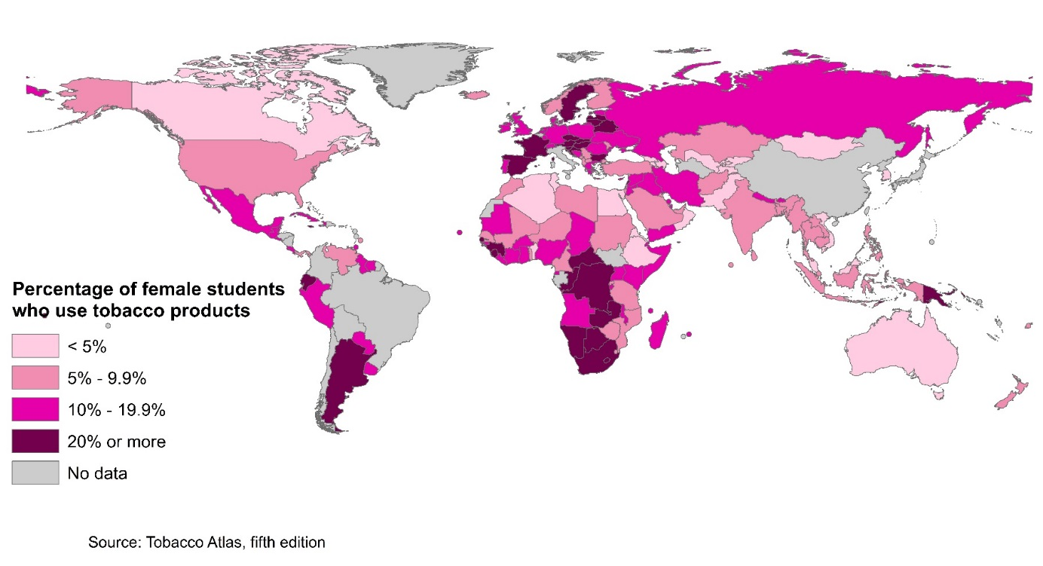
Supplementary Figure S19. Liver cancer incidence and mortality rates, females, age-standardized rate (world), 2012
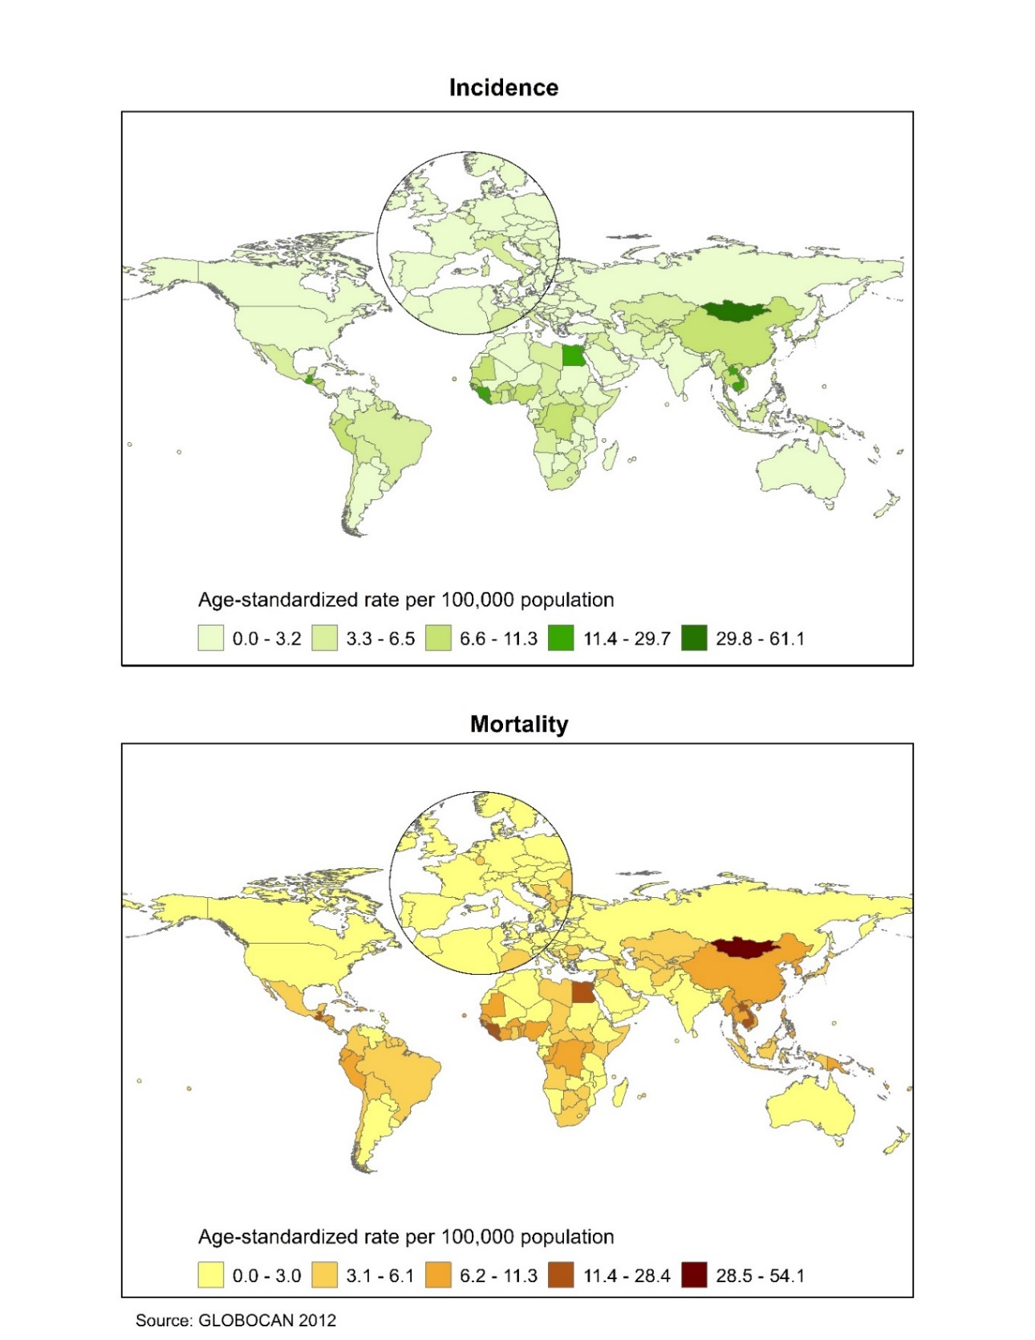
Supplementary Figure S20. Hepatitis B virus prevalence, both sexes, from systematic review of studies 1957-2013
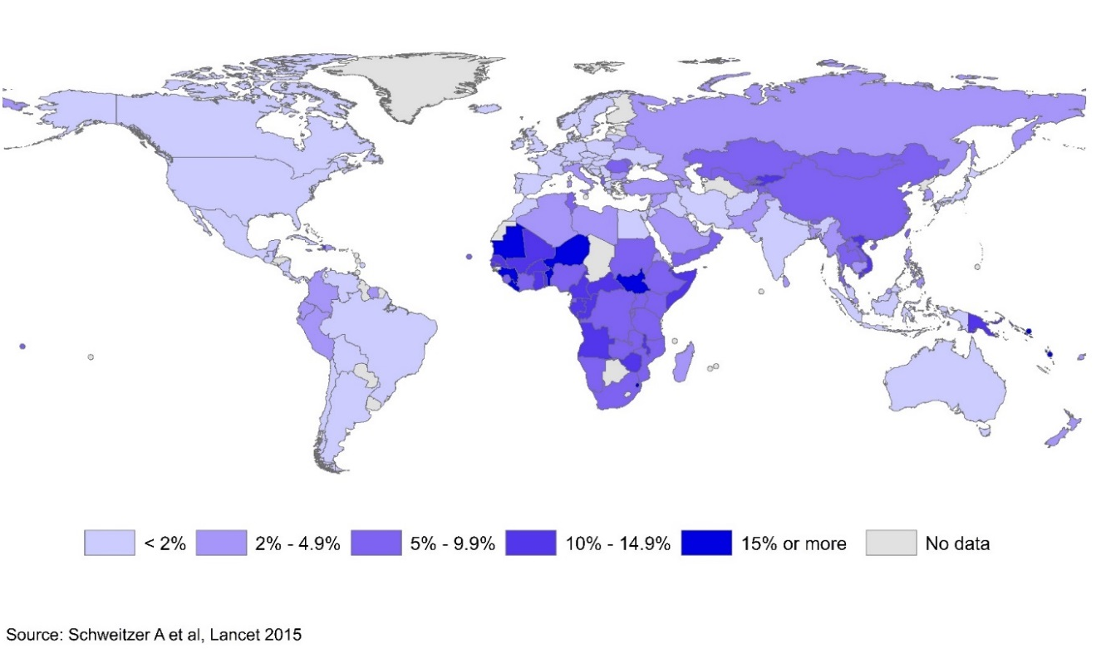
Supplementary Figure S21. Estimated hepatitis C virus prevalence, both sexes, 2005
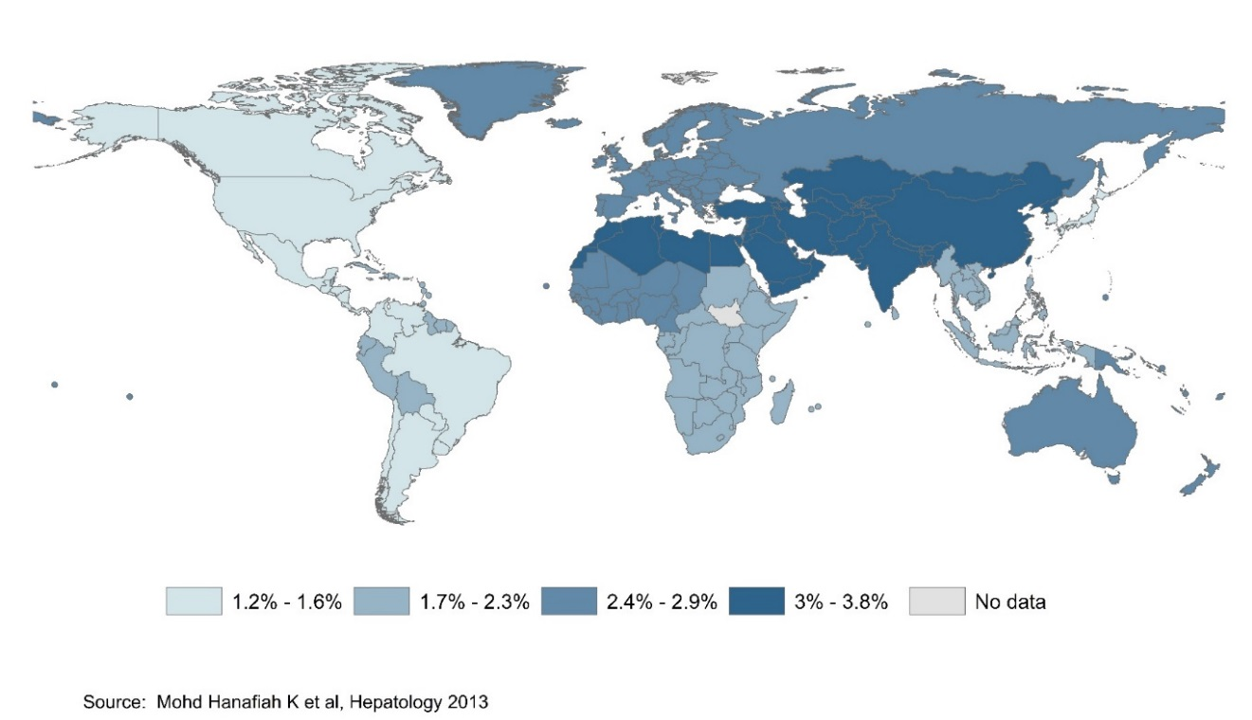
Supplementary Figure S22. Liver cancer mortality trends, females, age-standardized rate (world), select countries, 1995-2014
