Supplemental Information:
Supplemental Table 1. Characteristics of the studies included in the meta-analysis
Characteristics | No. of Risk Estimates | References
Study Design
Prospective Cohort studies | 6 | [11, 14, 17, 18, 22, 25, 27, 28]
Population-Based Case- Controls | 4 | [10, 16, 19, 23, 29]
Hospital-Based Case- Controls | 8 | [2, 12, 13, 15, 20, 21, 24, 26]
Sex
Both M/F combined | 5 | [12, 17, 19, 21, 23, 27-29]
Females only | 6 | [2, 13, 16, 18, 25, 26]
Males only | 12 | [2, 10, 11, 14, 15, 17, 18, 20, 22, 24-26]
Region
Asia | 8 | [11, 13, 15, 18, 19, 22, 24, 26]
Europe | 5 | [2, 10, 17, 23, 25, 29]
North America | 4 | [12, 14, 16, 21, 27, 28]
South America | 1 | [20]
Smoking Status
All combined | 14 | [2, 10, 12-15, 17-19, 21, 22, 24-26]
Non-smokers | 3 | [2, 16, 23, 27]
Smokers | 3 | [2, 11, 20]
Histologies
All histological subtypes | 17 | [2, 10-25]
Adenocarcinomas | 2 | [2, 26, 27]
Squamous/Small cell | 3 | [2, 20, 26, 27]

Supplemental Table 2. Pooled analysis using random effects model for ever vs. never coffee drinking, stratified by study design.
Smoking Status | Design | No. Studies | RR | 95% CI | Heterog. p - value
All* | HCC | 8 | 1.08 | 0.86 - 1.30 | < .001
All* | PCC | 5 | 0.97 | 0.68 - 1.27 | 0.10
All* | Prospective Cohort | 9 | 1.18 | 1.05 - 1.31 | < .001
Smoking Adjusted° | HCC | 7 | 0.97 | 0.82 - 1.11 | 0.02
Smoking Adjusted° | PCC | 4 | 0.91 | 0.70 - 1.12 | 0.40
Smoking Adjusted° | Prospective Cohort | 5 | 1.14 | 1.01 - 1.28 | <.001
All* = None, ex, & current smokers
°Smoking Adjusted = Non-smokers studies and studies that adjusted for smoking

Supplemental Table 3. Pooled analysis using random effects model for ever vs. never coffee drinking, stratified by region.
Smoking Status | Region | No. Studies | RR | 95% CI | Heterog. p - value
All* | Asia | 8 | 1.23 | 0.88 - 1.58 | < .001
All* | Europe | 7 | 1.13 | 0.82 - 1.43 | <.001
All* | Americas^ | 7 | 1.12 | 1.02 - 1.22 | <.001
Smoking Adjusted° | Asia | 4 | 0.85 | 0.67 - 1.03 | 0.16
Smoking Adjusted° | Europe | 5 | 1.02 | 0.69 - 1.36 | 0.02
Smoking Adjusted° | Americas^ | 7 | 1.12 | 1.02 - 1.22 | <.001
All* = None, ex, & current smokers
Smoking Adjusted° = Non-smokers studies and studies that adjusted for smoking
Americas^ = Studies from North & South America

Supplementary Materials and Methods
Systematic Search Terms
Search Terms PubMed
Pulmonary Neoplasms OR Pulmonary Neoplasm OR Lung Neoplasm OR Lung Neoplasms OR Lung cancer OR Lung cancers OR pulmonary cancer OR Pulmonary Cancers OR "Lung Neoplasms"[Mesh] Pulmonary tumor OR lung tumors OR lung tumor OR pulmonary tumors AND ("Coffee"[Mesh]) OR Coffee
Search Terms EMBASE
Cancer, cancers, coffee, lung, lung cancer, lung cancers, lung neoplasm, lung neoplasms, lung tumor, lung tumors, neoplasm, neoplasms, pulmonary, pulmonary cancer, pulmonary cancers, pulmonary neoplasm, pulmonary neoplasms, pulmonary tumor, pulmonary tumors, tumor, tumors

Total Search yielded 182 articles between PubMed and EMBASE

Search Terms PubMed
("Diet"[Mesh]) AND (Pulmonary Neoplasms) OR Pulmonary Neoplasm) OR Lung Neoplasm) OR Lung Neoplasms) OR Lung cancer) OR Lung cancers) OR pulmonary cancer) OR Pulmonary Cancers) OR "Lung Neoplasms"[Mesh]))) NOT (("Coffee"[Mesh]) OR Coffee)

Total Search yielded 1101 articles were found but none of these had relevant data, on coffee and lung cancer, to be extracted.

Search Terms PubMed
Pulmonary Neoplasms) OR Pulmonary Neoplasm) OR Lung Neoplasm) OR Lung Neoplasms)
OR Lung cancer) OR Lung cancers) OR pulmonary cancer) OR Pulmonary Cancers) OR "Lung Neoplasms"[Mesh])) AND Food Habits) NOT (("Coffee"[Mesh]) OR Coffee)

Total Search yielded 210 articles were found but none of these had relevant data, on coffee and lung cancer, to be extracted.
Total 8 from Tang et. al’s citations [4].
Supplemental Figure 1. Pooled analysis forest plot adjusting for smoking, stratified by gender
Men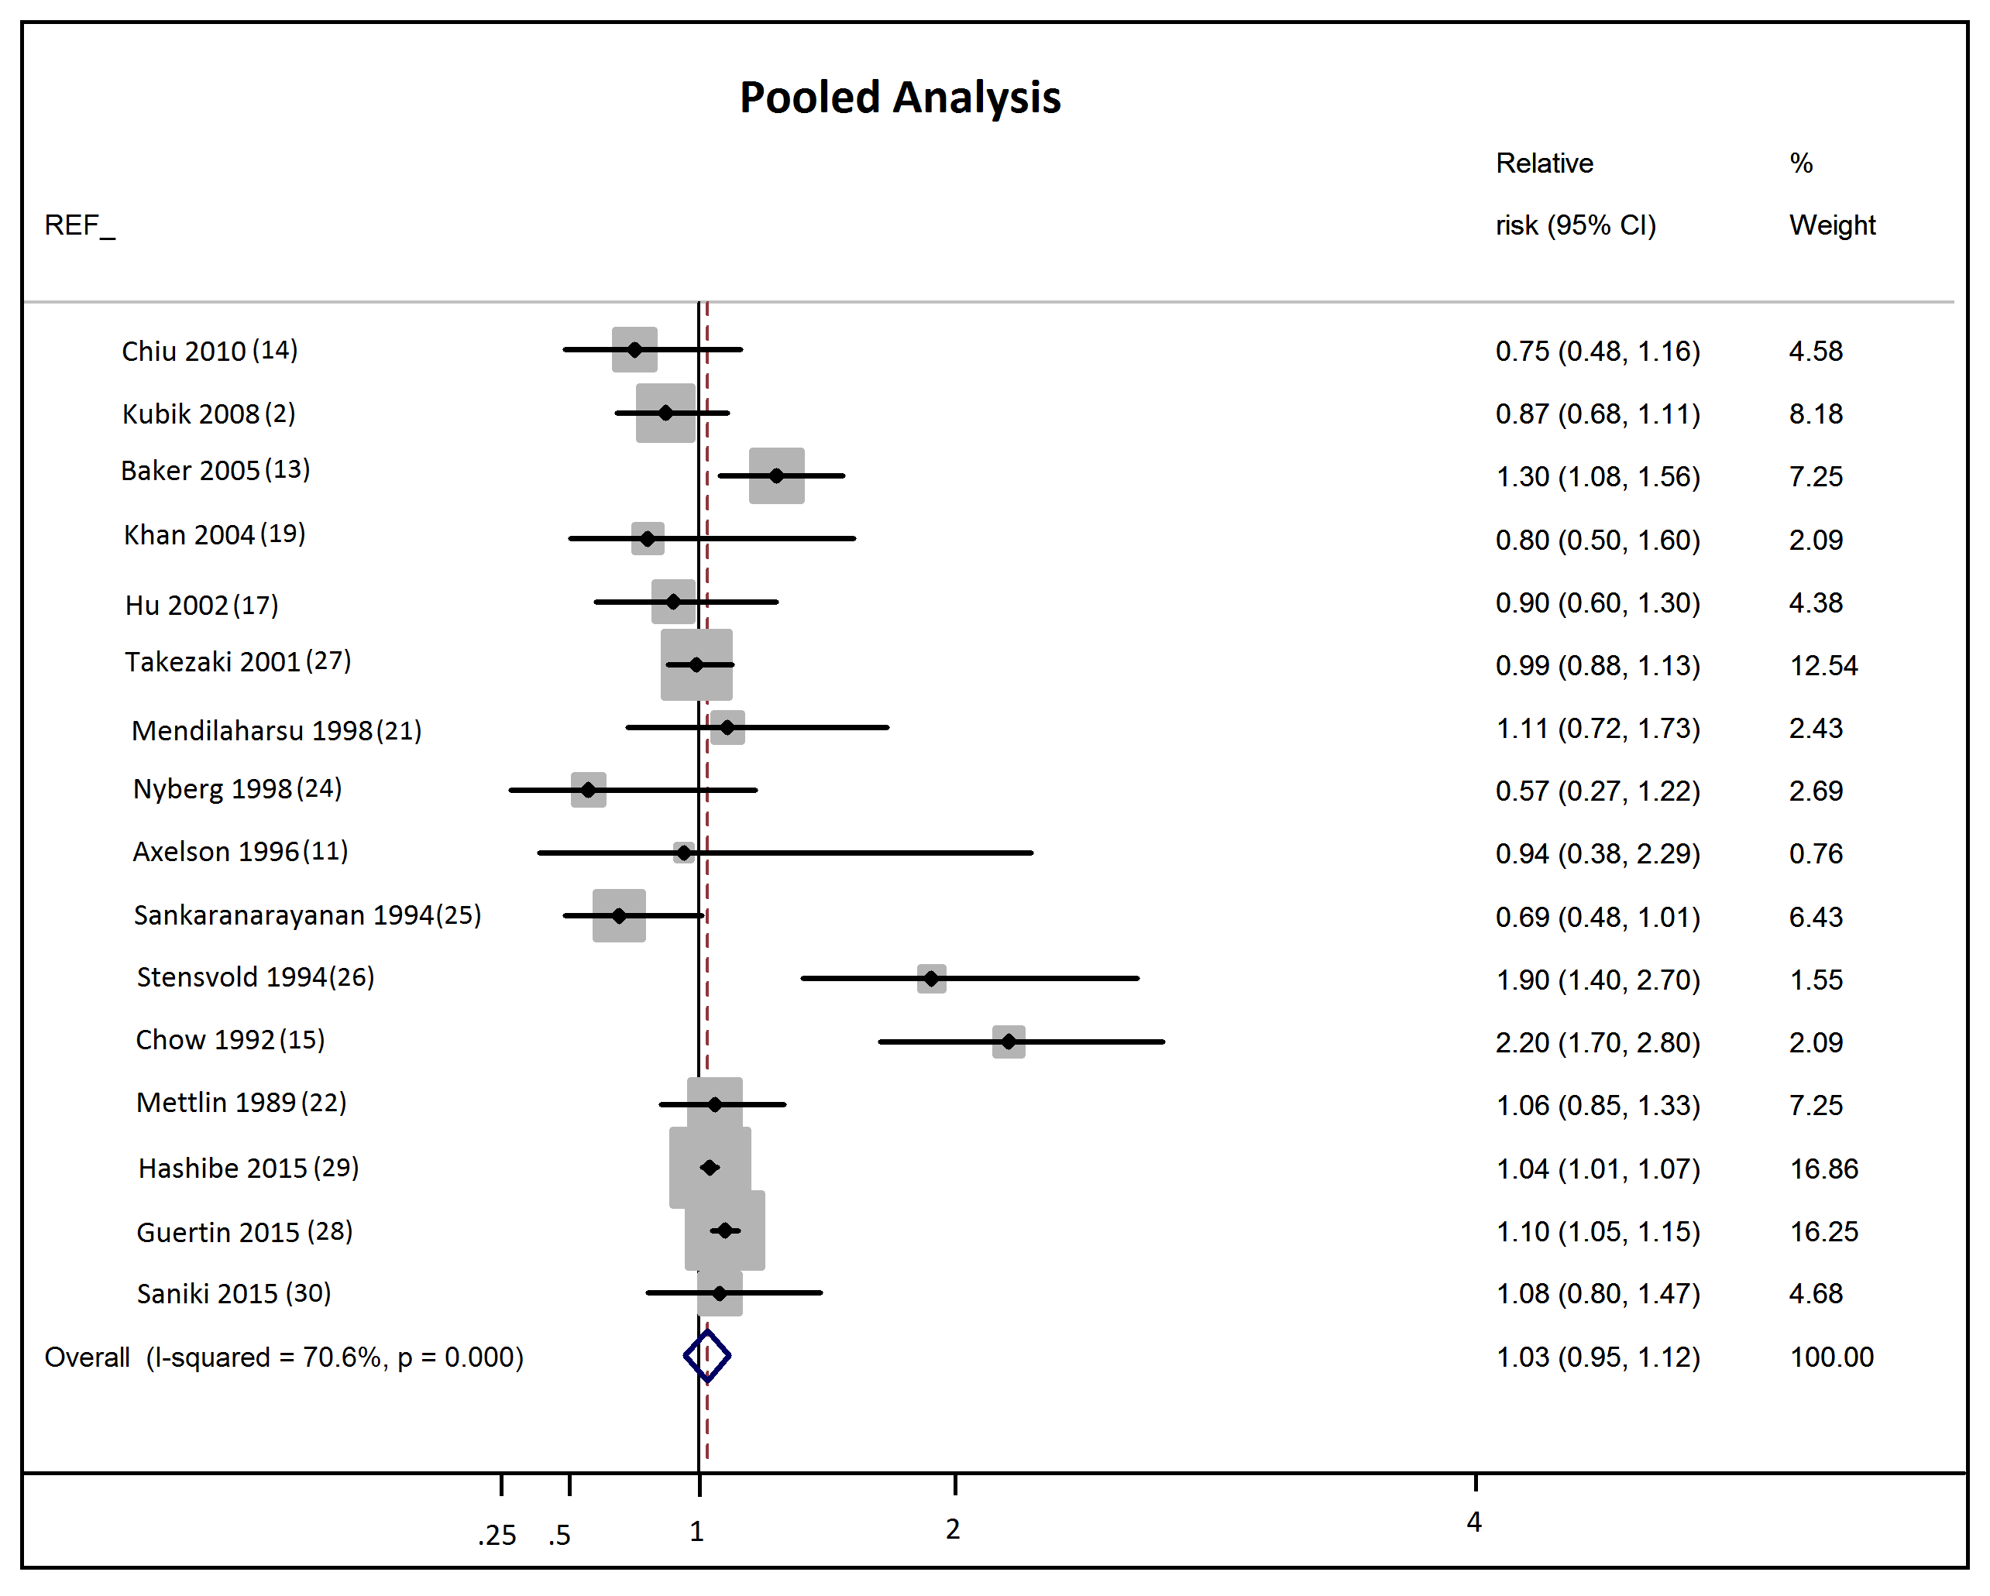

Supplemental Figure 2. Forest plot for all non-smokers, stratified by gender
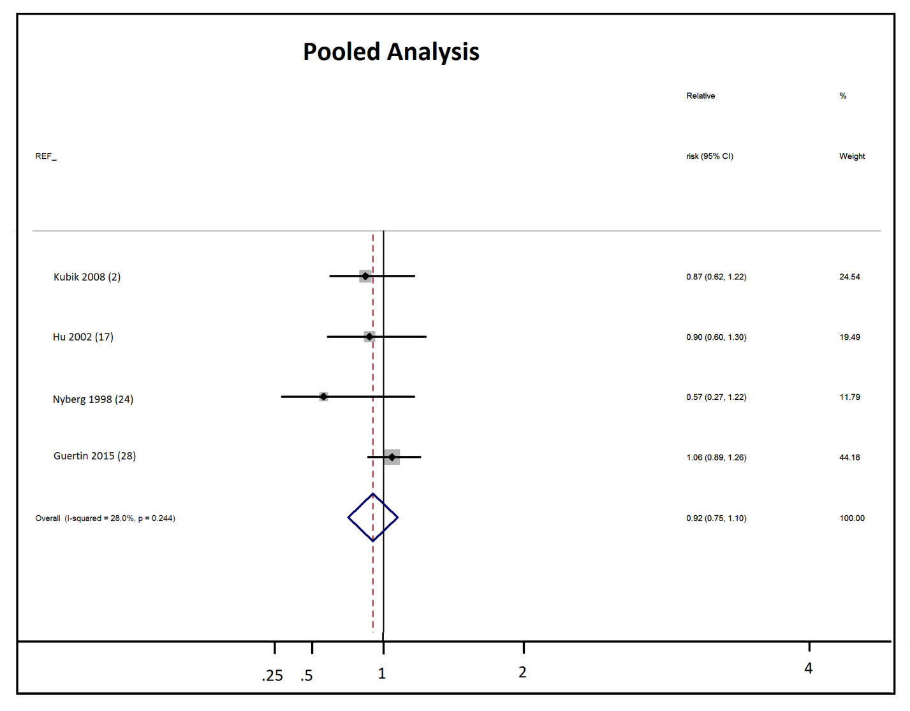

Supplemental Figure 3. Funnel Plot
