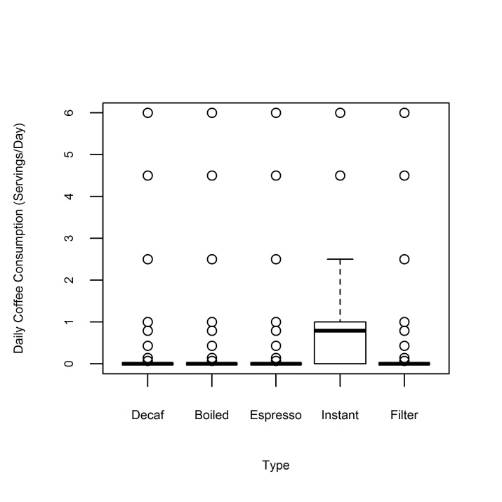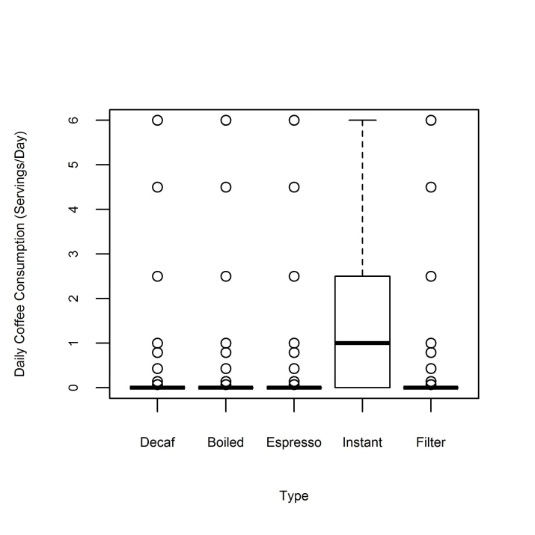
B
A
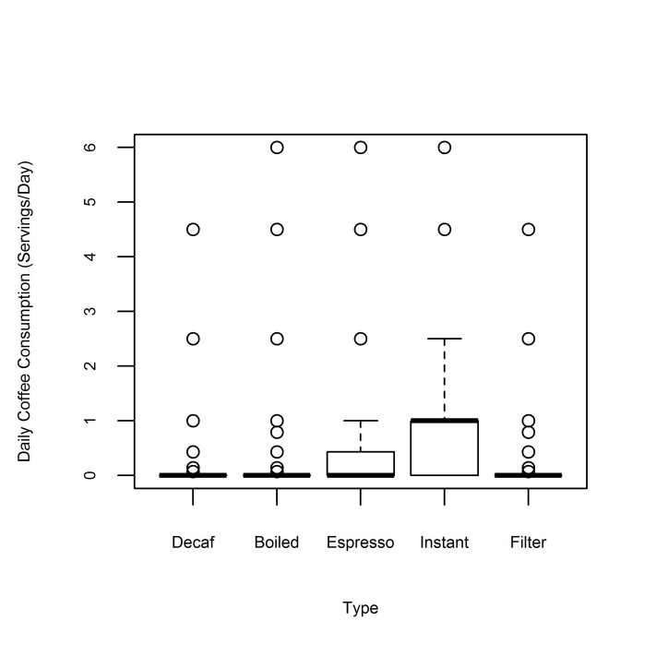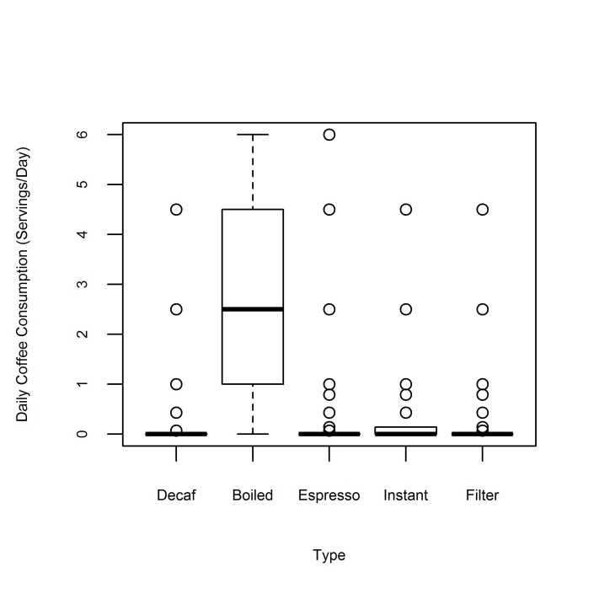
D
C
Supplementary Figure 1. Consumption patterns of different coffee types in A) the total MECC sample, B) Ashkenazi Jews, C) Sephardi Jews, and D) Arabs.

