Supplementary Figure S1. All sites cancer incidence rates by sex in select registries, 2003–2007
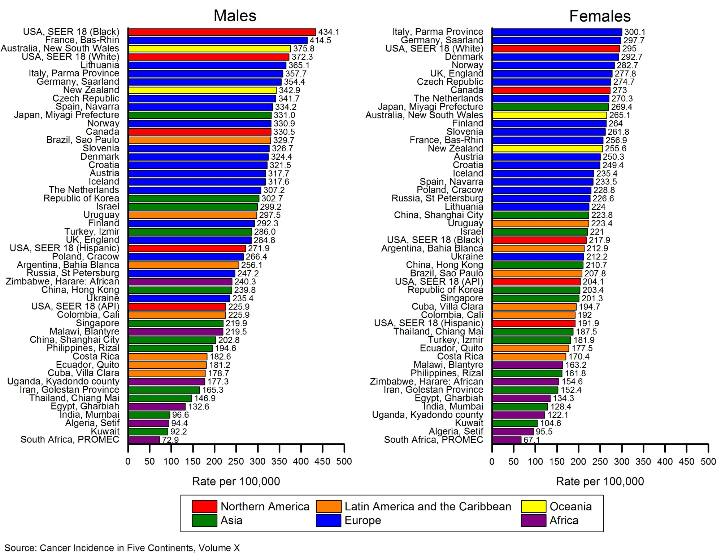
Supplementary Figure S2. All sites cancer mortality rates by sex, select countries, 2003–2007
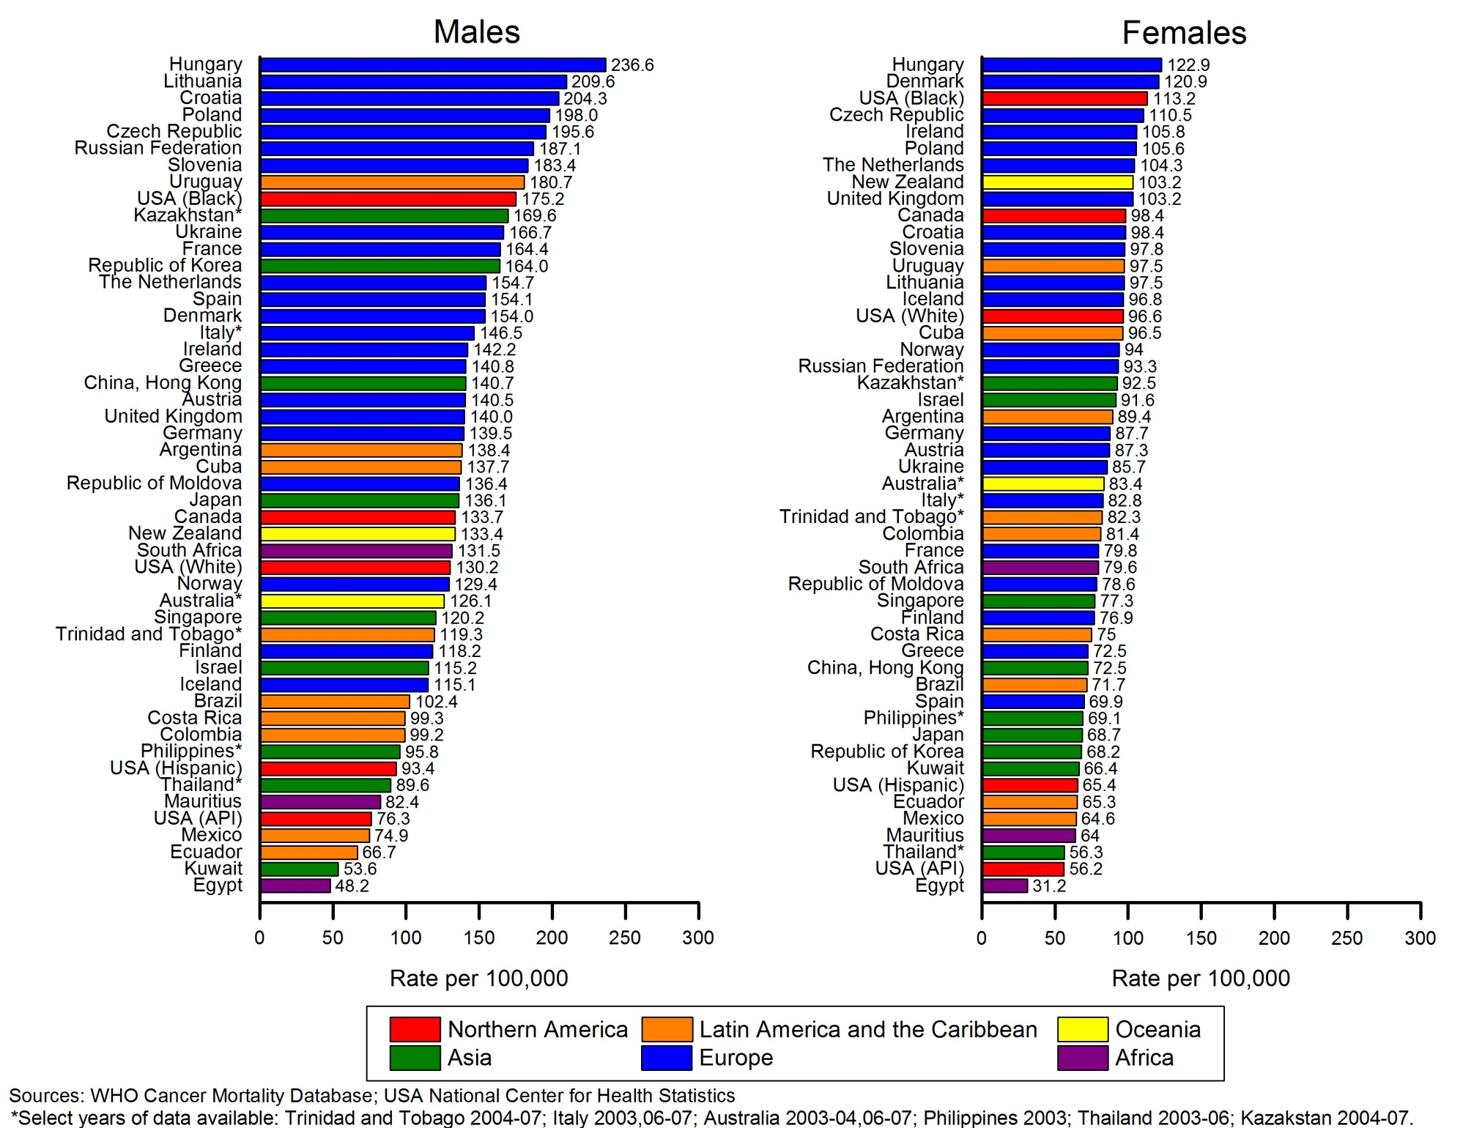
Supplementary Figure S3. Lung cancer mortality rates by sex, select countries, 2003–2007
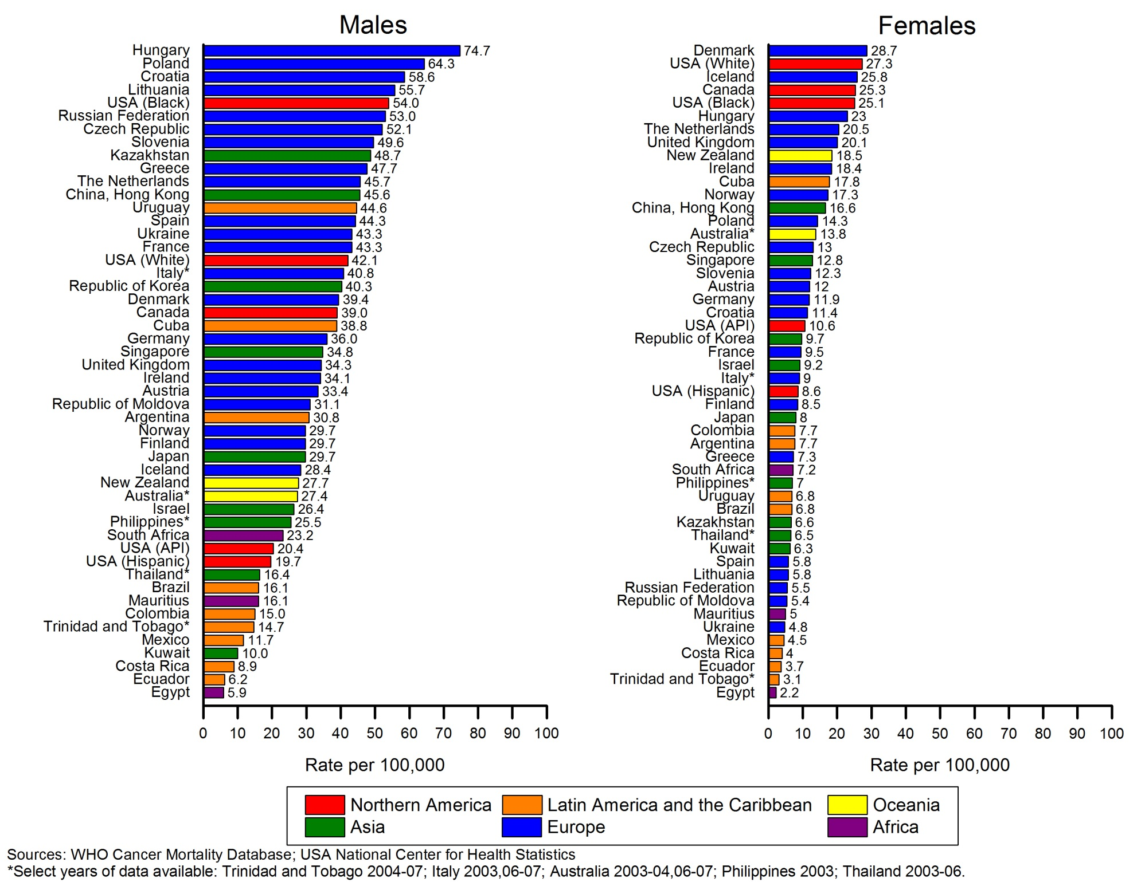
Supplementary Figure S4. Lung cancer mortality trends by sex, select countries, 1950–2012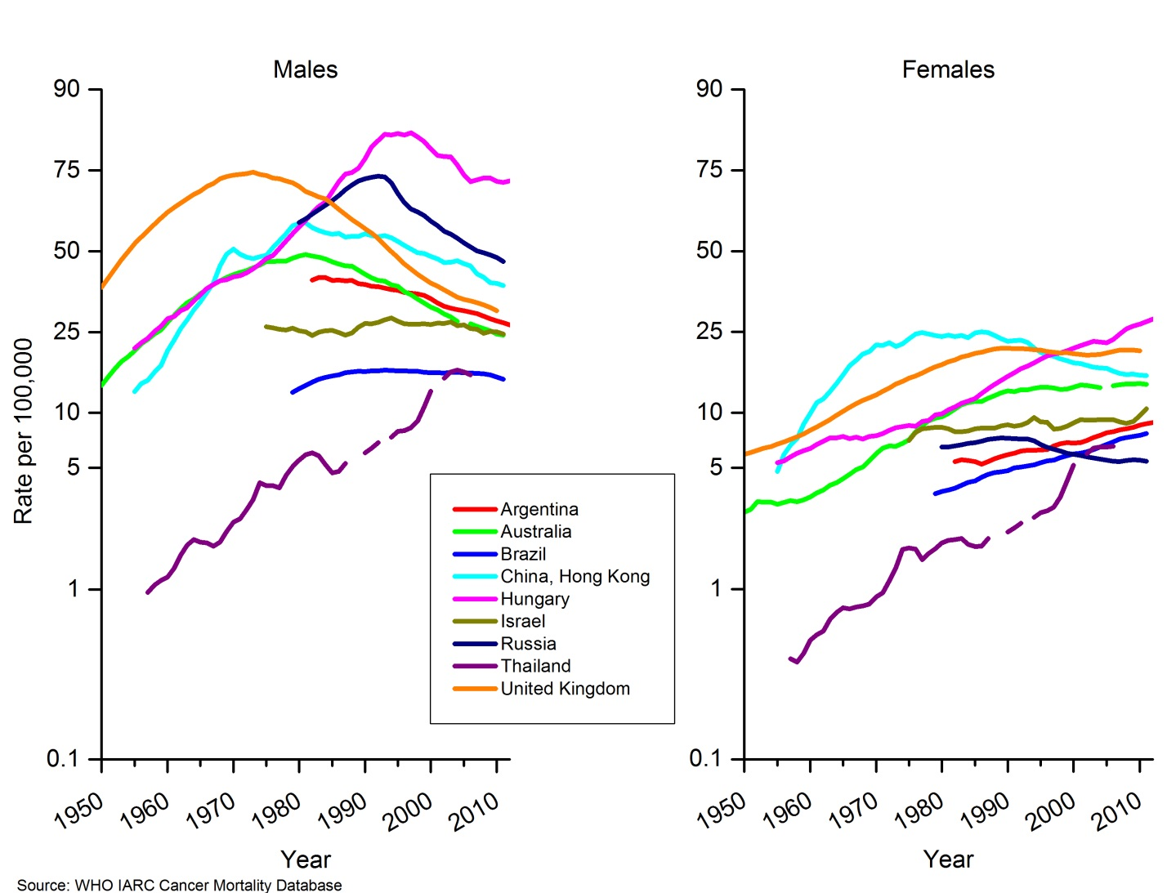
Supplementary Figure S5. Colorectal cancer incidence rates by sex in select registries, 2003–2007
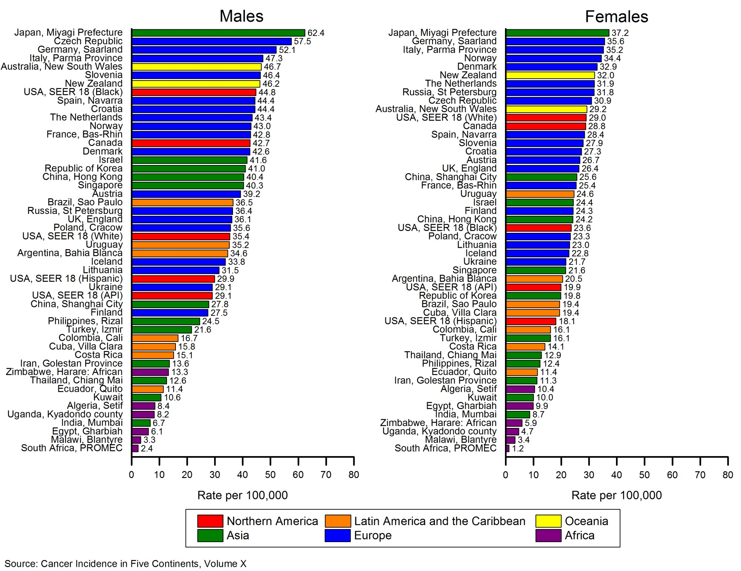
Supplementary Figure S6. Colorectal cancer mortality rates by sex, select countries, 2003–2007
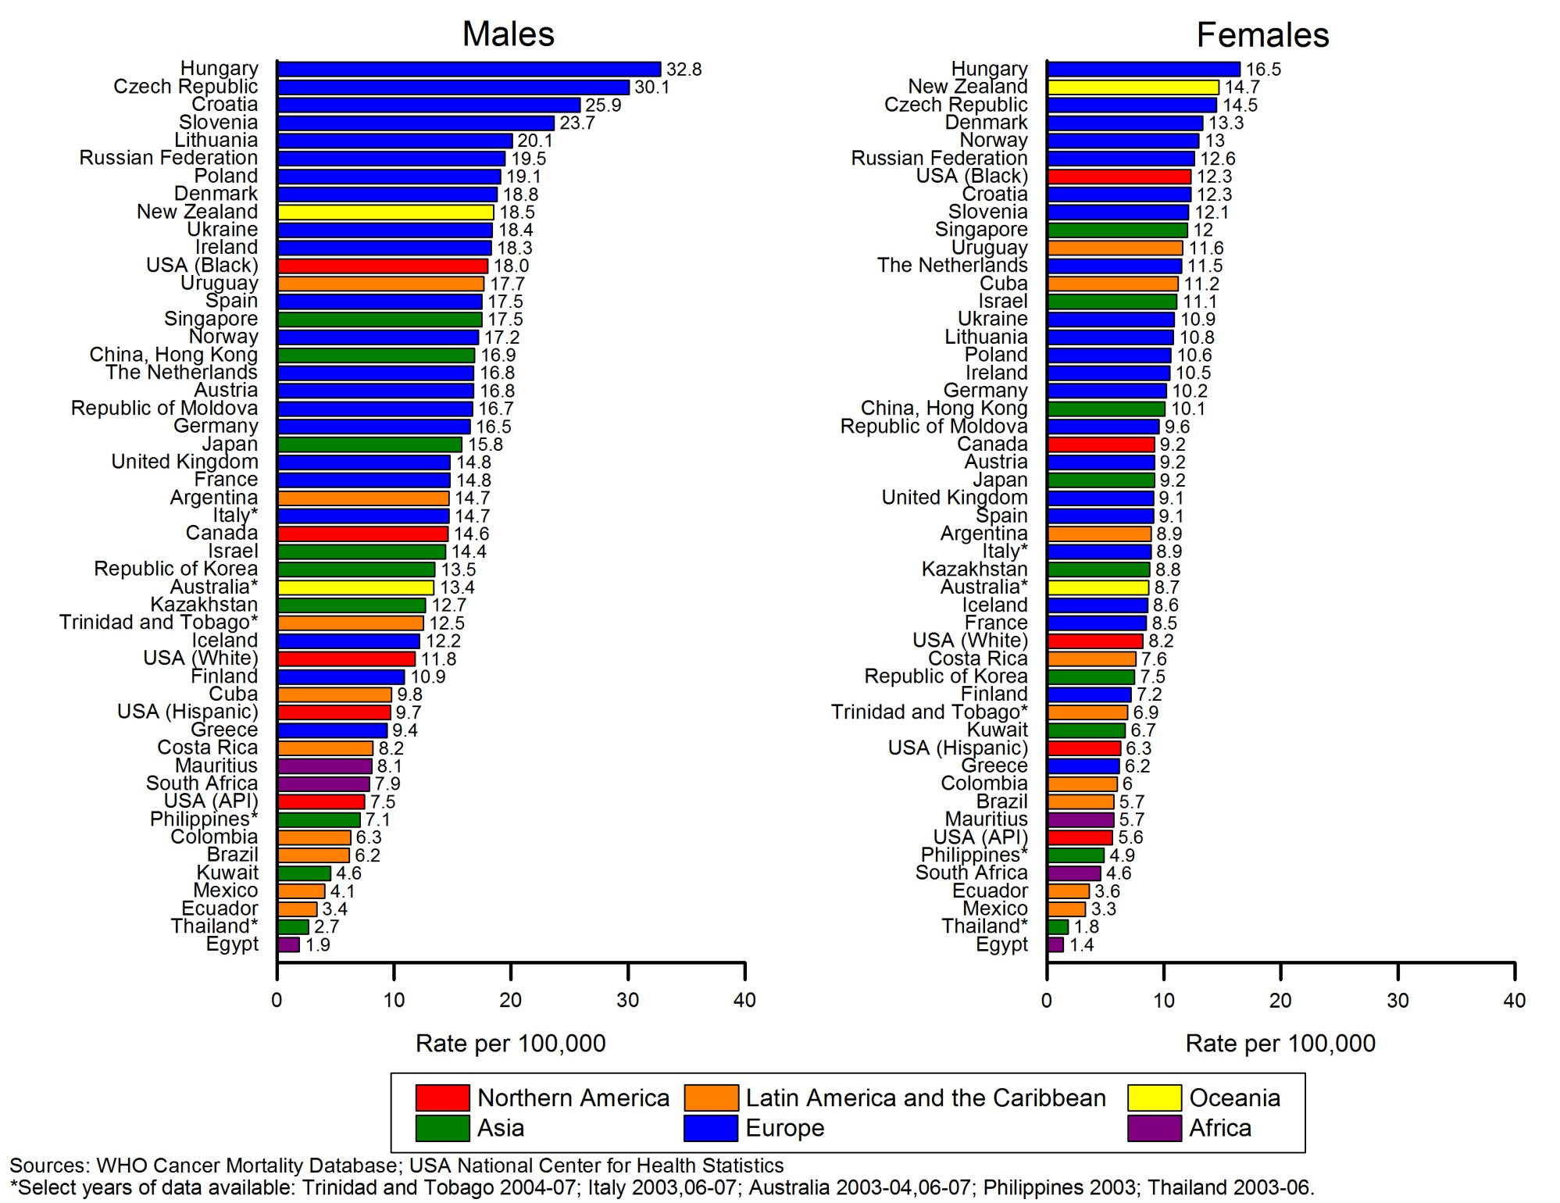
Supplementary Figure S7. Female breast cancer incidence and mortality rates in select registries and countries, 2003–2007
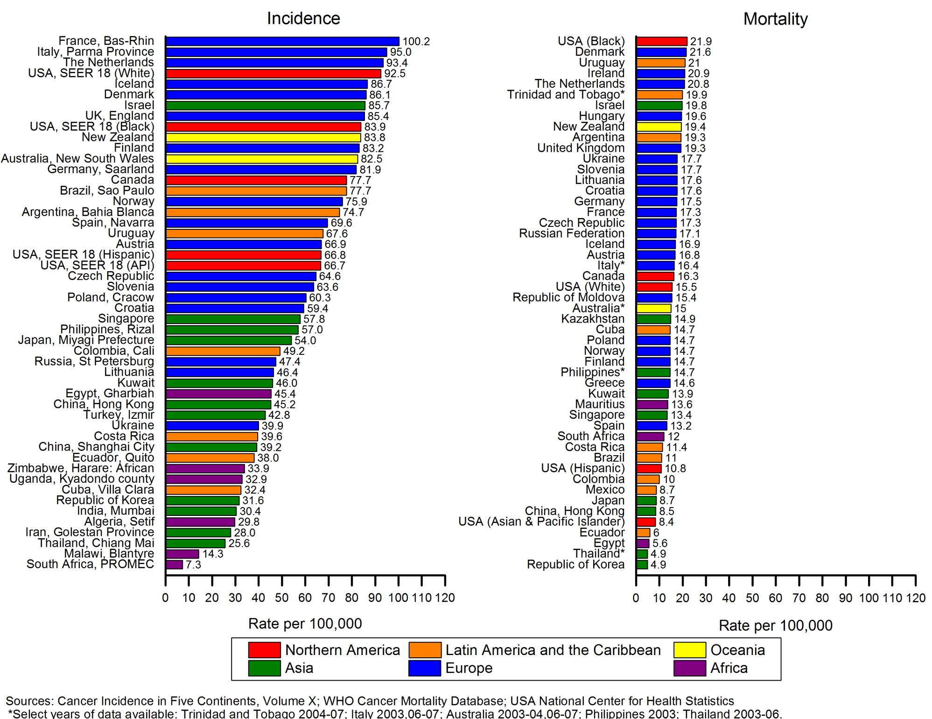
Supplementary Figure S8. Female breast cancer mortality trends, select countries, 1950–2012
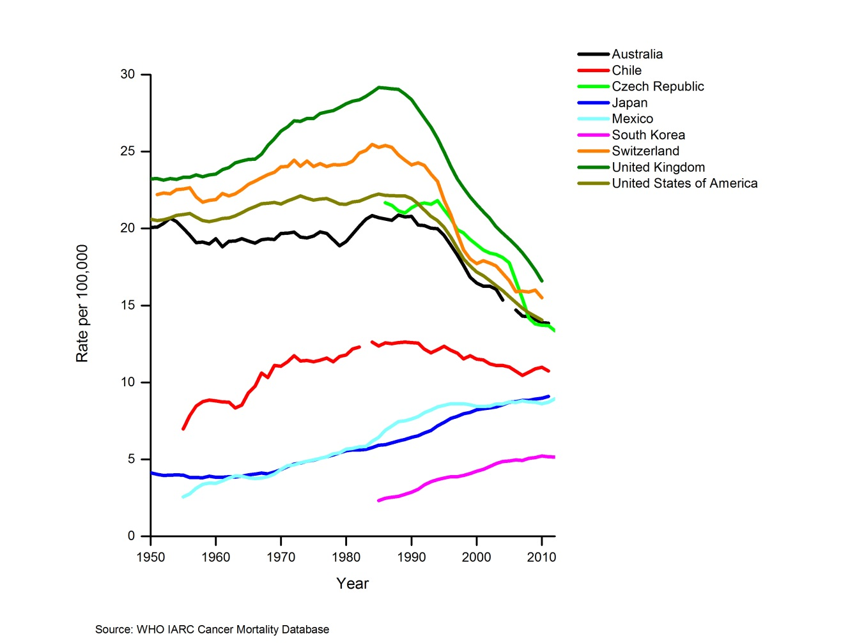
Supplementary Figure S9. Prostate cancer incidence and mortality rates in select registries and countries, 2003–2007
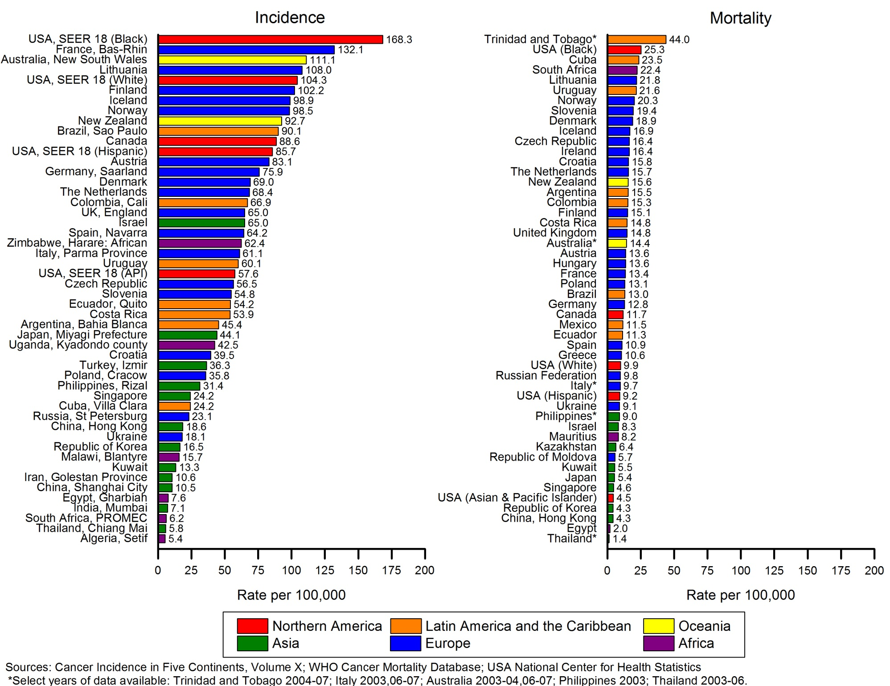
Supplementary Figure S10. Prostate cancer mortality trends, select countries, 1950–2012
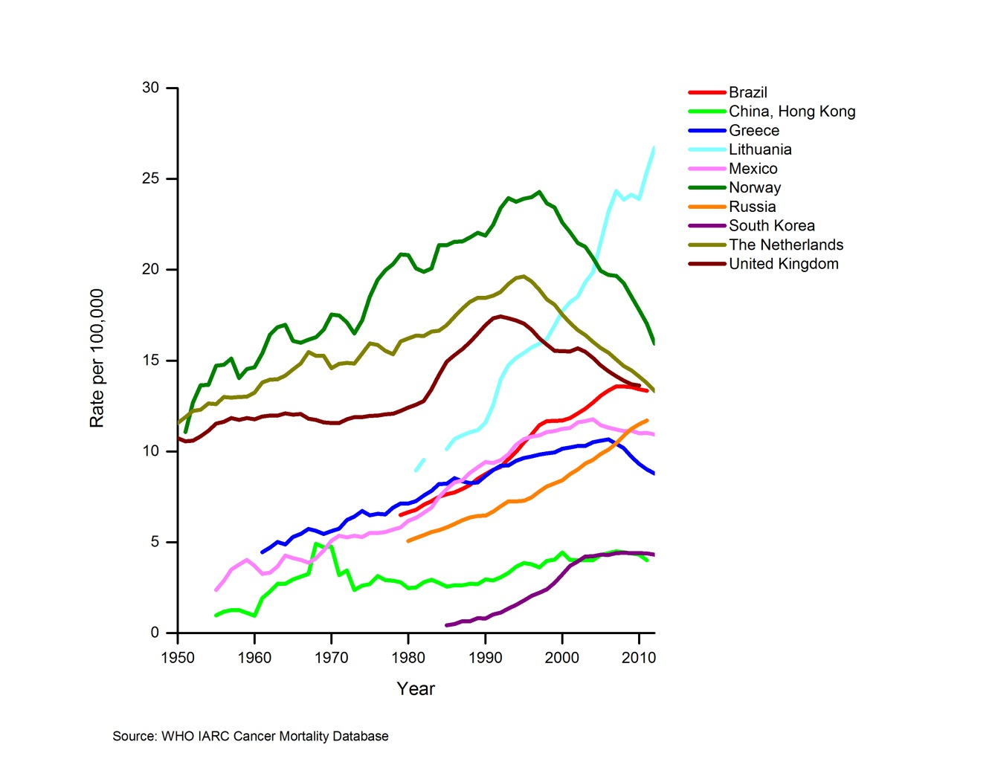
Supplementary Figure S11. Stomach cancer mortality rates by sex, select countries, 2003–2007
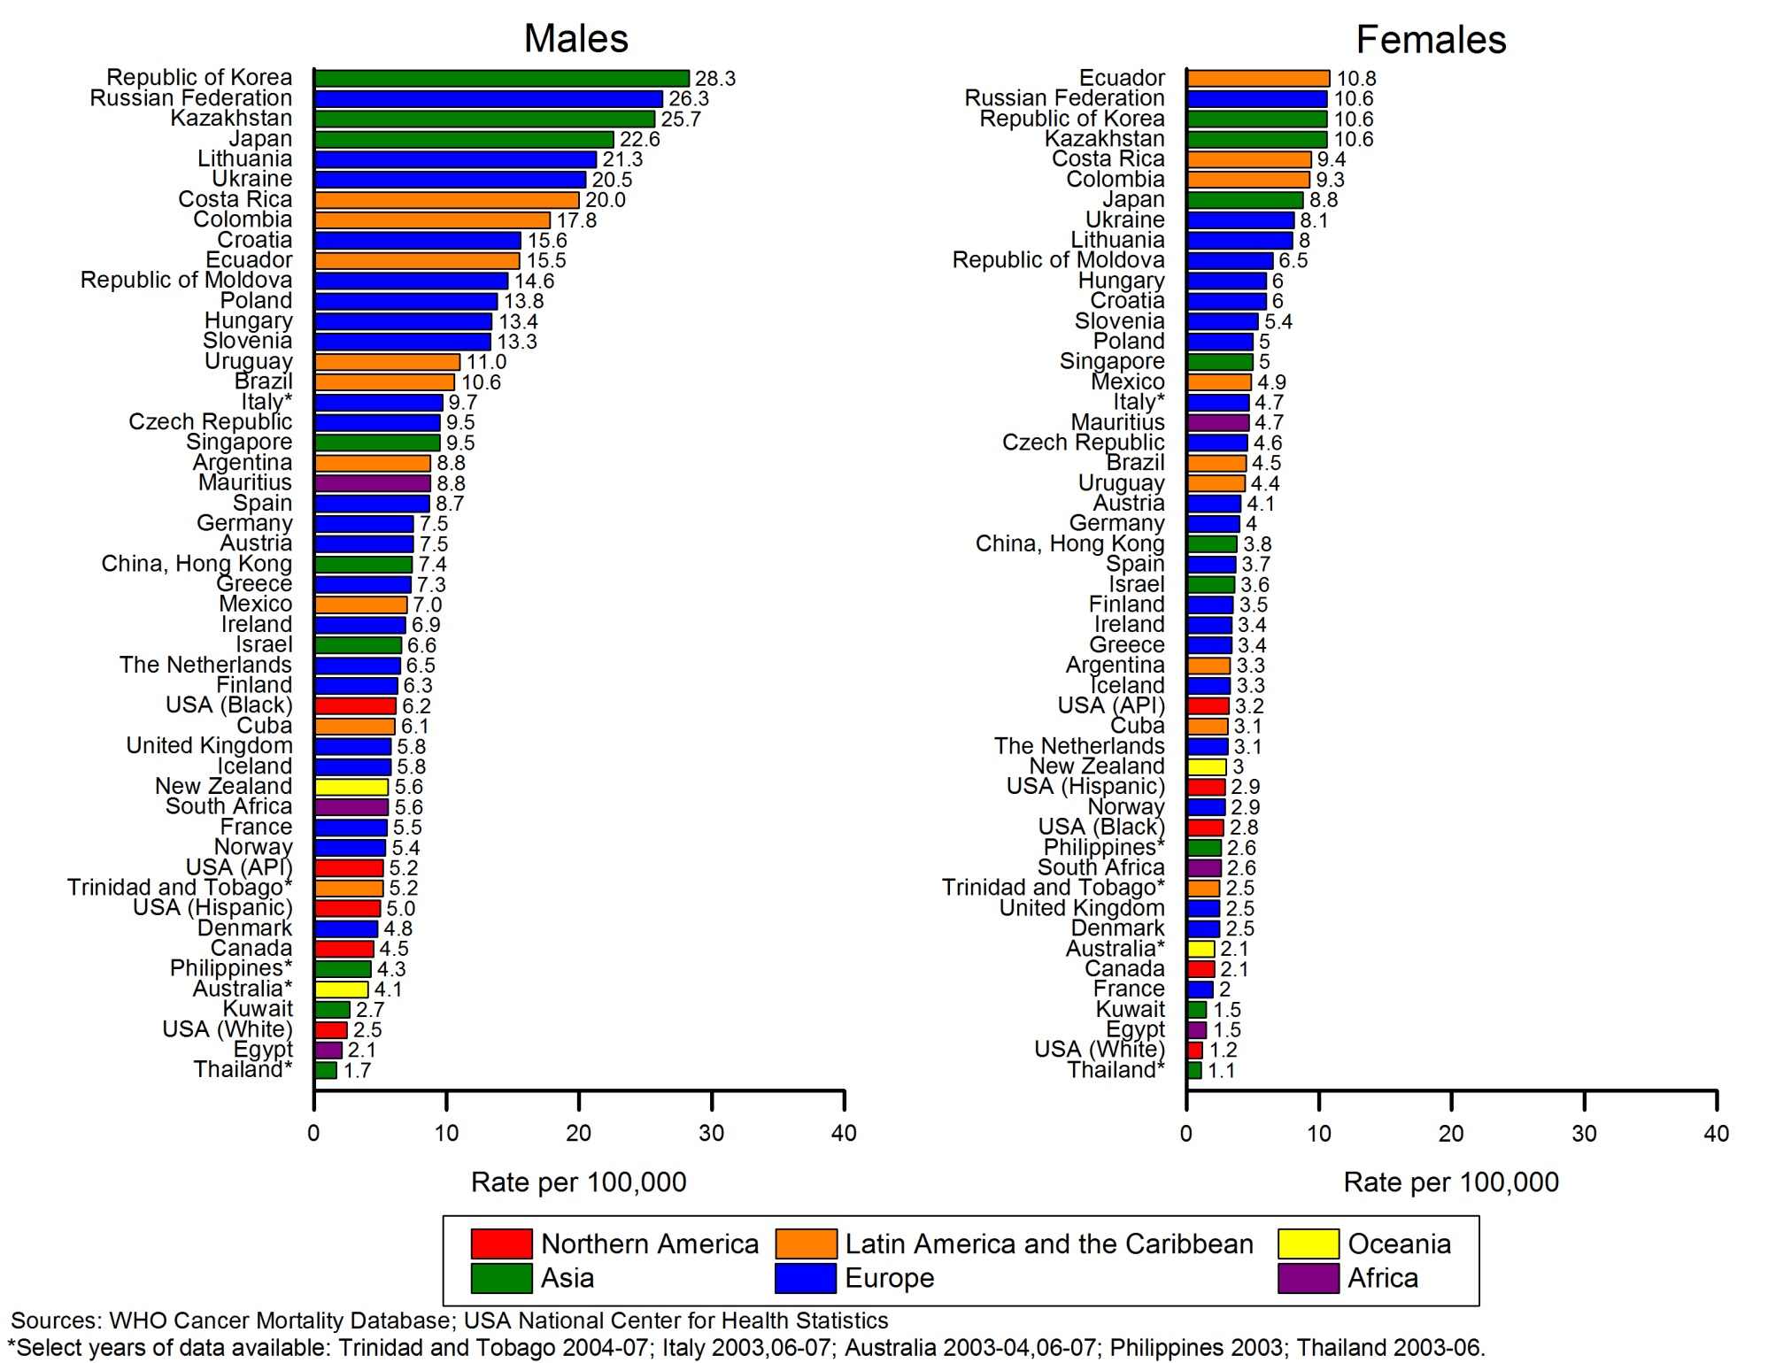
Supplementary Figure S12. Stomach cancer mortality trends, males, select countries, 1950–2012
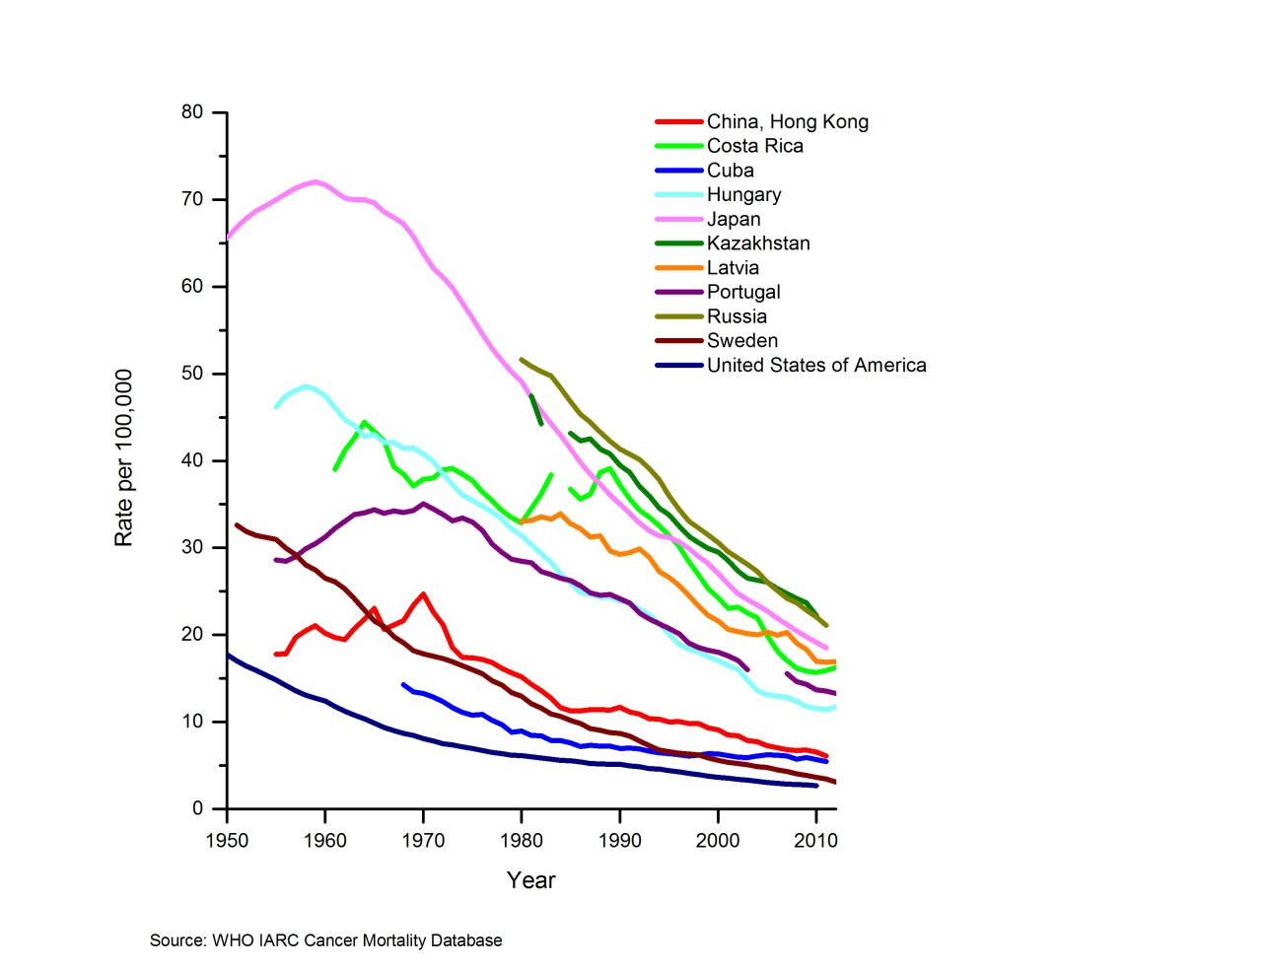
Supplementary Figure S13. Liver cancer incidence rates by sex in select registries, 2003–2007
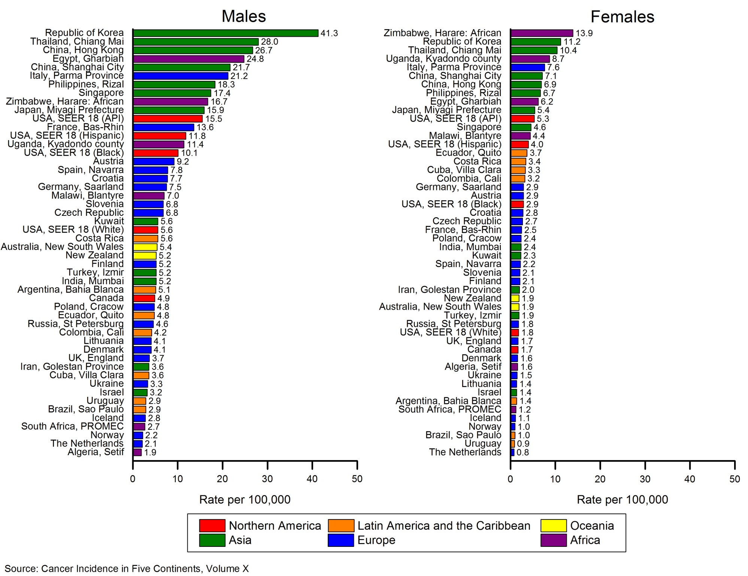
Supplementary Figure S14. Liver cancer mortality rates by sex, select countries, 2003–2007
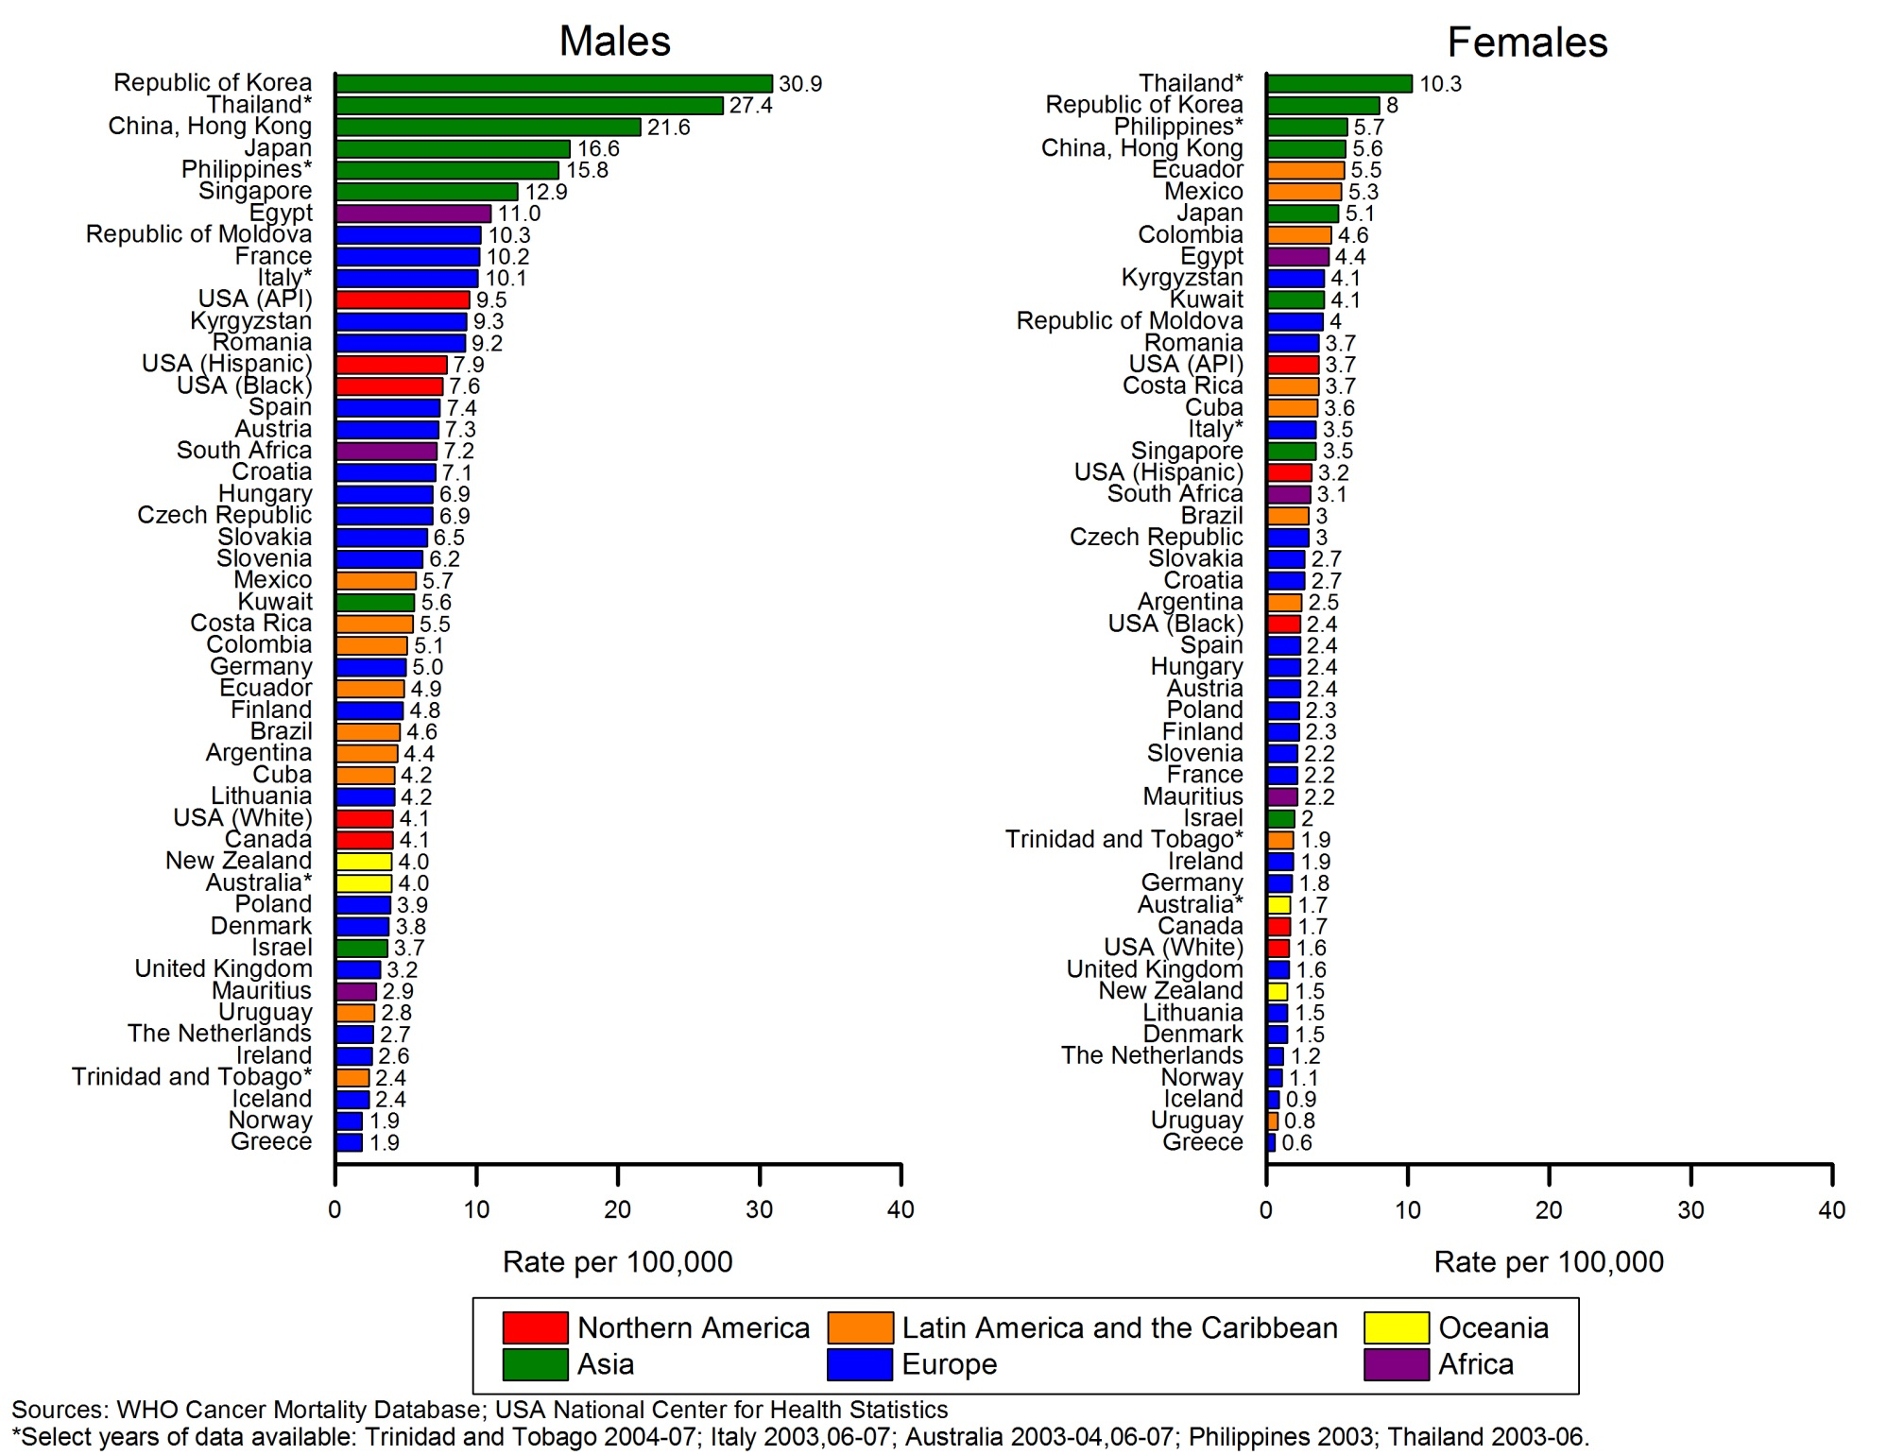
Supplementary Figure S15. Esophageal cancer incidence rates by sex in select registries, 2003–2007
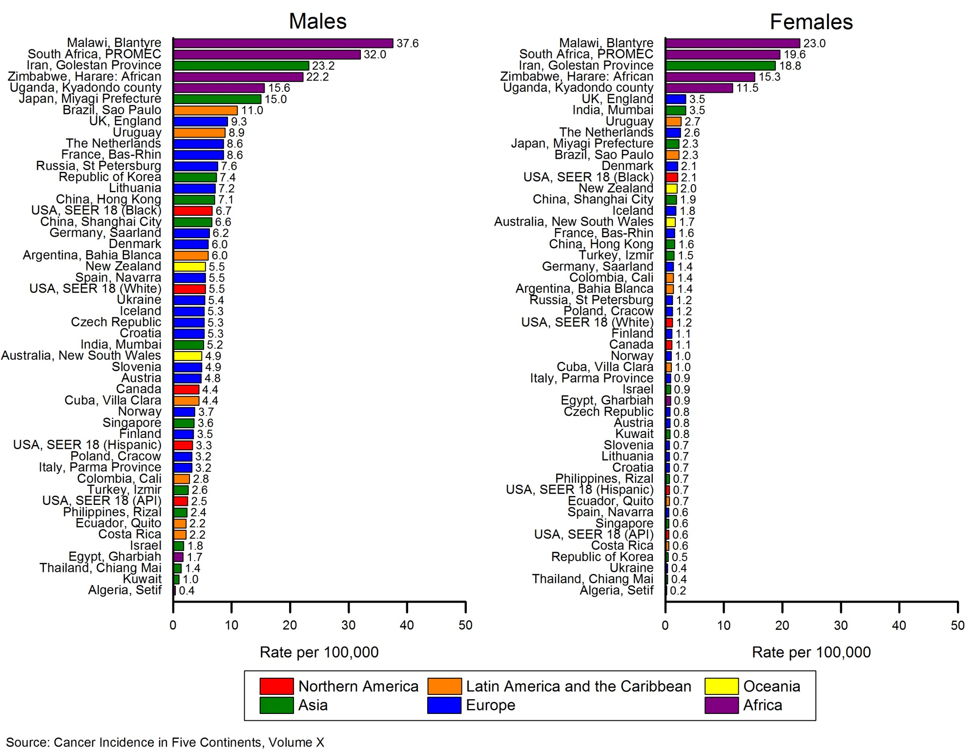
Supplementary Figure S16. Esophageal cancer mortality rates by sex, select countries, 2003–2007
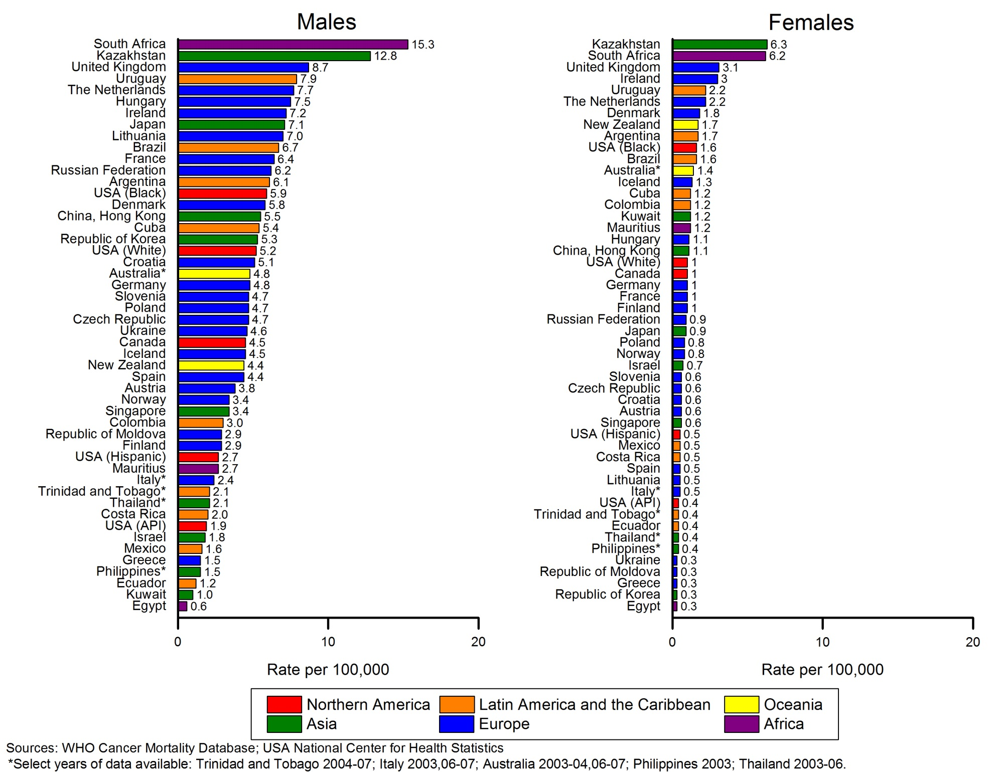
Supplementary Figure S17. Cervical cancer incidence and mortality rates in select registries and countries, 2003–2007
