Supplementary File S4. Reference miRNAs
S4a. Reference miRNAs for relative expression calculations
 | CV | adj-R² | p-value
miR-16-1-5p | 0.376 | 0.941 | <2.2e-16
miR-16-2-5p | 0.403 | 0.940 | <2.2e-16
miR-26a-1-5p | 0.469 | 0.919 | <2.2e-16
miR-26a-2-5p | 0.482 | 0.919 | <2.2e-16

MiRNAs were selected as reference for relative expression calculations based on low CV and high adjusted-R². A low CV indicates low standard deviation combined with high average expression. The R² denotes the percentage of variation in the miRNA expression that can be explained by the library size. The adjusted-R² adjusts the R² for the sample size and the number of variables in the model.
Abbreviations: CV= coefficient of variation, adj-R²= adjusted coefficient of determination
S4b. Relation between microRNA expression and library size, and residual plots
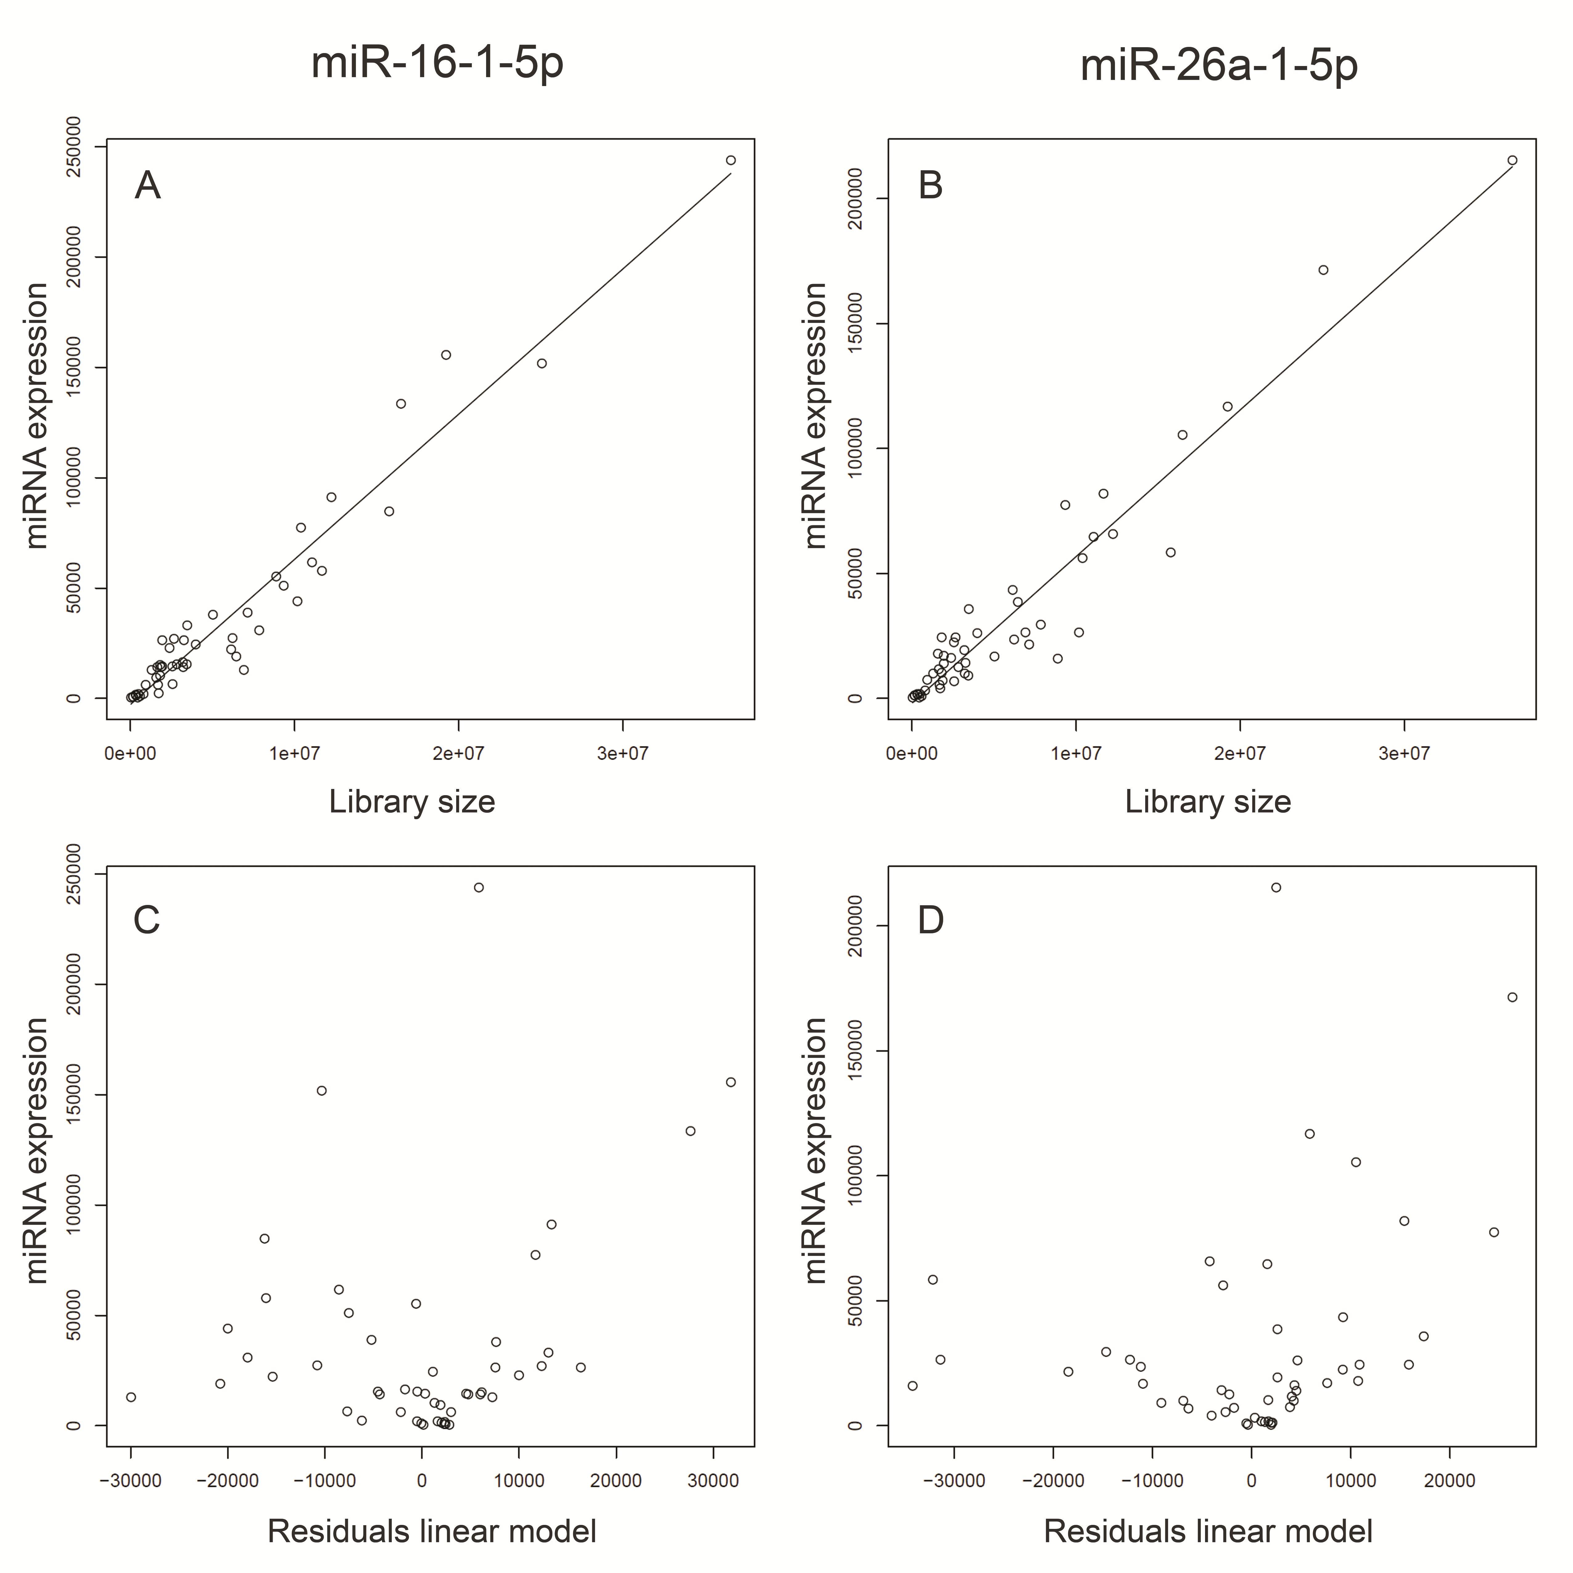
Next generation sequencing data (HiSeq) were used to determine which miRNAs would be suitable references for use in PCR-based technical validation of expression profiles and validation of differential expression results. Shown is the linear relation between expression of the identified reference miRNAs and library size, with in A. miR-16-1-5p and in B. miR-26a-1-5p. The data points lie close to the 45°-line, indicating strong linear relation, as would be expected from the high adj-R²-values (Supplementary File S4a). The residuals of linear modeling, plotted against the miRNA expression, shown in C. for miR-16-1-5p and in D. for miR-26a-1-5p. Residual plots showed no obvious relation, and were indicative for a good fit of the linear model.
S4c. Validation of microRNA combination miR-16-5p and miR-26a-5p as suitable reference for PCR

The genome cancer atlas (TCGA) data portal was accessed to download all available colon cancer samples with level 3 Illumina HiSeq miRNA sequencing data. All available unique tumor samples from TNM-stage I-IV samples, including both MSI and MSS phenotype, were used for validation (N=235). Next, all annotated miRNAs were selected amongst unannotated, precursor and stemloop sequences, and the sum of their counts was designated as miRNA library size per sample. In the TCGA dataset, 3p isoforms are indicated as ‘star’ sequences, while 5p isoforms are indicated as ‘mature’ sequences. The sum of raw counts from all annotated mature (=5p) reference miRNAs (miR-16-1-5p, miR-16-2-5p, miR-26a-1-5p and miR-26a-2-5p) were analyzed against the miRNA library sizes using a linear regression analysis. Analysis showed a p-value of 2.2e-16, accompanied by an adjusted-R² of approximately 0.6 for the proposed combination of miR-16-5p and miR-26a-5p. With an expected lower explained variance due to multiple confounding factors, like lab, inclusion of MSI-phenotype samples, protocol-effects and differences in miRNA alignment and crossmapping correction, these results endorse our findings that the combination of miR-16-5p and miR-26a-5p are suitable as reference for Taqman-based approaches.

