Supplement

Supplementary Figure S1. Trends in lung cancer mortality among women aged 30–49, 1985–2011, age-standardized rate (world)

Supplementary Figure S2. Trends in lung cancer mortality among women aged 50–74, 1985–2011, age-standardized rate (world)

Supplementary Figure S3. Trends in lung cancer mortality among women aged 30–74, 1985–2011, age-standardized rate (world)

Supplementary Figure S4. Lung cancer mortality rates in 2006–2010 among females aged 30–74. Age-standardized rate (world).

Supplementary Figure S5. Trends in lung cancer mortality rates among women aged 30–74 for select areas, 1950–2011. Age-standardized rate (world), three-year moving averages.

Supplementary Table S1. Trends in lung cancer mortality rates among females age 30–74

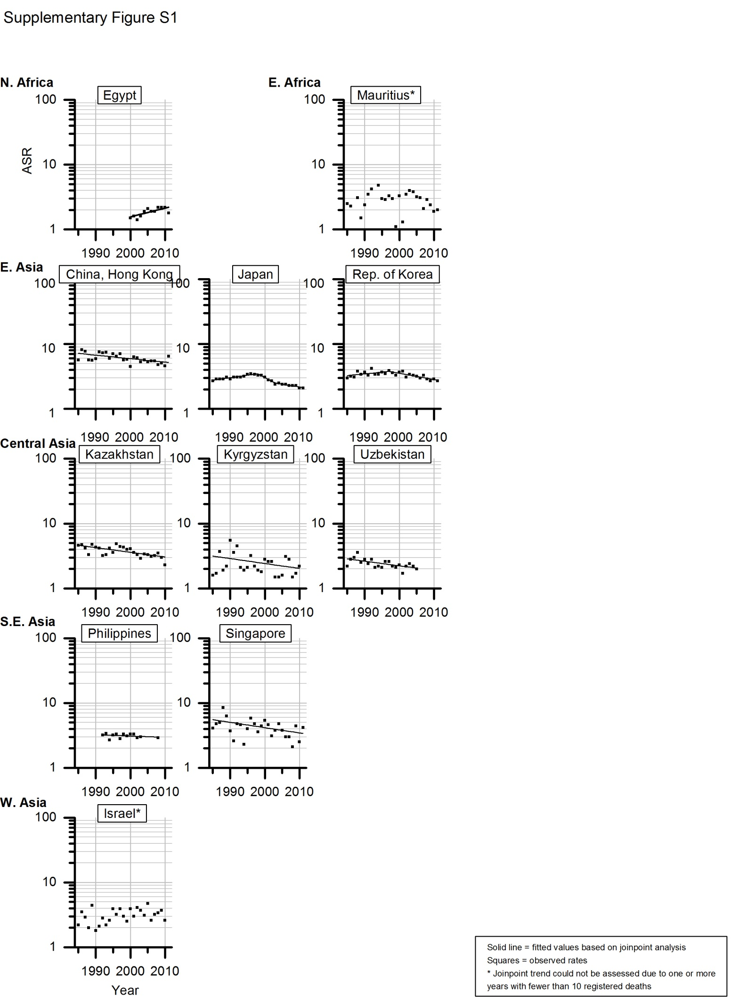
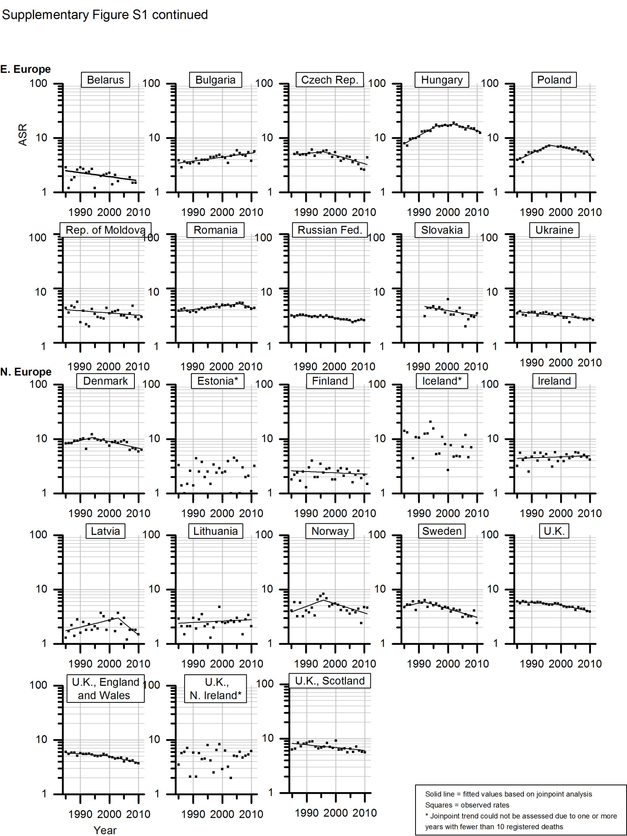
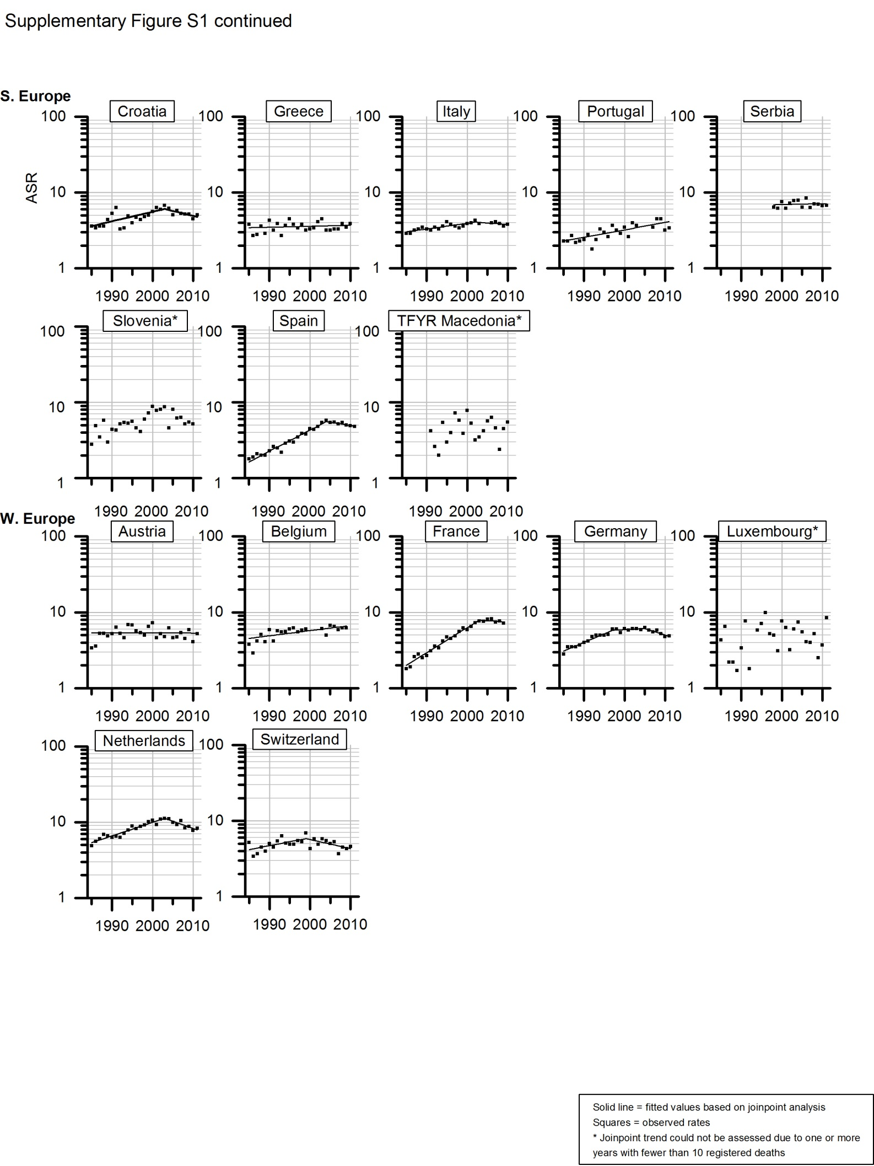
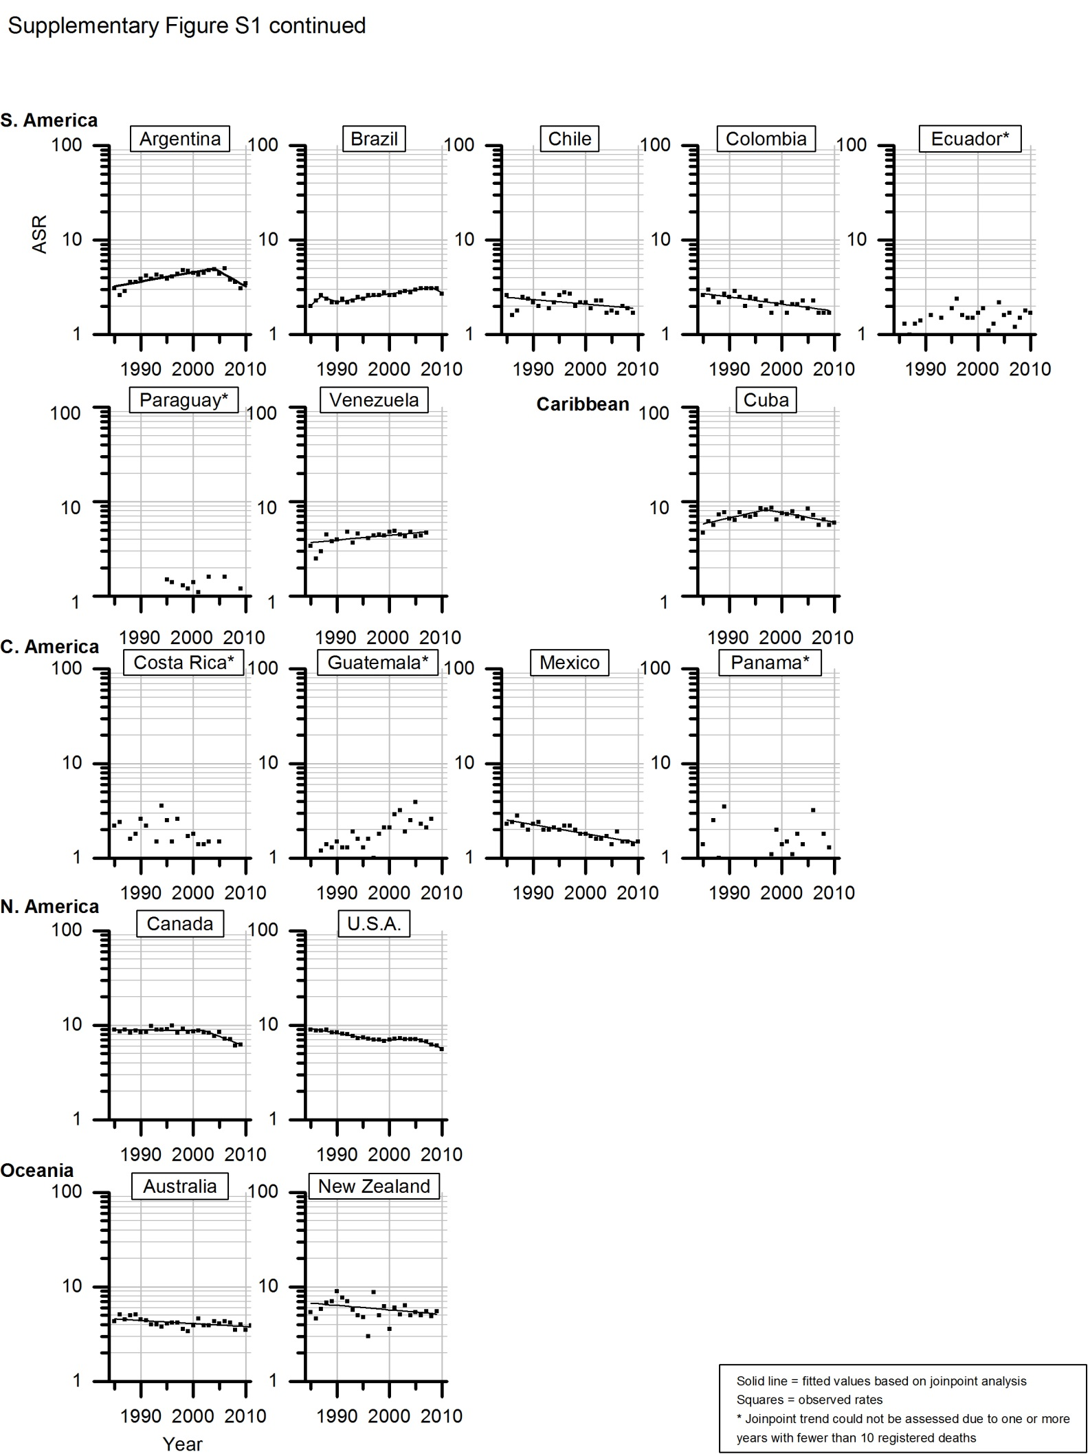
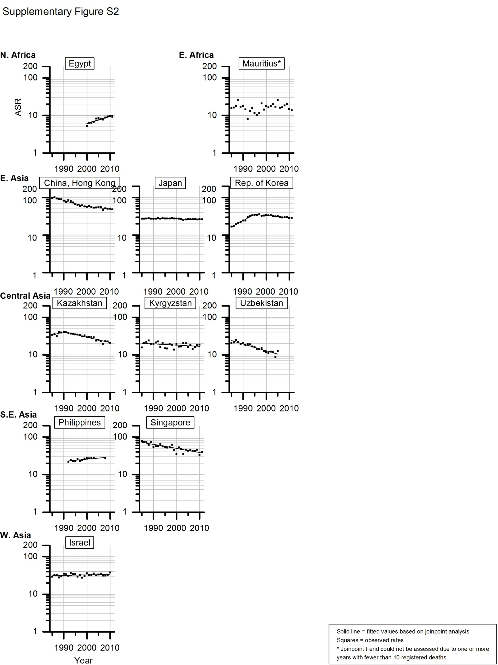
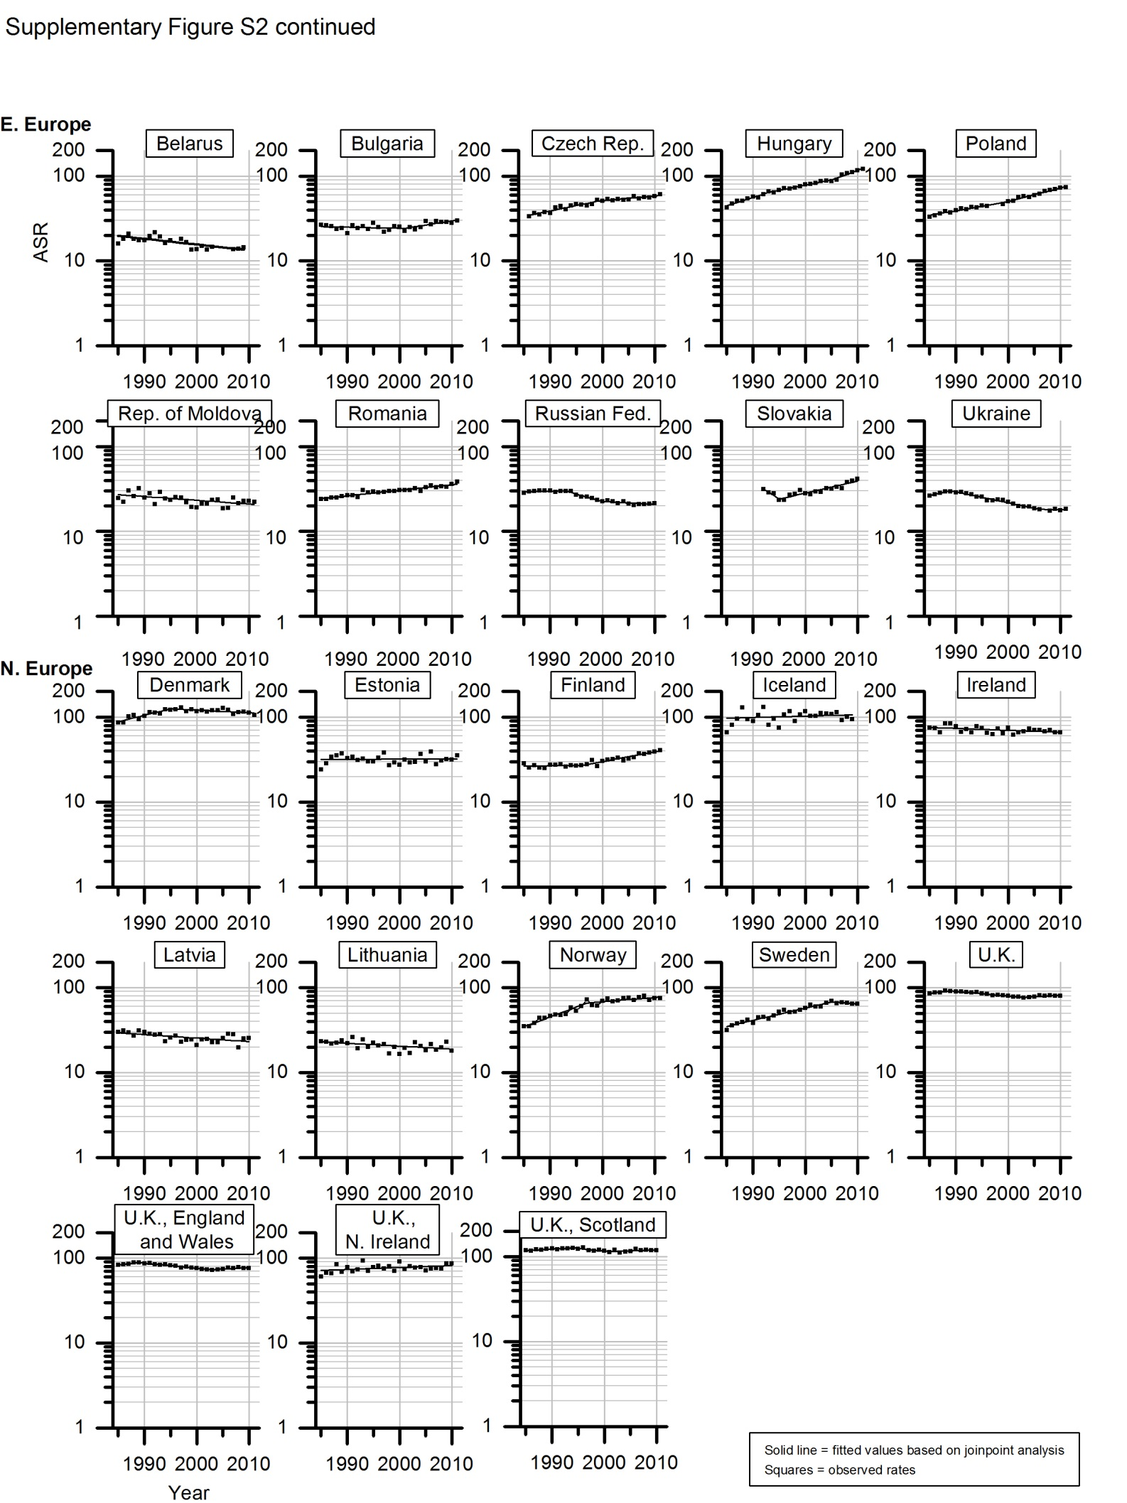
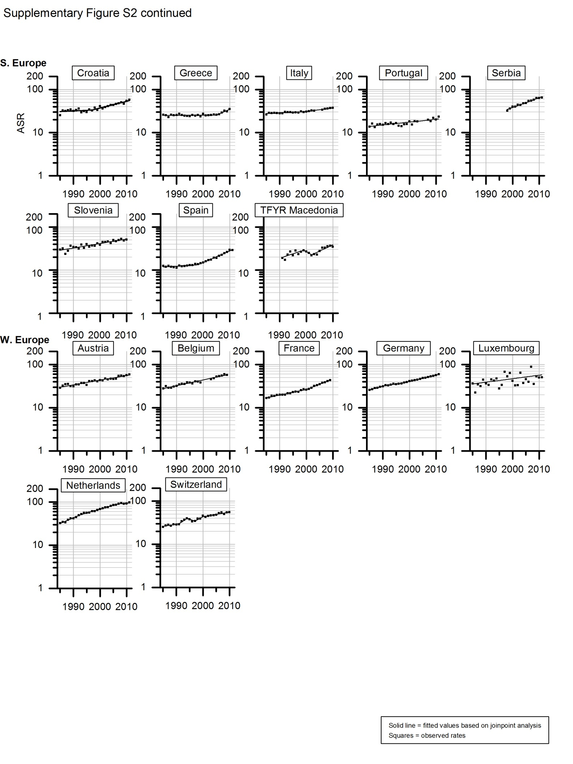
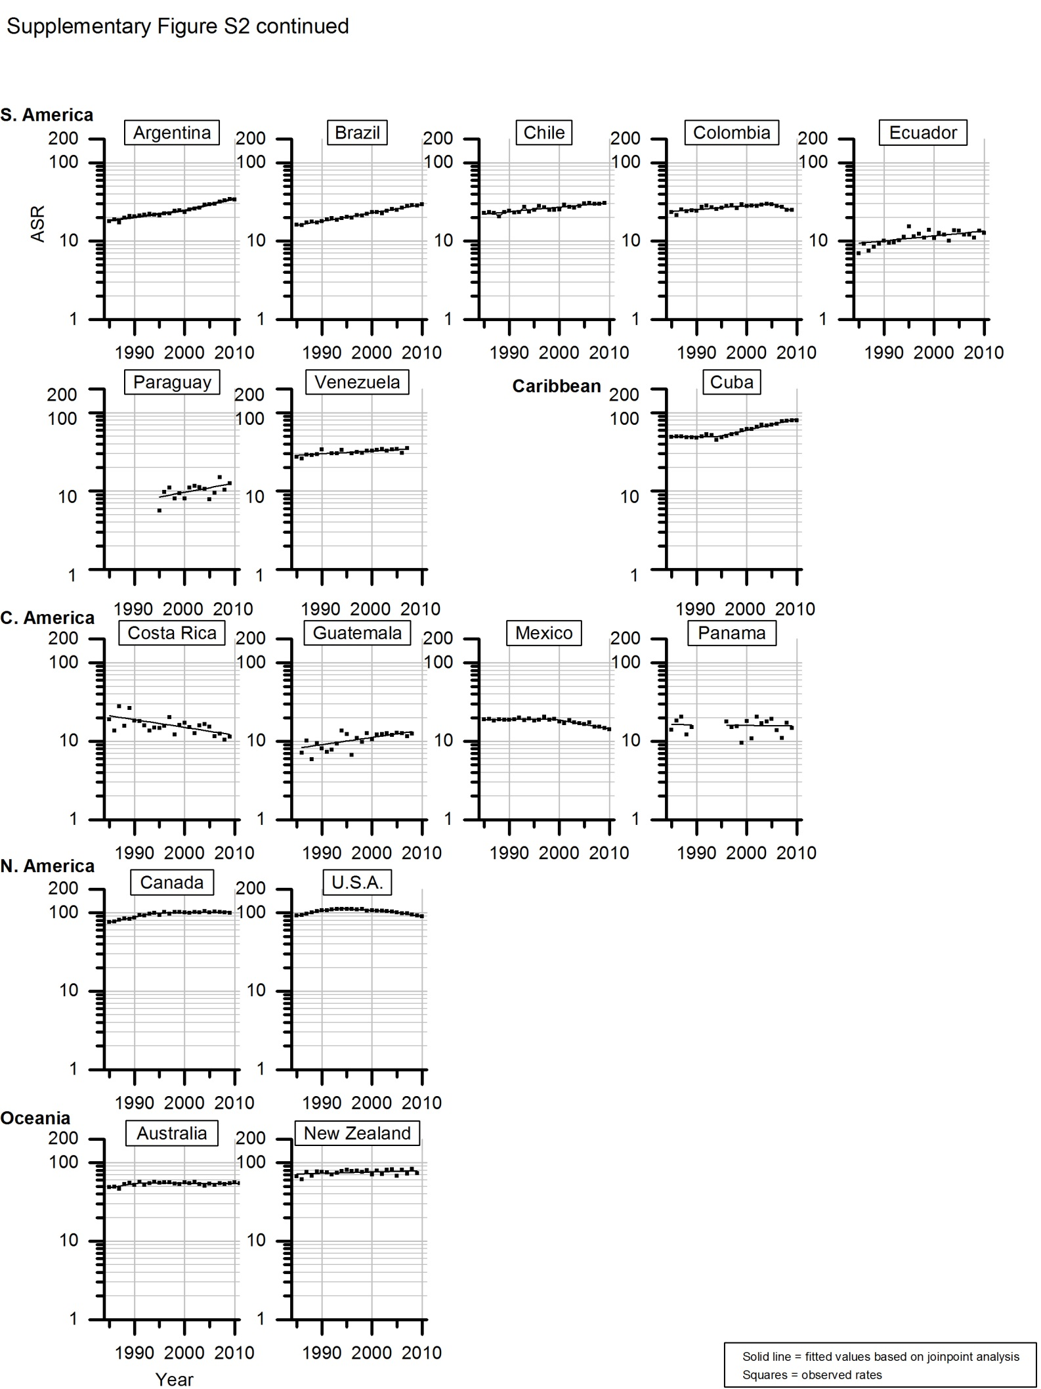
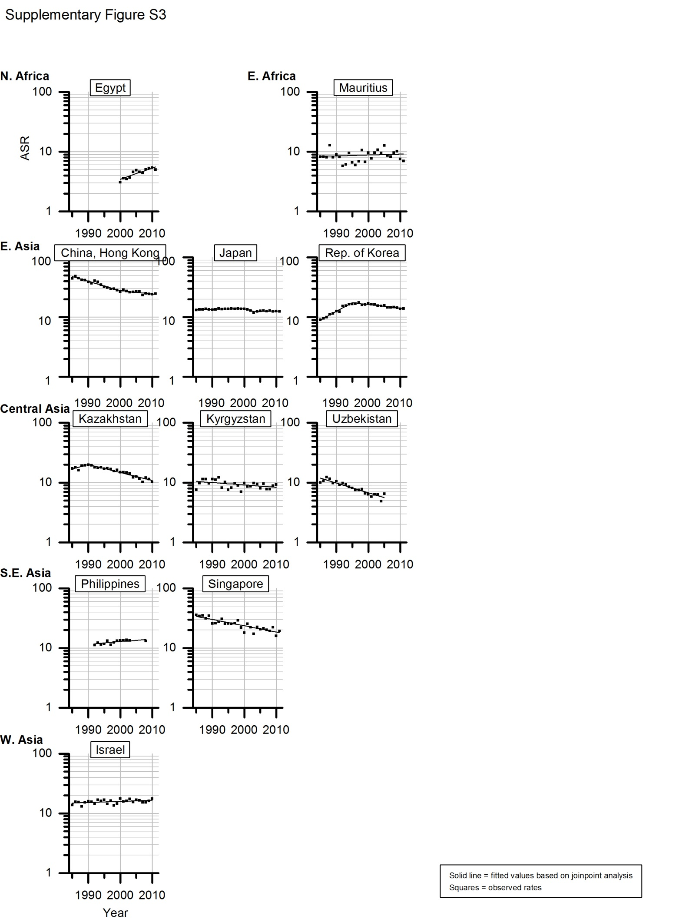
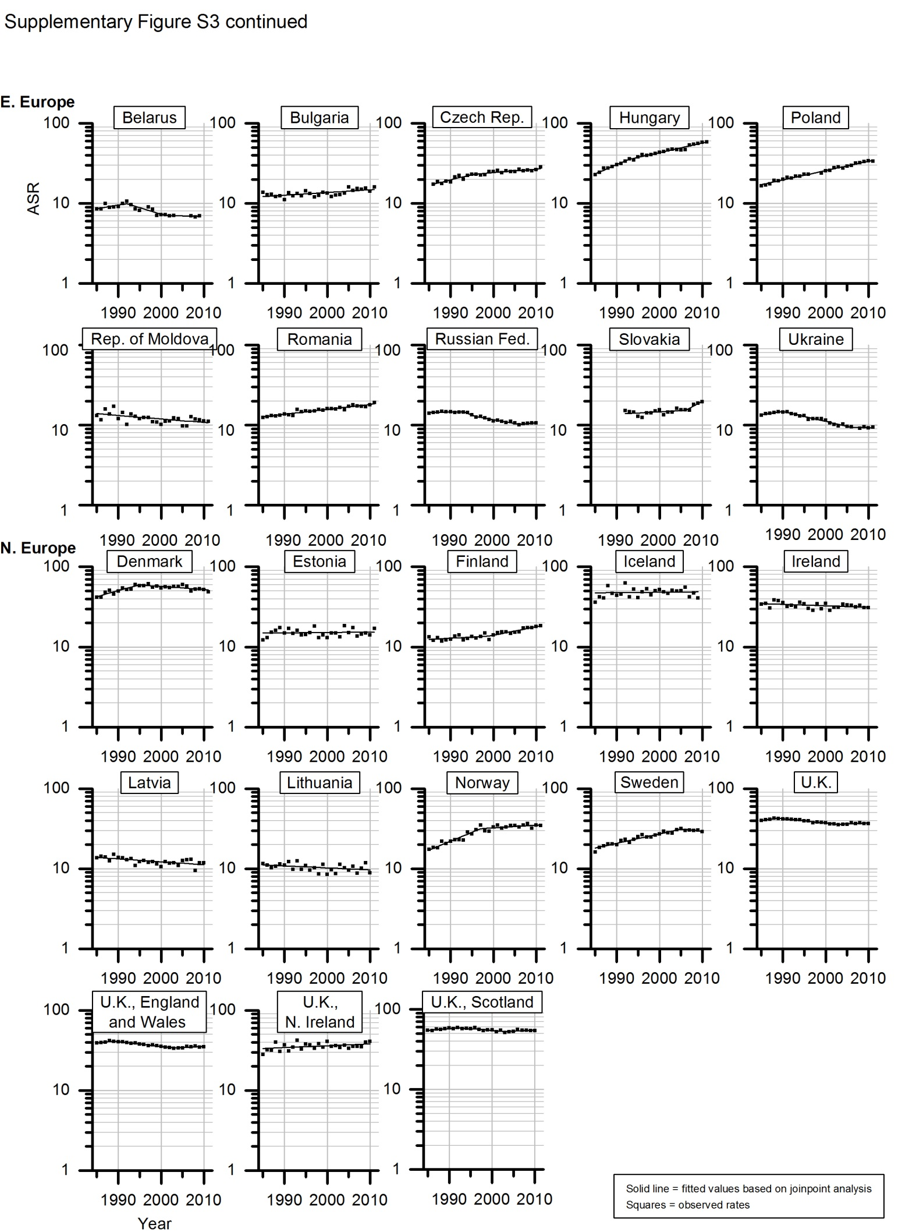
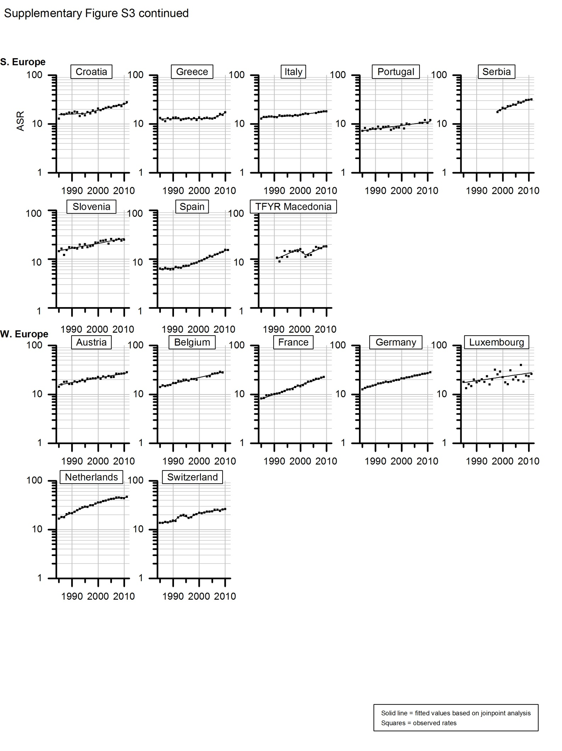
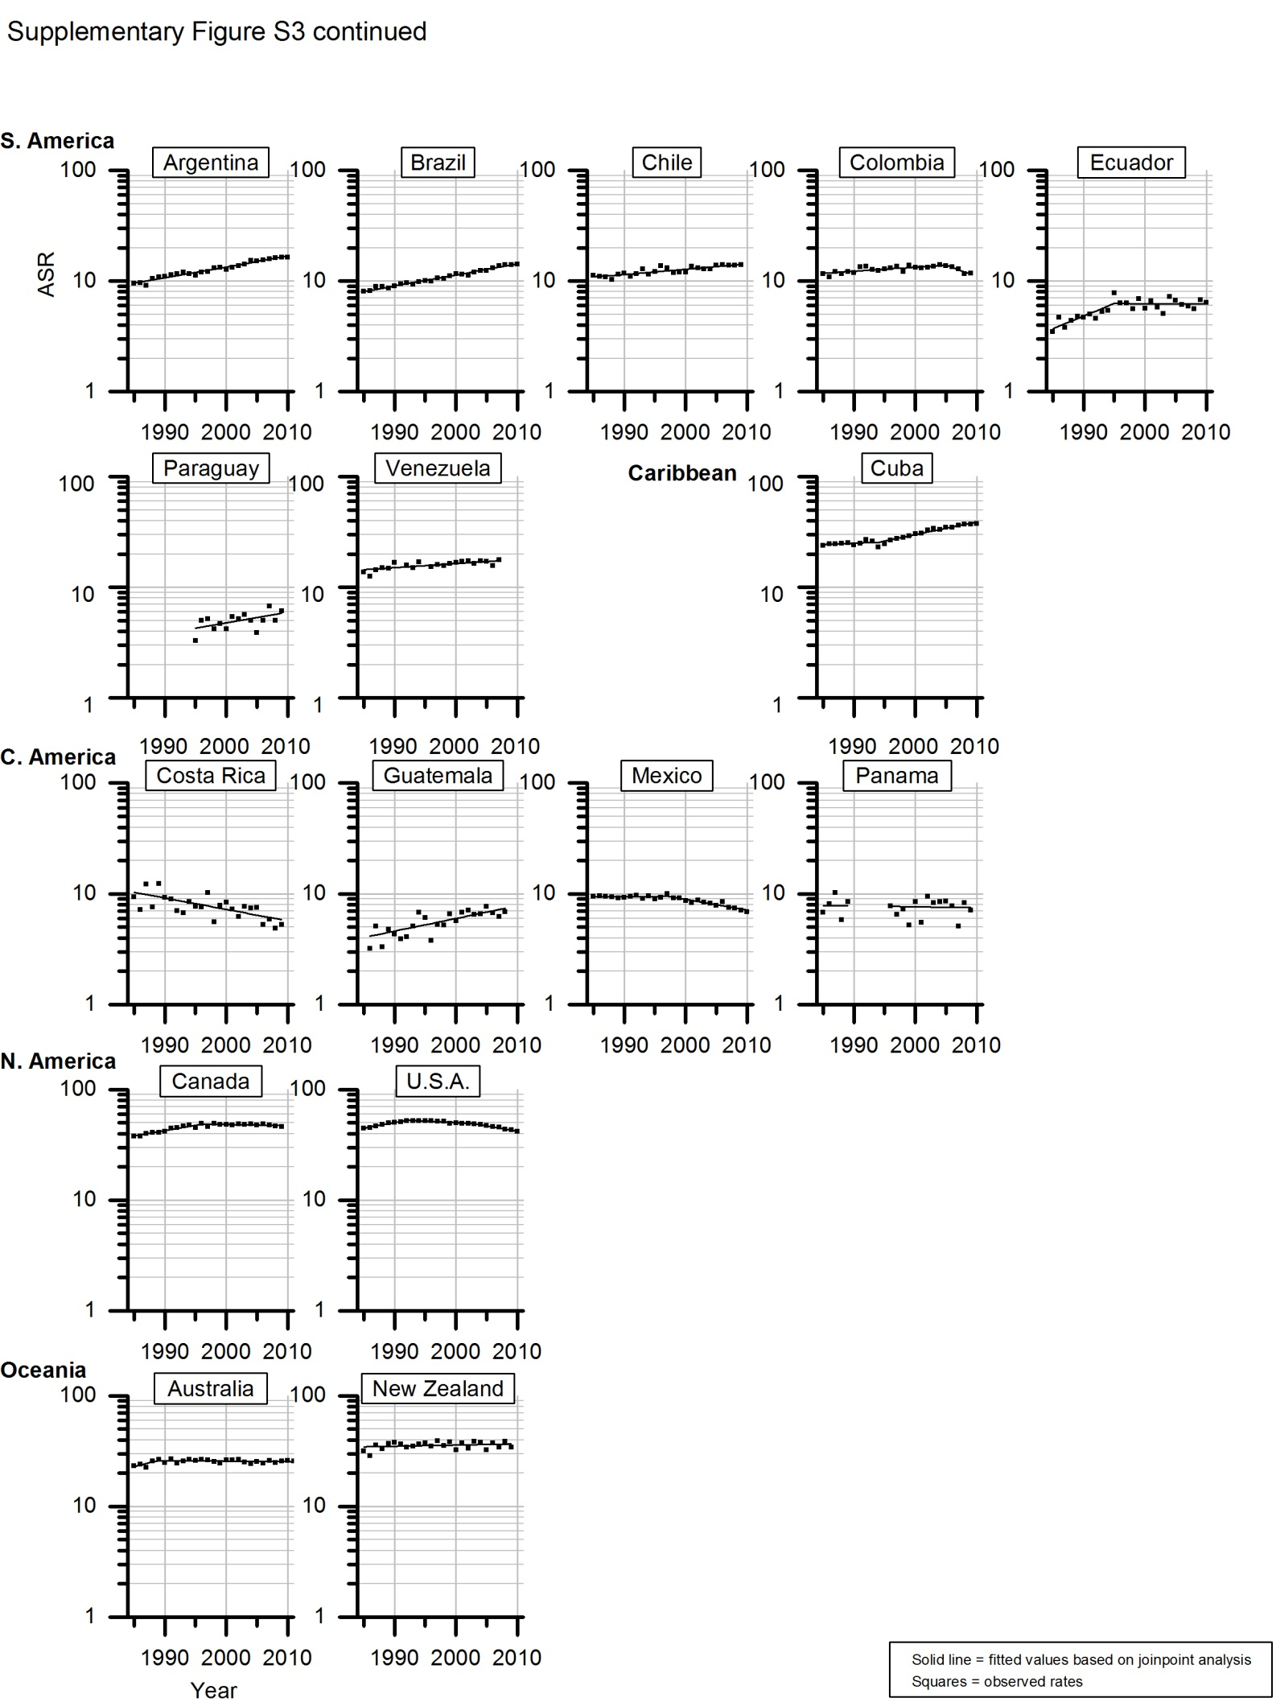
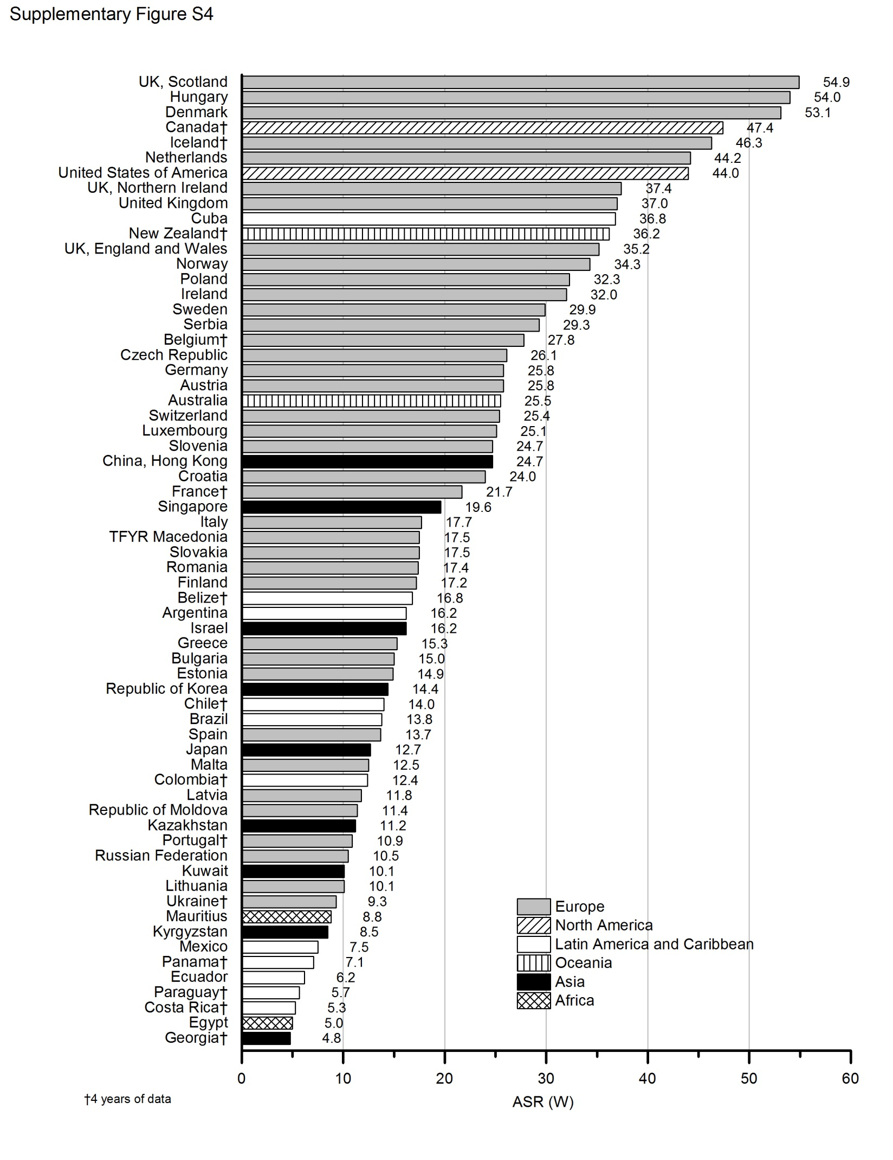
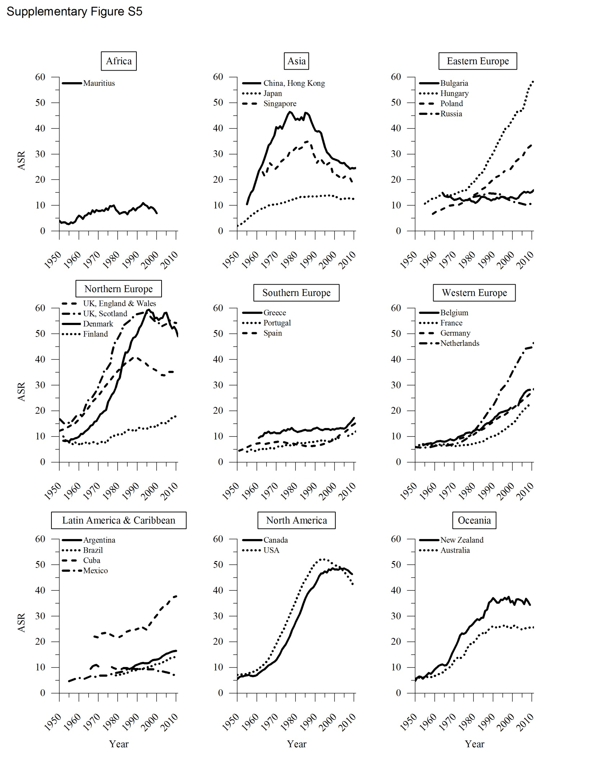
Supplementary Table S1
 | Trend 1 |  | Trend 2 |  | Trend 3 |  | Trend 4 |  | Trend 5 |  | AAPC
 | Years | APC | Years | APC | Years | APC | Years | APC | Years | APC | Last five years
AFRICA
Eastern Africa
Mauritius | 1985–2011 | 0.3 |  |  |  |  |  |  |  |  | 2007–2011 | 0.3
Northern Africa
Egypt | 2000–2011 | 4.4ª |  |  |  |  |  |  |  |  | 2007–2011 | 4.4 ª
ASIA
Eastern Asia
China, Hong Kong | 1985–2000 | -3.6 ª | 2000–2011 | -1.3 ª |  |  |  |  |  |  | 2007–2011 | -1.3 ª
Japan | 1985–2000 | 0.2 ª | 2000–2003 | -3.7 ª | 2003–2011 | 0.3 |  |  |  |  | 2007–2011 | 0.3
Republic of Korea | 1985–1995 | 7.0 ª | 1995–2011 | -1.4 ª |  |  |  |  |  |  | 2007–2011 | -1.4 ª
Central Asia
Kazakhstan | 1985–1990 | 3.6 ª | 1990–2010 | -3.0 ª |  |  |  |  |  |  | 2006–2010 | -3.0 ª
Kyrgyzstan | 1985–2010 | -0.9 ª |  |  |  |  |  |  |  |  | 2006–2010 | -0.9 ª
Uzbekistan | 1985–2005 | -3.7 ª |  |  |  |  |  |  |  |  | 2001–2005 | -3.7 ª
South-Eastern Asia
Philippines^{c} | 1992–2008 | 1.0 ª |  |  |  |  |  |  |  |  | 2000–2008 | 1.0 ª
Singapore | 1985–2011 | -2.4 ª |  |  |  |  |  |  |  |  | 2007–2011 | -2.4 ª
Western Asia
Israel | 1985–2010 | 0.4 ª |  |  |  |  |  |  |  |  | 2006–2010 | 0.4 ª
EUROPE
Eastern Europe
Belarus^{c} | 1985–1992 | 2.0 | 1992–2001 | -3.7 ª | 2001–2009 | -0.3 |  |  |  |  | 2002–2009 | -0.3
Bulgaria | 1985–2011 | 0.8 ª |  |  |  |  |  |  |  |  | 2007–2011 | 0.8 ª
Czech Republic | 1986–1995 | 3.1 ª | 1995–2011 | 1.1 ª |  |  |  |  |  |  | 2007–2011 | 1.1 ª
Hungary | 1985–1993 | 5.3 ª | 1993–2011 | 2.8 ª |  |  |  |  |  |  | 2007–2011 | 2.8 ª
Poland^{b} | 1985–2011 | 2.7 ª |  |  |  |  |  |  |  |  | 2007–2011 | 2.7 ª
Republic of Moldova | 1985–2011 | -1.0 ª |  |  |  |  |  |  |  |  | 2007–2011 | -1.0 ª
Romania | 1985–2011 | 1.4 ª |  |  |  |  |  |  |  |  | 2007–2011 | 1.4 ª
Russian Federation | 1985–1993 | 0.3 | 1993–1996 | -4.7 | 1996–2006 | -2.1 ª | 2006–2010 | 1.1 |  |  | 2006–2010 | 1.1
Slovakia | 1992–2006 | 0.7 | 2006–2010 | 6.8 ª |  |  |  |  |  |  | 2006–2010 | 6.8 ª
Ukraine^{b} | 1985–1990 | 1.8 ª | 1990–2006 | -2.8 ª | 2006–2011 | -0.2 |  |  |  |  | 2006–2011 | -0.2
Northern Europe
Denmark | 1985–1995 | 3.4 ª | 1995–2011 | -0.9 ª |  |  |  |  |  |  | 2007–2011 | -0.9 ª
Estonia | 1985–2011 | 0.1 |  |  |  |  |  |  |  |  | 2007–2011 | 0.1
Finland | 1985–1999 | 0.7 | 1999–2011 | 2.5 ª |  |  |  |  |  |  | 2007–2011 | 2.5 ª
Iceland | 1985–2009 | 0.1 |  |  |  |  |  |  |  |  | 2005–2009 | 0.1
Ireland | 1985–2010 | -0.4 ª |  |  |  |  |  |  |  |  | 2006–2010 | -0.4 ª
Latvia | 1985–2010 | -0.8 ª |  |  |  |  |  |  |  |  | 2006–2010 | -0.8 ª
Lithuania | 1985–2010 | -0.6 ª |  |  |  |  |  |  |  |  | 2006–2010 | -0.6 ª
Norway | 1985–1997 | 5.3 ª | 1997–2011 | 0.8 ª |  |  |  |  |  |  | 2007–2011 | 0.8 ª
Sweden | 1985–2005 | 2.7 ª | 2005–2010 | -1.3 |  |  |  |  |  |  | 2006–2010 | -1.3
United Kingdom | 1985–1989 | 1.6 ª | 1989–2003 | -1.3 ª | 2003–2010 | 0.6 ª |  |  |  |  | 2006–2010 | 0.6 ª
UK, England and Wales | 1985–1989 | 1.4 ª | 1989–2003 | -1.4 ª | 2003–2010 | 0.6 ª |  |  |  |  | 2006–2010 | 0.6 ª
UK, Northern Ireland | 1985–2010 | 0.5 ª |  |  |  |  |  |  |  |  | 2006–2010 | 0.5ª
UK, Scotland | 1985–1992 | 1.2 ª | 1992–2003 | -1.0 ª | 2003–2010 | 0.6 |  |  |  |  | 2006–2010 | 0.6
Southern Europe
Croatia | 1985–1995 | 0.6 | 1995–2011 | 3.0 ª |  |  |  |  |  |  | 2007–2011 | 3.0 ª
Greece | 1985–2005 | 0.1 | 2005–2010 | 5.5 ª |  |  |  |  |  |  | 2006–2010 | 5.5 ª
Italy^{b} | 1985–1999 | 0.8 ª | 1999–2010 | 1.7 ª |  |  |  |  |  |  | 2006–2010 | 1.7 ª
Portugal^{c} | 1985–2011 | 1.7 ª |  |  |  |  |  |  |  |  | 2007–2011 | 1.7 ª
Serbia | 1998–2011 | 4.4 ª |  |  |  |  |  |  |  |  | 2007–2011 | 4.4 ª
Slovenia | 1985–2010 | 2.4 ª |  |  |  |  |  |  |  |  | 2006–2010 | 2.4 ª
Spain | 1985–1995 | 1.4 ª | 1995–2011 | 5.1 ª |  |  |  |  |  |  | 2007–2011 | 5.1 ª
TFYR Macedonia | 1991–1999 | 5.8 ª | 1999–2002 | -8.7 | 2002–2010 | 5.9 ª |  |  |  |  | 2006–2010 | 5.9 ª
Western Europe
Austria | 1985–2011 | 2.2 ª |  |  |  |  |  |  |  |  | 2007–2011 | 2.2 ª
Belgium^{c} | 1985–2009 | 2.9 ª |  |  |  |  |  |  |  |  | 2005–2009 | 2.9 ª
France | 1985–2009 | 4.4 ª |  |  |  |  |  |  |  |  | 2005–2009 | 4.4 ª
Germany | 1985–1991 | 4.1 ª | 1991–2011 | 2.7 ª |  |  |  |  |  |  | 2007–2011 | 2.7 ª
Luxembourg | 1985–2011 | 1.8 ª |  |  |  |  |  |  |  |  | 2007–2011 | 1.8 ª
Netherlands | 1985–1994 | 5.7 ª | 1994–2005 | 4.0 ª | 2005–2011 | 1.2 ª |  |  |  |  | 2007–2011 | 1.2 ª
Switzerland | 1985–1990 | 1.3 | 1990–1993 | 10.7 | 1993–1996 | -3.6 | 1996–2000 | 5.2 ª | 2000–2010 | 1.9 ª | 2006–2010 | 1.9 ª

 | Trend 1 |  | Trend 2 |  | Trend 3 |  | Trend 4 |  | Trend 5 |  | AAPC
 | Years | APC | Years | APC | Years | APC | Years | APC | Years | APC | Years
LATIN AMERICA AND THE CARIBBEAN
Caribbean
Cuba | 1985–1994 | 0.5 | 1994–2010 | 2.7 ª |  |  |  |  |  |  | 2006–2010 | 2.7 ª
Central America
Costa Rica | 1985–2009 | -2.4 ª |  |  |  |  |  |  |  |  | 2005–2009 | -2.4 ª
Guatemala | 1986–2008 | 2.7 ª |  |  |  |  |  |  |  |  | 2004–2008 | 2.7 ª
Mexico | 1985–1997 | 0.1 | 1997–2010 | -2.2 ª |  |  |  |  |  |  | 2006–2010 | -2.2 ª
Panama^{d} | 1985–2009 | -0.2 |  |  |  |  |  |  |  |  | 2005–2009 | -0.2
South America
Argentina | 1985–2010 | 2.3 ª |  |  |  |  |  |  |  |  | 2006–2010 | 2.3 ª
Brazil | 1985–2010 | 2.3 ª |  |  |  |  |  |  |  |  | 2006–2010 | 2.3 ª
Chile | 1985–2009 | 1.1 ª |  |  |  |  |  |  |  |  | 2005–2009 | 1.1 ^{a`}
Colombia | 1985–2005 | 0.8 ª | 2005–2009 | -4.5 ª |  |  |  |  |  |  | 2005–2009 | -4.5 ª
Ecuador | 1985–1995 | 5.4 ª | 1995–2010 | 0.0 |  |  |  |  |  |  | 2006–2010 | 0.0
Paraguay | 1995–2009 | 2.2 ª |  |  |  |  |  |  |  |  | 2005–2009 | 2.2 ª
Venezuela^{b} | 1985–2007 | 0.9 ª |  |  |  |  |  |  |  |  | 2003–2007 | 0.9 ª
NORTHERN AMERICA |  |  |  |  |  |  |  |  |  |  | –
Canada | 1985–1996 | 2.3 ª | 1996–2009 | -0.2 |  |  |  |  |  |  | 2005–2009 | -0.2
United States of America | 1985–1992 | 2.4 ª | 1992–2003 | -0.6 ª | 2003–2010 | -2.2 ª |  |  |  |  | 2006–2010 | -2.2 ª
OCEANIA
Australia | 1985–1989 | 3.2 | 1989–2011 | -0.1 |  |  |  |  |  |  | 2007–2011 | -0.1
New Zealand | 1985–2009 | 0.2 |  |  |  |  |  |  |  |  | 2005–2009 | 0.2

APC = Annual Percent Change; AAPC = Average Annual Percent Change
a) The APC or AAPC is statistically different from zero.
b) Time series missing 1-2 years of data (Poland, 1997-1998; Ukraine, 2007; Italy, 2004-2005; Venezuela, 1991, 1995)
c) Time series missing 3-4 years of data (Philippines, 2004-2007; Belarus, 1996, 2004-2006; Portugal, 2004-2006; Belgium, 2000-2002)
d) Time series missing 5+ years of data (Panama, 1990-1995)

