Supplemental Figure 2. (A) Overall clinical stage and (B) overall pathological stage distribution stratified by age.
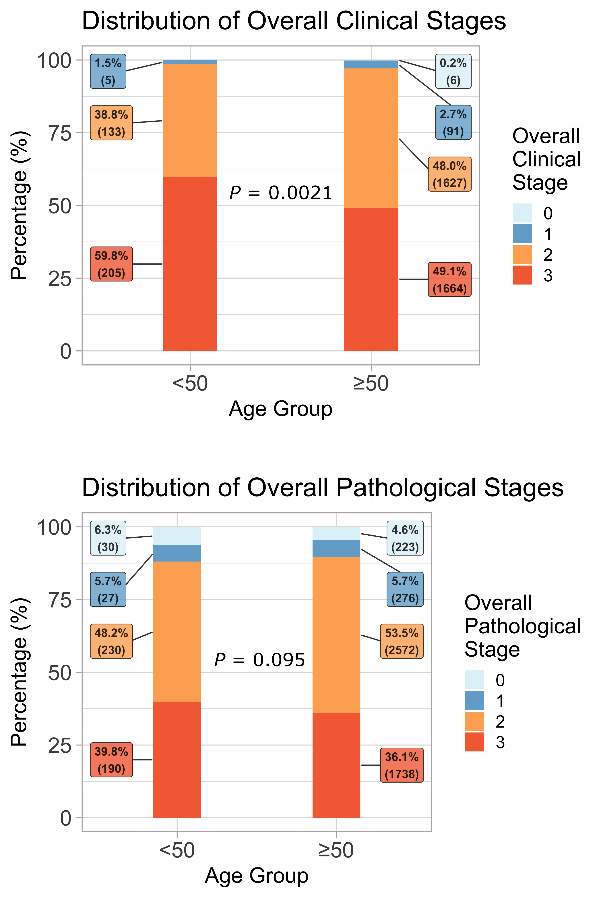
B
A

