Supplementary Table 2
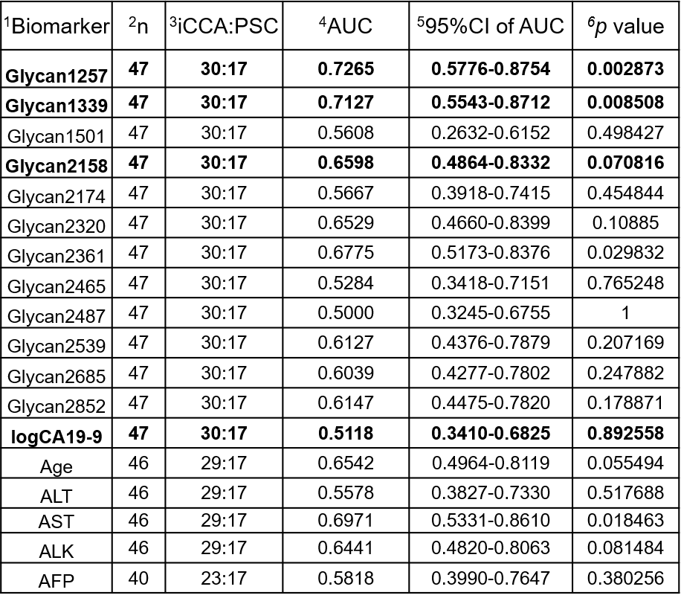
Supplementary Table 2. Lists individual N-glycans, ALT (Alanine transaminase), AST (aspartate aminotransferase), ALK (Alkaline phosphatase), and AFP (Alpha-fetoprotein) of analysis to differentiate patients with iCCA from PSC.
¹Possible biomarkers ²n: number of total patients ³distribution of iCCA (n=30) and PSC (n=17) patients. ⁴AUC (Area Under the Curve) ⁵CI (confidence interval) ⁶p value. Some iCCA patients were excluded from the analysis due to missing clinical information.

