Figure S11. Functional Well-Being Over Time
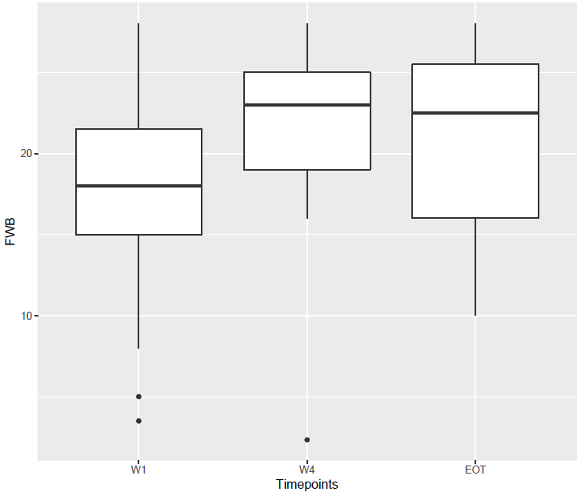
Abbreviations: EOT: end of treatment; FWB: functional well-being; W1: week 1; W4: week 4.

