Figure S10. Emotional Well-Being Over Time by Response
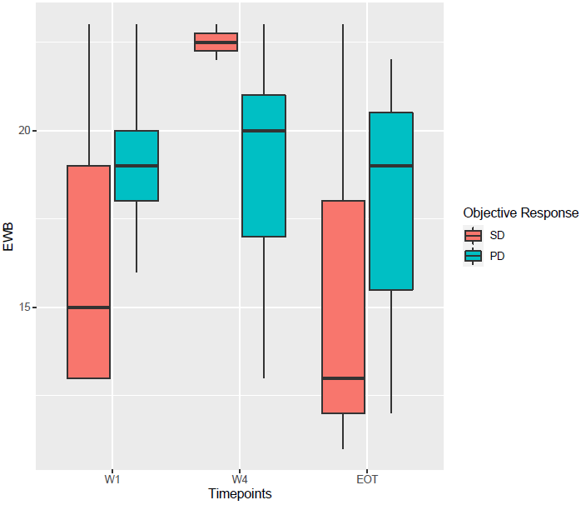
Abbreviations: EOT: end of treatment; EWB: emotional well-being; PD: progressive disease; SD: stable disease; W1: week 1; W4: week 4.

