Figure S6. Physical Well-Being Over Time by Response
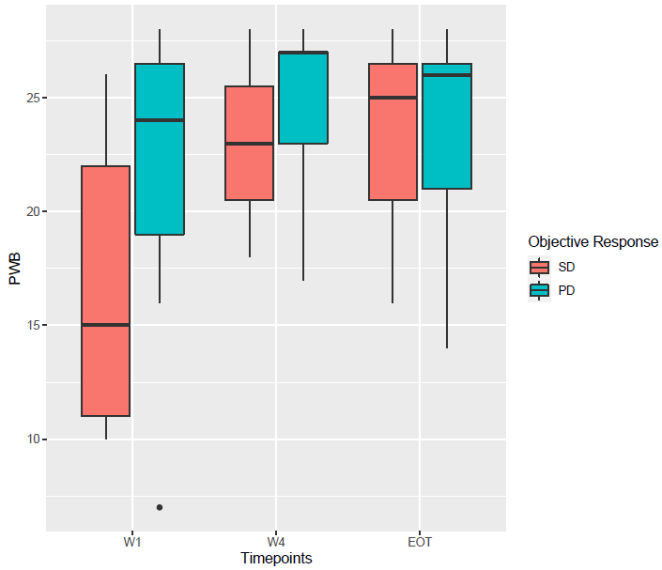
Abbreviations: EOT: end of treatment; PD: progressive disease; PWB: physical well-being; SD: stable disease; W1: week 1; W4: week 4.

