Figure S5. Physical Welling-Being Over Time
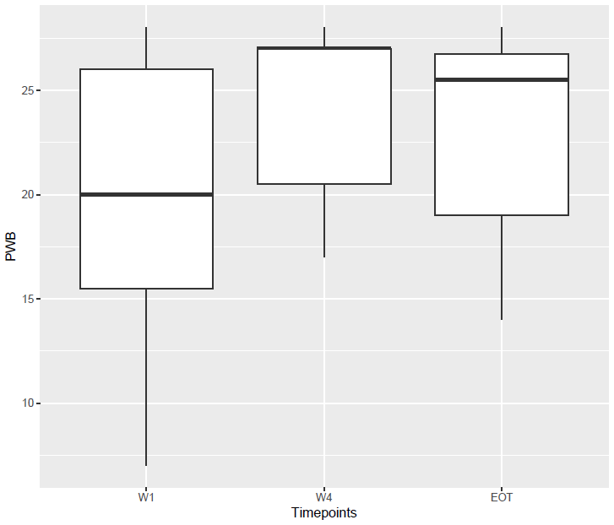
Abbreviations: EOT: end of treatment; PWB: physical well-being; W1: week 1; W4: week 4.

