S4. Residuals analysis of joint shared random effect model
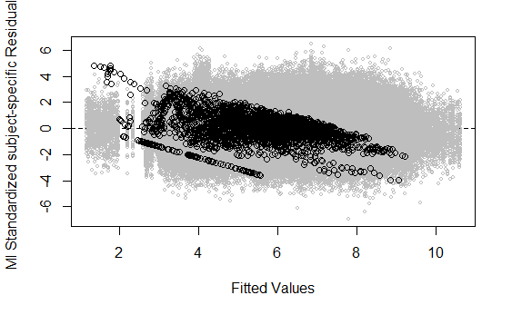
Residuals analysis of the joint shared random effect model with multiple imputation (in grey) to tackle the problem of dropout during the follow-up.

