TITLE: TAK-676: A Novel Stimulator of Interferon Genes (STING) Agonist Promoting Durable Interferon-Dependent Anti-Tumor Immunity in Preclinical Studies

Authors:
Elizabeth Carideo Cunniff¹*, Yosuke Sato¹*, Doanh Mai¹*, Vicky A. Appleman¹, Shinji Iwasaki², Vihren Kolev¹, Atsushi Matsuda², Judy Shi¹, Michiyo Mochizuki², Masato Yoshikawa², Jian Huang¹, Luhua Shen¹, Satyajeet Haridas¹, Vaishali Shinde¹, Chris Gemski¹, Emily R. Roberts¹, Omid Ghasemi^{1†}, Hojjat Bazzazi^{1‡}, Saurabh Menon¹, Tary Traore^{1§}, Pu Shi^{1¶}, Tennille D. Thelen¹**, Joseph Conlon^{1††}, Adnan O. Abu-Yousif¹, Christopher Arendt¹, Michael H. Shaw¹, and Masanori Okaniwa¹

*Authors contributed equally to this manuscript

Affiliations:
¹Takeda Development Center Americas, Inc. (TDCA), Lexington, MA, USA
²Takeda Pharmaceutical Company, Ltd., Fujisawa, Kanagawa, Japan
†Current affiliation: Invicro, LLC, Needham, MA, USA
‡Current affiliation: Cytomx Therapeutics, South San Francisco, CA, USA
§Current affiliation: TScan Therapeutics, Waltham, MA, USA
¶Current affiliation: BeiGene, Cambridge, MA, USA
**Current affiliation: Atara Biotherapeutics, Inc., South San Francisco, CA, USA
††Current affiliation: Pfizer, Inflammation and Immunology, Cambridge, MA, USA

Corresponding authors:
Michael H. Shaw
Takeda Development Center Americas, Inc. (TDCA), 95 Hayden Avenue, Lexington, MA 02421, USA
Email: michael.shaw2@takeda.com
Phone: +1 (617) 761-6834

Masanori Okaniwa
Takeda Development Center Americas, Inc. (TDCA), 95 Hayden Avenue, Lexington, MA 02421, USA
Email: Masanori.Okaniwa2@takeda.com
Phone: +1 (617) 444-1596
Authors’ Disclosures
YS, ECC, DM, VAA, SI, VK, AM, JS, MM, MY, JH, LS, SH, VS, CG, ERR, HB, SM, TT, PS, JC, AOA-Y, CWA, MHS, MO disclose employment with Takeda. OG discloses previous employment with Takeda and current employment with Invicro, LLC. TDT discloses previous employment with Takeda and current employment with Atara Biotherapeutics, Inc.

SUPPLEMENTAL FIGURES

Supplementary Figure 1. Cell viability of A, human monocyte derived dendritic cells by TAK-676 at 24 hours from 5 donors, and B, of mouse bone marrow derived dendritic cells up to 72 hours from 2 donors.
Supplementary Figure 2. Mean plasma (left) and tumor (right) concentration–time curves of TAK-676 in BALB/c mice bearing A20 tumors after intravenous administration of TAK-676 at 0.025, 0.125, 0.25, 0.5, and 2 mg/kg.

Supplementary Figure 3. Mean percent body weight change over time in: A, BALB/c mice bearing CT26.WT syngeneic tumors; B, BALB/c mice bearing A20 syngeneic tumors; All data shown are representative of at least three independent experiments.

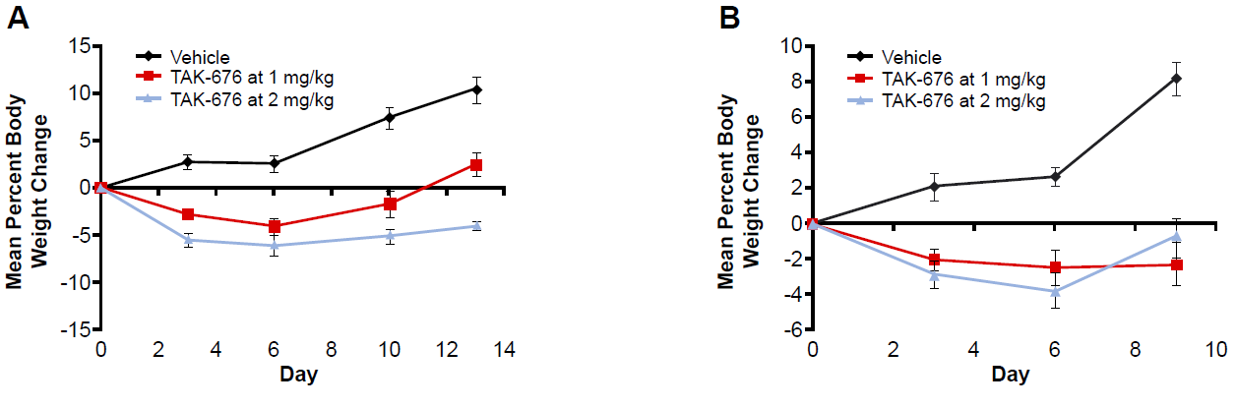

Supplementary Figure 4. Mean percent body weight change over time in WT or STING-deficient C57BL/6J-Tmem173gt/J (Goldenticket) mice bearing STING WT or deficient B16-F10 syngeneic tumors dosed with vehicle or TAK-676.
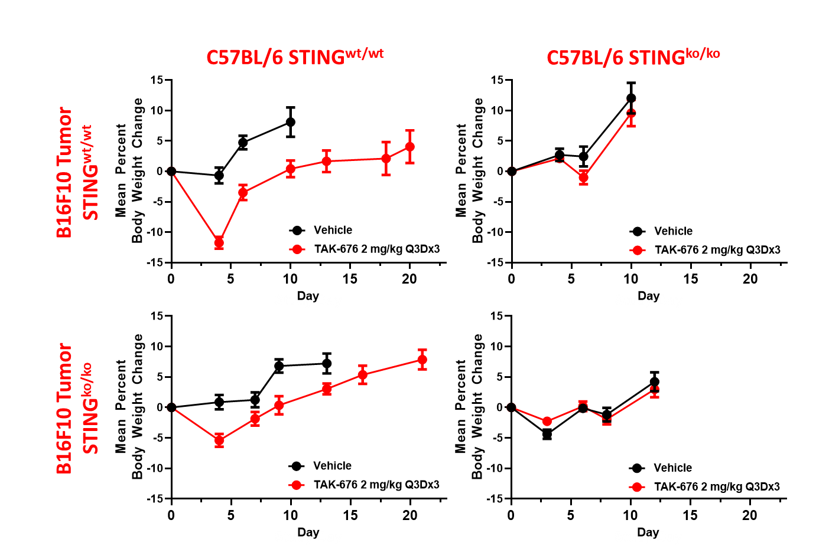
Supplementary Figure 5. Cytokine responses in plasma (left) and tumor (right) in A20 tumor-bearing mice following exposure to a single intravenous dose of vehicle or TAK-676: A, TNF-α; B, MCP-1; and C, IL-6. All data shown are representative of at least three independent experiments.
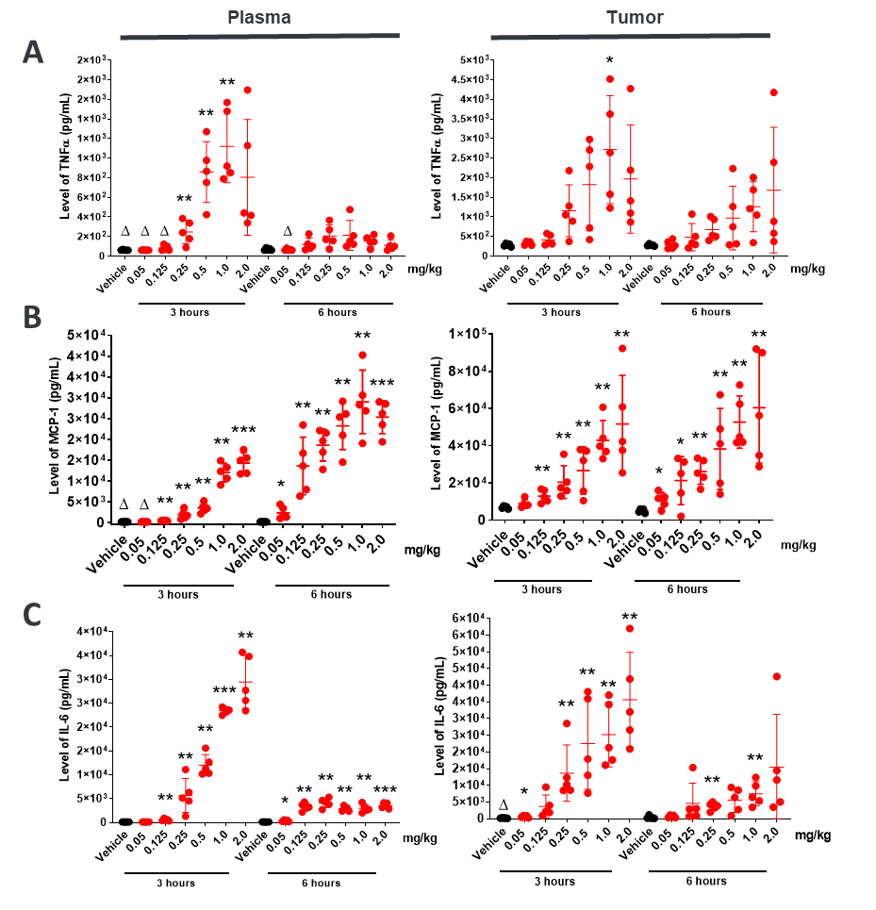Δ: Indicates that some samples in this group had values below the lower limit of quantitation of the assay or had values extrapolated beyond the standard range.
*: p value ≤ 0.05 relative to vehicle control.
**: p value ≤ 0.01 relative to vehicle control.
***: p value < 0.000001 relative to vehicle control.

