Supplementary Data to

Stromal FAP expression is associated with MRI visibility and patient survival in prostate cancer
Teijo Pellinen^{1,$,#}, Kevin. Sandeman^{2,3,$}, Sami Blom^{1,*}, Riku Turkki^{1,4,**}, Annabrita Hemmes¹, Katja Välimäki¹, Juho Eineluoto^{3,5}, Anu Kenttämies⁶, Stig Nordling², Olli Kallioniemi^{1,4}, Antti Rannikko^{3,5,7}, Tuomas Mirtti^{2,3,7}

¹Institute for Molecular Medicine Finland (FIMM), Helsinki Institute of Life Science (HiLIFE), University of Helsinki, Helsinki, Finland
²Department of Pathology, University of Helsinki and Helsinki University Hospital, Finland.
³Research Program in Systems Oncology, Faculty of Medicine, University of Helsinki, Finland.
⁴Science for Life Laboratory, Department of Oncology & Pathology, Karolinska Institutet, Stockholm, Sweden
⁵Department of Urology, University of Helsinki and Helsinki University Hospital, Finland.
⁶Department of Radiology, University of Helsinki and Helsinki University Hospital, Finland.
⁷iCAN-Digital Precision Cancer Medicine Flagship, Helsinki, Finland.
$Shared first author
*Affiliation at the time the work was conducted; now affiliated with Aiforia Technologies Oy, Helsinki, Finland.
**Affiliation at the time the work was conducted; now affiliated with AstraZeneca, Gothenburg, Sweden.
#Corresponding author: Dr Teijo Pellinen, Institute for Molecular Medicine Finland (FIMM), Helsinki Institute of Life Science (HiLIFE), University of Helsinki, Tukholmankatu 8, 00290, Helsinki, Finland. Tel. +358503005688. Email: teijo.pellinen@helsinki.fi

Supplementary Tables and Figures

Table S1. Patient clinical characteristics, cohort I (MRI-RALP), N=343.

Pre-operative clinical data
Age (years)
Median | 64.8
Range (min-max) | 43–79
cT
1 | 223
2 | 65
3–4 | 55
PSA (ng/ml)
Median | 8.9
Range (min-max) | 1.23–84
d'Amico risk
1 | 39
2 | 181
3 | 122
CAPRA risk
1 | 45
2 | 174
3 | 90
Pre-operative MRI data
MRI prostate volume
Median | 35
Range (min-max) | 12–125
MRI foci (N)
0 | 26
1 | 203
2 | 84
3 | 29
4 | 1
MRI PI-RADS
0 | 26
1 | 2
2 | 8
3 | 24
4 | 37
5 | 245
MRI capsular contact
0 (no) | 111
1 (maybe) | 163
2 (yes) | 69
MRI capsular contact
Median (mm) | 12
Range (mm) | 0–76
MRI EPE
no | 221
yes | 122
MRI EPE PI-RADS
0 | 174
1 | 41
2 | 0
3 | 17
4 | 59
5 | 52
MRI T classification
0 | 31
1c | 4
2 | 27
2a | 87
2b | 4
2c | 56
3 | 16
3a | 72
3b | 31
4 | 15
MRI N classification
0 | 336
1 | 6
2 | 1
Post-operative clinical data
Prostate weight
Median (g) | 48
Range (g) | 22–119
Tumor Foci (n) | 342
1 | 101
2 | 120
3 | 75
4 | 36
5 | 6
6 | 2
7 | 1
8 | 1
Cancer proportion (%)
Median | 15
Range (min-max) | 3–100
GGG | 343
1 | 14
2 | 135
3 | 152
4 | 10
5 | 32
Positive margin
no | 249
yes | 92
EPE
no | 215
yes | 115
If yes. median (mm) | 6
PNI
no | 40
yes | 303
SVI
no | 301
yes | 42
pTNM
2 | 208
3–4 | 135

cT, clinical tumor staging; PI-RADS, Prostate Imaging Reporting and Data System; MRI foci (N), number of tumor foci with MRI data; EPE, extra prostatic extension; GGG, Gleason Grade Group; PNI, perineural invasion; SVI, seminal vesicle invasion; pTNM, pathological stage.

Table S2. Patient clinical characteristics, cohort II (RP cohort); N=319.

Follow-up time after surgery (median years) | 16.5
Death from any cause (N) | 127
Death from PCa (N) | 26
Biochemical recurrence (N) | N/A*
Age (years)
Median | 64
Range (min-max) | 45–76
RP cancer proportion (%)
Median | 15
Range (min-max) | 0–90
RP Gleason score
5 | 11
6 | 74
7 | 186
8 | 37
9 | 10
pT
≤2 | 184
≥3 | 127
*This series was collected partly prior to routine PSA follow-up

Table S3. MRI protocol details.

Sequence | Slice thickness (mm) | Resolution (mm) | b-values | Temporal resolution (s) | Acquisition time (s) | Flip Angle
T2 | 3 | 0,6 x 0,7
DWI¹ for calculating ADC² | 3 |  | 0, 100, 800
DWI for detection | 3 |  | 2000
DCE³ | 4 |  |  | 8 | 180 | 10

¹Diffusion-weighted imaging, ²apparent diffusion coefficient, ³Dynamic contrast-enhanced (Dotarem®, 0.2 ml/kg, 2 ml/s).

Table S4. TMA spot-level correlations of stromal mfIHC variables (Spearman rho) in cohort I.

Variable | CD163 cells | CD8 cells | FAP cells | SMA cells
CD163-pos cells | 1 | 0.51** | 0.43** | -0.21**
CD8-pos cells | 0.51** | 1 | 0.44** | -0.17**
FAP-pos cells | 0.43** | 0.44** | 1 | -0.30**
SMA-pos cells | -0.21** | -0.17** | -0.30** | 1

**P-value<0.01, two tailed, N=1606 TMA cores.

Table S5. Patient-level correlations of mfIHC variables with genomic alterations (PTEN status, ERG status), Gleason grade grouping (GGG), and BCR status (Spearman rho) in cohort I.

Variable | PTEN_MRI- | PTEN_MRI+ | ERG_MRI- | ERG_MRI+ | GGG | BCR status
CD163_Be | 0.08 | 0.01 | 0.00 | -0.05 | 0.02 | 0.05
CD163_MRI- | -0.02 | 0.06 | 0.14* | 0.05 | -0.02 | 0.04
CD163_MRI+ | 0.11 | -0.16** | 0.01 | 0.19** | 0.07 | 0.00
CD8_Be | 0.07 | -0.11 | 0.01 | -0.02 | 0.06 | 0.09
CD8_MRI- | 0.01 | -0.06 | 0.05 | 0.03 | -0.03 | 0.06
CD8_MRI+ | 0.09 | -0.10 | 0.07 | 0.08 | -0.21* | -0.10
FAP_Be | 0.03 | -0.10 | 0.02 | -0.03 | -0.02 | 0.07
FAP_MRI- | -0.15* | -0.04 | 0.09 | 0.00 | -0.09 | 0.00
FAP_MRI+ | 0.20* | -0.31** | -0.02 | 0.06 | 0.14* | 0.14*
SMA_Be | -0.15 | -0.04 | 0.03 | 0.02 | -0.06 | -0.15*
SMA_MRI- | -0.05 | 0.00 | 0.09 | 0.03 | -0.09 | -0.08
SMA_MRI+ | -0.08 | 0.16** | 0.20* | 0.15** | -0.30** | -0.24**

*P-value<0.05, two tailed, **P-value<0.01, two tailed, N(Be)=272, N(MRI-)=197, N(MRI+)=302.

Table S6. Crosstab association analysis of FAP and SMA with PTEN, ERG, GGG, and BCR status in cohort I TMA cores representing MRI-visible regions (chromogenic staining).

 | FAP |  |  | SMA
Variable | Low (N=139) | High (N=140) | P | Low (N=151) | High (N=151) | P
PTEN |  |  | <0.001 |  |  | 0.424
Neg (n=42) | 8(19%) | 34(81%) |  | 22 (52%) | 20 (48%)
Pos (n=237) | 131(55%) | 106(45%) |  | 139 (50%) | 140 (50%)
ERG |  |  | 0.148 |  |  | 0.026
Neg (n=210) | 104 (53%) | 47 (49%) |  | 106 (54%) | 91 (46%)
Pos (n=92) | 35 (43%) | 47 (57%) |  | 33 (40%) | 49 (60%)
GGG |  |  | 0.15 |  |  | 0.004
1 (n=6) | 5 (83%) | 1 (17%) |  | 5 (83%) | 1 (17%)
2 (n=112) | 52 (51%) | 50 (49%) |  | 38 (37%) | 64 (63%)
3 (n=143) | 69 (52%) | 64 (48%) |  | 77 (55%) | 56 (45%)
4 (n=10) | 3 (30%) | 7 (70%) |  | 7 (60%) | 3 (40%)
5 (n=31) | 10 (36%) | 18 (64%) |  | 12 (77%) | 16 (23%)
BCR |  |  | 0.004 |  |  | 0.459
No (n=248) | 131 (53%) | 116 (47%) |  | 121 (49%) | 126 (51%)
Yes (n=32) | 8 (25%) | 24 (75%) |  | 18 (56%) | 14 (44%)
na (n=42)

¹P-value (Fisher’s exact when applicable, chi-square when not). Significant P-values are shown in bold.

Table S7. AUROC analysis for risk prediction models.
AUROC risk model | Variables | AUC of roc | P
1 | Age, CAPRA, GGG, pTNM | 0.7806
2 | FAP, Age, CAPRA, GGG, pTNM | 0.7915 | 0.6141

¹P, P-value (DeLong’s test). AUROC, area under receiver operating characteristic (ROC) curve.

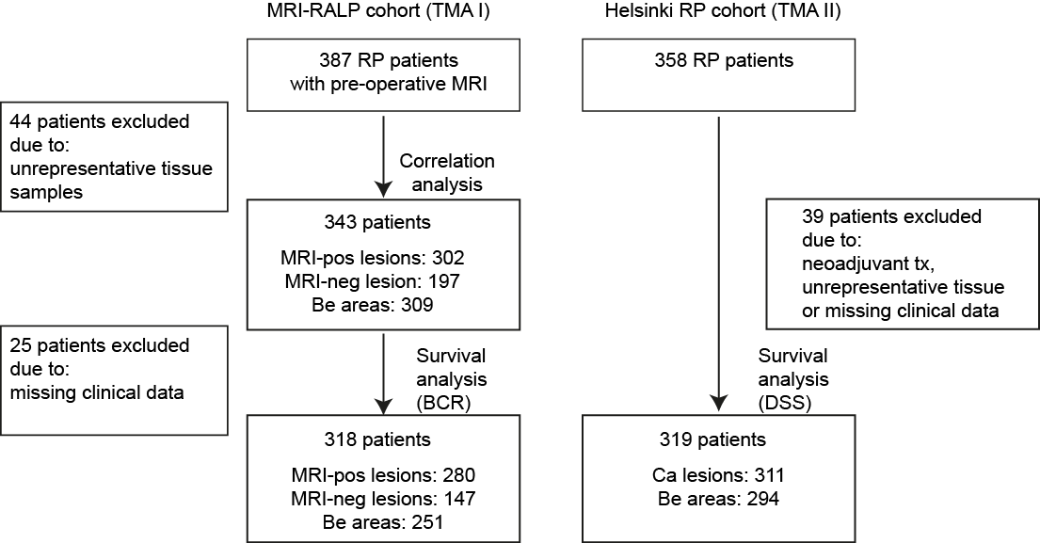

Figure S1. REMARK diagram. Study inclusion and exclusion criteria for prostate cancer patient samples in the MRI-RALP (cohort I) and RP (cohort II) cohorts. MRI, magnetic resonance imaging; RALP, robotic assisted laparoscopy prostatectomy; RP, radical prostatectomy; MRI-pos, MRI true-positive; MRI-neg, MRI false-negative; Be, benign; Ca, cancer; BCR, biochemical recurrence; DSS, disease-specific survival; tx=therapy.

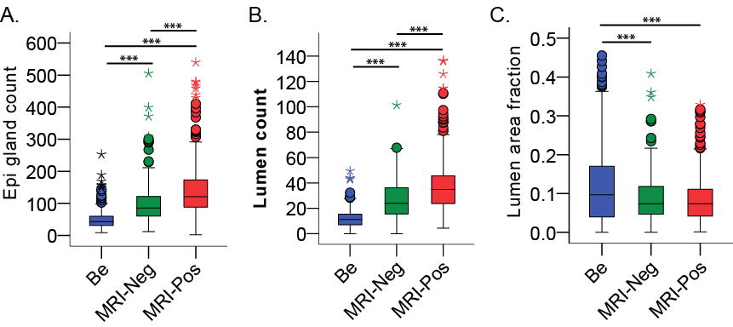

Figure S2. Tissue compartment differences in benign tissue areas, MRI false-negative cancer lesions, and MRI true-positive cancer lesions. A. Epithelial (Epi) gland count in each patient (N=343) as normalized by total tissue TMA core area and averaged by replicates. B. Lumen count in each patient TMA core as normalized by total tissue TMA core area and averaged by replicates. C. Lumen area fraction from total tissue area in a TMA core for each patient average of replicates. Pairwise nonparametric Mann-Whitney with asymptotic 2-tailed significances are shown (***P<0.001).

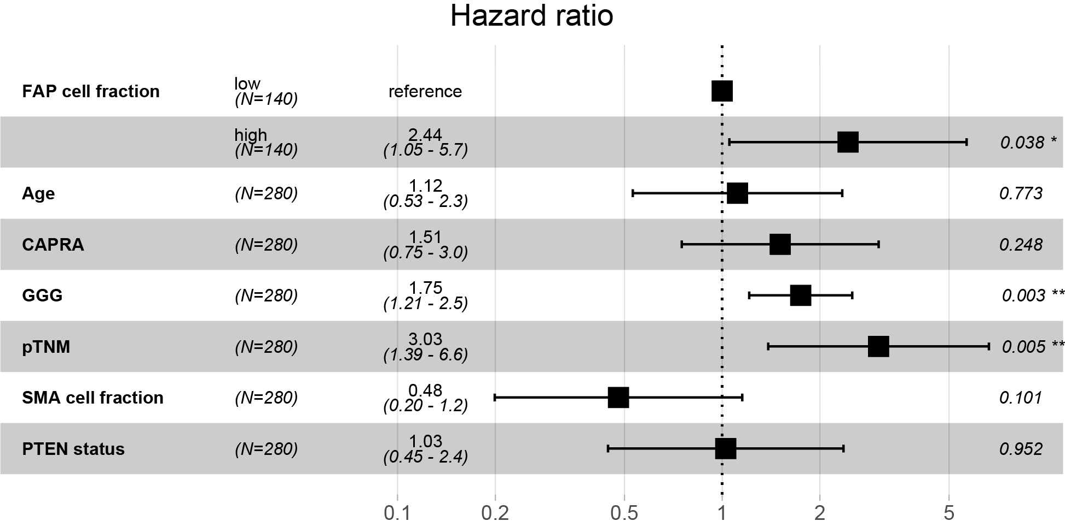
Figure S3. Stromal FAP positive cell fraction is an independent predictor of BCR in true-positive MRI lesions in cohort I (Multiplex mfIHC measurements). Multivariable Cox regression survival analysis with median dichotomized FAP and SMA, as measured using mfIHC in stromal cells. FAP and SMA positive stromal cell fractions were adjusted with Age (median cut-off 65 years), pre-operative CAPRA risk (scores 1 to 3), post-operative Gleason grade group (GGG scores 1 to 5), pathological TNM stage (pTNM; 2 vs. 3-4), as well as with stromal SMA cell fraction (median cut-off) and tumor PTEN status (null vs. positive). *P-value<0.05, **P-value<0.01 (two tailed).

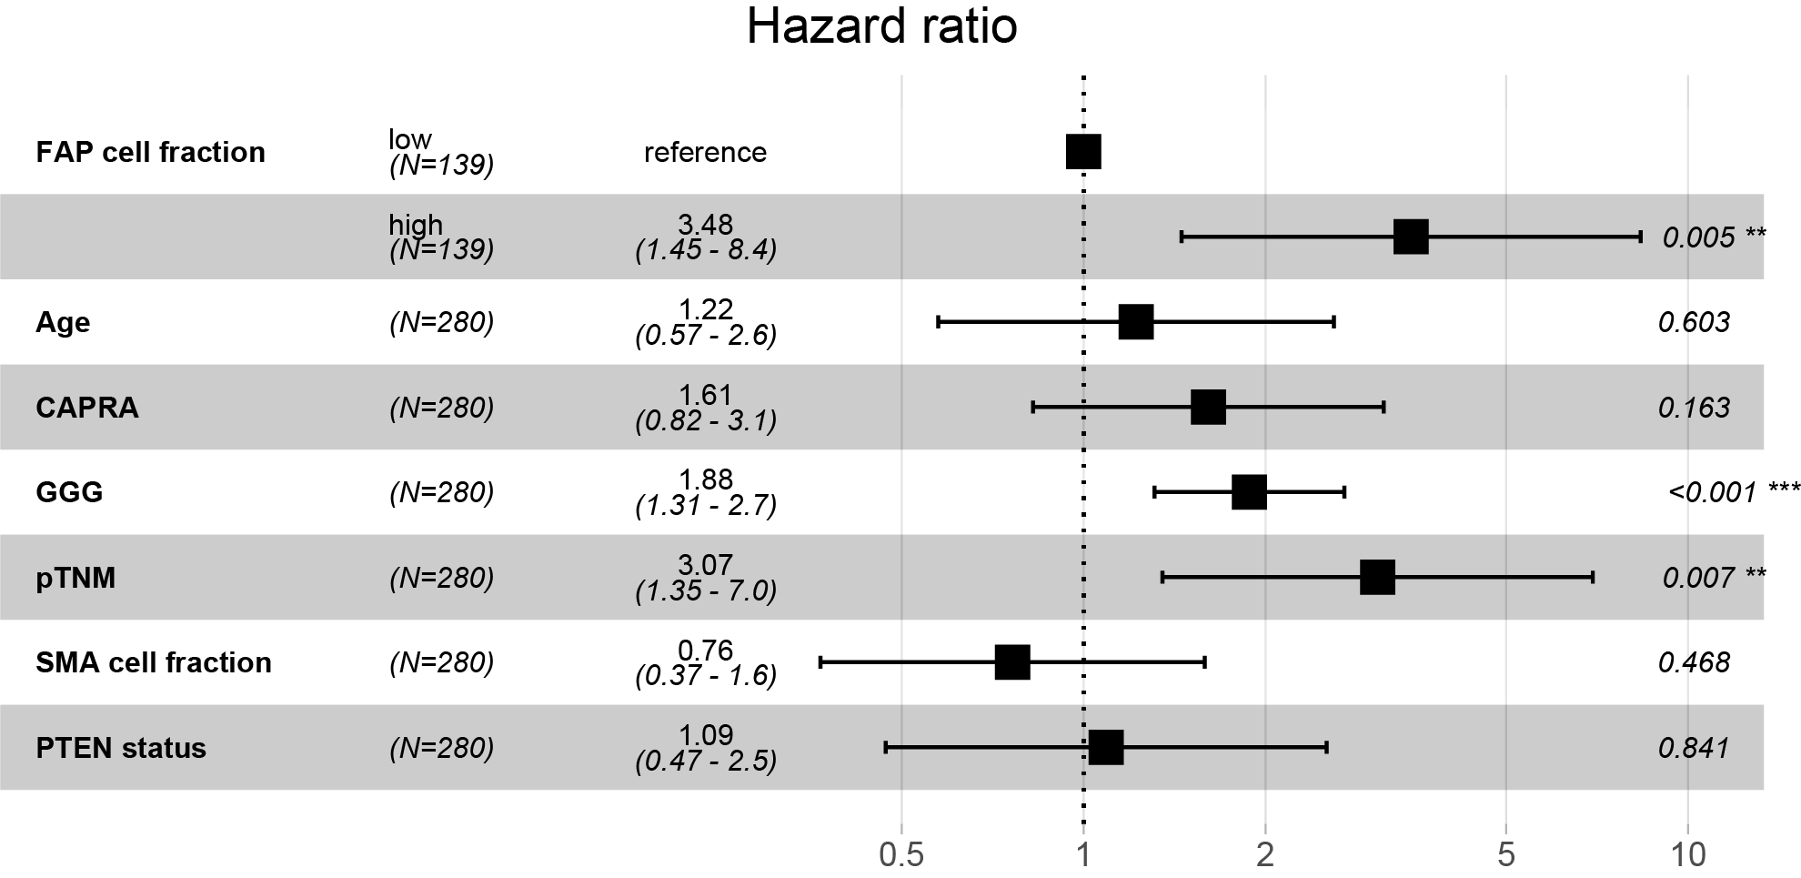
Figure S4. FAP positive cell fraction is an independent predictor of BCR in true-positive MRI lesions in cohort I (chromogenic IHC + machine learning measurements). Multivariable Cox regression survival analysis with median dichotomized FAP and SMA, as measured using conventional IHC and machine learning in cells of total tissue. FAP and SMA positive stromal cell fractions were adjusted with Age (median cut-off 65 years), pre-operative CAPRA risk (scores 1 to 3), as well as post-operative Gleason grade group (GGG scores 1 to 5), pathological TNM stage (pTNM; 2 vs. 3-4), as well as with stromal SMA cell fraction (median cut-off) and tumor PTEN status (null vs. positive). *P-value<0.05, **P-value<0.01 (two tailed).

