Supplementary Materials and Methods
Fig. S1. Profiling of each CD44 exon expression in tumor cells. (A-B) CD44 exons expression in different types of tumors were obtained from the TSVdb database. Heat map showed CD44 exons expression in different tumor tissues and corresponding normal tissues (A). Heat map showed relative expression of CD44 exons in indicated tumors, which were normalized to the expression level in normal tissues (B). (C) Statistical analysis of CD44 exons expression in ICC and corresponding normal tissues. (D) Statistical analysis of CD44 splicing variants (as indicated in Fig. 1A) expression in ICC and corresponding normal tissues. Data represent as mean ± SEM. ns. not significant; p < 0.05, *; p < 0.001, ***. (two-way ANOVA with Dunnett's multiple comparisons test).
Fig. S2. Profiling of CD44v expression in several cancer cell lines. (A) mRNA was extracted from indicated several cancer cell lines and transcribed into cDNA by reverse transcriptase reaction. cDNA (20-50 ng) was subjected to PCR analysis with primers targeted to exons 5 and 16 of human CD44 (forward: 5’- ATCCCAGACGAAGACAGTCCC-3; reverse: 5’ – TGTTTGCTCCACCTTCTTGAC -3’). The positions of PCR products were shown as indicated (CD44s: 160 bp; CD44v: 289-3200 bp). GAPDH expression was used as a loading control. (B) Venn diagram shows differences among gene clusters that co-expressed with CD44 exon. The exon 8 and exon 9 exhibit similar expression pattern, that significantly differed with other exons.
Fig. S3. Screening, characterization and validation strategy for mAb targeting CD44v5. (A) Schematic representation of screening strategy for mAb targeting CD44v5. (B-C) The hybridoma-derived murine mAbs were preliminarily screened by ELISA. The candidate mAbs were subjected to WB and FCM for further validation. Representative image of WB (B) and FCM (C) for examination of binding activity and specificity of candidate mAbs. (D) The affinity of murine candidate mAbs (2H10, 2A5, and 1D8) and humanized mAb (H1D8) were characterized by using Surface Plasmon Resonance (SPR). SPR sensorgrams (top) and binding affinity of the mAbs-antigens interaction as indicated (bottom).
Fig. S4. Humanization, eukaryotic expression and purification of anti-CD44v5 mAb. (A) Schematic representation of humanization of anti-CD44v5 murine mAb1D8. The complementary determining regions (CDRs) were grafted from murine variable regions onto the human IgG1/k constant regions. (B) Schematic representation of eukaryotic expression and purification strategy for humanized mAb H1D8. The heavy chain and light chain were cloned into pcDNA3.4, and 293F cells were applied for H1D8 production. The H1D8 were purified by protein A affinity chromatography. (C) SDS-page analysis of purified humanized H1D8 mAb. Reduced and non-reduced samples (5 μg) were subjected to SDS-page. The molecular weight marker (kDa) is indicated on the left. The arrows showed the monomer heavy chain/light chain, and heterodimer as indicated.
Fig. S5. Identification of the epitope for humanized mAb H1D8. (A) The variable exons were deleted one-by-one, in order to identify the potential epitope for H1D8. Each truncated CD44 proteins were fused with Flag tag. Schematic image for truncated CD44 construction (left). WB analysis of truncated CD44v via H1D8, and anti-Flag mAb was used as loading control (right).
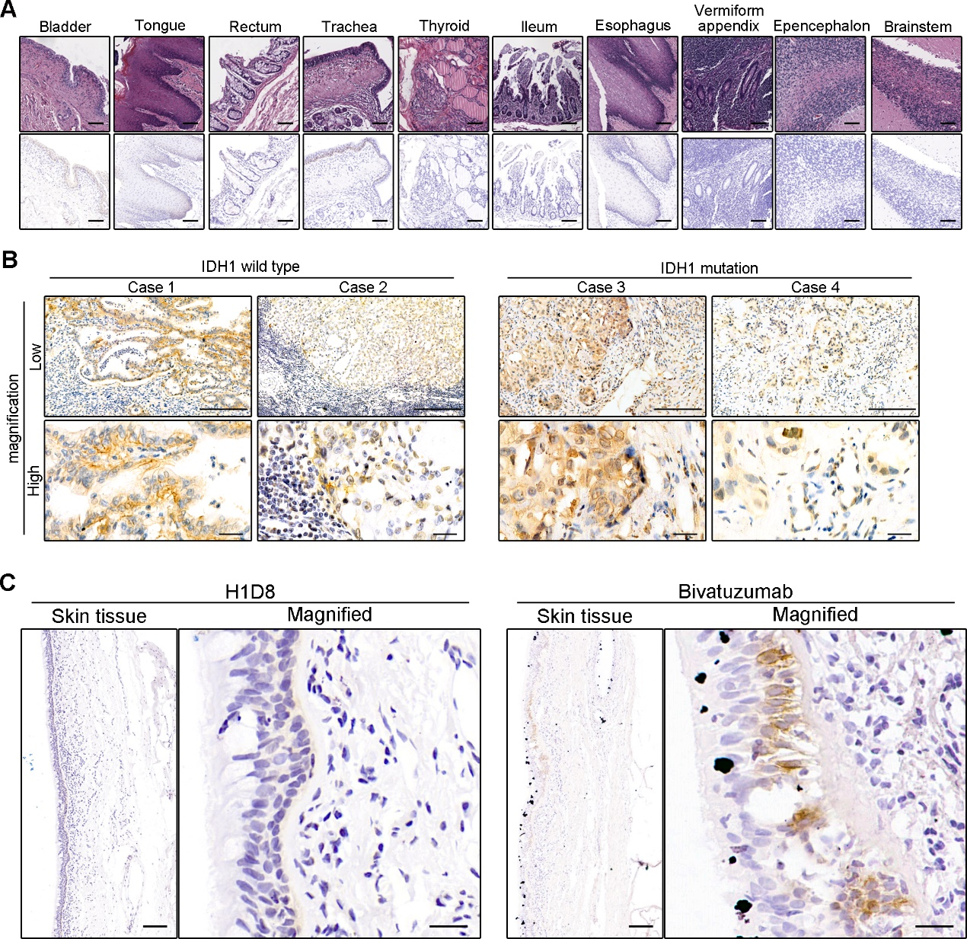
Fig. S6. Expression profile of CD44v5 across human normal and ICC tumor tissues. (A-B) Human normal tissues (as indicated) and ICC tumor tissues (including wildtype IDH1, and IDH1 mutation) were subjected to IHC via H1D8 for detection CD44v5 expression. Representative H&E images (top) and IHC images (bottom) for detection CD44v5 expression profile in human normal tissues (A). Scale bar = 100 μm. Representative IHC images for detection CD44v5 expression in human ICC tumor tissues with/without IDH1 mutation (B). Scale bar = 200 μm (low magnification) and 25 μm (high magnification). (C) Representative IHC image for detection of CD44v5 and CD44v6 expression in human normal skin tissues, via H1D8 mAb and Bivatuzumab respectively. Scale bar = 200 μm and 20 μm (magnified field).
Fig. S7. Characterization of H1D8-DC. (A) SDS-page analysis of H1D8 and H1D8-DC. (B) Hydrophobic interaction chromatography (IHC) of H1D8-DC (up). Free mAb was identified as unlabeled H1D8 based on the HPLC retention time and UV spectrum. The drug-to-antibody values was calculated according to the percentage peak area information (down).
Fig. S8. Enhanced cytotoxicity of H1D8-DC against CD44v5-positive/CTSB-high cancer cells, but not CD44v5-negative/CTSB-low cell lines. (A) Representative image of flow cytometric analysis of CD44v5 expression on the surface of several human cancer cells by using H1D8 mAb. (B) Immunoblotting of CTSB expression in indicated cell lines. GAPDH expression was used as a loading control. (C-J) Indicated cells were treated with H1D8-DC in indicated concentration for 48 h. Viability of the human non-malignant cell lines (C), breast cancer cell lines (D), melanoma cell line (E), gastric cell lines (F), pancreatic carcinoma cell line (G), hepatocarcinoma cell line (H) and keratinocyte cell line (I). Statistical analysis of expressions of CD44v5 and CTSB (J, top), and cytotoxicity (J, bottom) in indicated cell lines. (K) Viability of human keratinocyte cell line, HaCat, incubated with bivatuzumab mertansine (67 nM) or H1D8-DC (67 nM), respectively. Data represent as mean ± SEM.
Fig. S9. CTSB expression profile in Pan-cancer and corresponding normal tissues. (A) Statistical analysis of CTSB expression in pan-cancer and corresponding normal tissues constructed by GEPIA (TCGA). Horizontal bars represent the mean. (B) RT-qPCR analysis of CTSB mRNA expression in human ICC tumors and corresponding normal tissues (n=14). p < 0.001, ***. (paired Student’s t test with Welch's correction). (C-D) Representative IHC images for CTSB expression in human melanoma tumor tissue, corresponding normal skin tissue (C), and ICC tumor tissues (D) what were applied for PDX construction. Scale bar = 500 μm (C, left) and 50 μm (C, right; and D).
Fig. S10. Characterization of H1D8-DC. (A) H1D8-DC were stored in indicated conditions. Viability of CD44v-OE cells treated with stored H1D8-DC with indicated concentration (A, top). EC₅₀ was calculated (A, bottom), and used to indicate the in vitro stability. (B) Mouse pharmacokinetics of H1D8 and H1D8-DC. (C) H1D8-DC was intravenously injected into nude mice, and peripheral blood was collected after indicated time. The same concentration of H1D8-DC collected in indicated time, identified by ELISA, were added into CD44v-OE cells. Statistical analysis showed cell viability. ns, not significant. (one-way ANOVA, Dunnett’s multiple comparisons test)

