Computational and Functional Analyses of HER2 Mutations Reveal Allosteric Activation Mechanisms and Altered Pharmacologic Effects

Ishiyama et al.

SUPPLEMENTARY INFORMATION

Supplementary Table S1. List of the 35 previously determined HER2 oncogenic mutations (29).

Oncogenic HER2 mutationª | Domain involved
G309A | ECD (CR1)
S310F | ECD (CR1)
S310Y | ECD (CR1)
C311R | ECD (CR1)
E321G | ECD (CR1)
C334S | ECD (CR1)
S653C | TMD
V659E | TMD
L663P | TMD
R678Q | JMD
Q709L | JMD
L755-T759del | KD
L755P | KD
L755S | KD
I767M | KD
D769Y | KD
D769H | KD
E770-A771insAYVM | KD
Y772-A775dup | KD
M774-A775insAYVM | KD
A775-G776insYVMA | KD
G776-V777insYVMA | KD
G776V | KD
G776delinsVC | KD
G776delinsLC | KD
V777L | KD
G778-P780dup | KD
G778-S779insG | KD
P780-Y781insGSP | KD
L841V | KD
V842I | KD
T862A | KD
L866M | KD
L869R | KD
R896C | KD
ªThese mutations can be found in the OncoKB database (https://www.oncokb.org/).
CR, cysteine-rich; del, deletion; delins, deletion-insertion; dup, duplication; ECD, extracellular domain; ins, insertion; JMD, juxtamembrane domain; KD, kinase domain; TMD, transmembrane domain.

Supplementary Table S2. Validation of 111 HER2 mutations by Ba/F3 cell proliferation assay allowed identification of 37 oncogenic driver mutations and 74 neutral mutations

HER2 mutation | Domain involved | Fold growthª (mean ± SEM) | MAP score | Validation results | VAF mean | VAF min | VAF max
R34W | ECD (L1) | <1 | 0.04 | Neutral mutation | 0.28 | 0.07 | 0.48
R47H | ECD (L1) | <1 | 0.31 | Neutral mutation | 0.34 | 0.15 | 0.53
G58R | ECD (L1) | 3.24 ± 0.08 | 0.33 | Oncogenic driver mutation | 0.14 | 0.10 | 0.19
T67A | ECD (L1) | <1 | 0.13 | Neutral mutation | 0.47 | 0.47 | 0.47
R103Q | ECD (L1) | 7.45 ± 0.05 | 0.39 | Oncogenic driver mutation | 0.22 | 0.04 | 0.50
P122L | ECD (L1) | 3.69 ± 0.04 | 0.28 | Oncogenic driver mutation | 0.35 | 0.09 | 0.49
R143Q | ECD (L1) | <1 | 0.31 | Neutral mutation | 0.48 | 0.45 | 0.52
G151E | ECD (L1) | <1 | 0.16 | Neutral mutation | 0.05 | 0.05 | 0.05
R157Q | ECD (L1) | <1 | 0.13 | Neutral mutation | 0.29 | 0.18 | 0.49
R188H | ECD (L1) | <1 | 0.14 | Neutral mutation | 0.31 | 0.11 | 0.47
R217H | ECD (CR1) | <1 | 0.04 | Neutral mutation | 0.33 | 0.33 | 0.33
V219I | ECD (CR1) | 3.27 ± 0.07 | 0.64 | Oncogenic driver mutation | 0.28 | 0.28 | 0.28
G229R | ECD (CR1) | 3.07 ± 0.04 | 0.61 | Oncogenic driver mutation | 0.07 | 0.07 | 0.07
S250F | ECD (CR1) | <1 | 0.13 | Neutral mutation | 0.15 | 0.05 | 0.25
I263T | ECD (CR1) | <1 | 0.37 | Neutral mutation | 0.28 | 0.28 | 0.28
T273I | ECD (CR1) | <1 | 0.11 | Neutral mutation | 0.55 | 0.55 | 0.55
G292C | ECD (CR1) | 4.19 ± 0.33 | 0.72 | Oncogenic driver mutation | 0.10 | 0.10 | 0.10
G292R | ECD (CR1) | 2.25 ± 0.08 | 0.74 | Oncogenic driver mutation | 0.22 | 0.10 | 0.37
A293T | ECD (CR1) | 4.46 ± 0.21 | 0.13 | Oncogenic driver mutation | 0.28 | 0.13 | 0.44
S310F | ECD (CR1) | 3.99 ± 0.03 | 0.78 | Oncogenic driver mutation | 0.30 | 0.02 | 0.98
S310Y | ECD (CR1) | 3.52 ± 0.12 | 0.68 | Oncogenic driver mutation | 0.33 | 0.02 | 0.91
R340Q | ECD (CR1) | <1 | 0.08 | Neutral mutation | 0.31 | 0.05 | 0.50
C342Y | ECD (L2) | <1 | NA^{b} | Neutral mutation | 0.18 | 0.18 | 0.19
G346R | ECD (L2) | <1 | 0.37 | Neutral mutation | 0.12 | 0.12 | 0.12
G346V | ECD (L2) | <1 | 0.31 | Neutral mutation | 0.20 | 0.20 | 0.20
I370M | ECD (L2) | <1 | 0.11 | Neutral mutation | 0.56 | 0.56 | 0.56
P378L | ECD (L2) | <1 | 0.11 | Neutral mutation | 0.27 | 0.17 | 0.38
V424I | ECD (L2) | <1 | 0.07 | Neutral mutation | 0.51 | 0.37 | 0.72
R434Q | ECD (L2) | 4.02 ± 0.30 | 0.14 | Oncogenic driver mutation | 0.35 | 0.20 | 0.43
H470Q | ECD (L2) | <1 | 0.56 | Neutral mutation | 0.58 | 0.58 | 0.58
D483N | ECD (L2) | <1 | NA^{b} | Neutral mutation | 0.00 | 0.00 | 0.00
R487Q | ECD (L2) | <1 | 0.09 | Neutral mutation | 0.54 | 0.40 | 0.84
A497T | ECD (L2) | <1 | 0.13 | Neutral mutation | 0.53 | 0.26 | 0.96
E507K | ECD (L2) | <1 | 0.04 | Neutral mutation | 0.18 | 0.10 | 0.29
A510T | ECD (CR2) | <1 | 0.07 | Neutral mutation | 0.71 | 0.71 | 0.71
A516T | ECD (CR2) | 3.34 ± 0.03 | 0.06 | Oncogenic driver mutation | 0.42 | 0.23 | 0.60
C520F | ECD (CR2) | <1 | 0.05 | Neutral mutation | 0.30 | 0.18 | 0.41
G549E | ECD (CR2) | <1 | 0.55 | Neutral mutation | 0.07 | 0.07 | 0.07
Q568E | ECD (CR2) | <1 | 0.13 | Neutral mutation | 0.42 | 0.42 | 0.42
A588V | ECD (CR2) | 2.64 ± 0.10 | 0.21 | Oncogenic driver mutation | 0.35 | 0.06 | 0.64
K591M | ECD (CR2) | <1 | 0.26 | Neutral mutation | 0.49 | 0.49 | 0.49
F595L | ECD (CR2) | <1 | 0.15 | Neutral mutation | 0.20 | 0.13 | 0.27
G603C | ECD (CR2) | 3.15 ± 0.02 | 0.27 | Oncogenic driver mutation | 0.11 | 0.11 | 0.11
A622T | ECD (CR2) | <1 | 0.07 | Neutral mutation | 0.22 | 0.05 | 0.31
P625L | ECD (CR2) | <1 | N/Aª | Neutral mutation | 0.43 | 0.43 | 0.43
E645K | ECD (CR2) | <1 | 0.59 | Neutral mutation | 0.41 | 0.34 | 0.50
G660D | TMD | 2.80 ± 0.05 | 0.4 | Oncogenic driver mutation | 0.38 | 0.08 | 0.69
R678Q | JMD | 3.08 ± 0.03 | 0.76 | Oncogenic driver mutation | 0.27 | 0.02 | 1.00
G704R | JMD | <1 | 0.1 | Neutral mutation | 0.11 | 0.11 | 0.11
Q709L | JMD | 6.26 ± 0.59 | 0.57 | Oncogenic driver mutation | 0.25 | 0.06 | 0.47
E717V | KD | 5.50 ± 0.60 | 0.23 | Oncogenic driver mutation | 0.32 | 0.18 | 0.45
G727A | KD | <1 | 0.47 | Neutral mutation | 0.28 | 0.07 | 0.58
G732A | KD | <1 | 0.44 | Neutral mutation | 0.19 | 0.19 | 0.19
T733I | KD | 5.03 ± 0.04 | 0.73 | Oncogenic driver mutation | 0.36 | 0.04 | 0.94
V734F | KD | <1 | 0.08 | Neutral mutation | 0.45 | 0.45 | 0.45
A751T | KD | <1 | 0.18 | Neutral mutation | 0.29 | 0.29 | 0.29
L755S | KD | 3.23 ± 0.09 | 0.87 | Oncogenic driver mutation | 0.31 | 0.02 | 0.96
L755W | KD | <1 | 0.32 | Neutral mutation | 0.28 | 0.28 | 0.28
R756M | KD | <1 | NA^{b} | Neutral mutation | 0.00 | 0.00 | 0.00
D769H | KD | 3.25 ± 0.03 | 0.89 | Oncogenic driver mutation | 0.40 | 0.02 | 0.98
D769Y | KD | 3.11 ± 0.18 | 0.79 | Oncogenic driver mutation | 0.32 | 0.02 | 0.89
A775-G776insSVMA | KD | 3.41 ± 0.01 | NA^{b} | Oncogenic driver mutation | NA^{b} | NA^{b} | NA^{b}
A775-G776insVVMA | KD | 3.33 ± 0.05 | NA^{b} | Oncogenic driver mutation | NA^{b} | NA^{b} | NA^{b}
A775-G776insYVMA | KD | 3.82 ± 0.05 | NA^{b} | Oncogenic driver mutation | NA^{b} | NA^{b} | NA^{b}
A775V | KD | <1 | 0.25 | Neutral mutation | 0.20 | 0.09 | 0.31
G776V | KD | 2.93 ± 0.05 | 0.94 | Oncogenic driver mutation | 0.36 | 0.08 | 0.78
G776insVC | KD | 3.63 ± 0.07 | NA^{b} | Oncogenic driver mutation | NA^{b} | NA^{b} | NA^{b}
G776-V777insAVCV | KD | <1 | NA^{b} | Neutral mutation | NA^{b} | NA^{b} | NA^{b}
G776-V777insAVGCV | KD | <1 | NA^{b} | Neutral mutation | NA^{b} | NA^{b} | NA^{b}
G776-V777insLCV | KD | <1 | NA^{b} | Neutral mutation | NA^{b} | NA^{b} | NA^{b}
V777L | KD | 3.07 ± 0.04 | 0.87 | Oncogenic driver mutation | 0.41 | 0.03 | 0.94
V777-G778insC | KD | 2.57 ± 0.09 | NA^{b} | Oncogenic driver mutation | NA^{b} | NA^{b} | NA^{b}
P780-Y781insGSP | KD | 4.43 ± 0.16 | NA^{b} | Oncogenic driver mutation | NA^{b} | NA^{b} | NA^{b}
V777-G778insV | KD | 3.67 ± 0.23 | NA^{b} | Oncogenic driver mutation | NA^{b} | NA^{b} | NA^{b}
G778-S779insCPG | KD | 2.29 ± 0.02 | NA^{b} | Oncogenic driver mutation | NA^{b} | NA^{b} | NA^{b}
G778-S779insG | KD | 7.50 ± 0.77 | NA^{b} | Oncogenic driver mutation | NA^{b} | NA^{b} | NA^{b}
L785F | KD | <1 | 0.13 | Neutral mutation | 0.42 | 0.28 | 0.55
D808E | KD | <1 | 0.1 | Neutral mutation | 0.78 | 0.67 | 0.89
L823P | KD | <1 | 0.2 | Neutral mutation | 0.07 | 0.07 | 0.07
G832E | KD | <1 | 0.07 | Neutral mutation | 0.14 | 0.14 | 0.14
G832V | KD | <1 | 0.26 | Neutral mutation | 0.27 | 0.27 | 0.27
V842I | KD | 3.89 ± 0.05 | 0.89 | Oncogenic driver mutation | 0.30 | 0.02 | 0.98
T862A | KD | 2.55 ± 0.06 | 0.79 | Oncogenic driver mutation | 0.32 | 0.05 | 0.86
G865E | KD | <1 | 0.19 | Neutral mutation | 0.13 | 0.13 | 0.13
G865R | KD | <1 | 0.11 | Neutral mutation | 0.19 | 0.04 | 0.48
L869R | KD | 2.90 ± 0.07 | 0.69 | Oncogenic driver mutation | 0.40 | 0.10 | 0.81
Y877C | KD | <1 | 0.39 | Neutral mutation | 0.22 | 0.22 | 0.22
Q902H | KD | <1 | 0.13 | Neutral mutation | 0.12 | 0.12 | 0.12
S903I | KD | <1 | 0.19 | Neutral mutation | 0.08 | 0.08 | 0.08
W906C | KD | <1 | 0.03 | Neutral mutation | 0.25 | 0.25 | 0.25
W906G | KD | <1 | NA^{b} | Neutral mutation | 0.00 | 0.00 | 0.00
P922H | KD | <1 | 0.05 | Neutral mutation | 0.41 | 0.41 | 0.41
D950Y | KD | <1 | 0.11 | Neutral mutation | 0.04 | 0.04 | 0.04
S977T | KD | <1 | 0.06 | Neutral mutation | 0.63 | 0.63 | 0.63
G1015E | CTD | <1 | NA^{b} | Neutral mutation | 0.00 | 0.00 | 0.00
E1022K | CTD | <1 | 0.22 | Neutral mutation | 0.08 | 0.08 | 0.08
P1037L | CTD | <1 | 0.01 | Neutral mutation | 0.43 | 0.36 | 0.49
A1039T | CTD | <1 | 0.01 | Neutral mutation | 0.15 | 0.06 | 0.23
R1048C | CTD | <1 | 0.01 | Neutral mutation | 0.32 | 0.14 | 0.46
R1053G | CTD | <1 | 0.01 | Neutral mutation | 0.46 | 0.44 | 0.48
G1056S | CTD | <1 | 0 | Neutral mutation | 0.50 | 0.15 | 0.82
K1096N | CTD | <1 | 0.01 | Neutral mutation | 0.25 | 0.04 | 0.45
P1102L | CTD | <1 | 0.01 | Neutral mutation | 0.52 | 0.43 | 0.67
V1128I | CTD | <1 | 0.03 | Neutral mutation | 0.36 | 0.11 | 0.85
R1146W | CTD | <1 | 0.01 | Neutral mutation | 0.30 | 0.18 | 0.36
L1157R | CTD | <1 | 0.01 | Neutral mutation | 0.49 | 0.29 | 0.75
R1161Q | CTD | <1 | NA^{b} | Neutral mutation | 0.00 | 0.00 | 0.00
K1177E | CTD | <1 | 0.02 | Neutral mutation | 0.22 | 0.22 | 0.22
K1182Q | CTD | <1 | 0.01 | Neutral mutation | 0.44 | 0.36 | 0.50
Q1200H | CTD | <1 | 0.01 | Neutral mutation | 0.14 | 0.14 | 0.14
R1230Q | CTD | 5.31 ± 0.32 | 0 | Oncogenic driver mutation | 0.30 | 0.14 | 0.47
ªProliferation of Ba/F3 cells transformed with HER2 variants and cultured in the absence of IL-3 was measured over a 72-hour period. Fold growth calculated as reading at 72 hours divided by reading at time plating. ^{b}Missing MAP scores are due to a number of possible reasons: indels were excluded from the calculations; some missense mutations were either not found in the mutation database used for MAP analysis or excluded from MAP scoring due to missing features.
CR, cysteine-rich; CTD, C-terminal domain; del, deletion; delins, deletion-insertion; dup, duplication; ECD, extracellular domain; IL, interleukin; ins, insertion; JMD, juxtamembrane domain; KD, kinase domain; TMD, transmembrane domain; VAF, variant allelic fraction.

Supplementary Table S3. Clinical data, HER2 mutations, and other co-affected genes

[Table provided as an excel file]

Supplementary Table S4. Raw data generated to develop Figure 5A
 | HER2 WT |  |  | HER2 Δ16 |  |  | HER2 p95-M611 |  |  | HER2 S310F
Lapatinib, µM | Rep1 | Rep2 | Rep3 | Rep1 | Rep2 | Rep3 | Rep1 | Rep2 | Rep3 | Rep1 | Rep2 | Rep3
1.0000 | -0.412 | -0.441 | -0.452 | -0.178 | -0.194 | -0.232 | -0.209 | -0.217 | -0.240 | -0.231 | -0.272 | -0.256
0.3333 | -0.300 | -0.330 | -0.327 | 0.070 | 0.060 | -0.013 | -0.193 | -0.201 | -0.227 | 0.529 | 0.527 | 0.564
0.1111 | -0.163 | -0.212 | -0.249 | 0.771 | 0.821 | 0.710 | -0.177 | -0.183 | -0.194 | 0.803 | 0.863 | 0.813
0.0370 | 0.031 | -0.014 | -0.017 | 1.075 | 1.061 | 1.002 | 0.414 | 0.373 | 0.532 | 0.899 | 1.020 | 0.906
0.0123 | 0.533 | 0.593 | 0.483 | 1.056 | 1.094 | 1.025 | 0.907 | 1.081 | 1.219 | 1.049 | 1.082 | 0.990
0.0041 | 0.700 | 0.799 | 0.642 | 1.087 | 1.022 | 1.006 | 0.980 | 1.123 | 1.195 | 1.097 | 1.101 | 0.997
0.0014 | 0.963 | 1.020 | 0.951 | 1.100 | 1.043 | 0.965 | 1.007 | 1.089 | 1.116 | 1.034 | 1.093 | 1.032

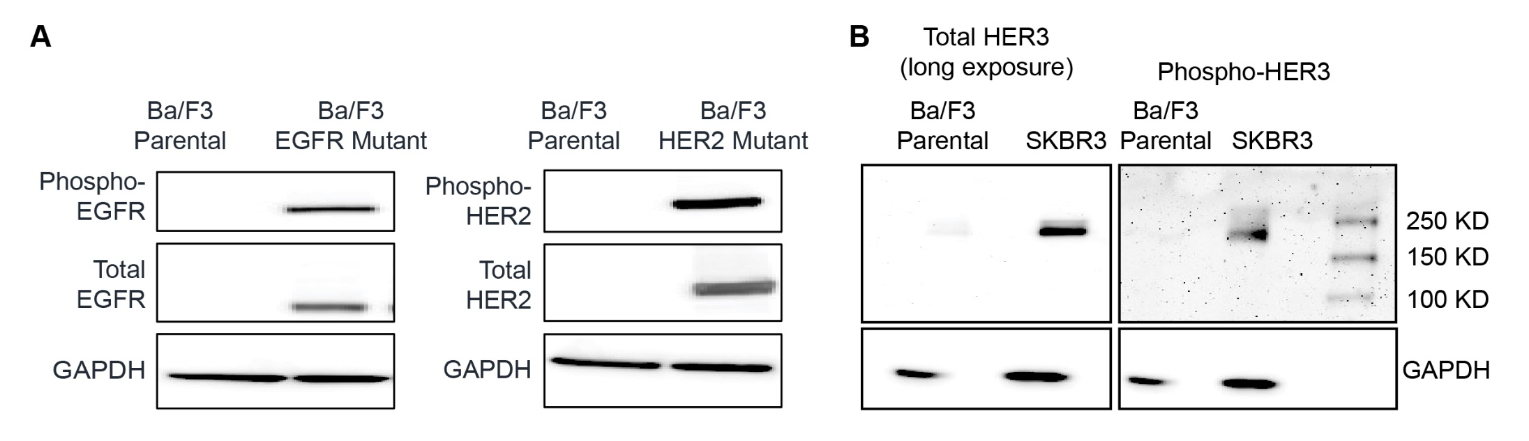

Supplementary Figure S1. Western blot to confirm lack of endogenous EGFR, HER2 and HER3 protein expression in Ba/F3 cells. Relative mutant EGFR/HER2 expressions in transformed Ba/F3 cells are shown in Panel A. HER3 expression levels (total and phosphorylated HER3) in SKBR3 cells are shown as a control in Panel B.

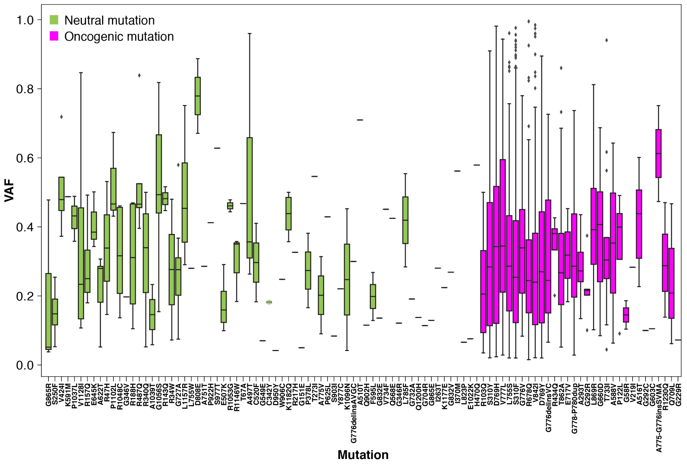

Supplementary Figure S2: Distribution of VAF for oncogenic and neutral HER2 mutations.

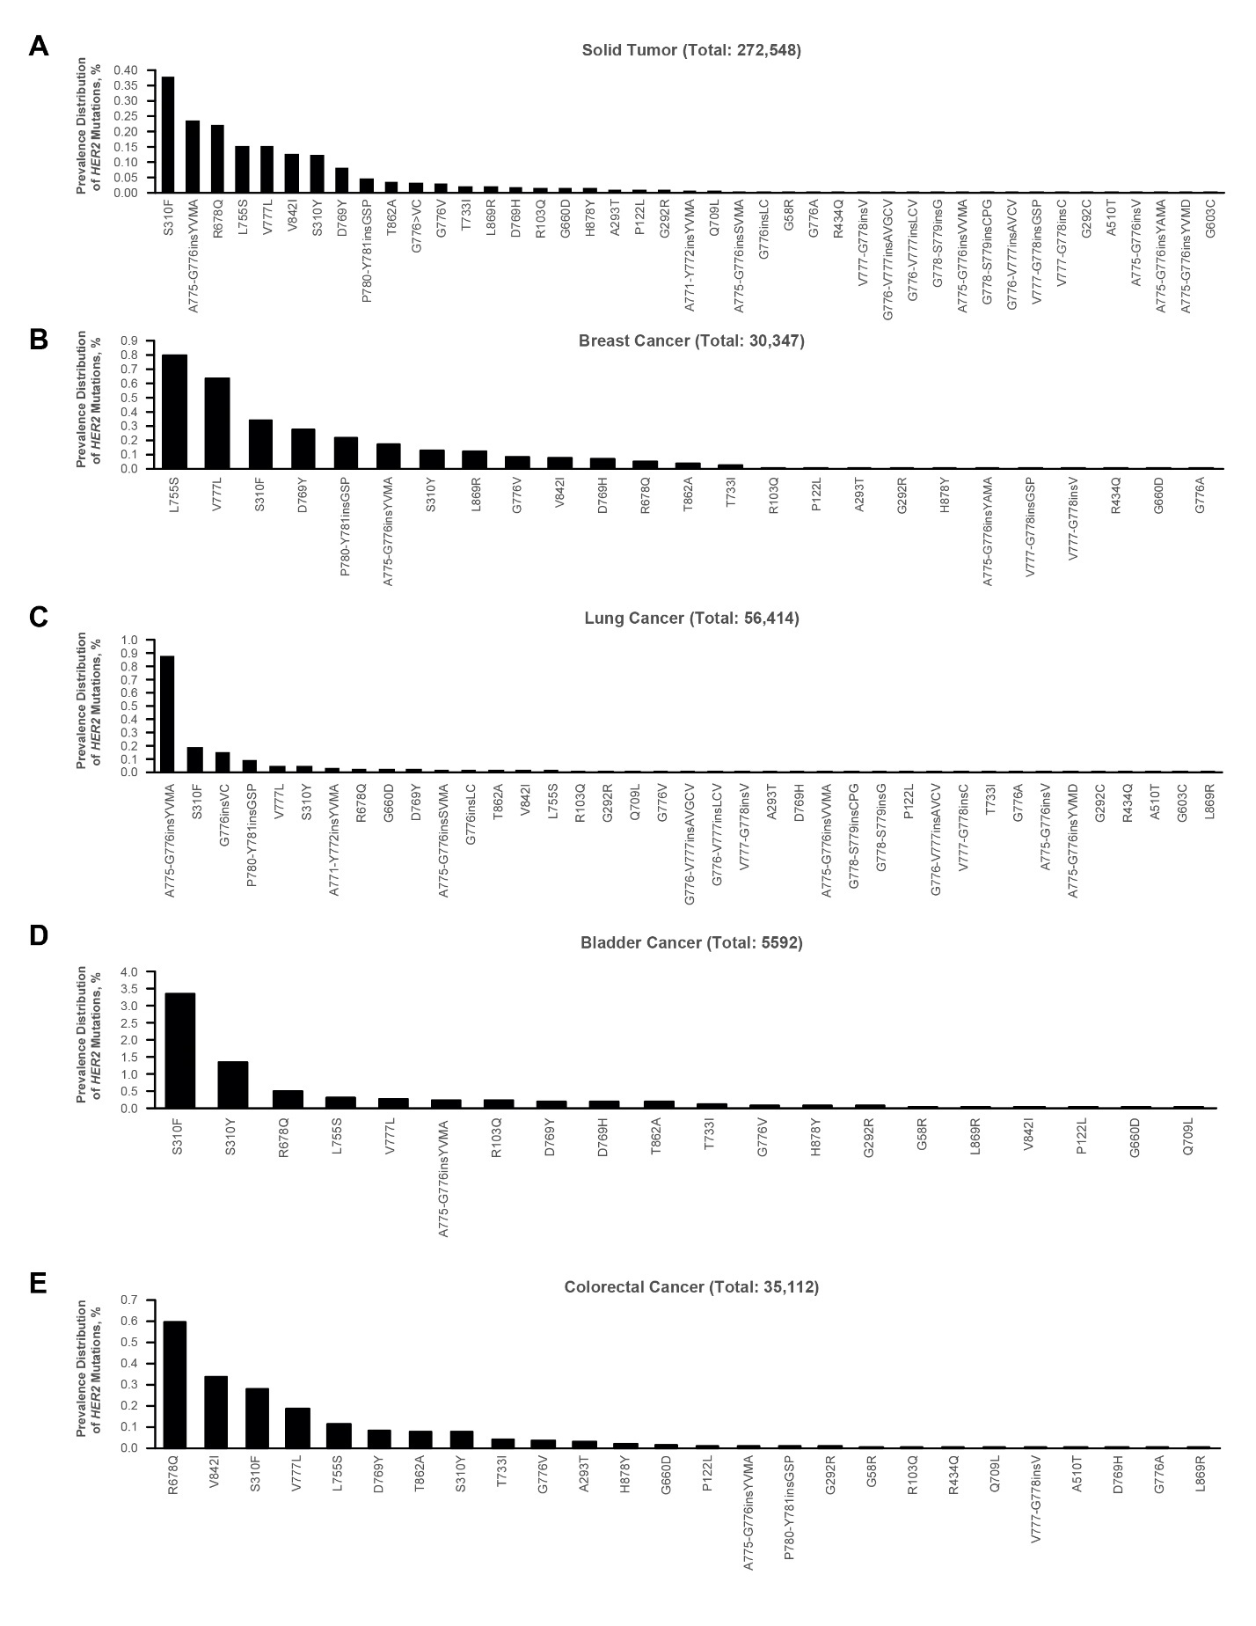
Supplementary Figure S3: Prevalence of validated driver mutations in A, solid tumor, B, breast, C, lung, D, bladder, and E, colorectal cancer.

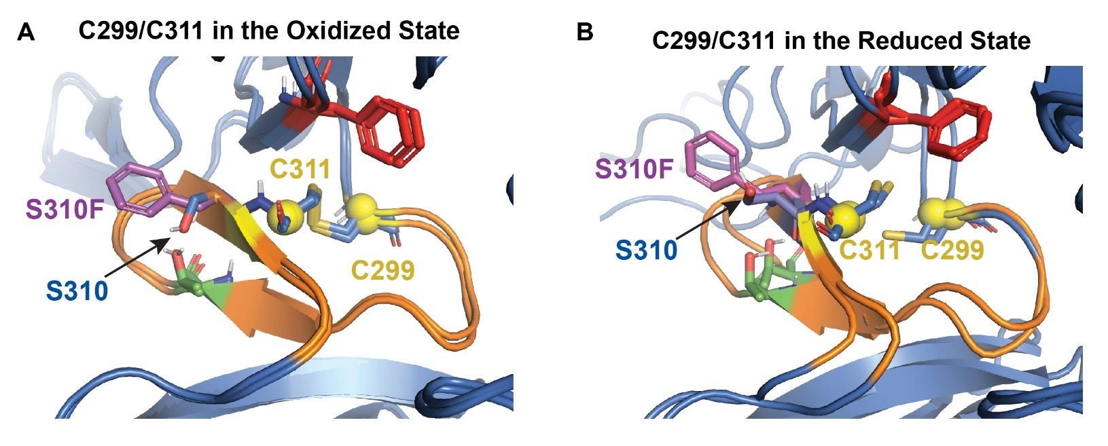

Supplementary Figure S4. MD simulations of S310F substitution
The effects of the S310F substitution is simulated by examining four different MD simulations using HER2 ECD structure (PDB IDs: 6J71) (see Methods). The four initial structures as MD starting conformation are: (1) HER2 WT structure (with Ser at position 310) with disulfide bond between Cys299-Cys311 (HER2 WT oxidized, captured in Panel A); (2) HER2 WT structure with no disulfide bond formed between Cys299-Cys311 (HER2 WT reduced, captured in
Panel B); (3) S310F-mutated structure (with Phe at position 310) with disulfide bond between Cys299-Cys311 (HER2 S310F oxidized, captured in Panel A); (4) S310F-mutated structure with no disulfide bond formed between Cys299-Cys311 (HER2 S310F reduced, captured in Panel B).

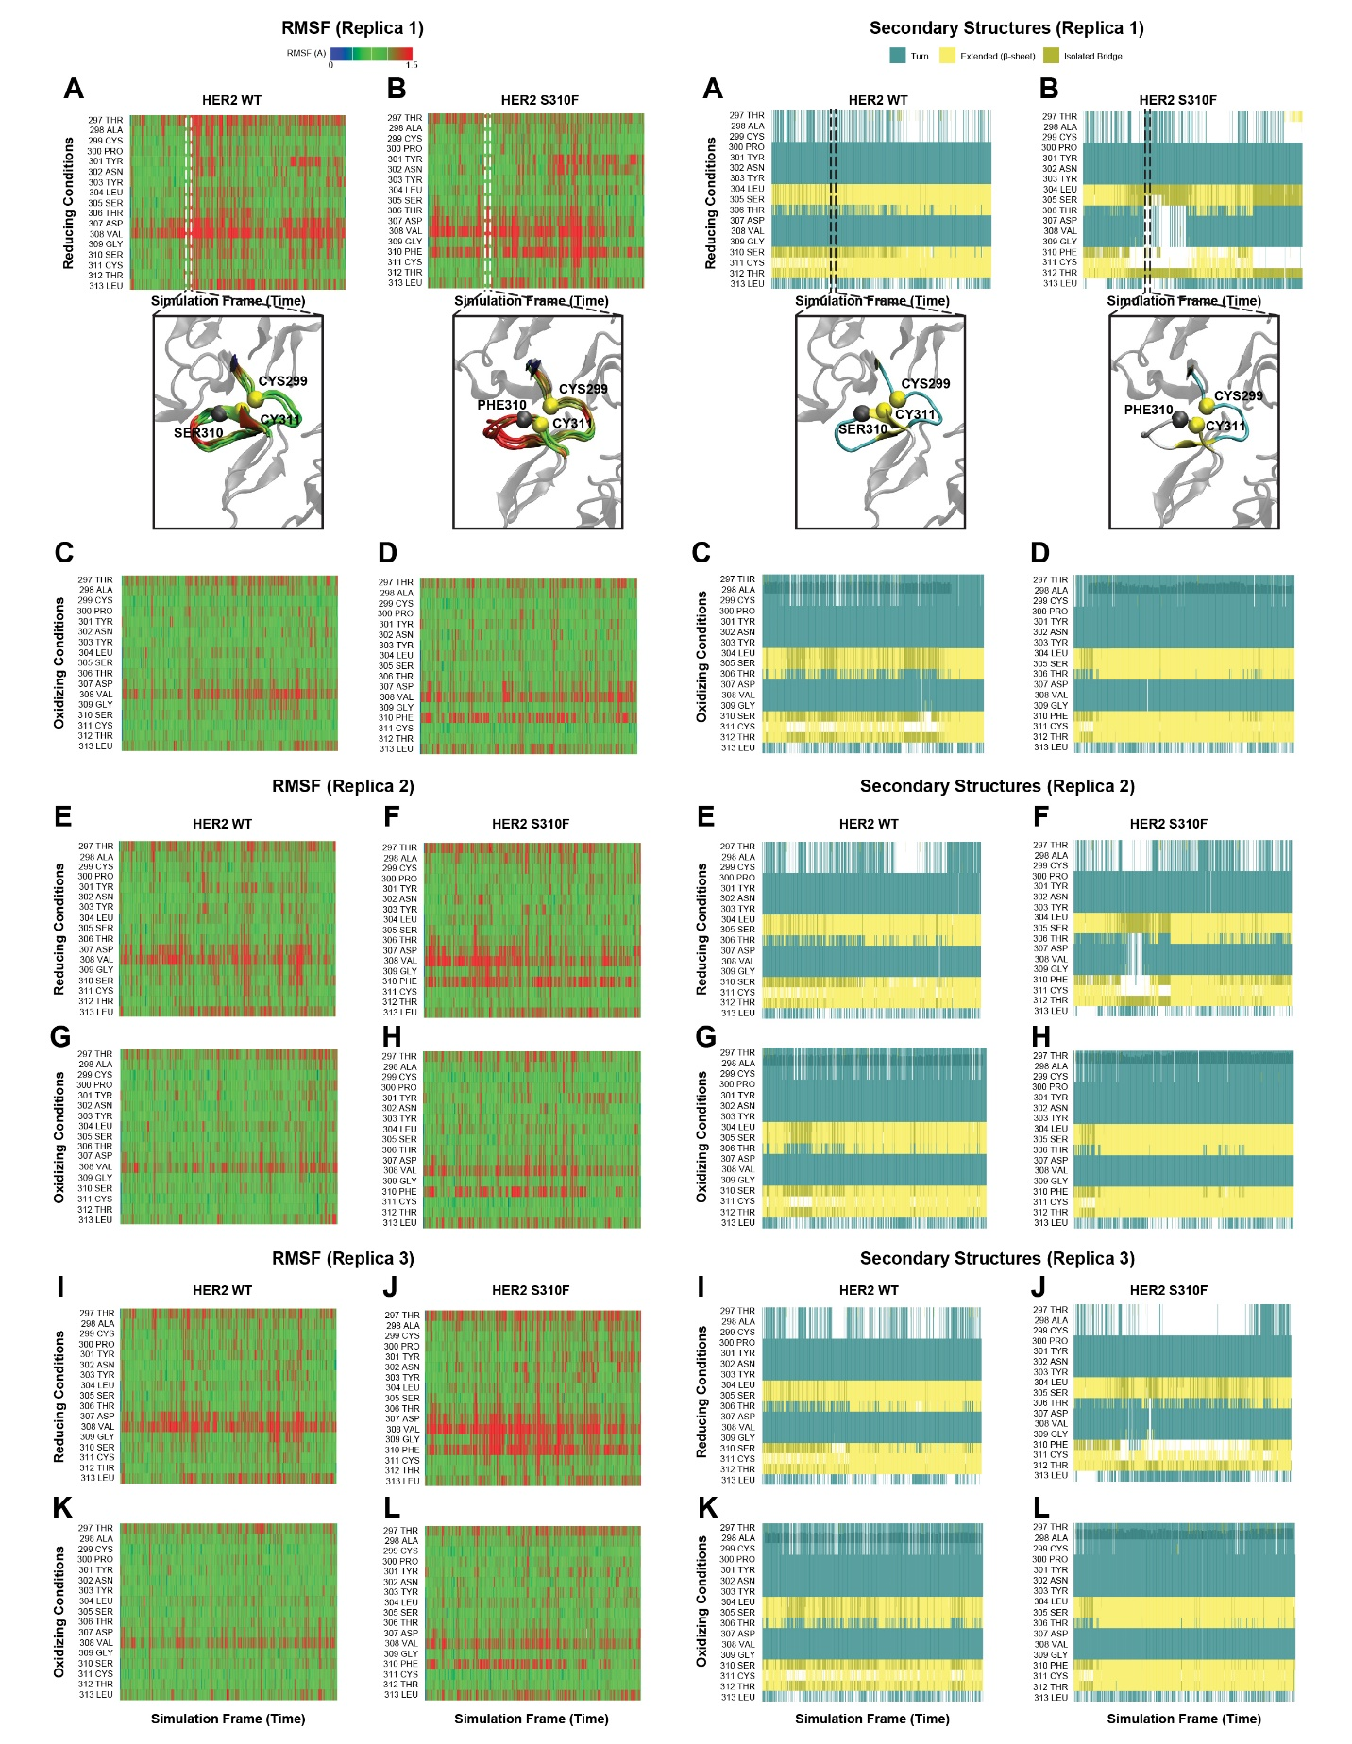
Supplementary Figure S5. TOP: Root mean square fluctuations (RMSF; left) and secondary structure changes (right) are shown on representative structures from WT (A) and mutant (B) simulations (Replica 1). The fluctuations and secondary structure annotations for residues between 297-313 are highlighted and the rest of the protein structures shown in transparent grey cartoon. Note that RMSF values for each residue from 5 windows (frames 183-187) around frame 185 are projected on the structure.
BOTTOM: RMSF (left) and secondary structure changes (right) during WT (A, C, E, G, I, K) and mutant (B, D, F, H, J, L) simulations in reducing and oxidizing conditions. In each replica simulation of HER2 S310F-reduced (B, F, J), we have observed substantially larger fluctuations around residues 308-310 upon substitution of Ser310 with Phe, compared with the residue fluctuations from the HER2 WT-oxidized, the HER2 WT-reduced, and HER2 S310F-oxidized simulations. It was also observed that the distance between Thr306 and Phe310 becomes larger in the HER2 S310F-reduced simulation (Fig. 4B). The larger fluctuations and distance between Thr306 and Phe310 residues may result in distortion of β-sheet spanning residues 310-312. This data from MD simulations suggests that S310F mutation may destabilize β-sheet–spanning residues 310-312 by destabilizing/weakening residue-residue interactions. As a consequence of the destabilization due to S310F mutation, free Cys311 may reach another Cys on its adjacent chain to form a disulfide bond for HER2 ECD dimerization.

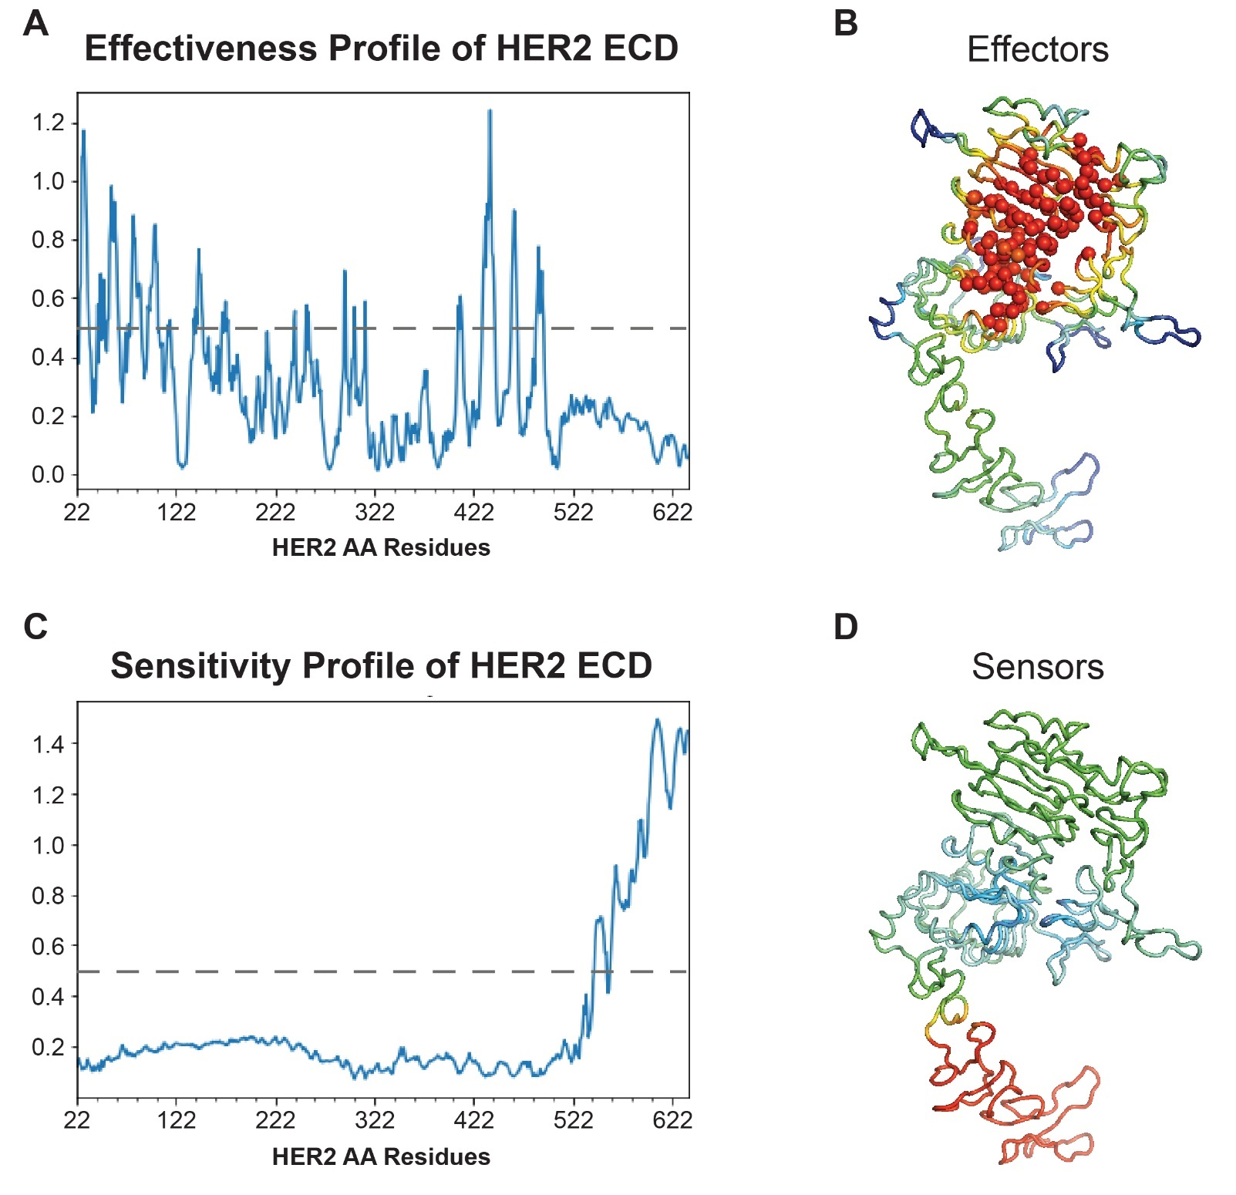
Supplementary Figure S6. Perturbation-response scanning (PRS) profile of HER2 ECD structure.
The effectiveness and sensitivity plots (A, C) describe the propensity of residues to propagate structural changes (as effectors, A), and to be sensitive to such effects (as sensors, C), respectively. The dotted black lines on the figures mark the cutoff (0.5) for defining the strongest effectors and sensors. The high-medium-low values of the effectors (B) and sensors (D) are indicated on the 3D structure of HER2 ECD using the red-green-blue spectrum. The highest effectors (>0.5) are shown with red circles and located at the interfaces of CR1, L1 and L2 domains of ECD structure (B).

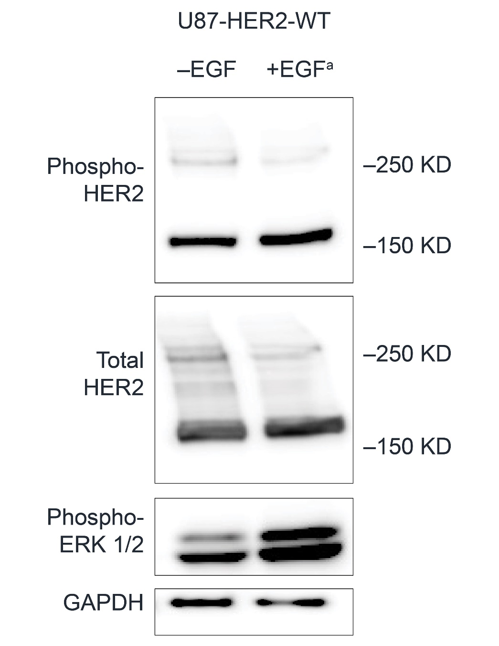
Supplementary Figure S7. Western blot for WT HER2 expressed in U87MG cells. WT HER2 does not exist as a covalent dimer.
ªU87MG cells were stimulated with 100 ng/mL of EGF for 5 minutes.

