Supplementary Information

Supplementary Figures
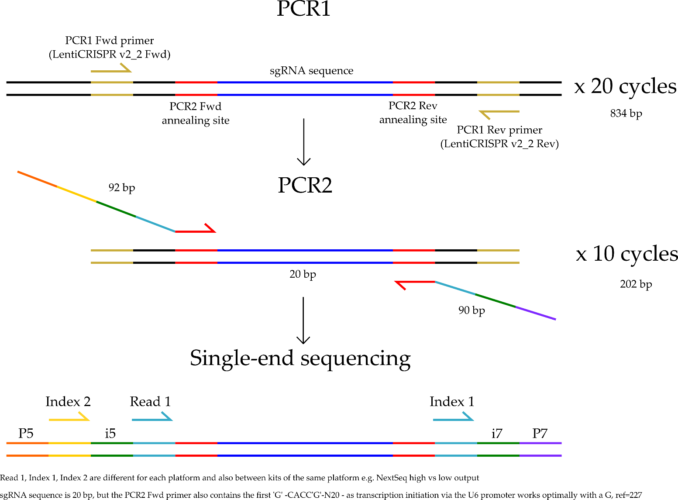
Supplementary Figure 1. Overview of the two-step PCR sequencing strategy for generation of sequencing libraries. Gold, PCR1 annealing sites; orange, P5; purple, P7; yellow, Index 2; green, i5 (Fwd) or i7 (Rev); red, PCR2 primer sites that binds the PCR1 amplicon; dark blue, sgRNA sequence to be amplified.

A MDA-MB-231 | MCF-7
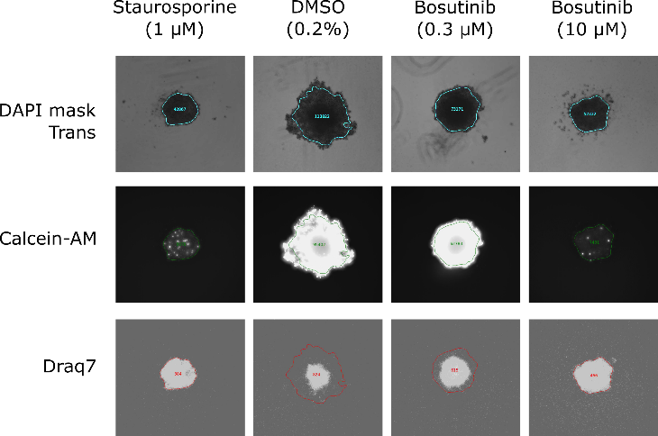 | 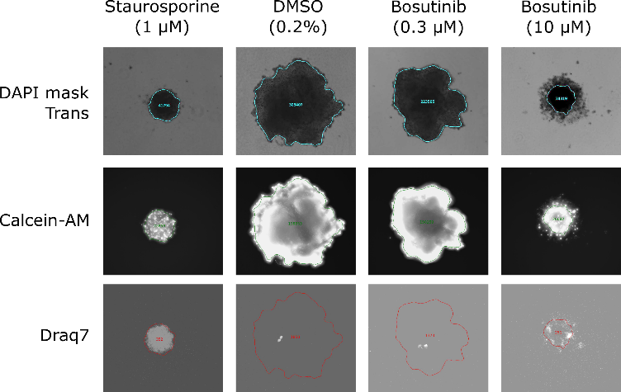
B
C

Supplementary Figure 2. Bosutinib treatment of MDA-MB-231 and MCF-7 spheroids. A) Representative maximum intensity projections of the MDA-MB-231 and MCF-7 cell lines quantified in Figure 1A. Round-bottom plates were seeded at 2,000 cells/well as described in the Methods. Images were acquired under 4x magnification on the ImageXpress platform. Spheroids were stained with Calcein-AM to give a ‘live cell’ readout, propidium iodide or Draq7 for a ‘dead cell’ readout and Hoechst 33342 for a ‘total cells’ readout. B-C) Western blot quantification for Figure 1B, n=1.

A MDA-MB-231 | MCF-7
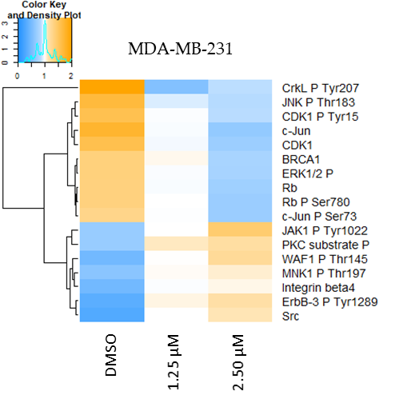 | 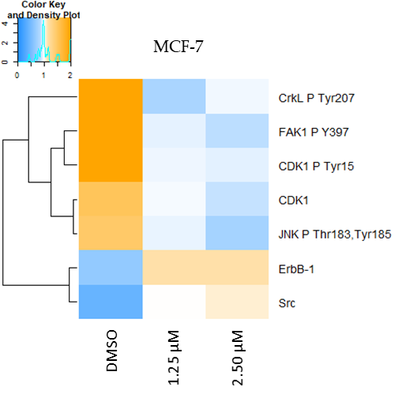
B

Supplementary Figure 3. RPPA analysis following bosutinib treatment of MDA-MB-231 and MCF-7 cells. A) RPPA data was median adjusted for each cell line. The mean of three technical replicates for one independent experimental replicate is shown. Cells were treated for 24h with EC₂₅ (1.25 µM) and EC₅₀ (2.5 µM) concentrations of bosutinib. Complete linkage clustering with Euclidean distance was used for hierarchical clustering in R. Significantly differentially altered fluorescence intensity with a p-value <0.05 and a log2 fold change of +/-0.75 are shown. A two-tailed t-test in R was used to calculate significance for DMSO (vehicle) compared to 2.5 µM bosutinib. B) Quantification of fluorescent signal intensity. Concentrations are for bosutinib. Error bars are SD.

A | B
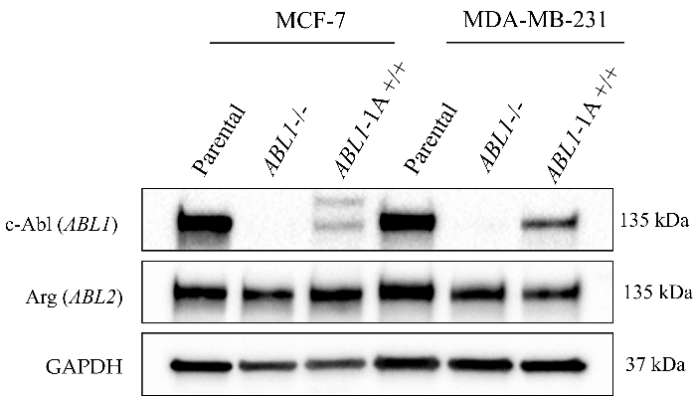 | 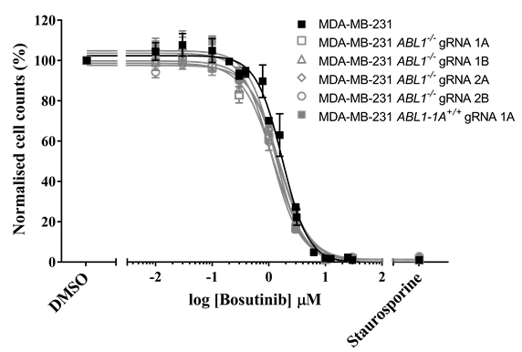
C
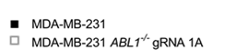  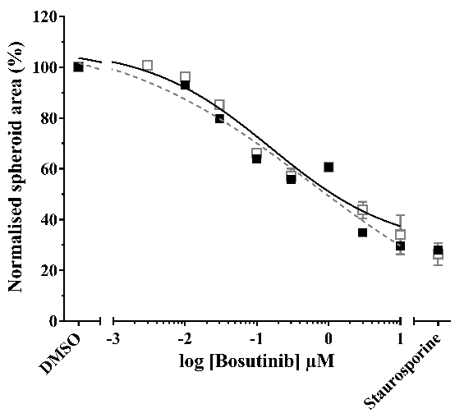 | 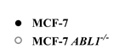  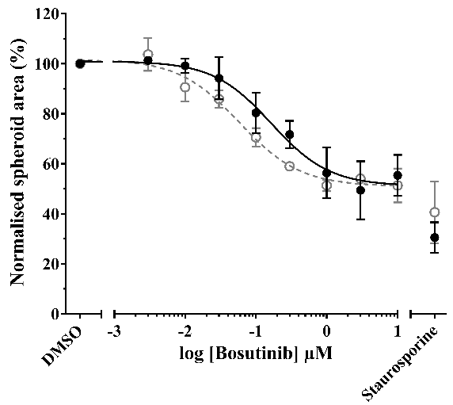
Supplementary Figure 4. Loss of ABL1 does not alter bosutinib sensitivity. A) CRISPR-eCas9 targeting ABL1 results in ABL loss in MCF-7 and MDA-MB-231 cell lines as assessed by Western blot. B) Normalised cell counts from Hoechst-stained images for bosutinib. Resazurin cell viability was the same (data not shown). C) 3D bosutinib 8-point dilution for EC₅₀ values. ABL1-1A refers to the ABL1 isoform 1a. Error bars are S.E.M. All data is the mean of three replicates.

A
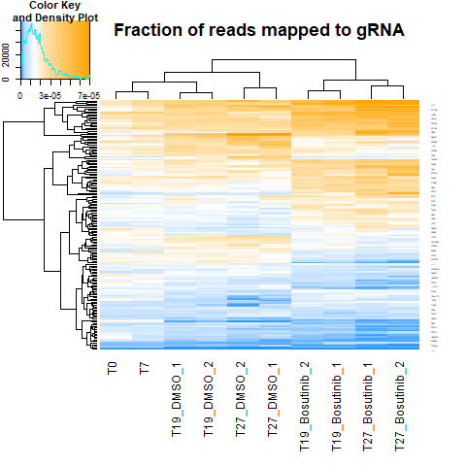
B
Enhancers | Suppressors
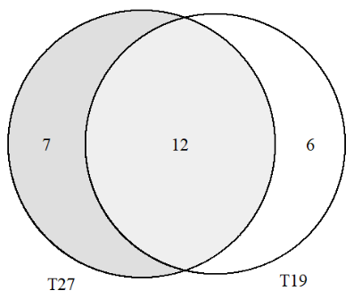 | 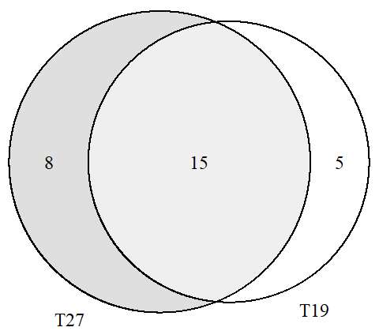
Supplementary Figure 5. Genome-wide CRISPR-Cas9 screen. A) Clustering of the fraction of reads mapped to guide RNAs (4 gRNAs per gene) from the top enhancer and suppressor genes for the T27 time point (n= 2 technical replicates). Samples with zero reads from next-generation sequencing at T0 were removed from the analysis. Complete linkage clustering with Euclidean distance was used for hierarchical clustering in R. n = 165. B) Top enhancer and suppressor genes from the TKOv3 bosutinib screen. Only genes with FDR <0.05 are shown.

A
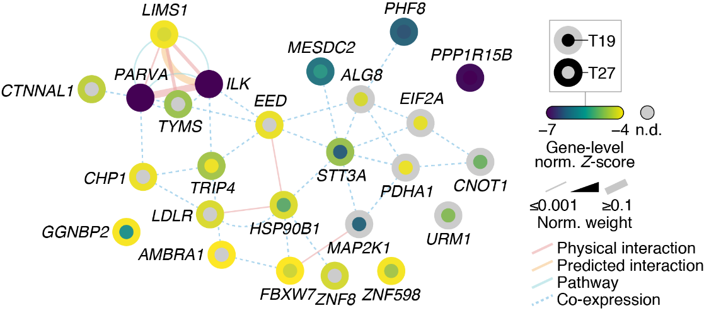
B
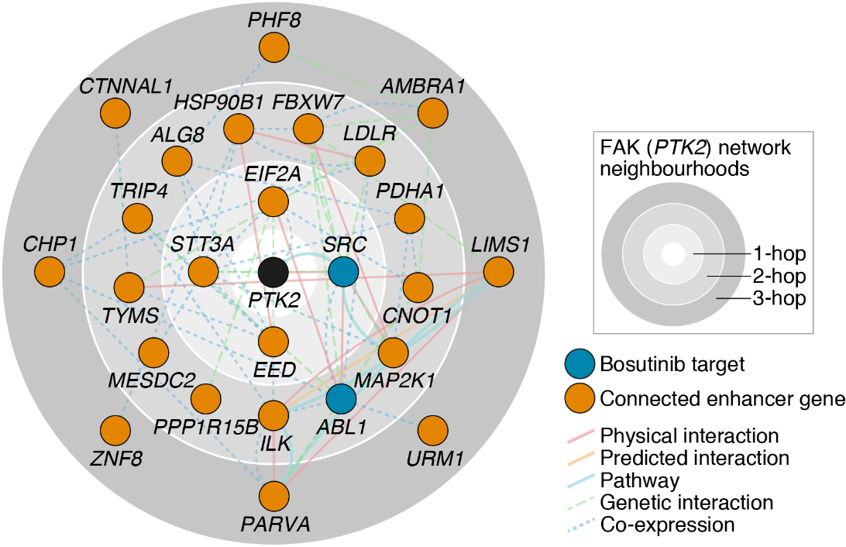
C
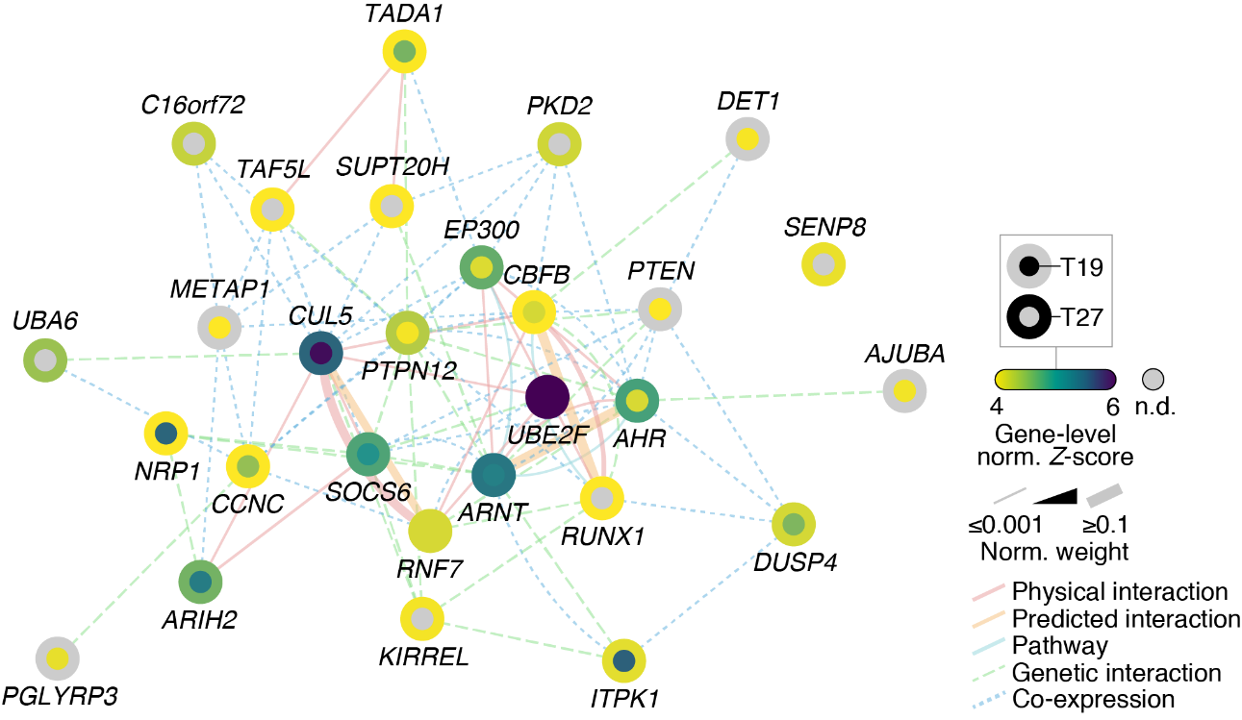

Supplementary Figure 6. Genome-wide CRISPR-Cas9 screen network analysis. A Network map for the combined T19 and T27 enhancer genes. B) FAK (PTK2)-centric network of connected top enhancer genes (combined T19 and T27 enhancer genes). The network was imputed with the bosutinib targets SRC and ABL and partitioned by FAK network neighbourhood (connectivity order). C) Network map for the combined T19 and T27 suppressor genes. A, C) Network edges were weighted according to evidence of co-functionality using GeneMANIA in Cytoscape.
A METABRIC (-TNBC) | TCGA (-basal)
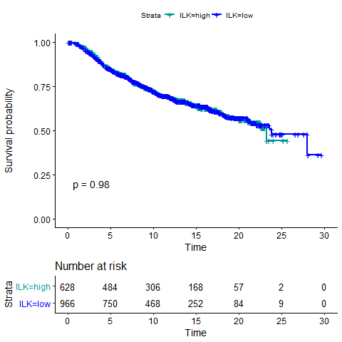 | 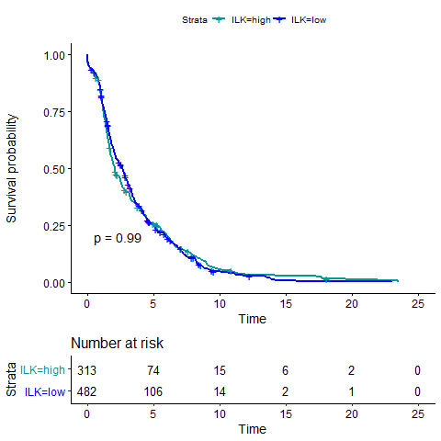
B METABRIC (+TNBC) | METABRIC (-TNBC)
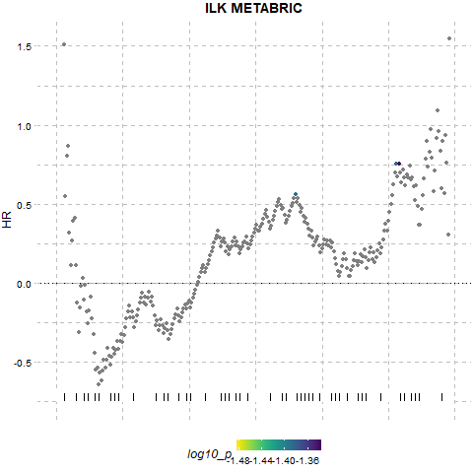 | 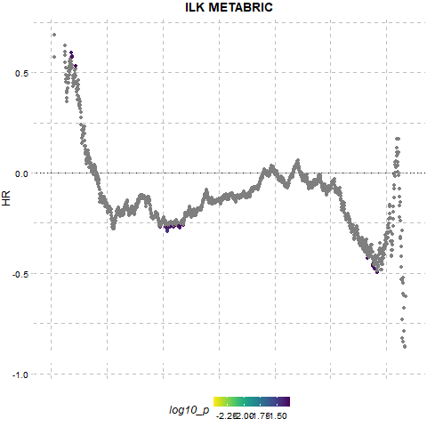
C TCGA (+basal) | TCGA (-basal)
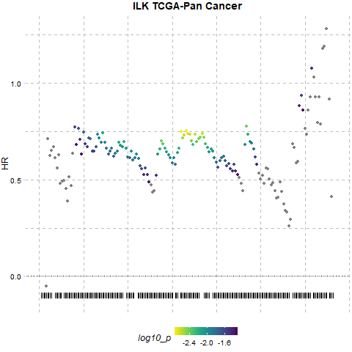 | 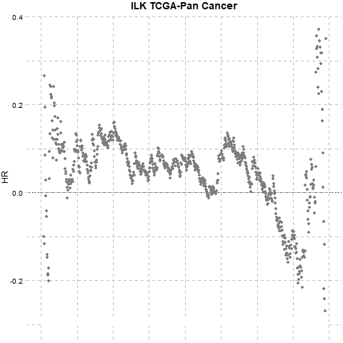

Supplementary Figure 7. A) Kaplan Meier plots for all METABRIC patients not in the TNBC subtype or TCGA-PanCancer patients not in the basal subtype to compare with Figure 2, panels E and F. The optimal threshold for dichotomisation of the datasets into high and low ILK expression was identified using the survivALL R package and ‘plotALL’ function for multi-cut point analysis using the METABRIC dataset. TCGA-PanCancer dataset was used as the validation dataset. Breast cancer-specific survival was used. B) Multi-cut point analysis for METABRIC dataset. C) Multi-cut point analysis for TCGA-PanCancer dataset.

A | B
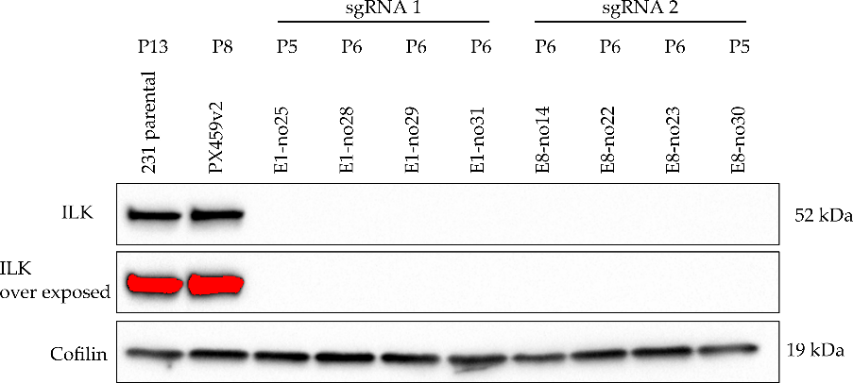  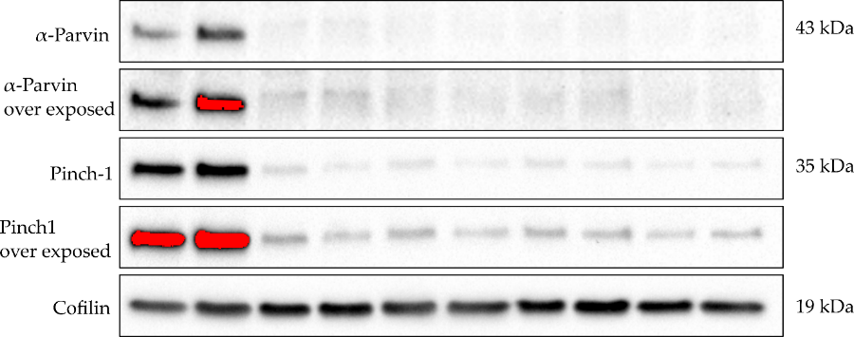  ILK gRNA 1A = E1-no28  ILK gRNA 1B = E1-no31  ILK gRNA 2 = E8-no23 | 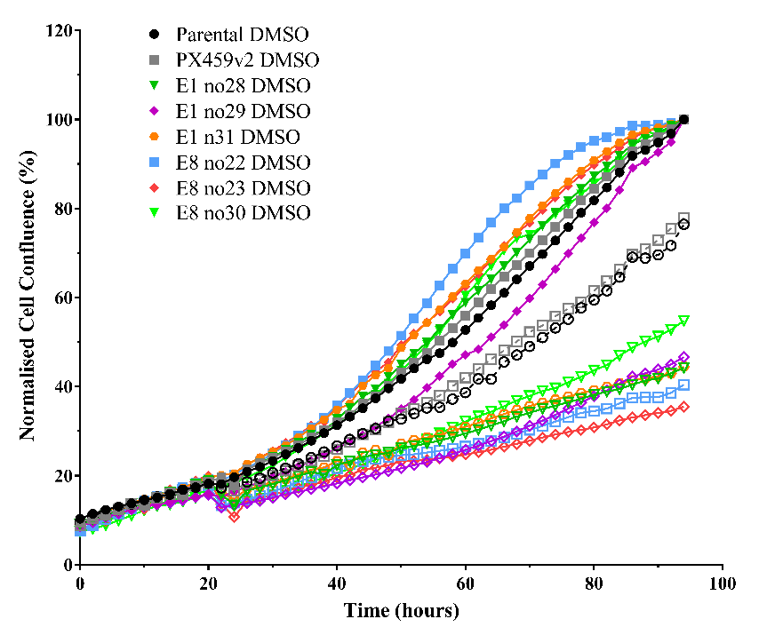
C | D
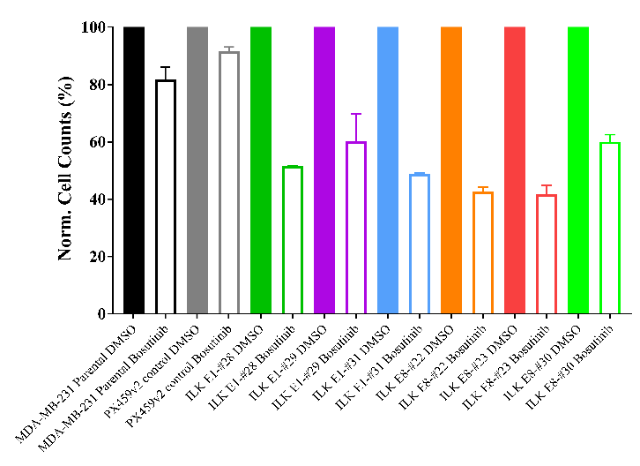 | 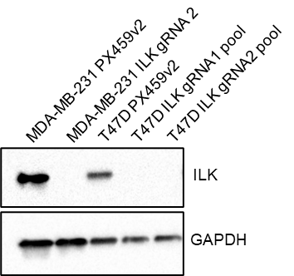
E | F
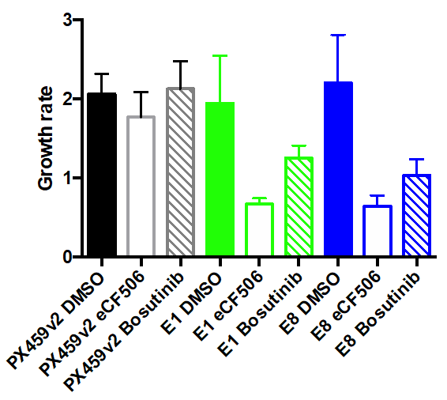  ILK gRNA 1= E1  IKL gRNA 2 =E8 | 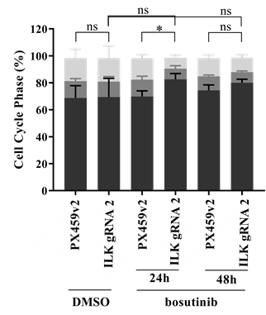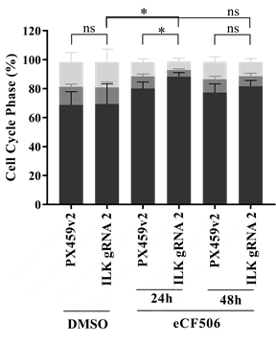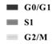
Supplementary Figure 8. A) CRISPR-Cas9 targeting ILK results in ILK loss in the MDA-MB-231 cell line as assessed by Western blot. PX459v2, empty-gRNA CRISPR control cells; E1 to E8, ILK knockout clones; P, passage number. B-C) IncuCyte live cell imaging: Hollow shapes/bars represent bosutinib, solid are DMSO. B) ILK loss potentiates bosutinib inhibition in real-time assays. MDA-MB-231 cells were seeded in 96-well plates at 8,000 cells/well and transferred to the IncuCyte Zoom. Cells were drugged (Bosutinib EC₂₀, 0.9 μM) at 24 hours post seeding. Error bars omitted for clarity. C) End-point quantification using normalised cell counts from Hoechst-stained images. Two to three independent experimental replicates were used, error bars were S.E.M. D) Pooled CRISPR ILK knockdown in T47D cells assessed by Western blot. E) ILK loss potentiates bosutinib inhibition in T47D cells. T47D cells were seeded in 96-well plates and transferred to the IncuCyte Zoom. Plates were drugged (0.9 μM bosutinib and 20 nM eCF506) at 24 h post seeding for 72 h. The growth rate was calculated from cell confluence measured in the IncuCyte. Three independent experimental replicates were used, error bars were S.E.M. F) Cell cycle analysis of bosutinib (EC₂₀= 0.9 μM) and eCF506 (EC₂₀= 40 nM) using propidium iodide and fluorescence-activated cell sorting. p-value refers to G1 values.

A
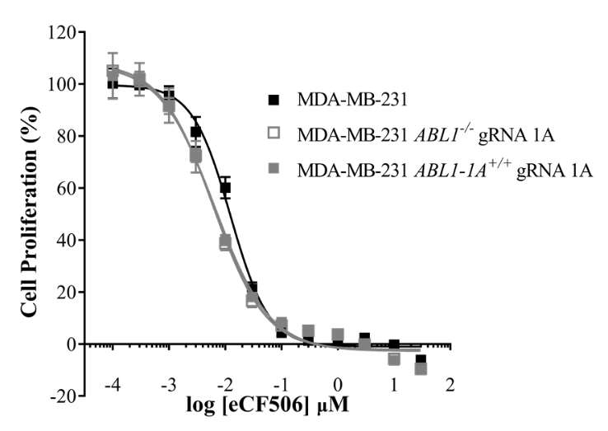
B
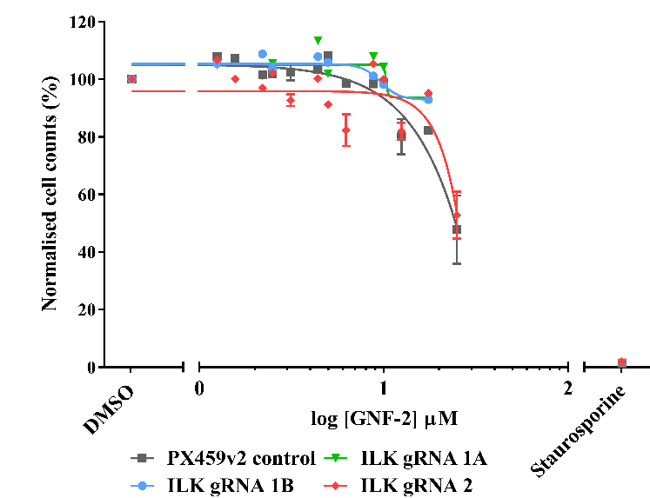

Supplementary Figure 9. A) Loss of ABL1 does not alter eCF506 sensitivity. Normalised resazurin 2D cell viability data. ABL1-1A refers to the ABL1 isoform 1a. Error bars are S.E.M. All data is the mean of three replicates. B) ABL inhibition does not synergise with ILK loss. Normalised cell counts from Hoechst-stained images in 2D. All error bars are S.E.M. Two independent experimental replicates are shown.

A | B
C | D
Supplementary Figure 10. ILK expression correlation with sensitivity to bosutinib in breast cancer cell line datasets. A) In-house bosutinib IC₅₀ (Temps et al. 2021 (24)) and cb5 microarray expression for ILK (16 cell lines). B) Cancerxgene bosutinib AUC and cb5 microarray expression for ILK (43 cell lines). C) Depmap bosutinib AUC (19Q4) and RNAseq mRNA expression for ILK (20Q3 Public) (20 cell lines). D) Depmap bosutinib log2 fold change drug sensitivity (19Q4) and protein expression for ILK (Q13418) (20 cell lines). Datasets were chosen based on the highest number of breast cancer cell lines.

A  *** | B
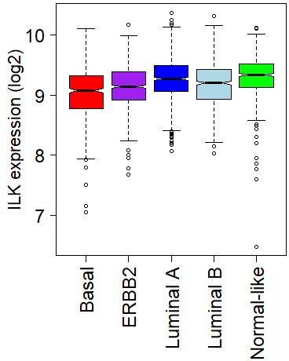 | 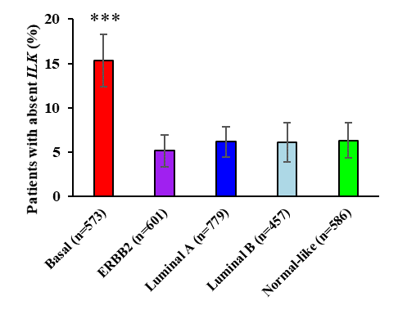
C
 | Absent | Marginal | Present | Row Totals
Basal (n=573) | 88 (44.37) [42.90] | 27 (21.99) [1.14] | 458 (506.63) [4.67] | 573
ERBB2 (n=601) | 31 (46.54) [5.19] | 20 (23.07) [0.41] | 550 (531.39) [0.65] | 601
Luminal A (n=779) | 48 (60.32) [2.52] | 28 (29.90) [0.12] | 703 (688.78) [0.29] | 779
Luminal B (n=457) | 28 (35.39) [1.54] | 22 (17.54) [1.13] | 407 (404.07) [0.02] | 457
Normal-like (n=586) | 37 (45.38) [1.55] | 18 (22.49) [0.90] | 531 (518.13) [0.32] | 586
Column Totals | 232 | 115 | 2649 | 2996 (Grand Total)
Chi-square test 63.3485, p-value < 0.00001.

D METABRIC  **** | TCGA  **
***  ****  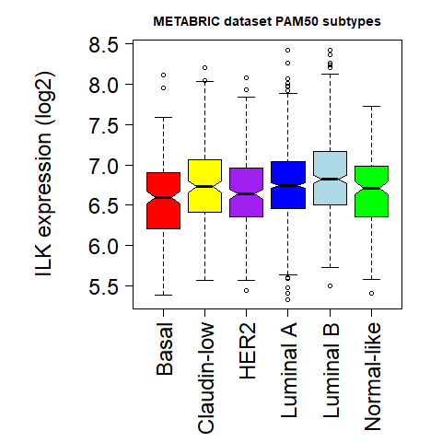 | 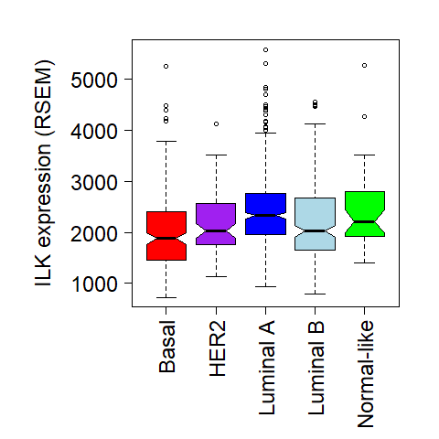  ****  *
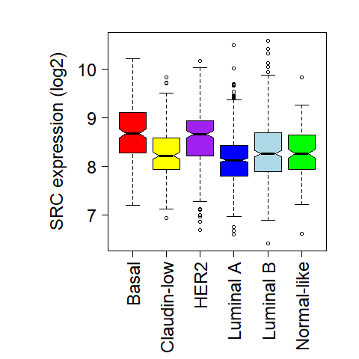  ****  ****  ****  **** | 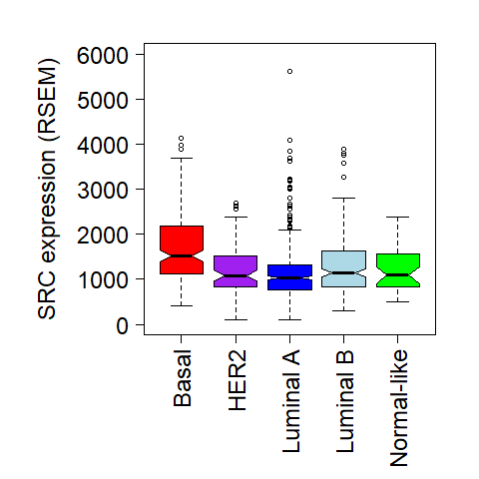  ***  ****  ****
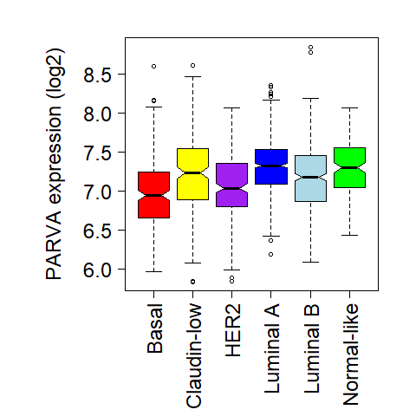  ****  ****  ****  **** | 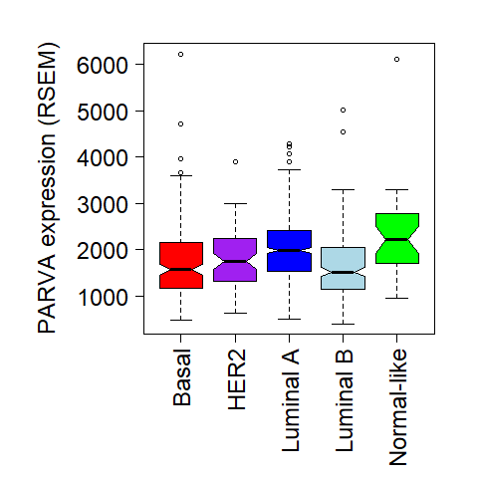  ****  ****
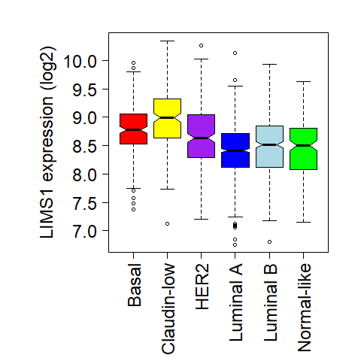  ****  **  ****  **** | 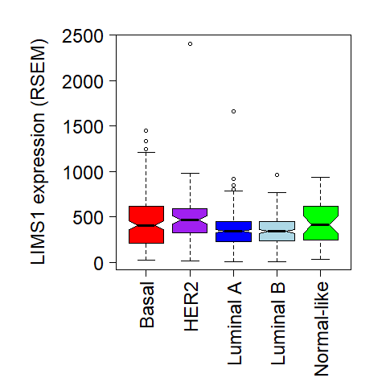  ****  ****

Supplementary Figure 11. Low ILK expression is pronounced in the basal subtype. A) ILK expression for the Sorlie subtypes across 17 breast cancer patient datasets (cb17, n=2,996). Tukey's Honest Significant Difference (Tukey HSD) was used. B) Absent status for ILK is defined by Affymetrix detection calls in the cb17 dataset. Sorlie intrinsic subtypes were assigned by nearest centroids. Error bars are 95% confidence intervals. C) Chi-square test stats for patients with absent, marginal and present ILK detectable calls for the different breast cancer subtypes from the cb17 dataset shown in B. D) ILK, SRC, PARVA and LIMS1 expression for the PAM50 breast cancer subtypes in the METABRIC (n = 1,896) and TCGA-PanCancer (n = 1,081) datasets. *, p-value < 0.05; **, p-value < 0.01; ***, p-value < 0.001; ****, p-value < 0.0001. Tukey HSD was used.
A
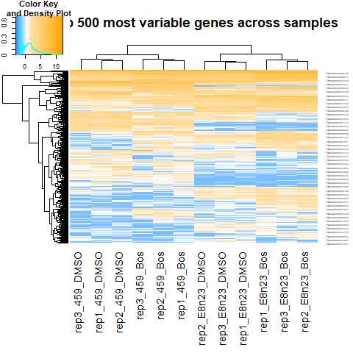
B Molecular Function | Cellular Component
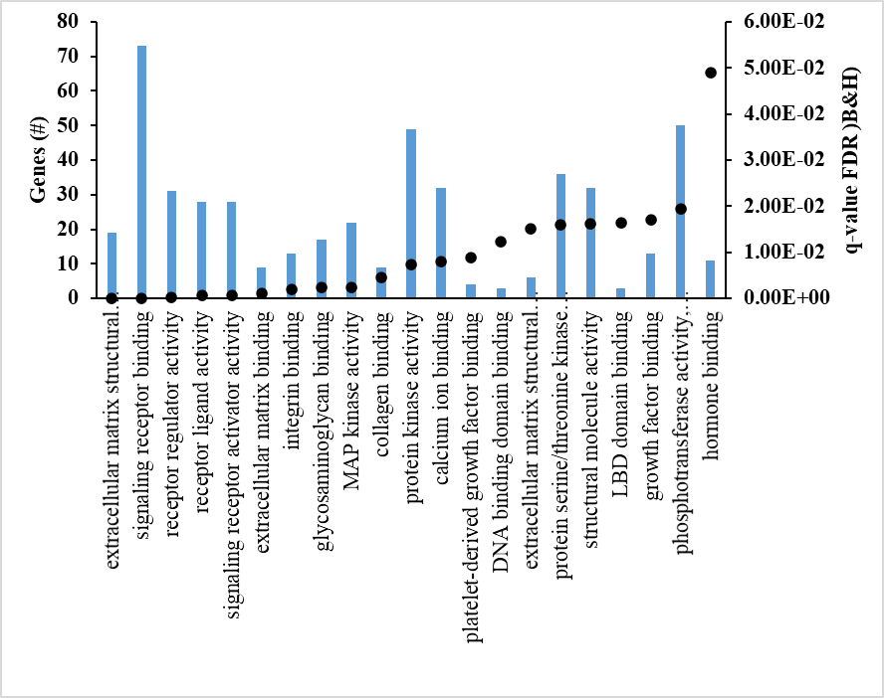 | 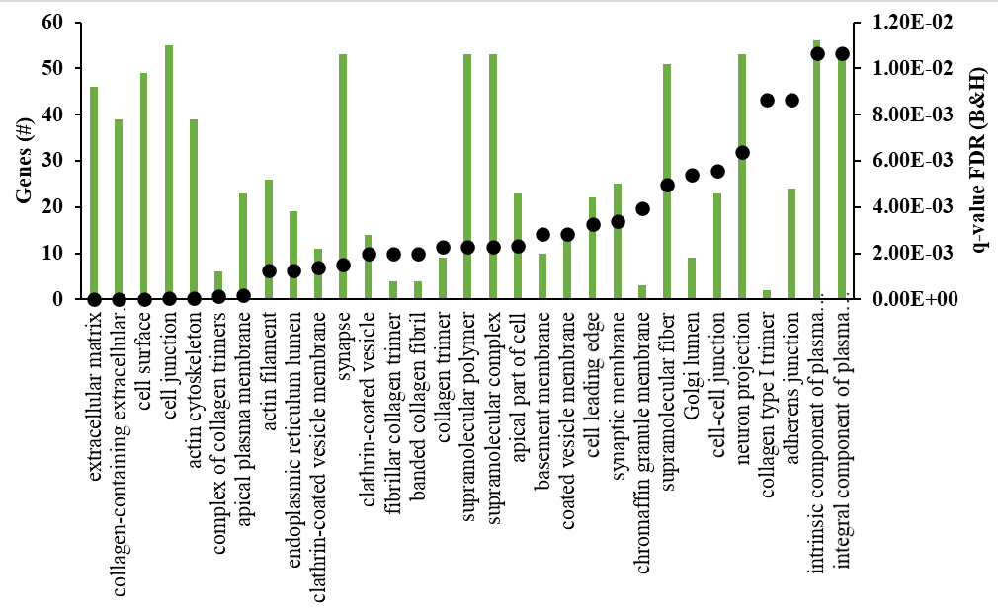
C
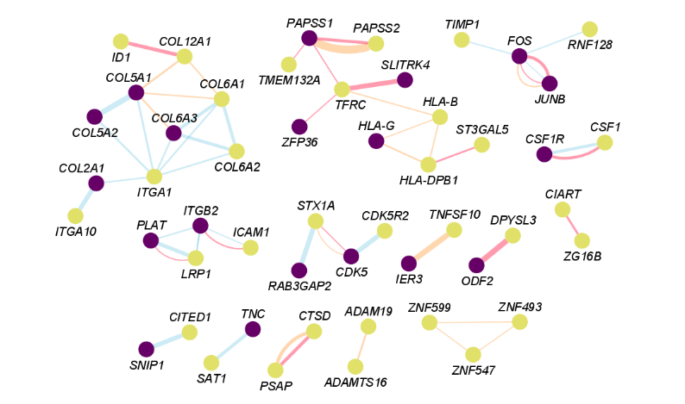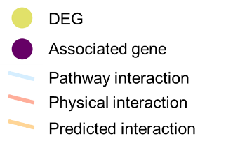
Supplementary Figure 12. RNAseq data analysis. A) Hierarchical clustering of log2 counts per million for the 500 most variable genes across all 12 samples. 459, PX459v2 CRISPR control; E8n23, ILK gRNA 2. Samples clustered as expected. B) ToppGene gene ontology analysis for the ILK dependent DEGs. The top hits from the molecular function and cellular component categories are shown. Black dots represent q-values. C) Network map for the 134 unique DEGs created using GeneMANIA in Cytoscape. Associated genes were determined in GeneMANIA based on published databases and specific omics publications.

A | B
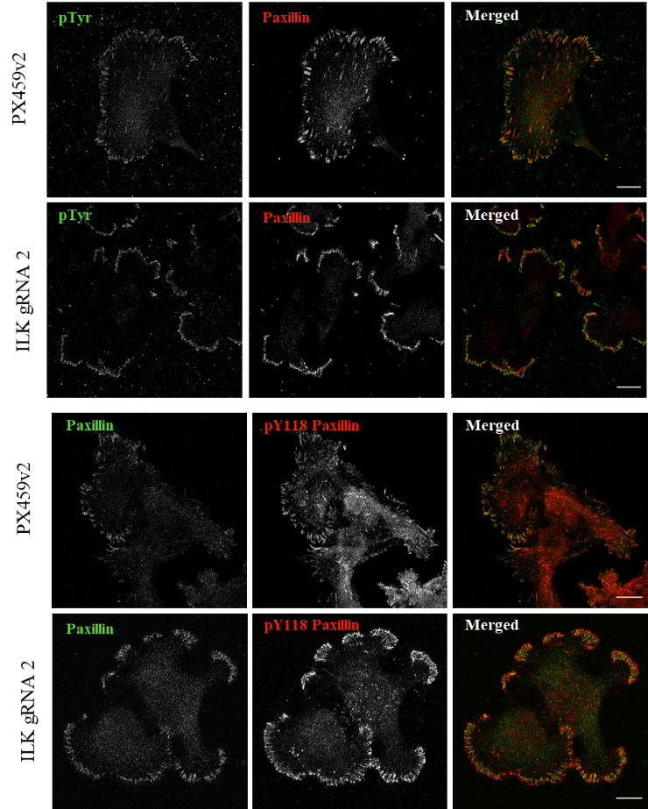 | 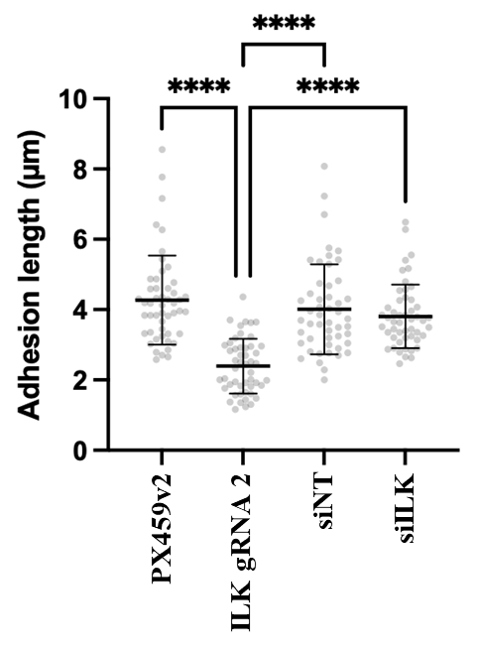
C
D
E
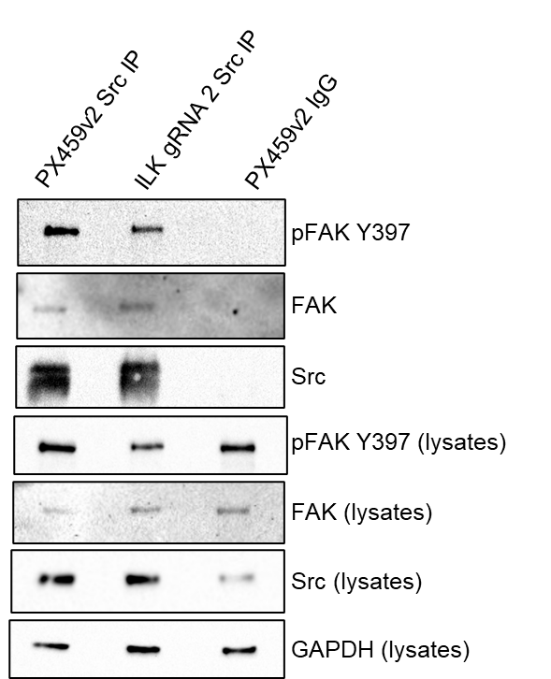

Supplementary Figure 13. A) Cells were grown on glass coverslips and stained with either anti-pTyr, anti-paxillin, anti-pY118 paxillin or phalloidin. Scale bars, 20 µm. Images are representative of 3 independent experiments. B) Quantification of focal adhesion length measured in ImageJ according to paxillin staining. Mean with SD are shown. **** p-value < 0.0001, one-way ANOVA. C) Western blot quantification for Figure 6A. PX, PX459v2; DM, DMSO; bos, bosutinib; eC, eCF506. Three independent experimental replicates are shown. Error bars are SD. The differential effect of bosutinib and eCF506 on pY397-FAK is due to the ability of bosutinib to bind SRC in an active conformation, this stabilising pY397-FAK, while eCF506 binds SRC in an inactive conformation resulting in destabilisation of FAK phosphorylation (Temps et al, 2021⁽²⁴⁾). D) Cell adhesion was quantified using the IncuCyte cell confluence image analysis before and after washing. All data were normalised to the DMSO PX459v2 control. DMSO shown as solid fill, bosutinib and eCF506 as clear fill. Bosutinib 0.9 µM and eCF506 40 nM were used. E) FAK-SRC immunoprecipitation. PX459v2 and ILK gRNA 2 cells were seeded in 150 cm dishes and left to attach for 48 h. Cells were washed twice with PBS before lysis with RIPA buffer. Immunoprecipitations were set up as described in the supplementary methods. The beads were separated using a magnetic rack before lysates were analysed by Western blot. In the anti-SRC blot, the upper band is SRC and the lower band is the IgG heavy chain.

A | B
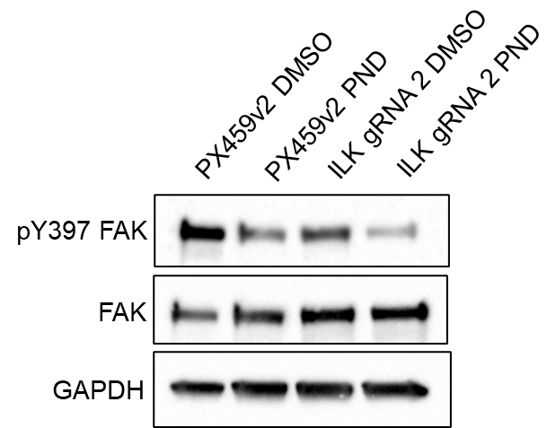  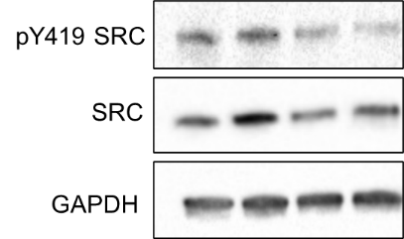 | 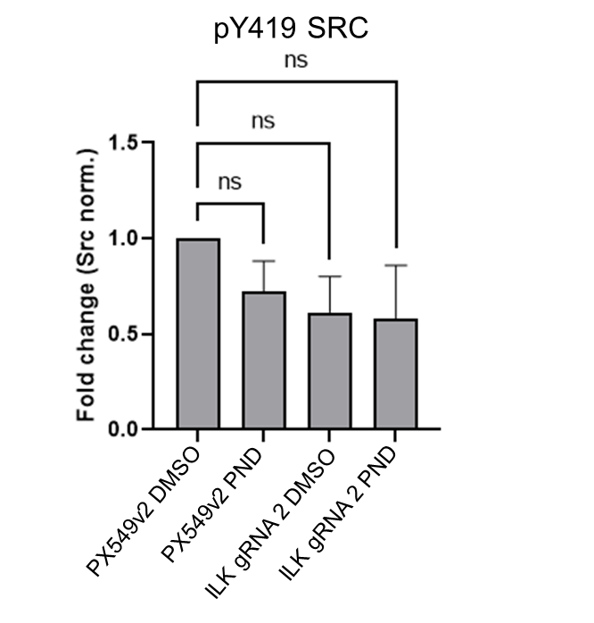
C
Stat3 P Tyr705
p38 MAPK PThr180,Tyr182
E-Cadherin
Akt P Thr308
Survivin
AMPK alpha
CrkL P Tyr207
IRS-1 P S636/639
mTOR P Ser2448
c-Jun P Ser73
CDK2
Zap70
Stat1 P Ser727
IGF-1R beta P Tyr1162,Tyr1163
IKK alpha/beta P Ser176/Ser177
Akt P Ser473
p53
c-Myc P Thr58,Ser62
Caspase 3
NFkB p105/p50
PKA
Tsc-2 (Tuberin) P Thr1462
Integrin beta4
Src

ILK gRNA 2
DMSO v bosutinib
ILK gRNA 2
DMSO v PND-1186
Met P Tyr1349
Stat5 P Tyr694
S6 Ribosomal protein P Ser235,Ser236
CDK1 (p34cdc2) P Tyr15
Rsk2 Pser 227
FLT3 P Tyr591 P Tyr591
Raf P Ser338
MEK1/2
Tuberin P S1387
ATM/ATR Substrate P Ser/Thr
Rb
Tau
Rb P Ser780
Rb P Ser807,Ser811
BRCA1
Smad3 P Ser423,Ser425
SHP2 P Tyr542
c-Myc
4E-BP1 P Ser65
p70 S6 Kinase P Thr421,Ser424
Raf1 (C-12)
p90 S6 kinase (Rsk1-3)
Cyclin D1 P Thr286

Supplementary Figure 14. A) Western blot analysis of MDA-MB-231 cell lines grown in 2D. Data are representative of three independent experimental replicates. PND; PND-1186, 100 nM. B) Quantification of Src activity from three independent Western blots. One-way ANOVA, NS: p-value > 0.05. C) RPPA analysis following bosutinib (0.9 µM, EC20) or PND-1186 (100 nM, EC20) treatment of MDA-MB-231 PX459v2 and ILK gRNA 2 cell lines. RPPA data was median adjusted for each cell line. The mean of three technical replicates for three independent experimental replicates are shown. Cells were treated for 24h. Complete linkage clustering with Euclidean distance was used for hierarchical clustering in R. Significantly differentially altered fluorescence intensity with a p-value <0.05 and a log2 fold change of +/-1.0 are shown. A two-tailed t-test in R was used to calculate significance for DMSO (vehicle) compared to drug treatment.

A |  | B
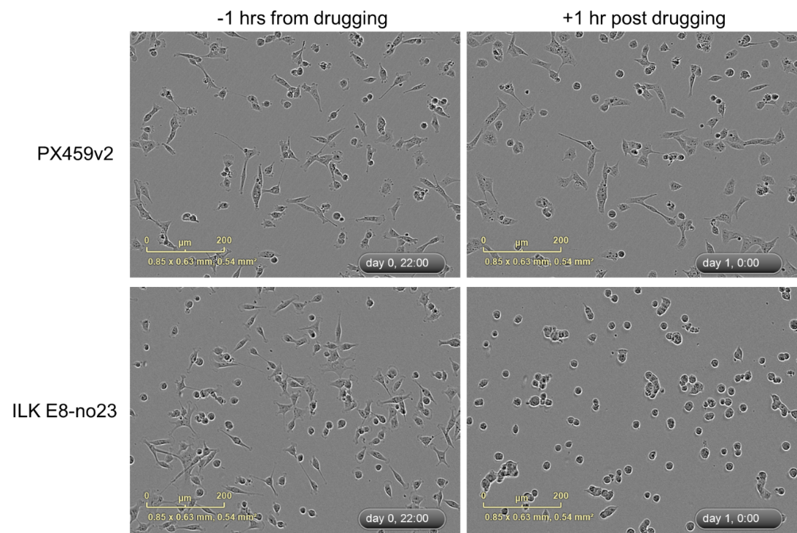  ILK gRNA 2 | 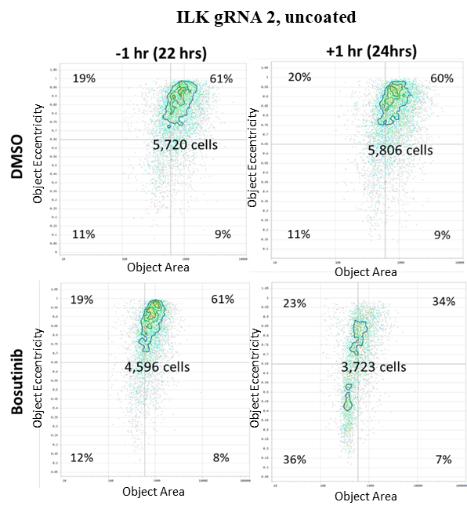
C |  | D
Supplementary Figure 15. A) IncuCyte images taken ±1 hr before/after drugging MDA-MB-231 cells. B) Cell-by-cell mask, rounded cells classifier whereby area <600 μM² (x-axis) and eccentricity <0.65 (y-axis) shown in the bottom left quadrant. Shown is a representative independent experimental replicate, three wells, 4 images per well. C-D) Cell rounding correlates with Caspase 3/7 activity. Cells were drugged at 24 hours post seeding. The IncuCyte was used to quantify phase confluence, green count (Caspase 3/7) and eccentricity. C) Caspase 3/7 green count normalised to phase confluence. D) Rounded cells ( <0.65 eccentricity) correlate with normalised Caspase 3/7 count. DMSO (grey), bosutinib 0.9 µM (red), eCF506 40 nM (blue) and PND-1186 100 nM (green) are shown. Before drugging (triangles), all samples have the same Caspase 3/7 activity and percent of rounded cells. After DMSO/drug treatment (circles) samples have a range of increased caspase 3/7 activities that directly correlate with an increased percentage of rounded cells.

A
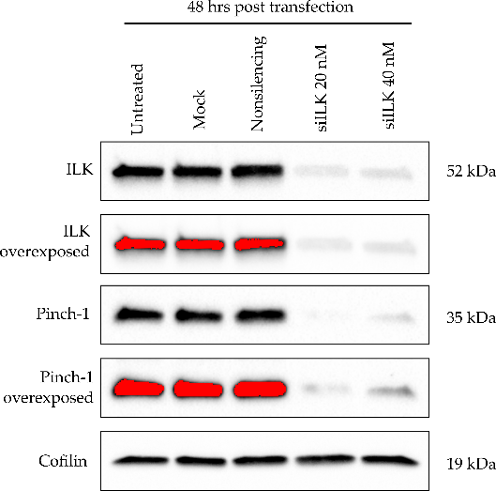 | 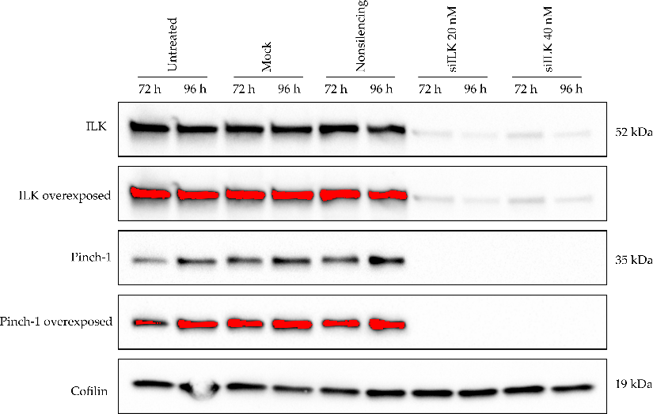
B | C

Supplementary Figure 16. ILK knockdown is not sufficient to enhance sensitivity to SRC inhibition. A) ILK knockdown using siRNA. Proteins for Western blot were extracted from a 24-well plate. B-C) 4,000 cells/well were seeded in 96-well plates. ILK siRNA at 20 nM was used as described in the Supplementary Methods. NTC, non-targeting control. B) Normalised cell counts from Hoechst-stained images. N=2 independent experimental replicates, error bars are S.E.M. C) The IncuCyte Zoom was used to quantify cell confluence. N=3 independent experimental replicates, error bars are S.E.M.

Supplementary Tables
Supplementary Table 1. NEB Next Ultra II Q5 PCR1 conditions. * Annealing temperatures were optimised for Q5 High‐Fidelity DNA Polymerase and tend to be higher than for other PCR polymerases. NEB Next Ultra II Q5 reactions require a 98˚C denaturation.
Protocol | Temperature | Time per step
Step 1: Initial Denaturation | 98˚C | 60 secs
Step 2: Denaturation | 98˚C | 10 secs
Step 3: Annealing | 69˚C* | 30 secs
Step 4: Extension | 72˚C | 30 secs
Back to Step 2 for a total of 20 cycles
Step 5: Final Extension | 72˚C | 2 min
 | 4˚C | ∞
Supplementary Table 2. Adapter PCR2 cycle conditions using NEB Next Ultra II Q5.
Protocol | Temperature | Time per step
Step 1: Initial Denaturation | 98˚C | 30 secs
Step 2: Denaturation | 98˚C | 10 secs
Step 3: Annealing | 55˚C | 30 secs
Step 4: Extension | 65˚C | 15 secs
Back to Step 2 for a total of 10 cycles
Step 5: Final Extension | 65˚C | 5 min
 | 4˚C | ∞
Supplementary Table 3. Truseq library-structured sequences for PCR1 and PCR2 Forward and Reverse primers. All sequences shown 5’ to 3’ direction. *Note that these primers are different to ‘LentiCRISPR_v2.1’ described in the Moffat laboratory protocol. As an illustration, orange, P5; purple, P7; yellow, Index 2; green, i5 (Fwd) or i7 (Rev); red, PCR2 primer site that binds PCR1 amplicon (‘PCR2 annealing site’ in Supplementary Figure 13); blue, spacer.
PCR1_Fwd_ LentiCRISPR_v2_2* | CTGCGTGCGCCAATTCTG
PCR1_Rev_ LentiCRISPR_v2_2* | AGAACCGGTCCTGTGTTCTG
D501 -F | AATGATACGGCGACCACCGAGATCTACACTATAGCCTACACTCTTTCCCTACACGACGCTCTTCCGATCTTTGTGGAAAGGACGAAACACCG
D502 -F | AATGATACGGCGACCACCGAGATCTACACATAGAGGCACACTCTTTCCCTACACGACGCTCTTCCGATCTTTGTGGAAAGGACGAAACACCG
D503 -F | AATGATACGGCGACCACCGAGATCTACACCCTATCCTACACTCTTTCCCTACACGACGCTCTTCCGATCTTTGTGGAAAGGACGAAACACCG
D504 -F | AATGATACGGCGACCACCGAGATCTACACGGCTCTGAACACTCTTTCCCTACACGACGCTCTTCCGATCTTTGTGGAAAGGACGAAACACCG
D701-R | CAAGCAGAAGACGGCATACGAGATCGAGTAATGTGACTGGAGTTCAGACGTGTGCTCTTCCGATCTACTTGCTATTTCTAGCTCTAAAAC
D702 -R | CAAGCAGAAGACGGCATACGAGATTCTCCGGAGTGACTGGAGTTCAGACGTGTGCTCTTCCGATCTACTTGCTATTTCTAGCTCTAAAAC
D705 -R | CAAGCAGAAGACGGCATACGAGATTTCTGAATGTGACTGGAGTTCAGACGTGTGCTCTTCCGATCTACTTGCTATTTCTAGCTCTAAAAC
Supplementary Table 4. Enhancer genes of bosutinib sensitivity in the MDA-MB-231 cell line identified by CRISPR-Cas9 screening. The top enhancer genes for the T27 time point are shown. The gene-level normalised Z-score was calculated using DrugZ. The Benjamini and Hochberg (B&H) false-discovery rate (FDR) was used to calculate significance. Normalised gene expression for the MDA-MB-231 cell line was calculated by whole-genome RNA sequencing. Gene copy number from canSAR. Bold genes are the IPP complex members.
Gene | Gene-level norm. Z-score for T27 | Rank | FDR (B&H) | Norm. gene expression | Gene copy number
ILK | -7.65 | 1 | 1.87E-10 | 785 | 3
PARVA | -7.49 | 2 | 3.18E-10 | 483 | 3
PPP1R15B | -6.90 | 3 | 1.54E-08 | 358 | 3
PHF8 | -5.96 | 4 | 5.67E-06 | 128 | 2
MESDC2 | -5.78 | 5 | 1.35E-05 | 795 | 2
STT3A | -4.66 | 6 | 0.00438 | 828 | 4
TYMS | -4.65 | 7 | 0.00438 | 1,427 | 3
TRIP4 | -4.59 | 8 | 0.00505 | 99 | 2
CTNNAL1 | -4.41 | 9 | 0.0102 | 2,369 | 3
ZNF8 | -4.27 | 10 | 0.0173 | 44 | 3
LDLR | -4.23 | 11 | 0.0191 | 1,814 | 3
HSP90B1 | -4.21 | 12 | 0.0191 | 7,677 | 3
EED | -4.12 | 13 | 0.0264 | 565 | 3
CHP1 | -4.10 | 14 | 0.0266 | 194 | 2
LIMS1 | -4.06 | 15 | 0.0293 | 236 | 3
ZNF598 | -4.04 | 16 | 0.0293 | 314 | 2
GGNBP2 | -4.03 | 17 | 0.0293 | 954 | 3
FBXW7 | -3.90 | 18 | 0.0454 | 269 | 3
AMBRA1 | -3.90 | 19 | 0.0454 | 39 | 3

Supplementary Table 5. ssODNs required for CRISPR-Cas9 sgRNA target sites for ILK.
Plasmid | ssODN 1 | ssODN 2 | Target site | On-target score
PX459v2- ILK gRNA1 | CACC – G*-CGGAGAACGACCTCAACCAG | AAAC-CTGGTTGAGGTCGTTCTCCG-C* | ILK exon 1 | 0.710
PX459v2- ILK gRNA2 | CACC-G*-ACATTGTAGAGGGATCCATA | AAAC-TATGGATCCCTCTACAATGT-C* | ILK exon 8 | 0.625
Note that whether the target DNA site is on the sense or antisense strand, the gRNA target site is found within the ssODN 1 and not ssODN 2. Additionally, the PAM is not included. Nucleotide sequences are shown in the 5’->3’ direction. * sgRNA expression from the U6 promoter can be enhanced by the inclusion of a 5’ guanine (G) after CACC for ssODN 1 and a 3’ cytosine (C) for ssODN 2, if the first native position of the 20-nt target site is not G (Bauer, D. E., Canver,2014).

Supplementary Table 6. ssODNs required for CRISPR-eCas9 sgRNA target sites for ABL1.
Plasmid | ssODN 1 | ssODN 2 | Target site | On-target score
eCas9 ABL1 gRNA1 | CACC-GGGGGACACACCATAGACAG | AAAC-CTGTCTATGGTGTGTCCCCC | ABL1 exon 4 | 0.6868
eCas9 ABL1 gRNA2 | CACC-GAAGAAATACAGCCTGACGG | AAAC-CCGTCAGGCTGTATTTCTTC | ABL1 exon 4 | 0.687
Note that whether the target DNA site is on the sense or antisense strand, the gRNA target site is found within the ssODN 1 and not ssODN 2. Additionally, the PAM is not included. Nucleotide sequences are shown in the 5’->3’ direction.

Supplementary Table 7. ANOVA for 3D bosutinib EC₅₀ values in a panel of breast cancer cell lines. ER, oestrogen receptor; PR, progesterone receptor; HER2, human epidermal growth factor receptor 2; EGFR, epidermal growth factor receptor; Triple-neg, triple negative. Bold text represents the cell lines that were the most sensitive to bosutinib. Data shown is calculated from three independent experimental replicates except MDA-MB-134-VI and MDA-MB-468, which are two independent experimental replicates. A one-way ANOVA with Bonferroni multiple-comparison correction was performed in Prism. NS, non-significant; *, p<0.05; **, p<0.01; ***, p<0.001; **** , p<0.0001.
Subtype classification | 3D spheroid area  EC₅₀ (µM) |  | MCF-7 | T47D | MDA-MB-134-VI | ZR-75-1 | MDA-MB-231 | MDA-MB-468
Luminal A (ER+, PR±, HER2-) | 0.17 | MCF-7 | - | *** | ** | **** | NS | *
Luminal A (ER+, PR+, HER2-) | 3.10 | T47D | *** | - | NS | NS | *** | NS
Luminal A (ER+, PR-, HER2-) | 2.90 | MDA-MB-134-VI | ** | NS | - | NS | ** | NS
Luminal B (ER+, PR±, HER2+) | >25.00 | ZR-75-1 | **** | NS | NS | - | **** | *
Triple-neg / claudin-low (ER-, PR-, HER2-) | 0.15 | MDA-MB-231 | NS | *** | ** | **** | - | *
Triple-neg / Basal (ER-, PR-, HER2-) | 1.57 | MDA-MB-468 | * | NS | NS | * | * | -

Supplementary Table 8. Top suppressor genes from the TKOv3 screen for the T27 time point are shown. Rank refers to suppressor gene rank. The gene-level normalised Z-score was calculated using DrugZ. The Benjamini and Hochberg (B&H) false-discovery rate (FDR) was used to calculate significance.
Gene | Gene-level norm. Z-score for T27 | Rank | FDR (B&H)
UBE2F | 6.33 | 1 | 2.21E-06
CUL5 | 5.31 | 2 | 0.000484
ARNT | 5.19 | 3 | 0.000633
AHR | 4.83 | 4 | 0.00304
SOCS6 | 4.79 | 5 | 0.00304
EP300 | 4.69 | 6 | 0.0042
ARIH2 | 4.62 | 7 | 0.0049
UBA6 | 4.44 | 8 | 0.0102
PTPN12 | 4.32 | 9 | 0.0155
C16orf72 | 4.25 | 10 | 0.0191
PKD2 | 4.20 | 11 | 0.021
DUSP4 | 4.18 | 12 | 0.021
RNF7 | 4.17 | 13 | 0.021
ITPK1 | 4.11 | 14 | 0.025
SENP8 | 4.08 | 15 | 0.0274
KIRREL | 4.03 | 16 | 0.032
TADA1 | 4.00 | 17 | 0.0329
SUPT20H | 3.99 | 18 | 0.0329
CBFB | 3.98 | 19 | 0.0329
CCNC | 3.90 | 20 | 0.0406
NRP1 | 3.90 | 21 | 0.0406
RUNX1 | 3.89 | 22 | 0.0406
TAF5L | 3.85 | 23 | 0.0468

Supplementary Table 9. ILK, LIMS1 and PARVA expression correlation with sensitivity to bosutinib in breast cancer cell line datasets.
ILK dataset | Pearson’s correlation | Spearman’s correlation
In-house (Temps et al. (24)) (16 cell lines) + cb5 | r(61) = 0.358, p = 0.004 | r(61) = 0.388, p = 0.002
Cancerxgene (43 cell lines) + cb5 | r(119) = 0.283, p = 0.002 | r(119) = 0.127, p = 0.164
Depmap mRNA (20 cell lines) | r(18) = 0.395, p = 0.085 | r(18) = 0.435, p = 0.056
Depmap protein (20 cell lines) | r(18) = 0.299, p = 0.199 | r(18) = 0.277, p = 0.238

LIMS1 dataset | Pearson’s correlation | Spearman’s correlation
In-house (Temps et al. (24)) (16 cell lines) + cb5 | r(61) = -0.343, p = 0.006 | r(61) = -0.298, p = 0.021
Cancerxgene (13 cell lines) + cb5 | r(49) = -0.317, p = 0.024 | r(49)= -0.234, p = 0.098
Depmap mRNA (7 cell lines) | r(5) = 0.800, p = 0.031 | r(5) = 0.857, p = 0.014
Depmap protein (6 cell lines) | r(4) = 0.490, p = 0.032 | r(4) = 0.600, p = 0.208

PARVA dataset | Pearson’s correlation | Spearman’s correlation
In-house (Temps et al. (24)) (16 cell lines) + cb5 | r(49) = -0.396, p = 0.001 | r(49) = -0.587, p = 0.001
Cancerxgene (12 cell lines) + cb5 | r(49) = -0.342, p = 0.0143 | r(49) = -0.156, p = 0.274
Depmap mRNA (7 cell lines) | r(5) = 0.408, p = 0.036 | r(5) = 0.714, p = 0.071
Depmap protein (6 cell lines) | NA | NA

