Supplementary Materials for

Quantitative Spatial Profiling of Immune Populations Reveals Prognostic Significances in Patients with Pancreatic Ductal Adenocarcinoma
Authors: Haoyang Mi^{1,}*, Shamilene Sivagnanam², Courtney B. Betts³, Shannon M. Liudahl^{3,#,} Elizabeth M. Jaffee^{4,5}, Lisa M. Coussens^{3,6,7,†,*}, Aleksander S. Popel^{1,5,†}
Affiliations:
¹Department of Biomedical Engineering, Johns Hopkins University School of Medicine, Baltimore, MD, United States
²Computatioanl Biology, Oregon Health and Science University, Portland, OR, United States
³Department of Cell, Development, and Cancer Biology, Oregon Health and Science University, Portland, OR, United States
⁴ Skip Viragh Center for Pancreatic Cancer, The Sidney Kimmel Comprehensive Cancer Center at Johns Hopkins, Johns Hopkins Medicine, Baltimore, MD, United States.
⁵Sidney Kimmel Comprehensive Cancer Center, Johns Hopkins University School of Medicine, Baltimore, MD, United States
⁶Brenden-Colson Center for Pancreatic Care, Oregon Health and Science University, Portland, OR, United States
⁷Knight Cancer Institute, Portland, OR, United States
#Current address: Clinical Research Division, Fred Hutchinson Cancer Research Center, Seattle, Washington, USA
†These authors jointly supervised this work
*Corresponding author. Email: hmi1@jhmi.edu (H.M.), coussenl@ohsu.edu (L.M.C.)

Figure. S1
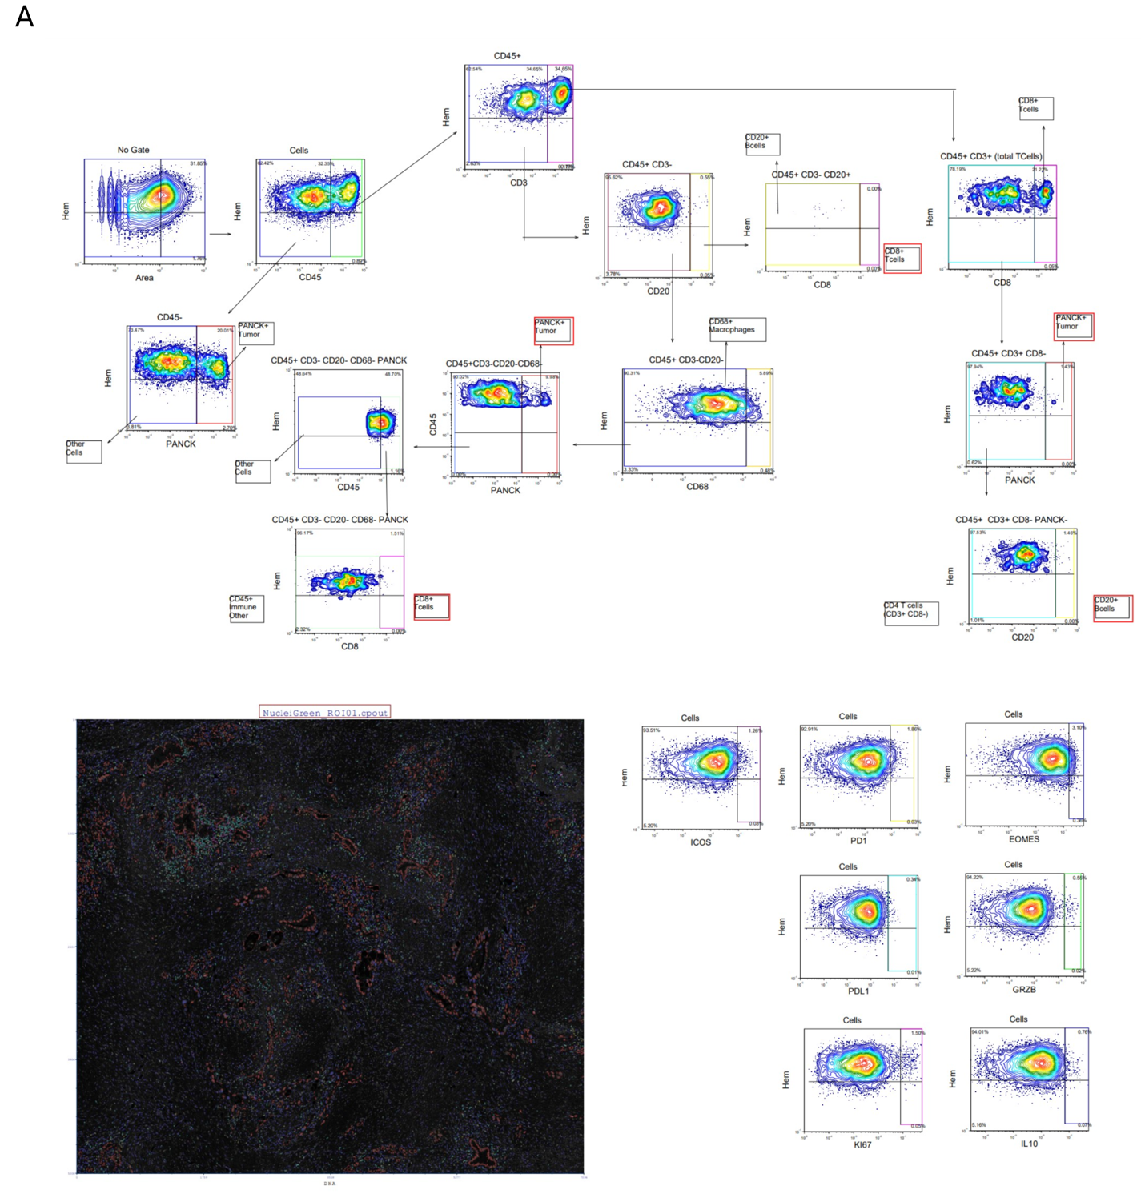
Gating strategy used for classifying cell types. A, Manual gating was performed in FCS Express Image Gating Cytometry RUO with gated cell selections overlaid on signal to visually validate classification. Text boxes label each cell population, while red boxes indicate backgated populations. Segmented cells were gated through a hierarchy starting with CD45 to identify leukocytes. B cells were identified by CD45⁺ CD3⁻ CD20⁺ CD8⁻ marker expression. CD8 T cells were classified by CD45⁺ CD3⁺ CD8⁺ and also backgated from CD3⁻/CD20⁺ and CD3⁻/CD20⁻ cell populations. CD4 T cells were classified by CD3⁺ CD8⁻ CD20⁻ PanCK⁻ expression. Myelo-monocytic cells were classified as cells with CD45⁺ CD3⁻ CD20⁻ CD68⁺ expression. Neoplastic epithelial cells were identified by CD45⁻ PanCK⁺ and also backgated on the CD3^{+/}CD8⁻ (CD4 T cell) population, as well as the CD45⁺ CD3⁻ CD20⁻ CD68⁻ population. The gate labeled, CD45⁺ Other, contained remaining cells that had CD45 expression, but no other markers utilized in this gating strategy. Functional markers (PD1, PDL1, Ki-67, GranzymeB, EOMES, ICOS, IL-10) were classified as positive or negative by thresholding based on the mean intensity of each marker on all cells.

Figure S2.
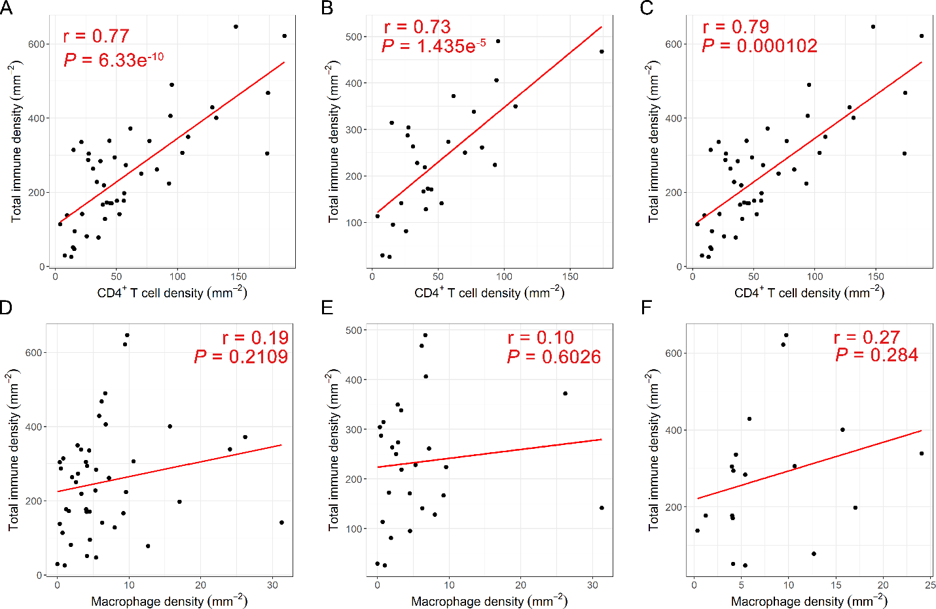
Correlation analysis between CD4⁺ T cell density and total immune density as well as macrophage density and total immune density. A and D, cell densities computed from the entire cohort. B and C, cell densities computed from short-term survivors. G and F, cell densities computed from long-term survivors.

Figure S3.
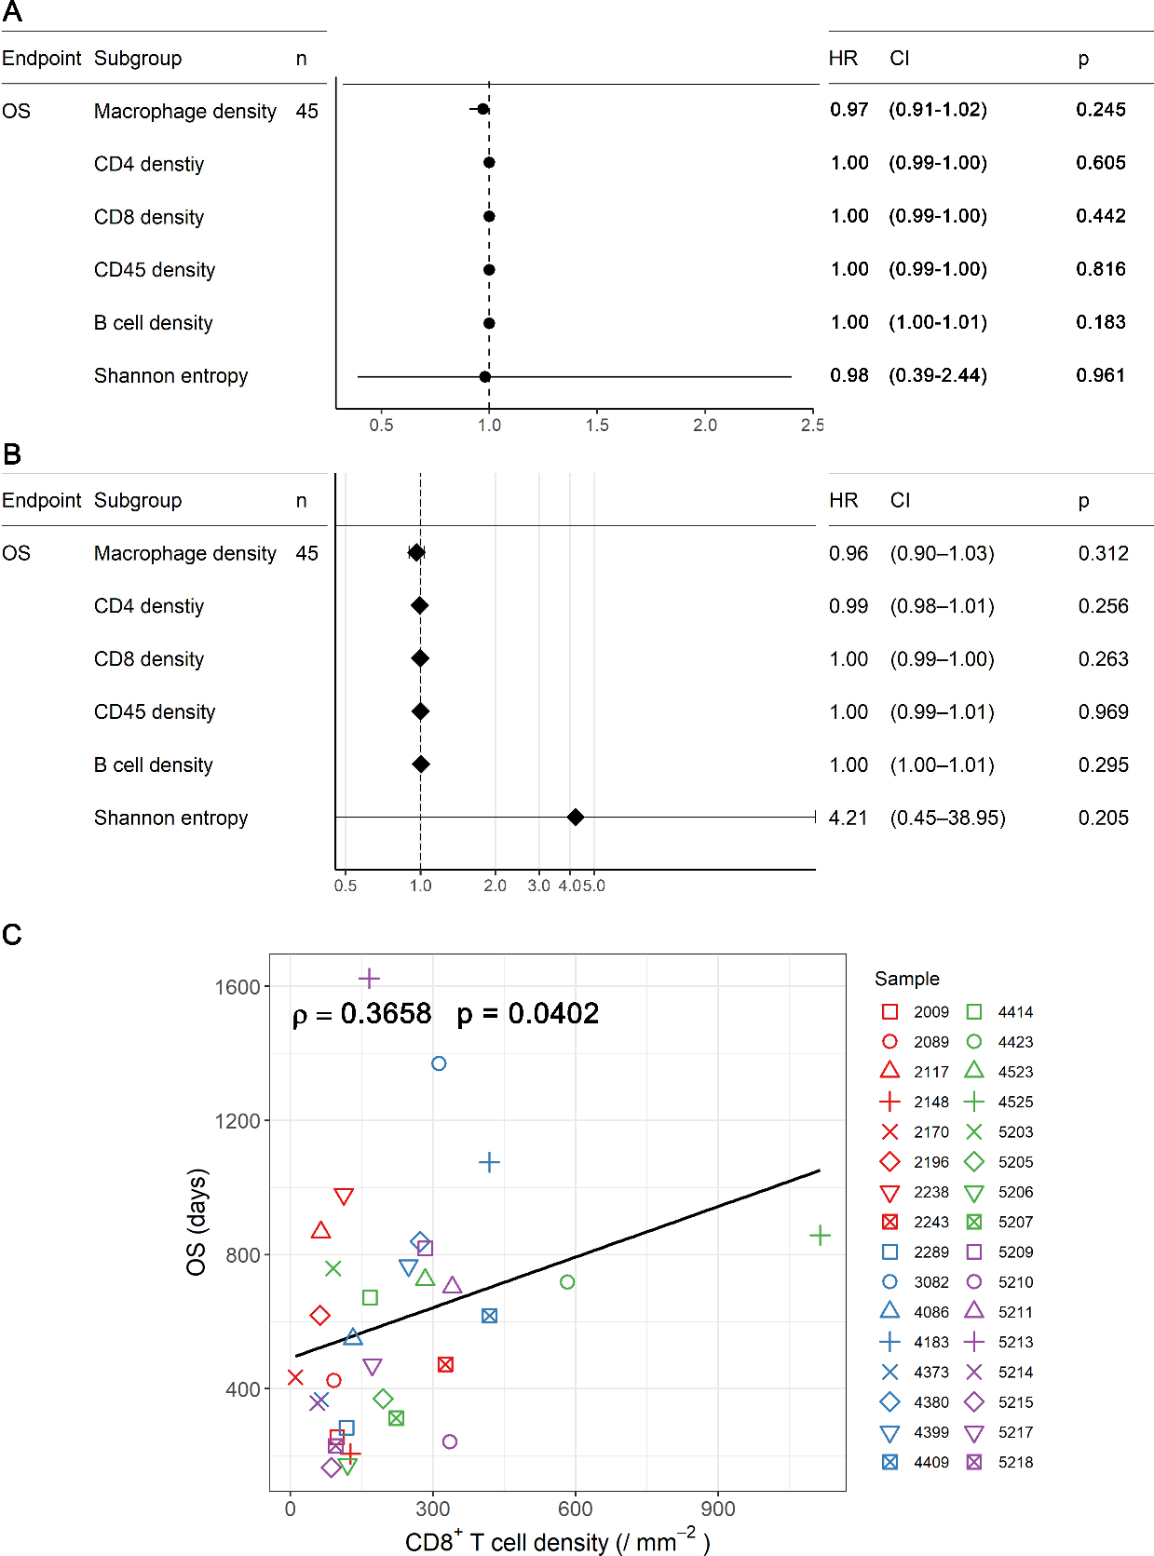
Results of A, Univariate survival analysis and B, multivariate survival analysis on first-order features using Cox regression model. C, correlation analysis on discovery cohort between CD8⁺ T cell density in lymphoid aggregates (LAs) and overall survival (OS) using spearman’s method.
Figure S4.
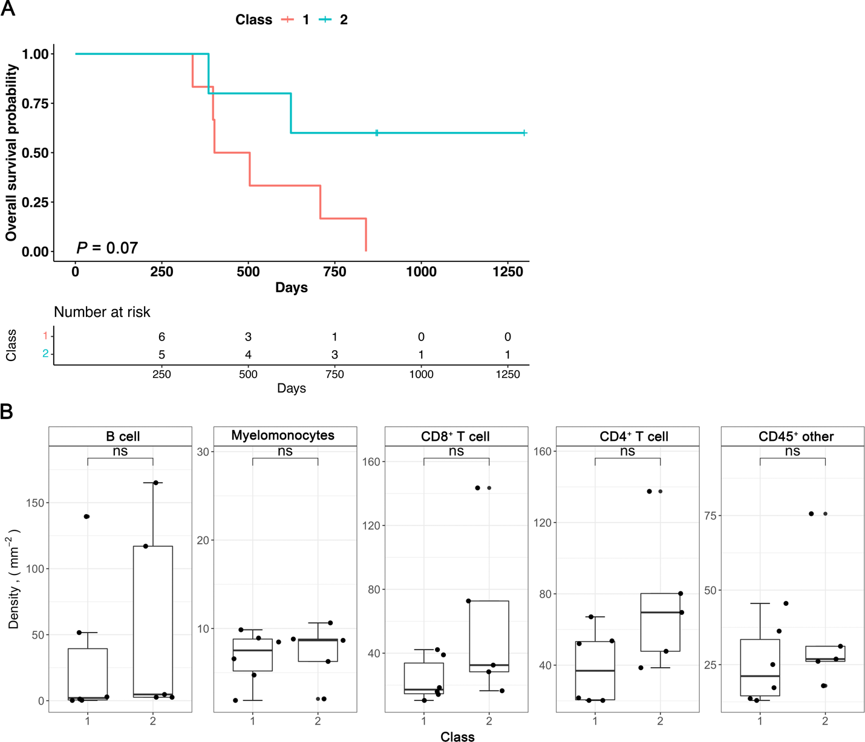
A, Kaplan-Meier curves revealing overall survival (OS) of patients based on classes defined by treatment strategies. B, comparisons between class 1 and 2 patients for each immune population. ns: not significant..
Figure S5.
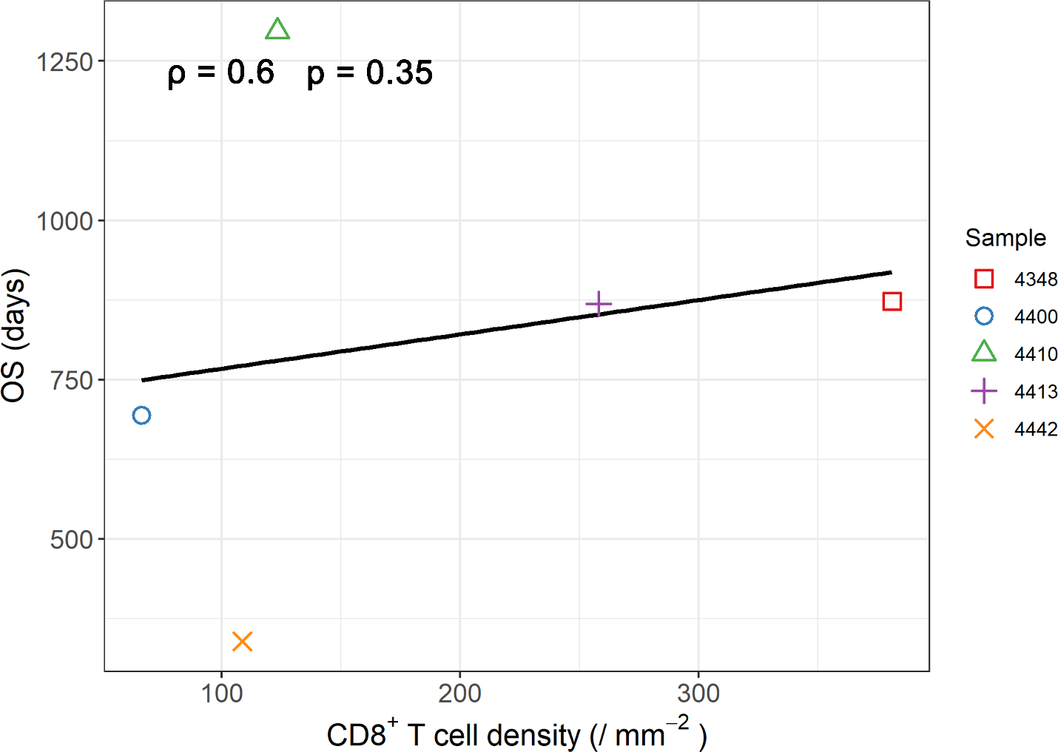
Correlation analysis on validation cohort (presurgically treated) between CD8⁺ T cell density in lymphoid aggregates (LAs) and overall survival (OS) using spearman’s method.
Table S1. Multiplex immunohistochemistry (mIHC) antibody panels
Primary Antibody | Hematoxylin | CD68 | CD45 | PD-L1 | CD3/CD20/NKp46 | Pan-cytokeratin | PD-1 | CD3
RRID | N/A | AB_306119 | AB_467274 | AB_2687655 | See footnotes | AB_777047 | AB_881954 | AB_149922
Clone | N/A | PG-M1 | HI30 | E1L3N | See footnotes | AE1/AE3 | NAT105 | SP7
Vendor | Dako | Abcam | ThermoFisher | Cell Signaling | See footnotes | Abcam | Abcam | ThermoFisher
Catalog # | S3301 | ab783 | 14-0459-82 | 13684S | See footnotes | ab27988 | ab52587 | RM-9107-S
Concentration | N/A | 1:50 | 1:100 | 1:100 | See footnotes | 1:2000 | 1:50 | 1:150
Incubation | 1 min @ RT | 30 min @ RT | 60 min @ RT | O/N @ 4ºC | 30 min @ RT | 30 min @ RT | 30 min @ RT | 30 min @ RT

Primary Antibody | CD8α | T-bet | CD20 | CD8α | CD138 | CD38 | IDO | CD4
RRID | AB_11000353 | AB_2616022 | AB_1139386 | AB_11000353 | AB_10987019 | AB_10986743 | AB_1977098 | AB_2335982
Clone | C8/144B | D6N8B | Polyclonal | C8/144B | MI15 | 38C03 (SPC32) | IF8.2 | SP35
Vendor | ThermoFisher | Cell Signaling | Abcam | ThermoFisher | ThermoFisher | ThermoFisher | Millipore Sigma | Ventana
Catalog # | MA5-13473 | 13232S | ab5694 | MA5-13473 | MA5-12400 | MA5-14413 | MAB10009 | 790-4423
Concentration | 1:100 | 1:500 | 1:200 | 1:100 | 1:20 | 1:100 | 1:100 | 1:4
Incubation | 30 min @ RT | O/N @ 4ºC | 60 min @ RT | 30 min @ RT | 30 min @ RT | 30 min @ RT | 30 min @ RT | 30 min @ RT

Primary Antibody | CD3 | Granzyme B | CD278/ICOS | CD27 | CD5 | IgD | MECA-79 | EOMES
RRID | AB_149922 | AB_304251 | AB_2827535 | AB_2827537 | AB_10985112 | AB_10974228 | AB_395099 | AB_10806889
Clone | SP7 | Polyclonal | SP98 | Polyclonal | 4C7 | EPR6146 | MECA-79 | Polyclonal
Vendor | ThermoFisher | Abcam | LifeSpan Bio | Novus Biologicals | ThermoFisher | Abcam | BD Bioscience | Millipore Sigma
Catalog # | RM-9107-S | ab4059 | LS-C210350-500 | NBP2-38434 | MA5-13308 | ab124795 | 553863 | AB2283
Concentration | 1:150 | 1:200 | 1:100 | 1:500 | 1:40 | 1:200 | 1:500 | 1:1000
Incubation | 30 min @ RT | 30 min @ RT | 30 min @ RT | 30 min @ RT | O/N @ 4ºC | O/N @ 4ºC | O/N @ 4ºC | 30 min @ RT

Primary Antibody | IL-10 | TCRB | Ki67
RRID | AB_1056749 |  | AB_1158031
Clone | JES3-12G8 |  | SP6
Vendor | LifeSpan Biosciences |  | Millipore Sigma
Catalog # | LS-C44484 |  | 275R-14
Concentration | 1:200 |  | 1:500
Incubation | O/N @ 4ºC |  | 30 min @ RT

Table S2. Baseline characteristics of presurgical treatment-naïve cohort.
 | Neoadjuvant-treated cohort (validation cohort)
Number of subjectsª | 46
Women, n (%) | 24 (52%)
Age in years, median (Q1, Q3) | 63.5 (58.0, 71.0)
Tumor location, n (%)
Head/Uncinate | 40 (87%)
Body/Tail | 6 (13%)
Tumor size in cm, median (Q1, Q3)^{b} | 3.4 (2.5, 4.5)
AJCC 8th ed. pT stage, n (%)
T1 | 7 (15%)
T2 | 23 (50%)
T3 | 15 (33%)
T4 | 1 (2%)
Tx (cannot be assessed) | -
AJCC 8th ed. pT stage, n (%)
N0 | 12 (26%)
N1 | 15 (33%)
N2 | 19 (41%)
Tumor differentiation, n (%)
Well/Moderately differentiated | 23 (51%)
Poorly differentiated/Undifferentiated | 22 (49%)
Unknown | 1
Resection margin status, n (%)
R0 | 20 (44%)
R1 | 25 (54%)
R2 | 1 (2%)
Lymphovascular invasion, n (%)
Negative | 11 (24%)
Positive | 34 (76%)
Unknown | 1
Perineural invasion, n (%)
Negative | 3 (7%)
Positive | 42 (93%)
Unknown | 1
Adjuvant treatment, n (%)
None | 5 (11%)
Chemotherapy only | 17 (37%)
Radiation or chemoradiation only | 4 (9%)
Chemoradiation and chemotherapy | 15 (32%)
Other/Unknown | 5 (11%)
SMAD4, n (%)
Lost | 6 (46%)
Intact | 5 (38%)
KRAS, n (%)
Wild-type | 0
Mutant | 22 (100%)
Unknown | 24
TP53, n (%)
Wild-type | 5 (23%)
Altered | 17 (77%)
Unknown | 24
CDKN2A, n (%)
Lost | 6 (27)
Intact | 16 (73%)
Unknown | 24
ªAmong 45/46 patients with evaluable single-cell data.
^{b}Abbreviations: Q1, 25th percentile; Q3, 75th percentile; AJCC, American Joint Committee on Cancer
Table S3. Baseline characteristics of presurgically treated cohort.
 | Neoadjuvant-treated cohort (validation cohort)
Number of subjectsª | 13
Women, n (%) | 4 (31%)
Age in years, median (Q1, Q3)^{b} | 61.0 (56.0, 59.0)
Tumor location, n (%)
Head/Uncinate | 10 (77%)
Body/Tail | 3 (23%)
Tumor size in cm, median (Q1, Q3) | 3.8 (2.9, 4.4)
AJCC 8th ed. pT stage, n (%)
T1 | 3 (23%)
T2 | 3 (23%)
T3 | 5 (38%)
T4 | 2 (15%)
AJCC 8th ed. pT stage, n (%)
N0 | 7 (54%)
N1 | 4 (31%)
N2 | 2 (15%)
Tumor differentiation, n (%)
Well/Moderately differentiated | 4 (31%)
Poorly differentiated/Undifferentiated | 6 (46%)
Unknown | 3 (23%)
Resection margin status, n (%)
R0 | 5 (38%)
R1 | 7 (54%)
R2 | 1 ( 8%)
Lymphovascular invasion, n (%)
Negative | 7 (54%)
Positive | 6 (46%)
Perineural invasion, n (%)
Negative | 0 (0%)
Positive | 13 (100%)
Presurgical treatment, n (%)
Chemotherapy only | 6 (46%)
Radiation or chemotherapy only | 1 (8%)
(Chemo)radiation and chemotherapy | 6 (46%)
Unknown | 0 (0%)
Presurgical chemotherapy agent, n (%)
FOLFIRINOX | 3 (23%)
Gemcitabine/nab-paclitaxel | 7 (54%)
Other combination | 3 (23%)
Unknown | 0 (0%)
Presurgical chemoradiation agent, n (%)
No concurrent chemoradiotherapy | 9 (69%)
Gemcitabine/nab-paclitaxel | 1 (8%)
5-FU or capecitabine | 3 (23%)
Histologic response to presurgical/neoadjuvant therapy, n (%)
Poor or no response | 3 (23%)
Moderate response | 3 (23%)
Marked response (minimal residual disease) | 6 (46%)
Unknown | 1 (8%)
Adjuvant treatment, n (%)
None | 6 (46%)
Chemotherapy only | 5 (38%)
Radiation or chemoradiation only | 0 (0%)
Chemoradiation and chemotherapy | 0 (0%)
Other/Unknown | 2 (15%)
ªAmong 10/13 patients with evaluable single-cell data.
^{b}Abbreviations: Q1, 25th percentile; Q3, 75th percentile; AJCC, American Joint Committee on Cancer
Table S4. Region of interest (ROI) areas summarized for each patient
Patient | ROI area (mm²)
ID | 1 | 2 | 3 | 4 | 5 | 6 | 7 | 8 | 9 | 10 | 11 | 12 | mean
2009 | 1.57 | 0.79 | 1.64 | 11.30 | 20.01 | 14.26 | 18.25 | 29.41 | / | / | / | / | 12.15
2089 | 29.63 | 40.87 | 34.30 | 14.39 | 14.49 | 10.82 | / | / | / | / | / | / | 24.08
2117 | 1.00 | 0.98 | 0.70 | 45.20 | 14.74 | 0.43 | 42.20 | 36.01 | 39.08 | / | / | / | 20.04
2148 | 12.16 | 55.70 | 42.77 | 36.56 | 19.59 | 30.91 | 1.40 | 5.30 | 9.21 | 4.29 | / | / | 21.79
2170 | 28.06 | 24.55 | 27.07 | 11.73 | / | / | / | / | / | / | / | / | 22.85
2196 | 0.30 | 0.66 | 0.52 | 37.63 | 37.22 | 42.21 | 31.83 | 23.60 | 14.78 | / | / | / | 20.97
2238 | 50.39 | 42.78 | 53.03 | 2.29 | 1.99 | 23.48 | 28.95 | 1.63 | / | / | / | / | 25.57
2243 | 5.49 | 1.73 | 40.45 | 38.21 | 27.93 | 28.44 | 5.29 | 8.79 | 5.21 | 13.05 | 6.55 | / | 16.47
2250 | / | / | 1.21 | 0.82 | 0.88 | 0.75 | 21.58 | 32.04 | 28.28 | 18.68 | 5.50 | 6.09 | 11.58
2256 | 16.45 | 6.17 | 9.73 | 8.29 | / | 14.08 | / | / | / | / | / | / | 10.94
2289 | 38.03 | 36.94 | / | 25.37 | 27.20 | 7.61 | / | / | / | / | / | / | 27.03
3082 | 4.48 | 1.05 | 6.58 | 3.99 | 39.65 | 42.15 | 24.3 | 13.41 | 9.55 | / | / | / | 16.14
4066 | 46.65 | 55.41 | 39.35 | 22.44 | 13.84 | / | / | / | / | / | / | / | 35.54
4086 | 47.96 | 44.04 | 31.93 | 25.89 | 20.28 | 3.04 | / | / | / | / | / | / | 28.86
4101 | 11.16 | 13.13 | 11.98 | / | / | / | / | / | / | / | / | / | 12.09
4145 | 4.25 | 4.40 | 3.71 | 2.83 | 4.21 | / | / | / | / | / | / | / | 3.88
4165 | 3.11 | 2.66 | 5.41 | 1.59 | 6.69 | 6.78 | / | / | / | / | / | / | 4.37
4183 | 8.56 | 1.69 | 2.90 | 1.00 | 1.63 | 2.80 | 9.10 | / | / | / | / | / | 3.95
4188 | 40.40 | 34.17 | 27.82 | 33.66 | 21.46 | 12.44 | / | / | / | / | / | / | 28.33
4304 | 37.47 | 42.97 | 34.43 | 25.20 | 23.54 | 12.09 | / | / | / | / | / | / | 29.28
4366 | 49.63 | 50.25 | 28.24 | 2.06 | 35.88 | 100.00 | / | / | / | / | / | / | 29.34
4373 | 2.70 | 5.71 | 4.30 | 3.57 | 43.99 | 46.82 | 42.51 | 37.41 | 33.98 | / | / | / | 24.55
4380 | 10.89 | 35.22 | 35.16 | 28.05 | 2.47 | 37.54 | 4.53 | 29.62 | 1.43 | 17.78 | / | / | 20.27
4399 | 6.05 | 6.66 | 32.21 | 29.06 | 42.73 | 29.06 | 19.74 | 3.20 | 1.52 | / | / | / | 19.61
4409 | 30.87 | 2.40 | / | / | 1.58 | 7.05 | 2.67 | 7.84 | / | / | / | / | 10.18
4414 | 48.47 | 42.79 | / | 0.99 | 34.20 | 41.77 | / | / | / | / | / | / | 33.64
4422 | 37.02 | 29.44 | 46.01 | 36.49 | 24.72 | 3.87 | 7.34 | / | / | / | / | / | 26.41
4423 | 10.99 | 26.09 | 31.60 | 28.24 | 20.02 | 0.70 | / | / | / | / | / | / | 19.61
4523 | 35.67 | 21.30 | 13.29 | 29.29 | 19.27 | 9.32 | / | / | / | / | / | / | 21.36
4525 | 23.98 | 15.88 | 5.87 | 1.33 | 2.56 | 10.45 | 6.05 | 10.91 | 12.22 | / | / | / | 9.92
5202 | 2.32 | 1.12 | 48.33 | 43.39 | 44.03 | 21.04 | 21.89 | 13.68 | / | / | / | / | 24.48
5203 | 65.94 | 38.51 | 38.11 | 8.10 | 6.72 | 20.06 | 12.87 | 14.03 | / | / | / | / | 25.54
5204 | 36.14 | 24.21 | 15.25 | 2.03 | 1.95 | 24.38 | 30.45 | / | / | / | / | / | 19.20
5205 | 1.60 | 11.96 | 6.68 | 2.12 | 32.93 | 45.17 | 39.73 | 19.27 | 19.66 | / | / | / | 19.90
5206 | 1.19 | 1.14 | 8.23 | 49.61 | 39.63 | 48.90 | / | / | / | / | / | / | 24.78
5207 | 12.38 | 9.75 | 6.21 | 3.83 | 19.71 | 22.49 | / | / | / | / | / | / | 12.39
5209 | 44.72 | 50.60 | 47.54 | 0.40 | 2.24 | 12.68 | 7.94 | 4.81 | / | / | / | / | 21.36
5210 | 39.58 | 19.71 | 37.54 | 38.09 | 17.02 | 8.82 | / | / | / | / | / | / | 26.79
5211 | 14.28 | 17.99 | 17.40 | 14.79 | 15.01 | / | / | / | / | / | / | / | 15.91
5212 | 32.63 | 12.39 | 44.83 | / | / | / | / | / | / | / | / | / | 29.95
5213 | 13.43 | 3.20 | 2.44 | 40.75 | 52.86 | 48.47 | / | / | / | / | / | / | 26.86
5214 | 27.23 | 22.02 | 41.89 | 0.78 | 3.63 | 10.20 | 28.05 | 29.49 | 4.17 | 4.51 | / | / | 17.20
5215 | 6.67 | 1.83 | 1.18 | 16.05 | 32.57 | 13.91 | 20.86 | 21.57 | 3.20 | / | / | / | 13.09
5217 | 1.88 | 1.73 | / | 11.53 | 8.58 | 22.51 | 6.88 | 19.54 | 12.60 | / | / | / | 10.66
5218 | 0.62 | 1.21 | 27.00 | 40.29 | 21.77 | 9.70 | 9.91 | 3.94 | / | / | / | / | 14.31

Table S5.
Cell pair |  | Distance interval ($μ$m)
From | To | 10 - 20 | 20 – 30 | 30 – 40 | 40 - 50 | Entire span
CD4⁺ T | CD8⁺ T | 0.2240 | 0.0683 | 0.2686 | 0.5165 | 0.0264
CD8⁺ T | CD4⁺ T | 1 | 1 | 1 | 1 | 1
CD4⁺ T | B | 0.4622 | 0.0713 | 0.0847 | 0.1638 | 0.0037
B | CD4⁺ T | 1 | 1 | 1 | 1 | 1
CD4⁺ T | Macrophage | 2.3548e-5 | 2.3048e-6 | 3.773e-7 | 7.5463e-7 | 4.1068e-11
Macrophage | CD4⁺ T | 0.0435 | 0.0372 | 0.004 | 0.0080 | 2.1789e-4
CD8⁺ T | B | 0.0002 | 0.0014 | 0.0017 | 0.0032 | 4.5496e-8
B | CD8⁺ T | 0.0002 | 0.0087 | 0.1731 | 0.3338 | 2.2273e-5
CD8⁺ T | Macrophage | 0.0001 | 2.4120e-5 | 3.2874e-5 | 6.5749e-5 | 1.7637e-6
Macrophage | CD8⁺ T | 1 | 1 | 1 | 1 | 0.8938
B | Macrophage | 1 | 1 | 1 | 1 | 1
Macrophage | B | 1 | 1 | 1 | 1 | 1
Spatial correlation analysis of immune phenotype pairs using spatial G(r) function (Gcross). Gcross values were evaluated and compared between short- and long-term groups at each distance interval starting from 10$μ$m to 50 $μ$m and the entire span (Wilcoxon rank-sum test). P values were recorded and FDR-adjusted. Adjusted P < 0.05 was considered significant.

Table S6.
Enrichment score (SEn) – 400 simulations
Macrophage
Marker | PD-L1 | PD-1 | IL-10 | GZMB | Ki67 | EOMES | ICOS
Median S_{En} | 0.0425 | 0 | 1 | 0 | 0.0075 | 0.0025 | 0
Mean S_{En} | 0.3808 | 0.0788 | 0.6488 | 0.1280 | 0.2688 | 0.2915 | 0.0310
CD4⁺ T cell
Marker | PD-L1 | PD-1 | IL-10 | GZMB | Ki67 | EOMES | ICOS
Median S_{En} | 0.0475 | 1 | 1 | 0 | 0.4725 | 0.185 | 0
Mean S_{En} | 0.3325 | 0.7028 | 0.6587 | 0.1367 | 0.4840 | 0.3784 | 0.0355
Enrichment score (SEn) – 500 simulations
Macrophage
Marker | PD-L1 | PD-1 | IL-10 | GZMB | Ki67 | EOMES | ICOS
Median S_{En} | 0.0400 | 0 | 1 | 0 | 0.0060 | 0.0020 | 0
Mean S_{En} | 0.3809 | 0.0788 | 0.6489 | 0.1282 | 0.2692 | 0.2917 | 0.0312
CD4⁺ T cell
Marker | PD-L1 | PD-1 | IL-10 | GZMB | Ki67 | EOMES | ICOS
Median S_{En} | 0.0440 | 1 | 1 | 0 | 0.4920 | 0.2140 | 0
Mean S_{En} | 0.3325 | 0.7026 | 0.6584 | 0.1367 | 0.4857 | 0.3786 | 0.0358
Enrichment score (SEn) – 600 simulations
Macrophage
Marker | PD-L1 | PD-1 | IL-10 | GZMB | Ki67 | EOMES | ICOS
Median S_{En} | 0.04 | 0 | 1 | 0 | 0.0067 | 0.0017 | 0
Mean S_{En} | 0.3811 | 0.079 | 0.6488 | 0.1282 | 0.2689 | 0.2915 | 0.0311
CD4⁺ T cell
Marker | PD-L1 | PD-1 | IL-10 | GZMB | Ki67 | EOMES | ICOS
Median S_{En} | 0.0533 | 1 | 1 | 0 | 0.4767 | 0.2167 | 0
Mean S_{En} | 0.3328 | 0.7036 | 0.6587 | 0.1370 | 0.4843 | 0.3783 | 0.0361
Enrichment score computed for all functional markers on both macrophages and CD4⁺ T cells at per-ROI basis, denoted as S_{En} using different simulation times. Mean and median S_{En} were derived by summarizing values from all ROIs. Marker with highest mean and median S_{En} was selected as the primary contributing factor to the spatial clustering
Table S7. Exclusion analysis test result.
Removed Patient | P value
2117 | < 2.2e-¹⁶
2148 | < 2.2e-¹⁶
2243 | < 2.2e-¹⁶
2256 | < 2.2e-¹⁶
2289 | < 2.2e-¹⁶
3082 | < 2.2e-¹⁶
4066 | < 2.2e-¹⁶
4101 | < 2.2e-¹⁶
4165 | < 2.2e-¹⁶
4183 | < 2.2e-¹⁶
4304 | < 2.2e-¹⁶
4373 | < 2.2e-¹⁶
4380 | < 2.2e-¹⁶
4399 | < 2.2e-¹⁶
4409 | < 2.2e-¹⁶
4414 | < 2.2e-¹⁶
4422 | < 2.2e-¹⁶
4423 | < 2.2e-¹⁶
4523 | < 2.2e-¹⁶
4525 | < 2.2e-¹⁶
5202 | < 2.2e-¹⁶
5205 | < 2.2e-¹⁶
5209 | < 2.2e-¹⁶
5210 | < 2.2e-¹⁶
5211 | < 2.2e-¹⁶
5212 | < 2.2e-¹⁶
5213 | < 2.2e-¹⁶
5214 | < 2.2e-¹⁶
5215 | < 2.2e-¹⁶
5217 | < 2.2e-¹⁶
5218 | < 2.2e-¹⁶

