Supplementary Figure 1. Inferred genetic ancestry using common polymorphisms called from off-target and on-target sequencing reads from AR ChIP-seq data.
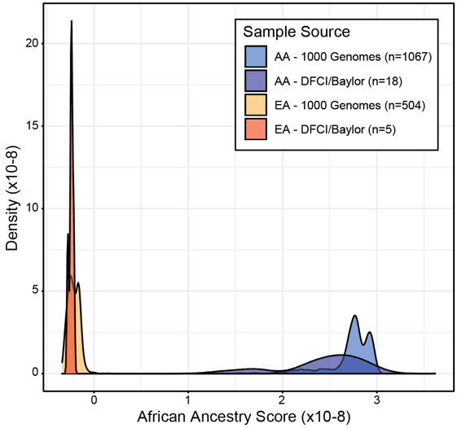

Histogram shows the African ancestry score for the prostate samples included in this analysis as well as samples from 1000 Genomes Project for reference.

