Supplementary data
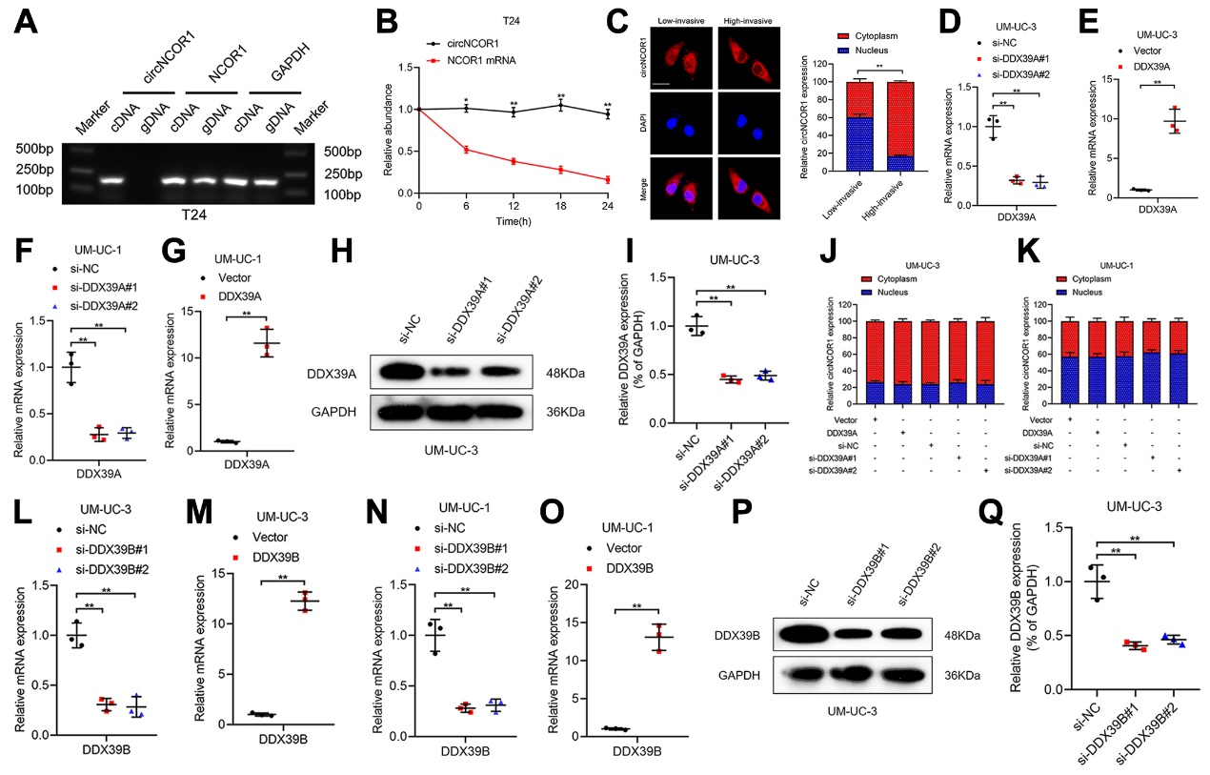Supplementary Figure S1. DDX39B mediates the nuclear exportation of circNCOR1. A, PCR with agarose gel electrophoresis assay of circNCOR1 and NCOR1 in the cDNA and gDNA of T24 cells. B, Assessment of circNCOR1 and NCOR1 mRNA stability in T24 cells. C, FISH and subcellular fraction analysis of circNCOR1 cellular localization in established high- and low-invasive BCa cells. Scale bars: 5 μm. D–G, qRT-PCR analysis of DDX39A expression in high-invasive BCa cells (UM-UC-3) and low-invasive BCa cells (UM-UC-1) after knocking down or overexpressing DDX39A. H and I, Western blotting and quantification analysis of DDX39A expression in UM-UC-3 cells after knocking down DDX39A. J and K, Subcellular fraction analysis of circNCOR1 in high-invasive BCa cells (UM-UC-3) and low-invasive BCa cells (UM-UC-1) after overexpressing or downregulating DDX39A. L–O, qRT-PCR analysis of DDX39B expression in high-invasive BCa cells (UM-UC-3) and low-invasive BCa cells (UM-UC-1) after knocking down or overexpressing DDX39B. P and Q, Western blotting and quantification analysis of DDX39B expression in UM-UC-3 cells after knocking down DDX39B. The statistical difference was assessed through 1-way ANOVA followed by Dunnett’s tests in D, F, I, L, N and Q; and 2-tailed Student’s t-test in B, E, G, M and O; and the χ² test in C, J and K. Error bars show the standard deviation (SD) from three independent experiments. *P < 0.05; **P < 0.01.

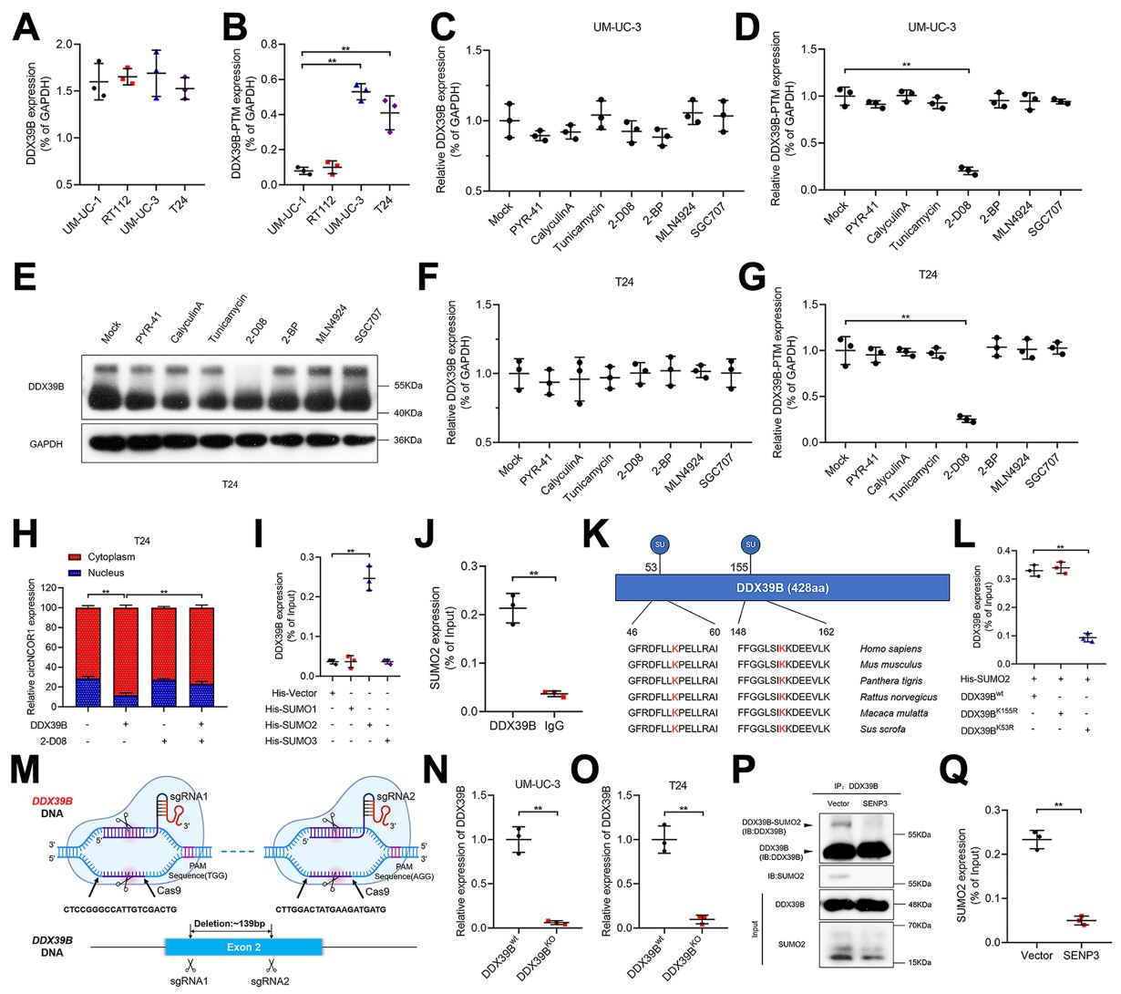Supplementary Figure S2. SUMOylation promotes DDX39B-mediated circNCOR1 nuclear exportation. A and B, Western blotting and quantification analysis verified the PTM of DDX39B in BCa cells. C-G, Western blotting and quantification analysis of the PTM level of DDX39B after inhibitors treatment in UM-UC-3 and T24 cells. H, Subcellular fraction analysis of circNCOR1 cellular localization in indicated T24 cells. I, Western blotting and quantification analysis of the SUMOylation type of DDX39B in UM-UC-3 cells. J, Western blotting and quantification analysis verified the SUMO2 modification of DDX39B after co-IP with anti-DDX39B and IgG control in UM-UC-3 cells. K, Sequence alignment of DDX39B homologs in various species. L, Western blotting and quantification analysis verified that the SUMO2 modification site of DDX39B was the K53 residue. M, Schematic illustration of DDX39B knockout using the CRISPR-Cas9 system. N and O, qRT-PCR analysis of DDX39B expression in high-invasive BCa cells (UM-UC-3 and T24) after knocking out DDX39B. P and Q, Western blotting and quantification analysis verified that SENP3 decreased SUMO2 modification of DDX39B. The statistical difference was assessed through 1-way ANOVA followed by Dunnett’s tests in A-D, F, G, I and L; and 2-tailed Student’s t-test in J, N, O and Q; and the χ² test in H. Error bars show the SD from three independent experiments. *P < 0.05; **P < 0.01.
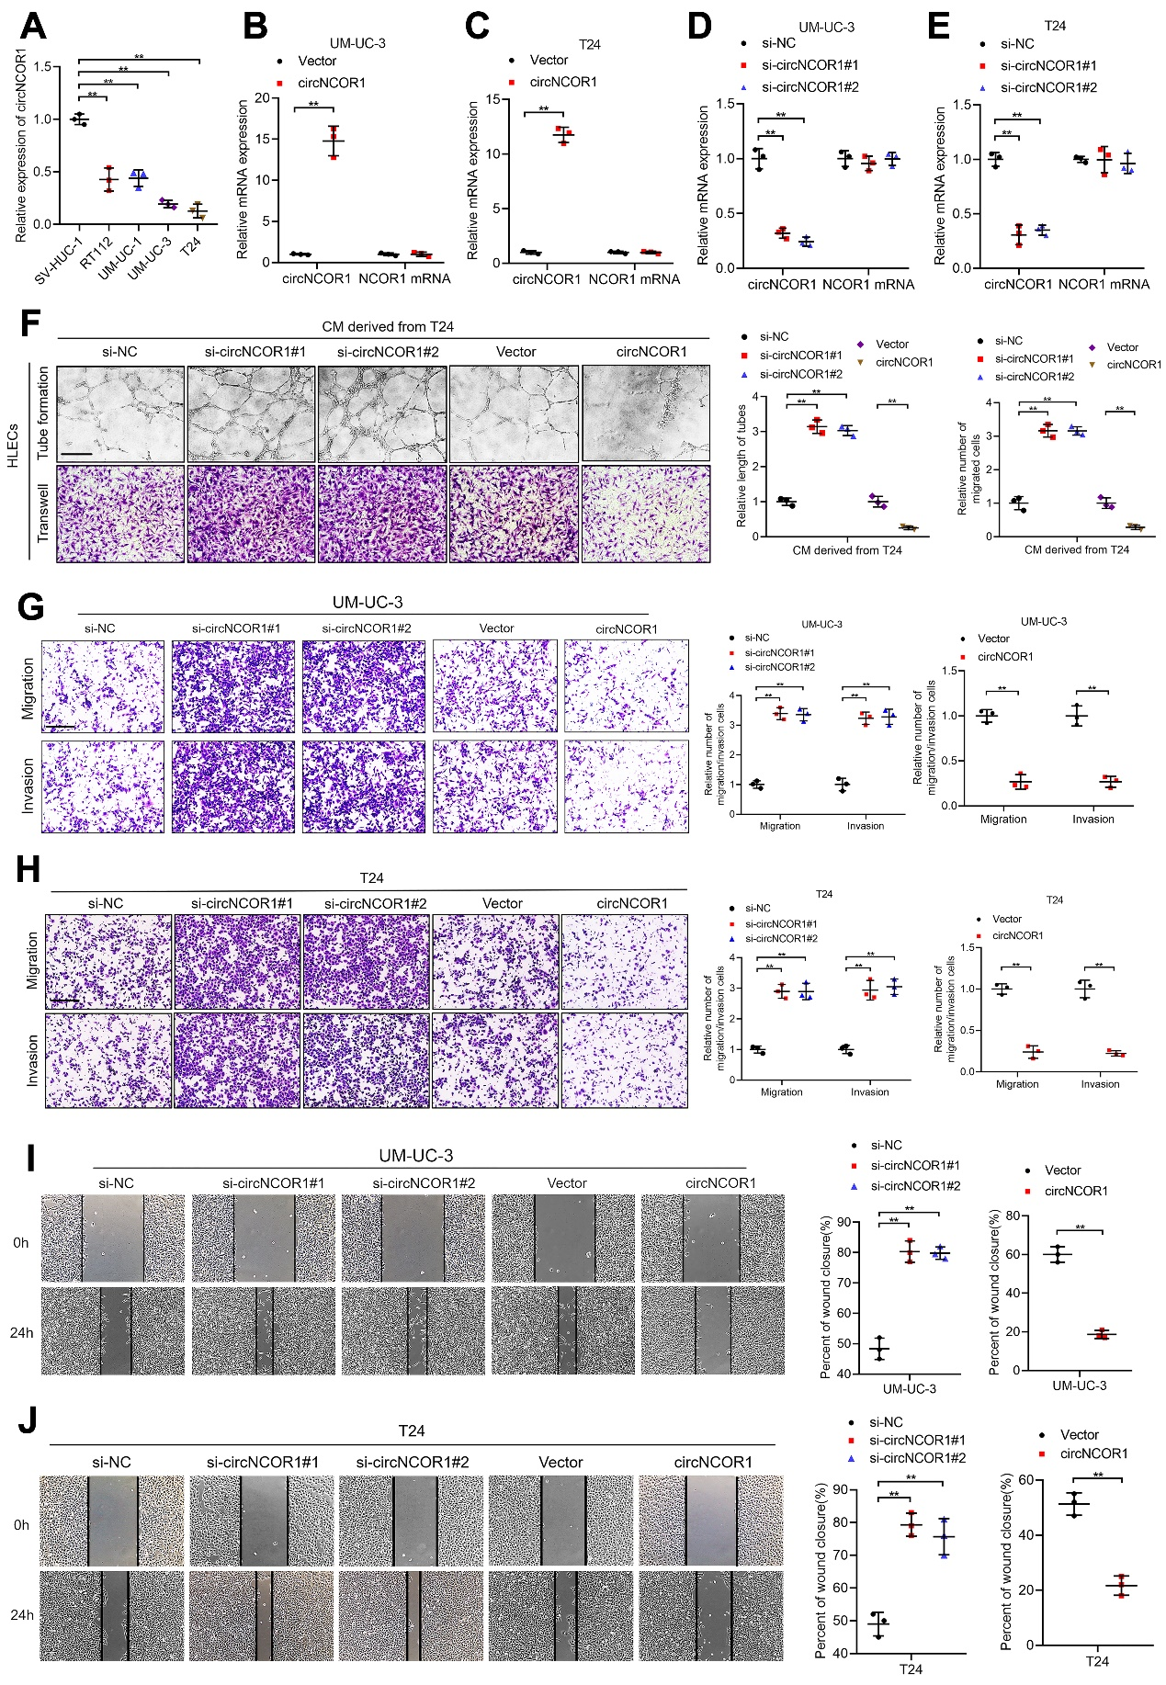
Supplementary Figure S3. circNCOR1 suppresses migration and invasion of BCa cells in vitro. A, qRT-PCR analysis of the circNCOR1 expression in human normal bladder epithelial cells (SV-HUC-1) and BCa cells. B–E, qRT-PCR analysis of circNCOR1 expression in UM-UC-3 and T24 cells after silencing or overexpressing circNCOR1. F, Representative images and quantification of tube formation and Transwell migration of HLECs cocultured with circNCOR1-downregulated or -overexpressing T24 cells. Scale bars: 100 μm. G and H, Representative images of Transwell migration and invasion for UM-UC-3 and T24 cells after knocking down or overexpressing circNCOR1. Scale bars: 100 μm. I and J, Representative images of wound healing assays for UM-UC-3 and T24 cells after knocking down or overexpressing circNCOR1. Scale bars: 100 μm. The statistical difference was assessed through 1-way ANOVA followed by Dunnett’s tests in A and D–J; and 2-tailed Student’s t-test in B, C and F–J. Error bars show the SD from three independent experiments. *P < 0.05; **P < 0.01.

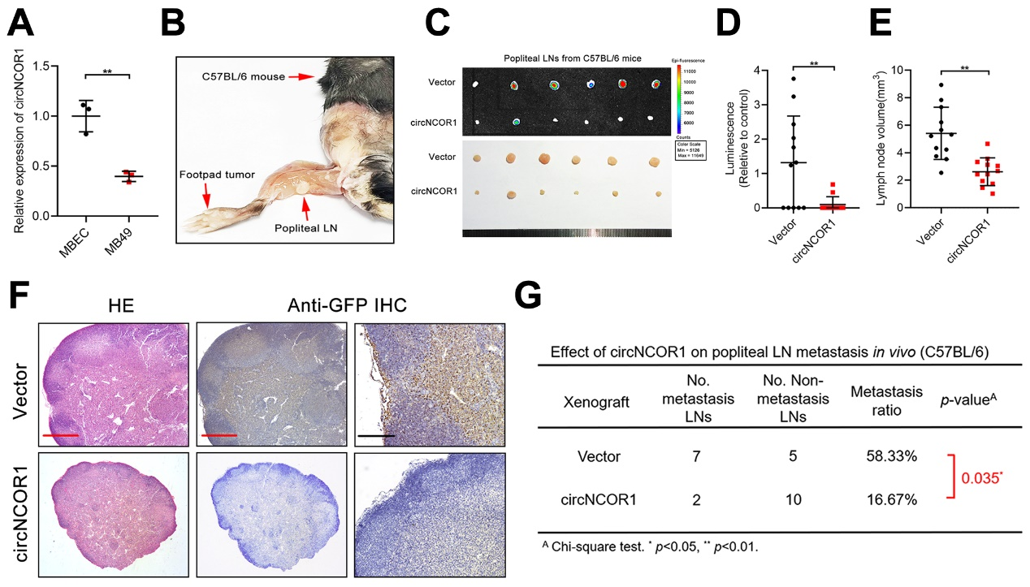Supplementary Figure S4. circNCOR1 suppresses migration and invasion of BCa cells in vivo. A, qRT-PCR analysis of the circNCOR1 expression in murine bladder epithelial cells (MBEC) and MB49 cells. B, Representative image of the popliteal LN in a C57BL/6 mouse. C, Representative bioluminescence image of excised popliteal LNs from the C57BL/6 mice (n = 12 per group). D and E, Quantification of the luminescence (D) and volume (E) of popliteal LNs in C57BL/6 mice after overexpressing circNCOR1 (n = 12 per group). F, Representative images of anti-GFP IHC analysis of C57BL/6 mice popliteal LNs (n = 12 per group). Scale bars: 500 μm (red), Scale bars: 100 μm (black). G, The popliteal LN metastatic rates of the C57BL/6 mice (n = 12 per group). The statistical difference was assessed through 2-tailed Student’s t-test in A, D and E; and the χ² test in G. Error bars show the SD from three independent experiments. *P < 0.05; **P < 0.01.

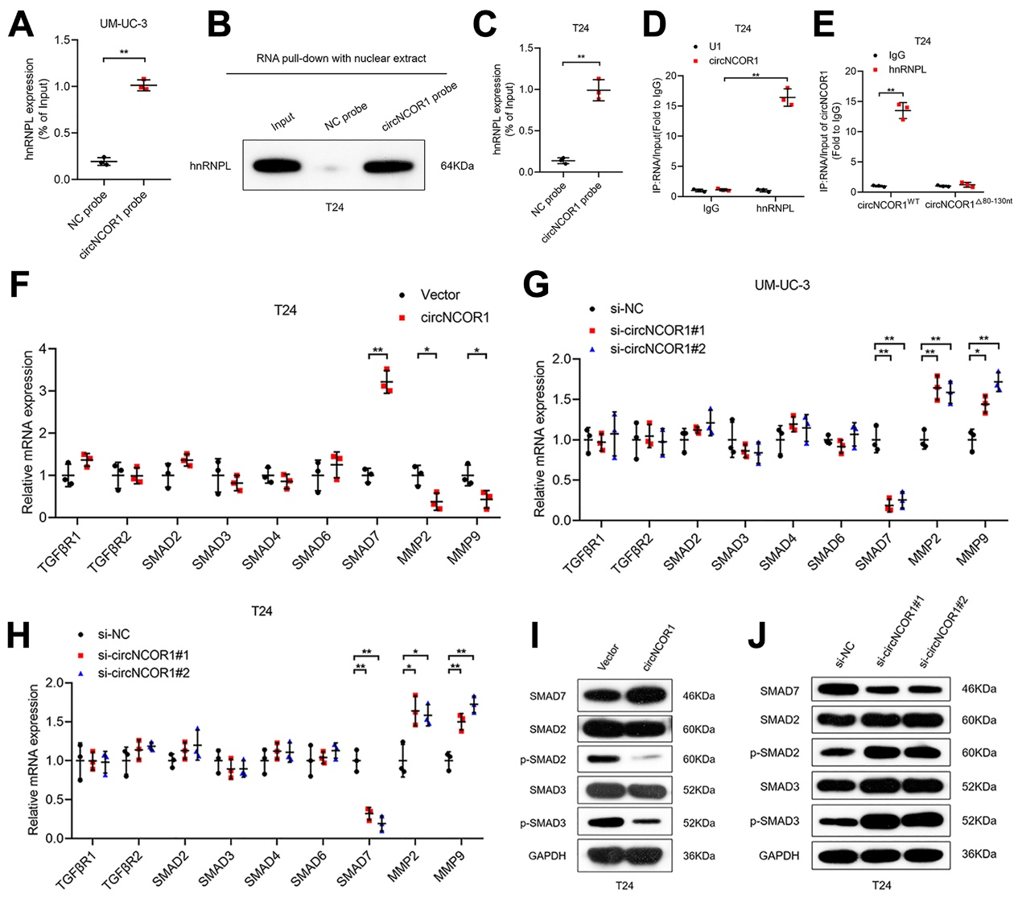Supplementary Figure S5. circNCOR1 promotes SMAD7 transcription by recruiting hnRNPL. A-C, Western blotting and quantification analysis of the interaction between circNCOR1 and hnRNPL. D, RIP assays revealed the enrichment of circNCOR1 by hnRNPL in T24 cells. E, RIP assays after deletion the 80–130-nt regions of circNCOR1 in T24 cells. F, qRT-PCR of TGFβ signaling pathway-related genes in circNCOR1-overexpressing T24 cells. G and H, qRT-PCR analysis of the TGFβ signaling pathway-related genes after circNCOR1-silencing in UM-UC-3 and T24 cells. I and J, Western blotting analysis of crucial proteins in the TGFβ–SMAD signaling pathway after circNCOR1 overexpression or downregulation in T24 cells. The statistical difference was assessed through 1-way ANOVA followed by Dunnett’s tests in G and H; and 2-tailed Student’s t- test in A and C-F. Error bars show the SD from three independent experiments. *P < 0.05; **P < 0.01.

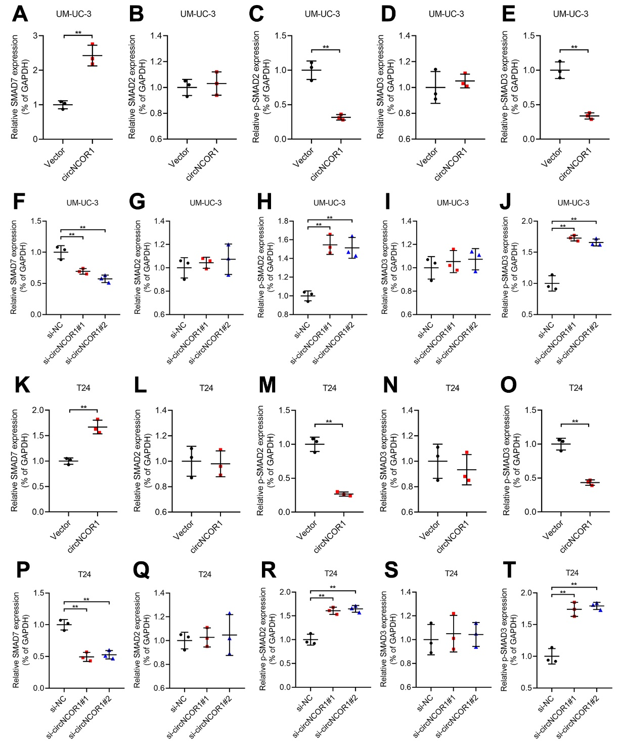Supplementary Figure S6. circNCOR1 inhibits TGFβ/SMAD signaling pathway by upregulating SMAD7. A-E, Western blotting and quantification analysis of TGFβ signaling pathway-related genes in circNCOR1-overexpressing UM-UC-3 cells. F-J, Western blotting and quantification analysis of TGFβ signaling pathway-related genes in circNCOR1-silencing UM-UC-3 cells. K-O, Western blotting and quantification analysis of TGFβ signaling pathway-related genes in circNCOR1-overexpressing T24 cells. P-T, Western blotting and quantification analysis of TGFβ signaling pathway-related genes in circNCOR1-silencing T24 cells. The statistical difference was assessed through 2-tailed Student’s t- test in A-E and K-O; and 1-way ANOVA followed by Dunnett’s tests in F-J and P-T. Error bars show the SD from three independent experiments. *P < 0.05; **P < 0.01.
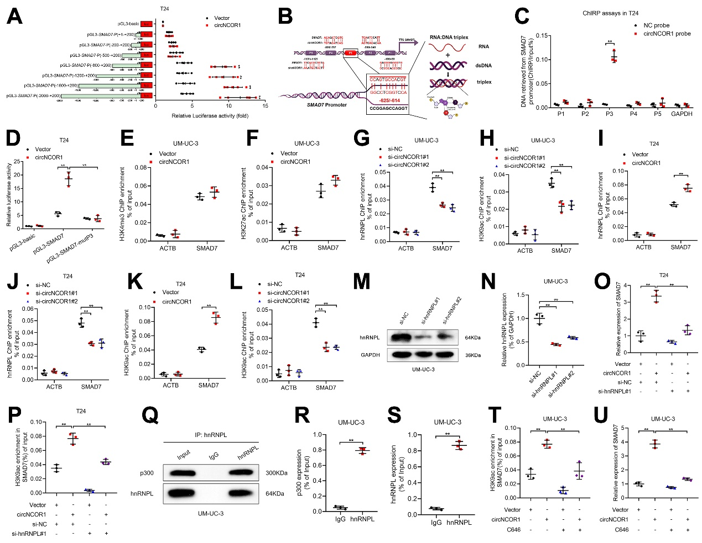
Supplementary Figure S7. circNCOR1 activates SMAD7 transcription by increasing H3K9ac on SMAD7 promoter. A, Transcriptional activity of SMAD7 in circNCOR1-overexpressing T24 cells transfected with truncated SMAD7 promoter luciferase plasmids. B, Schematic illustrating the DNA–RNA triplex structure between circNCOR1 and the SMAD7 promoter. C, ChIRP assays detected the circNCOR1-associated chromatin fragments of SMAD7 promoter in T24 cells. D, Luciferase activity was detected in T24 cells after muting the circNCOR1-binding site on SMAD7 promoter. E and F, ChIP-qPCR analysis of H3K4me3 and H3K27ac enrichment on SMAD7 promoter in circNCOR1 overexpressing UM-UC-3. G–L, ChIP-qPCR analysis of hnRNPL and H3K9ac enrichment on SMAD7 promoter in circNCOR1 overexpressing or circNCOR1-silencing UM-UC-3 and T24 cells. M and N, Western blotting and quantification analysis of hnRNPL expression in UM-UC-3 cells after knocking down hnRNPL. O, qRT-PCR analysis of SMAD7 expression in circNCOR1-overexpressing T24 cells with or without silencing hnRNPL. P, ChIP-qPCR analysis of H3K9ac enrichment on SMAD7 promoter in circNCOR1-overexpressing T24 cells with or without silencing hnRNPL. Q-S, Co-IP and quantification analysis of the interaction between hnRNPL and p300. T, ChIP-qPCR analysis of H3K9ac enrichment on SMAD7 promoter in circNCOR1-overexpressing UM-UC-3 cells with the treatment of C646. U, qRT-PCR analysis of SMAD7 expression in circNCOR1-overexpressing UM-UC-3 cells with the treatment of C646. The statistical difference was assessed through 2-tailed Student’s t- test in A, C, E, F, I, K, R and S; and 1-way ANOVA followed by Dunnett’s tests in D, G, H, J, L, N, O, P, T and U. Error bars show the SD from three independent experiments. *P < 0.05; **P < 0.01.
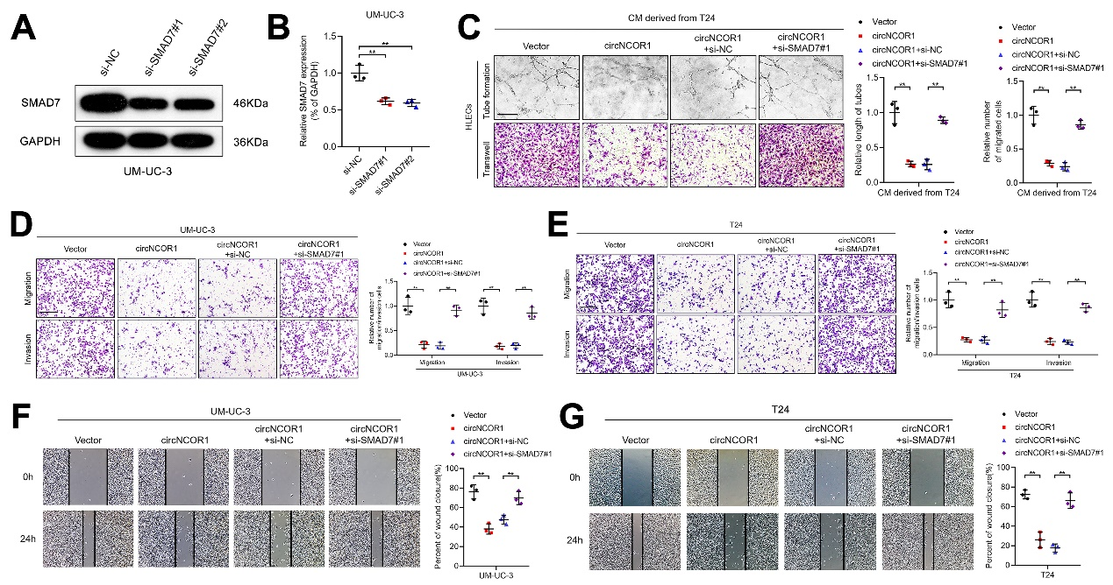Supplementary Figure S8. circNCOR1 inhibits migration and invasion of BCa cells via inhibiting TGFβ–SMAD signaling pathway. A and B, Western blotting and quantification analysis of SMAD7 expression in UM-UC-3 cells after knocking down SMAD7. C, Representative images and quantification of tube formation and Transwell migration for HLECs co-cultured with circNCOR1-overexpressing T24 cells with or without silencing SMAD7. Scale bars: 100 μm. D and E, Representative images of Transwell migration and invasion for circNCOR1-overexpressing UM-UC-3 and T24 cells with or without silencing SMAD7. Scale bars: 100 μm. F and G, Representative images of wound healing assays for circNCOR1-overexpressing UM-UC-3 and T24 cells with or without silencing SMAD7. Scale bars: 100 μm. The statistical difference was assessed through 1-way ANOVA followed by Dunnett’s tests in B; and 2-tailed Student’s t- test in C-G. Error bars show the SD from three independent experiments. *P < 0.05; **P < 0.01.

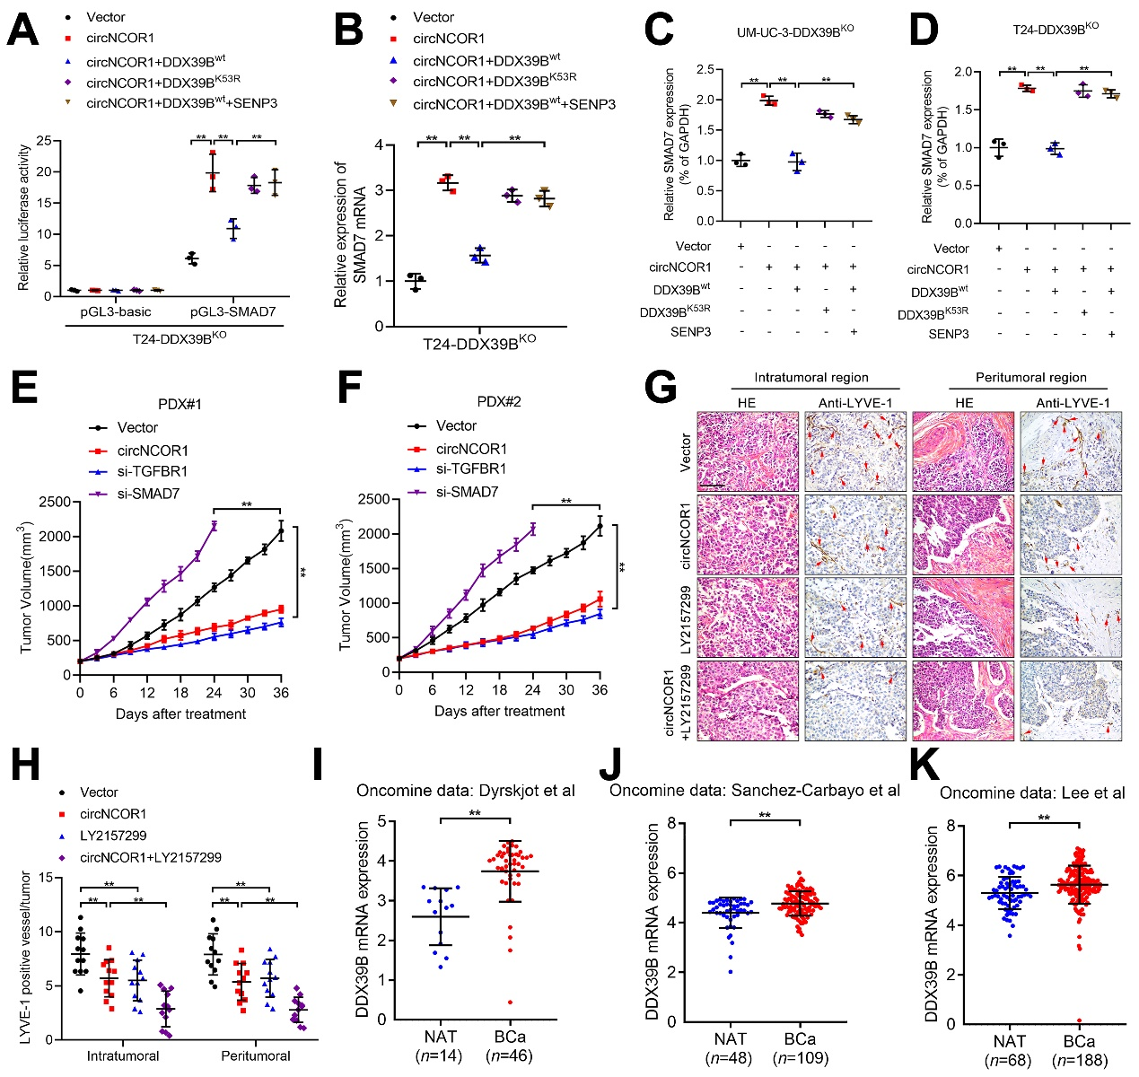Supplementary Figure S9. SUMOylated DDX39B inhibits the circNCOR1-induced SMAD7 upregulation. A, Luciferase activity of SMAD7 promoter was detected in indicated T24 cells. B, qRT-PCR analysis of SMAD7 expression in indicated T24 cells. C and D, Western blotting and quantification analysis of SMAD7 expression in indicated UM-UC-3 and T24 cells. E and F, The tumor volume of PDXs after circNCOR1, si-TGFBR1 and si-SMAD7 treatment in the mice (n = 6 per group). G and H, Representative IHC images and percentages of LYVE-1-indicated lymphatic vessel density in the tumor tissues of PDXs. Scale bars: 100 μm. I-K, Analysis of Oncomine database revealed the overexpression of DDX39B in BCa tissues compared with NATs. The statistical difference was assessed through 1-way ANOVA followed by Dunnett’s tests in A-F and H; and the nonparametric Mann-Whitney U test in I–K. Error bars show the SD from three independent experiments. *P< 0.05; **P < 0.01.

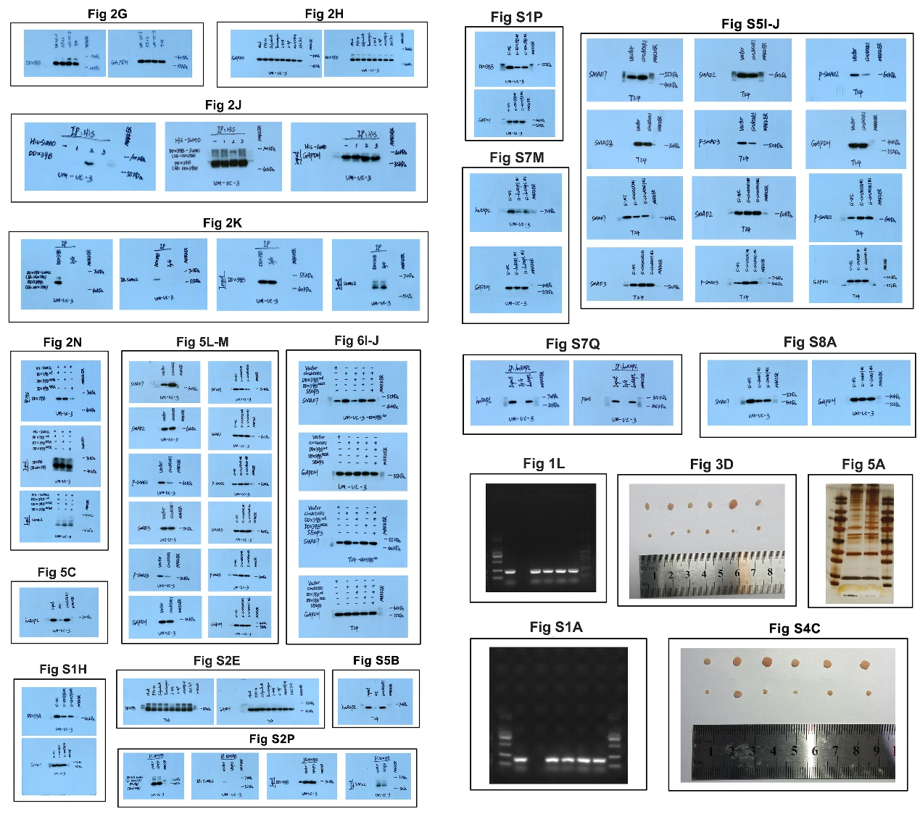
Supplementary Figure S10. Full uncut original pictures.

Supplementary Table S1. Correlation between circNCOR1 expression and clinicopathologic characteristics of BCa patients (n=228)
Characteristics | No. of cases | circNCOR1 expression
 |  | Low | High | P-value^{i}
Total cases | 228 | 114 | 114
Gender |  |  |  | 0.574
Male | 152 | 74 | 78
Female | 76 | 40 | 36
Age |  |  |  | 0.414
< 65 | 88 | 47 | 41
≥ 65 | 140 | 67 | 73
T grade |  |  |  | 0.028*
Low | 84 | 34 | 50
High | 144 | 80 | 64
T stage |  |  |  | 0.008**
T2 | 68 | 24 | 44
T3 | 114 | 64 | 50
T4 | 46 | 28 | 18
Lymphatic metastasis |  |  |  | 0.001**
Negative | 175 | 74 | 101
Positive | 53 | 40 | 13
Abbreviations: No. of cases = number of cases; T grade = tumor grade. ^{i} Chi-square test, * P <0.05, ** P <0.01.
Supplementary Table S2. Univariate and multivariate analysis of Overall Survival (OS) for circNCOR1 expression in BCa patients (n = 228)
Variables | Univariate analysis |  |  | Multivariate analysis
 | HR | 95%CI | P-value^{i} | HR | 95%CI | P-value^{i}
Age (<65 vs. ≥65) | 0.936 | 0.630-1.390 | 0.743
Gender  (Male vs. Female) | 1.083 | 0.715-1.641 | 0.705
T grade (High vs. Low) | 1.090 | 0.733-1.621 | 0.670
Lymphatic metastasis (positive vs. negative) | 2.444 | 1.641-3.641 | 0.001** | 2.151 | 1.418-3.263 | 0.001**
circNCOR1 expression  (High vs. Low) | 0.549 | 0.370-0.816 | 0.003** | 0.663 | 0.438-0.991 | 0.048*
Abbreviations: HR = hazard ratio; 95%CI =95% confidence interval; T grade = tumor grade. ^{i} Cox regression analysis, * P <0.05, ** P <0.01.
Supplementary Table S3. Univariate and multivariate analysis of Disease-Free Survival (DFS) for circNCOR1 expression in BCa patients (n = 228)
Variables | Univariate analysis |  |  | Multivariate analysis
 | HR | 95%CI | P-value^{i} | HR | 95%CI | P-value^{i}
Age (<65 vs. ≥65) | 0.865 | 0.604-1.241 | 0.431
Gender  (Male vs. Female) | 1.064 | 0.732-1.547 | 0.743
T grade (High vs. Low) | 1.010 | 0.707-1.442 | 0.958
Lymphatic metastasis (positive vs. negative) | 2.192 | 1.510-3.182 | 0.001** | 1.958 | 1.330-2.883 | 0.001**
circNCOR1 expression (High vs. Low) | 0.592 | 0.417-0.841 | 0.003** | 0.686 | 0.477-0.987 | 0.042*
Abbreviations: HR = hazard ratio; 95%CI = 95% confidence interval; T grade = tumor grade. ^{i} Cox regression analysis, * P <0.05, ** P <0.01.
Supplementary Table S4. Correlation between SMAD7 expression and clinicopathologic characteristics of BCa patients (n=344) in TCGA subset
Characteristics | No. of cases | SMAD7 expression
 |  | Low | High | P-value^{i}
Total cases | 344 | 172 | 172
Gender
Male | 253 | 127 | 126 | 0.903
Female | 91 | 45 | 46
Age |  |  |  | 0.055
< 65 | 121 | 52 | 69
≥ 65 | 223 | 120 | 103
T grade |  |  |  | 0.333
Low | 18 | 11 | 7
High | 326 | 161 | 165
T stage |  |  |  | 0.096
T2 | 104 | 52 | 52
T3 | 186 | 86 | 100
T4 | 54 | 34 | 20
Lymphatic metastasis |  |  |  | 0.144
Negative | 221 | 104 | 117
Positive | 123 | 68 | 55
Abbreviations: No. of cases = number of cases; T grade = tumor grade. ^{i} Chi-square test, * P <0.05, ** P <0.01.
Supplementary Table S5. Primers and probes used in the experiments.
Gene | Sequence (5’-3’) | Application
circNCOR1 | F: AATGATTCCAGTGCCACGTG  R: AGGTTCTGTGTTTCCTCGAGA | qRT-PCR
NCOR1 | F: GAAGGTGAGGTGCTGTGAAC  R: ACCACAGTAAGTTGTCAGTGC | qRT-PCR
U1 | F: CAGGGGAGATAACGTGACCA  R: GGGAAAAGCACGGACACAG | qRT-PCR  RIP
18S rRNA | F: AGCAGACATTGACCTCACCA  R: CCTCTATGGGCCCGAATCTT | qRT-PCR
TGFβR1 | F: GACGGCGTTACAGTGTTTCT  R: GAGGGTGCACATACAAACGG | qRT-PCR
TGFβR2 | F: TCCTTCAAGCAGACCGATGT  R: AGCACTCAGTCAACGTCTCA | qRT-PCR
SMAD2 | F: CTTTGTGCAGAGCCCCAATT  R: CTTGTTACCGTCTGCCTTCG | qRT-PCR
SMAD3 | F: CTCTGGGTGCTTGGGAACTA  R: ATCCAAATGCAGCCAAACGT | qRT-PCR
SMAD4 | F: TCCAGCCTCCCATTTCCAAT  R: ACCTTGCTCTCTCAATGGCT | qRT-PCR
SMAD6 | F: AGCGGATTTCTGACCCATCA  R: GTATTCTTTTCCCCACCGCC | qRT-PCR
SMAD7 | F: ATCCAAGCACCACCAAACAC  R: TTGGGACTGCAAACCTCTCT | qRT-PCR
MMP2 | F: AATCCCACCAACCCTCAGAG  R: GTGCCCTCTTGAGACAGTCT | qRT-PCR
MMP9 | F: GAGTTCCCGGAGTGAGTTGA  R: AAAGGTGAGAAGAGAGGGCC | qRT-PCR
GAPDH | F: CACATCGCTCAGACACCATG  R: TGACGGTGCCATGGAATTTG | qRT-PCR ChIRP
ACTB | F: TGGCACCACACCTTCTACAA  R: CCAGAGGCGTACAGGGATAG | ChIRP
DDX39A | F: AGGTGTCTGTGTTCTTCGGT  R: CCAGCATCTTGTCACACTCG | qRT-PCR
DDX39B | F: TCTGGCTTTCGTGACTTCCT  R: GCCAAGACAAACACTGCTGT | qRT-PCR
SMAD7-P1 | F: ACAAAACCAATGAATGAAGCGC  R: AGGGGAGAGAGATAGGTGGG | ChIRP
SMAD7-P2 | F: AAACCAATGAATGAAGCGCTAG  R: CCGATGGAGGGGAGAGAGAT | ChIRP
SMAD7-P3 | F: CATTCCAGAGCTGTGCACAA  R: GCGCTGTCTCGGTTTAAAAGA | ChIRP
SMAD7-P4 | F: GGGTATATGTTTCTTCGGGACC  R: CATTCATTTGCATGCAGGCC | ChIRP
SMAD7-P5 | F: GTTTCACTGCTGGCCTGATC  R: TAGAAACGGGCATGGCATTG | ChIRP
DDX39B-sgRNA1 | CTCCGGGCCATTGTCGACTG | CRISPR-Cas9
DDX39B-sgRNA2 | CTTGGACTATGAAGATGATG | CRISPR-Cas9
si-circNCOR1#1 | sense: CCAGAGAGGCAGAGGUGCAGA  antisense: UCUGCACCUCUGCCUCUCUGG | si-RNA
si-circNCOR1#2 | sense: AGGCAGAGGUGCAGAAAAUAG  antisense: CUAUUUUCUGCACCUCUGCCU | si-RNA
si-SMAD7#1 | sense: CGCACUCGGUGCUCAAGAA  antisense: UUCUUGAGCACCGAGUGCG | si-RNA
si-SMAD7#2 | sense: GAGGCUGUGUUGCUGUGAA  antisense: UUCACAGCAACACAGCCUC | si-RNA
si-DDX39A#1 | sense: GCAGCAGUACUACGUCAAATT  antisense: UUUGACGUAGUACUGCUGCTT | si-RNA
si-DDX39A#2 | sense: GCGAGUCAACAUCGUCUUUTT  antisense: AAAGACGAUGUUGACUCGCTT | si-RNA
si-DDX39B#1 | sense: GAGCGCUUCUCUAAAUACATT  antisense: UGUAUUUAGAGAAGCGCUCTT | si-RNA
si-DDX39B#2 | sense: GUGCUACCUUGAGCAAAGATT  antisense: UCUUUGCUCAAGGUAGCACTT | si-RNA
si-hnRNPL#1 | sense: GAUUGACGGUGUGGUGGAATT  antisense: UUCCACCACACCGUCAAUCTT | si-RNA
si-hnRNPL#2 | sense: CGGAUGUUCUUUACACUAUTT  antisense: AUAGUGUAAAGAACAUCCGTT | si-RNA
circNCOR1 | UCAGAACUAUUUUCUGCACCUCUGCCUCUCUGGCUC  5’-DIG labeled and 3’-DIG labeled | ISH
circNCOR1 | UCAGAACUAUUUUCUGCACCUCUGCCUCUCUGGCUC  5’-Cy3 labeled and 3’-Cy3 labeled | FISH

Supplementary Table S6. Antibodies used in the experiments.
Product | Source | No. of Catalogue
Western blot:
anti-hnRNPL | Abcam | ab6106
anti-SMAD2 | Cell Signaling Technology | 5339T
anti-SMAD3 | Cell Signaling Technology | 9523T
anti-SMAD7 | Abcam | ab216428
anti-p-SMAD2 | Cell Signaling Technology | 18338T
anti-p-SMAD3 | Cell Signaling Technology | 9520T
anti-DDX39A | Abcam | ab176348
anti-DDX39B | Abcam | ab181061
anti-GAPDH | Abcam | ab8245
anti-SUMO2 | Abcam | ab233222
anti-KAT3B/p300 | Abcam | ab275378
IHC:
anti-LYVE-1 | Abcam | ab218535
anti-GFP | Abcam | ab290
anti-SMAD7 | Abcam | ab216428
IF:
anti-hnRNPL | Abcam | ab6106
anti-DDX39B | Abcam | ab176348
anti-LYVE-1 | Abcam | ab218535
IP:
anti-DDX39B | Abcam | ab176348
anti-6X His | Abcam | ab18184
anti-H3K9ac | Abcam | ab4441
anti-H3K27ac | Abcam | ab4729
anti-H3K4me3 | Abcam | ab8580
anti-hnRNPL | Abcam | ab6106
Secondary antibody:
Western blot:
anti-rabbit IgG-HRP | Cell Signaling Technology | 7074
anti-mouse IgG-HRP | Cell Signaling Technology | 7076
IHC:
anti-rabbit IgG-HRP | Proteintech | SA00001-2
anti-mouse IgG-HRP | Proteintech | SA00001-1
IF:
Alexa Fluor 555 | Invitrogen | A32773
Alexa Fluor 488 | Invitrogen | A32766

Supplementary materials and methods
RNA pull-down assays
The proteins interacting with circNCOR1 were examined by RNA pull-down assays according to the manufacturer’s protocol of Magnetic RNA-Protein Pull-Down Kit (Thermo Scientific, Waltham, MA, USA, Cat#20164). Biotinylated circNCOR1 probe was synthesized by GenePharma (Suzhou, China). A Total of 2 × 10⁷ BCa cells were lysed in 200 μl lysis buffer and immediately frozen in liquid nitrogen, which were then stored in -80°C for completely lysing at least 2 h. Meanwhile, 50 μl washed streptavidin labelled magnetic beads (Invitrogen, Waltham, MA, USA, Cat#88817) were incubated with 50 pmol biotinylated circNCOR1 probe for 30 min at room temperature. The supernatant of lysate was extracted by ultracentrifugation for 10 min at 120,000 g and mixed with preprocessed magnetic beads for incubation at least 1 h. The beads were washed briefly with wash buffer for five times. Finally, the retrieved proteins were used for western blotting and mass spectrometry analysis.
Immunohistochemistry (IHC)
For IHC analysis, the paraffin-embedded tissue sections were first processed at 60°C for 2 h, followed by dewaxing with xylene and rehydration with different concentrations of ethanol, respectively. Subsequently, the antigen was repaired with EDTA and the catalase was blocked by peroxidase inhibitors, followed by the incubation with goat serum for 30 min at room temperature. Next, the sections were incubated with the primary antibodies at 4°C overnight, after which the sections were incubated with the secondary antibodies at room temperature for 30 min. Finally, 3,3'-Diaminobenzidine (DAB) and hematoxylin was used for staining, and the Nikon eclipse 80i (Nikon, Tokyo, Japan) was applied for the capture of images. Supplementary Table S6 lists the detailed antibodies used in the experiments.
In situ hybridization (ISH)
circNCOR1 expression in paraffin-embedded BCa tissues was detected using an Enhanced Sensitive ISH Detection Kit II (Boster Biological Technology, Pleasanton, CA, USA, Cat# MK1032). After deparaffinization and rehydration, the tissue sections were digested by pepsin to expose the RNA fragments and hybridized with a double (5′ and 3′)-digoxin (DIG)-labelled circNCOR1 probe at 37°C overnight. Next, the sections were incubated with anti-DIG antibody at 37°C for 2 h, followed by BCIP/NBT (5-bromo-4-chloro-3-indolyl phosphate/nitro blue tetrazolium) staining and nuclear fast red counterstaining. Images were recorded with a Nikon Eclipse 80i (Nikon). Supplementary Table S5 shows the circNCOR1 probe sequences used for the ISH.
RNA immunoprecipitation (RIP)
RIP experiments were conducted to confirm the interaction between circNCOR1 and hnRNPL with an EZ-Magna RIP kit (Merck, Darmstadt, Germany, Cat#17-701). Briefly, 2×10⁷ BCa cells were harvested and lysed in RIP lysis buffer at 4°C for 10 min. Then, the cell lysate was centrifugated for 10 min at 120,000 g, after which the cell extracts were collected and co-immunoprecipitated with magnetic beads conjugated with anti-hnRNPL (Abcam, Cambridge, MA, USA, ab6106, RRID: AB_305294) overnight. The retrieved RNAs were eluted and further subjected to qRT-PCR analysis. Supplementary Table S6 lists the detailed antibodies used in the experiments.
Luciferase reporter assays with serial fragments of the SMAD7 promoter
Luciferase reporter assays were performed to detect the regulatory role of circNCOR1 in SMAD7 transcriptional activation. Briefly, truncated sequences of +200 to -2000 bp in the SMAD7 promoter were cloned in a pGL3-Basic luciferase reporter vector (Igebio, Guangzhou, China). The luciferase reporter plasmids were co-transfected into UM-UC-3 and T24 cells. After 48 h incubation, luciferase activity was measured using a luciferase reporter assay kit (Promega, Madison, WI, USA, Cat#E1910) and was standardized to the ratio between firefly and Renilla luciferase activity.
Chromatin immunoprecipitation (ChIP)
To detect the interacting DNA fragments of hnRNPL and H3K9ac, ChIP was conducted with an EZ-Magna ChIP A/G kit (Millipore, Billerica, MA, USA, Cat#17-371). Briefly, 1 × 10⁷ BCa cells were harvested and crosslinked in 4% paraformaldehyde at room temperature for 10 min, after which the chromatins were isolated with cell lysis buffer and nuclear lysis buffer, respectively. Then, the chromatins were sheared into 500–800-bp fragments by sonication and hybridized with anti-hnRNPL antibody (Abcam, Cambridge, MA, USA, ab6106, RRID: AB_305294) or anti-H3K9ac antibody (Abcam, Cambridge, MA, USA, ab4441, RRID: AB_2118292). Subsequently, the binding complexes were immunoprecipitated with protein A/G-coated magnetic beads at 4°C overnight. The retrieved DNA was eluted and purified from the beads and analyzed by quantitative real-time (qRT)-PCR. Normal mouse immunoglobulin G (IgG) was used as the negative control. Supplementary Table S6 lists the detailed antibodies used in the experiments.
Chromatin isolation by RNA purification (ChIRP)
For affinity capture of the chromatin interacting with circNCOR1, we conducted ChIRP experiments using a Magna ChIRP RNA Interactome Kit (Millipore, Cat#17-10494) following the manufacturer’s instructions. Biotin-labeled circNCOR1 probes were designed by GenePharma (Suzhou, China). BCa cells (4 × 10⁷) were fixed in 1% formaldehyde and lysed in cell lysis buffer. The cell lysate was sonicated to shear the chromatin into 200–1000-bp fragments in an ultrasonic processor at 4°C for 1 h. The chromatin sample was incubated with biotinylated circNCOR1 probes and recovered using streptavidin-conjugated magnetic beads at 4°C overnight. The beads were washed with washing buffer five times. The combined DNA was extracted for qRT-PCR analysis. Supplementary Table S5 lists the detailed sequences of the probes.
Proteins extraction and Western blotting analysis
As for total proteins extraction, BCa cells were harvested and washed with PBS three times, followed by the thorough lysis with RIPA lysis buffer supplemented with a cocktail of phosphatase inhibitors and protease inhibitors at 4°C for 30 min. After centrifuging at 120,000 g for 30 min, the supernatant was collected and the proteins concentration was measured by BCA kit (CWBio, Taizhou, China, Cat#CW0014S). To evaluate the expression of targeted proteins, the western blotting analysis was conducted. Briefly, 20 μg total proteins obtained from BCa cells was separated by 10% SDS–PAGE gel electrophoresis and transferred onto a polyvinylidene fluoride (PVDF) membrane. After blocking the nonspecific bindings with 5% BSA, the membranes were incubated with corresponding primary antibodies at 4°C overnight and followed secondary antibodies conjugated to HRP at room temperature for 1 h. The immunoblots were detected by ECL chemiluminescence kit (Thermo Scientific, Cat#32209) and quantified using Image J software (ImageJ, RRID:SCR_003070). Supplementary Table S6 lists the detailed antibodies used in the experiments and Supplementary Figure S10 shows the full uncut original pictures.
RNA extraction and qRT-PCR analysis
The total RNA of BCa cells was extracted using Trizol reagent (Takara Bio, Japan, Cat#9109) following the manufacturer’s instructions. Subsequently, RNA sample was reverse transcribed by Hiscript III Reverse Transcriptase kit (Vazyme, Nanjing, China, Cat#R312-01) and corresponding RNA expression was evaluated by qRT-PCR with ChamQTM Universal SYBR qPCR Master Mix kit (Vazyme, Cat#Q711-02). The detailed sequence of primers used are listed in Supplementary Table S5.
CircRNA sequencing
Total RNA samples (2 μg) were extracted and reverse transcribed as the same steps described in RNA extraction and qRT-PCR analysis. Next, sequence of the back-splicing site in circNCOR1 was amplified using 2 × Es Taq MasterMix (Dye) kit (CWBio, Cat#CW0690) according to the manufacturer’s protocols. Sanger sequencing was conducted to analyze the specific sequence of the back-splicing site in circNCOR1.
RNase R treatment and actinomycin D assays
To detect the stability of circNCOR1, the RNase R treatment and actinomycin D assays were performed. As for RNase R treatment assays, 2 μg total RNA was incubated for 30 min at 37°C with or without 3 U/μl RNase R (Geneseed Biotech, China, Cat#R0301). The expression of circNCOR1 and NCOR1 mRNA were then analyzed by qRT-PCR assays.
As for actinomycin D assays, approximately 1 ×10⁵ per well of T24 and UM-UC-3 cells were prepared in a 6-well plate before a treatment of 5 μg/ml actinomycin D (APExBIO, Houston, TX, USA, Cat#A4448) at indicated time points (6, 12, 18 and 24 h). Then the cells were harvested, and total RNA was extracted to analyze the circNCOR1 expression using qRT-PCR assays.
Plasmids and siRNA transfection
circNCOR1, His-tagged SUMO1, SUMO2, and SUMO3, SENP3 and hnRNPL overexpression plasmid, circNCOR1-hnRNPL binding mutation plasmid, and empty vector plasmid were constructed using pcDNA3.1 (RRID: Addgene_79663) vector by Igebio (Guangzhou, China). SiRNAs for downregulation of circNCOR1, DDX39A, DDX39B, SMAD7 and hnRNPL were purchased from Igebio. Then, BCa cells were transfected with indicated plasmids and siRNAs, respectively, using the Lipofectamine 3000 kit (Invitrogen, Cat# L3000015) according to the manufacturer’s instructions. The efficiency of transfection was evaluated by qRT-PCR and western blotting analysis.
Lentiviral transfection
In order to construct the circNCOR1 stable overexpression cell lines, full-length of circNCOR1 was packaged into a lentivirus vector (Igebio), which was transfected into HEK-293T cells (RRID: CVCL_0063). After 60 h of transfection, the amplified lentiviruses were harvested and concentrated by ultracentrifugation at 120,000 g for 2 h. Then BCa cells were infected using the extracted lentivirus and the successfully infected cell lines were obtained by selection with puromycin (Solarbio, Beijing, China, Cat#P8230). The oligonucleotide sequences of siRNAs and target sequences for constructing lentiviral plasmids are listed in Supplementary Table S5.
Subcellular fraction assays
PARISTM kit (Thermo Scientific, Cat#AM1921) was conducted to detect the localization of circNCOR1 in differently treated BCa cells according to the manufacturer’s instructions. Briefly, 1 × 10⁶ BCa cells were harvested and washed with ice-cold PBS for the preparation of nuclear and cytoplasm separation. Afterwards, the cell precipitation was lysed by Cell Fractionation Buffer and Cell Disruption Buffer, respectively. RNA from nuclear and cytoplasm was extracted using Trizol reagents (Takara Bio, Cat#9109). qRT-PCR analysis was performed to determine the cellular location of circNCOR1. 18sRNA and U1 were used as internal references.
Tube formation assays
Briefly, a mixture totaling 400 µl per well of Matrigel (BD Biosciences, Franklin Lakes, NJ, USA, Cat#356234) and FBS-free ECM (1:2, v/v) was placed in 24-well plates and incubated at 37°C overnight. Then, the equivalent amount of 1 × 10⁵ HLECs was harvested and resuspended in 300 µl FBS-free ECM and seeded into the Matrigel-covered plates prior to 4 h incubation. The images of the formed lymphatic vessels were captured using inverted fluorescence microscopy and the tube length was analyzed with ImageJ (NIH, Bethesda, MD, USA, RRID:SCR_003070).
Transwell assays
The migration and invasion ability of BCa cells and the migration ability of HLECs were evaluated by Transwell assays using Transwell chambers (Corning Costar Corp, USA, Cat#3422) according to the manufacturer’s protocol. Briefly, 700 μl of serum-containing culture medium was added into lower chamber and 1 × 10⁵ BCa cells or 3 × 10⁴ HLECs suspension were planted into upper chamber on 300 μl matrix gel or 300 μl serum-free culture medium, respectively. After incubation approximately 4 h for HLECs, 6 h for T24 and 12 h for UM-UC-3, upper chamber cells were fixed and stained by 0.1% crystal violet. Images were captured using Nikon eclipse 80i (Nikon) and the Image J software (NIH) was used to count the migrated cells at five random fields.
Wound healing assays
Briefly, 3 × 10⁵ BCa cells were seeded into 12-well plates until 100% density, followed by scratching with 20 μl pipette tips to create a wound. The migration ability of BCa cells was measured by the distance of wound closure between two sides at 0h and 24 h, respectively.
RNA fluorescence in situ hybridization (FISH)
The FISH assays were performed to observe the distribution of circNCOR1 in BCa cells by a FISH Kit (RiboBio, Guangzhou, China, Cat#C10910). Briefly, 1 × 10⁴ BCa cells were cultured on a confocal dish for 24 h. Next, the cells were fixed and permeabilized using 4% paraformaldehyde for 10min and 0.5% Triton X-100 for another 10 min, respectively. Subsequently, Cy3-labelled circNCOR1 probe (GenePharma, Suzhou, China) was hybridized with cells at 37°C overnight. Then, 4′,6-diamidino-2-phenylindole (DAPI) was applied for the staining of nuclei and images were photographed under ZEISS Lam 710 focal microscope (Carl Zeiss AG, Oberkochen, Germany).
Immunofluorescence (IF) assays
To determine the co-localization of hnRNPL and circNCOR1 in BCa cells. 1 × 10⁴ BCa cells were planted in confocal dish and washed three times using ice-cold PBS before permeabilizing by 0.5% Triton X-100 for 15 min. Then, cells were blocked with 5% BSA and incubated in the anti-hnRNPL antibody at 4°C overnight, followed with the treatment of corresponding secondary antibody for 1 h and DAPI to stain the nuclei for 15 min. Images were captured under ZEISS Lam 710 focal microscope (Carl Zeiss AG). To detect the correlation between DDX39B and LYVE-1-indicated microlymphatic vessel density (MLD) in BCa tissues, the sections were incubated with the primary antibodies at room temperature for 1 h, after which the sections were incubated with the FITC or CY3 conjugated secondary antibodies at room temperature for 30 min and DAPI was used for the staining of nuclei. The images were captured under ZEISS Lam 710 focal microscope (Carl Zeiss AG). Supplementary Table S6 lists the detailed antibodies used in the experiments.
Silver staining
After RNA pulldown and co-immunoprecipitation, equal volume of protein samples was electrophoretic separated by 10% SDS-PAGE gel which were then washed and silver stained using Silver stain kit (Thermo Scientific, Cat#24612) according to manufacturer’s instruction.
Co-immunoprecipitation assays
Co-Immunoprecipitation Kit (Thermo Scientific, Cat# 88804) was used to detect the DDX39B and hnRNPL interacting proteins, in which cells were harvested and lysed in 500 μl co-IP lysis buffer supplemented with a cocktail of phosphatase inhibitor and proteinase inhibitor. After centrifugation at 12,000 g for 30 min, the supernatant of lysates was mixed with magnetic beads conjugated by indicated antibodies for immunoprecipitation at 4°C overnight. Beads were washed three times with washing buffer and the binding proteins were eluted for further analysis using western blotting and mass spectrometry analysis. Supplementary Table S6 lists the detailed antibodies used in the experiments.

