Germline and somatic genetic variants in the p53 pathway interact to affect cancer risk, progression and drug response
Running title: p53 pathway SNPs and mutations interact to affect cancer
Ping Zhang^{1,18}, Isaac Kitchen-Smith¹, Lingyun Xiong¹, Giovanni Stracquadanio^{1, 16}, Katherine Brown^{2,17}, Philipp H. Richter¹, Marsha D. Wallace^{1, 18}, Elisabeth Bond¹, Natasha Sahgal¹, Samantha Moore¹, Svanhild Nornes^{1, 20}, Sarah De Val^{1, 20}, Mirvat Surakhy¹, David Sims², Xuting Wang³, Douglas A. Bell³, Jorge Zeron-Medina^{1, 15}, Yanyan Jiang⁴, Anderson J. Ryan⁴, Joanna L. Selfe⁵, Janet Shipley⁵, Siddhartha Kar^{6, 19}, Paul D. Pharoah⁶, Chey Loveday⁷, Rick Jansen⁸, Lukasz F. Grochola⁹, Claire Palles¹⁰, Andrew Protheroe¹², Val Millar¹³, Daniel V. Ebner¹³, Meghana Pagadala¹⁴, Sarah P. Blagden¹¹, Tim S. Maughan¹¹, Enric Domingo¹¹, Ian Tomlinson¹⁰, Clare Turnbull⁷, Hannah Carter¹⁴ and Gareth L. Bond^{1, 21}

Supplementary Methods
Supplementary Figures S1-S5

Supplementary Methods
Assigning TP53 mutational status to breast, ovarian cancers and TCGA tumors
We curated TP53 pathogenic missense mutations by integrating up-to-date functional evidence from both literature and databases. Specifically, we combined the 2 lists of TP53 driver mutations in human tumors (1,2) to obtain a list of 323 TP53 driver mutations. To determine which of these 323 TP53 diver mutations are oncogenic (either dominant negative or gain of function), we relied on two sources of annotations: 188 missense mutations were curated to be oncogenic in the IARC TP53 Database (release 18) (3); 1101 missense mutations were ascertained by the human cancer cell-based saturation mutagenesis screen (4) (filter criteria: A549_p53WT_Nutlin-3_Z-score > 1 and A549_p53NULL_Nutlin-3_Z-score > 1 and A549_p53NULL_Etoposide_Z-score < -1). In total, we were able to find 218 out of 323 TP53 pathogenic mutations are oncogenic (Supplementary Table S1). 2,262 TP53 mutations in 2,201 unique breast cancer samples (from 12 studies; excluding 737 duplicate mutations in samples sequenced by multiple studies) and 492 TP53 mutations in 471 unique ovarian cancer samples (from 3 studies; excluding 477 duplicate mutations in samples sequenced by multiple studies) were downloaded from cBioPortal on 2018-09-14 (http://www.cbioportal.org). All TP53 missense mutations were extracted and matched with the curated lists of pathogenic and oncogenic TP53 missense mutations as described above. Then cancers with pathogenic missense mutations and oncogenic missense mutations were counted. Specifically, 1113 out of 2262 (49.2%) TP53 mutations in breast cancer are pathogenic missense mutations, of which 1012 (90.9%) are oncogenic. Similarly, 260 out of 492 (52.8%) TP53 mutations in ovarian cancer are pathogenic missense mutations, of which 228 (87.7%) are oncogenic.
The TP53 gene mutation profiles in TCGA primary tumors were downloaded from the TCGA data portal (https://gdc-portal.nci.nih.gov/). These TP53 mutation calls (1,245 unique mutations in 3,956 tumors) were classified into pathogenic (1,097 unique mutations in 3,895 tumors), benign (143 unique mutations in 148 tumors), or unclear (5 unique mutations in 5 tumors) based on curated datasets (2,3). The TP53 pathogenic missense mutations were further annotated as loss of function, or oncogenic as described above. Tumors without TP53 mutations were assigned as TP53 wild type; Tumors with at least one pathogenic TP53 mutations were assigned as TP53 mutant; Tumors with only pathogenic TP53 missense mutations were assigned as TP53 missense mutant; Tumors with only oncogenic TP53 missense mutations were assigned as TP53 oncogenic missense mutant. The copy number profiles of TP53 in TCGA primary tumors were retrieved from the Broad GDAC Firehose (https://gdac.broadinstitute.org/) through the fbget tool (v0.1.11 released Oct 31 2017).
Analysis for subtype heterogeneity SNPs with Breast and Ovarian cancer association studies
Summary statistics of GWASs for breast cancer susceptibility were downloaded on 2018-03-12 (http://bcac.ccge.medschl.cam.ac.uk/bcacdata/oncoarray/gwas-icogs-and-oncoarray-summary-results/), which included summary statistics from case-control association analyses for ER-positive breast cancer cases (ER+BC) and ER-negative breast cancer cases (ER-BC) compared against disease-free controls. Summary statistics of GWASs for ovarian cancer susceptibility were downloaded on 2018-04-16 (https://www.ebi.ac.uk/gwas/downloads/summary-statistics), which included summary statistics for SNP association with low grade serous ovarian cancer (LGSOC), and with high grade serous ovarian cancer (HGSOC). Estimates of effect sizes [log(OR)s] for subtype-specific case-control studies and their corresponding standard errors were utilized for meta- and heterogeneity-analyses using METAL (2011-03-25 release) (5), under an inverse variance fixed-effect model. Cochran’s Q statistic was calculated to test for heterogeneity and the I² statistic to quantify the proportion of the total variation that was caused by heterogeneity.

Genotype imputation and population stratification
Genotype data was obtained and filtered as described (6). Briefly, we obtained genotype calls from the Birdsuite-processed (7) Affymetrix 6.0 SNP arrays for matched normal samples from the TCGA data portal (https://gdc-portal.nci.nih.gov/), set low confidence SNP calls to missing, filtered individuals and SNPs with < 95% call rate and SNPs with MAF < 1% and imputed untyped genotypes using the secure Michigan Imputation Server (8). We used a PCA analysis over genotypes to remove samples that did not cluster tightly with Europeans from the HapMap III reference population. The genotype data of 7,021 TCGA patients clustered tightly with Europeans.

Cancer GWAS SNPs
The GWAS catalog was downloaded on 2018-02-28 (https://www.ebi.ac.uk/gwas/). We selected the GWAS significant lead SNPs (p-value <5e-08) in Europeans, and retrieved the associated proxy SNPs using the 1000 Genomes phase 3 data through the web server: rAggr (http://raggr.usc.edu). In brief, we selected the GWAS lead SNPs that were identified in European ancestry cohorts, and only defined proxies that met the following criteria: Population: EUR; Min MAF: ≥ 0.01; R2 range: ≥ 0.8; Max distance: 500KB; Max # Mendel error: 1; HWE p-value: 1e-6; Min genotype %: 95. All proxies were mapped to the Ensembl Release 91 (dbSNP build 150) to retrieve the hg38 genomic coordinates using R package biomart.
RNA isolation, cDNA synthesis, Quantitative real-time reverse transcription PCR and RNA-seq analysis
Cells were lysed and total RNA was prepared using the RNeasy kit (Qiagen) according to the manufacturer’s protocol. cDNA was synthesized using SuperScript VILO Master Mix (ThermoFisher). Quantitative real-time reverse transcription PCR (qRT-PCR) was carried out in triplicates with SYBR® Green Real-Time PCR Master Mix (Qiagen) on an ABI StepOnePlus System (Applied Biosciences). The transcript levels were normalised using the readings for GAPDH. 3’ RNA-seq libraries were prepared using a standardised protocol followed by sequencing using a HiSeq4000 platform (Illumina) at the Oxford Genomics Centre (Wellcome Trust Centre for Human Genetics, Oxford, UK). Sequencing reads were mapped to hg19 using the HISAT2 alignment algorithm (version 2.1.0). The aligned Binary-sequence Alignment Format (BAM) files were used to determine the transcript counts through featureCounts (version 1.6.2). For the differential expression analyses, the raw read counts were used as input into the R package DESeq2 (version 1.24.0) for analysis. The raw sequencing datasets have been deposited into Gene Expression Omnibus database (GSE143561).

GDSC drug sensitivity analysis
TP53 mutation, copy number, RNAseq gene expression data, and drug IC50 values for the cancer cell lines were downloaded from Genomics of Drug Sensitivity in Cancer (GDSC; release-8.1). Specifically, a list of the mutated genes “mutations_20191101.csv”, the processed CNV data “cnv_gistic_20191101.csv” and RNAseq gene expression data “rnaseq_read_count_20191101.csv” were downloaded from https://cellmodelpassports.sanger.ac.uk/downloads. The drug response data (GDSC1_fitted_dose_response_15Oct19) was downloaded from https://www.cancerrxgene.org/downloads/bulk_download. Cell lines without TP53 mutations were assigned as TP53 wild type; Cell lines with TP53 somatic mutations (“cancer_driver” defined by GDSC) and copy-number alterations (GISTIC score < 0) were assigned as TP53 mutant and CNV loss; The classified cell lines were further grouped based on the gene transcript levels: low (≤ 1st quartile), intermediate (> 1st quartile and < 3rd quartile), high (≥ 3rd quartile). The effects of the mutation status or transcript levels on drug sensitivity were then determined with a linear model approach with log₂ of the IC50 values as dependent variable and CNV status or transcritpt levels as independent variable.

MTT assay
Cells were plated into a 96-well plate overnight. MTT (ThermoFisher) was dissolved in PBS and added to the cells to a final concentration of 0.75 mg/ml for 4h. Thereafter, the medium was aspirated. The formazan salt was solubilised in isopropanol and measured at 570 nm using an ELISA reader.

CRISPR/Cas9-mediated genome editing

The Cas9 expression vector was obtained from Addgene (#62988). sgRNAs were designed and constructed as described previously (9). Briefly, the sgRNA oligos were designed and analyzed using the CRISPR design tool (http://crispr.mit.edu/), and the ones with highest rating sores were selected. For the human U6 promoter-based transcription, a guanine (G) base was added to the 5′ of the sgRNA when the 20bp guide sequence did not begin with G. The oligo sequences for the sgRNA synthesis are listed in Supplementary Table S2. Next, the annealed oligos were cloned into the BbsI restriction sites of the Cas9 expression vector. The donor construct pMK-RQ-HDR-donor for generating the p53-REs knock in clones was synthesized by GeneArt Gene Synthesis service and integrated into the G418 resistant vector pMK-RQ (GeneArt, ThermoFisher). The donor constructs for the homology directed repair (HDR) rs78378222-HDR-donor were synthesized by GeneArt Gene Synthesis service (ThermoFisher) generated for the homology directed repair (HDR) in Hap1 cells. For genomic deletions, 5x10⁵ cells were seeded in a 12-well plate and transfected with 0.5 g of each sgRNA constructs. After 24 hours, cells were incubated in puromycin for 48 hours. Subsequently, a single-cell suspension was prepared and seeded at a low density in 96-well plate for 3-4 weeks. Clones that were derived from more than one cell were excluded from further experiments. Individual colonies were picked and expanded for PCR-based genotyping with primers outside and inside of the targeting region (Supplementary Table S2). Correctly targeted clones were further confirmed by Sanger sequencing or TagMan genotyping, and the copy number of the heterozygous knock out cells was confirmed by TaqMan Copy Number Assays. For the knock-in, cells were transfected with a guide RNA (see sequences in Supplementary Table S2) together with a recombination donor flanked with 1-kb right and left homology arms where the PAM site was mutated to prevent donor DNA cleavage (a point mutation from CCA to GCA). Transfected cells were selected by treatment with puromycin and G418 for 48 hours. Based on the same procedures for genomic deletion, correctly targeted clones were validated by PCR-based genotyping, Sanger sequencing and copy number determination.
In vivo study
All animal procedures were carried out under a UK Home Office project licence (PPL30/3395). Before submitting to the Home Office, the project licence was approved by the Oxford University Animal Welfare and Ethical Review Board (AWERB). Mice were housed at Oxford University Biomedical Services, UK. 6-8 week-old female BALB/c nude mice (Charles River, UK) were injected subcutaneously with 5x10⁶ 2102EP cells in a 1:1 mixture of serum-free medium and Matrigel. When the average tumor volume reached approximately 130 mm³, animals were divided into four groups (6 per group) and received the following treatments: 1. Vehicle group: p.o. vehicle A (2% DMSO/ 30% PEG300/ dH2O) on day 1-5 & day 8-12, once daily; i.p. vehicle B (saline) on day 1, 8 and 12, once daily; 2. Doxorubicin group: i.p. Doxrubicin 4mg/ kg (Sigma) in vehicle B on day 1, 8 and 12, once daily; 3. Dasatinib group: p.o. Dasatinib 25mg/kg (Selleckchem) in vehicle A on day 1-5 and day 8-12, once daily; 4. Combination group: p.o. Dasatinib 25mg/kg on day 1-5 and day 8-12, once daily; i.p. Doxorubicin 4mg/ kg 1h after Dasatinib dosing on day 1, 8 and 12, once daily. Mouse weights and tumor volumes were measured 3 times per week. All mice were sacrificed on day 12.

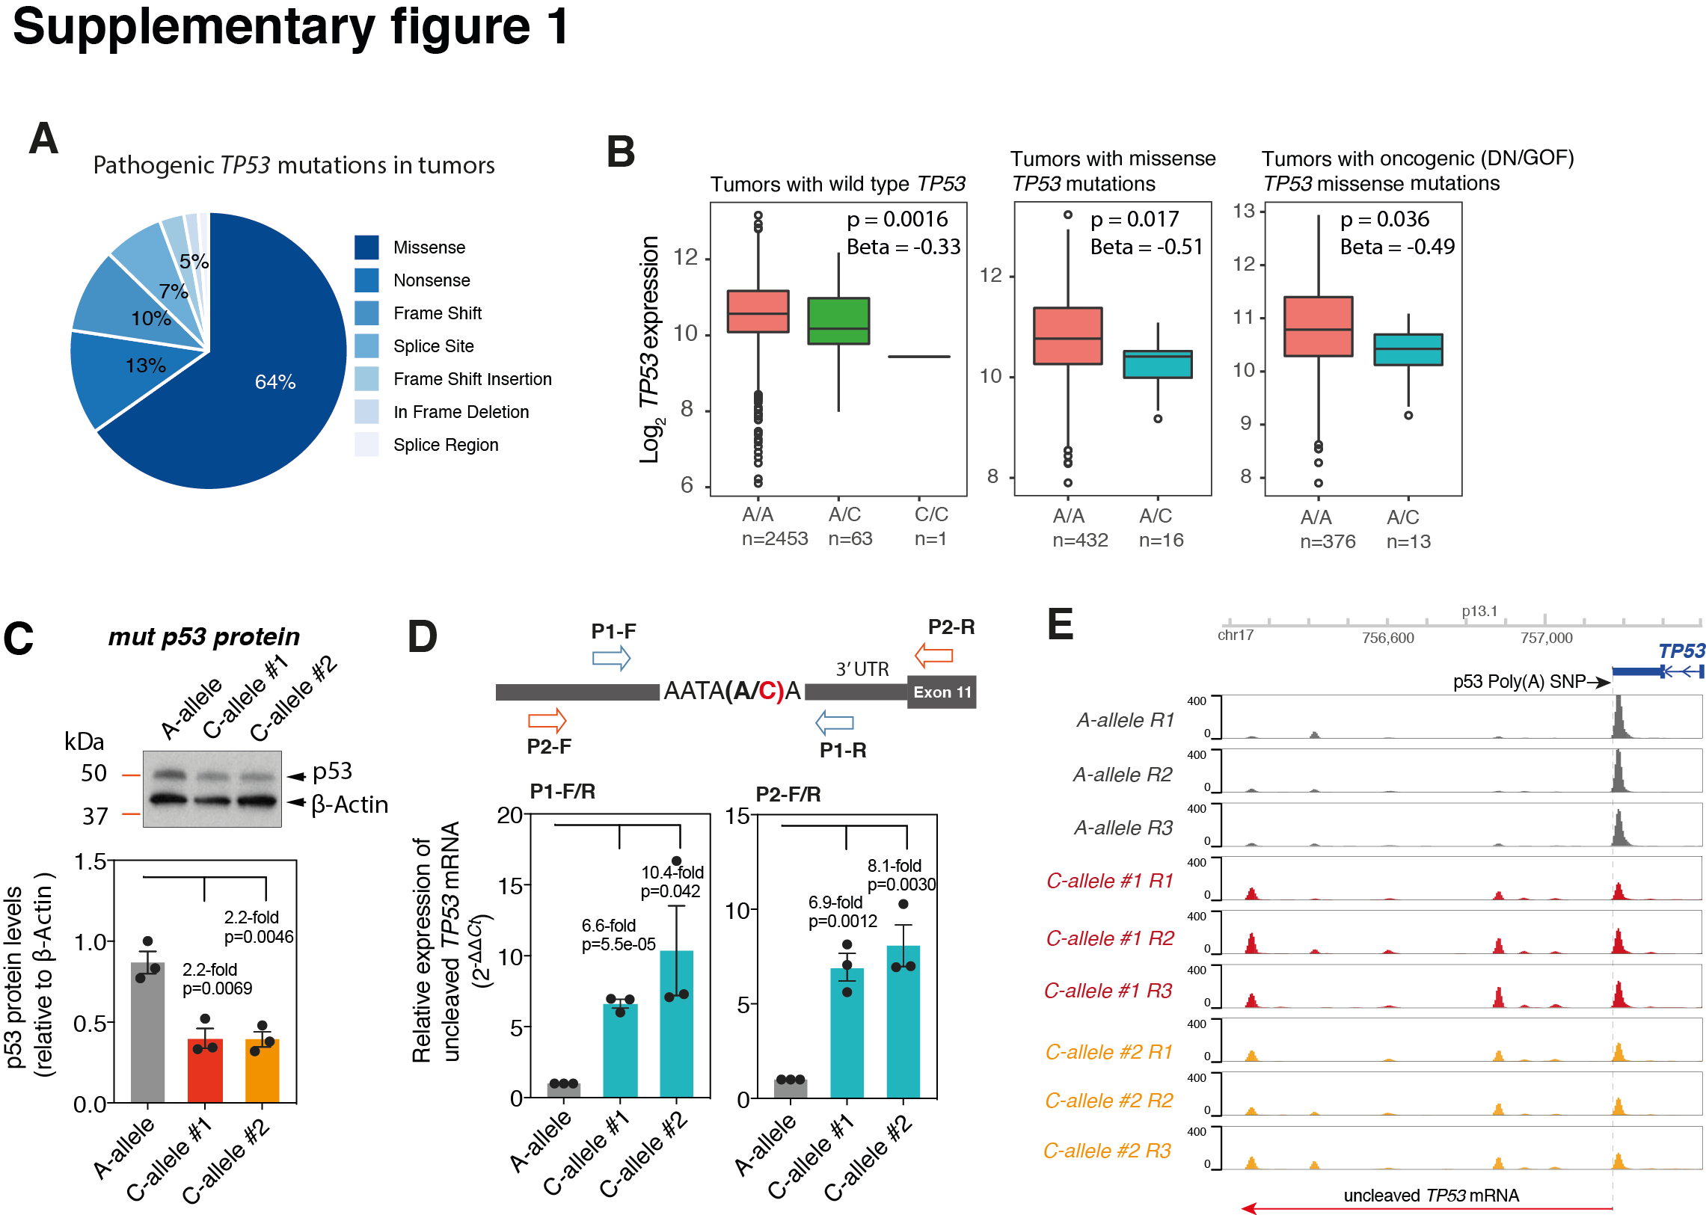
Figure S1. (A) A pie chart of the percentages of different classes of pathogenic TP53 mutations in the 3,985 tumors of the TCGA cohort that had TP53 sequence information available. (B) Box plots of TP53 mRNA expression levels in tumors from individuals with differing genotypes of the p53 poly(A) SNP. The mRNA levels are depicted for individuals with wild type TP53 (left), missense TP53 mutations (center) and oncogenic TP53 missense mutations (right). The p-values and beta coefficients were determined using a linear model. (C) A bar plot of p53 protein levels for each genotype in Hap1 cells, measured using densitometric analyses of results from Western blot analyses (upper panel) and normalized to β-actin. Error bars represent SEM of 3 independent experiments. p-values were calculated using a two-tailed t-test. (D) A schematic overview of the qRT-PCR strategy to measure the levels of uncleaved TP53 mRNA in Hap1 cells of differing genotypes (upper). Two bar plots of uncleaved TP53 mRNA levels for each genotype in Hap1 cells, measured using qRT-PCR normalized to GAPDH (lower). Two sets of primers (P1-F/R and P2-F/R) were used to amplify the TP53 pre-mRNAs. (E) The results are presented of 3’ RNA sequencing of logarithmically growing cells from multiple clones and replicates of cells with the p53 poly(A) SNP C-alleles (red and orange tracks) and with multiple replicates of the A-allele clone (grey bars). The track abundance is plotted for each replicate for the RNAs found at the 3’ end of the TP53 gene and a diagram of the gene is found above the plots for reference. A vertical dotted line and horizontal arrow indicates the uncleaved p53 RNAs.

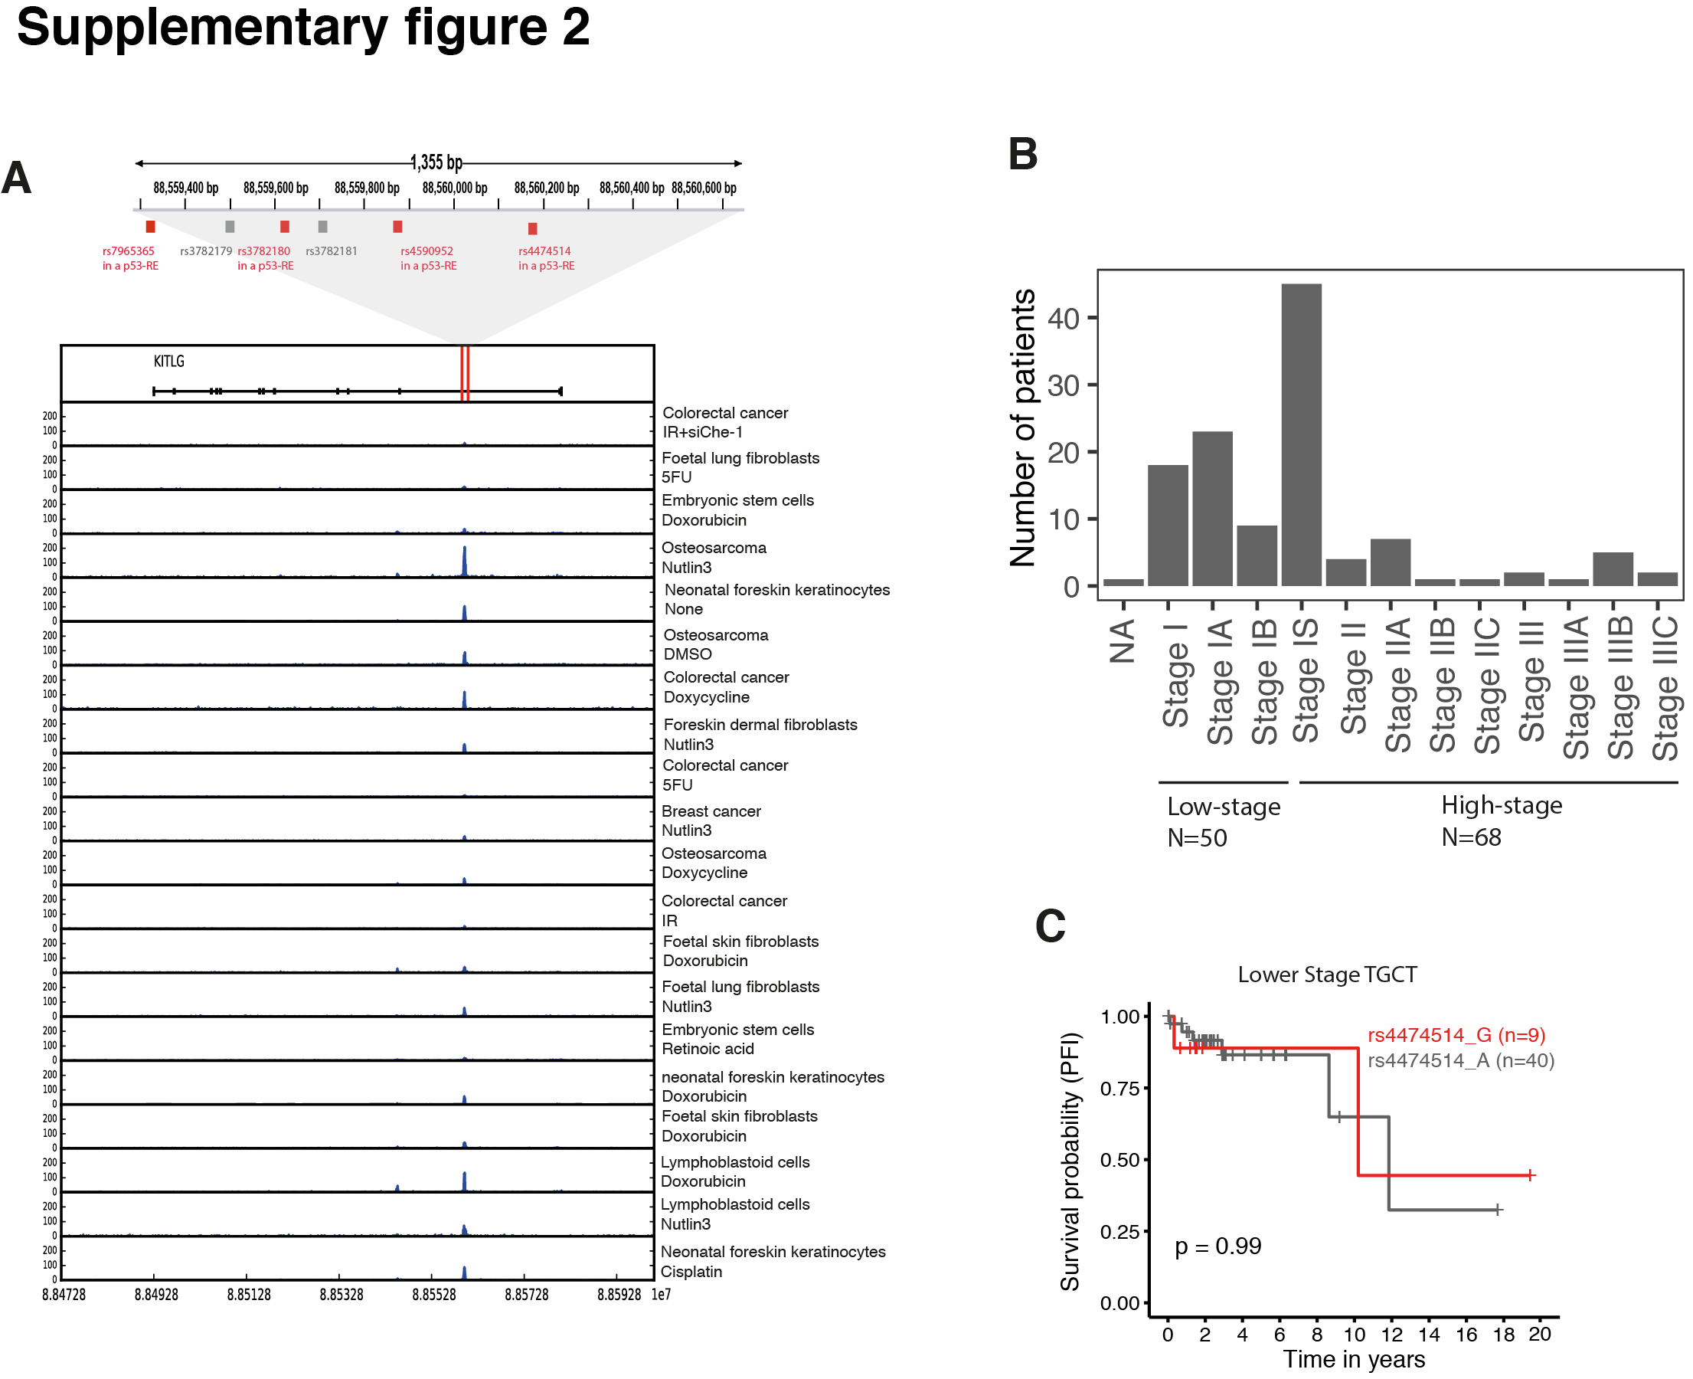
Figure S2. (A) A highly p53-occupied risk locus contains four SNPs that reside in predicted p53-REs (red boxes). The publicly available p53 ChIP-seq datasets are listed in the below Table. (B) A bar plot showing the number of the patients with high-stage (IS, II, III) or low low-stage (I) TGCT based on American Joint Committee on Cancer (AJCC) pathologic tumor stages and clinical stages (also see Supplementary Table S8). (C) A Kaplan-Meier survival curve for PFI in low-stage wtTP53 testicular cancer patients carrying either the risk (orange) or the non-risk allele (grey) of the KITLG risk SNP.

The publicly available p53 ChIP-seq datasets (related to Supplementary Fig. S2A)

Dataset | PMID | Cell Line | Treatment | GEO | UID
18_24078252 | 24078252 | WA09 | None | GSE39912 | 200039912
19_24078252 | 24078252 | WA09 | Doxorubicin | GSE39912 | 200039912
20_24078252 | 24078252 | WA09 | Retinoic Acid | GSE39912 | 200039912
25_22127205 | 22127205 | IMR90 | 5FU | GSE31558 | 200031558
10_25415302 | 25415302 | HCT116 | 5FU | GSE58714 | 200058714
5_25996291 | 25996291 | HCT116 | IR | GSE60267 | 200060267
31_25996291 | 25996291 | HCT116 | IR+siChe-1 | GSE60267 | 200060267
4_26183718 | 26183718 | SW480 | Doxycycline | GSE67108 | 200067108
13_25058159 | 25058159 | MCF7 | Nutlin-3a | GSE47043 | 200047043
6_25790137 | 25790137 | IMR90 | None | GSE53491 | 200053491
7_25790137 | 25790137 | IMR90 | RasG12V | GSE53491 | 200053491
8_25790137 | 25790137 | IMR90 | RasG12V+E1A | GSE53491 | 200053491
9_25790137 | 25790137 | IMR90 | Etoposide | GSE53491 | 200053491
26_21459846 | 21459846 | Saos2 | Doxycycline | GSE15780 | 200015780
27_24823795 | 24823795 | primary | None | GSE56674 | 200056674
28_24823795 | 24823795 | primary | Cisplatin | GSE56674 | 200056674
29_24823795 | 24823795 | primary | Doxorubicin | GSE56674 | 200056674
21_23775793 | 23775793 | U2OS | DMSO | GSE46642 | 200046642
22_23775793 | 23775793 | U2OS | Doxorubicin | GSE46642 | 200046642
23_23775793 | 23775793 | U2OS | Nutlin-3a | GSE46642 | 200046642
24_23775793 | 23775793 | U2OS | None | GSE46642 | 200046642
0_27163456 | 27163456 | primary | Nutlin-3a | GSE77225 | 200077225
1_27163456 | 27163456 | primary | DMSO | GSE77225 | 200077225
11_25391375 | 25391375 | IMR90 | DMSO | GSE58740 | 200058740
12_25391375 | 25391375 | IMR90 | Nutlin-3a | GSE58740 | 200058740
3_25883152 | 25883152 | GM06170 | Doxorubicin | GSE55727 | 200055727
30_25883152 | 25883152 | GM00011 | Doxorubicin | GSE55727 | 200055727
14_24120139 | 24120139 | GM12878 | IR | GSE46993 | 200046993
15_24120139 | 24120139 | GM12878 | Nutlin-3a | GSE46992 | 200046992
17_24120139 | 24120139 | GM12878 | Doxorubicin | GSE46991 | 200046991

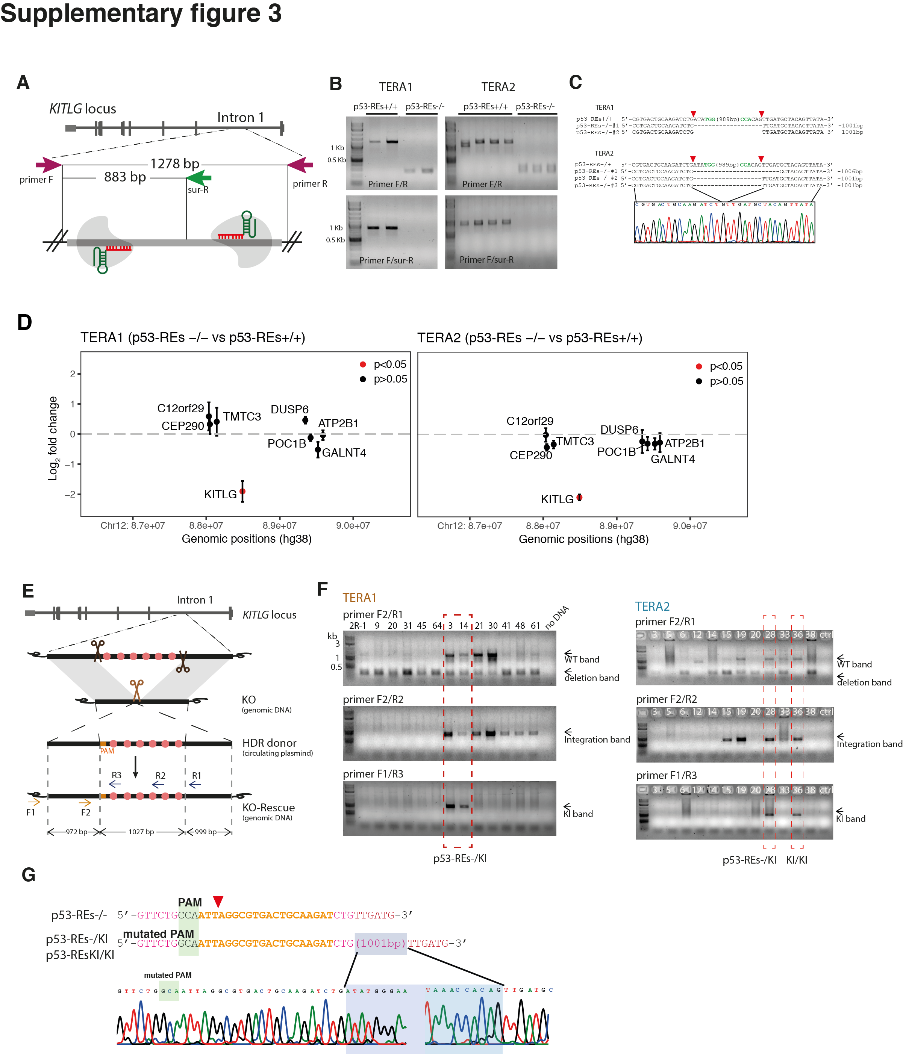
Figure S3. Characterization of the p53-bound KITLG locus in non-edited p53-REs+/+, knock-out p53-REs-/- or knock-in clones. (A) A diagram of the CRISPR/cas9-mediated genomic editing strategy utilized. Red and green arrows indicate the primers used for PCR-based validation. (B) PCR results of genomic DNA isolated from p53-REs+/+ or p53-REs-/- clones by using primers indicated in (A) where two sets of primers (see Supplementary Table S2 for primer sequences) were designed for genomic editing detection of the sgRNAs-targeted KITLG locus in TERA1 and TERA2 cells. (C) Sanger sequencing analysis of the non-edited p53-REs+/+ and knock-out p53-REs-/- clones. The 5′-NGG adjacent motifs (PAMs) are shown in green and sites of cleavage by Cas9 are indicated by red triangles. (D) Differences in cDNA levels of transcripts encoded by genes surrounding the KITLG p53-RE cluster (±2Mbp). cDNA levels were measured using qRT-PCR normalized to GAPDH and error bars represent SEM of three independent experiments. p-values were calculated using a two-tailed t-test. (E) A diagram of the CRISPR-mediated genomic editing utilized for generating the knock-in clones. The 5′-NGG adjacent motifs (PAMs) are shown in orange. The primers used for PCR-based genotyping and sanger sequencing are shown by arrows. (F) PCR results of genomic DNA isolated from knock out or knock in clones by using primers indicated in (E) where three sets of primers were designed for genomic editing detection of the sgRNAs-targeted KITLG locus. (G). Sanger sequencing analysis of the non-edited and the knock-in clones. In the knock-in clones, the p53-bound region in KITLG intron 1 was fully inserted by using a DNA donor containing a mutated PAM site (a point mutation from CCA to GCA).

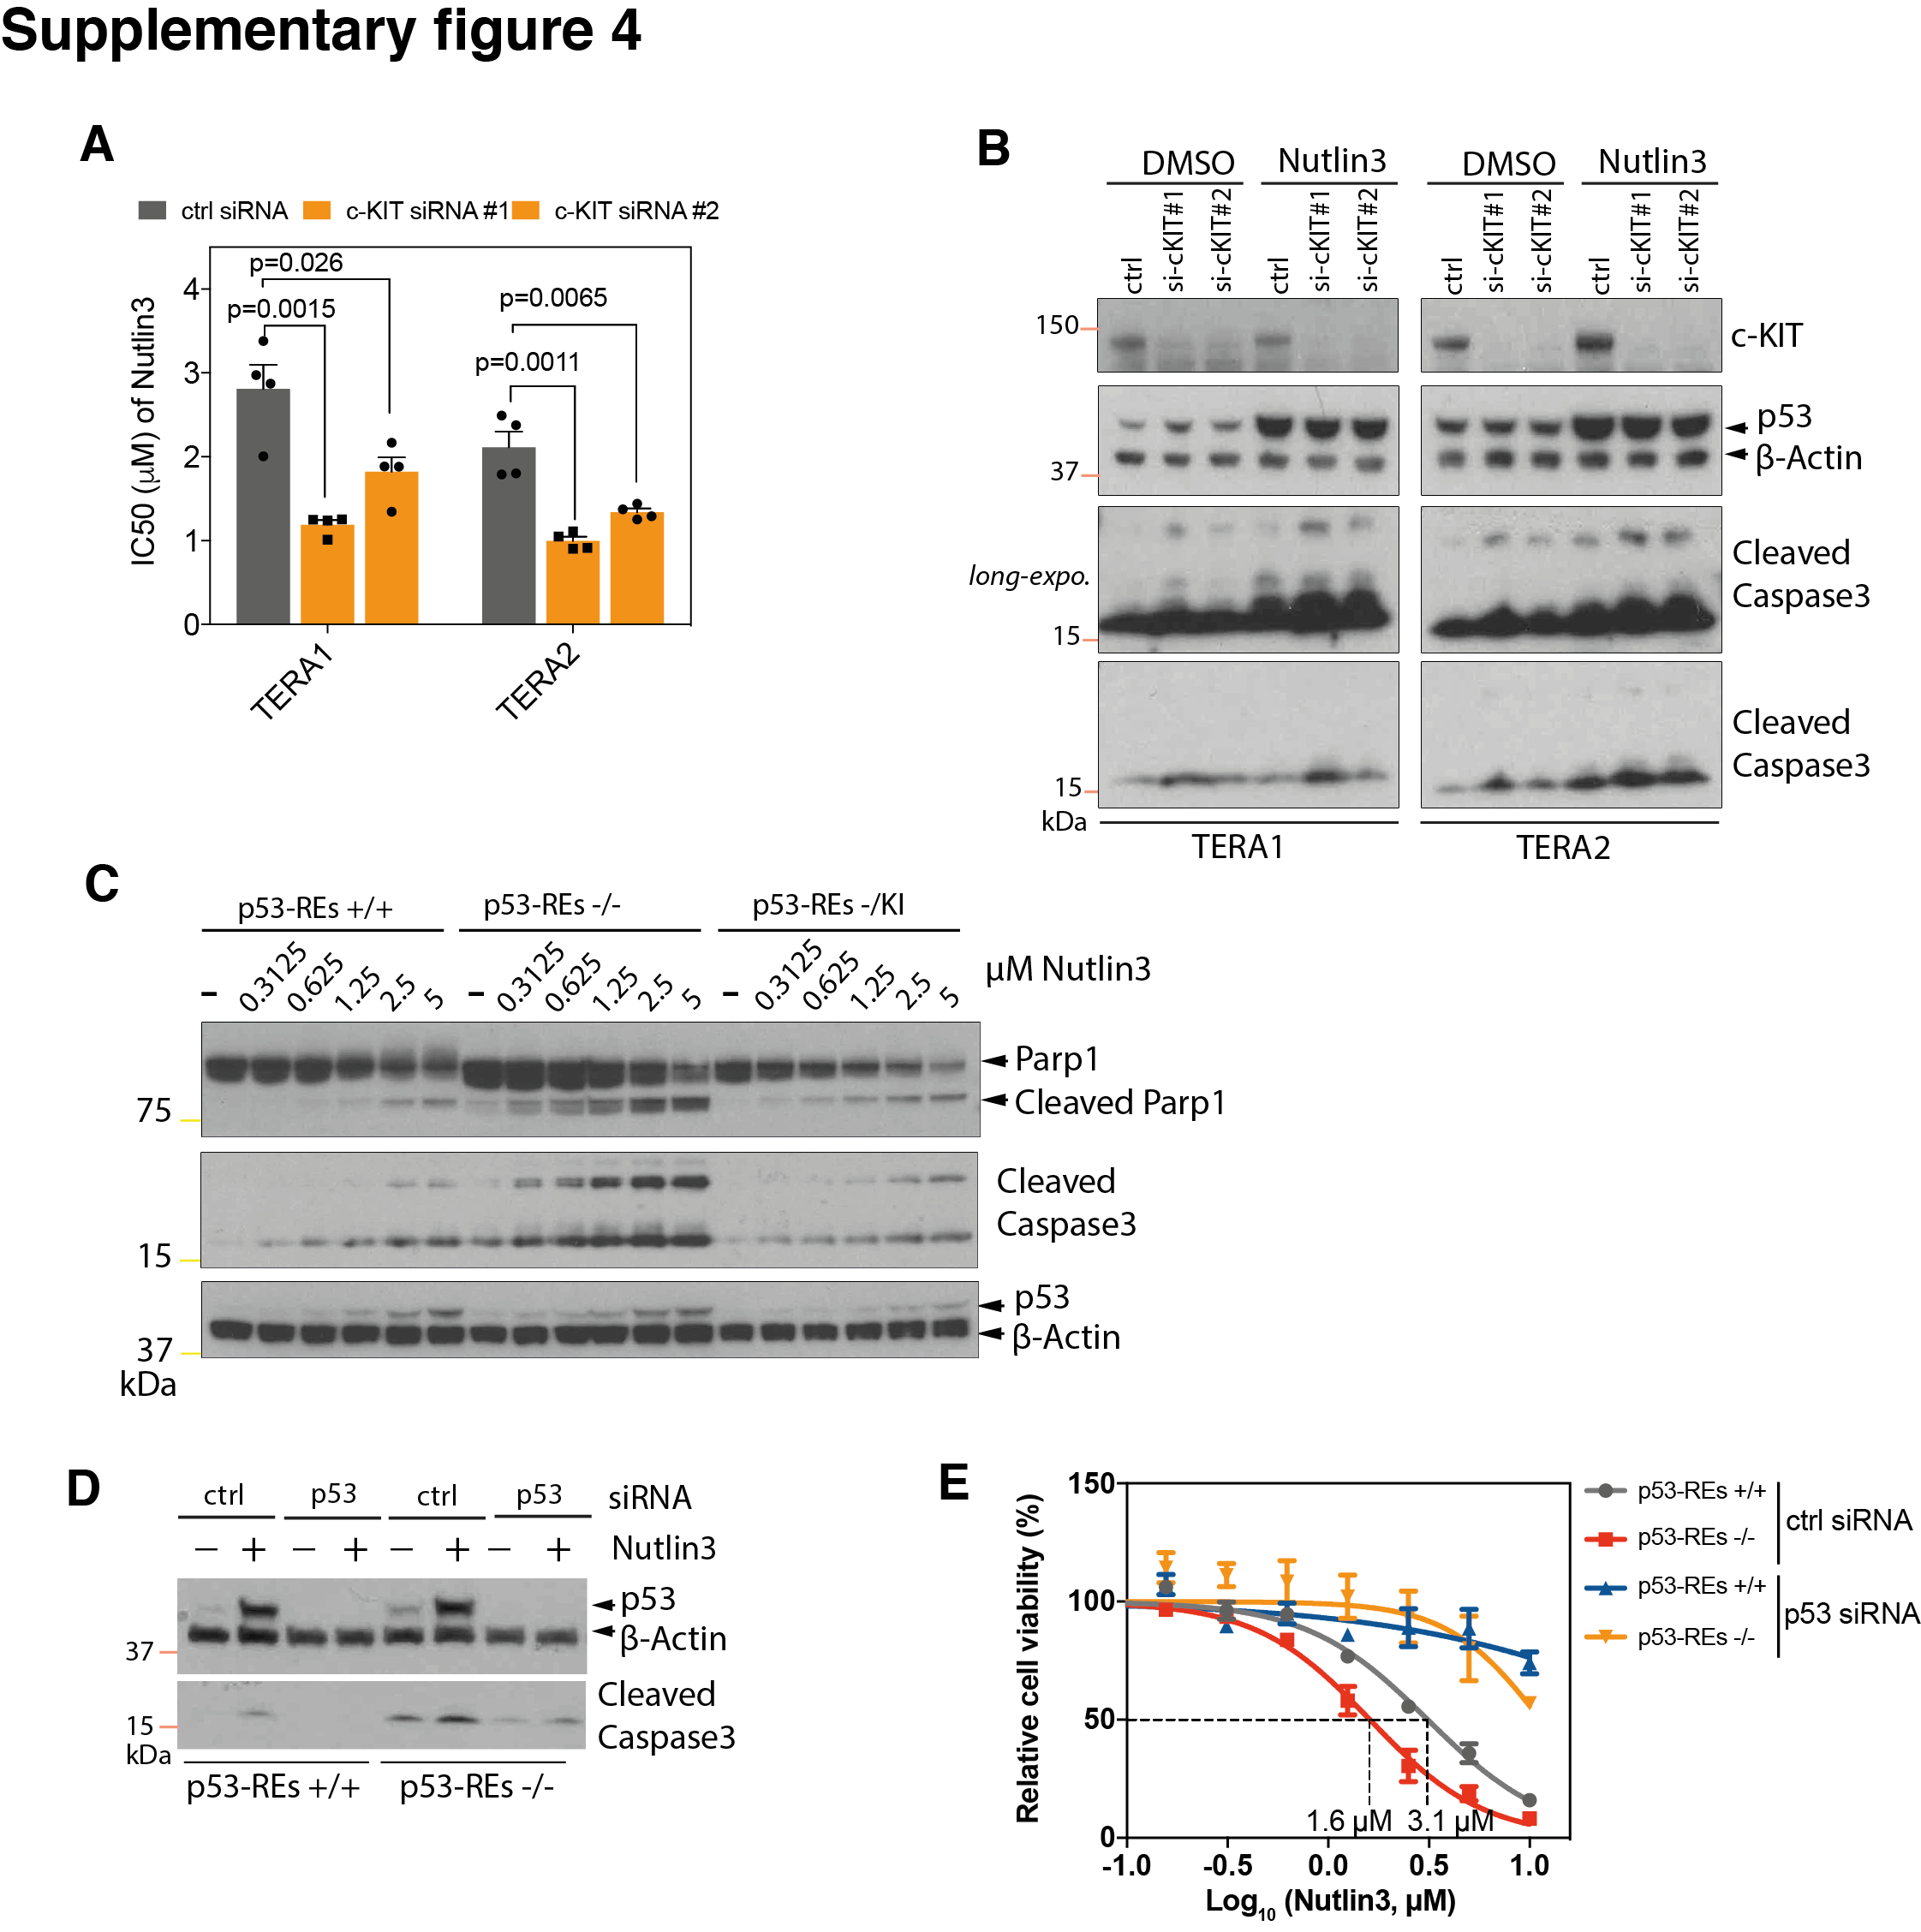
Figure S4. The p53 bound region of KITLG protects against p53-mediated apoptosis. (A) A bar graphs of average IC50 values of TERA1 and TERA2 cells that were transfected with two different siRNAs targeted against c-KIT or with a control non-targeted siRNA pool. The cell viability was analyzed by a MTT assay, and IC50s were calculated. Error bars represent SEM in 4 independent biological replicates. p-values were calculated by the two-tailed t-test. (B) Western blot analysis of the siRNA treated cells with or without Nutlin3 (10 μM) treatment for 6 hours. The cells were lysed and analyzed for c-KIT, p53 and cleaved-caspase3 protein expression. (C) Western blot analysis of p53-REs+/+, p53-REs-/- and -/KI of TERA1 cells that were treated with an increasing amount of nutlin3 for 24 hours. The cells were lysed and analyzed for p53, Parp1 and cleaved-caspase3 protein expression. (D) Western blot analysis of the siRNA treated cells with or without Nutlin3 (10 μM) treatment for 6 hours. The cells were lysed and analyzed for p53 and cleaved-caspase3 protein expression. (E) Dose-response curves for cell viability of the siRNA treated cells with or without Nutlin3 treatment. Error bars represent SEM of 2 different clones per genotype.

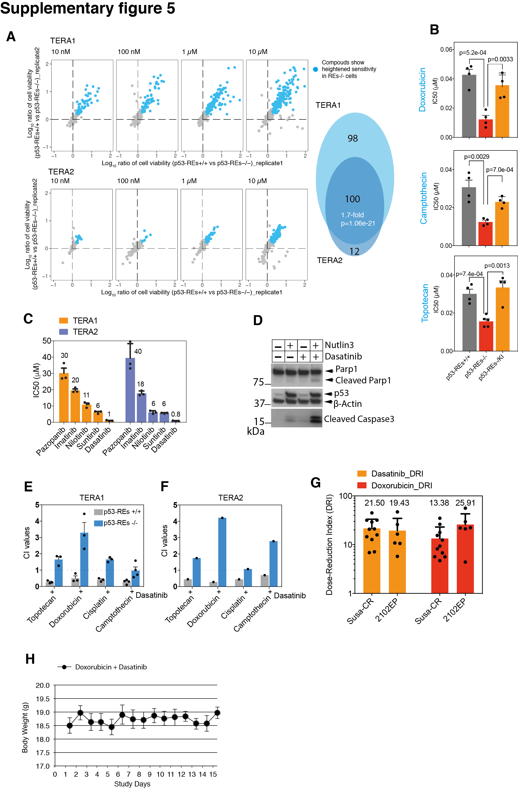
Figure S5. p53/KITLG pro-survival signaling can attenuate responses to p53-activating agents. (A) Scatter plots of the ratio (log₁₀ scale) of cell viability between p53-REs+/+ and p53-REs-/- cells in response to different compounds. The compounds to which the p53-REs -/- cells respond better (blue dots) are defined as hits (i.e., the relative cell viability after treatment in p53-REs+/+ cells versus p53-REs-/- cells is more than1.5 fold in both replicates). Venn diagram (right panel) of the overlap between the number of hits in TERA1 and TERA2 cells. The p-value for the statistical significance of the overlap was calculated with the hypergeometric probability test (http://nemates.org/MA/progs/overlap_stats.html). (B) Bar plots of average IC50 values for 3 TOPO inhibitors in p53-REs+/+ (grey bars, two clones), p53-REs-/- (red bars, two clones) p53-REs-/KI (orange bars, one clone) of TERA1 cells. Error bars represent SEM of at least two independent biological replicates. (C) Bar plots of the IC50 values of TERA1 and TERA2 cells in response to 5 different c-KIT inhibitors. Error bars represent SD of 3 independent biological replicates. (D) Western blot analysis of TERA1 cells that were treated with Nutlin3 (10 μM), Dasatinib (2 μM) or combination of Nutlin3 and Dasatinib for 6 hours, lysed and analyzed for p53, acetylated p53, Parp1 and cleaved-caspase3 protein expression. (E-F) Bar plots of combination indexes of Topotecan, Doxorubicin, Cisplatin or Camptothecin with Dasatinib in p53-REs+/+ (grey bars) and p53-REs-/- (blue bars) of TERA1 and TERA2 cells. (G) A bar plot showing the dose-reduction index (DRI) in Susa-CR and 2102EP cells treated with Dasatinib and Doxorubicin. Treatment combination in Susa-CR cells led to a 22-fold reduction of concentration for Dasatinib (from 5.56uM to 259nM) and 13-fold for Doxorubicin (from 0.28uM to 20.93nM; Fig. 3). Similarly, combination treatment in 2102EP resulted in a 19-fold (19.43 from 1.06uM to 54.55nM) and a 26-fold (from 0.23uM to 8.88nM) dosage reductions for Dasatinib and Doxorubicin respectively. Each dot represents one biological replicate. Error bars represent means ± SEM. (H) Weight curves of non-tumor bearing female BALB/c mice upon combination treatment of Doxorubicin and Dasatinib. Mice were weighed daily for the duration of the study. Error bars represent means ± SEM (n=3). p.o. Dasatinib (25 mg/kg) on day 1-5; i.p. Dxorubicin (4 mg/kg) 1h after Dasatinib dosing on day 1. p.o.: oral administration; i.p.: intraperitoneal injection. On day 15, all mice were sacrificed.

References
1. Bailey MH, Tokheim C, Porta-Pardo E, Sengupta S, Bertrand D, Weerasinghe A, et al. Comprehensive Characterization of Cancer Driver Genes and Mutations. Cell 2018;174(4):1034-5
2. Chang MT, Asthana S, Gao SP, Lee BH, Chapman JS, Kandoth C, et al. Identifying recurrent mutations in cancer reveals widespread lineage diversity and mutational specificity. Nature biotechnology 2016;34(2):155-63
3. Bouaoun L, Sonkin D, Ardin M, Hollstein M, Byrnes G, Zavadil J, et al. TP53 Variations in Human Cancers: New Lessons from the IARC TP53 Database and Genomics Data. Human mutation 2016;37(9):865-76
4. Giacomelli AO, Yang X, Lintner RE, McFarland JM, Duby M, Kim J, et al. Mutational processes shape the landscape of TP53 mutations in human cancer. Nature genetics 2018;50(10):1381-7
5. Willer CJ, Li Y, Abecasis GR. METAL: fast and efficient meta-analysis of genomewide association scans. Bioinformatics 2010;26(17):2190-1
6. Carter H, Marty R, Hofree M, Gross AM, Jensen J, Fisch KM, et al. Interaction Landscape of Inherited Polymorphisms with Somatic Events in Cancer. Cancer discovery 2017;7(4):410-23
7. Korn JM, Kuruvilla FG, McCarroll SA, Wysoker A, Nemesh J, Cawley S, et al. Integrated genotype calling and association analysis of SNPs, common copy number polymorphisms and rare CNVs. Nature genetics 2008;40(10):1253-60
8. Das S, Forer L, Schonherr S, Sidore C, Locke AE, Kwong A, et al. Next-generation genotype imputation service and methods. Nature genetics 2016;48(10):1284-7
9. Ran FA, Hsu PD, Wright J, Agarwala V, Scott DA, Zhang F. Genome engineering using the CRISPR-Cas9 system. Nature protocols 2013;8(11):2281-308

