Supplemental Information
Title: Mesenchymal stem cell-secreted extracellular vesicles instruct stepwise dedifferentiation of breast cancer cells into dormancy at bone marrow perivascular region

Authors: Oleta A. Sandiford, Robert J. Donnelly, Markos El-Far, Lisa M. Burgmeyer, Garima Sinha, Sri Harika Pamarthi, Lauren S. Sherman, Alejandra I. Ferrer, Dariana E. DeVore, Shyam A. Patel, Yahaira Naaldijk, Sara Alonso, Pradeep Barak, Margarette Bryan, Nicholas M. Ponzio, Ramaswamy Narayanan, Jean-Pierre Etchegaray, Rakesh Kumar, Pranela Rameshwar

Reagents
Fetal Bovine Serum (FBS), tissue culture grade PBS (pH 7.4), Dulbecco Modified Eagle Medium (DMEM), L-glutamine (2 mM), Penicillin-Streptomycin (2 mM), Trypsin, Pyronin-Y, EDTA-free Protease Inhibitor Cocktail, Phosphatase Inhibitor Cocktail 2 and doxorubicin were purchased from Millipore Sigma (St. Louis, MO), EGM-2 Endothelial Growth Media from Lonza (Walkersville MD), FBS Premium Select from Atlanta Biologicals (Lawrenceville, GA), exosome-depleted FBS from System Biosciences (Palo Alto, CA), RPMI 1640 and human recombinant insulin from Gibco (Grand Island, NY), FxCycle PI/RNase Staining Solution, Vybrant Multidrug Resistant Assay Kit, Total Exosome Isolation Reagent, Alexa Fluor 647 (F647) and 7-Aminoactinomycin D (7AAD) from Invitrogen (Carlsbad, CA), Total Exosome RNA, Protein Isolation Kit, BCA Protein Assay Kit, SuperSignal West Femto Maximum Sensitivity Substrate reagent, Lipofectamine 3000, and Restore Western Blot Stripping from Thermo Fisher Scientific (Waltham, MA), PVDF membranes from Perkin Elmer (Waltham, MA), Mini-PROTEAN TGX Precast Gels, Bradford protein assay reagent, glycine, 2X loading dye, sodium dodecyl sulfate and Kaleidoscope pre-stained standards from Bio-Rad (Hercules, CA), luciferase substrate and β-galactosidase assay kit from Promega (Madison, WI) and, Cyto-ID Autophagy Detection Kit from Enzo Life Science (Farmingdale, NY).

Antibodies and Cytokines
Rabbit anti-human ALIX and goat anti-rabbit IgG-HRP were purchased from System Biosciences; rabbit anti-CDK4, rabbit monoclonal anti-tsg101, rabbit anti-ATG5, rabbit anti-ß-catenin, rabbit anti-MDR1/ABCB1, rabbit polyclonal anti-CyclinD1, rabbit polyclonal p53, and rabbit anti-IgG-HRP from Cell Signaling (Denver, MA); rabbit anti-Cyclin D1 from R&D Systems (Minneapolis, MN) and mouse anti-human β-actin, from Santa Cruz Biotechnology (Dallas, TX); rabbit anti-MnSOD from abcam; mouse anti-human CD9-PerCP Cy5.5, CD63-PE, CD146-PE, CD31-APC and CD90-APC from BD Biosciences (San Jose, CA), rabbit anti-TSG101 from Novus Biologicals (Centennial. CO), rabbit anti-GRP78 and Alexa Fluor 647 dye from ThermoFisher Scientific.

Sorting of BCC subsets
We selected BCC subsets, as described (1). Briefly, BCCs, stably transfected with pEGFP1-Oct3/4 or pEdsRED1-Oct3/4, were selected based on GFP intensities on the FACSDiva (BD Biosciences). Since GFP is under the control of Oct4a promoter, GFP intensity served as a surrogate of the relative stemness of the cells (1). The top 5% GFP^{hi} cells were designated Oct4A^{hi}, which were previously shown to be mostly CSCs (1). We designated the bottom 5% cells with low GFP intensity as Oct4a^{lo} and the middle (20%) designated Oct4a^{med} and Oct4a^{med/lo}, from top to bottom.

Culture of mesenchymal stem cells (MSCs)
We expanded MSCs from BM aspirates, as described (2). Briefly, we diluted unfractionated aspirates in DMEM with 10% FCS (D10 media) and then added to vacuum gas plasma-treated plates (BD Falcon; Franklin Lakes, NJ). After 3 days, we removed red blood cells and granulocytes by Ficoll-Hypaque density gradient centrifugation. The mononuclear fraction was replaced in the plates using protocol, which was modified from our previous reports. The difference is as follows: the mononuclear fraction was added with media that were comprised of fresh D10 media and equal volume of media that was saved from the previous culture. We also reused the plates as we found homogeneity and excellent growth when there was prior deposit of matrices from MSCs, previously in culture. At weekly intervals, fresh media replaced 50% of the culture media. The adherent cells were serially passage at 80% confluence. At passage 4, the cells were negative for CD34, CD45 and CD14; positive for CD29, CD73, CD90, CD105 and CD44, and differentiated into adipogenic and osteogenic cells (3).

Culture of primary BM endothelial cells (EC)
The method to expand ECs was previously described (4). Briefly, MNCs were isolated from BM aspirates by Ficoll Hypaque density gradient centrifugation and then added to T25 tissue culture flasks (Greiner Bio-One, Monroe NC) at 10⁷ in 7 mL of EGM-2 Endothelial Growth Media. At about 21 days, the cells reached confluence and the adherent cells were passaged.

Transmigration Assay
The migration of BCCs across ECs were previously described (4). We assessed the effect of BM microenvironmental cells (MSCs and ECs) in BCC migration in a transwell system with 0.8 μ membranes. At day 1, MSCs ${(10}^{3})$ were resuspended in 40 µl of 10% DMEM and seeded at the bottom of FluoroBok transwell inserts (Corning, NY). These inserts allow the measurement of fluorescent cells that have migrated to the bottom of the outer well without considering fluorescent cells within the inner well. After 24 h, the MSCs adhere at the bottom of membranes. The wells were overturned and placed on top of the outer wells of a 24-well plate with 500 µl of fresh media. The next day, the media in the outer wells were removed and replenished with 500 µl of EC media containing 10⁴ ECs.
After 24 h, ${we BCCs were prepared as follows: 10}^{6}$BCCs, untreated or exposed to naïve MSC exosomes, were fluorescent-labelled with 2 µM 5-chloromethylfluorescein diacetate (CMFDA) (ThermoFisher Scientific, MA). Labeling occurred by incubating the BCCs with CMFDA for 30 min at 37°C, followed by centrifugation at 300 g for 7 min. We resuspended the cell pellets in 1 ml of EC media.
Prior to adding the labeling BCCs, we replaced the media in both wells with 500 µl of EC media and then added ${10}^{4} labeled$ BCCs into the inner wells. The plates were incubated for 3 h at 37°C. Fluorescence intensity was measured in the bottom and top parts of the inserts using Synergy HTX Multi-Mode microplate reader (BioTek Instruments, VT) at an excitation of 485/20 and emission of 528/20.

Reporter Gene Assay
Reporter gene assays were performed as described (5).MDA-MB-231 were transfected with human cyclin D1 promoter in pGL3-basic. The cyclin D1 promoter was obtained from Addgene (which was a donation from Frank McCormick laboratory- Cambridge, MA). pβgal was previously described (5). The cells were transfected with Lipofectamine 3000, as per manufacturer’s instruction. The cells were co-transfected with pβgal as described (5). After 24 h, cell lysates were prepared using 1X Promega lysis buffer. Protein concentration was determined using the Bradford protein assay reagent. Luciferase and β-galactosidase levels were quantified using kits from Promega. Relative luminescence unit (RLU) was calculated after normalization with β-galactosidase activity.

Flow cytometry
Exosome: Purified exosomes were analyzed for markers by incubating with anti-CD63 Dynabead (Invitrogen,) according to manufacturer’s protocol. Briefly, we incubated the purified exosomes with anti-CD63-PE Dynabeads overnight at 4ºC. After this, we selected the beads with a magnetic separator and then labelled them with anti-CD90-APC, -CD63-PE and -CD9-PerCP Cy5.5 at 1/100 final dilution, 30 mins at room temperature. After one wash with PBS, we analyzed the labeled beads on the FACS Calibur. We incubated anti-CD63 to ensure specificity of the beads because there will be exposed sites, as suggested by the manufacturer of the beads.
Cell Viability: 7-AAD was used to discern viable and non-viable cells. 7-AAD was diluted in DMSO at 1 mg/mL and then aliquoted as stock solution in 10 µL volumes. Experimental labeling used the stock solution at 1/200 in PBS and then immediately acquired on FAC Calibur.
Oct4a Expression: MDA-MB-231-GFP/RFP were treated with or without exosomes for different times. Cells were washed twice with PBS and then analyzed for GFP/RFP intensities using the FACS Calibur.
Data Analyses: All acquired data from the FACS caliber were analyzed with BD CellQuest software and ModFit LT (Verity House Software).

Immunocytochemistry
GFP/RFP ^{hi, med, low} sorted MDA-MB-231 were seeded in 6-well plate. After 24 h, adherent cells were fixed with 3.7% formaldehyde for 15 mins at room temperature (RT) followed by permeabilization for 10 mins using 0.2% Triton X-100 in PBS. The cells were blocked with 1% BSA in PBS for 1 h. The wells were washed twice with 1X PBS then incubated for 2h at RT with the following: anti-H2AX (1/200) and anti-PARP (1/200). All antibodies were diluted in 1X PBS. After incubation, the wells were washed with 1X PBS and then incubated with goat anti-mouse IgG -Texas Red and goat anti-rabbit IgG-PE. The cells were imaged with the EVOS FL Auto2.

In vivo studies
Female NSG mice (8 wk) in BALB/c background were purchased from Jackson Laboratories (Bar Harbor, Maine) and housed in an AALAC-accredited facility at Rutgers, New Jersey Medical School (Newark, NJ). The use of mice followed a protocol, approved by the Institutional Animal Care and Use Committee (IACUC), Rutgers (Newark, NJ). BCC subsets (Oct4a^{med} or Oct4a^{lo}), 10⁶ in 0.2 mL sterile PBS, were injected intravenously via the tail vein of NSG at 5/group. This number was adequate for statistical analyses. After 72 h, we harvested both femurs. One was used for immunohistochemistry (see below) and the other to collect cells. We collected the cells by flushing with RPMI containing 2% FCS in a syringe attached to a 27-gauge needle.

Immunohistochemistry
Immunohistochemistry for human pan-cytokeratin, CD29, CD146 and Numa was performed with sections from murine femurs, as described (2). Briefly, sections were dewaxed by heating at 56⁰C overnight, dewaxed with xylene and ethanol, followed by rehydration. The cells were fixed and then permeabilized with 0.1% Triton-X, washed 3x in 1X PBS and then incubated overnight at 37⁰C in a humidified chamber with primary antibodies at 1/200 final dilution. The slides were washed and then incubated with fluorescence-tagged secondary antibodies at 1/500 final dilution for 2 h at room temp in a humidified chamber. After this, the slides were imaged using EVOS FL Auto2. The results of immunohistochemical analyses of slides from mice and human sections were quantified with Image J. We counted BCCs in 10 fields/slide.

Real time PCR
Total RNA was extracted with miRCURY RNA isolation Kit from Exiqon (Woburn, MA) according to manufacturer’s’ protocol. Purified RNA (10 ng) was immediately reverse transcribed using the TaqMan® Small RNA Assay (ThermoFisher) with the following conditions: 16⁰C for 30 min, 42⁰C for 30 min, and 85⁰C for 5 min. Real-time PCR was performed with 2 ng cDNA using TaqMan Universal PCR Master Mix 2x No AmpErase UNG (Thermo Fisher). The following primers were purchased from Life Technologies:
Hes1: Forward 5´- aag aaa gat agc tcg cgg ca - 3´, Reverse 5´- aaa cac ctt agc cgc ctc tc - 3´
KLF4: Forward 5´- aac ctt acc act gtg act gg - 3´, Reverse 5´- cat atc cac tgt ctg gga tt - 3´
ID2: Forward 5´- aaa aac agc ctg tcg gac ca - 3´, Reverse 5´- att cag aag cct gca agg aca - 3´
Cyclin D1: Forward 5´- cct aag ttc gct tcc gat ga - 3´, Reverse 5´- acg tca gcc tcc aca ctc tt - 3´
β-actin: Forward 5´- gcc cta taa aac cca gcg gc - 3´, Reverse 5´- aga ggc gta cag gga tag ca - 3´
GFP: Forward 5´- act tct tca agt ccg cca t - 3´, Reverse 5´- ggc cat gat ata gcg ttg t - 3´
Nanog: Forward 5' caa tgg tgt gac gca ggg at 3´, Reverse: 5' gac tgg atg ttc tgg gtc tgg 3'
GAPDH: Forward 5' cag aag act gtg gat ggc c - 3´, Reverse: 5´ - cca cct tct tga tgt cat c -3´
POU5F1 (Oct4a) Forward 5´ - ctg aag cag aag agg atc ac - 3´, Reverse 5´ - gct ttg cat atc tcc tga ag - 3´
Notch1: Forward 5´- cca agt ata gcc tat ggc aga a -3´; Reverse 5´ - aag tct gac gtc cct cac tg - 3´.

The data is presented as the relative gene expression (2^{ΔΔCt}), which was calculated as follows: The Ct value of the reference (β –actin) was subtracted from the Ct of gene of interest.

Western Blot Analyses
Whole cell extracts were prepared by lysing the cells with ice-cold lysis buffer containing the following: 50 mM Tris HCl (pH 7.4), 100 mM NaCl, 2 mM MgCl₂, 10% glycerol, 1% NP-40 and protease inhibitor cocktail tablets (3 tablets/50 mL). Total protein was quantitated with the Pierce BCA Protein Assay kit (Thermo Fisher). Extracts (12 µg) were electrophoresed on 12% SDS-PAGE followed by transfer to PVDF membranes (BioRad, Hercules, CA). The membranes were incubated overnight at 4°C with primary antibodies (GRP78, CDK4, Cyclin D1, p53, ALIX, tsg101, Oct4a, Notch1, Nanog, KLF4, Hes1, ID2, PgP1 (MDR1), ATG5, MnSOD, and ß-catenin), each at 1/1000 final dilution in 5% milk, diluted in PBS. Membranes that were reprobed were stripped with Restore Western blot Stripping Buffer. After incubation with primary antibodies, membranes were washed four times with 1X PBS containing 0.1% TWEEN (PBST). The primary antibodies were identified with horseradish peroxidase (HRP)-conjugated secondary anti-rabbit IgG (1/2000) at room temperature for 1 h. Membranes were washed four times with PBST followed by HRP detection with SuperSignal™ West Femto Maximum Sensitivity Substrate. Molecular weights of bands were determined by comparing with Kaleidoscope Pre-stained standards. Band densities were normalized to β-actin bands using Un-Scan-It software (Silk Scientific Inc, Orem, Utah).

Serial passaging of tumorsphere
The method for serial passages of tumorsphere was previously described (1). Sorted CSCs were seeded at 1 cell/well in 96-well low adhesion plate (Costar, Corning, NY). After 7-10 days, the tumorspheres were treated with trypsin and single cell suspension cells were passed through a 40 µ mesh (BD cell strainer cap tube). Cell viability was determined via Trypan Blue dye exclusion. Cells were seeded at 1 cell/well in ultra-low attachment plates. Serial passaging repeated the process up to four times.

Multidrug resistance assay
Multidrug resistance was determined with Vybrant multidrug resistance assay (ThermoFisher, Waltham, MA). The method followed manufactures’ instructions. Briefly, BCCs, pretreated with exosomes, were seeded in 96 well plate at 5 x 10⁵ cells/well. Verapamil, a known inhibitor of P-gp, was used as a positive control. Then 100 µl MDR dye solution (calcein AM 0.25 µM) was added to each well and incubated in the dark for 1 h. Fluorescence was determined using ex/em 494/517 nm.

Cell cycle analyses
Cell cycle analyses were performed with 7-ADD and Pyronin Y labeling, as described (2,6). Briefly, the cells were fixed with 1% formaldehyde for 15 mins, permeabilized with absolute ice-cold ethanol for 10 mins, washed with PBS and then subjected to consecutive labeling with 7-AAD (1 mg/mL) for 30 mins at 4°C and Pyronin-Y (1 mg/mL) for 30 mins at 4°C. The cells were washed with 1x PBS and then analyzed on the BD FACS Calibur. We gated the population entering Go/G1 phase and then selected those in Go phase. The data analyzed with BD CellQuest software and ModFit LT (Verity House Software, Topsham, ME).

Cell Proliferation
Proliferation was determined with CyQUANT Cell Proliferation Assay Kit (ThermoFisher, Waltham, MA), according to manufacturer’s guide. Briefly, cells were seeded in 96 well plate at 2.5 x 10⁴ cells/well and treated with exosomes. At time points Day 1, 3, 5,7 cells were analyzed.

Mitochondrial Superoxide Assay
BCCs with stable pOct4a-GFP were pre-treated with naïve or primed exosomes for 7 days. After this, the cells were washed with 1x PBS and then incubated with 5 M MitoSox™ Red for 30 mins. This was followed by washing with 1x PBS then immediately analyzed with the EVOS FL2 microscope (ThermoFisher) for MitoSox activity.

Autophagy Detection
We studied autophagy with the CYTO-ID Autophagy detection kit (Enzo Life Science, Farmingdale NY), according to manufacturer’s guide. Briefly, exosome-treated BCCs were incubated in the dark for 30 min with Cyto-ID Green Detection Reagent. The cells were washed with 1X PBS and then immediately imaged under FL1 (FITC) channel. Positive control treated BCCs with rapamycin (500 M) for 16 h.

Cellular ROS Activity
ROS activity was determined with DCFDA/H2DCFDA Cellular ROS Assay Kit (Abcam, Cambridge MA). The method followed manufactures’ instructions. Briefly, BCCs, pretreated with exosomes (see above), were seeded in 96 well plate at 2.5 x 10⁴ cells/well. After overnight adherence, we washed the cells followed by adding 25 M DCFDA. The cells were incubated for 30 min at 37⁰C. Positive control included treatment with 55 M Tert-Butyl Hydrogen Peroxide (TBHP) (Abcam) for 2 h. The cells were analyzed for fluorescence intensity at Ex/Em 485/535 using Synergy HTX Multi-Mode Reader (Biotek, Winooski, VT).

dSTORM (direct Stochastic Optical Reconstruction Microscopy) nanoimaging
dSTORM microscopy, which uses photoactivatable fluorophores with minimum photobleaching, was used to analyze MVs at the particulate level. MVs, purified with anti-CD63 Dynabeads, were labeled with anti-CD9-Alexa 647 at 1/200 dilution for 20 min at room temperature. The exosomes were washed with PBS and then placed onto a clean ibidi chamber with #1.5 glass. The dSTORM imaging buffer was added and the samples imaged on a Nanoimager S Mark II from ONI (Oxford Nanoimaging) using laser 640 nm at 30 msec exposure and 10000 frames. Localization image was generated in Nimos 1.3 software with real-time localizer.
Live cell imaging of Exosomes entering BCCs
The labeled exosomes (above) were labeled with the lipophilic dye, F647 and then added to BCCs with pOct4-GFP. Images were acquired in real time at 37⁰ C on Nanoimager S using 100X 1.4NA objective.

Transmission Electron Microscopy (TEM)
TEM analyses of exosomes were performed at the Core Imaging Lab of Robert Wood Johnson Medical School, Rutgers University (Piscataway, NJ), as described (2). Briefly, we added exosomes to formavar carbon coated grids and then stained with PTA (phosptungstaic acid). The grid was scoped on a JEOL 1200EX electron microscope and digital images were obtained using Advanced Microscopy Techniques (AMT camera) (Woburn, MA).

Single Cell RNA Sequencing
MDA-MB-231 cells were untreated or treated for 7 days with naïve or primed MSC-derived exosomes, as described in Fig. 1A. The cells taken to the Genomics Core Facility at New Jersey Medical for sequencing. Briefly, using a microfluidic system, single cell droplets were encapsulated with a microparticle coated with oligonucleotides containing a unique molecular identifier (UMI), PCR handler, cell-specific barcode and a terminal oligo-dT in lysis buffer. Droplets were broken and the mRNA-bound microparticles were reverse transcribed, strand reversed and amplified. The resulting double stranded cDNA created the sequencing library using the Nextera Library construction reagents (Illumina). The Illumina NexSeq550 generated the data.

Exosome RNA Sequencing
Total RNA from exosomes was isolated using the miRCURY RNA isolation Kit from Exiqon (Woburn, MA). The Genomics Center at Rutgers New Jersey Medical School (Newark, NJ) performed the RNA-Seq. At the facility, polyA RNA was purified using NEBNext® Poly(A) mRNA Magnetic Isolation Module (New England BioLabs, Ipswich, MA). Next generation sequencing (NGS) libraries were prepared using the NEB Ultra II Library Preparation Kit and NEBNext® Multiplex Oligos for Illumina (Dual Index Primers Set 1) (New England BioLabs). The generation of the libraries followed manufacturer’s protocol. Quality control of the libraries used the Qubit instrument and the high sensitivity Kit from Thermo Fisher as well as Tapestation 2200 instrument and D1000 ScreenTapes from Agilent (Santa Clara, CA). The libraries were diluted to 2 nM and then denatured as per Illumina’s protocol and run on Illumina’s NextSeq instrument using 1X75 cycle high throughput kit.

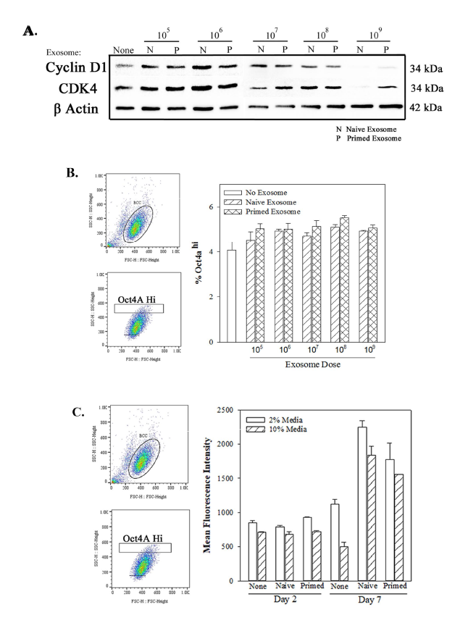

Figure S1. Dose-response of BCC versus exosome (naïve and primed). A) BCCs were cultures with different amounts of naïve or primed exosomes. After 48 h, whole cell extracts were analyzed by western blot for CyclinD1, CDK4 and β-actin. B) The studies in `A’ were repeated and the cells analyzed by FACscan for GFP intensity. The data are presented as % Oct4a^{hi} ±SD, n=3. C) The studies in `A’ were repeated with 10⁸ exosomes added at 2 day intervals with 2 and 10% FCS. The cells were analyzed by FACScan for fluorescence intensity (FI). The results are presented as mean FI (MFI)±SD, n=3.
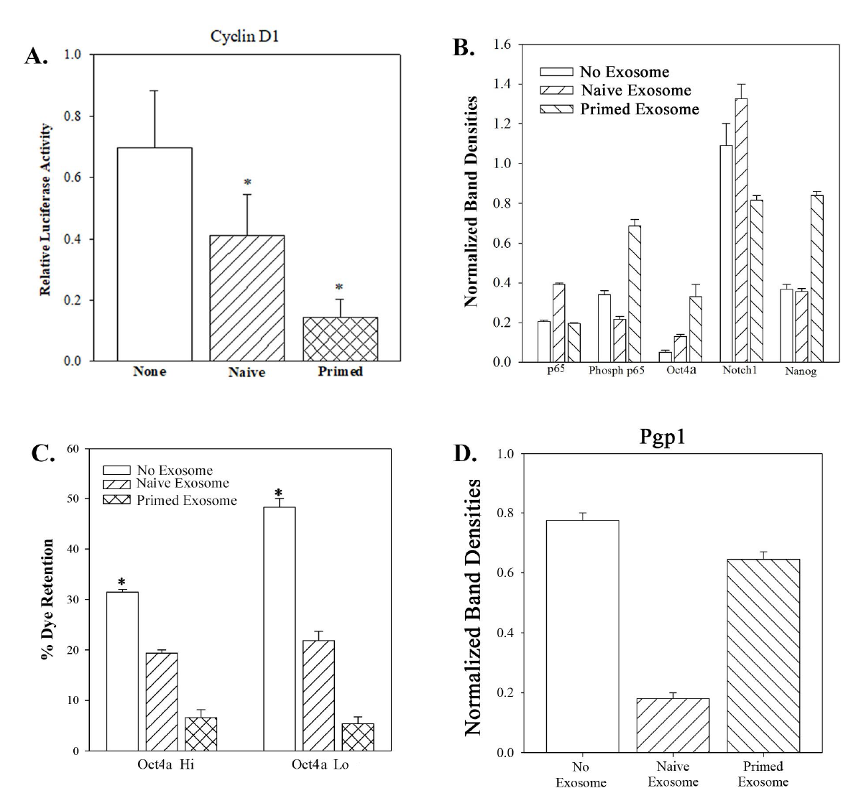
Figure S2. A) BCCs were transfected with CyclinD1 reporter gene-Luc and then treated with 10⁸ exosomes. After 48 h, cell lysates were analyzed for luciferase and β-galactosidase activity. The data were normalized for β-galactosidase and presented as Relative Luciferase activity±SD, n=3. B) Shown are the normalized band densities for the Western blot in Figure 2C. The results are mean±SD, n=3. C) Multidrug Resistance (MDR) dye efflux was assessed in Oct4a^{hi} vs Oct4a^{lo} BCCs, treated with naïve and primed exosomes for 7 days. The data are presented as % Dye Efflux±SD,n=3. D) Normalized band densities for the Western blot shown in Figure 2I. The data represent 3 experiments.
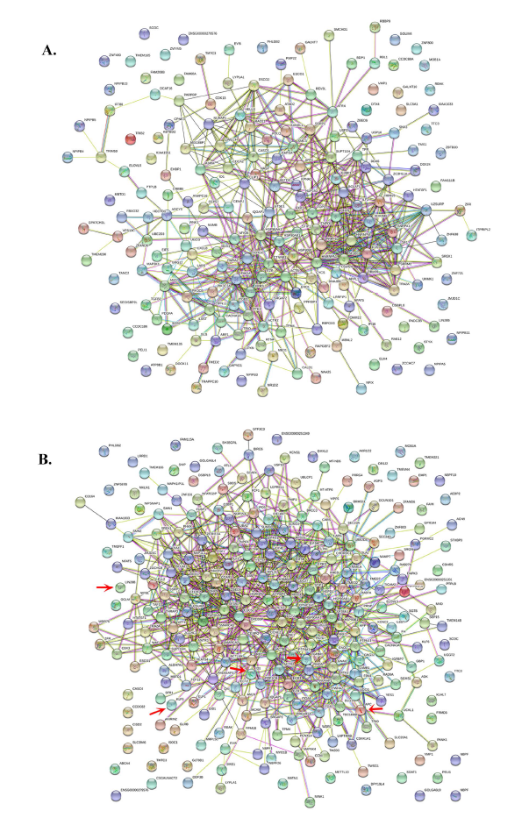
Figure S3. The genes from Fig. 4B were subjected to STRING for protein-protein interaction: A) Oct4a^{hi} BCCs. B) Oct4a^{lo} BCCs. Red arrow identified stem cell-associated genes.
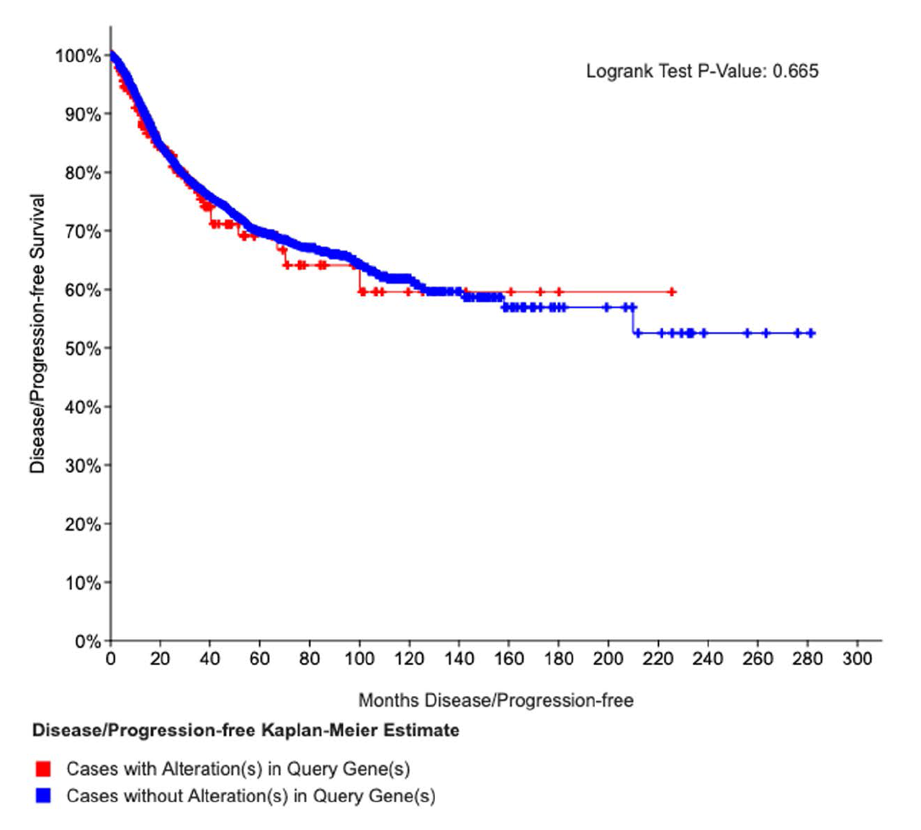
Figure S4. Survival analysis of differentially expressed genes show in Fig. 4A (Red) using The Cancer Genome Analysis (TCGA).
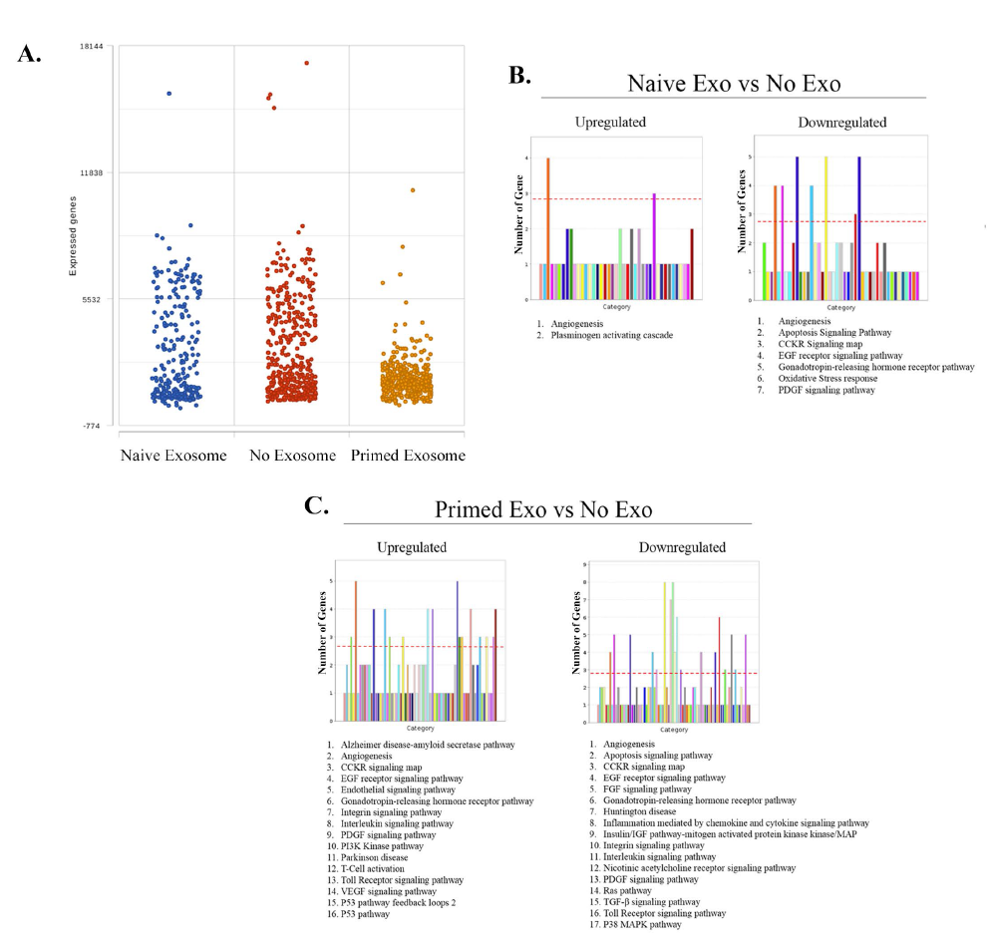
Figure S5. A) Shown are the number of expressed genes in the Single cell RNA-Seq data in Figure 5A: untreated (no exosome) or exosome-treatment - naïve and primed. B and C) Panther gene ontology analyses of upregulated and downregulated signaling pathways shown in Figure 5B: naïve vs. no exosome (B), or primed vs. no exosome (C).
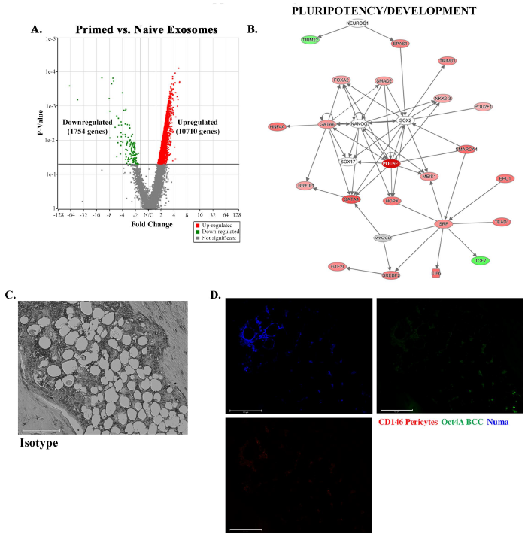
Figure S6. A) Volcano plot of the genes shown in Figure 6E illustrate those up and downregulated, based Partek. B) IPA analyses of the genes in `A’ from primed vs naïve MSC-derived exosomal genes selected the network linked to the genes associated with pluripotency and develpment. Highlighted in red (middle) is Oct4a/POUF1 gene. C) Isotype control of Figure 7B. D) Representative individual immunohistochemical labeling for CD146 (PE), Oct4a (GFP) and Numa (Alexa 405) using sections from mice femurs. The images represents the merged labeling in Figure 7B.

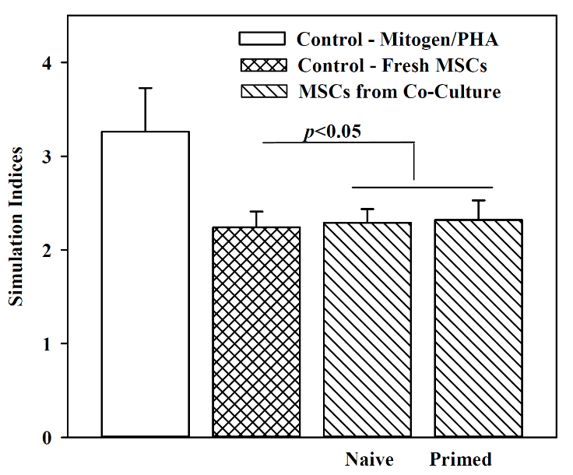

Figure S7. Comparable effects of MSCs between fresh (expanded MSCs) and those in co-culture (Fig. 1). Peripheral blood mononuclear cells (PBMCs) from five different healthy donors were assessed in one-way mixed lymphocyte reaction (MLR) as described (3). Positive controls: Incubation with phytohemagglutnin (PHA) or fresh MSCs. The MSCs were harvested from naïve and primed co-cultures (Fig. 1) and the results showed similar stimulation indices as fresh MSCs. The results indicate no change in function after exposure to BCCs.

References

1. Patel SA, Ramkissoon SH, Bryan M, Pliner LF, Dontu G, Patel PS, et al. Delineation of breast cancer cell hierarchy identifies the subset responsible for dormancy. Sci Rep 2012;2:906.
2. Bliss SA, Sinha G, Sandiford OA, Williams LM, Engelberth DJ, Guiro K, et al. Mesenchymal Stem Cell-Derived Exosomes Stimulate Cycling Quiescence and Early Breast Cancer Dormancy in Bone Marrow. Cancer Res 2016;76(19):5832-44.
3. Potian JA, Aviv H, Ponzio NM, Harrison JS, Rameshwar P. Veto-like activity of mesenchymal stem cells: functional discrimination between cellular responses to alloantigens and recall antigens. J Immunol 2003;171(7):3426-34.
4. Corcoran KE, Trzaska KA, Fernandes H, Bryan M, Taborga M, Srinivas V, et al. Mesenchymal stem cells in early entry of breast cancer into bone marrow. PLoS One 2008;3(6):e2563.
5. Qian J, Yehia G, Molina C, Fernandes A, Donnelly R, Anjaria D, et al. Cloning of human preprotachykinin-I promoter and the role of cyclic adenosine 5'-monophosphate response elements in its expression by IL-1 and stem cell factor. J Immunol 2001;166(4):2553-61.
6. Lim PK, Bliss SA, Patel SA, Taborga M, Dave MA, Gregory LA, et al. Gap junction-mediated import of microRNA from bone marrow stromal cells can elicit cell cycle quiescence in breast cancer cells. Cancer Res 2011;71(5):1550-60.

