Supplementary Data

Tervonen et al.

Oncogenic Ras disrupts epithelial integrity by activating the transmembrane serine protease hepsin
SUPPLEMENTARY INFORMATION TEXT
SUPPLEMENTARY MATERIALS AND METHODS

Mouse lung tumor model
Lox-stop-lox (here Kras; C57Bl/6J background)(1) and Trp53^{fl/fl} mice (here p53; C57Bl/6J background) (2) were purchased from the Jackson Laboratory. The Kras^{+/LSL-G12D} mice were genotyped using primers described in Table S5. (originally from Jackson Laboratory, www.jaxmice.jax.org). The primers recognize wild type allele (507 bp band) and G12D allele (600 bp band). PCR protocol was: 1. 94°C for 3 min, 2. 94°C for 30 s, 3. 60°C for 1 min, 4. 72°C for 1 min, 5. 72°C for 2 min, 6. 4°C, steps 2-4 were repeated 40 times. To initiate tumor formation, 9-12 weeks old Kras;p53^{fl/fl} (3) mice were anesthetized with isoflurane and intranasally infected with adenovirus-CMV-Cre constructs (Gene Transfer Vector Core, University of Iowa, USA) with 107 PFU in 60 μL volume. Mice showing disease symptoms (weight loss, labored breathing) were sacrificed and lungs were harvested and fixed immediately with 4% formaldehyde overnight at room temperature (RT). Fixed samples were paraffin-embedded and 5 μm sections were processed for IHC analysis.

Primary mouse mammary epithelial cell (MMEC) isolations and culturing
MMECs were isolated from 8-14 weeks old Kras^{+/LSL-G12D} female mice and from wild-type littermates as described previously (4). Shortly, mammary glands were first dissected and finely chopped. Tissue was incubated with 0.01 mg of Collagenase A (Sigma) per 1 g of tissue in media (DMEM/F12, 2.5% FCS, 5 μg mL⁻¹ insulin, 50 μg mL⁻¹, gentamycin and 200 mM glutamine) in gentle shaking at 37°C for 2 h. The resulting suspension was then first centrifuged 1400 rpm for 10 min and pulse centrifuged 4-6 times 1400 rpm to get the preparation free of other cells than MMECs. MMECs were trypsinized with 0.05% Trypsin-EDTA for 5-10 min to obtain smaller organoid units and drained through a 70 μm cell strainer (Beckton Dickinson). Thereafter, cells were counted and plated on low adhesion plates (Nunc) in MMEC growth media.

Egg white 3D cell culture
This method has been described previously (5,6). In brief, organic egg white was isolated from yolk and spread on the bottom of each well of the 8-well chamber slides that were then placed into 60°C for 1 h to let the egg white solidify. After one wash with culture media, 2500 trypsinized cells in 400 μL of culture media were plated in each well. Cells were incubated at 37°C and 5% CO₂ to allow them form acinar structures.

3D organotypic culture of primary MMECs
Primary 3D culture was performed as described previously (4). In short, Matrigel^{tm} (Becton Dickinson) was prepared according to the manufacturer’s instructions. MMEC mammospheres were trypsinized with 0.05% Trypsin-EDTA for 5-10 minutes, centrifuged and suspended with liquid Matrigel^{tm} and plated onto 8-chamber slides approximately 1500 cells per well to form in-Matrigel^{tm} culture. 3D cultures were grown in DMEM/F12 growth media lacking FCS. Immunofluorescent staining and image acquisition was performed as described earlier (4,7).

2D immunofluorescence staining (IF)
For 2D IF, cells grown and treated on top of cover slips were fixed and permeabilized with cold 100% methanol (-20°C) for 5 min at RT. Cells were then blocked with 0.1% BSA in PBS for 30 min at RT, and incubated in primary antibody for 1 h and secondary antibody for 45 min. For both 2D and 3D IF, nuclei were counterstained with Hoechst 33258 (Sigma) and cover slips were mounted on objective glasses with Immu-Mount (Thermo Scientific).

Serine protease activity assays
Cell-based peptide cleavage assays were performed in a similar manner as published previously (5). Briefly, in the cell-based hepsin activity assay, the concentration for fluorogenic tertbutoxycarbonyl-Gln-Arg-Arg-AMC (BOC-QRR-AMC) substrate was 50 μM. To quantitate serine protease activity, cells were treated with PBS (intact cells) or 1% Triton-X 100-PBS buffer (permeabilizing conditions) in each 96-well plate well and, thereafter, BOC-QRR-AMC substrate was administered onto the cells. Peptide cleavage was measured at 37°C using a VictorX3 ELISA plate reader (PerkinElmer) or FLUOstar Omega (BMG Labtech) at wavelengths 350^{em}/450^{ex} nm.

To measure BOC-QRR-AMC substrate cleavage activity in “on top” 3D egg white culture of MCF10A-based epithelial structures with inducible HRas^{V12} activated by DOX (HRas^{V12 ON}, 900 ng ml⁻¹, at day 4), 50 μM substrate was applied for 2 h on day 6 and substrate- containing media was collected and cleavage activity was measured as above. Hepsin function blocking antibody (Ab25, 1 μM) was added to 3D culture media at day 4.

qRT-PCR
RNA was isolated from MMECs using the RNeasy isolation kit (Qiagen) according to the manufacturer’s instructions. The cDNA synthesis was performed using the DyNAmo cDNA synthesis kit (Finnzymes) and qPCR reaction was done using the DyNAmo HS SYBR Green qPCR kit (Finnzymes) and using the AbiPrism 7500 Fast Real-Time PCR system (Applied Biosystems). Relative mRNA amounts of HPN were assayed by comparing PCR cycles to GAPDH using the CT method (Livak and Schmittgen, 2001), and normalizing the samples to control genotypes. The following run protocol was used for qRT-PCR: 1. 50°C for 10 min, 2. 95°C for 10 min, 3. 95°C for 15 s, 4. 60°C for 45 s, 5. 72°C for 45 s, steps 3-5 were repeated for 40 cycles and data acquisition was done during step 4. The HPN qPCR protocol and primers were previously described (Tervonen et al, 2016). See Table S5. for primer sequences.

Cloning
Lentiviral ORF expression constructs of KRas-pLenti6/V5 and HSF1-pLenti6/V5 were generated by Gateway cloning. Briefly, number 100008289 or 100008319 entry clone from the human ORFeome collaboration library was transferred into the pLenti6/V5-DEST (Life Technologies) destination vector using a standard Gateway LR reaction protocol. HRas^{V12} construct was acquired in a Gateway compatible pENTR1A (w99-1) vector (gift from Dr. Eric Campeua, AddGene plasmid #22252) and Gateway cloned into the doxycycline inducible pINDUCER20 destination vector (kind gift from Dr. Guang Hu, National Institute of Environmental Health and Sciences, NC). The Hepsin-pINDUCER20 construct has been described before(5).

Transfections
JetPEI® transfection reagent (Polyplus Transfection) was used for transient transfection of expression plasmids into 293FT cells according to the manufacturer’s instructions. The total amount of plasmid DNA used was 1 μg per 6-well plate well of 5 x 10⁵ cells seeded 24 h before. Cell lysates were collected 48 h after transfection.

Recombinant adenovirus production and transductions
Adenoviral transductions were performed essentially as described previously(4). Shortly, Isolated MMECs were infected on low adhesion plates with AdenoCre (or control Adeno GFP, both generously provided by Dr. Tomi Mäkelä, University of Helsinki) virus using MOI 25 in DMEM/F12 growth media for 18 h. Next day after the AdenoCre transductions, the mammospheres were washed 2-3 times with DMEM/F12 growth media. 72 h after infection, the cells were either placed in 3D culture or lysed for qRT-PCR analysis.

Cathepsin B assay
MCF10A or MCF10A-HRas^{V12} cells were suspended at concentration of 500,000 cells/ml in growth media with 21 µM VIVAprobe™ lysosome staining kit Cathepsin B substrate and incubated for 60 min (37°C, 5% CO₂) followed by analysis with BD Accuri C6 Flow Cytometer (BD Biosciences, NJ, USA).

Image acquisition, image analysis and quantitation
Confocal images from immunofluorescently-stained 2D and 3D cell cultures were acquired with the Zeiss LSM Meta 510, Zeiss LSM 780 or Leica TCS SP8 CARS microscopes and phase contrast and epifluorescent imaging was performed with a Zeiss Axio Imager microscope. For 3D phase contrast images of MMEC organoids image analysis was performed essentially as described previously (8). Shortly, digital images were opened in Image J software (version 1.42q, National Institute of Health) and converted to 16-bit format. Next, binary contrast enhancement (thresholding) was applied to the image by defining a grayscale cutoff point. The cutoff point was manually set by adjusting the threshold to accurately cover the acini by comparing them to the original image. Also, in the thresholded image, acini that were slightly attached to each other were separated using the Pen tool. Finally, the thresholded and separated acini were measured for Area and Circularity. Images from immunofluorescently-stained 2D cell cultures obtained with a confocal microscope were quantitatively analyzed as described before(5). Immunofluorescently-stained 3D cultures of human cell lines were visually scored for apical and basal polarity marker expression and epithelial integrity under an epifluorescent microscope (see manuscript text for details). Sample images from IHC-stained human paraffin-embedded breast cancer patient samples were obtained with a Leica DM LB, and visually scored for positive staining with ImageJ. Immonublots exposed to films were scanned and, thereafter, analyzed with ImageJ software.

Analyzing histoscore from immunohistochemical staining
Histoscore was determined from collagen IV IHC stained MDA-MB-231 paraffin-fixed xenograft tumor sections. For this, we used QuPath software (version 0.2.0-m8) (Bankhead et al, 2017, PMID: 29203879). Cell counts were analyzed based on hematoxylin staining and collagen IV staining intensity based on DAB staining using cell + membrane detection tool from window sized 100 μm x 100 μm. The individual Cell: DAB OD Mean values were used to set weak staining, moderate staining and strong staining classes. The histoscore was calculated using a following formula: (1 x % weak staining) + (2 x % moderate staining) + (3 x % strong staining) = histoscore.

SUPPLEMENTARY FIGURES
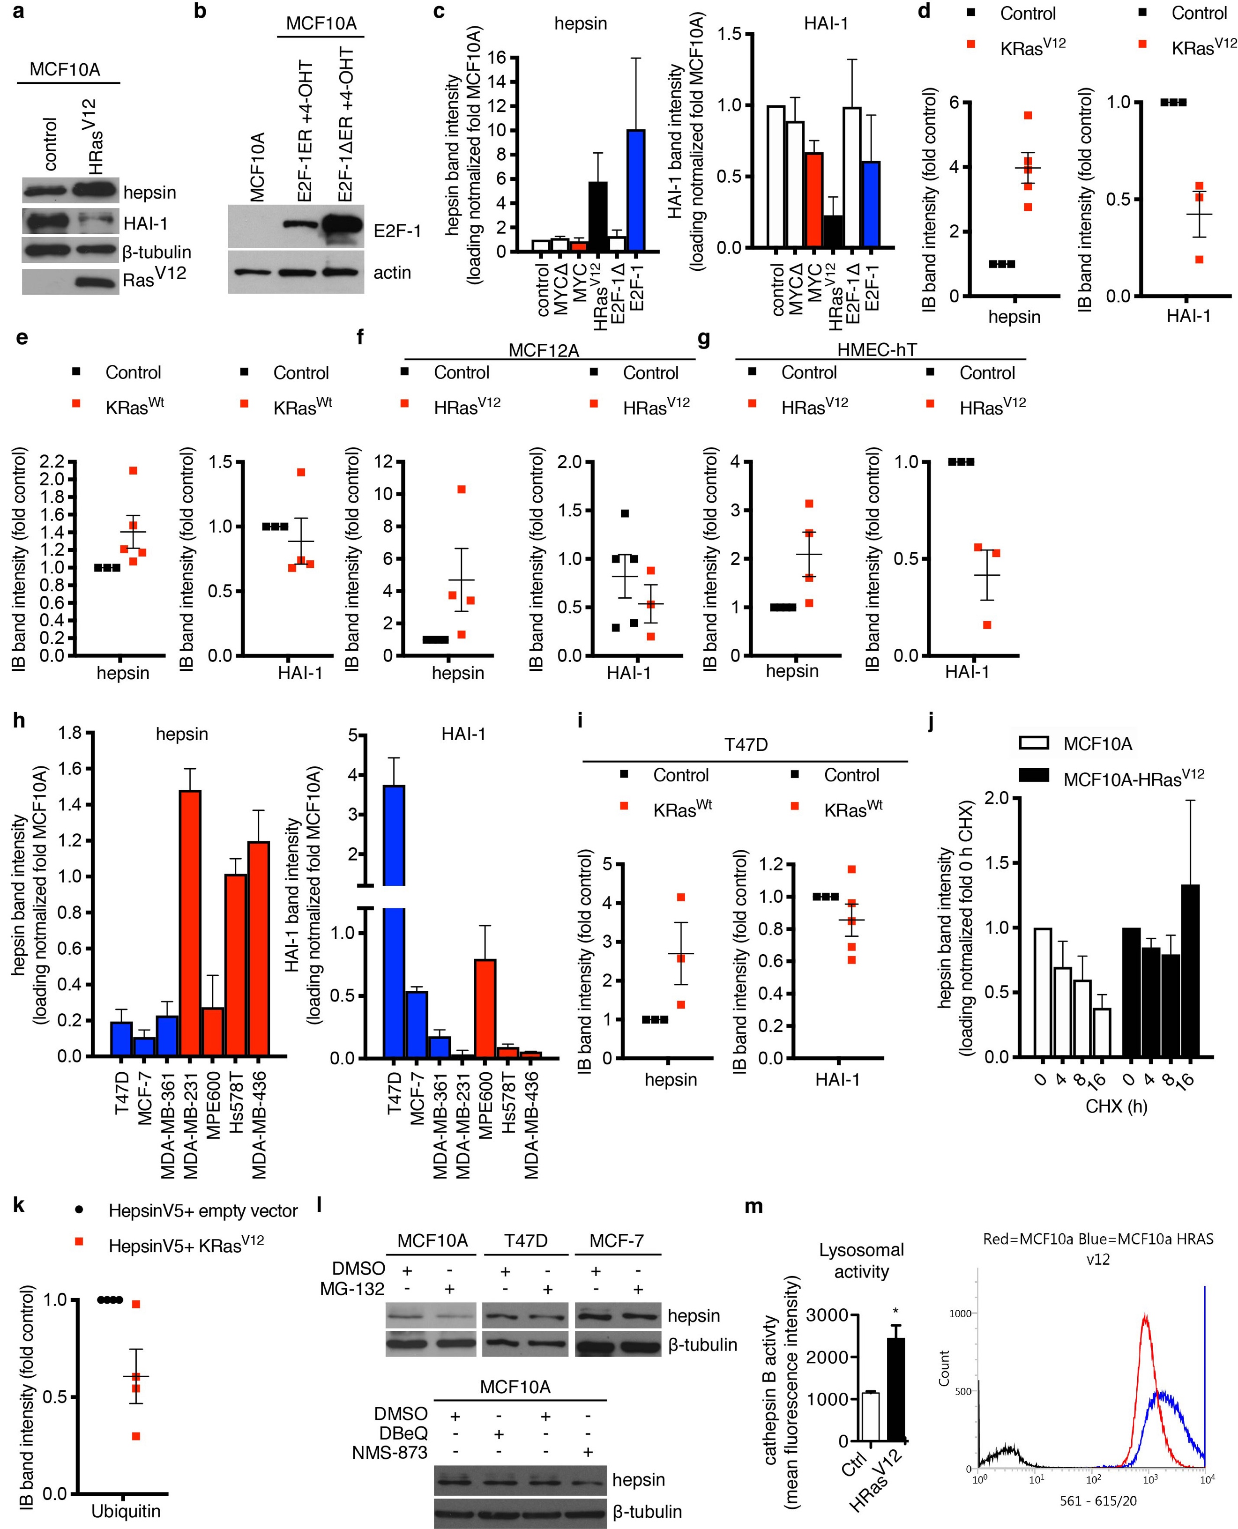
Supplementary Fig 1. Oncogenic Ras causes hepsin protein deregulation. a HRas^{V12} was stably overexpressed in non-malignant MCF10A mammary epithelial cells and cell lysates were subjected to immunoblotting with hepsin, HAI-1, Ras^{V12} and β-tubulin antibodies. Control= MCF10A cells expressing the empty vector. b Immunoblot analyses with E2F-1 and actin antibodies from cell lysates of MCF10As cells treated tamoxifen (4-OHT) to induce overexpression of E2F-1 ER or E2F-1Δ ER (a mutant inactive form). Normal MCF10A cells served as control. c-k Immunoblots were exposed to films, scanned and, thereafter, loading normalized (c-j) hepsin and HAI-1 immunoblot intensities (j, only hepsin) from digital images were quantitated from at least three independent experiments. k Loading normalized total ubiquitin immunoblot intensities from digital images were quantitated from at least three independent experiments. l The effect of proteasomal inhibition with MG-132 (1 μM, 24 h) in MCF10As, T47Ds and MCF-7s, and with DBeQ (5 μM, 48 h) or NMS-873 (50 nM, 96 h) in MCF10As analyzed by immunoblotting with antibodies against hepsin and β-tubulin. m On the left, cathepsin B activity measured with flow cytometry in MCF10A-HRas^{V12} cells compared to control. (right) Image of flow cytometry analysis of active cathepsin B expression in MCF10A-HRas^{V12} cells compared to MCF10A cells expressing the empty vector. For c-k and m, data are presented as mean ± s.e.m. In m, P-value was calculated using two-tailed unpaired Student’s t-test. p*<0.05.
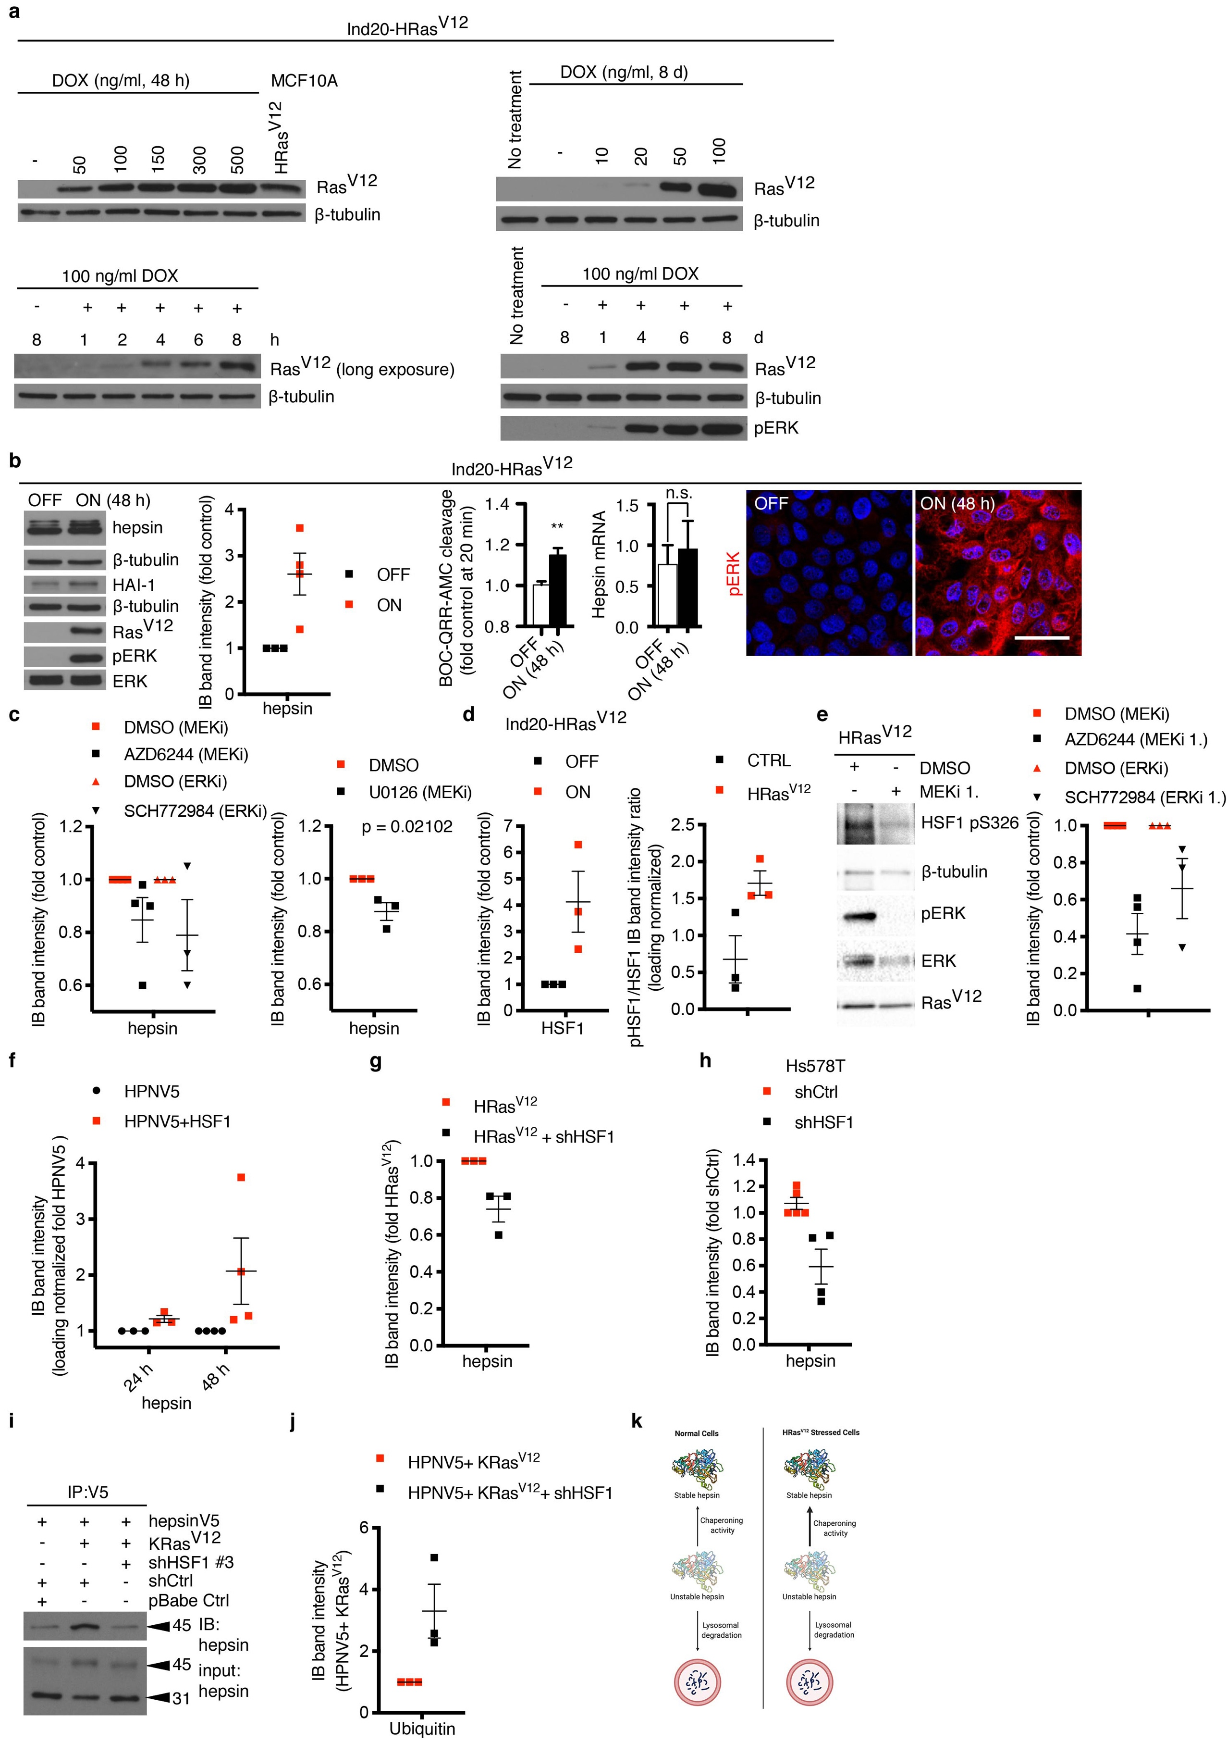
Supplementary Fig 2. Characterization of inducible HRas^{V12} and MAPK-HSF1 axis in hepsin regulation. a Immunoblot analysis validating doxycycline (DOX)-inducible pINDUCER20-HRas^{V12} (referred to as Ind20-HRas^{V12} in the manuscript) in MCF10A cells. For all of the following experiments in b, HRas^{V12} was short-term DOX-induced (100 ng ml⁻¹, 48 h) in MCF10A cells. Immunoblot analysis with antibodies against hepsin, HAI-1, Ras^{V12} and phospho ERK (pERK), total ERK (ERK) and β-tubulin from cell lysates (the blots on the left) and quantitation (second from left) from at least three independent experiments. Immunofluorescent analysis (image panel) of pERK (red) in fixed monolayer cell cultures, ELISA assay (histogram on the left) of whole cell BOC-QRR-AMC peptide substrate cleavage activity (n= 6 biological replicates), and a real-time quantitative RT-PCR analysis of hepsin mRNA expression (histogram on the right) (n= 4 to 5 biological replicates) (OFF = -DOX vehicle and ON = +DOX). c-h and j Immunoblots were exposed to films, scanned and, thereafter, loading normalized immunoblot intensities for indicated antibodies from digital images were quantitated from at least three independent experiments. c The right hand dot blot shows quantitation of ind20-HRas^{V12} ON cells treated with 10 M U0126 for 48 h. In d (right), quantitation of intensity ratio between HSF1 pS326 and total HSF1 in MCF10A-HRas^{V12} compared to MCF10A-empty vector is shown. e Immunoblot analysis with antibodies against HSF1 pS326, Ras^{V12}, pERK, ERK and β-tubulin from cell lysates of MCF10A-HRas^{V12} and control cells expressing control vector treated with MEKi 1. (10 μM, 72 h) (the blots on the left) and quantitation (dot blots, also ERKi 1., 5 μM, 72 h, treated samples) from at least three independent experiments. f Quantitation of immunoblots with hepsin antibody from cell lysates of 293FT cells transfected with hepsin-V5 (HPNV5) and HSF1 or HPNV5 and empty vector follow by indicated time period. g and h Quantitation of immunoblots with hepsin antibody from cell lysates of MCF10A-HRas^{V12} (g) or Hs578T cells (h) transduced with shHSF1 or shCtrl. i Immunoprecipitation with hepsin V5 antibody followed by immunoblot analyses with hepsin antibody from cell lysates of 293FT cells transfected with HPNV5, KRas^{V12}, shHSF1 #3, or control expression vectors (pBabe Ctrl and shCtrl) and their combinations. j Quantitation of immunoblot resulted from immunoprecipitation with hepsin V5 antibody followed by immunoblot analyses with ubiquitin antibody from cell lysates of 293FT cells transfected with HPNV5, KRas^{V12}, and shHSF1 #3 compared to hepsin-V5, KRas^{V12}, and shCtrl transfected cells (fold HPNV5+KRas^{V12}+shCtrl). k Schematic presentation of stability regulation. In b, nuclei were visualized with Hoechst (blue) and the scale bar represents 20 μm. For b-h and j, data are presented as mean ± s.e.m., and P-values were calculated using a two-tailed unpaired Student’s t-test. p**<0.01. n.s, not significant.
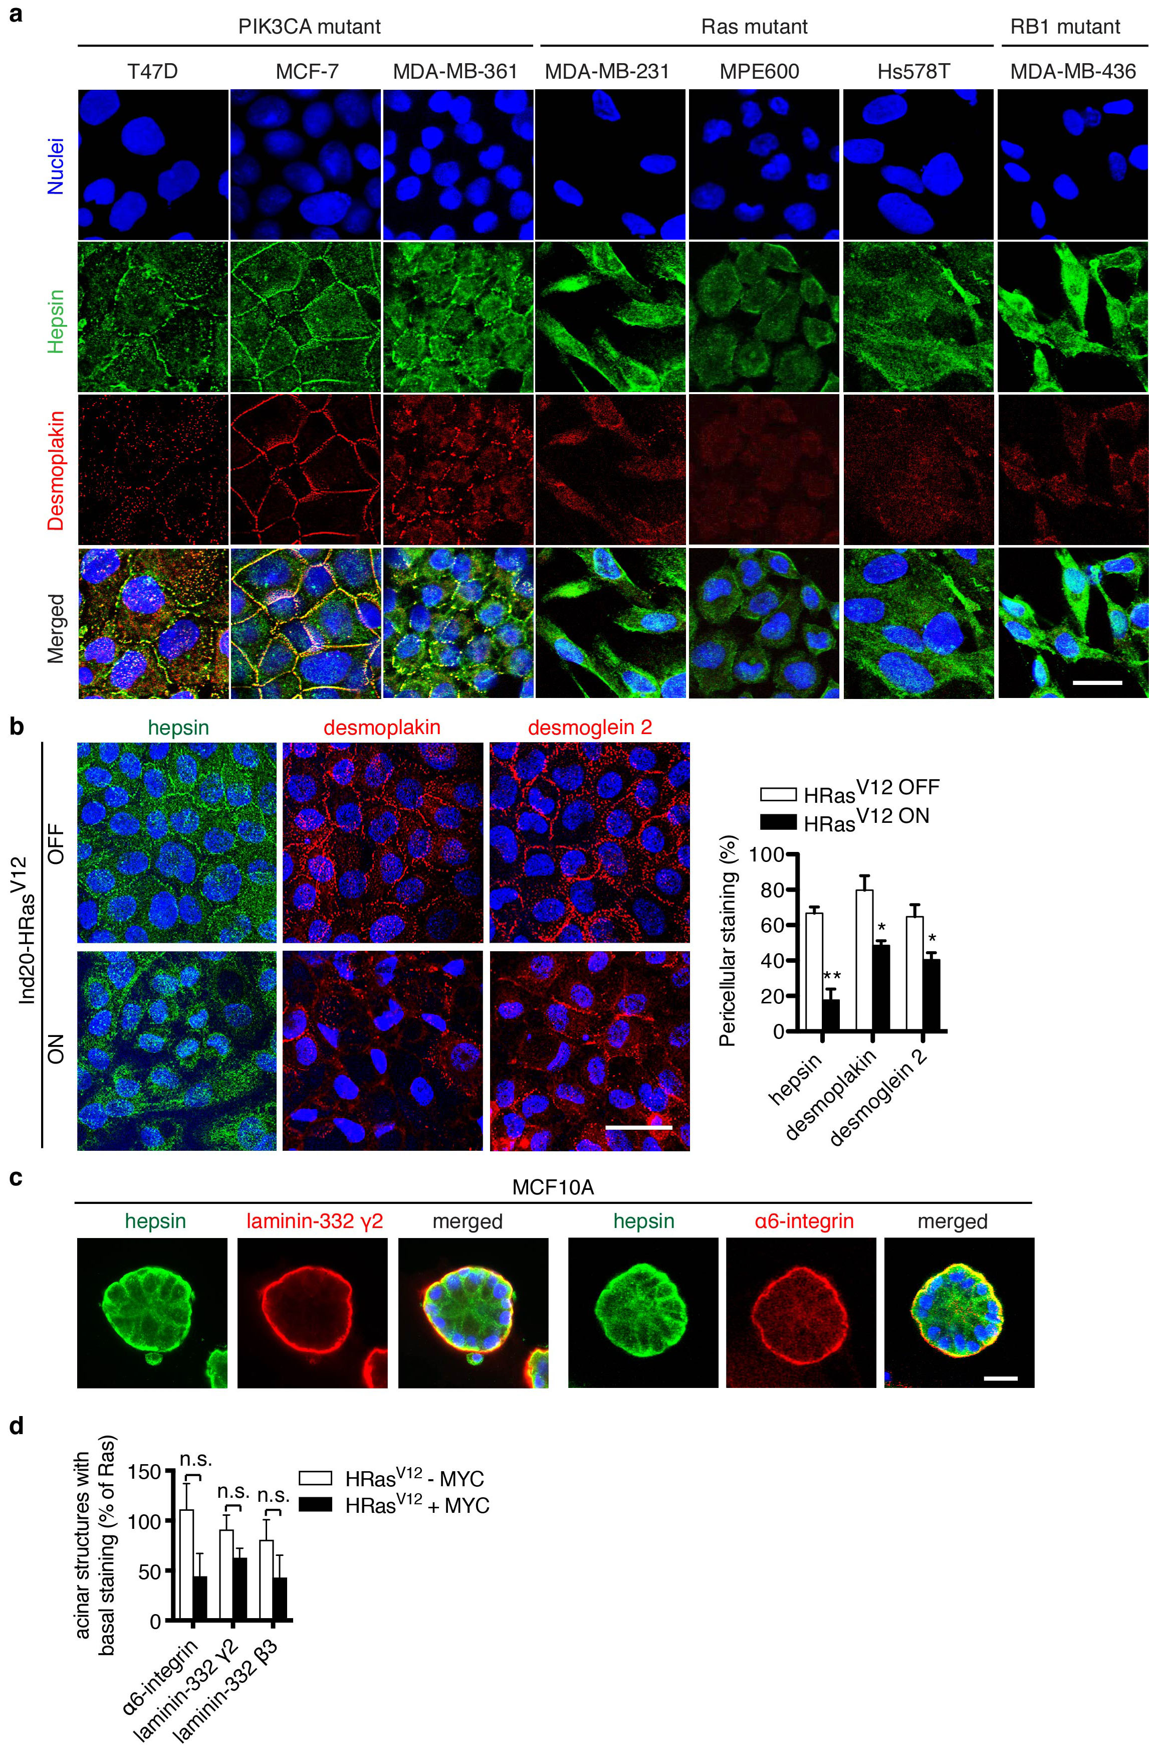
Supplementary Fig 3. Oncogenic Ras deregulates hepsin protein expression and causes the redistribution of hepsin from basolateral membranes to the cytosol, and alters desmosomes and hemidesmosomes in mammary epithelial cell lines. a Immunofluorescent staining of hepsin (green) and desmoplakin (red) in different 2D-cultured breast cancer cell lines harboring PIK3CA, Ras or RB mutations as indicated. b Immunofluorescent analysis of hepsin (green) and desmosomal proteins desmoplakin (red, middle panel) and desmoglein 2 (red, right panel) after acute HRas^{V12} induction in MCF10A cells. Histogram on the right shows the quantitation of the pericellular localization of hepsin, desmoplakin and desmoglein 2 immunostaining (OFF= -DOX vehicle and ON= +DOX) (n= 3 biological replicates). c Immunofluorescent staining with antibodies against hepsin (green), laminin-332 γ2 (red) and α6-integrin (red) in MCF10A 3D egg white-cultured epithelial structures. Cells were 3D-cultured for 7 days before fixing and immunofluorescent staining. d Analyses of immunofluorescent staining with antibodies against laminin-332 β3, laminin-332 γ2 and α6-integrin in 3D egg white-cultured structures of MCF10A cells stably overexpressing HRas^{V12} and inducible MYC ER (+MYC, tamoxifen-activated in the beginning of the 3D culturing). Control cells were MCF10A-HRas^{V12} MYC ER treated with vehicle (-MYC) (n= 3 biological replicates). In a-c, nuclei were visualized with Hoechst (blue) and the scale bar represents 20 μm. For b, d data are presented as mean ± s.e.m., and P-values were calculated using a two-tailed unpaired Student’s t-test. p*<0.05, p**<0.01. n.s, not significant.
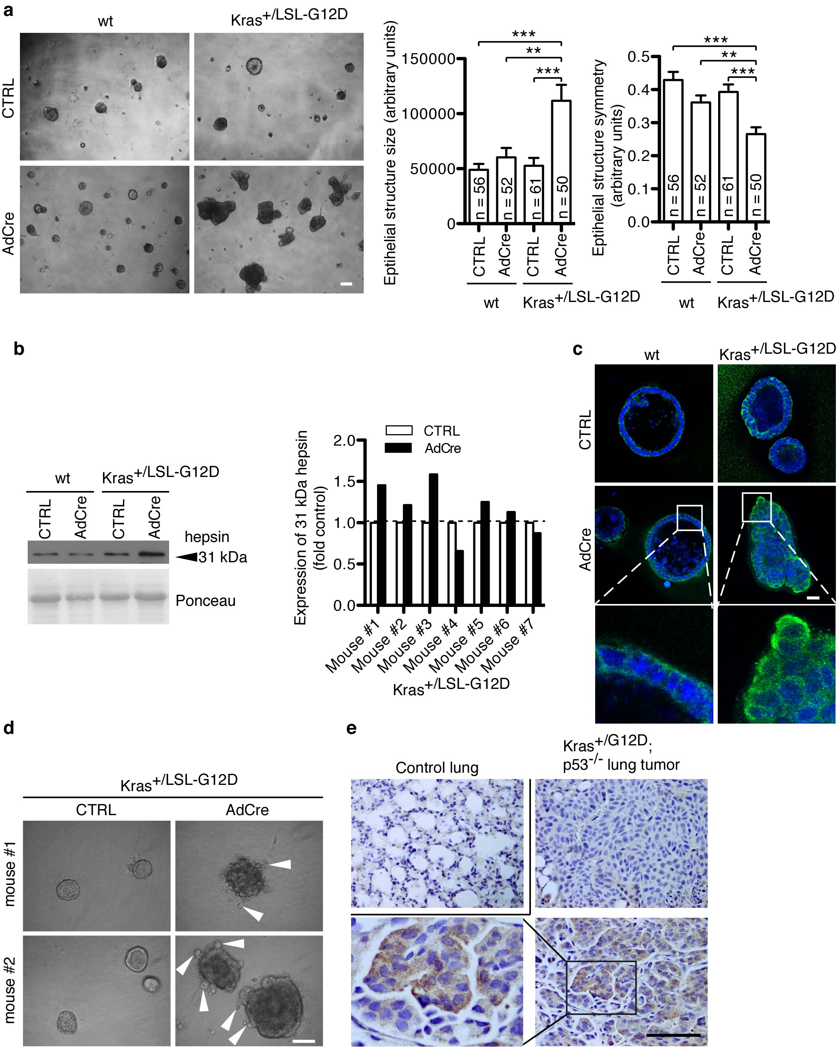
Supplementary Fig 4. Physiological expression level of oncogenic Kras induces active hepsin. a Phase contrast images of wt and Kras^{+/LSL-G12D} mouse mammary epithelial cells (MMEC)s with or w/o adenoviral Cre (AdCre) expression ex vivo (panels on the left). Quantitation of epithelial structure size (histogram on the left) and symmetry (right) based on phase contrast images (n-values denote the pooled number of epithelial structures in each group in 3 independent experiments, CTRL= no adenoviral infection). b Immunoblot analysis (left) of active hepsin (31 kDa) protein in Kras^{G12D}-expressing mouse mammary epithelial cell lysates compared to controls (wt with and w/o adenoviral Cre (AdCre) treatment or Kras^{+/LSL-G12D} without AdCre). Histogram (on the right) shows the ratio of active hepsin (31 kDa) with or w/o AdCre treatment of MMECS derived from 7 different Kras^{+/LSL-G12D} mice. c Immunofluorescent analysis of hepsin (green) in ex vivo AdCre- activated Kras^{+/LSL-G12D} MMEC-derived 3D cultured epithelial structures (inserts show magnified views of the boxed area, and nuclei were visualized with Hoechst). d Phase contrast images of ex vivo AdCre-activated Kras^{+/LSL-G12D} MMECs in 3D cultures showing bulging cells (white arrow heads). e Immunohistochemical analysis with antibody against hepsin (brown) in sporadic lung tumors created by inhalation of AdCre virus in Kras^{+/LSL-G12D}; p53^{-/-} double transgenic mice in formalin fixed paraffin embedded (FFPE) sections compared to control lung tissue (n-values denote the number of control lungs and independent tumors; nuclei were counterstained with hematoxylin). ). In a and e scale bars represent 100 μm and in c, d 20 μm. For a, data are presented as mean ± SD, and P-values were calculated using a two-tailed unpaired Student’s t-test. p**<0.01, p***<0.001.

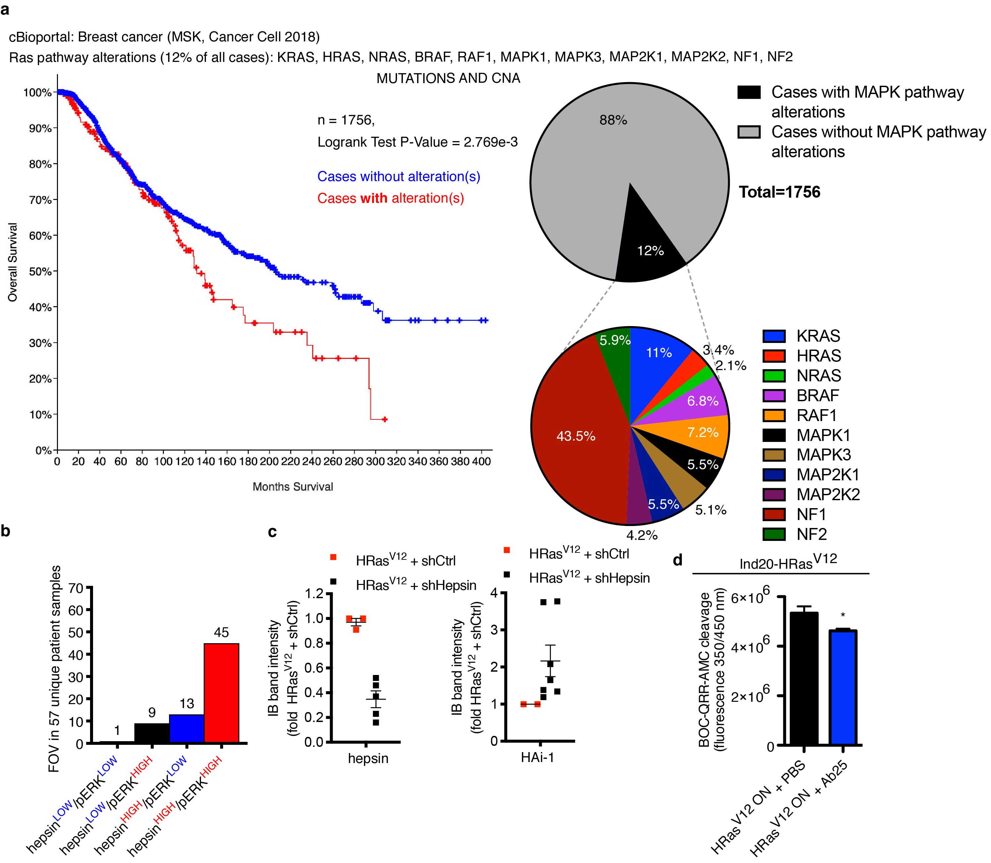
Supplementary Fig 5. Clinical incidence of MAPK pathway alterations in breast cancer together with hepsin, and hepsin knockdown with shRNA or function blocking Ab in Ras mutant cells. a Ras-MAPK pathway in breast cancer. Ras-MAPK pathway mutations and copy number alterations (CNA) status and overall patient survival in MSK, Cancer Cell, 2018 sample set visualized with cBioportal (on the left). An analysis of Ras-MAPK pathway mutations and copy number alterations in the MSK set (pie charts). b Immunohistochemical co-expression analysis of hepsin and phospho-ERK (pERK) in serial sections from human breast tumors (68 fields of view in 57 unique patient samples). c Immunoblots were exposed to films, scanned and, thereafter, loading normalized immunoblot intensities from digital images for hepsin and HAI-1 antibodies in MCF10A-HRas^{V12} cell lysates stably expressing shHepsin or shCtrl were quantitated from at least three independent experiments. d 3D-cultured MCF10A epithelial structures with inducible HRas^{V12} activated by DOX (HRas^{V12 ON}, 900 ng ml⁻¹, at day 4) showed pericellular BOC-QRR-AMC peptide substrate cleavage activity (substrate added to media covering the 3D structures) that could be inhibited by hepsin function blocking antibody Ab25 (1 μM, at day 4, and substrate applied for 2 h at day 6) (n= 4 biological replicates). For c and d, data are presented as mean ± s.e.m., and P-values were calculated using a two-tailed unpaired Student’s t-test. p*<0.05.

SUPPLEMENTARY TABLES
TABLE S1. Ethical Permits
Object | Authority | Number
Use of human breast cancer samples | the National Supervisory Authority for Welfare and Health | 731/05.01.00.06/2009
Non-cancerous samples | the Ministry of Social Affairs and Health of Finland | 243/13/03/02/13, § 157, 18.9.2013
Experimental animals | The National Animal Ethics Committee of Finland | ESAVI-3216/04.10.07/2013

TABLE S2. Reagents
Reagent | Supplier
4-hydroxytamoxifen (4-OHT) | Sigma-Aldrich/Merck
Ab25 | Gift from Dr. Kirchhofer, Genentech Inc.(9)
AZD6244 (Selumetinib) | Selleckchem.com
Cyclohexamide | Sigma-Aldrich/Merck
Doxycycline hyclate | Sigma-Aldrich/Merck
fluorogenic peptide substrate Boc-Gln-Arg-Arg-AMC (BOC-QRR-AMC) | BACHEM, Cat.no. I-1655.0025
Hoechst | Sigma-Aldrich/Merck
MG-132 | Calbiochem/Millipore
DBeQ (JRF 12) | LifeSensors
NMS-873 | LifeSensors
Bafilomycin B1 | Sigma-Aldrich/Merck
Concanamycin A | Sigma-Aldrich/Merck
Rapamycin | Sigma-Aldrich/Merck
SCH772984 | Selleckchem.com
KRIBB11 (Calbiochem) | MerckMillipore
BEZ235 | Selleckchem.com
Ly294002 | Cell Signaling Technologies
Erk inh II | Santa Cruz Biotechnology
U0126 | Cell Signaling Technologies

TABLE S3. Antibodies
Antibody | Supplier
AKT (pan) (C67E7) | Cell Signaling Technologies, RRID:AB_915783
Alexa-488-conjugated secondary antibodies (IF) | Invitrogen
Alexa-546-conjugated secondary antibodies (IF) | Invitrogen
biotinylated secondary antibodies (IHC) | Vector Laboratories
Desmoglein 2 | Abcam, RRID:AB_2093427
Desmoplakin (I+II) | Abcam, RRID:AB_443375
E2F-1, clone KH95/E2F | BD Pharmingen, RRID:AB_395308
ERK | Cell Signaling Technologies, RRID:AB_330744
GAPDH | Cell Signaling Technologies, RRID:AB_561053
GM130 x | BD Transduction Laboratories
HAI-1 (T-20) | Santa Cruz Biotechnology, RRID:AB_647764
Hepsin | Cayman Chemicals, RRID:AB_10078640
HSF1 (E-4) | Santa Cruz Biotechnology, RRID:AB_627753
Laminin-332 β3 (H-300) | Santa Cruz Biotechnology, RRID:AB_2296802
Laminin-332 γ2, clone D4B5 | Millipore, RRID:AB_94454
Lamp2, clone H4B4 | Abcam, RRID:AB_470709
Pan-Ras, clone EP1125Y | Abcam, RRID:AB_2121042
Phospho-ACC Ser79 | Cell Signaling Technologies, RRID:AB_330337
Phospho-AKT (Thr308) (D25E6) | Cell Signaling Technologies, RRID:AB_2629447
Phospho-ERK1/2 Thr202/Tyr204 | Cell Signaling Technologies, #4377S
Phospho-ERK1/2 Tyr204/Tyr187 (IF) | Cell Signaling Technologies, #5726
Phospho-HSF1 Ser326, clone EP1713Y | GeneTex, RRID:AB_10619698
Ras^{V12} | Calbiochem, #OP38
α6-integrin (CDW49f) | Millipore, RRID:AB_93603
β-tubulin | Abcam, RRID:AB_2210370
V5 | Invitrogen, RRID:AB_2556564
Ubiquitin | Sigma-Aldrich/Merck, RRID:AB_477667
HSP70/72 | Enzo Life Sciences, Inc., RRID:AB_11180512

TABLE S4. Cell lines and culture media composition

Name | Culture media components
293FT (Invitrogen), cat#R70007 | DMEM (Lonza), 10% fetal bovine serum (Biowest), 2 mM L-glutamine, penicillin and streptomycin (Lonza)
HeLa (ATCC), RRID:CVCL_0030 | DMEM (Lonza), 10% fetal bovine serum (Biowest), 2 mM L-glutamine, penicillin and streptomycin (Lonza)
HMEC-hTERT (HMECs from ATCC) | Same media used as for MCF10As and the culture protocol has been described in(7)
Hs578T (ATCC), RRID:CVCL_0332 | DMEM (Lonza), 10% fetal bovine serum (Biowest), 2 mM L-glutamine, 10 μg/ml human insulin, penicillin and streptomycin (Lonza)
MCF-7 (ATCC), RRID:CVCL_0031 | EMEM (Bio Whittaker), 1 x MEM Non-essential amino acids (Gibco), 10% fetal bovine serum (Biowest), 2 mM L-glutamine, 10 μg/ml human insulin, penicillin and streptomycin (Lonza)
MCF10A (ATCC), RRID:CVCL_0598 | culture media has been described in(7)
MCF12A,RRID:CVCL_3744 | culture media has been described in(10)
MDA-MB-231 (ATCC), RRID:CVCL_0062 | Leibovitz's L-15 Medium (Bio Whittaker), 10% fetal bovine serum (Biowest), 2 mM L-glutamine, 10 μg/ml human insulin, penicillin and streptomycin (Lonza)
MDA-MB-361 (ATCC), RRID:CVCL_0620 | Leibovitz's L-15 Medium (Bio Whittaker), 10% fetal bovine serum (Biowest), 2 mM L-glutamine, 10 μg/ml human insulin, penicillin and streptomycin (Lonza)
MDA-MB-436 (ATCC), RRID:CVCL_0623 | Leibovitz's L-15 Medium (Bio Whittaker), 10% fetal bovine serum (Biowest), 2 mM L-glutamine, 10 μg/ml human insulin, penicillin and streptomycin (Lonza)
MMEC | DMEM/F12 media (Gibco), insulin (5 μg/ml), hydrocortisone (1 μg/ml), mouse EGF (10 ng/ml), glutamine (200 mM), gentamycin (50 μg/ml) and penicillin and streptomycin (all from Sigma) supplemented with 10% FCS.
MPE 600 (Gift from Dr. Outi Monni, University of Helsinki), RRID:CVCL_9875 | RPMI 1640 (Lonza), 10% fetal bovine serum (Biowest), 2 mM L-glutamine, 10 μg/ml human insulin, penicillin and streptomycin (Lonza)
T47D (ATCC), RRID:CVCL_0553 | RPMI 1640 (Lonza), 10% fetal bovine serum (Biowest), 2 mM L-glutamine, 10 μg/ml human insulin, penicillin and streptomycin (Lonza)

TABLE S5. Primer sequences

Target | Forward sequence | Reverse sequence
GAPDH RT-PCR (AbiPrism) | AGGTCGGTGTGAACGGATTTG | TGTAGACCATGTAGTTGAGGTCA
Genotyping Kras^{G12D}: Primer 1 | GTCGACAAGCTCATGCGGG
Genotyping Kras^{G12D}: Primer 2 | CGCAGACTGTAGAGCAGCG
Genotyping Kras^{G12D}: Primer 3 | CCATGGCTTGAGTAAGTCTGC
HPN RT-PCR(11) | CATTGTGGCTGTTCTCCTCA | CAGCTCGGAGTGGGTCAGT

TABLE S6. shRNA in pLKO.1 vector (Sigma-Aldrich/Merck)

Gene name | shRNA Name | Clone ID
HPN | shHepsin #1 | TRCN0000073353
HPN | shHepsin #5 | TRCN0000222612
HSF1 | shHSF1 #2 | TRCN0000007481
HSF1 | shHSF1 #3 | TRCN0000007482
Non-target control | shControl | SHC002

TABLE S7. Vector Constructs
Plasmid | Obtained from | Affiliation | Addgene plasmid #
pBabe-puro MycERtm | Dr. Gerard Evan | University of Cambridge, Cambridge, UK
pBabe-puro MycΔERtm | Dr. Gerard Evan | University of Cambridge, Cambridge, UK
pWzl blast h-TERT | Dr. Martin McMahon | University of California, San Francisco, CA
 | Dr. Robert A. Weinberg | Massachusetts Institute of Technology, Cambridge, MA
pWzl-hygro HrasV12 | Dr. Scott Lowe | Memorial Sloan Kettering Cancer Center, NY | 18749
pWzl hygro (empty backbone) | Dr. Scott Lowe | Memorial Sloan Kettering Cancer Center, NY | 18750
pBabe-puro K-RasV12 | Dr. William Hahn | Dana-Farber cancer institute, MA | 9052
RasV12 (HrasV12) in pENTR1A (w99-1) | Dr. Eric Campeau | University of Massachusetts, Worcester, MA | 22252
pBabe-puro (HAERE2F-1) E2F-1ERtm | Dr. Kristian Helin and Dr. Karin Helin | BRIC, University of Copenhagen, Copenhagen, Denmark
pBabe-puro (HAERE132) E2F-1ΔERtm | Dr. Kristian Helin and Dr. Karin Helin | BRIC, University of Copenhagen, Copenhagen, Denmark
pDSL_hpUGIH vector | AFCS; www.signalinggateway.org)

SUPPLEMENTARY REFERENCES

1. Jackson EL, Willis N, Mercer K, Bronson RT, Crowley D, Montoya R, et al. Analysis of lung tumor initiation and progression using conditional expression of oncogenic K-ras. Genes Dev 2001;15:3243-8.
2. Marino S, Vooijs M, van Der Gulden H, Jonkers J, Berns A. Induction of medulloblastomas in p53-null mutant mice by somatic inactivation of Rb in the external granular layer cells of the cerebellum. Genes Dev 2000;14:994-1004.
3. Jackson EL, Olive KP, Tuveson DA, Bronson R, Crowley D, Brown M, et al. The differential effects of mutant p53 alleles on advanced murine lung cancer. Cancer Res 2005;65:10280-8.
4. Partanen JI, Tervonen TA, Myllynen M, Lind E, Imai M, Katajisto P, et al. Tumor suppressor function of Liver kinase B1 (Lkb1) is linked to regulation of epithelial integrity. Proc Natl Acad Sci U S A 2012;109:E388-97.
5. Tervonen TA, Belitskin D, Pant SM, Englund JI, Marques E, Ala-Hongisto H, et al. Deregulated hepsin protease activity confers oncogenicity by concomitantly augmenting HGF/MET signalling and disrupting epithelial cohesion. Oncogene 2016;35:1832-46.
6. Pant SM, Belitskin D, Ala-Hongisto H, Klefstrom J, Tervonen TA. Analyzing the Type II Transmembrane Serine Protease Hepsin-Dependent Basement Membrane Remodeling in 3D Cell Culture. Methods Mol Biol 2018;1731:169-78.
7. Partanen JI, Nieminen AI, Makela TP, Klefstrom J. Suppression of oncogenic properties of c-Myc by LKB1-controlled epithelial organization. Proc Natl Acad Sci U S A 2007;104:14694-9.
8. Marques E, Englund JI, Tervonen TA, Virkunen E, Laakso M, Myllynen M, et al. Par6G suppresses cell proliferation and is targeted by loss-of-function mutations in multiple cancers. Oncogene 2016;35:1386-98.
9. Ganesan R, Zhang Y, Landgraf KE, Lin SJ, Moran P, Kirchhofer D. An allosteric anti-hepsin antibody derived from a constrained phage display library. Protein Eng Des Sel 2012;25:127-33.
10. Nieminen AI, Eskelinen VM, Haikala HM, Tervonen TA, Yan Y, Partanen JI, et al. Myc-induced AMPK-phospho p53 pathway activates Bak to sensitize mitochondrial apoptosis. Proc Natl Acad Sci U S A 2013;110:E1839-48.
11. Li Y, Yu Z, Zhao X, Shen SH. Identification and characterization of hepsin/-TM, a non-transmembrane hepsin isoform. Biochim Biophys Acta 2005;1681:157-65.

