List of Supplemental Material

Supplemental File 1-2

Supplemental Text

Supplemental Figures S1-S6

Supplemental Tables S1-S2

Supplemental Text

Updated network model (2020 version)

The updated network model (the 2020 version) used for the cell line-specific network models of MCF7 and T47D is based on our previous model (the 2017 version) (1). The main modifications to the 2017 network model are (i) the addition of nodes to explicitly represent gene products that were previously a single combined node ($p21_T$ and $p27_T$ instead of $p21/p27_T$, $BCL2$and $BCLXL$ instead of $BCL2$) and the addition of drugs that target some of these nodes ($S63845$, $Navitoclax$), (ii) the addition of nodes that denote microenvironments ($ER_microenvironment$, $HER3_microenvironment$) that were previously implicitly included, (iii) the addition of the node $MYC_targets$, (iv) the addition of nodes to explicitly denote the transcriptional status of certain genes of interest ($BCLXL_T$, $MCL1_T$, $MYC_T$, $Rb_T$, $PTEN_T$), (v) a negative interaction from $ER transcription$ to $ESR1$, and (vi) minor modifications to the network structure based on a re-evaluation of the evidence used for those interactions and our experimental results.

In addition to these changes in the network structure, the 2020 model modified the regulatory function of multiple nodes. (The regulatory function of a node determines its next state as a function of the state of its regulators. Because we denote each node level with a Boolean variable, the regulatory function of each Boolean variable can be expressed as a logical rule.) The great majority of these changes were minor and a direct consequence of the addition of new nodes and their edges. The most significant change was in the regulatory functions for the nodes $Apoptosis$, $Proliferation$, $pRb$, and $E2F$. Here we give an overview of the 2020 model and the most significant changes. More details on the modifications to each rule of the 2020 model can be found in Supplemental File 1.

Explanation of node names

ESR1 – the transcript of the ESR1 gene, which encodes the estrogen receptor.
ER - estrogen receptor status of the cell.
ER_transcription - ESR1's activity in regulating the transcription of its target genes. Depends on the activity of ESR1 and its cofactors.
ER_transcriptional_feedback_1 - Encodes for the biological outcome of high activity of ER_transcription and the negative interaction from ER transcription to ESR1
ER_transcriptional_feedback_2 - Same as ER_transcriptional_feedback_1, but has memory of its past activation through a positive self-loop.
ER_microenvironment - Estrogen-rich cellular microenvironment. When combined with upregulation of ESR1 it can result in high activity of ER_transcription.
HER2- human epidermal growth factor receptor 2.
HER3 - human epidermal growth factor receptor 3.
HER3_T - transcript of HER3.
HER2/3 – heterodimer of HER2 and HER3.
HER3_microenvironment - Neuregulin-rich cellular microenvironment. Together with upregulation of HER3 it can result in high activity of HER2/3.
IGF1R – insulin-like growth factor 1 receptor (IGF1R) and insulin receptor (INSR).
IGF1R_T – transcript of IGF1R or INSR.
PIP3 – phosphatidylinositol – (3,4,5) –triphosphate.
PI3K – phosphatidylinositol – 4,5- biphosphate 3-kinase, encoded by the gene PIK3CA.
PTEN – phosphatase and tensin homolog.
PTEN_T – transcript of PTEN.
AKT – protein kinase B.
RAS – Ras family small GTPase.
MAPK – merged node that includes RAF- rapidly accelerated fibrosarcoma kinase family, MEK - mitogen-activated protein kinase kinase, and ERK- extracellular signal-regulated kinase.
FOXA1 – forkhead box protein A1.
PBX1 – pre-B cell leukemia transcription factor 1.
KMT2D – histone-lysine N methyltransferase 2D.
MYC - transcription factor encoded by the proto-oncogene c-myc.
MYC_T - transcript of MYC.
MYC_targets - Genes regulated by MYC’s transcriptional regulatory activity and mTORC1-pathway-dependent protein translation
PDK1 – 3-phosphoinositide dependent protein kinase 1, encoded by the gene PDPK1.
PDK1_pm - 3-phosphoinositide dependent protein kinase 1 localized in the plasma membrane.
SGK1 – serum and glucocorticoid-induced kinase 1.
SGK1_T – transcript of serum and glucocorticoid-induced kinase 1.
PIM – Pim-1 Proto-Oncogene, Serine/Threonine Kinase (PIM1), Pim-2 Proto-Oncogene, Serine/Threonine Kinase (PIM2), and Pim-3 Proto-Oncogene, Serine/Threonine Kinase (PIM3). Denotes both the transcript of these genes and their signaling activity.
CDK4/6 - cyclin dependent kinase 4/6.
cyclinD - cyclin D1.
cycD/CDK4/6 – complex formed by cyclin D1 and cyclin dependent kinase 4/6.
cycE/CDK2 – complex formed by cyclin E and cyclin dependent kinase 2.
cycE/CDK2_T – transcriptional status of cyclin E and cyclin dependent kinase 2.
pRb – Inactive state of retinoblastoma (Rb) family proteins, in which Rb proteins are unbound from E2F family members.
Rb_T - Transcript of retinoblastoma (Rb) family proteins.
E2F - transcriptional activator members of the E2F family.
p21 – WAF1/CIP1, cyclin-dependent kinase inhibitor 1, encoded by the gene CDKN1A.
p21_T - Transcript of p21.
p27- KIP1, cyclin-dependent kinase inhibitor 1B, encoded by the gene CDKN1B.
p27_T - Transcript of p27.
p21/p27 - Combined activity of p21 and p27.
p21/p27_T - Combined transcriptional status of p21 and p27.
mTORC1 - mechanistic target of Rapamycin complex 1.
mTORC2_pm - mechanistic target of Rapamycin complex 2 localized in the plasma membrane.
mTORC2 - mechanistic target of Rapamycin complex 2 not localized in the plasma membrane and possibly localized in the mitochondria.
TSC – tuberous sclerosis complex 1 (TSC1) and tuberous sclerosis complex 2 (TSC2).
PRAS40 - proline-rich Akt substrate of 40 kDa, a component of mTORC1.
FOXO3 - forkhead box O3 protein.
FOXO3_Ub – forkhead box O3 protein degraded through the ubiquitin proteasome pathway.
S6K – p70 ribosomal S6 kinase.
EIF4F - eukaryotic initiation factor 4A (EIF4A), eukaryotic initiation factor 4G (EIF4G), eukaryotic translation initiation factor 4E (EIF4E), and eukaryotic translation initiation factor 4E binding protein 1 (4EBP1).
Translation – processes related to ribosome translation, cap-dependent translation.
Proliferation – Propensity of the cell to commit to cell cycle progression. Focuses on two requirements: cell cycle transition from G1 to S (through E2F), and the transcriptional status of MYC targets.
BCL2- B-cell lymphoma 2 protein. Part of the anti-apoptotic BCL-2 family.
BCL2_T – B cell lymphoma 2 transcript
MCL1 – Encoded by the gene MCL1. Part of the anti-apoptotic BCL-2 family.
MCL1_T - MCL1 transcript
BCLXL – B-cell lymphoma-extra large, encoded by the gene BCL2L1. Part of the anti-apoptotic BCL-2 family.
BCLXL_T - BCLXL transcript
BAD- Bcl-2-associated death promoter, apoptosis sensitizer family representative
BIM- Bcl-2-like protein 11, apoptosis activator family representative
BIM_T – transcript of BCl-2-like protein 11
Apoptosis - Propensity of the cell to commit to programmed cell death.

Alpelisib – Isoform-specific drug inhibitor of PI3K alpha, also known as BYL719
Fulvestrant – drug inhibitor of the estrogen receptor, a type of selective estrogen receptor degrader (SERD)
Neratinib – drug inhibitor of EGFR and HER2
Palbociclib – drug inhibitor of CDK4/6
Everolimus) – mTORC1 and mTORC2 inhibitor
Trametinib – drug inhibitor of MAPK signaling (specifically, of MEK1 and MEK2)
Ipatasertib – drug inhibitor of AKT
S63845 - drug inhibitor of MCL1. A type of BH3 mimetic.
Navitoclax - drug inhibitor of BCL-2 and BCL-XL. A type of BH3 mimetic.

Attractors, initial conditions, and source nodes

The nodes of the 2020 model denote either the state of an intracellular entity (e.g. gene transcript, protein, signaling molecule), a biological outcome ($Apoptosis$, $Proliferation$, $ER_transcription_feedback_1$, $ER_transcription_feedback_2$), a drug ($Alpelisib$, $Fulvestrant$, $Neratinib$, $Palbociclib$, $Everolimus$, $Trametinib$, $Ipatasertib$, $S63845$, $Navitoclax$), or a cellular microenvironment ($HER3_microenviroment$, $ER_microenviroment$).

Nodes that are not regulated by other network nodes are called source nodes. They include all nodes denoting drugs and microenvironments, and also include 18 nodes that denote the basal transcriptional status of genes ($IGF1R_T$, $HER2$, $HER3_T$, $PDK1$, $SGK1_T$, $PIM$, $PTEN_T$, $p27_T$, $p21_T$, $BIM_T$, $BCL2_T$, $BCLXL_T$, $MCL1_T$, $ER$, $FOXA1$, $PBX1$, $MYC_T$, and $Rb_T$) . There are also some nodes that are only regulated by nodes denoting drugs ($CDK4/6$ and $mTORC2$) and which we will also refer to as source nodes.

The state of the majority of these source nodes is dictated by our context of interest: ER+ PIK3CA mutant breast cancer and the cell lines MCF7 and T47D. For this context and in both cell lines we have that 11 of these source nodes are active (i.e., have the node state 1; $IGF1R_T$, $PTEN_T$, $p27_T$, $BIM_T$, $MCL1_T$, $ER$, $FOXA1$, $PBX1$, $MYC_T$, $CDK4/6$, and $Rb_T$) and 7 are inactive (i.e., have the node state 0; $PDK1$, $SGK1_T$, $PIM$, $HER2$, $HER3_T$, $mTORC2$, $BCL2_T$). The state of $BCLXL_T$ and $p21_T$ is cell line-specific. The state of the source nodes denoting drugs and cellular microenvironments are set according to the treatment that is being modeled.

The 2020 model has 32 attractors (all of them steady states) under the selected source node states and under the inactive state of all drugs and cellular microenvironments: 4 cancerous states with high survivability ($Apoptosis=0$) and 28 cancerous states with low survivability ($Apoptosis=1,2,3$). Each of these steady states can either be primed for apoptosis ($BIM_T=BIM=1$) or unprimed ($BIM_T=BIM=0$), and can have the node $ER_transcription_feedback_2$ (which denotes the memory of previous activation of the negative feedback loop from $ER_transcription$ to $ESR1$) either active or inactive.

As the initial state of each simulation we randomly choose one of the two high survivability cancerous steady states with $ER_transcription_feedback_2=0$, namely, the primed with probability 1/3 and the unprimed state with probability 2/3.

Update probability of the nodes and model timescales

The update probability of node $k$ ($p_{k}$) depends on whether the node is categorized as a fast ($p_{k}=p_{fast}$) or a slow ($p_{k}=p_{slow}$) node. We categorize nodes into fast or slow based on whether activation of the node denotes a (fast) signaling event or a (slow) transcriptional or translational event. Following our 2017 model (1), the fast probability is chosen to be 5 times faster than the slow probability ($p_{fast}=5 p_{slow}$) because we did not observe any appreciable difference in the average steady state behavior of $Apoptosis_{norm}$ or $Proliferation_{norm}$ by further increasing the multiplicative factor beyond 5 in our model. Note that the real difference in time scales is significantly larger; ~10⁻³-1 s for signaling events and ~10¹-10² mins for transcriptional and translational events (2,3).

The time unit in the model is determined by the slow nodes (i.e., the transcriptional and translational events): it is equal to the average number of time steps needed to update a slow node. Comparing the time units it takes for $ER_transcription_2$ to be upregulated in the model (~5 time units, see Supplemental Fig. S4B) with the time observed in the MCF7 experiments in (4) (~12 hours), we estimate 1 time unit in the model to be ~2-3 hours, which is consistent with the 10¹-10² mins range for transcriptional and translational events.

The fast nodes are: AKT, BAD, cycE_CDK2, cycD_CDK4/6, pRb, EIF4F, FOXO3, HER2/3, KMT2D, MAPK, mTORC1, mTORC2_pm, p21_p27, PDK1_pm, PI3K, PIM, PTEN, PIP3, PRAS40, RAS, S6K, SGK1, Translation, TSC, ER_microenvironment, HER3_microenvironment, Alpelisib, Fulvestrant, Neratinib, Palbociclib, Everolimus, Trametinib, Ipatasertib, S63845, Navitoclax

The slow nodes are: BIM, BIM_T, BCL2, BCL2_T, BCLXL, BCLXL_T, MCL1, MCL1_T, HER2, HER3, HER3_T, cycE_CDK2_T, IGF1R, IGF1R_T, ER, ESR1, FOXA1, PBX1, ER_transcription, cyclinD, CDK46, Rb_T, E2F, p27_T, p21_T, p21_p27_T, SGK1_T, PDK1, ER, mTORC2, FOXO3_Ub, Apoptosis, Proliferation, MYC, MYC_T, MYC_targets, ER_transcription_feedback_1, ER_transcription_feedback_2, PTEN_T.

The use of only two update probabilities ($p_{fast}$ and $p_{slow}$) does not fully capture the heterogeneous timescales of these processes, and is meant to be a simple approximation. We do not have the timecourse experimental data nor a good methodology to infer the update probabilities, and this was the reason for using only two timescales. It is important to note that, even though the update probabilities are fixed in the model, the stochasticity of the general asynchronous updating scheme (5,6) makes sure that each simulation samples multiple update orders. These update orders are what give rise to the probability of the system to converge to different attractors. In general, the probabilistic basin of attraction of an attractor can depend weakly or strongly on the update probabilities of a node.

In a Jupyter Notebook included in the GitHub repository of the model (https://github.com/jgtz/BreastCancerModelv2, BreastCancerModelv2/Jupyter notebook/Modified Update Probabilities.ipynb), we explore the effect of adding a third timescale (5x slower than the slow timescale) for the $Apoptosis$, $Proliferation$, $ER_transcription_feedback_1$, and $ER_transcription_feedback_2$ nodes. We do this for the MCF7-specific model and the cases of no perturbation, alpelisib, alpelisib + s63845, alpelisib + FOXO3 KD, alpelisib + RB KD, and alpelisib + p21/p27 KD. In all of these cases, the average $Apoptosis_{norm}$ and $Proliferation_{norm}$ for the case with 3 timescales was almost identical to the case in which only 2 timescales were used, and the differences were within the range expected from the standard error of the mean. For the case where 3 timescales were used, the simulation takes a longer time to reach a steady state (from ~20 time units to ~50 time units), as expected from the inclusion of a slower timescale. A more detailed exploration of the update probabilities is beyond the scope of the current work

Normalized value of Apoptosis and Proliferation ($Apoptosis_{norm}$ and $Proliferation_{norm}$)

The nodes $Apoptosis$ and $Proliferation$ denote the propensity of a cell to commit to programmed cell death and cell cycle progression, respectively. $Apoptosis$ and $Proliferation$ are multi-level nodes and each of them can take the discrete values 0, 1, 2, or 3. To facilitate the interpretation of the state of the nodes and weigh differently each of the states, we use the normalized variables $Apoptosis_{norm}$ and $Proliferation_{norm}$,

$$Apoptosis_{norm} = w_{A1}I(Apoptosis,1)+w_{A2}I(Apoptosis,2)+w_{A3}I(Apoptosis,3)$$
$$Proliferation_{norm} = w_{P1}I(Proliferation,1)+w_{P2}I(Proliferation,2)+w_{P3}I(Proliferation,3)$$

Here $I(v,s)$ is the indicator function ($I(v,s)=1$ if $v=s$, and $I(v,s)=0$ otherwise) and the normalized values are weighted exponentially (that is, $w_{Xi}=1/2^{3-i }$, with $X=A,P$and $i=1,2,3$). These weights are such that $Apoptosis=0, 1, 2, 3$ results in $Apoptosis_{norm}=0, 0.25, 0.5, 1$, respectively, and the same for $Proliferation$. This is the same principle we followed in the 2017 model, but the weights are modified for the case of Proliferation since the 2020 model has 4 node states for Proliferation, while the 2017 model had 5. The weight of $Apoptosis=1$ ($w_{A1}$) in $Apoptosis_{norm}$ is one of the differences in the cell line-specific models.

Cell line-specific models

The cell line-specific models for MCF7 and T47D use the 2020 network model. The MCF7-specific and T47D-specific models differ only in three aspects:

- The source node $BCLXL_T$, which denotes the expression of the gene encoding for BCL-XL, is active in T47D ($BCLXL_T=1$) but not in MCF7 ($BCLXL_T=1$), in agreement with Fig. 3E. This also results in a difference in the state of $BCLXL$ in the attractors of MCF7 ($BCLXL=0$) and T47D ($BCLXL=1$).
- The source node $p21_T$, which denotes the expression of the gene CDKN1A, is more active in MCF7 ($p21_T=2$) than T47D ($p21_T=1$), in agreement with Fig. 5E.
- The weight of $Apoptosis=1$ ($w_{A1}$) in $Apoptosis_{norm}$ is larger in MCF7 ($w_{A1}=0.25$) than in T47D ($w_{A1}=0.125$). This is in agreement with Figs. 2D and 3E.

FOXO3, ER microenvironment, HER3 microenvironment

The 2020 model includes nodes that denote microenvironments: a microenvironment that induces ER activity when ESR1 is upregulated ($ER_microenvironment$) and a microenvironment that induces HER2/HER3 activity when HER3 is upregulated ($HER3_microenvironment$). These microenvironment nodes are included so that the 2020 model can be consistent with both our experimental results on FOXO3 (which upregulates ESR1 and HER3) and previous work on resistance mechanisms to PI3Kα inhibitors in these microenvironments.

In addition to its tumor suppressor effect, FOXO3 acts as an oncogene in the context of PI3K inhibition in breast cancer. Increased FOXO3 nuclear activity through PI3K/AKT inhibition in breast cancer results in feedback activation of receptor tyrosine kinases (e.g. HER3 or IGF1R, (7–9)) and ER transcriptional activity (4). A consequence of the dual tumor suppressor and oncogene effect of FOXO3 is that, depending on their relative strength, a decrease in FOXO3 activity can result in reduced sensitivity to PI3Kα inhibition (if the tumor suppressor effect dominates) or increased sensitivity (if the oncogenic feedback activation effect dominates). In the 2017 network model we previously built (1), $FOXO3=0$ led to a multi-faceted change in the response to alpelisib compared to the normal (unperturbed) response to alpelisib: reduction in apoptosis ($Apoptosis_{norm} =0.33$ vs $Apoptosis_{norm} =0.70$, through FOXO3’s effect on BIM) and also a reduction in proliferation ($Proliferation_{norm}=0.13$ vs $Proliferation_{norm} =0.25$, through FOXO3’s feedback activation effect on ESR1).

Given the reduction in alpelisib-induced apoptosis caused by $FOXO3=0$, we considered downregulation of FOXO3 as a potential resistance mechanism to alpelisib. However, since $FOXO3=0$ also resulted in a reduction in proliferation (and survivability) through feedback regulation of ER transcription, downregulation of FOXO3 could increase sensitivity to alpelisib in microenvironments in which the feedback activation effects dominate. For example, in an estrogen-rich microenvironment, reduced ER transcriptional activity caused by downregulation of FOXO3 might result in an increased sensitivity to alpelisib, and similarly in a HER3-activating environment (e.g. the brain microenvironment or a neuregulin-rich environment (9)). Our 2017 model did not explicitly include the presence of these microenvironments, and implicitly assumed an ER microenvironment.

The logical rules of the microenvironment target nodes in the 2020 network model are such that $ER_microenvironment$ is necessary for long-term $ESR1=2$ ($f_{ESR1_2}=1$) and $HER3_microenvironment$ is necessary for $HER2/3=2$ ($f_{HER2_3_2}=1$). The updated rules for these nodes are the same as the one in the 2017 model except that each has an extra term:

$$f_{ESR1_2}=f_{ESR1_2}(previous model) and (ER_microenvironment or not ER_transcription_feedback_2)$$
$$f_{HER_2_3_2}=f_{HER_2_3_2}(previous model) and (HER3_microenvironment)$$

The 2020 network model is able to recapitulate the reduced sensitivity to PI3Kα inhibitors in HER3 and ER microenvironments, for which FOXO3-mediated upregulation of HER3 and ESR1 has a greater weight on survival than the tumor suppressor role of FOXO3. The 2020 model also recapitulates the reduced PI3Kα inhibitor sensitivity to FOXO3 knockdown we observed in our experiments, in which the absence of HER3 and ER microenvironments leads to the tumor suppressor effect of FOXO3 to dominate. In particular, in the 2020 model FOXO3 knockdown results in both a reduction in apoptosis and an increase in proliferation in response to PI3Kα inhibitors.

Apoptosis

In the 2017 model, the rule for the node $Apoptosis$ assumed that alpelisib alone would induce cell death. This was because alpelisib resulted in the transcriptional upregulation of BIM, the phosphorylation and activation of BAD, and the transcriptional downregulation of MCL1. The 2017 model also assumed that the combination of alpelisib and fulvestrant would result in an increase in cell death compared to either of them alone (through upregulation of BCL2). The regulatory function for $Apoptosis$ also assumed that downregulation of MCL1 or BCL2 alone would not induce cell death. In our experiments, alpelisib did not result in a significant induction of cell death, and only showed a significant induction when combined with BH3 mimetics (Figs. 2D-E, 3C-D). Fulvestrant did not result in a significant increase in cell death, either alone or when combined with alpelisib. We did not observe a significant decrease in MCL1 protein expression in response to alpelisib and found that MCL1 inhibitor s63845 alone (or in combination with BCL-XL/BCL-2 inhibitor navitoclax) resulted in the induction of cell death (Figs. 2D-E, 3C-D).

To capture our experimental results, we modify the regulatory function for $Apoptosis$ so that alpelisib alone (through its induction of BIM and BAD) will only have a small effect on apoptosis ($Apoptosis=1$). For this to be the case, we also needed to remove the edge responsible for the downregulation of MCL1 caused by alpelisib, and instead have MCL1 depend only on the basal transcriptional status of MCL1 ($MCL1_T$) and the presence of the drug s63845. We also removed the edge responsible for the induction of cell death by fulvestrant (from $ER_transcription$ to $BCL2$) since we did not observe a significant induction of apoptosis by fulvestrant. Since BH3 mimetics alone had a larger effect on apoptosis than alpelisib alone, we modified the rule so that low activity of MCL1, BCL-XL, and BCL2 resulted in a larger effect on apoptosis ($Apoptosis=2$). The largest effect on apoptosis ($Apoptosis=3$) was the combination of low activity of MCL1, BCL-XL, and BCL2, and induction of BIM.

$$f_{Apoptosis}=(BIM and BAD) or Apoptosis$$
$$f_{Apoptosis_2}=not (MCL1 or BCL2 or BCLXL) or Apoptosis_2$$
$$f_{Apoptosis_3}=(BIM and not (MCL1 or BCL2 or BCLXL)) or Apoptosis_3$$
$$f_{MCL1}=MCL1_T and not S63845$$
$$f_{BCLXL}=BCLXL_T and not Navitoclax$$
$$f_{BCL2}=BCL2_T and not Navitoclax$$

Negative interaction from ER transcription to ESR1

Alpelisib-induced upregulation of ESR1 is only transient (4,10). It is unclear what the mechanism behind ESR1’s upregulation being transient is, but we enforce it through a negative feedback loop from $ER_transcription$ to $ESR1$. In particular, we use nodes ($ER_transcription_feedback$, $ER_transcription_feedback_2$) to encode time delays and make this negative feedback loop slow.

$$f_{ER_transcription_2}=f_{ER_transcription_2} (previous model) =KMT2D and FOXA1 and PBX1 and ESR1_2$$
$$f_{ER_transcription_feedback}=ER_transcription_2$$
$$f_{ER_transcription_feedback_2}=ER_transcription_feedback or ER_transcription_feedback_2$$
$$f_{ESR1_2}=f_{ESR1_2}(previous model) and (ER_microenvironment or not ER_transcription_feedback_2)$$

MYC targets

In the 2017 model, the node denoting cap-dependent translation ($Translation$), which is regulated by the mTORC1 pathway, was a direct regulator of the state of $Proliferation$. This was based on previous work on the importance of cap-dependent translation in response to PI3K/mTOR inhibitors (8) and the biological knowledge on mTOR-mediated translational control (11). Recent work on PI3K inhibitors, PI3K pathway signaling and MYC-driven cancer made us reconsider the direct interaction from $Translation$ to $Proliferation$, and we instead assume that this interaction is mediated by a new node, $MYC_targets$.

Very recent work on PI3Kα inhibitors found that multiple MYC target gene expression signatures (including the hallmark signatures (12)) are strongly downregulated in response to alpelisib in MCF7 and T47D cells, and that MYC overexpression can cause resistance to PI3Kα inhibitors (13). This is consistent with past work showing that overexpression of MYC or of eIF4F (which is part of the mTORC1 pathway and a direct regulator of $Translation$ in our 2017 and 2020 models) induces resistance to PI3K/mTOR inhibitors (14,15). These results are also consistent with very recent work finding a mutual exclusivity of PIK3CA and MYC alterations (16), and the correlation of MYC and PI3K pathways signatures in breast and other cancers (17).

This work points to an overlap between the downstream effect of MYC and the mTORC1 pathway that is not fully captured in the 2017 model. To capture this overlap, the 2020 model includes the new node $MYC_targets$ (the name of the MYC hallmark signatures in (12)), which denotes genes regulated by MYC and by mTORC1-dependent translation through the EIF4 factors.

The regulatory function for $MYC_targets$ is such that either Translation and basal MYC activity ($MYC=1$) or high MYC activity alone ($MYC=2$) can result in high activity of MYC targets ($MYC_targets=2$). Translation or MYC activity ($MYC≥ 1$) alone can result in in intermediate activity of MYC targets ($MYC_targets=1$).

$$f_{MYC_targets}=(MYC_2 or MYC) or Translation$$
$$f_{MYC_targets_2}=(MYC_2) or (MYC and Translation)$$

Proliferation, pRb, and E2F

In the 2020 model, $pRb$, $E2F$, and $Proliferation$ each have one less state compared to the 2017 model (in the 2020 model $pRb$ and $E2F$ have 3 states and $Proliferation$ has 4 states). This change is motivated by the relatively small effect on PI3Kα inhibitor sensitivity seen by FOXO3 and RB1 knockdown compared to what was seen for other PI3Kα inhibitor resistance mechanisms (see e.g. (18)).

In the 2017 model, $pRb$ and $E2F$ could have 4 states, which reflected distinct degrees of phosphorylation of Rb and their distinct ability to bind and inhibit the E2F family of transcription factors: unphosphorylated, multiple hypo-phosphorylated states (e.g. phosphorylation at 1 or 2 sites), and hyper-phosphorylated (19–21). The unphosphorylated Rb binds and inhibits the E2F family, while the ability to inhibit E2F is lower in the hypo-phosphorylated forms, and the lowest in the hyper-phosphorylated form. Note that there is significant evidence that RB1 KD results in the upregulation of E2F transcription factors in ER+ breast cancer (22–24). There is also evidence that there is an increase in Rb activity in response to PI3Kα inhibitors (see (25) where they measured Rb phosphorylation in ER+ cell lines in response to PI3Kα inhibitors) and a downregulation of E2F transcriptional activity in response to alpelisib (see (13), where the used the HALLMARK_E2F_TARGETS gene signature in RNA-seq data from MCF7 and T47D cell lines treated with alpelisib).

Given that our experiments showed that RB1 knockdown has a small effect on sensitivity to alpelisib (Fig. 6), this suggests that we need less than 4 states of Rb to capture its effect on its targets, $E2F$ and $Proliferation$. The number of states of $pRb$ may not be fully dictated by the phosphorylation states of Rb. Since $Proliferation$ denotes the propensity of cells to enter the cell cycle, a more appropriate interpretation is to consider $pRb$ as the activity level of Rb in terms of its inhibitory effect on E2F and on the proliferation propensity (where $pRb=2$ denotes no anti-proliferative effect and $pRb=0$ is the maximum anti-proliferative effect) .

Using the above interpretation, the activity levels of $pRb$ would still depend on the activity of the cyclin E and cyclin D complexes (nodes $cyclinE/CDK2$ and $cycD/CDK4/6$), which regulate the activation of Rb during cell cycle progression. We assume that $pRb=2$ requires the activity of both the cyclin D and E complexes ($cyclinE/CDK2=1$ and $cycD/CDK4/6=1$) or high activity of the cyclin D complex ($cycD/CDK4/6=2$). For $pRb=1$, the activity of either complex is sufficient. In addition, since the loss of Rb results in no inhibitory effect of Rb on E2F family members, we encode this in the rules by enforcing that $Rb_T=0$ results in $pRb=2$ (i.e., no inhibitory effect on the node $E2F$).

$$f_{pRb}=(cycD_CDK46_2 or cycD_CDK46) or not Rb_T$$
$$f_{pRb_2}=((cycD_CDK46 and cycE_CDK2) or cycD_CDK46_2) or not Rb_T$$
$$f_{E2F}=pRb$$
$$f_{E2F_2}=pRb_2$$

In the 2017 model, the number of states of the node $Proliferation$ (5 states) was determined by the number of states of its regulators $E2F$ (4 states) and $Translation$ (2 states), and the ability to reproduce previous knowledge on the response and resistance to PI3Kα inhibitors and other drugs in ER+ breast cancer. In the 2020 model, the number of states for the node Proliferation is constrained by our experimental results.

We assume that, in the absence of drugs, the cell has the highest proliferation propensity ($Proliferation=3$). With alpelisib, there is a much lower proliferation propensity. This is nevertheless not the lowest possible proliferation propensity, as the fact that combination of alpelisib and fulvestrant further reduces cell viability but not apoptosis suggests that proliferation propensity is even lower in this case. The lower proliferation propensity in response to alpelisib would then correspond to $Proliferation=1$, and the lowest one (e.g., in response to alpelisib and fulvestrant) would correspond to $Proliferation=0$. Resistance mechanisms to alpelisib such as knockdown of PTEN, knockdown of TSC1/2, or PIM1 overexpression, should allow the cell to stay at the highest proliferation propensity ($Proliferation=3$), while the reduced sensitivity seen in FOXO3 or RB1 knockdown in our experiments should result in a small decrease of proliferation propensity ($Proliferation=2$). To accomplish this ordering of states, we assume that the highest state of Proliferation ($Proliferation=3$) can be achieved only with the highest activity of MYC targets ($MYC_targets=2$) and an active state of E2F ($E2F≥ 1$). The intermediate state ($Proliferation=2$, corresponding to the reduced alpelisib sensitivity seen for knockdown of FOXO3 or RB1) can be achieved by high activity of E2F ($E2F= 2$). The lowest active state of $Proliferation$ ($Proliferation=1$) can be achieved with the activity of either MYC targets ($MYC_targets≥ 1$) or E2F ($E2F≥ 1$)

$$f_{Proliferation}=MYC_targets or E2F$$
$$f_{Proliferation_2}=E2F_2$$
$$f_{Proliferation_3}=MYC_targets_2 and (E2F_2 or E2F)$$

Assessment of the model’s performance

To assess how well the model can recapitulate the current knowledge of response/resistance to PI3Kα inhibitors (including our own experiments) and other drugs, we compared the outcomes of several key experimental and clinical outcomes in ER+ breast cancer with the model’s behavior. We find that the model recapitulates the outcomes in 21 out of 26 cases (Supplemental Table S2). The five outcomes that the model could not reproduce are coming from experiments in this work and are the following: (1) Rb knockdown does not reduce sensitivity to PI3Kα inhibitors in MCF7, (2) the combinations of alpelisib with everolimus, navitoclax, ipatasertib, or palbociclib are synergistically efficacious drug combinations in MCF7, (3) the combinations of alpelisib with everolimus, s63845, or navitoclax are synergistically efficacious drug combinations in T47D, (4) fulvestrant induces a small amount of apoptosis in MCF7, and (5) everolimus induces a small amount of apoptosis in MCF7.

The discrepancies between the model and the experiments reflect the inability of the model to fully capture cell line-specific effects (case 1), the synergistically efficacious effect of some drugs (cases 2 and 3), or the small amount of apoptosis induced by some drugs (cases 4 and 5). In the following we discuss each discrepancy.

For case 1, unlike the other cell line specific effects that we incorporated in the MCF7-specific and T47D-specific model, it is not clear why Rb KD has an effect in T47D cells but not in MCF7. The lack of a molecular mechanism that could explain this difference between MCF7 and T47D is the reason behind this discrepancy.

For cases 2-3, the model’s outcome is consistent with alpelisib + the cell line specific BH3 mimetic combination (s63845 for MCF7, s63845 + navitoclax for T47D) having the largest synergistically efficacious effect among the observed drug combinations, but not with the synergistically efficacious effect of all drug combinations with alpelisib (i.e., drugs having a $β_{obs}$ larger than the null $β_{obs}$). In MCF7 and T47D, alpelisib + fulvestrant are synergistically efficacious in our experiments and the model is consistent with this result. The model does not capture the other synergistically efficacious effects seen. Alpelisib + everolimus and alpelisib + navitoclax are synergistically efficacious in both cell lines, although this effect is based on a small change in relative growth rate in T47D. The rest of the alpelisib combinations are not synergistically efficacious in both cell lines. The alpelisib + everolimus case could reflect a residual mTORC1 activity in cell lines sensitive to alpelisib, as seen for alpelisib-resistant cells in (26). The other discrepancies could be related to the continuous nature of synergistic efficacy, which may not be captured using discrete variables.

For cases 4-5, we are not certain of the molecular mechanism underlying the small amount of apoptosis induced by everolimus and fulvestrant alone. The apoptotic effect of everolimus could be accounted for if we introduced a residual mTORC1 activity in cell lines sensitive to alpelisib, added a new discrete level to $MCL1$, and re-introduced the $Translation→MCL1$ interaction we removed from the 2020 model. The apoptotic effect of fulvestrant could be accounted for if we introduced a new discrete level to $BCL2$ and re-introduced the $ER_transcription→BCL2$ interaction we removed from the 2020 model. In the end, we decided not to include this extra complexity to the model given that the apoptosis induced experimentally was small and we were not certain about the underlying molecular mechanism.

Supplemental Materials and Methods

Drug treatment
Drugs that were used to treat cells include taselisib (Selleck Chemicals # S7103), alpelisib (Selleck Chemicals # S2814), s63845, everolimus (Selleck Chemicals # S1120), navitoclax (Selleck Chemicals # S1001), fulvestrant (Sigma Aldrich # I4409), ipatasertib (Thermo Fisher Scientific # NC0742252), palbociclib (Selleck Chemicals #S1116).

Generation of plasmids and engineered cells
We cloned sgRNA into lentiCRISPRv2 vector (gift from Dr. Adam Bass’s laboratory) and lentivirus was produced in 293T cells using psPAX2 and pCMV-VSV-G plasmids. T47D or MCF7 cells were infected with lentivirus to derive stable cell lines expressing sgRNA to target FOXO3 (FOXO3_1: CGCCGACTCCATGATCCCCG, FOXO3_2: GGAAGAGCGGAAAAGCCCCC) or CDKN1B (CDKN1B_1: GGAGAAGCACTGCAGAGACA, CDKN1B_2: GGACCACGAAGAGTTAACCC) or non-targeting (NT) sgRNA controls (NT_0: GTATTACTGATATTGGTGGG, NT: ACGGAGGCTAAGCGTCGCAA). The sequences for the guides for FOXO3 and CDKN1B were obtained from the DepMap 18Q3 release. Cells were selected by puromycin (Life Technologies #A1113803). RB1 and CRISPR non-targeting guide cells used as control for RB1-related experiments were obtained as a gift from Flora Luo and the Garraway laboratory, and have been previously characterized (27).

Western blotting
Cell lysates were prepared in RIPA buffer (Sigma Aldrich # R0278) supplemented with dithiothreitol (Life Technologies # 15508013), phenylmethane sulfonyl fluoride (Sigma Aldrich # P7626), protease inhibitor cocktail (Sigma Aldrich # P8340) and phosphatase inhibitor tablets (Roche # 4906845001). NuPAGE 4-12% Bis-Tris Midi protein gels (Invitrogen # WG1402A) were used for western blot. After electrophoresis, gel was transferred using Trans-Blot Turbo PVDF or nitrocellulose transfer pack (Bio-Rad # 1704158 and # 1704156). Membranes were probed with specific primary antibodies at 4 °C overnight and then incubated with corresponding HRP-conjugated secondary antibodies. We use Pierce ECL Plus Western Blotting Substrate (Thermo Fisher Scientific # 32132X3) as developing reagent.

Primary antibodies used in this study are: FOXO3 (CST #2497S), CDKN1B (CST #3698S), p-AKT (CST #12694S), pS6 (CST #4857S), MCL (CST #5453S), PARP (CST #9532S), cleaved PARP (CST #5625S), Actin (C4) (SC-47778). Secondary antibodies are from Invitrogen (anti-mouse A16090, anti-rabbit 32260, anti-goat 81-1620).

Cell death assays
Cells were treated as indicated and stained with fluorescent conjugates of annexin-V and PI (1 µg/ml final concentration) and analyzed on a FACSCanto machine (BD, Franklin Lakes, NJ, USA). Annexin V was prepared as previously described (28,29). Viable cells are Annexin-V negative and PI negative, and cell death is expressed as 100% – viable cells.

Dynamic BH3 profiling
Dynamic BH3 profiling was performed as previously described in detail (28,29). ER+ breast cancer cell lines were incubated in RPMI with 10% FBS for T47D and DMEM with 10% FBS for MCF7, at different times and drug concentration as indicated. To perform DBP in cell lines, 2 × 10⁴ cells/well were used. We used BIM BH3 peptide concentrations of 0.01, 0.03, 0.1, 0.3, 1, 3, and 10 μM. We used a FACS-based BH3 profiling to perform the analysis, cytochrome c release was measured after a 60 minutes incubation of digitonin-permeabilized cells with BH3 peptides. % priming stands for the % cytochrome c released for each BH3 concentration tested. Δ% priming stands for the maximum difference in % priming between treated (drug) and non-treated (no drug) cells among the BH3 concentrations tested.

Statistical analysis
All statistical analysis was performed using R (version 3.6.0). Pearson and Spearman correlations and p values were calculated using the cor.test function from the stats package using a two-sided test. Statistical comparisons in cell viability were performed using a two-sample, two-sided unpaired t-test using the t.test function from the stats package. A p value of less than 0.05 was considered to be statistically significant. Robust z-scores $z$ for a value $x_{j}$ in a distribution ${D=[x}_{1},...,x_{n}]$ were obtained by subtracting the median ($median$) and dividing by the median absolute deviation ($mad$), that is, $z(x_{j})=[x_{j}-median(D)]/mad(D)$.

Genomic data from breast cancer tumor datasets
We used cbioportal (https://www.cbioportal.org/, May 2021) to download the genomic data and annotations from multiple breast cancer tumor datasets, namely, TCGA PanCancer, METABRIC, MSK IMPACT 2018, (30), and The Metastatic Breast Cancer Project (see Supplemental Table S1). We consider inactivating genomic alterations to be loss-of-function (LOF) mutations (frameshift, nonsense, and nonstop mutations, excluding those in tumors with high mutation burden) and copy number deep deletions (based on the annotations in cbioportal). The cbioportal data on which this analysis is based on can be found in Supplemental File 2.

Model simulations
Model simulations were performed using similar methodology as in (1). The simulations of the discrete network models were done by mapping the discrete network model into a Boolean model, which was then simulated using the BooleanDynamicModeling Java library, which is available on GitHub (https://github.com/jgtz/BooleanDynamicModeling). To simulate multi-level nodes, we use a Boolean variable to denote each level greater than 1. For example, for a 3-level node with states 0, 1, and 2, we have 2 variables (Node and Node_2), and for a 4-level node we have 3 variables (Node, Node_2, and Node_3).

Supplemental References

1. Gómez Tejeda Zañudo J, Scaltriti M, Albert R. A network modeling approach to elucidate drug resistance mechanisms and predict combinatorial drug treatments in breast cancer. Cancer Converg. 2017;1:5.
2. Milo R, Jorgensen P, Moran U, Weber G, Springer M. BioNumbers—the database of key numbers in molecular and cell biology. Nucleic Acids Research. 2010;38:D750–3.
3. Milo R, Phillips R. Cell Biology by the Numbers. Garland Science; 2015.
4. Bosch A, Li Z, Bergamaschi A, Ellis H, Toska E, Prat A, et al. PI3K inhibition results in enhanced estrogen receptor function and dependence in hormone receptor–positive breast cancer. Sci Transl Med. 2015;7:283ra51-283ra51.
5. Garg A, Di Cara A, Xenarios I, Mendoza L, De Micheli G. Synchronous versus asynchronous modeling of gene regulatory networks. Bioinformatics. 2008;24:1917–25.
6. Saadatpour A, Albert I, Albert R. Attractor analysis of asynchronous Boolean models of signal transduction networks. J Theor Biol. 2010;266:641–56.
7. Chandarlapaty S, Sawai A, Scaltriti M, Rodrik-Outmezguine V, Grbovic-Huezo O, Serra V, et al. AKT inhibition relieves feedback suppression of receptor tyrosine kinase expression and activity. Cancer Cell. 2011;19:58–71.
8. Muranen T, Selfors LM, Worster DT, Iwanicki MP, Song L, Morales FC, et al. Inhibition of PI3K/mTOR leads to adaptive resistance in matrix-attached cancer cells. Cancer Cell. 2012;21:227–39.
9. Kodack DP, Askoxylakis V, Ferraro GB, Sheng Q, Badeaux M, Goel S, et al. The brain microenvironment mediates resistance in luminal breast cancer to PI3K inhibition through HER3 activation. Sci Transl Med. 2017;9:eaal4682.
10. Toska E, Osmanbeyoglu HU, Castel P, Chan C, Hendrickson RC, Elkabets M, et al. PI3K pathway regulates ER-dependent transcription in breast cancer through the epigenetic regulator KMT2D. Science. 2017;355:1324–30.
11. Ma XM, Blenis J. Molecular mechanisms of mTOR-mediated translational control. Nat Rev Mol Cell Biol. 2009;10:307–18.
12. Liberzon A, Birger C, Thorvaldsdóttir H, Ghandi M, Mesirov JP, Tamayo P. The Molecular Signatures Database (MSigDB) hallmark gene set collection. Cell Syst. 2015;1:417–25.
13. Donnella HJ, Webber JT, Levin RS, Camarda R, Momcilovic O, Bayani N, et al. Kinome rewiring reveals AURKA limits PI3K-pathway inhibitor efficacy in breast cancer. Nat Chem Biol. 2018;14:768–77.
14. Ilic N, Utermark T, Widlund HR, Roberts TM. PI3K-targeted therapy can be evaded by gene amplification along the MYC-eukaryotic translation initiation factor 4E (eIF4E) axis. Proc Natl Acad Sci U S A. 2011;108:E699-708.
15. Muellner MK, Uras IZ, Gapp BV, Kerzendorfer C, Smida M, Lechtermann H, et al. A chemical-genetic screen reveals a mechanism of resistance to PI3K inhibitors in cancer. Nat Chem Biol. 2011;7:787–93.
16. Schaub FX, Dhankani V, Berger AC, Trivedi M, Richardson AB, Shaw R, et al. Pan-cancer Alterations of the MYC Oncogene and Its Proximal Network across the Cancer Genome Atlas. Cell Syst. 2018;6:282-300.e2.
17. Zhang Y, Kwok-Shing Ng P, Kucherlapati M, Chen F, Liu Y, Tsang YH, et al. A Pan-Cancer Proteogenomic Atlas of PI3K/AKT/mTOR Pathway Alterations. Cancer Cell. 2017;31:820-832.e3.
18. Le X, Antony R, Razavi P, Treacy DJ, Luo F, Ghandi M, et al. Systematic Functional Characterization of Resistance to PI3K Inhibition in Breast Cancer. Cancer Discov. 2016;6:1134–47.
19. Bertoli C, de Bruin RAM. Cell Division: Turning cell cycle entry on its head. Elife. eLife Sciences Publications Limited; 2014;3:e03475.
20. Lundberg AS, Weinberg RA. Functional inactivation of the retinoblastoma protein requires sequential modification by at least two distinct cyclin-cdk complexes. Mol Cell Biol. 1998;18:753–61.
21. Ezhevsky SA, Nagahara H, Vocero-Akbani AM, Gius DR, Wei MC, Dowdy SF. Hypo-phosphorylation of the retinoblastoma protein (pRb) by cyclin D:Cdk4/6 complexes results in active pRb. Proc Natl Acad Sci U S A. 1997;94:10699–704.
22. Herschkowitz JI, He X, Fan C, Perou CM. The functional loss of the retinoblastoma tumour suppressor is a common event in basal-like and luminal B breast carcinomas. Breast Cancer Res. 2008;10:R75.
23. Malorni L, Piazza S, Ciani Y, Guarducci C, Bonechi M, Biagioni C, et al. A gene expression signature of retinoblastoma loss-of-function is a predictive biomarker of resistance to palbociclib in breast cancer cell lines and is prognostic in patients with ER positive early breast cancer. Oncotarget. 2016;7:68012–22.
24. Guarducci C, Bonechi M, Benelli M, Biagioni C, Boccalini G, Romagnoli D, et al. Cyclin E1 and Rb modulation as common events at time of resistance to palbociclib in hormone receptor-positive breast cancer. NPJ Breast Cancer. 2018;4:38.
25. Vora SR, Juric D, Kim N, Mino-Kenudson M, Huynh T, Costa C, et al. CDK 4/6 inhibitors sensitize PIK3CA mutant breast cancer to PI3K inhibitors. Cancer Cell. 2014;26:136–49.
26. Elkabets M, Vora S, Juric D, Morse N, Mino-Kenudson M, Muranen T, et al. mTORC1 inhibition is required for sensitivity to PI3K p110α inhibitors in PIK3CA-mutant breast cancer. Sci Transl Med. 2013;5:196ra99.
27. Wander SA, Cohen O, Gong X, Johnson GN, Buendia-Buendia JE, Lloyd MR, et al. The Genomic Landscape of Intrinsic and Acquired Resistance to Cyclin-Dependent Kinase 4/6 Inhibitors in Patients with Hormone Receptor-Positive Metastatic Breast Cancer. Cancer Discov. 2020;10:1174–93.
28. Montero J, Sarosiek KA, DeAngelo JD, Maertens O, Ryan J, Ercan D, et al. Drug-induced death signaling strategy rapidly predicts cancer response to chemotherapy. Cell. 2015;160:977–89.
29. Montero J, Gstalder C, Kim DJ, Sadowicz D, Miles W, Manos M, et al. Destabilization of NOXA mRNA as a common resistance mechanism to targeted therapies. Nat Commun. 2019;10:5157.
30. Razavi P, Dickler MN, Shah PD, Toy W, Brown DN, Won HH, et al. Alterations in PTEN and ESR1 promote clinical resistance to alpelisib plus aromatase inhibitors. Nature Cancer. Nature Publishing Group; 2020;1:382–93.
31. Meyer CT, Wooten DJ, Paudel BB, Bauer J, Hardeman KN, Westover D, et al. Quantifying Drug Combination Synergy along Potency and Efficacy Axes. Cell Syst. 2019;8:97-108.e16.
32. Hopkins BD, Pauli C, Du X, Wang DG, Li X, Wu D, et al. Suppression of insulin feedback enhances the efficacy of PI3K inhibitors. Nature. 2018;560:499–503.
33. Gao J, Aksoy BA, Dogrusoz U, Dresdner G, Gross B, Sumer SO, et al. Integrative analysis of complex cancer genomics and clinical profiles using the cBioPortal. Sci Signal. 2013;6:l1.
34. Hoadley KA, Yau C, Hinoue T, Wolf DM, Lazar AJ, Drill E, et al. Cell-of-Origin Patterns Dominate the Molecular Classification of 10,000 Tumors from 33 Types of Cancer. Cell. 2018;173:291-304.e6.
35. Pereira B, Chin S-F, Rueda OM, Vollan H-KM, Provenzano E, Bardwell HA, et al. The somatic mutation profiles of 2,433 breast cancers refines their genomic and transcriptomic landscapes. Nat Commun. 2016;7:11479.
36. Razavi P, Chang MT, Xu G, Bandlamudi C, Ross DS, Vasan N, et al. The Genomic Landscape of Endocrine-Resistant Advanced Breast Cancers. Cancer Cell. 2018;34:427-438.e6.
37. Wagle N, Painter C, Krevalin M, Oh C, Anderka K, Larkin K, et al. The Metastatic Breast Cancer Project: A national direct-to-patient initiative to accelerate genomics research. Journal of Clinical Oncology. 2016;34:LBA1519–LBA1519.
38. Juric D, Castel P, Griffith M, Griffith OL, Won HH, Ellis H, et al. Convergent loss of PTEN leads to clinical resistance to a PI(3)Kα inhibitor. Nature. 2015;518:240–4.
39. Costa C, Wang Y, Ly A, Hosono Y, Murchie E, Walmsley CS, et al. PTEN Loss Mediates Clinical Cross-Resistance to CDK4/6 and PI3Kα Inhibitors in Breast Cancer. Cancer Discov. 2020;10:72–85.
40. Zwang Y, Jonas O, Chen C, Rinne ML, Doench JG, Piccioni F, et al. Synergistic interactions with PI3K inhibition that induce apoptosis. Elife. 2017;6:e24523.
41. Castel P, Ellis H, Bago R, Toska E, Razavi P, Carmona FJ, et al. PDK1-SGK1 Signaling Sustains AKT-Independent mTORC1 Activation and Confers Resistance to PI3Kα Inhibition. Cancer Cell. 2016;30:229–42.
42. Herrera-Abreu MT, Palafox M, Asghar U, Rivas MA, Cutts RJ, Garcia-Murillas I, et al. Early Adaptation and Acquired Resistance to CDK4/6 Inhibition in Estrogen Receptor-Positive Breast Cancer. Cancer Res. 2016;76:2301–13.
43. André F, Ciruelos E, Rubovszky G, Campone M, Loibl S, Rugo HS, et al. Alpelisib for PIK3CA-Mutated, Hormone Receptor–Positive Advanced Breast Cancer. N Engl J Med. Massachusetts Medical Society; 2019;380:1929–40.

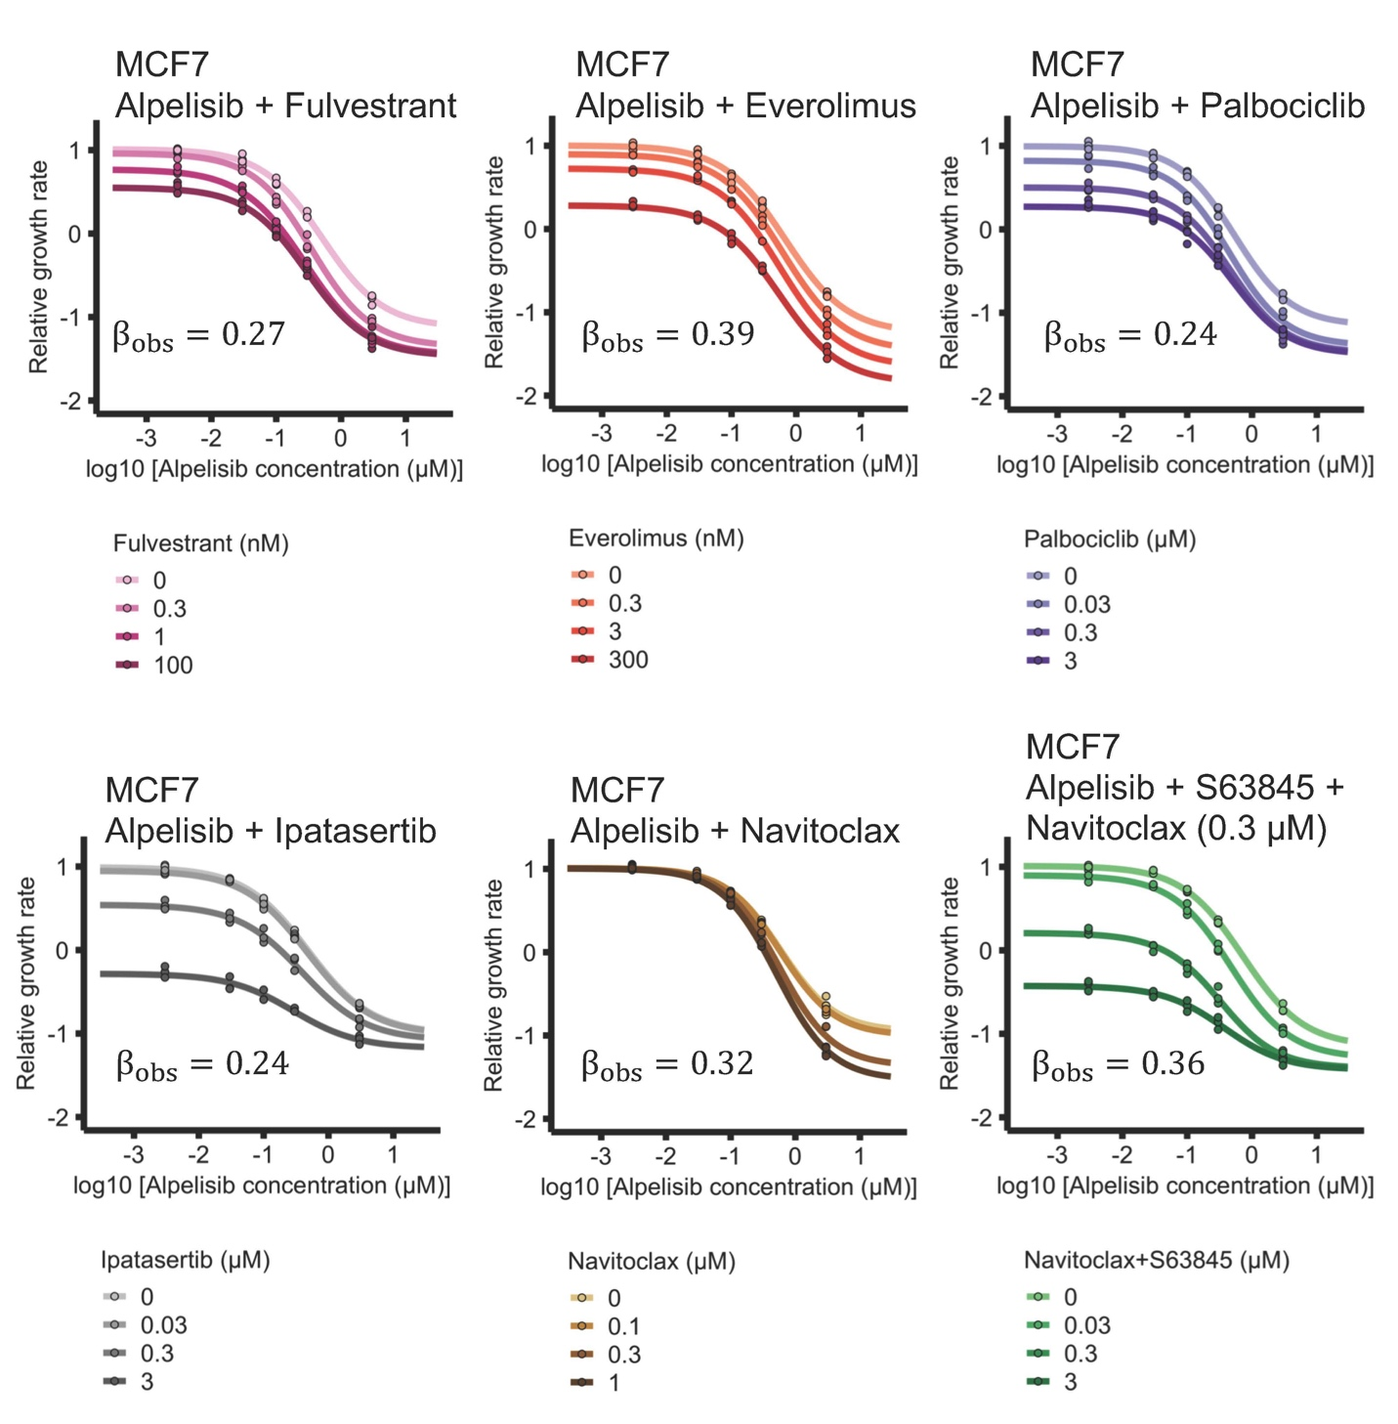
Supplemental Fig. S1. Combination and synergistic efficacy of alpelisib with selected clinically relevant drugs and BH3 mimetics in MCF7. The selected clinically relevant drugs are fulvestrant (a selective estrogen receptor degrader), everolimus (an inhibitor of mTOR), palbociclib (a CDK4/6 inhibitor), and ipatasertib (a pan-AKT inhibitor). The BH3 mimetics are navitoclax (a BCL-XL/BLC-2 inhibitor) and s63845 (a MCL1 inhibitor). Efficacy scores $β_{obs}$ are calculated using MuSyC (31), and are such that $β_{obs}>0$ means synergistic behavior and $β_{obs}<0$ means antagonistic behavior.

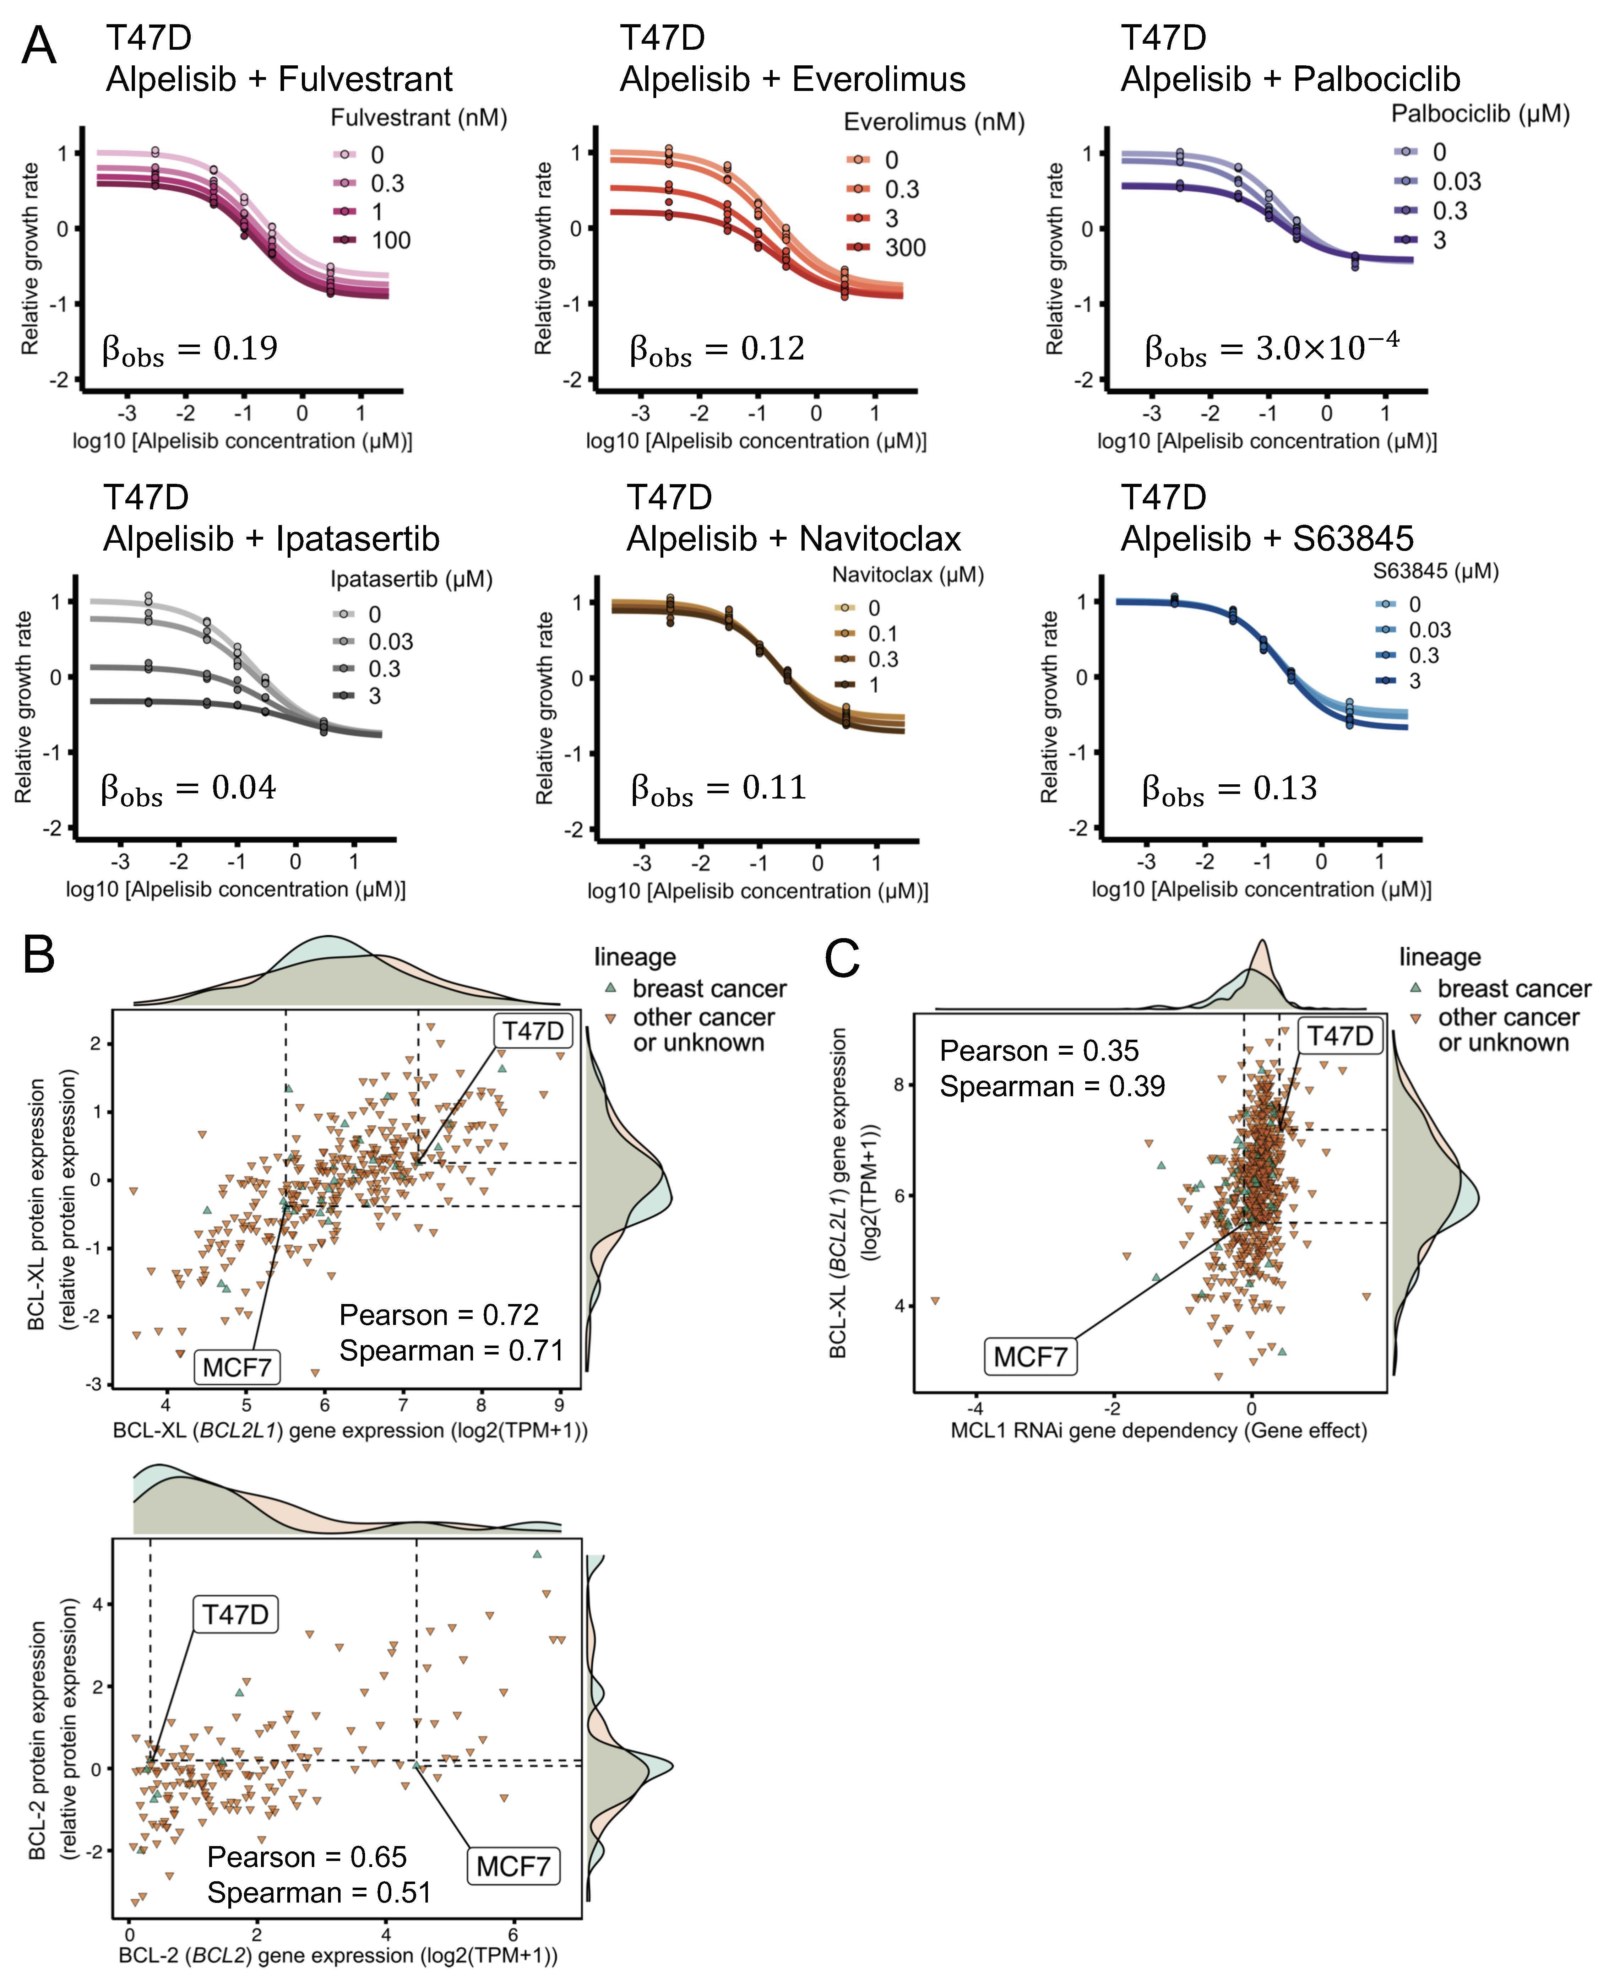
Supplemental Fig. S2. Combination of alpelisib with selected clinically relevant drugs and BH3 mimetics in T47D and gene/protein expression correlates for sensitivity to MCL1 knockout. (A) Drug response curves of alpelisib combined with clinically relevant drugs and BH3 mimetics in T47D. The selected clinically relevant drugs are fulvestrant (a selective estrogen receptor degrader), everolimus (an inhibitor of mTOR), palbociclib (a CDK4/6 inhibitor), and ipatasertib (a pan-AKT inhibitor). The BH3 mimetics are navitoclax (a BCL-XL/BLC-2 inhibitor) and s63845 (a MCL1 inhibitor). Efficacy scores $β_{obs}$ are calculated using MuSyC (31), and are such that $β_{obs}>0$ means synergistic behavior and $β_{obs}<0$ means antagonistic behavior. (B) Gene and protein expression of BCL-XL (BCL2L1) (top) and BCL-2 (BCL2) (bottom). The higher gene and protein expression of BCL-XL in T47D compared to MCF7 is consistent with T47D requiring navitoclax to be sensitive to combined alpelisib and s63845. (C) Sensitivity to MCL1 knockout in a dataset that combines multiple RNAi loss-of-functions screen datasets is strongly correlated with BCL-XL gene expression. MCF7 is more sensitive to MCL1 RNAi knockout than T47D (MCF7’s MCL1 gene effect is less than that of T47D), consistent with their differential sensitivity to s63845. The combined dataset uses the Achilles (Broad), DRIVE (Novartis), and Marcotte RNAi loss-of-functions screen datasets.

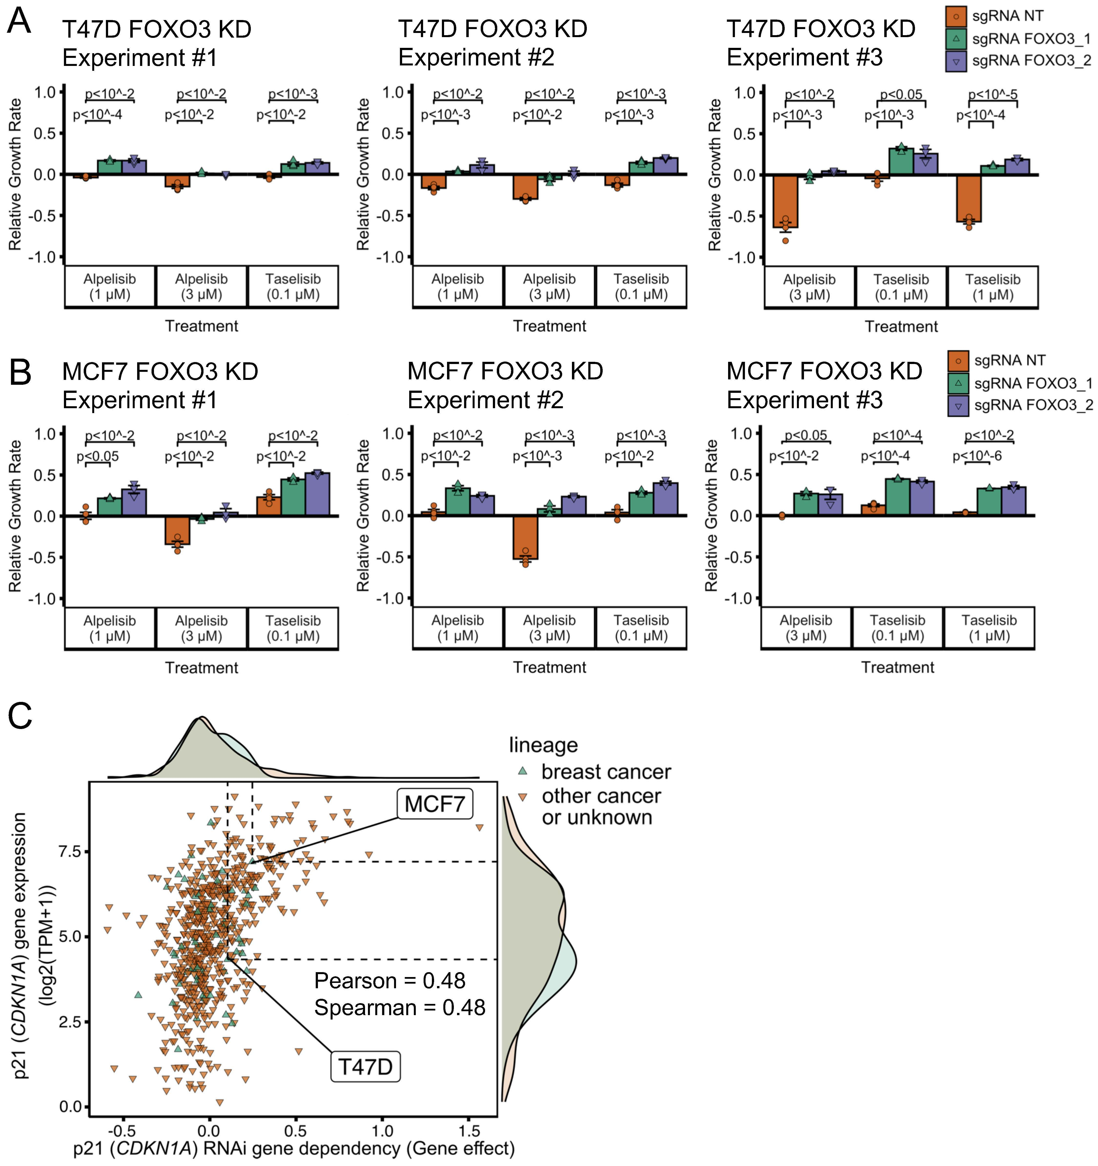
Supplemental Fig. S3. Reproducibility of FOXO3 knockdown’s reduced sensitivity to PI3Kα inhibitors and gene effect of p21 (CDKN1A) knockout from RNAi loss-of-functions screen datasets. (A-B) Reproducibility of FOXO3 knockdown’s reduced sensitivity to PI3Kα inhibitors seen in Fig. 4. Each experiment was done in a separate 96-well plate. Experiments #1 and #2 were done in the same week and are normalized according to the same day 0 untreated 96-well plate. The relative growth rate is calculated with respect to the growth rate of the DMSO control of each cell line condition in the growth curves in Fig. 4. (C) Gene effect of p21 (CDKN1A) knockout from a dataset that combines multiple RNAi loss-of-functions screen datasets is strongly correlated with p21 gene expression. Consistent with T47D’s p21 gene expression, the gene effect of p21 RNAi knockout on T47D is smaller than that on MCF7. The combined dataset uses the Achilles (Broad), DRIVE (Novartis), and Marcotte RNAi loss-of-functions screen datasets.
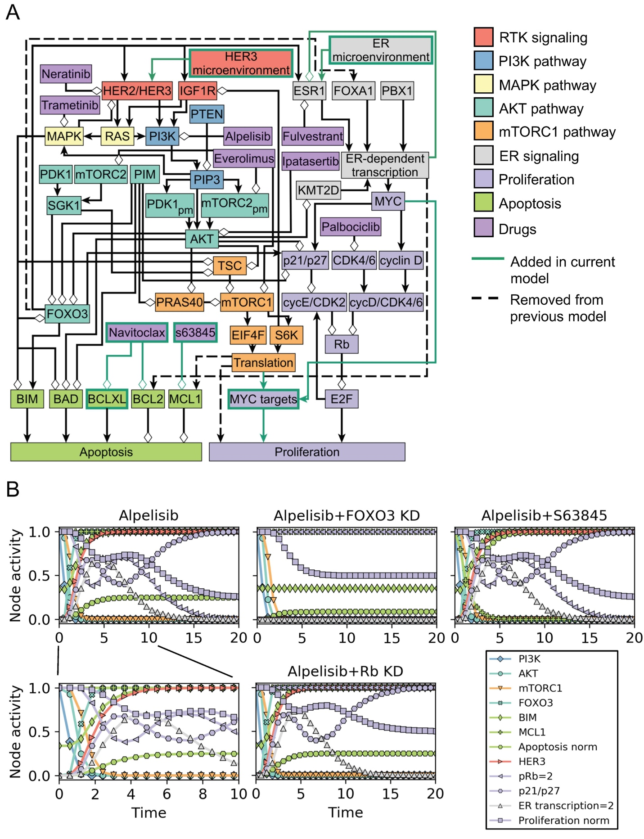
Supplemental Fig. S4. Updated network model (2020 version) of oncogenic signal transduction in ER+, PIK3CA mutant breast cancer. (A) Cell line-specific models are based on the network model shown, which is an updated version (2020 version) of the network model of Zanudo et al. 2017 (1). The 2020 network model incorporates new knowledge on ER+ breast cancer drug resistance, i.e. references (13,27,32) and the discrepancies between our experimental results and the Zanudo et al. 2017 model. The 2020 model has only slight modifications to the network structure compared to the 2017 model, and these are shown in panel A with a green node outline (for node additions), green arrow (for edge additions), or a dashed line (for edge deletions). Positive interactions are drawn with black arrowheads and negative interactions are drawn with white diamonds. More details on the modifications done to the 2017 model and the reasoning behind them can be found in the Supplemental Text and Supplemental File 1. (B) Timecourse of the node activity (average node state) in response to alpelisib in the 2020 network model. In particular, we show the timecourse for the MCF7-specific network model. In response to alpelisib, the 2020 model shows a quick inactivation of multiple pathways (AKT, MAPK, mTORC1), followed by the activation of $FOXO3$. Activation of $FOXO3$ results in the activation of $BIM$ (through transcriptional upregulation), which together with the inactivation of $BAD$ by $AKT$ results in an increase in $Apoptosis$. Activation of $FOXO3$ also activates $HER3$ and $ER transcription=2$ (through transcriptional upregulation of HER3 and ESR1), the latter of which is transient due to a negative feedback loop. The transient activation of results in the non-monotonic behavior of $Proliferation_{norm}$, which decreases because of the inactivation of MYC targets by the mTORC1 pathway and the activation of $p21/p27$ and $pRb=2$, but is transiently counteracted by $ER transcription=2$ . The timecourse for the response to alpelisib + FOXO3 knockdown shows how the response of multiple elements in the 2020 model depends on $FOXO3$ activation, including $BIM$, $Apoptosis_{norm}$, $p21/p27$, $HER3$, and the non-monotonic response of $pRb=2$, $ER transcription=2$, and $Proliferation_{norm}$. The timecourse for the response to alpelisib + s63845 differ to that of alpelisib alone in the state of the nodes $MCL1$ and $Apoptosis_{norm}$. The timecourse for the response to alpelisib + Rb knockdown differs to that of alpelisib alone only in the state of the nodes of $pRb$, $E2F$, and $Proliferation_{norm}.$

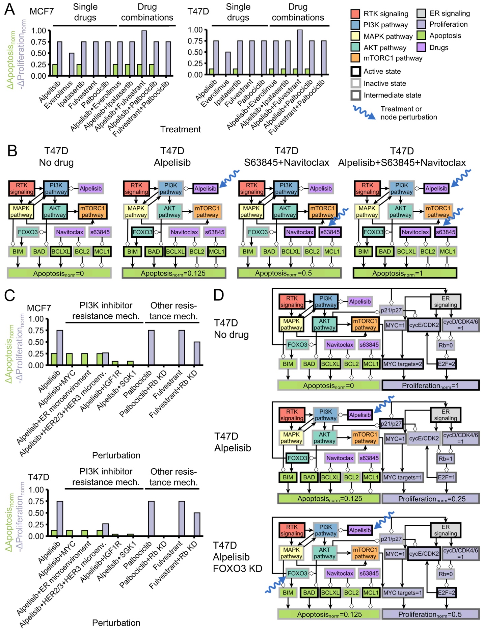
Supplemental Fig. S5. Additional drug combinations and resistance mechanisms in cell line-specific network models. (A) Response of MCF7-specific and T47D-specific network models (based on the 2020 version of the model) to single drugs relevant in the context of ER+ breast cancer and the combination of these drugs with alpelisib. (B) T47D-specific model reproduces the observed cell death response to BH3 mimetics, alpelisib, and their combination seen in this cell line (compare to the experimental results in Fig. 3C). We show the state of the nodes that influence $Apoptosis$ in response to alpelisib, BH3 mimetics, and their combination. In the networks, positive interactions are drawn with black arrowheads and negative interactions are drawn with white diamonds. (D) Cell line-specific network models reproduce the drug resistance effect of PI3Kα inhibitor resistance mechanisms and other resistance mechanisms. Simulations in which a drug resistance mechanism is active show an increased survivability (reduced $Proliferation$ and/or increased $Apoptosis$) compared to the case of the drug alone (panel C). (E) T47D-specific model reproduces the reduced sensitivity to alpelisib caused by FOXO3 knockdown. We show the state of the nodes that influence $Apoptosis$ and $Proliferation$ in response to alpelisib, FOXO3 knockdown, and their combination. The models encodes the biological outcomes of cell death and proliferation using $Apoptosis_{norm}$ and $Proliferation_{norm}$, respectively, which are a weighted and normalized (between 0 and 1) measure of the state of the nodes $Apoptosis$ and $Proliferation$. Starting from a cancerous state of each model, we perform 10,000 simulations in which the specified treatment or perturbation is maintained throughout the simulation, and obtain the average value of $Apoptosis_{norm}$ and $Proliferation_{norm}$ at the end of the simulations. $ΔApoptosis_{norm}$ and $ΔProliferation_{norm}$ of a perturbation denote the difference with respect to the case of no perturbation ($Apoptosis_{norm}=0$, $Proliferation_{norm}=1$), and are such that decreased survivability means an increase in $ΔApoptosis_{norm}$ or $-ΔProliferation_{norm}$.

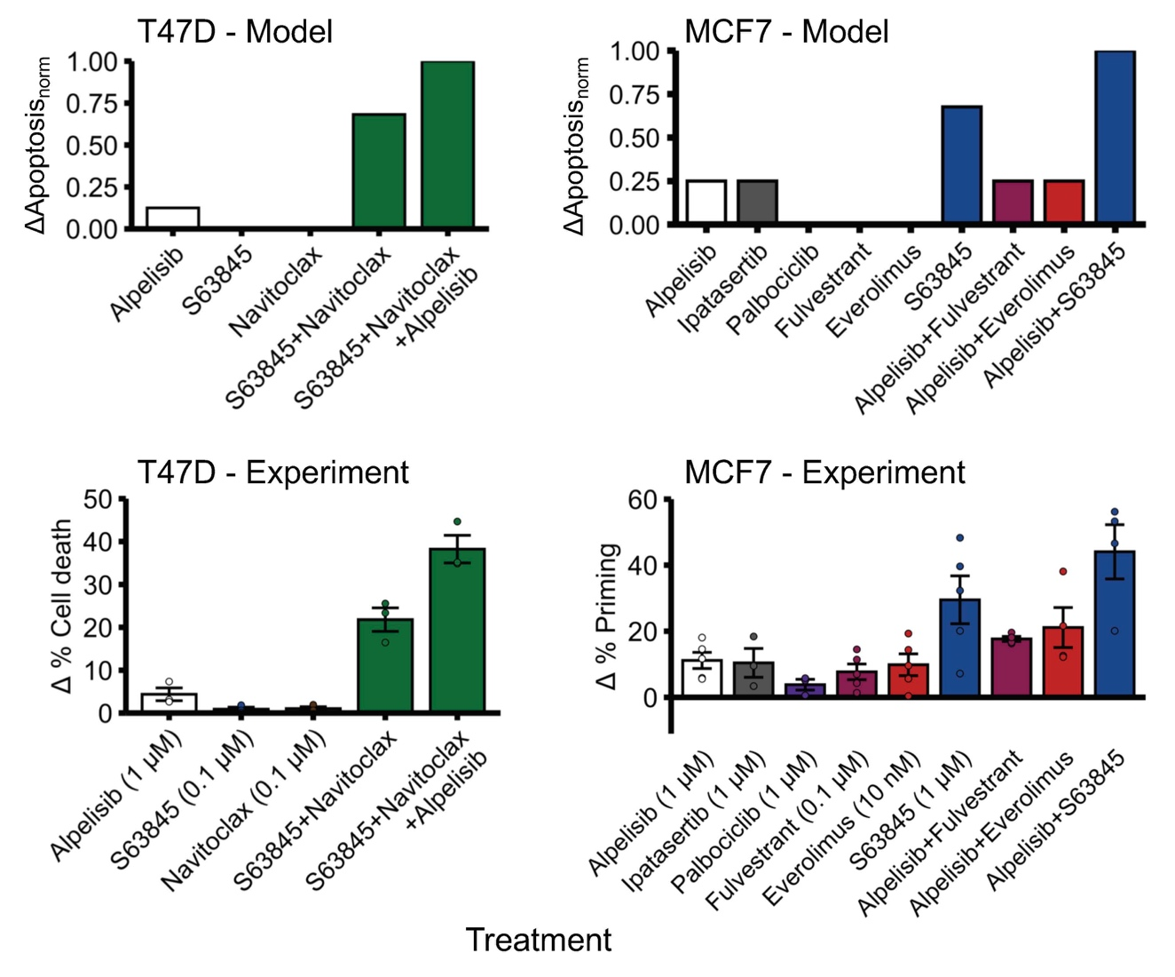
Supplemental Fig. S6. Cell line-specific network models reproduce the observed cell death response to alpelisib, BH3 mimetics, and other drugs. The cell death response ($ΔApoptosis_{norm}$) in MCF7-specific and T47D-specific network models (top panel), which are based on the 2020 version of the model, is qualitatively similar to the experimentally observed cell death response in these cell lines (bottom panel). The experimental cell death results shown in the bottom panel are the same as in Figs. 2E and 3C. The models encode the biological outcomes of cell death using $Apoptosis_{norm}$, which is a weighted and normalized (between 0 and 1) measure of the state of the node $Apoptosis$. Starting from a cancerous state of each model, we perform 10,000 simulations in which the specified treatment or perturbation is maintained throughout the simulation, and obtain the average value of $Apoptosis_{norm}$ at the end of the simulations. $ΔApoptosis_{norm}$ of a perturbation denotes the difference with respect to the case of no perturbation ($Apoptosis_{norm}=0$).

Supplemental Table S1. Inactivating genomic alterations in FOXO3 and FOXO1 from publicly available breast cancer tumor datasets. We consider inactivating genomic alterations to be loss-of-function (LOF) mutations (frameshift, nonsense, and nonstop mutations, excluding those in tumors with high mutation burden) and copy number deep deletions (based on the annotations in cbioportal (33)). The cbioportal data on which this analysis is based on can be found in Supplemental File 2.

Study | FOXO3 alterations | FOXO1 alterations
The Cancer Genome Atlas, PanCancer Atlas (34) | Profiled in 1084 samples. 9 samples (0.8%) have a deep deletion. No samples have LOF mutations. | Profiled in 1084 samples. 15 samples (1.4%) have a deep deletion. No samples have a LOF mutation.
METABRIC (35) | Profiled in 2509 samples. 9 samples (0.4%) have a deep deletion. 13 samples (0.5%) have a LOF mutation. | Profiled in 2509 samples. 7 samples (0.2%) have a deep deletion. No samples have a LOF mutation.
MSK IMPACT 2018 (36) | Not profiled in the gene panel used. | Profiled in the gene panel used in 1486 samples. 2 samples (0.1%) have a deep deletion. 3 samples from 2 patients (2 independent samples, 0.1%) have a LOF mutation.
The Metastatic Breast Cancer Project (37) | Profiled in 237 samples. 2 samples (0.8%) have a deep deletion. No samples have a LOF mutation. | Profiled in 237 samples. 1 sample (0.4%) has a deep deletion. No samples have a LOF mutation.
Analysis of phase I/II trial of alpelisib + an aromatase inhibitor (30) | Not profiled in the gene panel used. | Profiled in the gene panel used in 20 out of 141 samples. One primary sample had a loss-of-function mutation (FOXO1 Q529*). The patient (Patient P-0003179 (P050)) had no clinical benefit from alpelisib + exemestane, and did not have genomic alterations in PTEN or ESR1. Other annotated mutations in the patient are TP53 K320*, and the hotspot mutations PIK3CA E524K, ERBB3 E928G, and ERCC2 N238S.

Supplemental Table S2. Compilation of key experimental and clinical outcomes in ER+ breast cancer reproduced by the 2020 model.

Experimental or clinical outcome | Reproduced by the model? (Y/N) | Reference
PTEN loss-of-function is a resistance mechanism to PI3Kα inhibitors | Y | (30,38,39)
TSC1/2 knockdown is a resistance mechanism to PI3Kα inhibitors | Y | (26)
Sustained mTORC1 activity is sufficient for resistance to PI3Kα inhibitors | Y | (26)
High PIM expression is a resistance mechanism to PI3Kα inhibitors | Y | (18,40)
High PDK1/SGK1 expression is a resistance mechanism to PI3Kα inhibitors | Y | (41)
High MYC expression is a resistance mechanism to PI3K inhibitors | Y | (13–15)
High IGF1R activity is a resistance mechanism to PI3Kα inhibitors | Y | (32)
HER3-inducing microenvironment induces resistance to PI3K inhibitors | Y | (9)
Upregulation of ESR1 expression induces resistance to PI3Kα inhibitors | Y (in ER microenvironment) | (4)
Rb knockdown is a resistance mechanism to CDK4/6 inhibitors | Y | (42)
Rb knockdown causes a small reduction in sensitivity to fulvestrant | Y | (27)
FOXO3 knockdown reduces sensitivity to PI3Kα inhibitors | Y | This work
Rb knockdown reduces sensitivity to PI3Kα inhibitors in T47D | Y | This work
Rb knockdown does not reduce sensitivity to PI3Kα inhibitors in MCF7 | N | This work
CDKN1B knockdown does not reduce sensitivity to PI3Kα inhibitors | Y | This work
Alpelisib + fulvestrant is an efficacious drug combination | Y | (4,43)
Alpelisib + fulvestrant is a synergistically efficacious drug combination in MCF7 and T47D | Y | This work
The combinations of alpelisib with everolimus, navitoclax, ipatasertib, or palbociclib are synergistically efficacious drug combinations in MCF7 | N | This work
The combinations of alpelisib with everolimus, s63845, or navitoclax are synergistically efficacious drug combinations in T47D | N | This work
Alpelisib + s63845 is a synergistically efficacious combination in MCF7 and induces more apoptosis than each drug on its own | Y | This work
Alpelisib + s63845 + navitoclax is a synergistically efficacious drug combination in T47D and induces more apoptosis than alpelisib or s63845 + navitoclax on their own | Y | This work
S63845 induces apoptosis on its own in MCF7 | Y | This work
S63845 + navitoclax induce apoptosis in combination but not on their own in T47D | Y | This work
Alpelisib induces a small amount of apoptosis in MCF7 and T47D | Y | This work
Fulvestrant induces a small amount of apoptosis in MCF7 | N | This work
Everolimus induces a small amount of apoptosis in MCF7 | N | This work

