Supplementary Fig. S7.

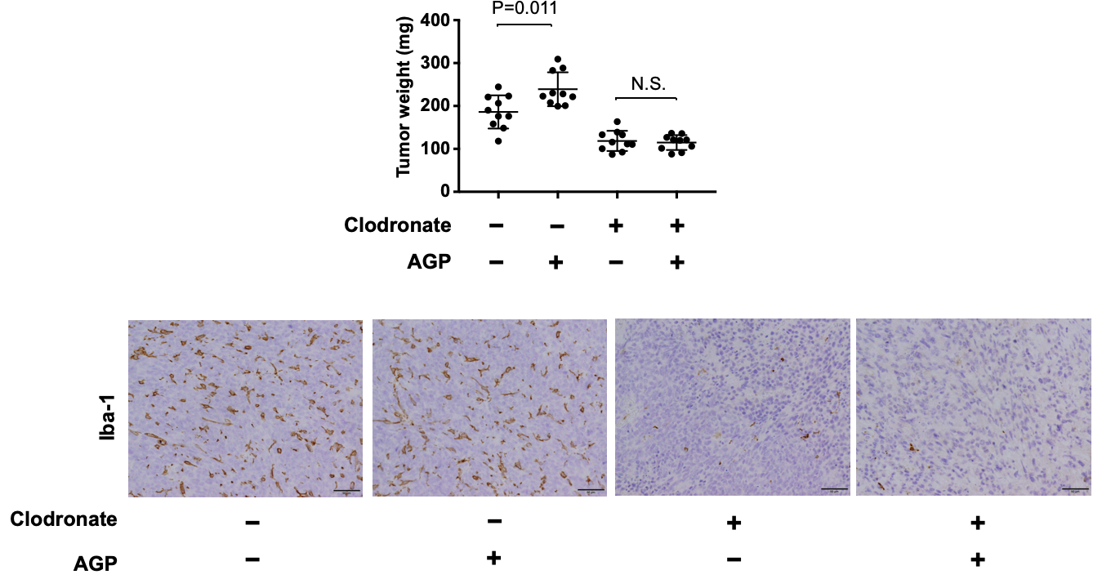

Supplementary Figure S7. Effect of macrophage depletion on tumor development in AGP-treated tumor-bearing mouse model. AGP (2 mg/mouse) was administered to LM8 bearing C3H HeN mice treated with clodronate liposome to deplete macrophages, followed by the determination of subcutaneous tumor weights (A) (n=10 mice per group). Iba-1-positive cells in LM8 subcutaneous tumor tissues were evaluated by immunostaining (B). Statistical differences between groups were calculated by non-repeated-measures ANOVA.

