Supplemental Information

Figure S1. TAZ expression in clinical GBM specimens (related to Figure 1).

A: TAZ mRNA levels in normal brain, low-grade glioma and GBM specimens from three glioma databases (*: p < 0.01, the Tukey's honestly significant difference test).
B: Kaplan-Meier curves of different GBM patient groups with high or low TAZ expression (Cutoff: median expression (top panel) or TAZ-high/low quartiles (bottom panel)) from the TCGA and CGGA database. Patient survival was compared in all GBM patients, patients with wild-type or mutant IDH1. Hazard ratio (HR) and p values were marked inside each panel.
C and D: Correlation analysis of mRNA levels of TAZ (WWTR1) and RTK ligands and receptors as marked in GBM specimens from the TCGA (n=454) and CGGA (n=1,012) datasets.

Figure S2. YAP and LATS1 are not modulated by EGF stimulation (related to Figure 1).

A and B: After growth factor depletion for 16 hours, GBM1B and A172 cells were treated with EGF for the indicated times (Con: untreated cells). The levels of YAP (A), phosphorylated and total LATS1 (B) were quantified by western blotting. Protein fold expression normalized to β-Actin or total LATS1 is shown below each lane.

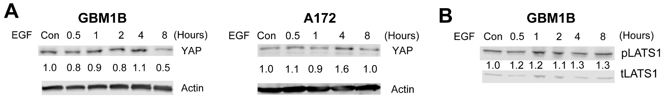

Figure S3. EGF-induced TAZ activation is blocked by the STAT3 and ERK1/2 inhibitor (related to Figure 2).

A and B: GBM1B cells were first depleted of growth factors and treated with +/- STAT3 (A) or ERK1/2 (B) inhibitors as marked for 16 hours (Stattic: 5 µM; FR180204: 50 µM). Cells receiving 4-hour EGF treatment were subjected to western blotting using total protein lysates. Protein fold expression normalized to β-Actin is shown below each lane.

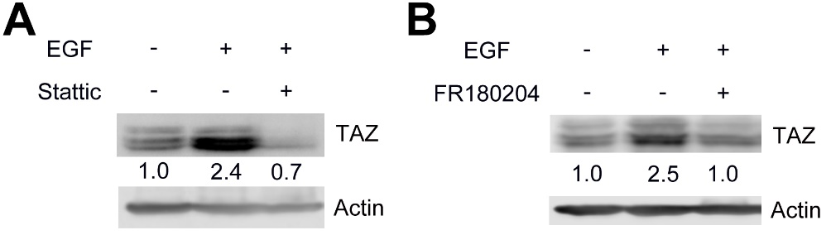

Figure S4. A clustergram graph shows the enrichment of TAZ-Up genes in the top 20 KEGG pathways as described in Fig. 5A. The top-ranked 60 genes are shown (related to Figure 4).

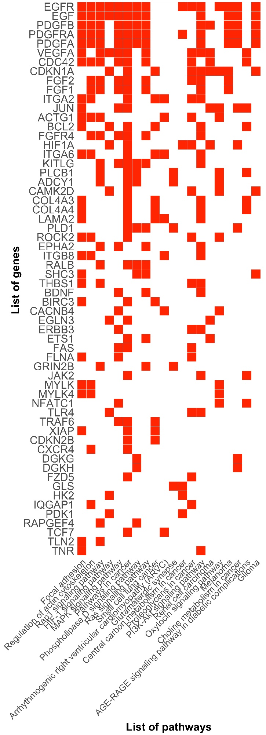
Figure S5. TAZ binding peaks proximal to validated TAZ-Up genes as marked (related to Figure 5).

The orientation of each transcript is marked by the arrow. Arrowheads mark peaks for validation in ChIP-PCR. (T: the transcription start site, TSS)

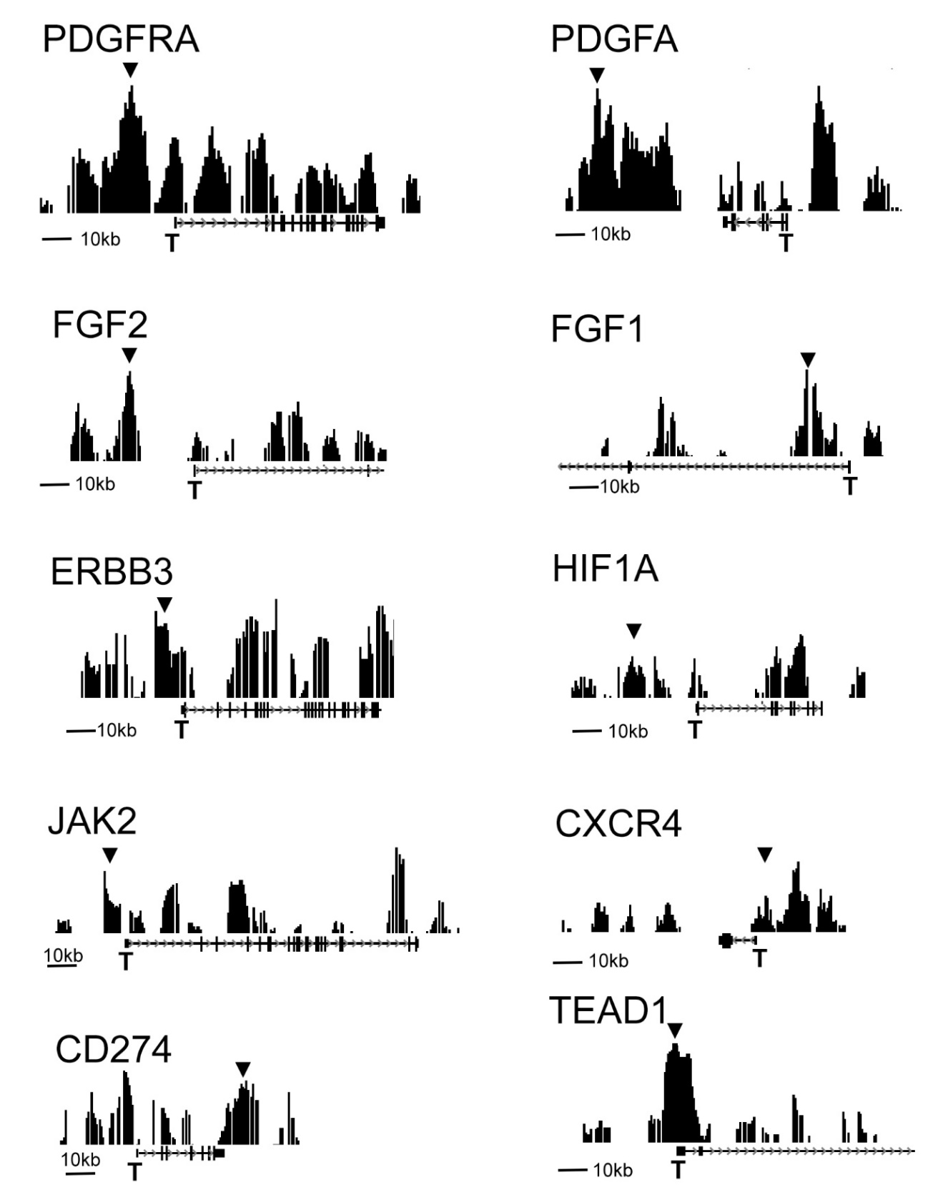

Figure S6. Correlation between TAZ and validated TAZ-Up genes (related to Figure 5).

Correlation analysis of mRNA levels of TAZ (WWTR1) and TAZ-Up gene targets in GBM specimens from the TCGA database (n=454, Pearson’s r value is marked inside each panel).

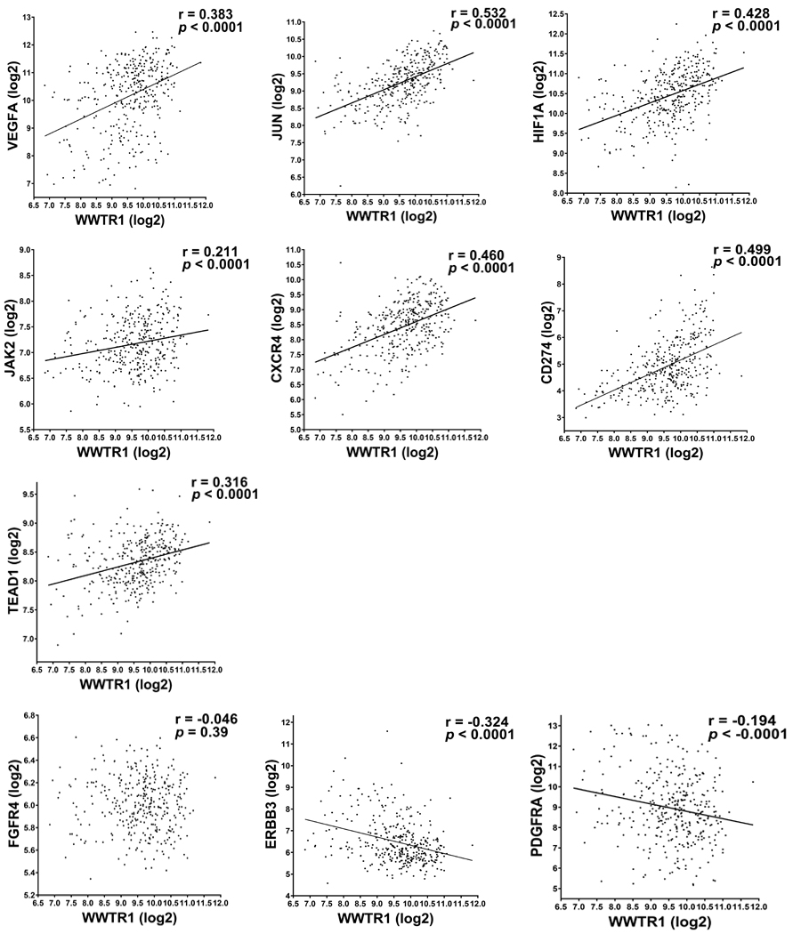

Figure S7. Enforced TAZ expression promotes the migration capability of GBM cells (related to Figure 6).

A172 and A172-TAZ cells were subjected to the scratch wound healing assay as described in Fig. 6I. Representative images showed migrating cells in the scratch area at three time points (Bar = 10 µm). Migrating cells in the regions marked by the red line were quantified in Fig. 6I.

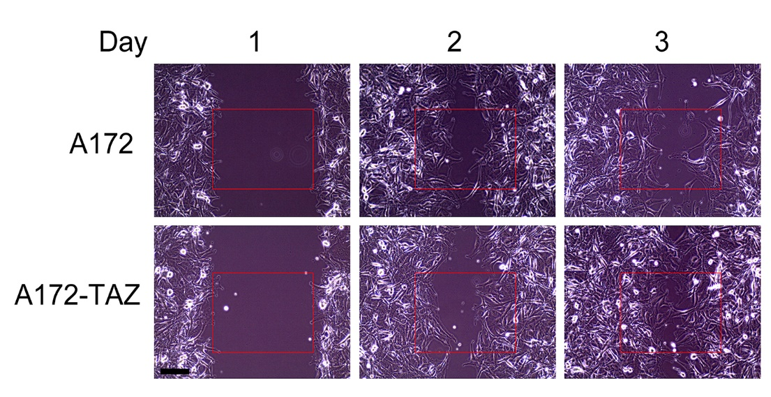

Figure S8. Ki67 and TAZ immunohistochemistry (IHC) staining in OS-treated tumor xenografts (related to Figure 7).

(A) After growth factor depletion for 16 hours, GBM1B cells were stimulated by EGF for the indicated times. The levels of phosphorylated and total ERK, STAT3 and AKT were quantified by western blotting. Fold expression of the phosphorylated proteins was normalized to the levels of total proteins and shown below each lane (EGF untreated control = 1.0).
(B) Representative results of Ki67 IHC staining in M1123 and GBM1B xenografts with +/- OS treatment. The percentage of Ki67+ cells were quantified.
(C) Representative results of TAZ IHC staining in M1123 and GBM1B xenografts with +/- OS treatment. IHC staining was quantified base on the integrated optical density (IOD) using the ImageJ software.
Bar = 50 µm.
Data are represented as mean ± SEM (n=5; *: p < 0.01).

Table S1: RNA-Seq results: DE genes in GBM1B cells with +/- 4-hour EGF treatment (related to Figure 4).
Table S2: RNA-Seq results: DE genes in GBM1B cells with +/- 24h EGF treatment (related to Figure 4).
Table S3: Merged DE genes that were altered by either 4-hour or 24-hour EGF treatment (related to Figure 4).
Table S4: TAZ binding peaks and genes as identified by ChIP-Seq (related to Figure 4).
Table S5: Transcription factor motifs with high similarity to the TAZ binding motif (related to Figure 4).
Table S6: TAZ-Up and TAZ-Down genes (related to Figure 4).
Table S7: KEGG pathways enriched in TAZ-Up and TAZ-Down genes (related to Figure 5).
Table S8: Key resources.

