Supplemental Materials

Supplemental Materials and Methods

Treatment protocols
MaFIA mice were treated with systemic (2 mg/kg, i.p.) or local (60 µg/6 μl, i.pl.) B/B-HmD (AP20187) or their vehicle (10% PEG-400, 1.7% tween 80 in 0.9% NaCl) for 5 consecutive days (daily, from day 10 to day 14 for B16-F10 melanoma cells and from day 4 to day 8 for LLC1 cells) (1,2) after cancer cell inoculation. In another set of experiments, AP20187 or its vehicle were administered by perineural (p.n., 60 µg/6 μl) injection at three adjacent sites (each at a distance of 2 mm) of the sciatic nerve trunk (from ∼10 to ∼16 mm from the paw surface) for 5 consecutive days (daily, from day 10 to day 14) after B16-F10 melanoma cell inoculation. Perineural injections were made as previously reported (3,4). Briefly, AP20187 or its vehicle were injected in the region surrounding the sciatic nerve at high thigh level of the right hind limb (from ∼10 to ∼16 mm from the paw surface) without skin incision in a volume of 6 μl using a microsyringe with a 30-gauge needle. The position of sciatic nerve at high thigh level was chosen by using the femoral head as a landmark. When Evans blue dye was injected according to this procedure, the appearance of the complete deposition of the dye surrounding the sciatic nerve was confirmed. This minimally invasive procedure allowed us to avoid nerve damage and resultant neuropathic pain (3,4).
To transiently deplete the monocyte/MΦ population, C57BL/6J mice received liposome-encapsulated clodronate (LCL, 5 mg/ml i.p., Clodronate Liposomes.com) or vehicle (liposome-encapsulated PBS) one day before and 14 consecutive days (daily, from day 1 to day 14) after B16-F10 melanoma cell inoculation. A neutralizing anti-CCL2 monoclonal antibody (40 μg/200 μl, i.p.) (#AF-479-NA, Mouse CCL2/JE/MCP-1, R&D system) or its vehicle (IgG2B, isotype control) were administered every 2 days (from day 8 to day 14) after B16-F10 melanoma cell inoculation. A neutralizing anti-M-CSF (#BE0204, clone 5A1, RRID:AB_10950309 BioxCells), anti-G-CSF (#MAB414, Clone 67604, RRID:AB_2085954 R&D system) and anti-GM-CSF (#BE0259, clone MP1-22E9, RRID:AB_2687738) monoclonal antibody (all, 300 μg/200 μl, i.p.) or their vehicle (IgG2B, isotype control) were administered at day 3, 7, 10 and 13 after B16-F10 melanoma cell inoculation. PLX3397 (40 mg/kg, i.p.) (#S7818, Selleckchem) or its vehicle (4% dimethyl sulfoxide, DMSO, 4% tween 80 in 0.9% NaCl) were administered for 7 consecutive days (daily, from day 8 to day 14) after B16-F10 melanoma cell inoculation. A-967079 (100 mg/kg, i.p.), PBN (100 mg/kg, i.p.), or their vehicle (4% DMSO, 4% tween 80 in 0.9% NaCl) were given at day 14 after B16-F10 melanoma cell inoculation.
M-CSF (1, 10 and 100 ng), G-CSF and GM-CSF (both, 100 ng) or their vehicle (0.9% NaCl) were i.pl. (20 μl) administered. A neutralizing anti-M-CSF monoclonal antibody (#BE0204, clone 5A1, BioxCells) (300 μg/200 μl, i.p.) or its vehicle (IgG2B, isotype control), A-967079 (100 mg/kg, i.p.), PBN (100 mg/kg, i.p.), or their vehicle (4% DMSO, 4% tween 80 in 0.9% NaCl), were administered 30 minutes and 1 hour before M-CSF (100 ng/20 μl, i.pl.). Peritoneal MΦs (up to 250 × 10⁶ cells per ml) were harvested from naïve C57BL/6J mice by peritoneal lavage with 10 ml of warm PBS, 4 days after thioglycolate (3%, 2 ml/mice, i.p.) injection. For inoculation, 20 µl of MΦs (3 x 10⁴ cells) were suspended in PBS and injected (i.pl.) in the hindpaw of MΦ-depleted tumor-bearing MaFIA mice at day 14 after cancer cell inoculation. Unless otherwise indicated, reagents were purchased from Sigma-Aldrich.

Mechanical allodynia
The measurement of mechanical paw-withdrawal threshold was carried out using von Frey filaments of increasing stiffness (0.02-2 g) applied to the plantar surface of the mouse hindpaw, according to the up-and-down paradigm (5). The 50% mechanical paw-withdrawal threshold (g) response was then calculated from the resulting scores.

Cold response
Cold sensitivity was assessed by measuring the acute nocifensive response to acetone-evoked evaporative cooling, as previously described (6).

Spontaneous nociception
After an acclimation period of 30 minutes, mouse behavior was videorecorded for 1 hour with no experimenters in the experimental room. The records were reviewed to determine the cumulative duration (seconds) of lifting/licking of the inoculated hindpaw.

Sciatic nerve explant culture
Sciatic nerve explants were prepared as previously reported (7). Briefly, sciatic nerve was removed under aseptic conditions and cut into six segments of about 5 mm in length. Tissues were placed into culture dishes and maintained free-floating in DMEM containing: 10% fetal calf serum, 2 mM L-glutamine, 100 U/ml penicillin, 100 mg/ml streptomycin, in an atmosphere of 95% air and 5% CO₂ at 37 °C. Explant cultures from untreated MaFIA mice were exposed to H₂O₂ (100 nM) in presence of A967079 (30 μM), PBN (50 μM), PLX3397 (1 μM) or their vehicle (0.03%, 0.05% and 0.001% DMSO, respectively) for 3 days. Tissues were then harvested, washed in PBS and fixed in 4% paraformaldehyde before being transferred to 30% sucrose overnight, frozen and cryosectioned at 20 μm in glass slide. Sections were coverslipped using a water-based mounting medium with DAPI (Abcam). The number of F4/80⁺ cells was counted in 10⁴ µm² boxes in the sciatic nerve trunk. Explant cultures from Plp1-Cre^{ERT+};Trpa1^{fl/fl}, Adv-Cre⁺;Trpa1^{fl/fl} and control mice were exposed to H₂O₂ (100 nM) or vehicle (0.9% NaCl) for 3 days and then assayed for CSF-1 content.

H₂O₂ assay
H₂O₂ level was assessed in sciatic nerve tissue by using the Amplex Red® assay (Invitrogen). Briefly, tissue was rapidly removed and placed into modified Krebs/HEPES buffer (composition in mmol/l: 99.01 NaCl, 4.69 KCl, 2.50 CaCl₂, 1.20 MgSO₄, 1.03 KH₂PO₄, 25.0 NaHCO₃, 20.0 Na-HEPES, and 5.6 glucose [pH 7.4]). Samples were minced and incubated with Amplex red (100 μM) and HRP (1 U/ml) (1 hour, 37 °C) in modified Krebs/HEPES buffer protected from light. Fluorescence excitation and emission were at 540 and 590 nm, respectively. H₂O₂ production was calculated using H₂O₂ standard and expressed as μmol/l of mg of dry tissue.

Multi-analyte ELISA assay
A series of chemokines and cytokines including IL-1α, IL-1β, IL-2, IL-4, IL-6, IL-10, IL-12, IL-17A, IFN-γ, TNF-α, TGF-1β, CCL2, CCL3, CCL4, M-CSF, G-CSF, and GM-GSF was assessed in the tumor and sciatic nerve tissue homogenates using a multi-analyte ELISA array kit (#336161, Qiagen) according to the manufacturer’s protocol. Samples were assayed in triplicate. The raw data obtained from the absorbance (optical density, OD 450 nm) readings were normalized to the mg of tissue.

M-CSF ELISA assay
M-CSF assay in mouse tissue. M-CSF was assayed in the tumor and sciatic nerve tissue homogenates at day 14 after cancer cell inoculation in C57BL/6J mice and in sciatic nerve explant cultures using a single-analyte ELISA array kit (#ab199084, Abcam) according to the manufacturer’s protocol. Samples were assayed in triplicate. Data were expressed as pg/mg of proteins.

M-CSF assay in cultured cells. HSC were plated in 96-well clear bottom black (5x10⁵ cells/well) and maintained in 5% CO₂ and 95% O₂ (24 hours, 37°C). The cultured medium was replaced and added with A967079 (30 µM), PBN (50 µM) or vehicle (0.5% DMSO) for 20 minutes at room temperature. HSC were then stimulated with H₂O₂ (100 nM), PF-4840154 (50 nM) or vehicle (PBS) for 16 hours in 5% CO₂ and 95% O₂. The cell supernatant was assayed for M-CSF content using a single-analyte ELISA array kit (#ab245714, Abcam) according to the manufacturer’s protocol. Data were expressed pg/ml.

PDL-1 ELISA assay
PDL-1 was assayed in the tumor and sciatic nerve tissue homogenates at day 14 after cancer cell inoculation in C57BL/6J mice using a single-analyte ELISA kit (#DY1019-05, R & D system) according to the manufacturer’s protocol. Samples were assayed in triplicate. Data were expressed as pg/mg of protein.

Immunofluorescence
The tumor and sciatic nerve tissues were dissected from anesthetized and transcardially perfused with PBS, followed by 4% paraformaldehyde, mice. The sciatic nerve and the hindpaw were postfixed for 24 hours, and paraffin embedded. Immunofluorescence staining was performed according to standard procedures. Briefly, after antigen retrieval (Ethylenediaminetetraacetic acid, EDTA, solution pH 9.0, Dako) for 20 minutes at 98 °C, sections (5 µm) were incubated with the following primary antibodies: F4/80 [1:50, MA516624, rat monoclonal (Cl:A3-1), RRID:AB_2538120 Thermo Fisher Scientific] diluted in antibody diluent (Roche Diagnostics) 1 hour at room temperature. Sections were then incubated for 2 hours in the dark with a fluorescent secondary antibody polyclonal, Alexa Fluor® 488, (1:600, Invitrogen). Sections were coverslipped using a water-based mounting medium with 4’6’-diamidino-2-phenylindole (DAPI, Abcam). The analysis of negative controls (non-immune serum) was simultaneously performed to exclude the presence of non-specific immunofluorescent staining, cross-immunostaining, or fluorescence bleed-through. For histological evaluation, sections were stained with hematoxylin/eosin and, based on the morphology, the boundaries of the nerve trunk corresponding to the epineurium were identified and reported in adjacent immunofluorescence images with dashed lines. The number of F4/80⁺ cells was counted in 10⁴ µm² boxes in the sciatic nerve trunk.

Real-Time PCR
RNA was extracted from human and mouse Schwann cells. Total RNA was extracted using the RNeasy Mini kit (Qiagen SpA), according to the manufacturer’s protocol. RNA concentration and purity were assessed spectrophotometrically by measuring the absorbance at 260 nm and 280 nm. Reverse transcription was performed with the Qiagen QuantiTect Reverse Transcription Kit (Qiagen SpA) following the manufacturer's protocol. For mRNA relative quantification, rt-PCR was performed on Rotor Gene® Q (Qiagen SpA). The sets of probes for human cells were as follow: ACTB (β-actin): Primer1, CCTTGCACATGCCGGAG: Primer2, ACAGAGCCTCGCCTTTG: Probe, /56-FAM/TCA TCC ATG /ZEN/GTGAGCTGGCGG /3IABkFQ/ (NCBI Ref Seq: NM_001101); CSF1 (csf1) Primer1, TCTTTCAACTGTTCTGGTCTAC: Primer2, TGT CGG AGT ACT GTA GC CA: Probe, /56-FAM/ACA GTC AGA/ZEN/TGGAGACCTCGTGC/31ABkFQ/ (NCBI Ref Seq: NM_172212). The sets of probes for mouse cells were as follow: ACTB (β-actin): Primer 1, GACTCATCGTACTCCTGCTTG; Primer 2, GATTACTGCTCTGGCTCCTAG; Probe, /56-FAM/CTGGCCTCA /ZEN/CTGTCCACCTTCC/3IABkFQ/ (NCBI Ref Seq: NM_007393); CSF1 (csf1): Primer1, CTTCATGCCAGATTGCCTTTG; Primer2, CGCATGGTCTCATCTATTATGTCT; Probe, /56-FAM/CAGCTGGAT/ZEN/GATCCTGTTTGCTACCT/3IABkFQ/ (NCBI Ref Seq: NM_001113529). The sets of primers for mouse DRGs were GAPDH: Primer 1, AATGGTGAAGGTCGGTGTG; Primer 2, GTGGAGTCATACTGGAACATGTAG (NCBI Ref Seq: NM_008084); activating transcription factor 3 (ATF3): Primer 1, AGCTGAGATTCGCCATCCAGAA, Primer 2, CTCGCCGCCTCCTTTTCCT (NCBI Ref Seq: NM_007498).

References
1. De Logu F, De Pra SD, de David Antoniazzi CT, Kudsi SQ, Ferro PR, Landini L, et al. Macrophages and Schwann cell TRPA1 mediate chronic allodynia in a mouse model of complex regional pain syndrome type I. Brain Behav Immun 2020
2. Bailey KN, Furman BD, Zeitlin J, Kimmerling KA, Wu CL, Guilak F, et al. Intra-articular depletion of macrophages increases acute synovitis and alters macrophage polarity in the injured mouse knee. Osteoarthritis and Cartilage 2020
3. Kiguchi N, Maeda T, Kobayashi Y, Kondo T, Ozaki M, Kishioka S. The critical role of invading peripheral macrophage-derived interleukin-6 in vincristine-induced mechanical allodynia in mice. Eur J Pharmacol 2008;592:87-92
4. Ma W, Quirion R. Increased calcitonin gene-related peptide in neuroma and invading macrophages is involved in the up-regulation of interleukin-6 and thermal hyperalgesia in a rat model of mononeuropathy. J Neurochem 2006;98:180-92
5. Chaplan SR, Bach FW, Pogrel JW, Chung JM, Yaksh TL. Quantitative assessment of tactile allodynia in the rat paw. J Neurosci Methods 1994;53:55-63
6. Antoniazzi CTD, Nassini R, Rigo FK, Milioli AM, Bellinaso F, Camponogara C, et al. Transient receptor potential ankyrin 1 (TRPA1) plays a critical role in a mouse model of cancer pain. Int J Cancer 2019;144:355-65
7. Leonhard C, Muller M, Hickey WF, Ringelstein EB, Kiefer R. Lesion response of long-term and recently immigrated resident endoneurial macrophages in peripheral nerve explant cultures from bone marrow chimeric mice. Eur J Neurosci 2002;16:1654-60

Supplemental Figures

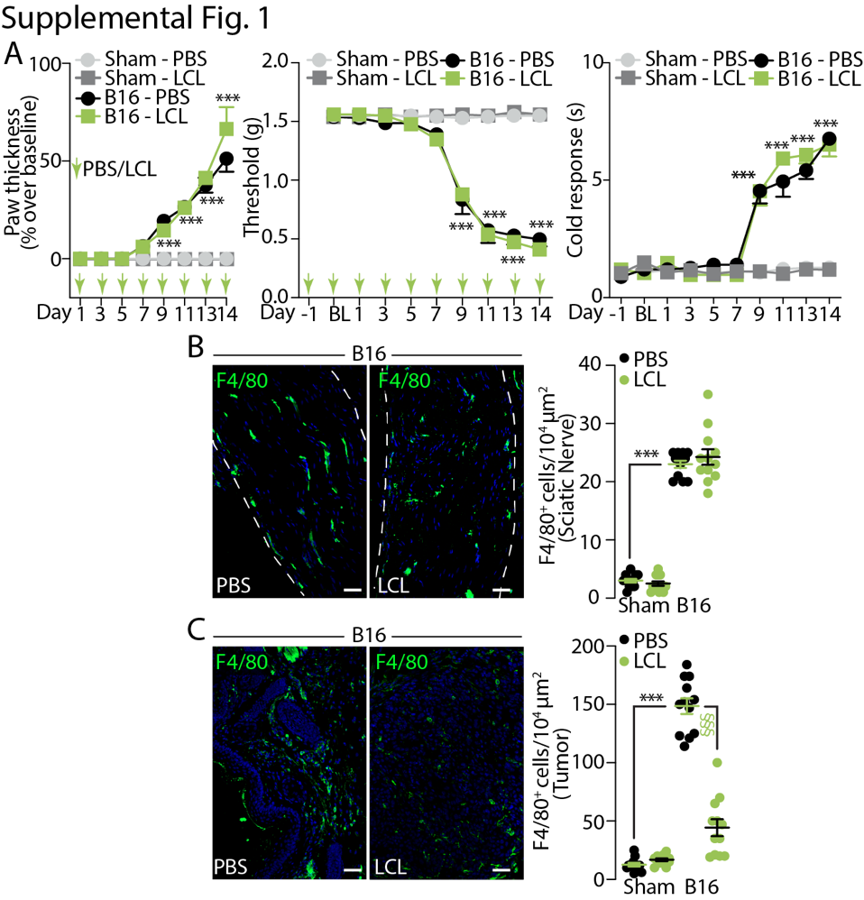

Supplemental Fig. 1. (A) Paw thickness, mechanical allodynia and cold response after B16-F10 melanoma (B16) in C57BL/6J mice treated with liposome-encapsulated clodronate (LCL) or PBS (i.p.). Representative images and pooled data of F4/80⁺ cell in ipsilateral sciatic nerve (B) and tumor (C) at day 14 after B16 cell inoculation or sham in C57BL/6J mice, treated with LCL or PBS (i.p.). BL, baseline. Green arrows indicate the time of treatment with PBS or LCL (i.p.). Dashed line delimits the epineurium. Scale bar 50 μm. N = 6 mice. ***P < 0.001 to Sham, Sham-PBS; §§§P < 0.001 to B16-PBS. Two-way (A) and one-way (B, C) ANOVA and Bonferroni post hoc test.

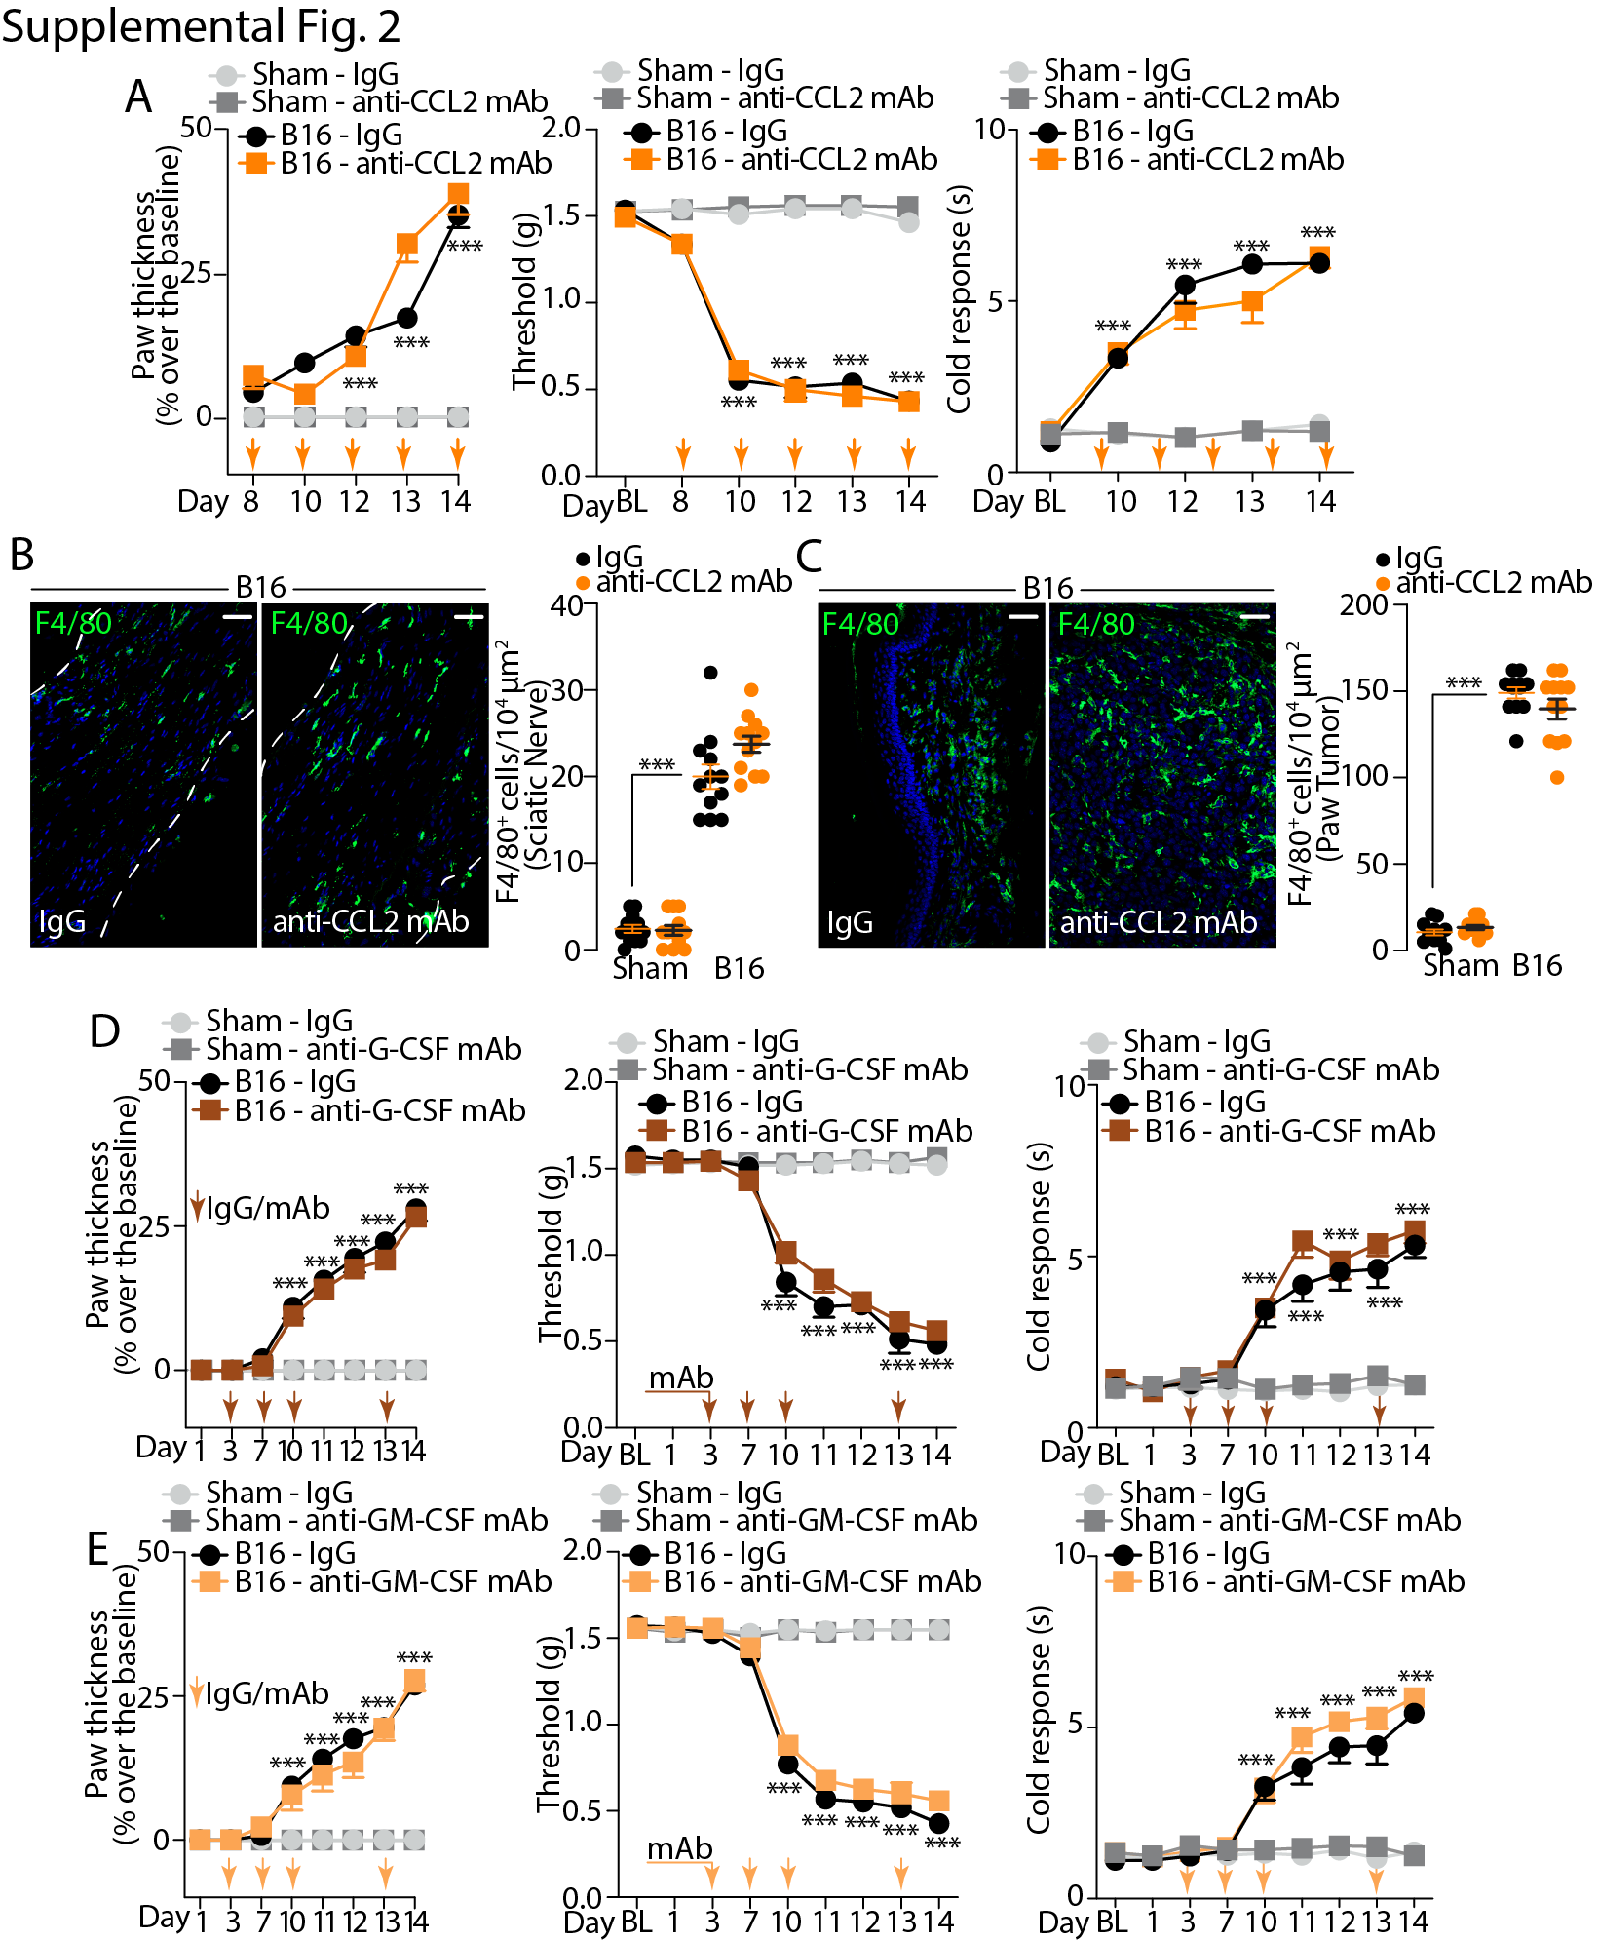

Supplemental Fig. 2. (A) Paw thickness, mechanical allodynia and cold response after B16-F10 melanoma (B16) cell inoculation or sham in C57BL/6J mice treated with an mAb anti-CCL2 or IgG2B (IgG) (i.p.). Representative images and pooled data of F4/80⁺ cells in ipsilateral sciatic nerve (B) and tumor (C) at day 14 after B16 cell inoculation or sham in C57BL/6J mice treated with a mAb anti-CCL2 or IgG (i.p.). Paw thickness, mechanical allodynia and cold response after B16 cell inoculation or sham in C57BL/6J mice, treated with a mAb anti-G-CSF or IgG (i.p.) (D) and a monoclonal mAb anti-GM-CSF or IgG (i.p.) (E). BL, baseline. Arrows indicate the time of treatments. Dashed line delimits the epineurium. Scale bar 50 μm. N = 6 mice. ***P < 0.001 to Sham-IgG. Two-way (A, D, E) and one-way (B, C) ANOVA and Bonferroni post hoc test.

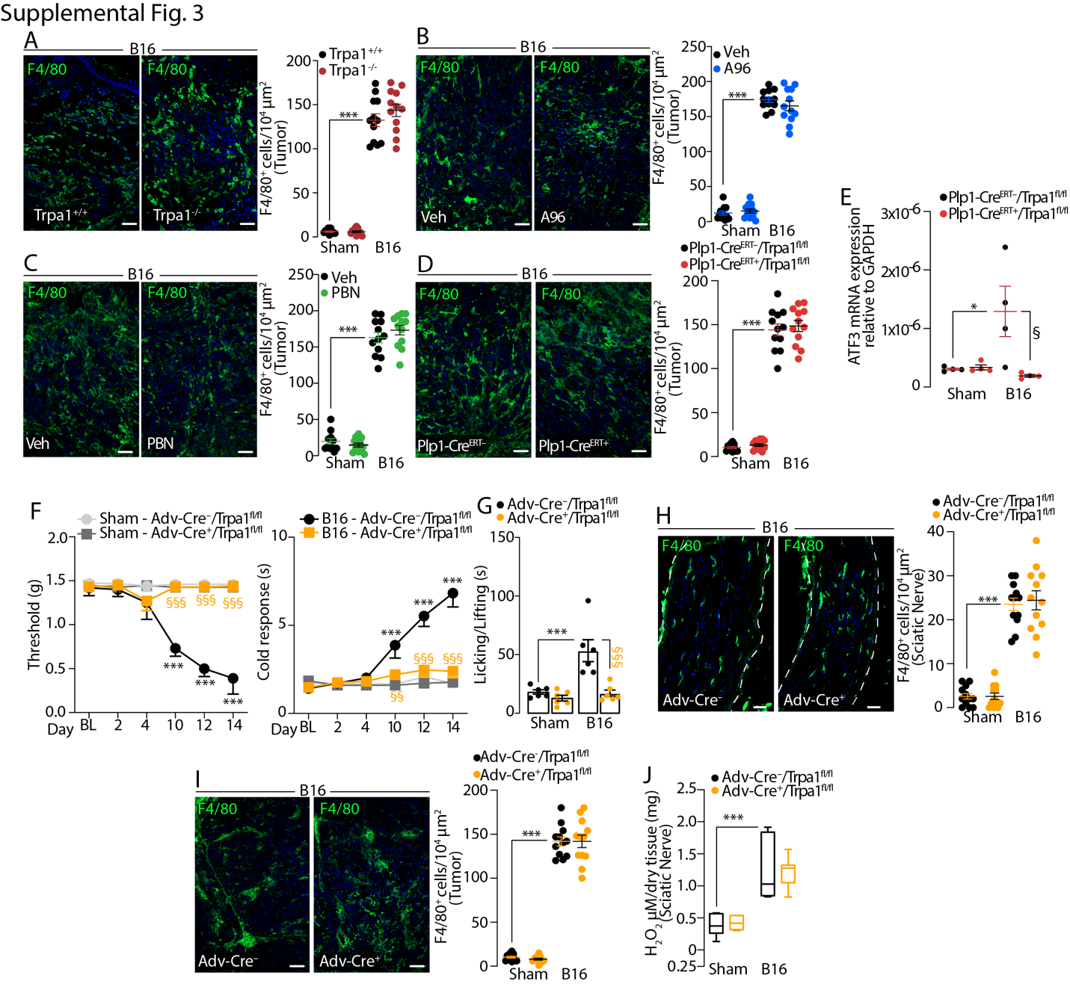

Supplemental Fig. 3. Representative images and pooled data of F4/80⁺ cells in tumor at day 14 after B16-F10 melanoma (B16) cell inoculation or sham in the following conditions: (A) Trpa1^{+/+} and Trpa1^{-/-} mice; (B) C57BL/6J mice, 60 minutes after A967079 (A96) or Veh (i.p.) and (C) PBN or Veh (i.p.) and (D) Plp1-Cre^{ERT-}/^{ERT+}/Trpa1^{fl/fl} mice. (E) ATF3 mRNA relative expression in DRGs from Plp1-Cre^{ERT-}/^{ERT+}/Trpa1^{fl/fl} mice. (F) Mechanical allodynia, cold response, (G) spontaneous nociception, typical images and data of F4/80⁺ cells in sciatic nerve (H) and tumor (I) and (J) H₂O₂ content in sciatic nerve after B16 cell inoculation or sham in Adv-Cre⁻/Cre⁺/Trpa1^{fl/fl} mice. Scale bar 50 μm. N = 6 mice. *P < 0.05, ***P < 0.001 to Sham, Sham-Plp1-Cre^{ERT-}/Trpa1^{fl/fl}, Sham-Adv-Cre⁻/Trpa1^{fl/fl}; §P < 0.05, §§P < 0.01, §§§P < 0.001 to B16-Plp1-Cre^{ERT-}/Trpa1^{fl/fl}, B16-Adv-Cre⁻/Trpa1^{fl/fl},..One-way ANOVA (A, B, C, D, E, G, H, I, J), Two-way ANOVA (F) and Bonferroni post hoc test.

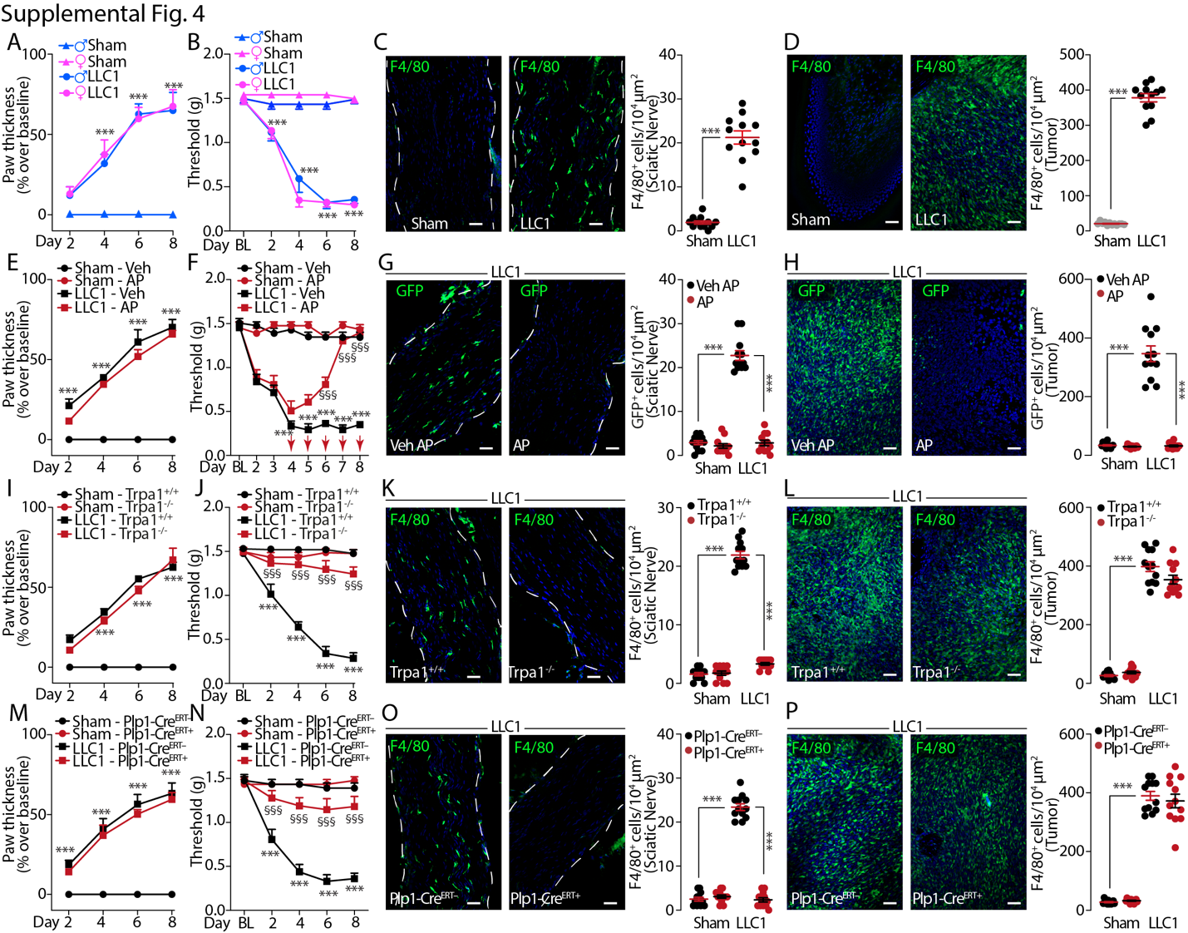

Supplemental Fig. 4. Mechanical allodynia and neuroinflammation induced by LLC1 cells inoculation in mouse hindpaw. Time-dependent increase in paw thickness (A) and mechanical allodynia (B) after LLC1 cells inoculation or sham in C57BL/6J male and female mice. Representative images and pooled data of F4/80⁺ cells in ipsilateral sciatic nerve (C) and tumor (D) after LLC1 cell inoculation or sham in C57BL/6J mice. Time-dependent increase in paw thickness (E) and mechanical allodynia (F) and representative images and pooled data of GFP⁺ cell in ipsilateral sciatic nerve (G) and tumor (H) after LLC1 cell inoculation or sham in MaFIA mice treated with AP12087 (AP) or Veh (i.p.). Time-dependent increase in paw thickness (I) and mechanical allodynia (J) and representative images and pooled data of F4/80⁺ cells in ipsilateral sciatic nerve (K) and tumor (L) after LLC1 cell inoculation or sham in Trpa1^{+/+} and Trpa1^{-/-} mice. Time-dependent increase in paw thickness (M) and mechanical allodynia (N) and representative images and pooled data of F4/80⁺ cells in ipsilateral sciatic nerve (O) and tumor (P) after LLC1 cells inoculation or sham in Plp1-Cre^{ERT-}/Trpa1^{fl/fl} and Plp1-Cre^{ERT+}/Trpa1^{fl/fl} mice. Immunofluorescence was performed at day 8 from LLC1 cell inoculation or sham. BL, baseline. Red arrows indicate the time of treatment with AP or Veh. Dashed line delimits the epineurium. Scale bar 50 μm. N = 6 mice. ***P < 0.001 to sham, Sham-Veh, Sham-Trpa1^{+/+}, Sham-Plp1-Cre^{ERT-}/Trpa1^{fl/fl}; §§§P < 0.001 to LLC1-veh, LLC1-Trpa1^{+/+}, LLC1-Plp1-Cre^{ERT-}/Trpa1^{fl/fl}. Two-way (A, B, E, F, I, J, M, N) and one-way (C, D, G, H, K, L, O, P) ANOVA and Bonferroni post hoc test.

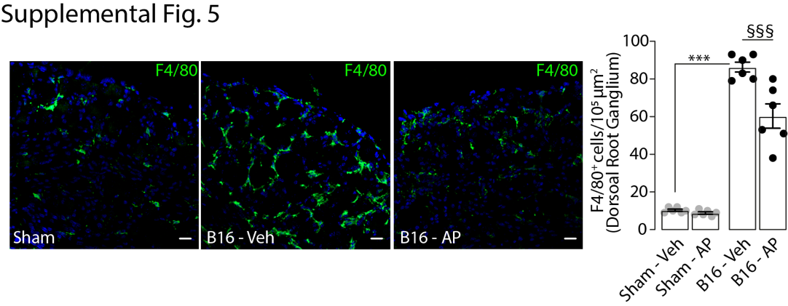

Supplemental Fig. 5. Representative images and pooled data of F4/80⁺ cells in DRGs at day 14 after B16-F10 melanoma (B16) cell inoculation or sham in the MaFIA mice treated with AP12087 (AP) or Veh (i.p.). Scale bar 20 μm. N = 6 mice. ***P < 0.001 to Sham-Veh; §§§P < 0.001 to B16-veh. One-way ANOVA and Bonferroni post hoc test.

